**Fahri Ulkat**

**090220756**

**ProblemSet4 Answers**

**Question1**

**a. Estimator and estimate:** An estimator is a rule used to estimate a population parameter from sample. An estimate is a value that is derived by using estimator.

**b. Unbiased estimator, consistent estimator and efficient estimator:** If expected value of an estimator equals to population parameter, it is called unbiased estimator. If estimator becomes more accurate as the sample size grows, it is called consistent estimator. With the smallest variance one among the unbiased estimator is called efficient estimator.

**c. Null hypothesis and alternative hypothesis:** Null hypothesis is testes for potential rejection. The hypethesis suggesting something else oppsinge the null hypothesis is called alternative hypethesis.

**d. One-sided alternative hypothesis and two-sided alternative hypothesis:** One-sided alternative hypothesis tests if a parameter only greater or lower than a value. Two-sided alternativa hypothesis tests if a parameter is equal or not.

**e. Test statistic:** A calculated value used to determine if observed data significantly deviates from null hpyothesis.

**f. Significance level:** The probability threshdol used to decide if a test statistic is significant.

**g. P-value:** It is the probability of obtaining observed or more extreme results when the null hypothesis is true.

**h. Critical value and rejection region**: A specific value to decide the border of rejection region called crtical value. If test statistic in rejection regian then we deny that hypothesisi.

**i. Confidence interval**: An interval which is found for a parameter of populaiton with a confidence level.

**Question2**



**Question3**

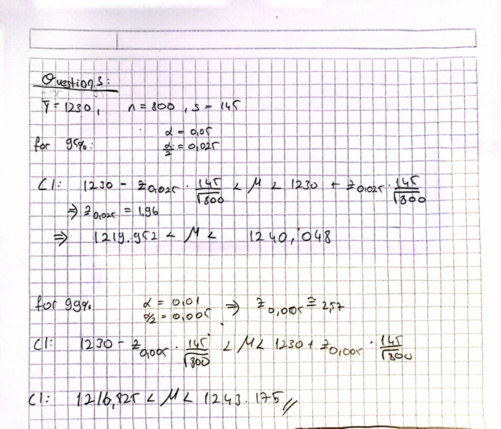

**Question4**

All the answers are in code.

