**Fahri Ulkat 090220756**

**Question1:**

**a. Population Regression Line:** The line that shows the relationship between variables on avarage within population.

**b. Dependent Variable:** The dependent variable is a variable that we are trying to predict with changes in independent variable. Also known as outcome variable.

**c. Independent Variable:** The variable used to explain dependent variable. It is not influenced by the dependent variable. Also known as explanatory variable.

**d. Regressor**: Another term for an independent variable which helps the the dependent variable.

**e. Parameters:** They are fixed values we are trying to use to define the relationship between variables.

**f. Error Term:** The difference between predicted value (E(Y|X)) and observed value of Y.

**g. Ordinary Least Squares Estimators:** Estimator which minimizes the loss function. It provides to find best parameters.

**h. Predicted Value:** The value that we obtained from the population regression line. The value that contain error which represents the diffrence between observed and predictel value.

**i. Residual:** The difference between observed and predicted value of Y.

**j. Regression R2:** It is a value between 0 and 1 which helps us to measure the how succesful X exlpains Y.

**k. Standard Error of the Regression (SER):** A value that measures the avarage distance of observe values from the regression line.

**l. Least Squares Assumptions:** Key assumptions needed for OLS. There are three assumption we covered: Zero-conditional mean, Random sampling, No large outliers assumption.

**Question2:**

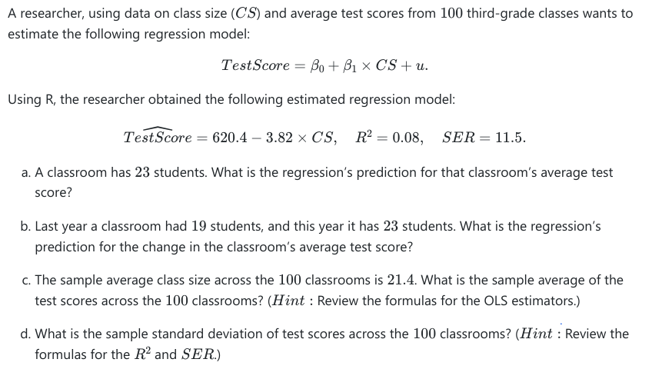

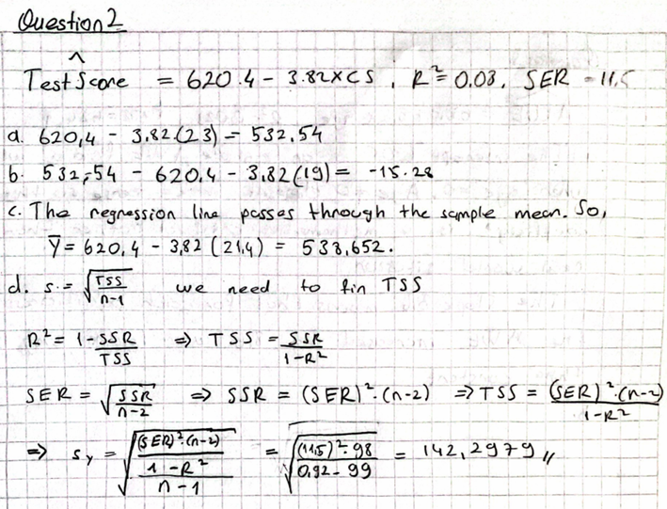

**Question3:**

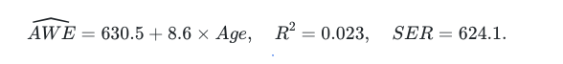

**a. Interpret the estimated coefficients.**

The intercept 630.5 is an estimate AWE for a worker when Age=0 but in this case it does not make sense. So, this coefficient is a mathematical artifact rather than a real world situation.

The slope 8.6 means that, for each additional age AWE incread 8.6 when holding other things constant.

**b. Interpret the SER measure. What are the units of measurement for the ? (Dollars? Years? or unit free?)**

The Standart Error of the Regression is an estimator of the standart deviation of the regression error terms. In this case SER is a measure of the difference between observed and predicted values of AWEs.

The unit of SER is the same unit with Y so it is dollar.

**c. Interpret the R2 measure. What are the units of measurement for the ? (Dollars? Years? or unit free?)**

The R2 score is a measure to find out how much X explain Y. In this case R2=0.023 means X explain Y very weakly.

R2 is a value between 0 and 1 in every case, so it is unit free.

**d. What is the predicted average weekly earnings for a worker who is ? What is the predicted average weekly earnings for a worker who is ?**

For age=23 -> 630.5 + 8.6 x 23 = 828.3

For age=40 -> 630.5 + 8.6 x 40 = 974.5

**e. Will the regression give reliable predictions for a worker who is years old? Explain.**

It will not give reliable predictions because dataset contains only workers aged 25-65. Even if it included higher ages, SLR may not be the best option to make a prediction because until some ages peoples income increase but after that it will start to decrease because they will get old.

**f. Given what you know about the distribution of earnings, do you think it is plausible that the distribution of errors in the regression model is normal? ( Do you think that the distribution is symmetric or skewed? What is the smallest value of earnings, and is it consistent with a normal distribution?)**

Income data usually have a right-skewed distribution because there is usually a minimum wage but no upper limit, which leads to high outliers. This skewness can cause the error terms in the regression model to be non-normally distributed. Since AWE cannot be negative, a perfect normal distribution is unlikely, since a normal distribution requires symmetry. Therefore the errors in the model are also likely to be skewed.

**g. The average age in the sample is 38. What is the average value of AWE in the sample?**

Since the regression line must pass through tha sample mean,

630.5 + 8.6 x (38) = 957.3

**Question4:**

**I have prepared a jupyter notebook for question 4 and converted to html file. You can find both in zipped file.**