TinkerCAD Project 1
Automatic Street Light Using Transistor & Photoresistor
Breadboard-Based Circuit Design

1. Description
This project demonstrates an automatic street light system built on a breadboard using discrete electronic components. The circuit uses a Light Dependent Resistor (LDR/Photoresistor) to sense ambient light levels and automatically controls an LED light source through a transistor switch.
When the surrounding environment becomes dark, the resistance of the LDR increases significantly. This change in resistance affects the base current of the NPN transistor (e.g., 2N2222 or BC547), causing it to enter saturation mode and allowing current to flow through the LED, turning it ON. Conversely, when light is present, the LDR resistance drops, the transistor is cut off, and the LED turns OFF.
Components used in this project:
- Power Supply: 9V DC (adjustable up to 30V for testing)
- LDR (Light Dependent Resistor / Photoresistor): Senses ambient light
- NPN Transistor (e.g., 2N2222): Acts as an electronic switch
- Resistor R1: 440 Ohm (current limiting resistor for LED)
- Resistor R2: 1k Ohm (base resistor for transistor)
- LED: Output indicator / light source
- Breadboard & Connecting Wires
The circuit is entirely passive (no microcontroller), making it simple, low-cost, and reliable for real-world street lighting automation applications.

2. Schema
The schematic below illustrates the circuit connections on the breadboard:
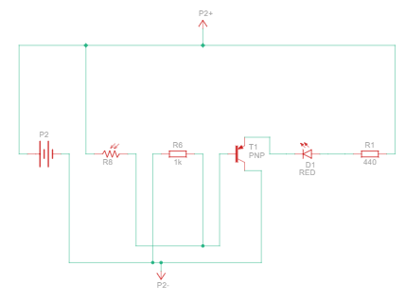

3. Calculations

3.1 LED Current Limiting (R1 = 440 Ohm)
Power Supply Voltage: Vcc = 9V
LED Forward Voltage: Vf = 2V (typical red LED)
Transistor Vce(sat) = 0.2V

Formula: R1 = (Vcc - Vf - Vce) / I_LED
R1 = (9 - 2 - 0.2) / 0.0154 = 440 Ohm
I_LED = (9 - 2 - 0.2) / 440 = 6.8V / 440 = ~15.4 mA
This is within the safe operating range for standard LEDs (max 20mA).

3.2 Transistor Base Resistor (R2 = 1k Ohm)
Base-Emitter Voltage: Vbe = 0.7V
Transistor hFE (current gain) = 100 (minimum for 2N2222)

Required base current to saturate transistor:
I_B = I_C / hFE = 15.4 mA / 100 = 0.154 mA
R2 = (Vcc - Vbe) / I_B = (9 - 0.7) / 0.000154 = 8.3 / 0.000154 = ~53.9 kOhm (max)
Using R2 = 1k Ohm ensures sufficient base current to fully saturate the transistor, providing a safety margin. This is the correct design choice.

3.3 Power Dissipation
Power in R1: P = I^2 x R = (0.0154)^2 x 440 = 0.000237 x 440 = ~0.104 W
Power in R2: P = (Vcc - Vbe)^2 / R2 = (8.3)^2 / 1000 = ~0.069 W
Both values are well within standard resistor power ratings (1/4 W = 0.25 W).

4. Simulation
The simulation was conducted using TinkerCAD Circuits. The circuit was tested under two lighting conditions:
Condition 1 - Dark Environment (LDR high resistance):
- LDR resistance increases to ~10k Ohm or higher
- Sufficient base current flows through R2 to saturate the transistor
- LED turns ON automatically
Condition 2 - Bright Environment (LDR low resistance):
- LDR resistance drops to ~100 Ohm or lower
- Voltage divider effect reduces base current below threshold
- Transistor enters cut-off mode, LED turns OFF
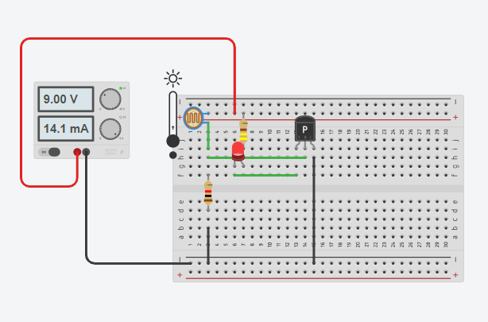

5. Troubleshooting

Troubleshooting Case 1: LED Burned Out (R1 Reduced to 216 Ohm at 30V)

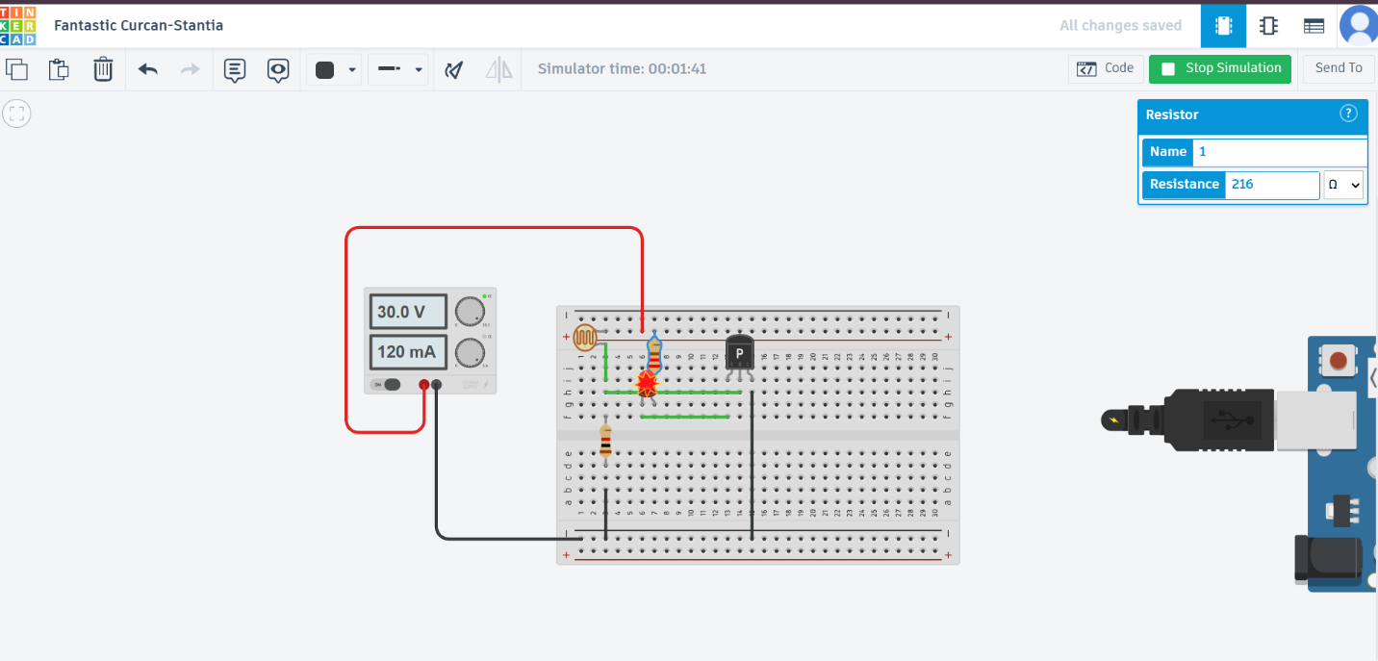
Problem:
During testing, the power supply voltage was increased to 30V while R1 (LED current limiting resistor) was reduced from 440 Ohm to 216 Ohm. This caused the LED to burn out immediately.
Root Cause Analysis:
Recalculating current with new values:
I_LED = (Vcc - Vf - Vce) / R1 = (30 - 2 - 0.2) / 216 = 27.8 / 216 = ~128.7 mA
The LED received approximately 128.7 mA, which is more than 6x the maximum rated current of 20 mA. This excessive current caused instant thermal breakdown and destruction of the LED.
Solution:
- Restore R1 to 440 Ohm or calculate proper value for 30V supply.
- For 30V supply: R1 = (30 - 2 - 0.2) / 0.02 = 27.8 / 0.02 = 1390 Ohm (use 1.5k Ohm standard value)
- Always verify current limits before changing supply voltage.
- Use a multimeter to measure actual current before powering LED.

Troubleshooting Case 2: LED Burned Out (R2 Reduced to 185 Ohm at 30V)

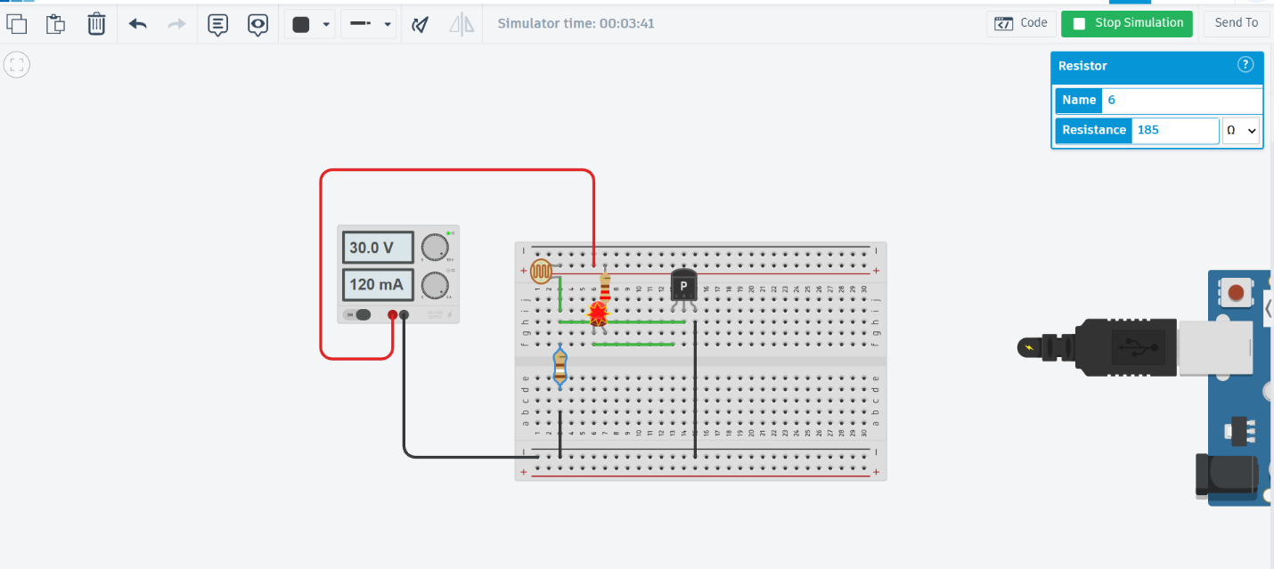
Problem:
The base resistor R2 was reduced from 1k Ohm to 185 Ohm and R1 was 220 while operating at 30V. This caused both the transistor and the LED to fail.
Root Cause Analysis:
New base current:
I_B = (Vcc - Vbe) / R2 = (30 - 0.7) / 185 = 29.3 / 185 = ~158.4 mA
This extreme base current causes the transistor to go into hard saturation and draws dangerously high collector current. The transistor overheats, loses current regulation capability, and the uncontrolled collector current destroys the LED.
Additionally, the transistor itself may suffer thermal runaway at such high base drive levels without adequate heat sinking.
Solution:
- Restore R2 to 1k Ohm minimum for 9V supply.
- For 30V supply: R2 = (30 - 0.7) / (I_C/hFE x 10) = calculate with proper safety margin.
- Never reduce base resistor below safe limits without recalculating collector current.
- Ensure power supply voltage matches the component ratings.

6. Questions

Question 1: Why is the transistor used in this circuit instead of connecting the LED directly to the LDR?
Answer:
The LDR alone cannot provide sufficient current to drive an LED reliably. An LDR is a passive component that only changes resistance based on light; it cannot amplify current. The NPN transistor acts as a current amplifier and switch: a small base current (controlled by the LDR and R2 voltage divider) controls a much larger collector current that properly powers the LED. This amplification effect (hFE = 100+) allows the sensitive LDR to control higher-power loads without degradation. Additionally, using a transistor protects the LDR from carrying excess current that could damage it.

Question 2: What would happen if the LDR was placed on the collector side instead of the base side of the transistor?
Answer:
If the LDR were placed on the collector side (in series with the LED and collector), it would act as a variable resistance in the LED current path rather than a control signal. In bright light, the LDR's low resistance would allow more current through the LED (LED brighter in light), and in dark conditions, the high LDR resistance would limit LED current (LED dim in dark). This is the opposite of the desired automatic street light behavior. The original design correctly places the LDR in the base circuit where it controls the transistor switching, providing proper dark-ON / light-OFF operation.

--- End of Project 1 ---

