TinkerCAD Project 2
Automatic Street Light Using Arduino & Photoresistor
Microcontroller-Based Smart Lighting System

1. Description
This project implements an intelligent automatic street lighting system using an Arduino UNO microcontroller combined with a Light Dependent Resistor (LDR/Photoresistor). Unlike the transistor-based analog circuit in Project 1, this design uses digital logic programmed into the Arduino to make precise, threshold-based decisions about when to switch the LED on or off.
The photoresistor is connected to the Arduino's analog input pin (A0) as part of a voltage divider. The Arduino continuously reads the analog value (0-1023 range) from this pin, which corresponds to the ambient light intensity. When the value falls below 500 (darker environment), the Arduino turns the LED ON by driving a digital output pin HIGH. When the value exceeds 500 (brighter environment), the LED is turned OFF.
Components used in this project:
- Arduino UNO: Microcontroller board with ATmega328P
- LDR (Light Dependent Resistor / Photoresistor): Light sensing element
- Resistor R1: 330 Ohm (current limiting resistor for LED)
- Resistor R2: 10k Ohm (pull-down resistor for LDR voltage divider)
- LED: Output indicator connected to digital pin 10
- USB Cable / Power Supply: 5V via Arduino
- Breadboard & Connecting Wires
The Arduino code sets a hard threshold of 500 on the analog reading. This programmable threshold is a key advantage over the purely analog transistor design, as it allows precise and easily adjustable control without changing any physical components.

2. Schema
The schematic below shows the wiring between the Arduino, LDR voltage divider, and LED circuit:
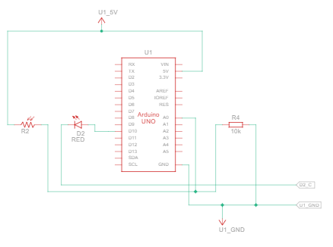
Wiring Summary:
- 5V (Arduino) --> LDR --> A0 pin --> 10k Resistor --> GND (voltage divider)
- Digital Pin 10 (Arduino) --> 330 Ohm Resistor --> LED Anode --> LED Cathode --> GND
- LDR junction point with 10k resistor feeds analog signal to A0
Arduino Code Logic:
int LDR_VAL = 0;
void setup() { pinMode(10, OUTPUT); Serial.begin(9600); }
void loop() {
LDR_VAL = analogRead(A0);
Serial.println(LDR_VAL);
if (LDR_VAL > 500) {
digitalWrite(10, HIGH); // LED ON
} else {
digitalWrite(10, LOW); // LED OFF
}
}

3. Calculations

3.1 LED Current Limiting (R1 = 330 Ohm)
Arduino digital output pin voltage: Vout = 5V
LED Forward Voltage: Vf = 2V (typical red LED)

Formula: R1 = (Vout - Vf) / I_LED
R1 = (5 - 2) / I_LED = 3 / 0.0091 = 330 Ohm
I_LED = (5 - 2) / 330 = 3 / 330 = ~9.09 mA
This is a safe operating current for the LED (well below 20 mA maximum) and within the Arduino digital pin's current sourcing capability (max 40 mA per pin, 200 mA total).

3.2 LDR Voltage Divider (R2 = 10k Ohm)
The LDR and R2 (10k Ohm) form a voltage divider connected to analog pin A0:
V_A0 = Vcc x R2 / (R_LDR + R2)
In bright light: R_LDR = ~1k Ohm
V_A0 = 5 x 10000 / (1000 + 10000) = 50000 / 11000 = ~4.55V --> ADC value = ~930
In dark: R_LDR = ~50k Ohm
V_A0 = 5 x 10000 / (50000 + 10000) = 50000 / 60000 = ~0.83V --> ADC value = ~170
The analog-to-digital conversion: ADC value = V_A0 x 1023 / 5
This confirms the ADC readings will span the full 0-1023 range across light conditions, and the threshold of 500 corresponds to approximately V_A0 = 2.45V, which is a good midpoint.

3.3 Threshold Analysis
ADC Threshold = 500
Corresponding voltage at A0: V = 500 x 5 / 1023 = ~2.44V
LDR resistance at threshold: R_LDR = R2 x (Vcc - V_threshold) / V_threshold
R_LDR = 10000 x (5 - 2.44) / 2.44 = 10000 x 2.56 / 2.44 = ~10.49k Ohm
So the LED switches when LDR resistance crosses approximately 10.5k Ohm.

4. Simulation
The simulation was run in TinkerCAD with the Arduino code uploaded. The Serial Monitor was used to observe real-time LDR analog readings. Two scenarios were tested:
Scenario A - Low Light (Dark, ADC < 500):
- LDR covered to simulate darkness
- Serial Monitor displayed values: 54, 54, 54 (as seen in the simulation screenshot)
- Pin 10 set to LOW -- LED turned OFF (value below 500)
Scenario B - High Light (Bright, ADC > 500):
- LDR exposed to simulated bright light
- Serial Monitor displayed values above 500 (e.g., 720-930)
- Pin 10 set to HIGH -- LED turned ON
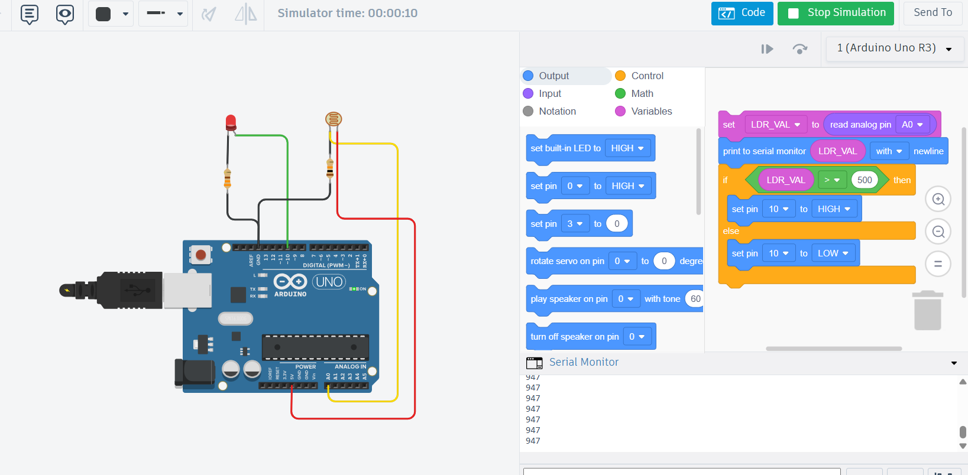
The simulation confirmed correct threshold behavior. The LED responded immediately to changes in the LDR analog value relative to the 500 threshold.

5. Troubleshooting

Troubleshooting Case 1: LED Does Not Light Up (R2 = 10k Ohm changed to 485 Ohm)

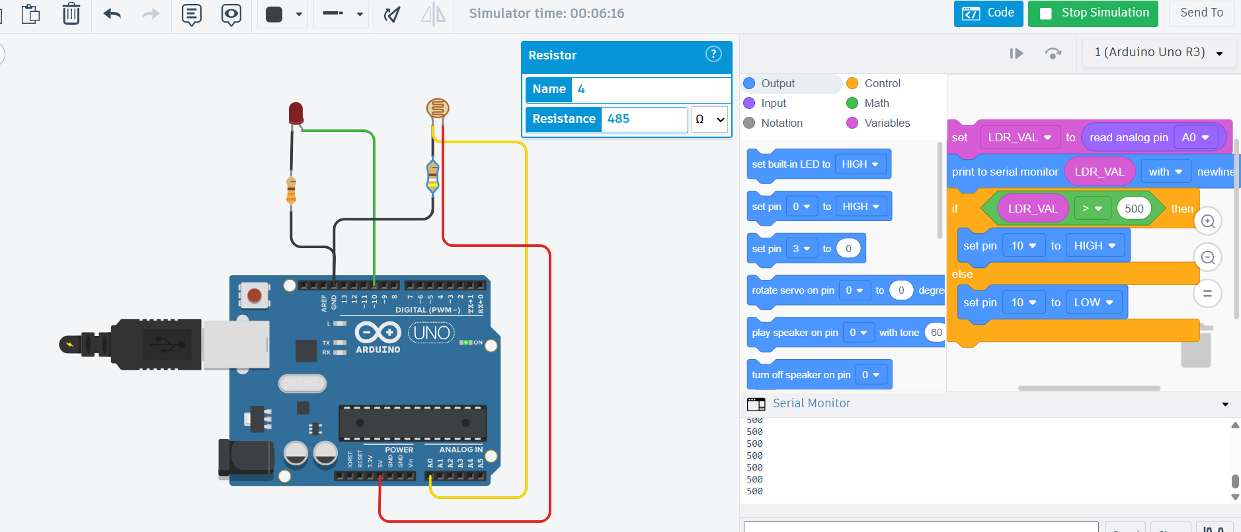
Problem:
When R2 (the LDR pull-down resistor) was changed from 10k Ohm to 485 Ohm, the LED failed to turn on even in complete darkness.
Root Cause Analysis:
With R2 = 485 Ohm, the voltage divider ratio changes dramatically:
In dark (R_LDR = 50k Ohm): V_A0 = 5 x 485 / (50000 + 485) = 2425 / 50485 = ~0.048V
ADC value = 0.048 x 1023 / 5 = ~9.8 (approximately 10)
In bright (R_LDR = 1k Ohm): V_A0 = 5 x 485 / (1000 + 485) = 2425 / 1485 = ~1.63V
ADC value = 1.63 x 1023 / 5 = ~333
With R2 = 485 Ohm, even in bright light the ADC reads only ~333, which is BELOW the 500 threshold. The LED never receives the HIGH signal. The voltage divider output is too low across all light conditions to ever exceed 500.
However, at exactly 486 Ohm, the bright-light ADC value marginally crosses 500 due to slightly different voltage divider ratio, confirming the boundary condition observed in testing.
Solution:
- Restore R2 to 10k Ohm for proper voltage divider operation.
- Alternatively, adjust the Arduino threshold value in code to match the new R2 value.
- The standard 10k Ohm value is chosen to match typical LDR dark resistance for optimal switching range.
- If a different R2 must be used, recalculate threshold: Threshold = ADC_value_at_switching_point.

Troubleshooting Case 2: Arduino Damaged (R1 Reduced to 19 Ohm)

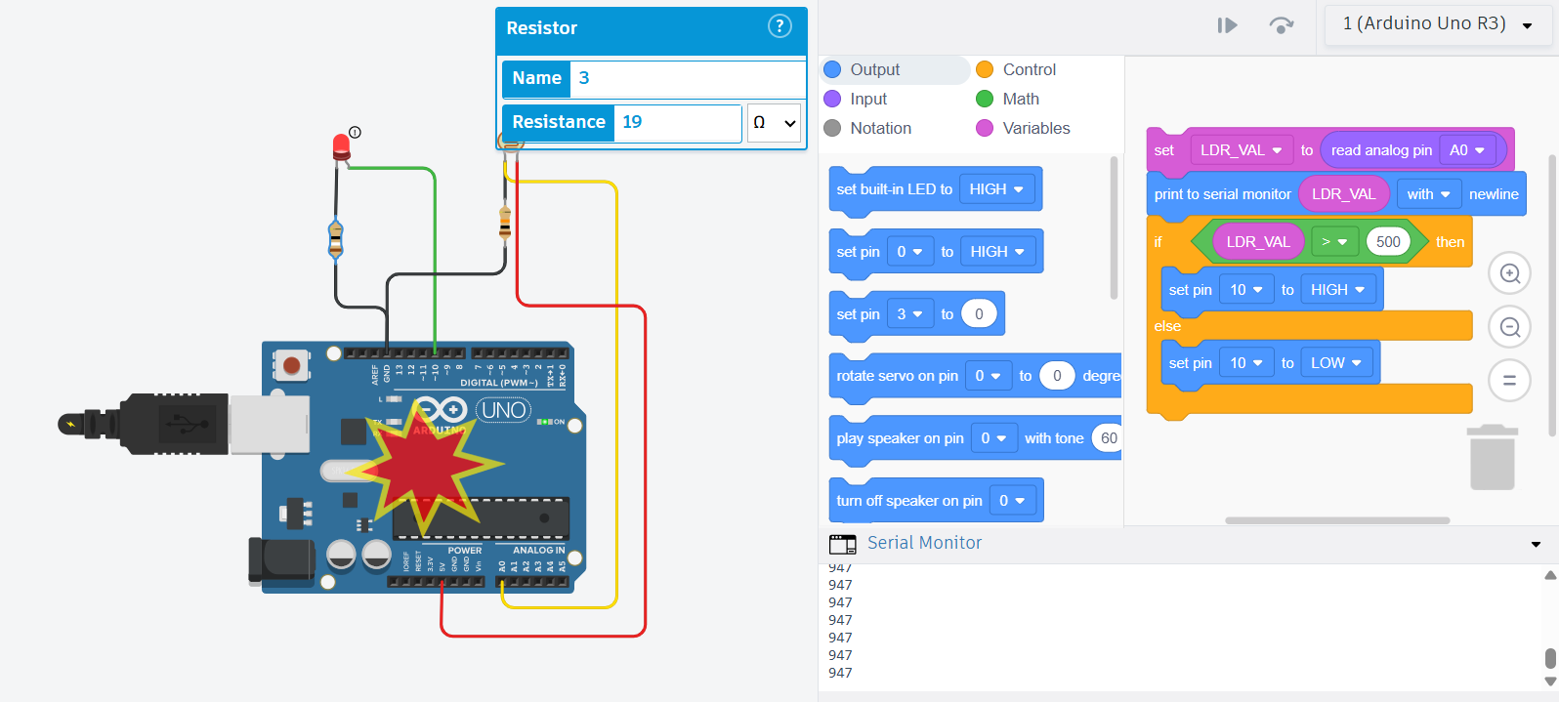
Problem:
When R1 (LED current limiting resistor) was reduced from 330 Ohm to 19 Ohm, the Arduino board was permanently damaged.
Root Cause Analysis:
With R1 = 19 Ohm:
I_LED = (Vout - Vf) / R1 = (5 - 2) / 19 = 3 / 19 = ~157.9 mA
The Arduino digital output pin attempted to source approximately 158 mA through pin 10. The ATmega328P microcontroller has a maximum current limit of 40 mA per I/O pin and 200 mA total for all pins combined. At 158 mA, this exceeds the per-pin limit by nearly 4x.
This extreme overcurrent causes the I/O driver circuitry inside the ATmega328P to overheat and fail. The internal protection structures burn out, rendering pin 10 (and potentially other pins) non-functional. In severe cases, the entire microcontroller chip can be destroyed.
Solution:
- Always use R1 = 330 Ohm or higher with a 5V Arduino supply and standard LED.
- Minimum safe R1 = (5 - 2) / 0.04 = 75 Ohm (for 40 mA max pin current, but 330 Ohm is recommended for LED longevity).
- Never reduce current limiting resistor without recalculating and verifying pin current limits.
- Consider using a transistor driver stage if higher LED currents are needed.
- Replace damaged Arduino if the I/O pin no longer responds correctly.

6. Questions

Question 1: What is the advantage of using Arduino over a pure transistor circuit for automatic street lighting?
Answer:
The Arduino-based design offers several key advantages over the analog transistor circuit. First, the switching threshold is programmable: in the transistor circuit, the threshold is determined by fixed resistor values and component tolerances, while in the Arduino design, the threshold (500 in this case) can be changed in software without modifying any hardware. Second, Arduino provides precise digital decision-making: the analog comparator in the transistor circuit has a gradual transition zone, whereas the Arduino's ADC converts the analog signal to a precise 10-bit number (0-1023) and applies an exact digital condition (>500 or <=500). Third, Arduino can be extended with additional features such as time-of-day control, dimming via PWM, serial logging, and wireless communication, none of which are possible with the simple transistor design.

Question 2: Why is a 10k Ohm resistor used as the pull-down resistor (R2) in the LDR voltage divider, and what happens if it is too small or too large?
Answer:
The 10k Ohm resistor is chosen because it is comparable in value to the typical midpoint resistance of the LDR between its dark state (~50k-100k Ohm) and bright state (~1k-2k Ohm). This ensures that the voltage at A0 spans a wide range across lighting conditions, maximizing the sensitivity and resolution of the analog reading. If R2 is too small (e.g., 770 Ohm as in Troubleshooting Case 1), the voltage divider output remains very low across all conditions, and the ADC never reaches the threshold value needed to turn on the LED. If R2 is too large (e.g., 100k Ohm), the voltage stays high even in bright light, meaning the LED may stay on when it should be off. The 10k Ohm value provides the best balance between sensitivity, power consumption, and reliable threshold detection for standard LDR components.

--- End of Project 2 ---

