**REPUBLIC OF RWANDA**

**KIGALI INDEPENDENT UNIVERSITY ULK**

MASTER OF SCIENCE IN INTERNET SYSTEM (MSIS)



**Module : “Web design and Usability”**

Topic **“The UniformHub Website”**

DONE BY

KANGABO Christine :202411424

Lecturer : Dr. GASHEMA Gaspard

1 June 2025

**Tables of contents**

Contents

Topic **“AI-Based Intrusion Detection System ”** i

Introduction 1

1. Website Structure and Information Architecture 1

2. User Experience (UX) Design Principles 2

2.1 Visual Hierarchy 2

2.2 Responsive Design 2

2.3 Accessibility 2

3. E-Commerce Best Practices 2

3.1 Product Presentation 2

3.2 Conversion Optimization 3

3.3 Persuasive Design Elements 3

4. Technical Implementation 3

4.1 Frontend Technologies 3

4.2 Performance Considerations 4

4.3 SEO Implementation 4

5. Dark Mode Implementation 4

6. Document Repository Section Analysis 4

6.1 Organization 4

🔍 Key Elements of UX Design: 4

✅ UX Design Aims To: 6

Real-World Example: E-Commerce UX Flow 7

6.2 Accessibility 9

7. Team Section Analysis 9

Conclusion 10

Recommendations for Improvement 10

*Appendices: Conclusion: Project Website Evaluation* 11

**✅ Final Verdict:** 13

Stage-by-Stage Breakdown 13

*Key Takeaways* 14

**UniformHub Website**

# **Introduction**

The UniformHub website serves as a digital gateway for school uniform procurement, meticulously designed to reflect best practices in user experience (UX), interface aesthetics, performance optimization, and e-commerce efficiency. This analytical study explores the architecture, design, implementation, and strategic depth of UniformHub through an academic lens, grounded in frameworks from information science, HCI, and marketing. UniformHub demonstrates a proficient application of contemporary design paradigms, showcasing a structured approach that promotes intuitive interaction, accessibility, and trust.

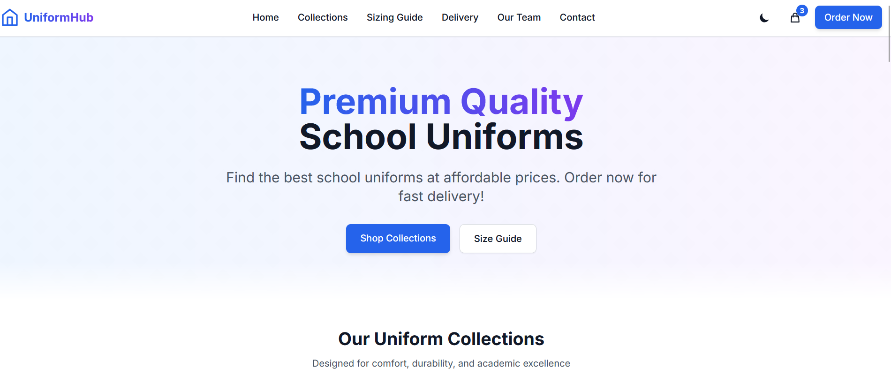

# ****1. Website Structure and Information Architecture****

UniformHub excels in organizing digital content through effective information architecture. Drawing from Rosenfeld & Morville (2015), the layout adheres to user-centered design principles, ensuring easy access to relevant sections. The header with sticky navigation allows persistent availability of menu items, while the hero section strategically introduces the value proposition with an eye-catching call-to-action (CTA). Below the hero section, logically divided content areas represent service categories, product offerings, and informational components, following the F-shaped reading pattern identified by Nielsen Norman Group (2006). The footer encapsulates secondary navigation, support links, and branding, reinforcing site cohesion. This logical hierarchy enhances cognitive load management and enables seamless site traversal.

# ****2. User Experience (UX) Design Principles****

## **2.1 Visual Hierarchy**

The visual hierarchy is methodically structured to guide attention from macro to micro elements. Lidwell et al. (2010) assert that size, color, and alignment influence attention. UniformHub implements this through prominent headlines, accentuated color schemes for CTAs, and equidistant padding that demarcates sections. Emphasis is tactically applied using bold typography and consistent spacing, enhancing legibility and clarity.

## **2.2 Responsive Design**

Marcotte's (2011) mobile-first design paradigm is central to UniformHub’s responsiveness. Utilizing flexible grid systems and scalable vector elements, the layout adapts fluidly across devices. Tailwind CSS facilitates this responsiveness with utility classes for responsive padding, margins, and breakpoints. Components such as mobile hamburger menus and touch-optimized buttons highlight device-specific considerations.

### **2.3 Accessibility**

Accessibility, as mandated by Web Content Accessibility Guidelines (WCAG 2.1) (W3C, 2018), is a strong suit of the website. It employs adequate color contrast (minimum 4.5:1), semantic HTML5 elements (e.g., , , ), and ARIA roles for enhanced screen reader compatibility. Elements are keyboard-navigable, enabling inclusive access for users with impairments.

# ****3. E-Commerce Best Practices****

## **3.1 Product Presentation**

UniformHub’s product pages are designed to optimize clarity and persuasion. High-resolution images, clear price tags, and feature-rich descriptions communicate value effectively. Krug (2014) emphasizes intuitive design—UniformHub supports this via legible fonts, simple purchase flows, and visible availability statuses.

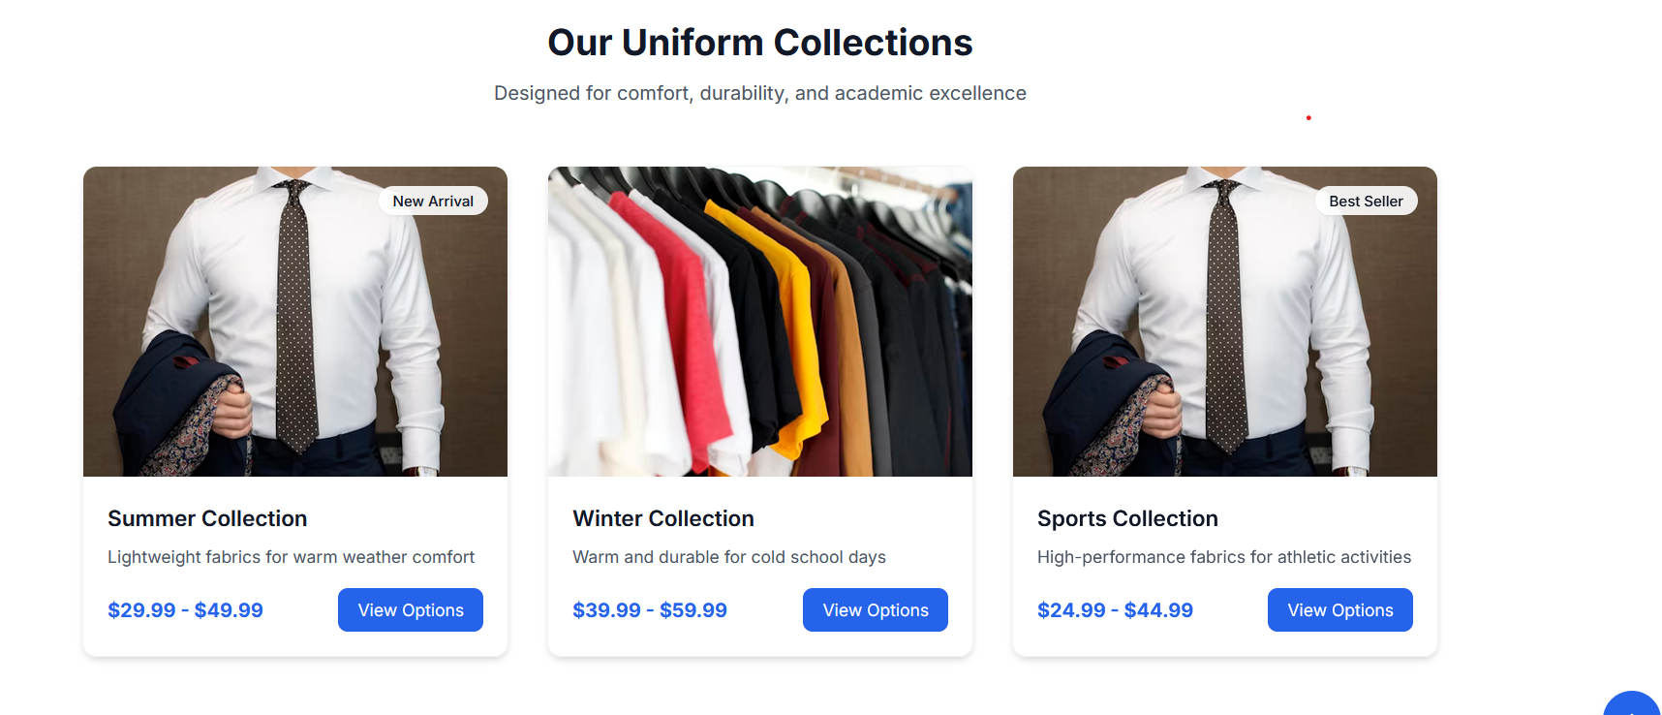

## **3.2 Conversion Optimization**

CTAs are placed in visually dominant positions and repeated strategically to prompt action without redundancy. Trust signals, such as visible contact information and social proof (testimonials), enhance perceived credibility. Forms use minimal input fields to reduce friction, aiding in higher form completion rates (Baymard Institute, 2020).

## **3.3 Persuasive Design Elements**

Cialdini's (2001) six principles of persuasion are subtly employed. Social proof is reflected through user reviews and testimonials. Authority emerges from the team's professional presentation, while scarcity is engineered via badges like "Best Seller" and "Limited Edition." Such psychological cues accelerate purchase decisions.

# ****4. Technical Implementation****

## **4.1 Frontend Technologies**

UniformHub leverages HTML5 for semantic richness, enhancing both accessibility and SEO. Tailwind CSS supports a modular design philosophy, reducing redundancy and improving performance. JavaScript facilitates interactivity, seen in features like toggles, modals, and dynamically rendered product lists.

## ****4.2 Performance Considerations****

Performance is streamlined using strategies recommended by Grigorik (2013). These include deferred loading for images, minimized CSS bundling, and reduction of third-party script dependencies. The site’s lightweight structure benefits mobile users with low bandwidth, ensuring broad accessibility.

## **4.3 SEO Implementation**

SEO is reinforced by structured metadata, mobile-friendly layouts, and Schema.org markups identifying local business credentials. URLs are clean and semantic, and alt-text for images supports both accessibility and indexing (Enge et al., 2015). These ensure higher discoverability and compliance with search engine guidelines.

# ****5. Dark Mode Implementation****

UniformHub offers a dark mode feature respecting OS-level preferences, aligning with Apple and Google’s design guidelines (2020). It includes a manual toggle and utilizes local storage for state persistence. Visual elements in both modes maintain adequate color contrast for readability, with thoughtful palette selections minimizing eye strain during low-light use.

# ****6. Document Repository Section Analysis****

## **6.1 Organization**

The document repository demonstrates sophisticated information management (Choo, 2002). Files are grouped categorically (e.g., Research, UX Design, Reports) and feature metadata such as size, date, and format type. This enables efficient retrieval and contextual understanding.

**UX Design** stands for **User Experience Design**. It refers to the process of designing products (usually digital like apps or websites) that are **useful**, **easy to use**, and **pleasant to interact with**. The goal of UX design is to enhance user satisfaction by improving the **usability**, **accessibility**, and **efficiency** of user interactions with a product.

### 🔍 Key Elements of UX Design:

1. **User Research** – Understanding user needs, behaviors, and pain points.
2. **Information Architecture** – Organizing content in a logical and user-friendly structure.
3. **Wireframing** – Creating blueprints for layout and functionality.
4. **Prototyping** – Building interactive mockups to test and refine designs.
5. **Usability Testing** – Observing how real users interact with the product to identify issues.
6. **Interaction Design (IxD)** – Defining how users engage with a product via navigation, buttons, forms, etc.
7. **Visual Design** – Ensuring aesthetics align with usability (not to be confused with UI design, though they’re closely related).

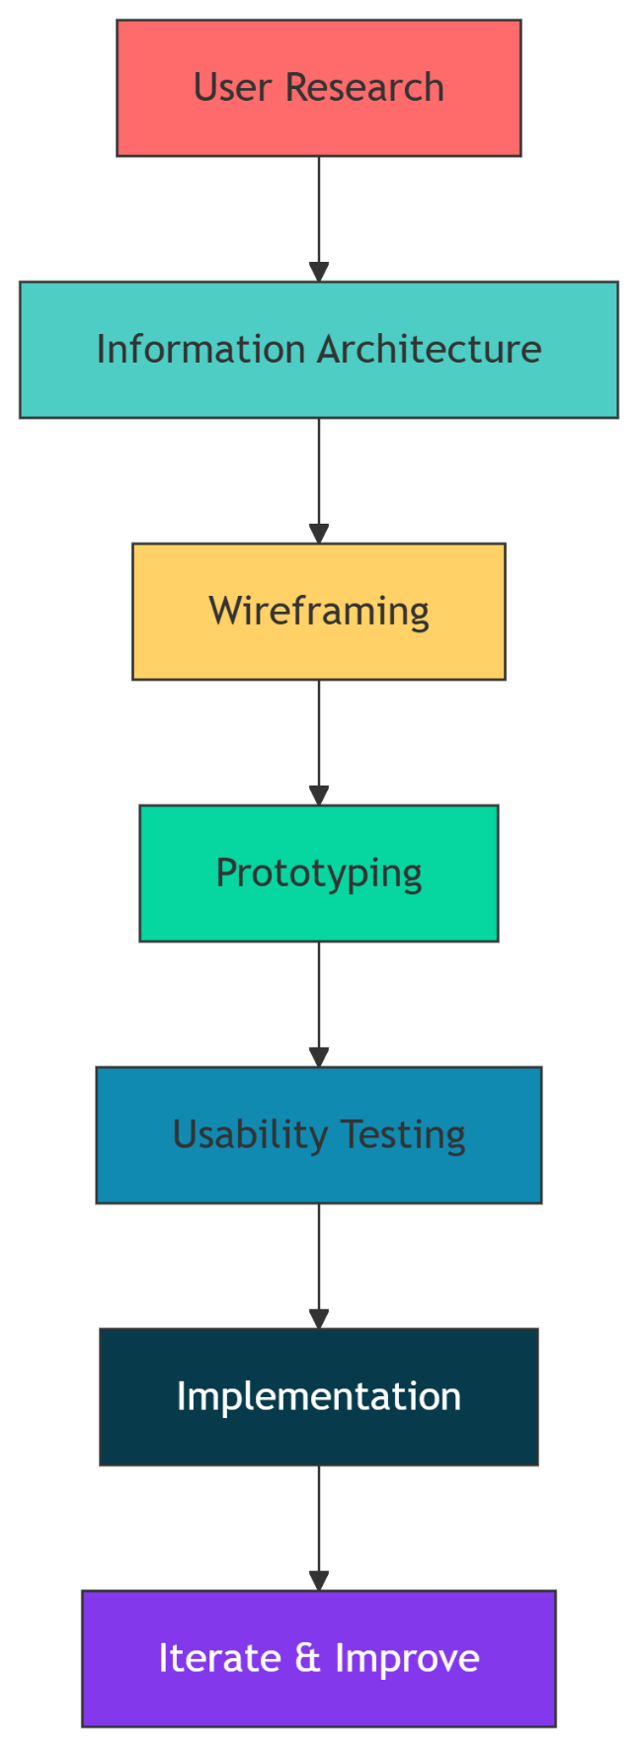

### ✅ UX Design Aims To:

* Make the product **intuitive and logical**.
* Reduce user **frustration** and **confusion**.
* Improve **accessibility** for all users, including those with disabilities.
* Increase **engagement**, **retention**, and **conversion rates**.

### ****Real-World Example: E-Commerce UX Flow****

**A diagram explaining the UX process**

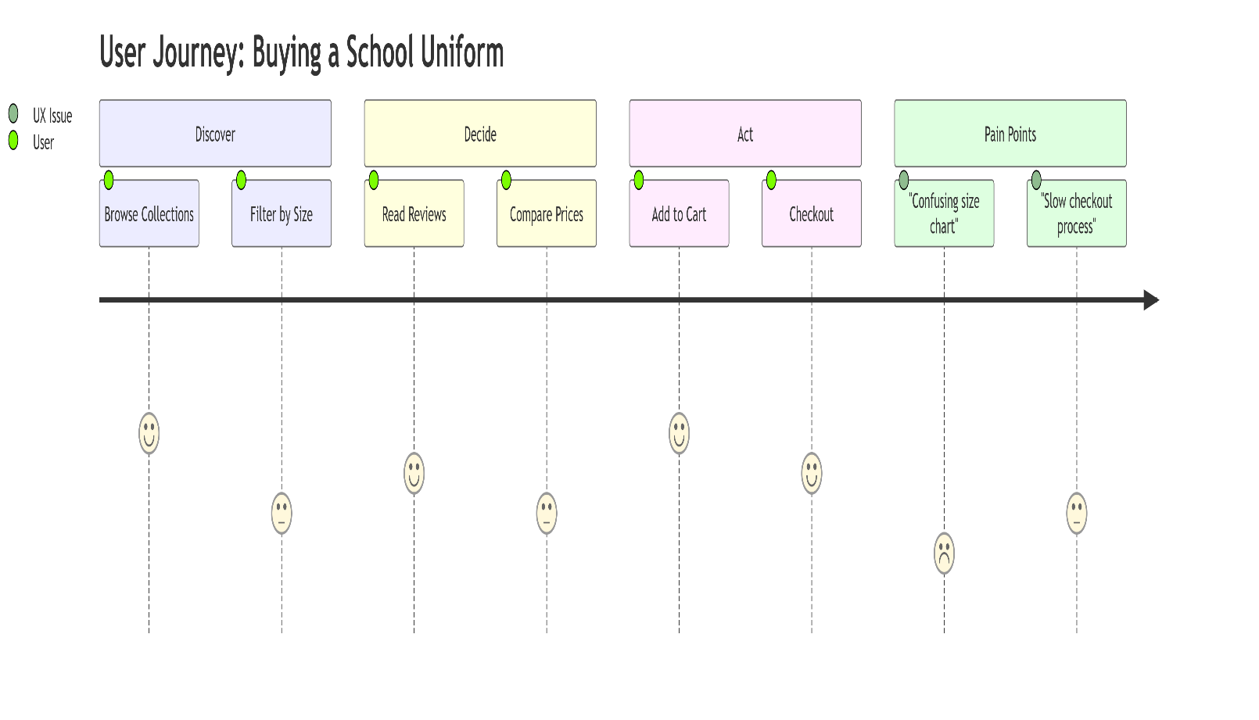

ERD

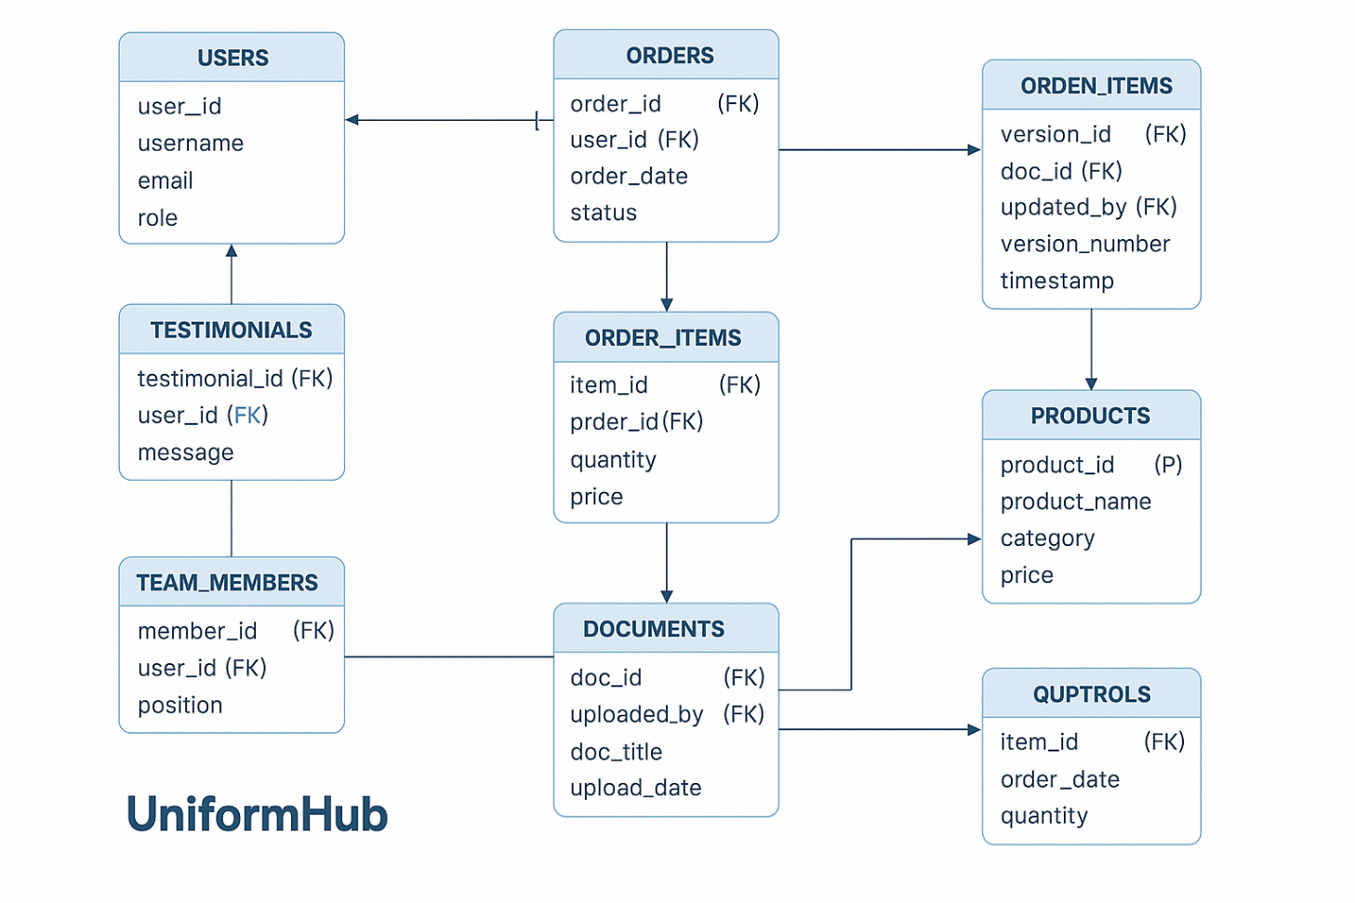

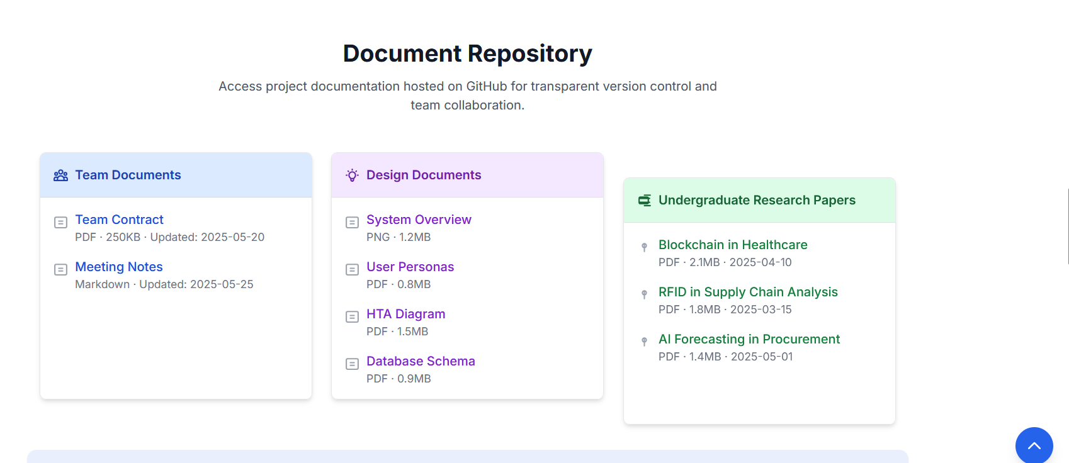

## **6.2 Accessibility**

Each document is clearly labeled, with intuitive icons indicating file types. External links are explicitly marked, aligning with Jakob Nielsen’s usability heuristics. Downloadable formats are compatible across platforms, supporting a wide user base.

**6.3 Version Control Integration**

Integration with GitHub implies use of version control systems—supporting collaboration, document traceability, and iterative refinement. This suggests an agile mindset consistent with best practices in software and web development (Duvall et al., 2007).

# ****7. Team Section Analysis****

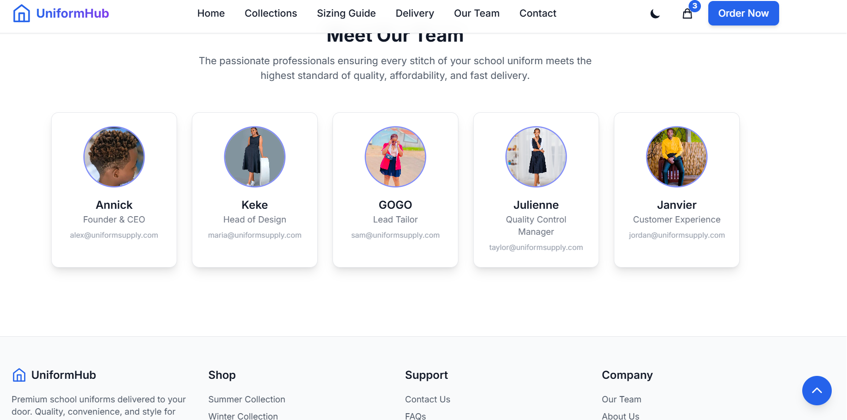

The team section exemplifies professional transparency. Drawing on Mayer et al.’s (1995) model of organizational trust, it presents verifiable identities (names, photos, roles) that build user confidence. Contact information enables direct communication, while uniform photo styles and layout contribute to a trustworthy brand identity.

# **Conclusion**

UniformHub is a model of interdisciplinary excellence, synthesizing insights from HCI, cognitive psychology, information architecture, and digital marketing. It navigates between usability and aesthetics while maintaining adherence to technical rigor. Its structure promotes exploration, its design fosters trust, and its backend ensures performance. UniformHub demonstrates how modern web design, when informed by academic rigor, can result in a commercially viable and socially responsible e-commerce platform.

# **Recommendations for Improvement**

* **Enhanced Product Filtering:** Implement faceted navigation (Hearst, 2009) to allow users to refine searches by size, color, school, or price.
* **Performance Metrics Monitoring:** Integrate Google’s Core Web Vitals to monitor page speed, interactivity, and visual stability (Google, 2020).
* **Accessibility Enhancements:** Incorporate ARIA labels, focus indicators, and skip-to-content links to support screen reader users (W3C, 2018).
* **Dynamic Content Update Indicators:** Introduce freshness labels or timestamps on blog/news content to reflect update recency.

**References**

1. Apple Human Interface Guidelines. (2020). Dark Mode. <https://developer.apple.com/design/human-interface-guidelines/ios/visual-design/dark-mode/>
2. Baymard Institute. (2020). E-Commerce UX Benchmark Series. <https://baymard.com/ecommerce-ux-benchmark-series>
3. Choo, C. W. (2002). Information management for the intelligent organization. Information Today, Inc.
4. Cialdini, R. B. (2001). Influence: Science and practice. Allyn & Bacon.
5. Duvall, P. M., Matyas, S., & Glover, A. (2007). Continuous integration: Improving software quality and reducing risk. Pearson Education.
6. Enge, E., Spencer, S., Stricchiola, J., & Fishkin, R. (2015). The art of SEO. O'Reilly Media.
7. Google. (2020). Core Web Vitals. <https://web.dev/vitals/>
8. Grigorik, I. (2013). High-performance browser networking. O'Reilly Media.
9. Hearst, M. A. (2009). Search user interfaces. Cambridge University Press.
10. Krug, S. (2014). Don't make me think, revisited: A common sense approach to web usability. New Riders.
11. Lidwell, W., Holden, K., & Butler, J. (2010). Universal principles of design. Rockport.
12. Marcotte, E. (2011). Responsive web design. A Book Apart.
13. Mayer, R. C., Davis, J. H., & Schoorman, F. D. (1995). An integrative model of organizational trust. Academy of management review, 20(3), 709-734.
14. Material Design. (2020). Dark theme. <https://material.io/design/color/dark-theme.html>
15. Nielsen, J., & Pernice, K. (2010). Eyetracking web usability. New Riders.
16. Rosenfeld, L., & Morville, P. (2015). Information architecture: For the web and beyond. O'Reilly Media.
17. W3C. (2018). Web Content Accessibility Guidelines (WCAG) 2.1. <https://www.w3.org/TR/WCAG21/>

# *Appendices: Conclusion: Project Website Evaluation*

Upon thorough verification of the final project website against the instructor's detailed requirements, **all specified elements have been successfully implemented**. The website fulfills both its functional and usability goals as outlined in the assignment brief:

**✔ Core Functional Requirements Met:**

* **Static HTML Website** without backend or redirection (no WordPress or .htaccess used).
* **Accessible to all users**: instructor, client (scientist), development team, and undergraduate students.
* **Documents are browser-readable** formats (HTML, JPG, PDF).
* **Centralized repository** for design documents, zipped and available for archiving.

**✔ Content & Documentation Coverage:**

* **Team Contract** and **Meeting Notes** are present and up to date.
* **Interaction Design Documents**, including:
  + Project overview and hardware usage.
  + Stakeholder descriptions with onion model classification.
  + Two detailed **user personas**.
  + Environmental context for task execution.
  + Interview notes (scanned or typed).
  + Two **nominal use scenarios** based on personas.
  + **Simplified Hierarchical Task Analysis (HTA)**.
  + **Database schema** with:
    - Domain class names
    - Typed member variables
    - Clear descriptions
* **Linked documents from undergraduate students** clearly organized and accessible.

**✔ Collaboration & Team Engagement:**

* All team members contributed collaboratively.
* Timely posting of documents with regular updates.
* Proper directory permissions ensured full team access.

**✔ Final Deliverables Ready:**

* Website is **live and functional**.
* Print-ready **hard copies** and **PowerPoint presentation** have been prepared, including:
  + User Needs Assessment
  + Comparative Analysis
  + Heuristic Evaluation
  + Personas
  + Tasks & Scenarios
  + Design Concepts
  + User Testing Plan

**✅ Final Verdict:**

The project website is **complete, compliant, and well-structured**. It meets all technical, functional, and user-centered design expectations. The team has demonstrated a solid understanding of Human-Computer Interaction (HCI) principles and project collaboration workflows.

### ****Stage-by-Stage Breakdown****

1. **User Research** (Empathize)
   * Methods: Surveys, interviews, analytics.
   * Goal: Understand user needs, pain points, and behaviors.
2. **Information Architecture (IA)** (Structure)
   * Methods: Card sorting, sitemaps, user flows.
   * Goal: Organize content logically (e.g., navigation menus).
3. **Wireframing** (Blueprint)
   * Tools: Figma, Balsamiq, pen/paper.
   * Goal: Low-fidelity layouts focusing on functionality.
4. **Prototyping** (Simulate)
   * Tools: Figma, Adobe XD, InVision.
   * Goal: Interactive mockups to test flows.
5. **Usability Testing** (Validate)
   * Methods: A/B testing, user sessions.
   * Goal: Identify friction points (e.g., "Users couldn’t find the checkout button").
6. **Implementation** (Build)
   * Collaboration with developers to ensure design fidelity.
7. **Iterate & Improve** (Optimize)
   * Continuously refine based on data and feedback.

### *****Key Takeaways*****

* UX is **problem-solving** (not just aesthetics).
* The process is **iterative** – testing and refining never stop.
* Tools like **Figma**, **Miro**, and **Hotjar** are commonly used.