31.03.2022

ULLAAS M
1NT19IS179

$mongo

>use lab

>inserting one

db.lab.insertOne(
... {
... "name":"abc",
... "city":"blore"})
{

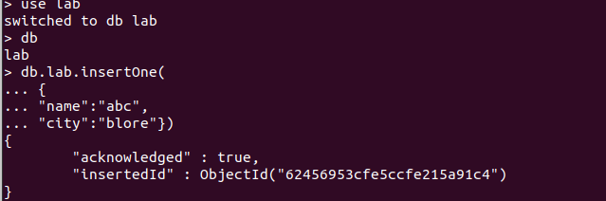

>inserting many
db.lab.insertMany([
... {"name":"vinayak","age":22,"elective":"EDA"},
... {"name":"sanjeev","age":21,"elective":"CC"},
... {"name":"madhu","age":21,"elective":"cloud"}])

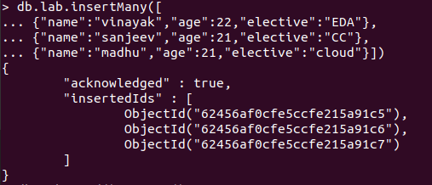

> db.lab.find().pretty()

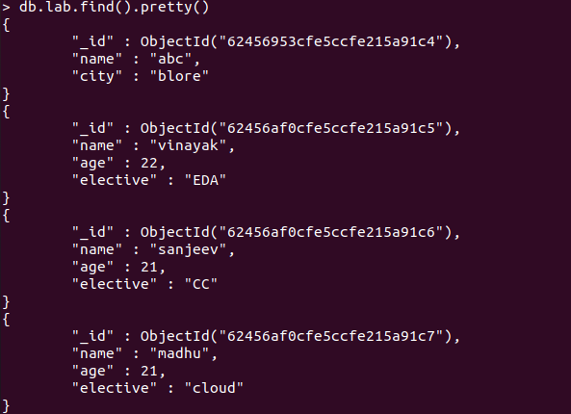

find

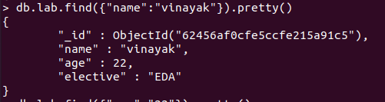

updatemany

db.lab.updateMany(
... {},
... {
... $set:{"college":"nmit"}
... }
... )
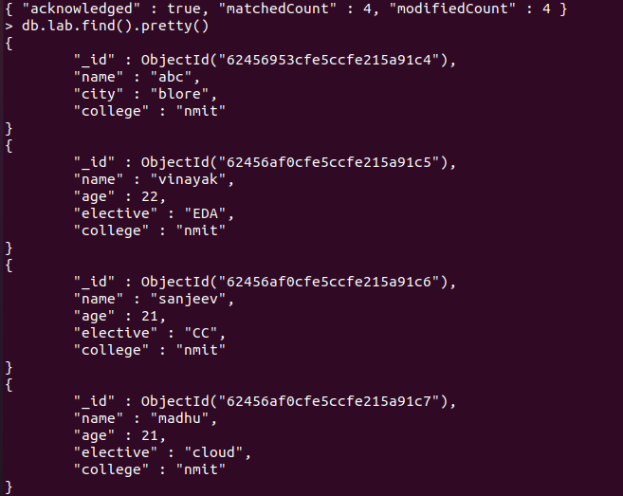

updateone
db.lab.updateOne(
... {"name":"abc"},
... {
... $set:{"name":"qwert"}
... }
... )
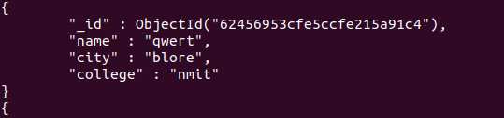

delete one

db.lab.deleteOne(
... {"name":"ullaas"}
... )

---ullaas deleted----

db.lab.insertOne(
... {"name":"ullaas","age":20,"elective":"EDA","college":"nmit"}
... )
{

UNSET
db.lab.updateMany( {"college":"nmit"}, {$unset:{"college":""} })

