Name:ULLAAS
USN:1NT19IS179

EXP-2 HADOOP COMMANDS

To start with hadoop

>hadoop version
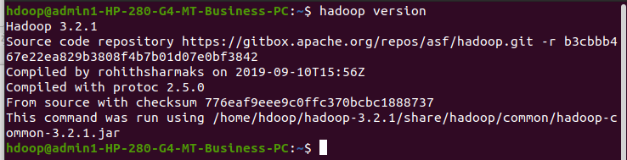

>start-dfs.sh
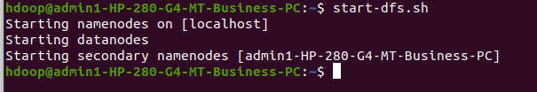

1. Create a directory named by your name
>hadoop fs -mkdir /ullaas
>hadoop fs -ls /

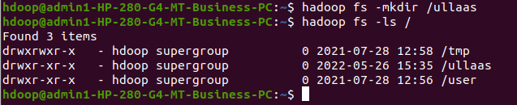

2. Add two empty files into it
>hadoop fs -touchz /ullaas/one.txt
>hadoop fs -touchz /ullaas/two.txt

3. List all the files in the directory that you have created
>hadoop fs -ls /ullaas

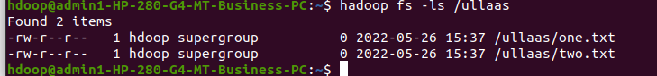

4. Create one more directory by your usn and put that inside the directory of your name
>hadoop fs -mkdir /ullaas/1NT19IS179
>hadoop fs -ls /ullaas

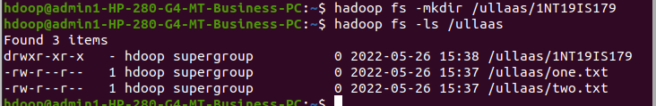

5. Create a file in your local system by the name_usn.txt and add the contents as "Syntax to list Is command is hadoop fs -Is "
>cat > ullaas_1NT19IS179.txt
>"Syntax to list ls command is hadoop fs -ls"
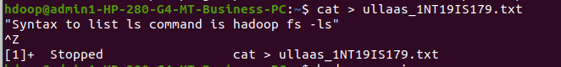

►Put the file usn_name.txt in your hdfs directory called usn
>hadoop fs -touchz /ullaas/1NT19IS179/1NT19IS179_ullaas.txt
>hadoop fs -ls /ullaas/1NT19IS179
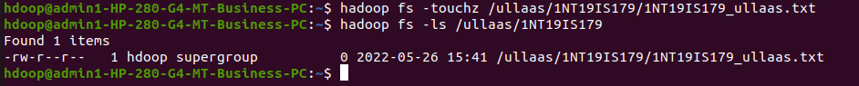

➤Put empty file of hdfs into the local file system
>hadoop fs -copyToLocal /ullaas/1NT19IS179/1NT19IS179_ullaas.txt
>ls
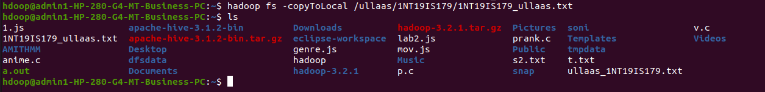

►Use mv command to move files from local file system and hdfs file system
>hadoop fs -mv /ullaas/two.txt /ullaas/1NT19IS179
>hadoop fs -ls /ullaas/1NT19IS179
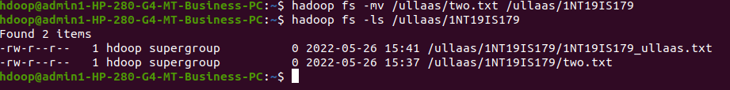

▸ Experiment of cp command
>hadoop fs -cp /ullaas/one.txt /ullaas/1NT19IS179
>hadoop fs -ls /ullaas/1NT19IS179
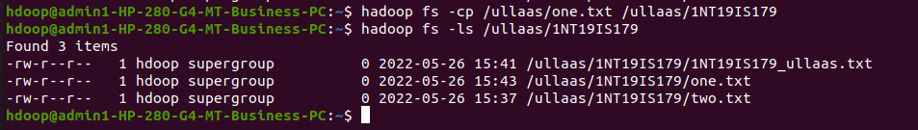

► Display the total size of all the files in name directory
>hadoop fs -du /ullaas
>hadoop fs -du -s /ullaas

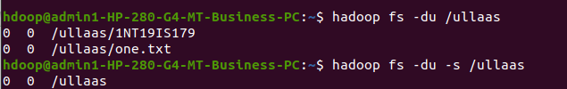

► Display each file size in usn directory Use stat command on name and usn directories
>hadoop fs -du /ullaas/1NT19IS179
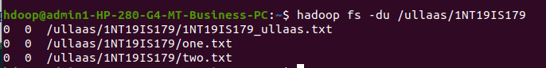

➤ Illustrate the use of append command
cat > one.txt
Hello
^Z
[4]+ Stopped cat > one.txt

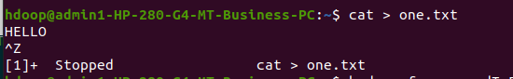

>hadoop fs -appendToFile one.txt /ullaas/1NT19IS179/two.txt
>hadoop fs -cat /ullaas/1NT19IS179/two.txt

