ULLAAS M
1NT19IS179

Use The mongo dB database to Exercise NOSQL Queries to Demonstrate the following with an
USECASE

1.CREATE DATABASE:

MongoDB use DATABASE_NAME is used to create database.
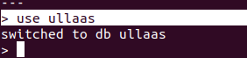
> use ullaas

2.Basic CRUD operations

insert one
db.ullaas.insertOne(
... { "name":"madhu",
... "city":"bangalore"})
{
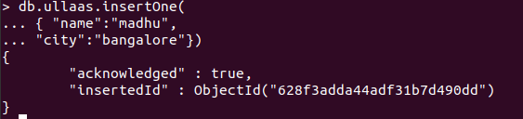

insert many
>inserting many
db.ullaas.insertMany([
... {"name":"vinayak","age":22,"elective":"EDA"},
... {"name":"sanjeev","age":21,"elective":"CC"},
... {"name":"madhu","age":21,"elective":"cloud"}])

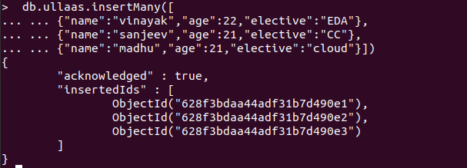

READING
db.ullaas.find()

{ "_id" : ObjectId("628f3adda44adf31b7d490dd"), "name" : "madhu", "city" : "bangalore" }
{ "_id" : ObjectId("628f3bdaa44adf31b7d490e1"), "name" : "vinayak", "age" : 22, "elective" : "EDA" }
{ "_id" : ObjectId("628f3bdaa44adf31b7d490e2"), "name" : "sanjeev", "age" : 21, "elective" : "CC" }
{ "_id" : ObjectId("628f3bdaa44adf31b7d490e3"), "name" : "madhu", "age" : 21, "elective" : "cloud" }

> db.ullaas.find()
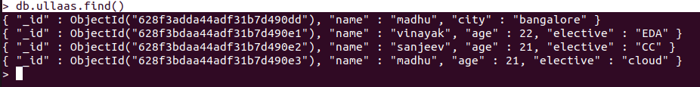
> db.ullaas.find().pretty()

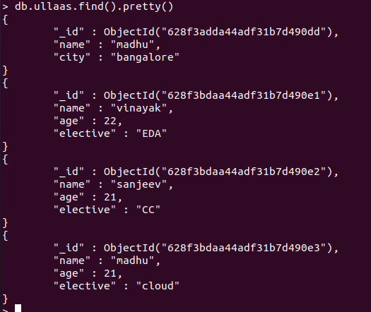

updatemany

db.ullaas.updateMany(
... {},
... {
... $set:{"college":"nmit"}
... }
... )
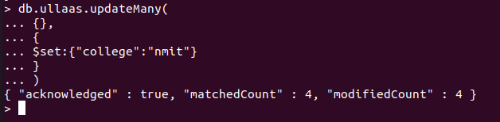
> db.ullaas.find().pretty()

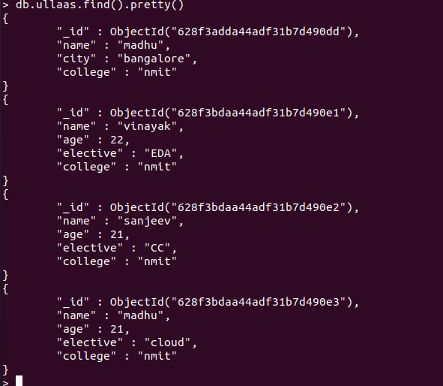

updateOne():
db.ullaas.updateOne(
... {"name":"madhu"},
... {
... $set:{"city":"tiptur"}
... }
... )

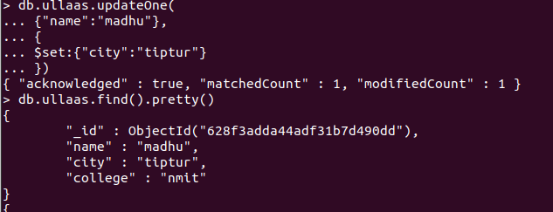
madhu city chnages to bangalore to tiptur

deleteOne()

> db.ullaas.deleteOne({"elective":"cloud"})

madhu got deleted where elective was cloud
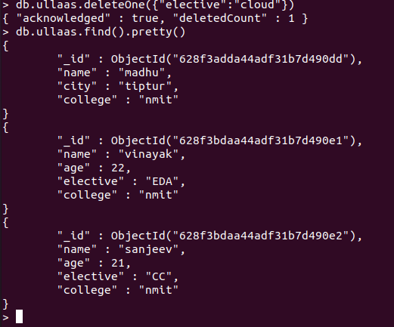

db.lab.insertMany([
... {"name":"vinayak","age":22,"elective":"EDA"},
... {"name":"sanjeev","age":21,"elective":"CC"},
... {"name":"madhu","age":21,"elective":"cloud"}])

deleteMany():

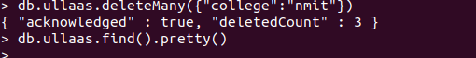
\\ data where college = nmit got deleted and i had to re insert data...\\

insertmany()

> db.ullaas.insertMany([ {"name":"vinayak","age":22,"college":"nmit"},{"name":"sanjeev","age":21,"college":"nmit"}, {"name":"sohan","city":"bangalore","college":"nmit"},{"name":"pratheek","city":"mangalore","college":"nmit"}, {"name":"madhu","city":"tiptur","college":"nmit"}])
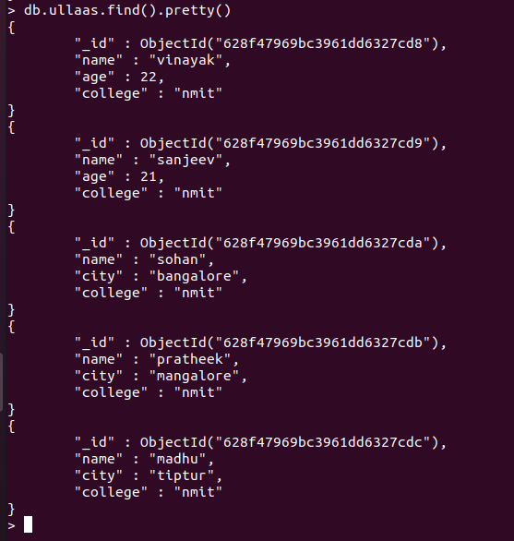

Replacing the document:

replaceOne():

db.ullaas.replaceOne(
{"name" : "vinayak"}, {"name" : "praneeth", "age" : "22", "college" : "nmit"})
{ "acknowledged" : true, "matchedCount" : 1, "modifiedCount" : 1 }

vinayak changed to praneeth

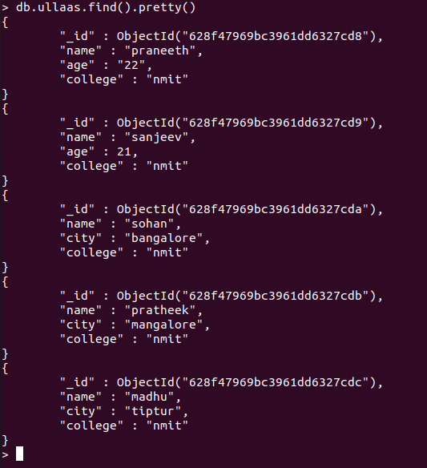

db.ullaas.find({“name”:”vinayak”}).pretty()

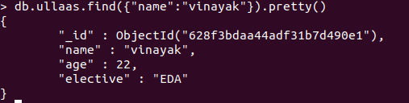

AGGREATE FUNCTIONS

