EXERCISE -1

ULLAAS M,1NT19IS179,C-2
02.06.2022

(>).Create a collection named "Employee" under the "EmployeeDB" database with each document in
the format shown below Table 1

use EmployeeDBullaas
switched to db EmployeeDBullaas
> db.createCollection("Employee1NT19IS179")
{ "ok" : 1 }
> show collections

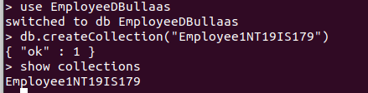

1. Populate the database with atleast 15 documents.

inserting values:

> db.EmployeeDBullaas.insertMany([
... {
... Firstname: "Ullaas",
... Middlename: "M",
... Lastname: "S",
... Age: 25,
... Salary: 50000,
... Designation: "Employee",
... Role: ["UI Designer"],
... },
... {
... Firstname: "Vinayak",
... Middlename: "P",
... Lastname: "Bhupal",
... Age: 28,
... Salary: 75000,
... Designation: "Manager",
... Role: ["Manager","UI Designer"],
... },
... {
... Firstname: "V",
... Middlename: "Sanjeev",
... Lastname: "vakada",
... Age: 27,
... Salary: 45000,
... Designation: "Employee",
... Role: ["Software Developer"],
... },
... {
... Firstname: "Vishal",
... Middlename: "Kumar",
... Lastname: "HK",
... Age: 27,
... Salary: 70000,
... Designation: "Researcher",
... Role: ["Team Lead","Tester", "UI Designer"],
... },
... {
... Firstname: "Rajesh",
... Middlename: "C",
... Lastname: "R",
... Age: 36,
... Salary: 55000,
... Designation: "Scientist",
... Role: ["Tester"],
... },
... {
... Firstname: "Pratheek",
... Middlename: "P",
... Lastname: "Nayak",
... Age: 36,
... Salary: 50000,
... Designation: "Researcher",
... Role: ["Team Lead"]
... },
... ]);
{
"acknowledged" : true,
"insertedIds" : [
ObjectId("6298815efd984093ac297e0f"),
ObjectId("6298815efd984093ac297e10"),
ObjectId("6298815efd984093ac297e11"),
ObjectId("6298815efd984093ac297e12"),
ObjectId("6298815efd984093ac297e13"),
ObjectId("6298815efd984093ac297e14")
]
}
>
>
> db.EmployeeDBullaas.insertMany([
... {
... Firstname: "Sohan",
... Middlename: "M",
... Lastname: "S",
... Age: 30,
... Salary: 45000,
... Designation: "Employee",
... Role: ["Manager"]
... },
... {
... Firstname: "vakada",
... Middlename: "Sai",
... Lastname: "Sanjeev",
... Age: 30,
... Salary: 40000,
... Designation: "Employee",
... Role: ["Junior Architect"],
... },
... {
... Firstname: "Vinayak",
... Middlename: "Vakada",
... Lastname: "M",
... Age: 30,
... Salary: 75000,
... Designation: "Employee",
... Role: ["Software developer","Tester"],
... },
... {
... Firstname: "Shriman",
... Middlename: "Kumar",
... Lastname: "M",
... Age: 40,
... Salary: 75000,
... Designation: "Scientist",
... Role: ["Tester"],
... },
... {
... Firstname: "Rakshith",
... Middlename: "n",
... Lastname: "reddy",
... Age: 38,
... Salary: 750000,
... Designation: "President",
... Role: ["Research and Developer"]
... },
... ]);
{
"acknowledged" : true,
"insertedIds" : [
ObjectId("6298815efd984093ac297e15"),
ObjectId("6298815efd984093ac297e16"),
ObjectId("6298815efd984093ac297e17"),
ObjectId("6298815efd984093ac297e18"),
ObjectId("6298815efd984093ac297e19")
]
}
>
> db.EmployeeDBullaas.insertMany([
... {
... Firstname: "choota",
... Middlename: "bheem",
... Lastname: "C",
... Age: 25,
... Salary: 45000,
... Designation: "Employee",
... Role: ["Junior Lead",],
... },
... {
... Firstname: "Praneeth",
... Middlename: "M V",
... Lastname: "L S S S",
... Age: 33,
... Salary: 60000,
... Designation: "Employee",
... Role: ["Software developer"],
... },
... {
... Firstname: "Tony",
... Middlename: "Howard",
... Lastname: "Stark",
... Age: 28,
... Salary: 69000,
... Designation: "Employee",
... Role: ["UI Designer"],
... },
... {
... Firstname: "Thanos",
... Middlename: "stones",
... Lastname: "infinity",
... Age: 29,
... Salary: 50000,
... Designation: "Scientist",
... Role: ["Research and Developer","UI Designer"],
... },
... {
... Firstname: "D",
... Middlename: "S",
... Lastname: "Prasad",
... Age: 30,
... Salary: 50000,
... Designation: "System Engineer",
... Role: ["Intern"],
... },
... ]);

2.List all the records having salary in the range of 20000 – 35000(Exclusive)

> db.EmployeeDBullaas.find({ $and: [ {Salary : {$gte: 20000}}, {Salary: {$lte: 35000}} ] }).pretty()

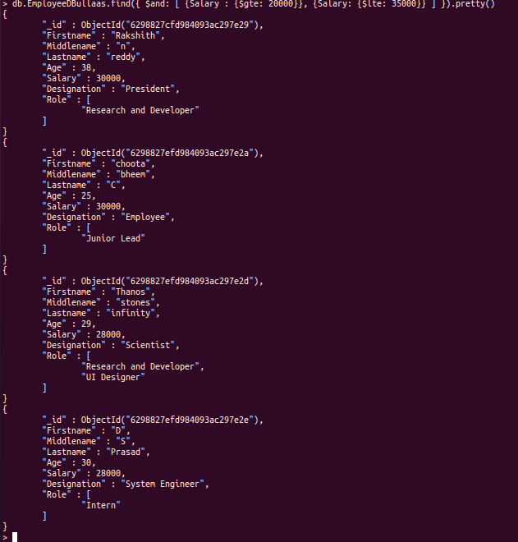

3.List all the Employee whose Middle name is "Kumar"

db.EmployeeDBullaas.find({"Middlename": "Kumar"}).pretty()
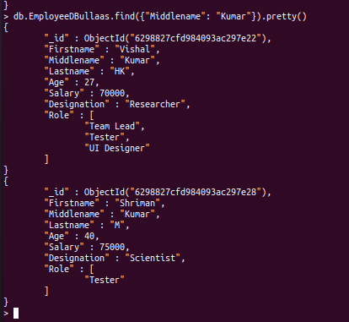

4. Count the number of Employees who has a role "Manager" in the Role field

> db.EmployeeDBullaas.count({Role: "Manager"})

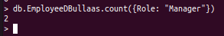

5. Find out all the documents who have age < 35 and salary in the range of 30000-35000

> db.EmployeeDBullaas.find({ $and: [ {Age: {$lte: 35}}, {Salary: {$gte: 30000}}, {Salary: {$lte: 35000}} ] }).pretty()

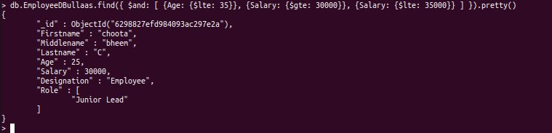

6. Delete an Employee whose "Firstname" is "Rajesh" and having the designation as "Scientist"

> db.EmployeeDBullaas.remove({$and:
... [
... {firstName: "Rajesh"},
... {designation: "Scientist"}
... ]
... })

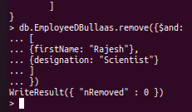

7. Update all the Employees whose role is "Team Lead" with a salary of 55650 INR
> db.EmployeeDBullaas.updateMany({Role: "Team Lead"}, {$set: {Salary: 55650}})

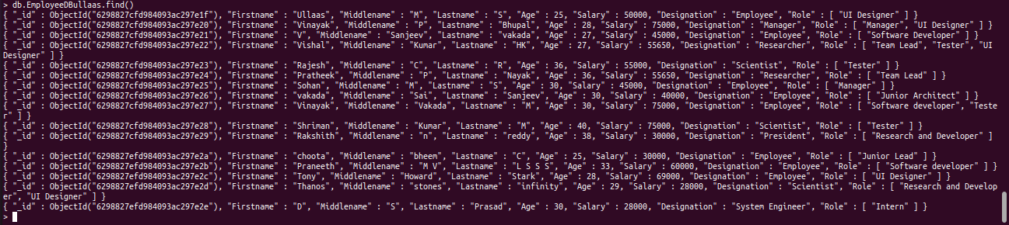

8. Group all the Employees by their age(common age should be there) and calculate the average salary obtained in the each group

> db.EmployeeDBullaas.aggregate([ {$group: {_id: "$Age",AVERAGE: {$avg: "$Salary"}}}])

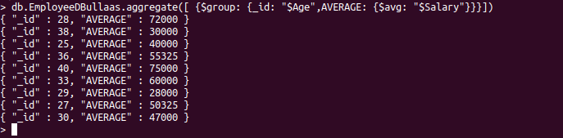

9. Apply the map-reduce to perform the above operation and obtain the results

> var mapfunction = function() { emit(this.Age, this.Salary)}
> var reducefunction = function(key, values) {return Array.avg(values)}
> db.EmployeeDBullaas.mapReduce(mapfunction, reducefunction, {'out': 'result'})
{ "result" : "result", "ok" : 1 }

