Online Compiler Comparison Report

Scope

This report compares **Cloud Compiler** with **Programiz**, **OnlineGDB**, **JDoodle**, **OneCompiler**, and **Ideone**.

The report is intentionally split into two evidence types:

• **Measured results**: real benchmark data for Cloud Compiler versus the locally available native toolchains on this machine.
• **Documented platform comparison**: feature-based comparison of Programiz and other online compilers using their official product pages and documentation.

This separation matters because external browser platforms were not benchmarked through an automated speed test in this workspace, so any direct runtime-speed claim about Programmiz, JDoodle, Ideone, or similar services would be weaker than the measured Cloud Compiler data.

Method

Measured optimization data

• Source: local benchmark run already generated in `reporting/compiler_comparison_results.json`
• Languages measured: Python, C, C++
• Modes measured: native local, Cloud Compiler sync, Cloud Compiler async

Documented comparison data

The external platforms were scored on:

• **Usability score (0-10)**: setup simplicity, sharing, input/output flow, collaboration, and accessibility
• **Optimization-support score (0-10)**: debugger depth, version selection, multi-file support, API/embed options, and advanced execution controls

These are **feature-support scores**, not raw runtime-speed measurements.

Graphs

Graph 1: Supported Language Count

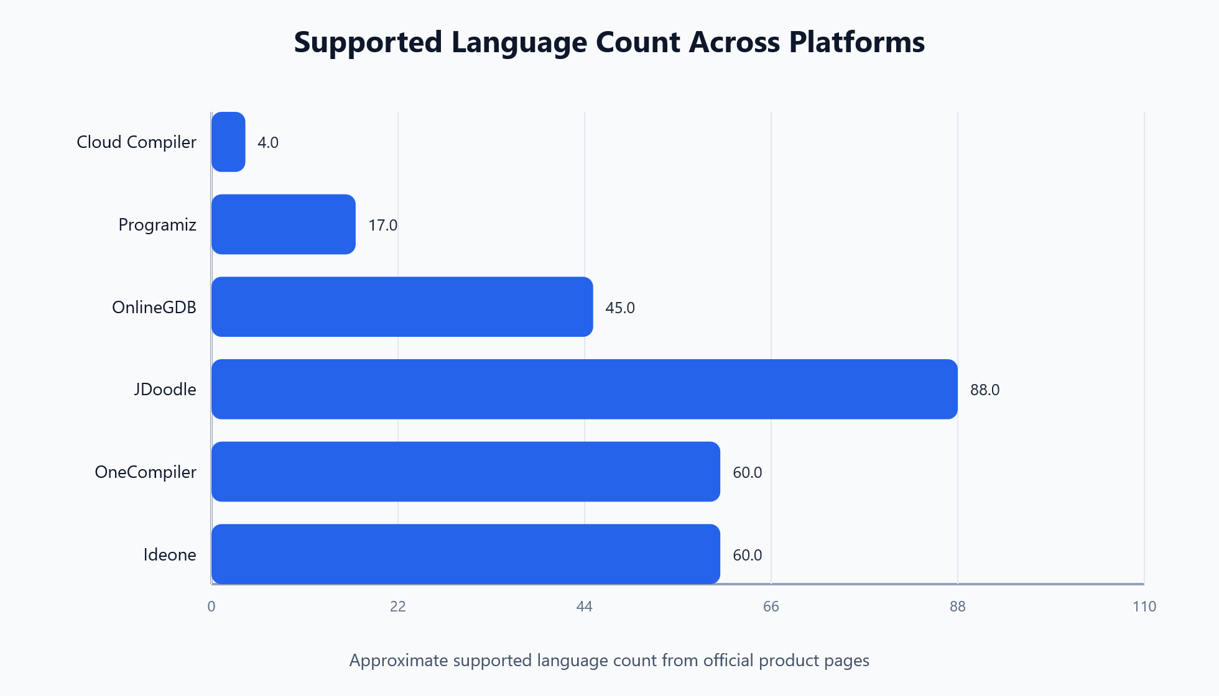

Graph 2: Usability Score

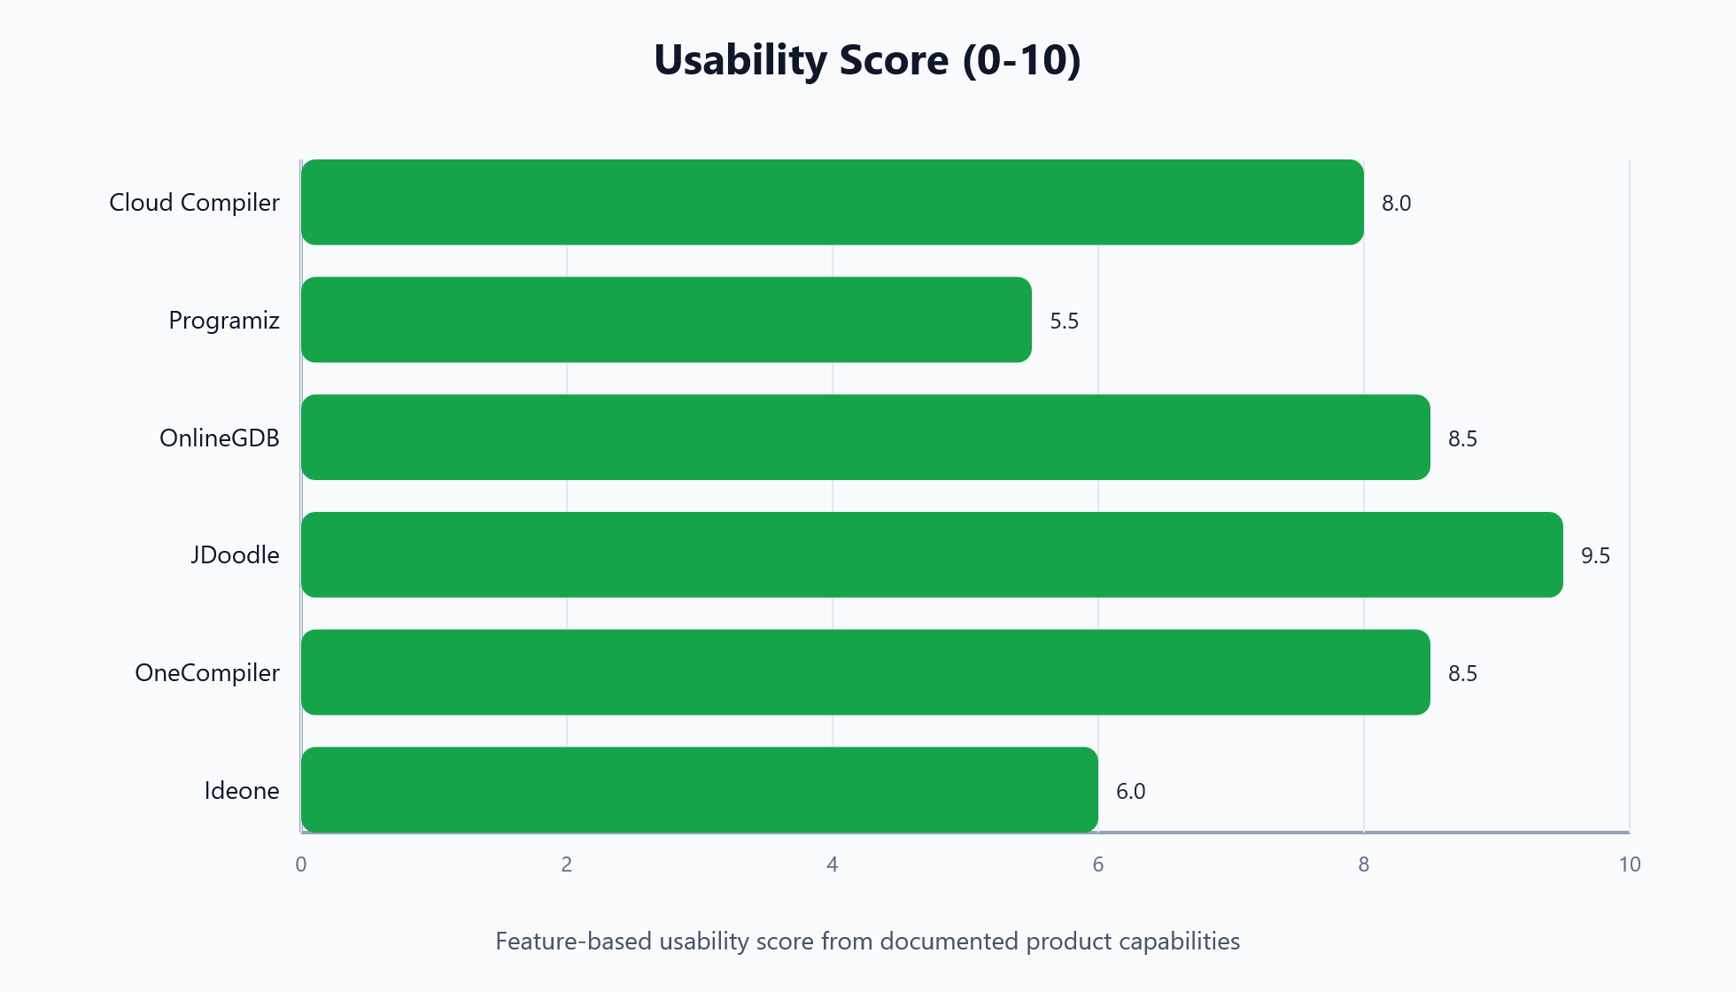

Graph 3: Optimization-Support Score

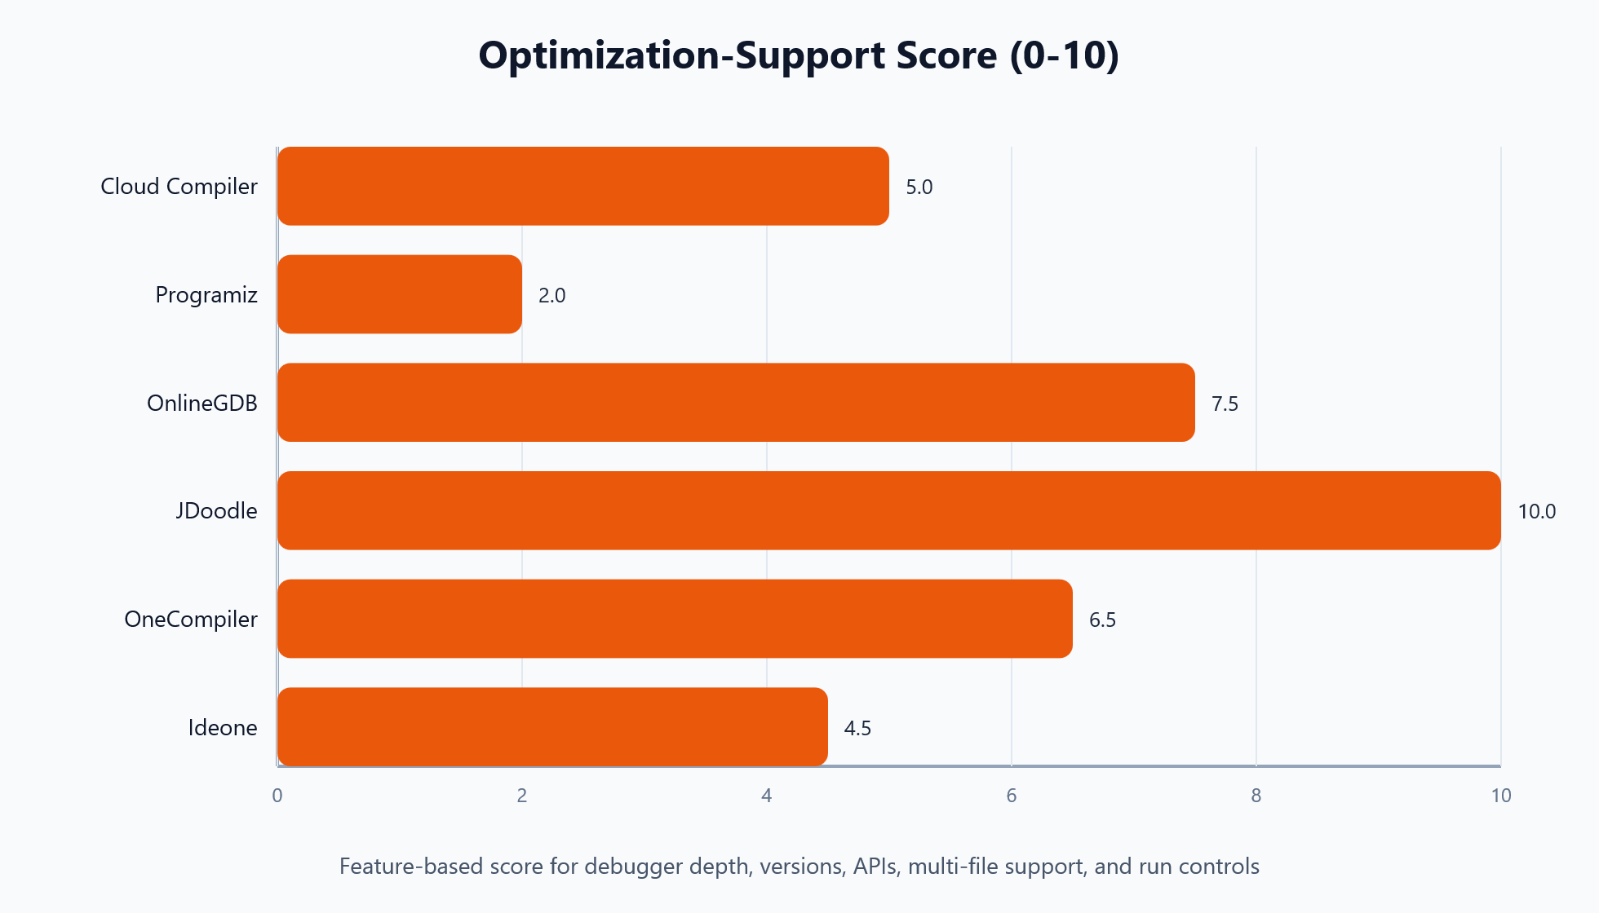

Graph 4: Cloud Compiler Measured Average Latency

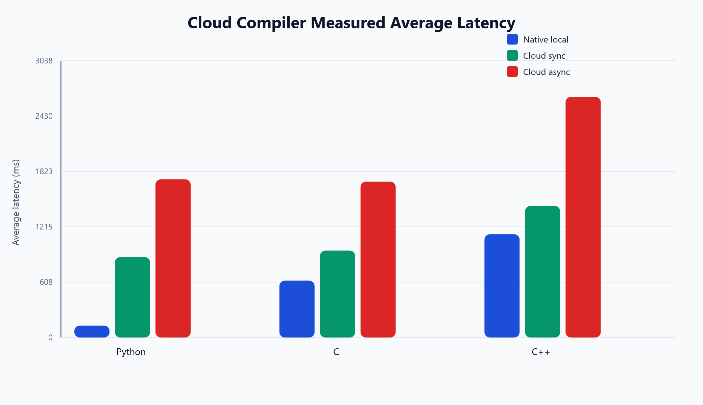

Platform Summary Table

Platform | Supported languages | Usability score | Optimization-support score
Cloud Compiler | 4 | 8.0 | 5.0
Programiz | 17 | 5.5 | 2.0
OnlineGDB | 45 | 8.5 | 7.5
JDoodle | 88 | 9.5 | 10.0
OneCompiler | 60 | 8.5 | 6.5
Ideone | 60 | 6.0 | 4.5

Feature Comparison

Platform | Debugger | Stdin | Sharing | Collaboration | API / Embed | Multi-file | Version selection | Mobile / Anywhere
Cloud Compiler | No | Yes | Partial | No | Internal API only | No | No | No
Programiz | No visible debugger | Not clearly documented on landing page | Yes | No visible collaboration | No visible API on examined pages | No visible multi-file workflow | No visible version selection | Not documented on examined pages
OnlineGDB | Yes | Yes | Yes | Classroom support | No prominent public API on examined page | Yes | Partial via language standards / variants | Browser-based
JDoodle | Advanced IDE features | Yes | Yes | Yes | Yes | Yes | Yes | Yes
OneCompiler | No prominent debugger on examined pages | Likely in product flow, not highlighted on about pages | Yes | Yes | Yes | Studio project environment available | Not prominently documented | Yes
Ideone | Basic debugging positioning | Yes | Yes | No visible collaboration suite | Yes | No visible multi-file workflow | Time limit and language variants shown | Yes

What the Graphs Show

Programmiz versus other online compilers

• **Programiz** is easy to use and share, which makes it good for quick learning tasks and short examples.
• Compared with **OnlineGDB**, **JDoodle**, and **OneCompiler**, Programiz exposes fewer advanced workflow features from the examined product pages.
• Programiz appears weaker than **OnlineGDB** for debugging, weaker than **JDoodle** for configurable IDE workflows and APIs, and weaker than **OneCompiler** for organizations, embedded editors, and team use.
• Against **Ideone**, Programiz looks more learning-oriented, while Ideone looks more like a remote execution service with API/widget roots and time-limit controls.

Where Cloud Compiler stands

• **Cloud Compiler** is much narrower in language coverage than Programiz and the larger commercial platforms.
• Its strongest differentiators are the combination of **browser execution**, **Docker isolation**, **sync plus async execution**, and **built-in worker/queue/system metrics**.
• In measured latency, Cloud Compiler is slower than native execution, especially in async mode.
• In managed usability, Cloud Compiler compares surprisingly well because it bundles stdin, output history, import/export, complexity analysis, and admin observability in one project.

Cross-Platform Takeaways

• **Cloud Compiler**: Best for managed browser-based execution inside this project.
• **Programiz**: Good for quick learning-oriented browser execution and easy sharing.
• **OnlineGDB**: Strong educational IDE with live debugging and classroom support.
• **JDoodle**: Most feature-rich documented platform in this comparison.
• **OneCompiler**: Strong general-purpose online coding platform with API and team features.
• **Ideone**: Simple remote execution service with broad language coverage and API/widget hooks.

Measured Cloud Compiler Performance Snapshot

Language | Native avg (ms) | Cloud sync avg (ms) | Cloud async avg (ms)
Python | 130.74 | 883.12 | 1736.48
C | 624.33 | 953.89 | 1710.8
C++ | 1133.48 | 1443.88 | 2641.79

Final Interpretation

• If the priority is **fast local execution**, native compilers remain the best baseline.
• If the priority is **simple browser use for beginners**, Programiz is attractive because of its low-friction interface.
• If the priority is **debugging and classroom use**, OnlineGDB is stronger than Programiz.
• If the priority is **enterprise-grade integrations, collaboration, multi-file projects, APIs, and configurable versions**, JDoodle is the strongest documented platform in this comparison.
• If the priority is **broad browser-based coding with APIs and team workflows**, OneCompiler is also very strong.
• **Cloud Compiler** is best positioned as a custom, observable, Docker-isolated educational or institutional platform rather than as the fastest compiler service in this group.

Recommendations for Your Project

1. Add multi-file project support if you want to compete more directly with JDoodle, OneCompiler, and OnlineGDB.
2. Add structured async telemetry and queue wait graphs so your observability advantage becomes more visible.
3. Add compiler version selection and advanced run flags for C, C++, Java, and Python.
4. Add sharing or saved project links to compete better with Programiz and Ideone.
5. Add debugger-oriented tooling or richer error grouping if debugging experience is part of your evaluation.
6. Keep using measured benchmark graphs for your own platform, but describe external platforms using documented features unless you can run controlled benchmarks against them fairly.

Sources

Platform | Source
Cloud Compiler | Local project analysis + measured benchmark run in reporting/compiler_comparison_results.json
Programiz | https://programiz.io/ and https://www.programiz.com/c-programming/online-compiler/
OnlineGDB | https://www.onlinegdb.com/ide
JDoodle | https://www.jdoodle.com/docs and https://www.jdoodle.com/docs/ide/languages-versions
OneCompiler | https://onecompiler.com/ , https://onecompiler.com/about , https://onecompiler.com/studio
Ideone | https://www.ideone.com/ and https://1.ideone.com/languages

Local benchmark source:

• `reporting/compiler_comparison_results.json`
• `reporting/Compiler_Comparison_Final_Report.md`

