What I do with your child's data
The Primer — a plain-English account of how your child's information is handled
I built The Primer. I'm writing this myself because I don't think a parent should have to take a children's product on faith, and because most privacy pages are written to survive a lawyer rather than to be understood by the person they're addressed to.
So this is the whole thing: what I collect, what leaves my servers, what I keep, and what I haven't built yet. If you only read one section, read the one about the voice recordings.

The five promises
- I don't sell your data or your child's. Not to anyone, not at any price.
- I don't train AI models on your child — not mine, and not my providers'.
- I don't send your child notifications, reminders, or streaks. Nothing in this product is designed to pull them back to it.
- You can read every word your child has been told, take a copy of all of it, or destroy all of it, whenever you want, without asking me.
- Where I haven't finished something, I say so on this page instead of waiting for you to find out.

The whole path, on one page
This is every stage your child's data passes through, in order. The rest of this document is just these steps explained one at a time.
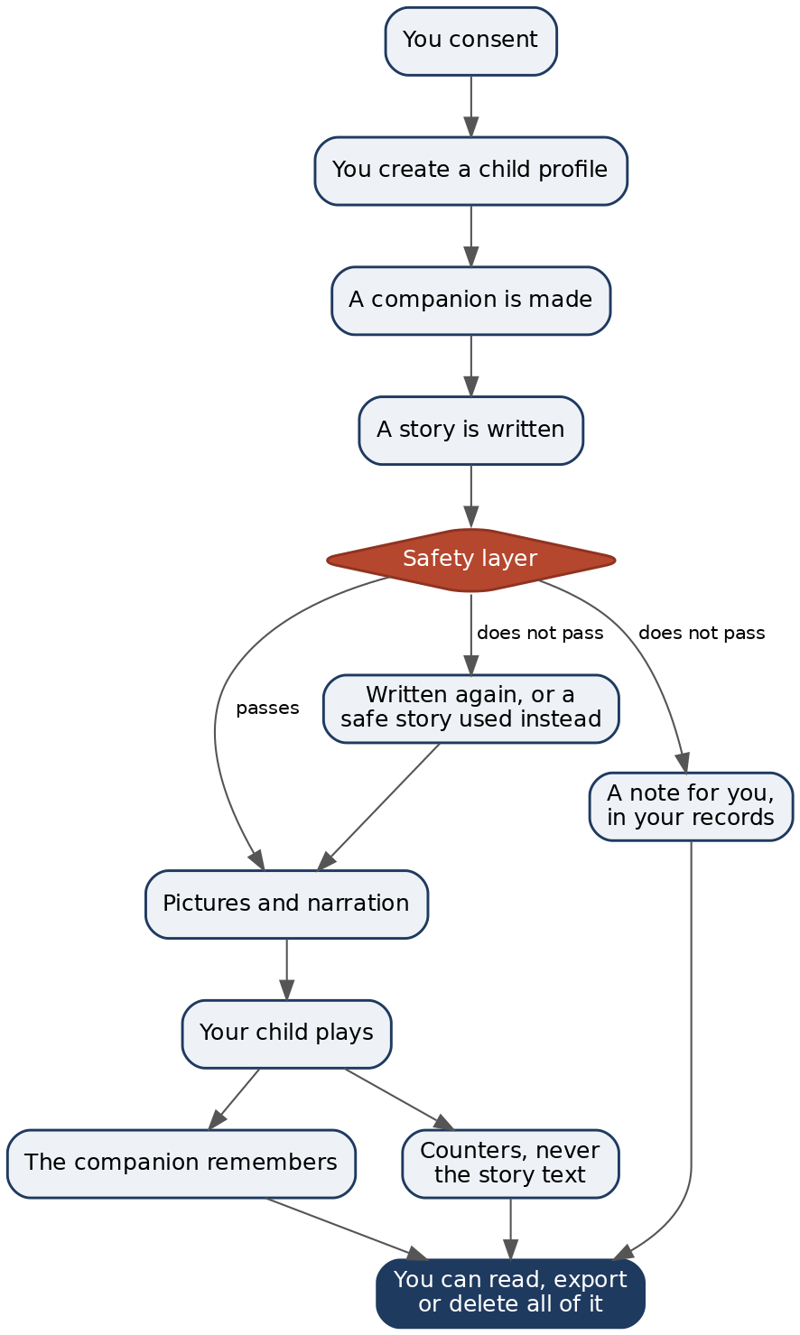
A story that fails that check never reaches your child. It gets written again under a constraint, and if it fails repeatedly it is swapped for a story I approved in advance. The version that failed is not shown to them, and it is not even saved — the only thing that survives it is a line in your records saying it happened. Those notes go to you. They never go into your child's story.

Nothing happens before you say yes
Every operation that creates data about your child runs through one consent check. Without your consent there is no profile, no companion, no greeting, no story. Nothing is generated and nothing is sent anywhere.
Withdrawing it later stops me making anything new. It does not lock you out of what already exists.
I'm making a point of that because I got it wrong once. For a while, one function guarded both “may I generate?” and “may you look?”, so a parent who withdrew consent also lost access to their own child's records — couldn't read them, couldn't export them. That's backwards. If you revoke consent, the thing that should stop is me using the data, not you seeing it. It's split into two separate checks now.

What I ask for, and what each thing is for
From you: an email address. That's it.
For each child:
What | Why it exists
First name or nickname | The companion says it out loud
Birthdate | Sets the age band the safety layer enforces
What they love | What tomorrow's story gets built out of
What frightens them | Copied into every generation as a hard rule
Topics to avoid | Same — a rule on every single generation

Then, as they play: the stories, the choices they make, how long a sitting lasted, and what the companion remembers.
I don't ask for a surname, an address, a school, a photograph, or any contact detail for your child. The companion is instructed never to ask for one either.

What actually leaves my servers
Writing a story needs an AI model, drawing it needs an image model, reading it aloud needs a voice. Three companies are involved, and they don't all get the same thing. As configured today:
Who | What they receive
Google (Gemini on Vertex AI) | The most. Writes the story, grades it for safety, condenses the memories, and checks the pictures. This is the one that sees your child's first name, their fears, your avoid-topics, and what the companion remembers.
Cloudflare (Workers AI) | Draws the pictures. Gets what the companion looks like, the name your child gave it, and the scene it's standing in — never your child's own name. Google's Imagen is the backup if Cloudflare is unavailable.
Google Cloud Text-to-Speech | Turns the finished sentence into audio. That sentence contains your child's first name whenever the companion says it. ElevenLabs is the backup.

Google sees the most because it's doing the thinking. It gets your child's fears, your avoid-topics and the companion's memories for one reason: those are the rules the story must be written against, and a model that wasn't told them couldn't keep them.
None of them get: your email, your account, or anything identifying your child beyond that first name.
On training: every route is on terms that forbid training on what I send. That isn't a promise I'm asking you to trust — the server refuses to boot if it's pointed at a cheaper tier that reserves the right to learn from your child's words. I can't misconfigure it in a hurry and not notice.
What I can't promise is anything about a provider's own internal logging. That isn't mine to control. I'd rather write that sentence than imply a guarantee I don't have.

The safety layer
Every generation takes one path, and there's only one door:
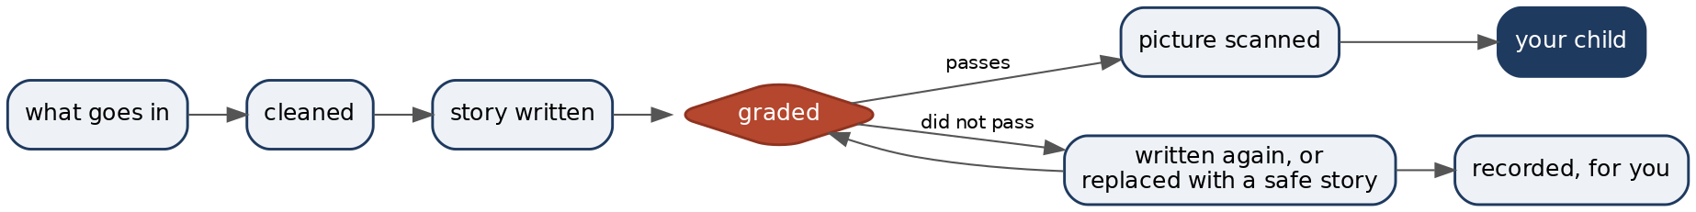
Note the loop. A story that doesn't pass goes back to be graded again, not forward. Only a version that passes is ever drawn, spoken or shown.
Two more rules hold this up.
If a check couldn't run, that is not a pass.
When the model-based grader is unreachable, the rule-based check stands on its own, and the beat is recorded as degraded. Nothing in this system turns “I didn't check” into “it's fine.”
Nothing is decided quietly.
Every rewrite, block and escalation is written down, and you can see all of it. The two places differ, so here is exactly where each one shows up:
- In the transparency log, a scene the safety layer rewrote carries a label saying so, next to the version your child actually saw.
- In your export, the full record — every rewrite, and also every block and escalation. A blocked scene never becomes part of the story, so it has nothing to label in the log; it appears in the export as an incident instead.
I include my own refusals because if I hid them, that's precisely the thing you'd most want to have seen.
Pictures are scanned on their own before they're stored or shown.

What the companion remembers
The memories are the point of the product. They're what let it say “do you still have that dragon you named?” six weeks later. I keep them as long as you keep the account, because throwing them away would mean throwing away the friendship your child built.
The memory text is encrypted in the database, with a key the database doesn't hold.

The voice recordings — read this one properly
If your child can read, the companion sometimes asks them to read a line aloud, and I keep that recording. This is on unless you turn it off — you don't have to switch it on, you have to switch it off, and I'd rather tell you that than let you find it.

What is true today
- The recording stays on my own machine. It is never uploaded to storage and never sent to another company.
- Nothing has listened to it. Not a person, not a program. There is no score, no verdict, no per-word result — the database has nowhere to put one.
- It decides nothing about your child, and the app never tells them they read something wrong.
- Switch it off for a child and every recording I hold of them is deleted immediately, files and all. Deleting the child or the account does the same.

What I am keeping them for
I should be straight about this, because “nothing listens to it” is true now and is not the end state I'm working towards.
I want the companion to help your child learn to read. To do that I need software that can hear a five-year-old say a sound and tell whether they got it — and the version I have was built and tuned on adults imitating children, which is not good enough to correct a real child with. These recordings are how I fix that.
So the plan, in order:
- Now. Collect. Nothing analyses anything.
- Next. Run the collected recordings through the detector, off in the background, and retune it against how children actually speak. Out of this, your dashboard starts showing which sounds your child has solid and which are shaky — in plain language, not a score. Still nothing reaches your child while they're reading.
- Only after that works. The companion starts gently correcting a sound as your child reads — in its own voice, and only for mistakes the detector has been proven right about.
Step 2 is the one to weigh, because that's where a recording stops being an archive and becomes an assessment of your child. When it's ready I'll say so here and on the dashboard, before it turns on, not after.

If that isn't a trade you want
Turn it off. The rest of the product works exactly the same, and your child is never told they opted out of anything.

What I count
I record that a story started, that a beat finished, how long a sitting ran.
These carry shape, never content. The code that writes them accepts simple values only, truncates them, and rejects anything larger — specifically so that nobody, including me on a tired evening, can pass in the story text and quietly turn a counter table into a transcript of what a four-year-old was told.
They're attached to your child's record and they die with it. Analytics gets no exception to deletion.

What you can do about any of it
All of this lives at /parent, behind the adult gate. None of it needs my permission, and none of it is affected by withdrawing consent.
Read what your child was told.
Sign in → Transparency. Every story, word for word, including the ones the safety layer rewrote or replaced. Reports, Weekly & growth and Insights are summaries for you; Transparency is the raw record.
Take a copy.
Privacy in the header → export. One zip: the account, each child's profile and settings, their companion, every adventure with every beat and every choice verbatim, every memory, learning progress, the world map, every report, and my safety incidents. No embeddings — that's 1,536 numbers per memory and it would tell you nothing.
Limit it without deleting.
A child's Settings: shorter sittings, a lower intensity ceiling, a narrower daily window, more avoid-topics. Every control there can only reduce. There is nothing in this product that lengthens your child's time in it.
Delete it.
Privacy → delete a child, or the whole account. A child takes their profile, companion, every story, memory, report, picture, and any recording of their voice. The account does that for every child, then removes the account.
Both are immediate and neither can be undone.
I keep one record of it, so I can prove the deletion happened. It is six things and no more: the date, the internal id of the account (which now points at nothing), a scrambled form of your email, and three counts — how many children, how many files, how many stored objects were removed. Nothing about who your child was, or a word they read or heard.
The scrambled email can't be turned back into an address. It can be matched if you already have the address, which is deliberate: it's how I can answer “was this account really deleted?” without keeping the account.

What I haven't done yet
 | Where it actually stands
Legal review | Hasn't happened. I wrote this and I wrote the code.
Backups | Full copy daily, each deleting itself after 7 days, so a deletion today is gone from every copy inside a week. Right now those copies sit on the same machine as the database and aren't separately encrypted. That changes before I take families beyond the pilot.
Restoring one | A backup only ever brings the whole service back after a disaster. It is never used to restore one family. Anything deleted before the disaster gets deleted again straight after — that step is in the written procedure, not in my memory.
Access logs | Nobody outside a very small team can reach this data, but I don't yet have audited logging of who looked at what. I'll build it before the pilot widens, and this page will say so when I have.
Provider logs | I control what I send and the terms it's sent under. I don't control what a provider writes in its own logs, and I'm not going to pretend otherwise.
Reading recordings | Kept on by default, which is a choice that suits a pilot of children whose parents I have spoken to personally and does not automatically suit a thousand. It gets revisited before this is open to families I haven't met.
A public version of this | The privacy centre is still behind sign-in, which means you have to create an account to read it. That's the wrong way round and I know it. This document is what I can hand you until there's a page anyone can open.

The 7-day number is read from the live setting wherever it's shown in the app, so it can't drift away from what the backups actually do.

Where this stands
The Primer is built for children, so COPPA and GDPR-K shaped it from the first line rather than being bolted on before launch.
The whole idea of this product is that you can check me. That's why the transparency log is word for word, why my own refusals are in your export, and why the list above exists. If anything on this page stops being true of the software, treat that as a bug and tell me.
— Ullas, founder

