**Sentiments Classifier using BERT**

**PROBLEM STAEMENT**

In this project we will be building a sentiment classifier using the bert pretained model. The dataset we will be using will be IMDB movie reviews datset.

**DESCRIPTION OVERVIEW**

The process of computationally identifying and categorizing opinions expressed in a piece of text, especially in order to determine whether the writer's attitude towards a particular topic, product, etc. is positive, negative, or neutral. Understanding people’s emotions is essential for businesses since customers are able to express their thoughts and feelings more openly than ever before. By automatically analyzing customer feedback, from survey responses to social media conversations, brands are able to listen attentively to their customers, and tailor products and services to meet their needs.

Sentiment analysis, however, helps businesses make sense of all this unstructured text by automatically tagging it. Sentiment analysis uses various Natural Language Processing (NLP) methods and algorithms, which we’ll go over in more detail in this section.

The main types of algorithms used include:

* **Rule-based** systems that perform sentiment analysis based on a set of manually crafted rules.
* **Automatic** systems that rely on machine learning techniques to learn from data.
* **Hybrid** systems that combine both rule-based and automatic approaches.

Sentiment analysis can be used for varous applications like :

* Social media monitoring
* Brand monitoring
* Voice of customer (VoC)
* Customer service
* Market research

**TECHNOLOGY USE**

Here we will be using **Anaconda Python 3.6 , Pytorch 1.4 with GPU support CUDA 10 with CuDNN 10.**

**INSTALLATION**

Installation of this project is pretty easy. Please do follow the following steps to create a virtual environment and then install the necessary packages in the following environment.

**In Pycharm it’s easy**

1. Create a new project.

2. Navigate to the directory of the project

3. Select the option to create a new new virtual environment using conda with python3.6

4. Finally create the project using used resources.

5. After the project has been created, install the necessary packages from requirements.txt file using the command pip install -r requirements.txt

**In Conda also it’s easy**

1. Create a new virtual environment using the command

conda create -n your_env_name python=3.6

2. Navigate to the project directory.

3. Install the necessary packages from requirements.txt file using the command

pip install -r requirements.txt

**WORKFLOW DIAGRAM**

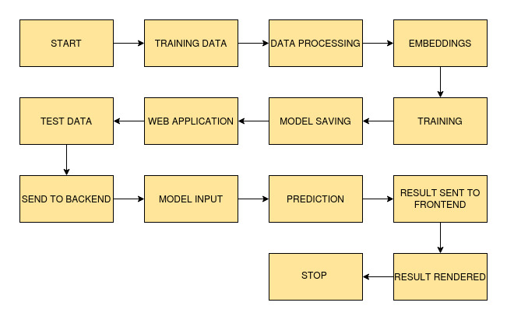

**IMPLEMENTATION**

**1. Project Directory**

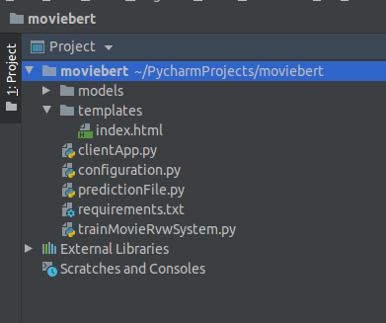

In this folder structure of the project

1. models :- this folder will keep the model that have been trained on the dataset using BERT architecture.

**2. requirements.txt**

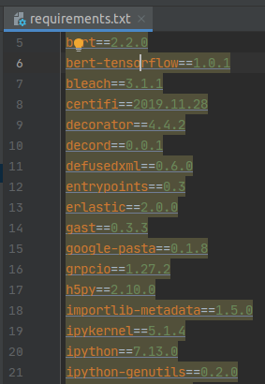

**3. clientApp.py**

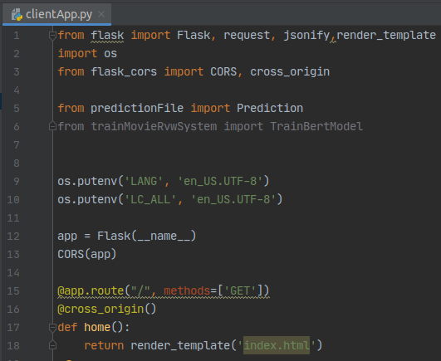

This python file will will be used to train/predict.

**4. predictionFile.py**

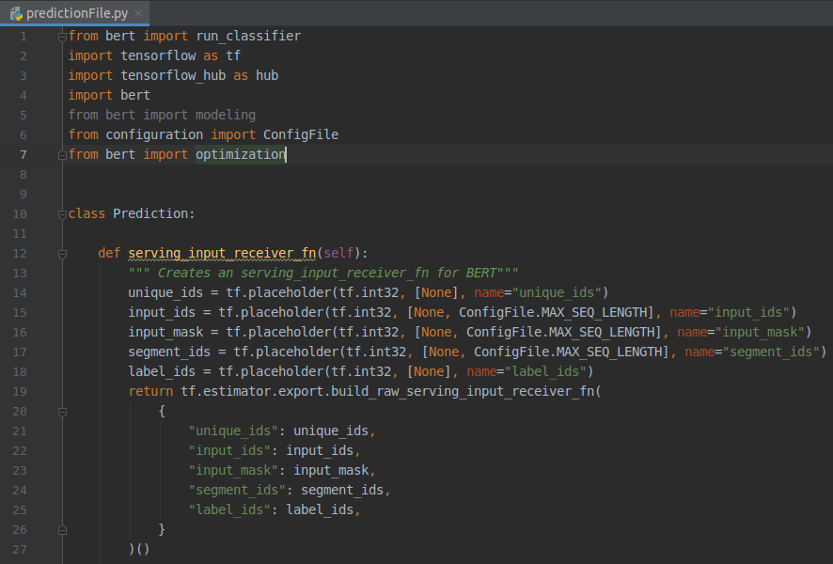

prediction file :- this is the file where predicton is done.

**TESTING IN LOCAL/API**

To do the test testing we need to run the clientApp.pyand after that web server will start at <http://0.0.0.0:5000/>

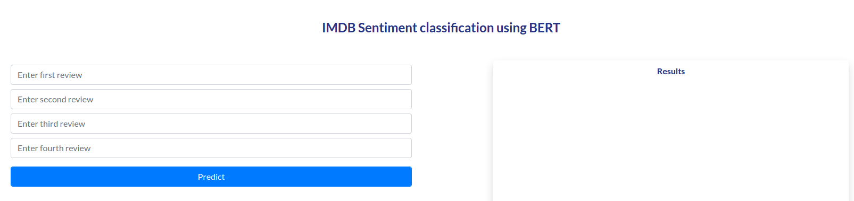

Enter the review or reviews and click on predict

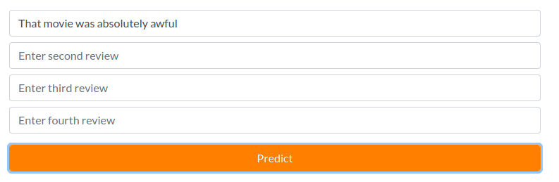After clicking predict

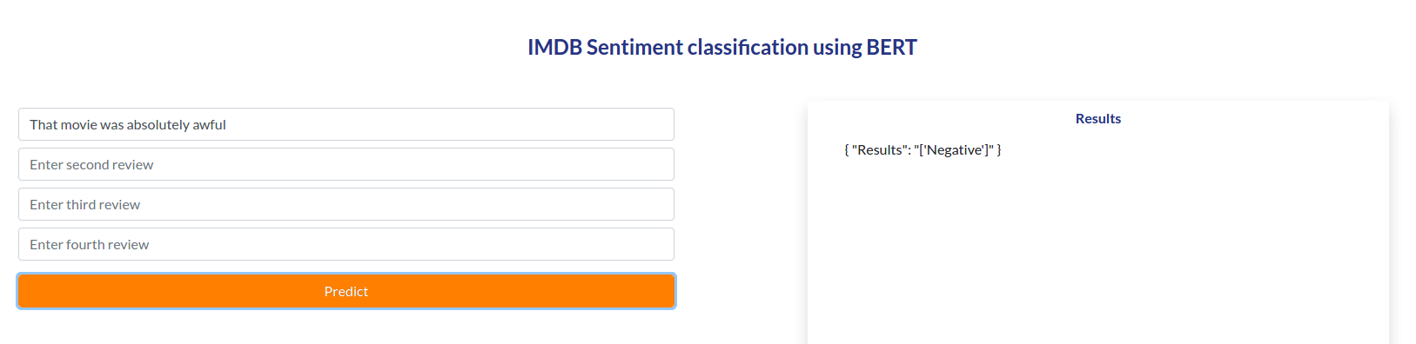

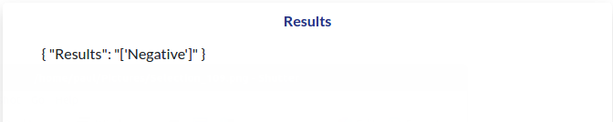

**CONCLUSION**

Here we successfully performed sentiment analysis and analyzed the reviews on the given dataset.

**COMPARISION**

More data or better larger dataset can be used to build a better model. We can also try out better pre trained model with fine tuning to increase the performance.