Introduction
The ATM Management System is a simple Java-based application designed to demonstrate basic concepts of Object-Oriented Programming, classes, objects, ArrayList, loops, conditional statements, and user input. The system allows users to create and store multiple accounts, view account details, and increase an employee's salary based on their name. A simple menu-driven interface provides four options: Create Account, Display All Accounts, Raise Salary, and Exit. The project demonstrates how Java can be used to build a basic interactive management system while organizing data efficiently using objects and an ArrayList.

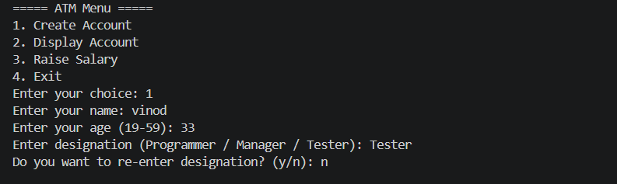

Create Account Feature
The Create Account feature allows the user to create and store multiple accounts using an ArrayList. The program takes the user's name, age, and designation as input. Age is validated to ensure it is between 19 and 59. The user can select Programmer, Manager, or Tester, and the salary is automatically assigned based on the designation. Finally, an Account object is created using the entered details and added to the ArrayList, allowing multiple accounts to be stored and displayed later.

Display All Accounts Feature

The Display All Accounts feature is used to show all the accounts stored in the ArrayList. First, the program checks whether the ArrayList is empty. If there are no accounts, it displays "No accounts found." Otherwise, a for loop goes through each account using accounts.get(i) and displays the account number, name, age, designation, and salary. Since the accounts are stored in an ArrayList, the feature can display multiple accounts that were created by the user.
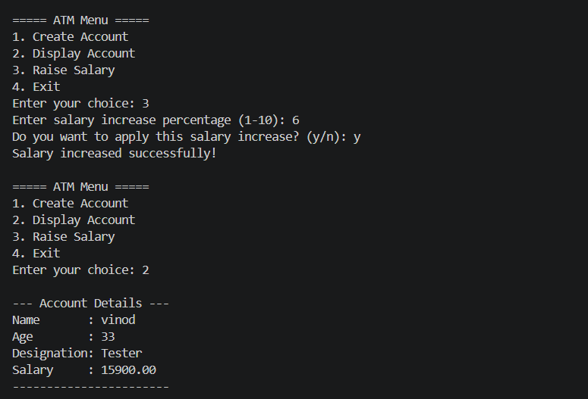

Raise Salary Feature
The Raise Salary feature allows the user to increase the salary of a particular employee by entering their name. The program first checks whether any accounts exist. It then searches the ArrayList using a for loop and equalsIgnoreCase() to find the employee by name. Once the account is found, the user enters a salary increase percentage between 1 and 10. The program calculates and displays the old salary and new salary, then asks the user for confirmation. If the user enters y, the new salary is updated in the Account object; if n is entered, the change is cancelled.

Exit Feature
The Exit feature allows the user to safely close the ATM program. When the user selects option 4, the program displays a thank-you message, closes the Scanner using sc.close(), and uses return to stop the main() method and terminate the program. This prevents the program from continuing to display the ATM menu after the user has chosen to exit.
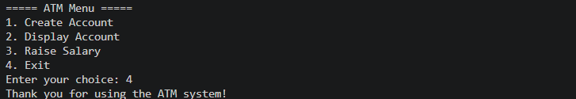

Conclusion
The ATM Management System successfully demonstrates the use of Java programming concepts to create a simple and interactive application. The project uses classes and objects to represent accounts and an ArrayList to store multiple account details. It also demonstrates loops, conditional statements, input validation, searching, and basic salary calculations. Through the four main features—Create Account, Display All Accounts, Raise Salary, and Exit—the project provides a clear understanding of how Java concepts can be combined to develop a practical menu-driven program.

