SOFTWARE ENGINEERING LAB 2
Agile Backlog Creation & Sprint Simulation in Jira
Name | Ullas T | Section | F
SRN | PES1UG24AM309 | Project | Faculty Research Grant & Publication Tracker
Problem Statement
Faculty Research Grant & Publication Tracker — this report documents the Agile backlog, priorities, story-point estimates, sprint simulation, burndown charts, and reflection for the Jira project.

1. Epics
Epic 1: Grant Fund Management
Manages grant fund allocations, grant expenses, and calculation of the remaining grant balance.
Epic 2: Publication & Citation Management
Manages faculty publications, publication indexing status, and citation metrics.
Epic 3: Co-author Approval Workflow
Supports submission of co-author details and review/approval by the Research Dean.
Epic 4: Grant Utilization & Analytics
Provides grant utilization status and fund burn-up analytics over time.
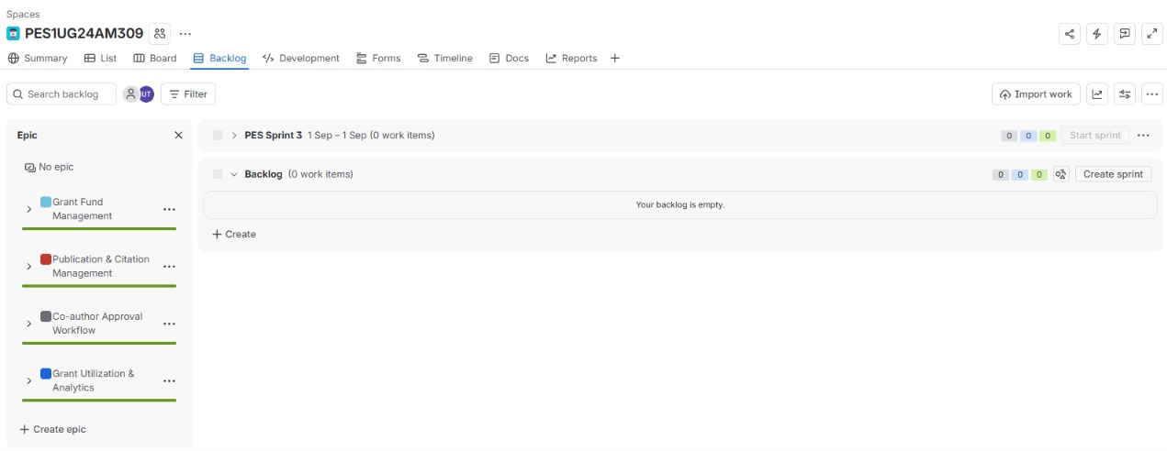
Figure 1: Jira backlog showing the four Epics.

2. User Stories

Epic 1: Grant Fund Management
Story | As a | I want | So that
US-1: Track Grant Fund Allocation | Faculty Researcher | To track grant fund allocations | I can monitor the budget allocated to the research grant.
US-2: Record Grant Expenses | Faculty Researcher | To record equipment procurement and other grant expenses | research expenditure is accurately tracked against the grant.
US-3: Calculate Remaining Grant Balance | Faculty Researcher | To calculate the remaining grant balance after expenses | I can know how much of the grant budget is still available.

Epic 2: Publication & Citation Management
Story | As a | I want | So that
US-4: Record Faculty Publications | Faculty Researcher | To record faculty publication details | I can maintain an accurate record of my research publications.
US-5: Track Publication Indexing Status | Faculty Researcher | To track the indexing status of publications | I can monitor the indexing status of my publications.
US-6: Track Citation Metrics | Faculty Researcher | To track citation metrics for publications | I can monitor publication performance and impact.

Epic 3: Co-author Approval Workflow
Story | As a | I want | So that
US-7: Submit Co-author Details | Faculty Researcher | To submit co-author details for approval | the required co-author information can be formally reviewed.
US-8: Review Co-author Approval | Research Dean | To review and approve submitted co-author details | co-author information is properly authorized before approval.

Epic 4: Grant Utilization & Analytics
Story | As a | I want | So that
US-9: View Grant Utilization | Faculty Researcher / Research Dean | To view grant allocation, expenses, and utilization status | stakeholders can monitor how sponsored research funds are being used.
US-10: Generate Fund Burn-up Analytics | Research Dean | To generate fund burn-up analytics showing expenditure against the allocated budget over time | I can monitor spending trends and remaining grant funds.

3. Priorities and Story Points
The User Stories were prioritized as High or Medium and estimated using Fibonacci-style story points, consistent with the lab handout.
Story | Priority | Story Points
US-1 Track Grant Fund Allocation | High | 3
US-2 Record Grant Expenses | High | 5
US-3 Calculate Remaining Grant Balance | High | 3
US-4 Record Faculty Publications | High | 3
US-5 Track Publication Indexing Status | High | 3
US-6 Track Citation Metrics | High | 5
US-7 Submit Co-author Details | High | 3
US-8 Review Co-author Approval | High | 3
US-9 View Grant Utilization | Medium | 3
US-10 Generate Fund Burn-up Analytics | Medium | 5
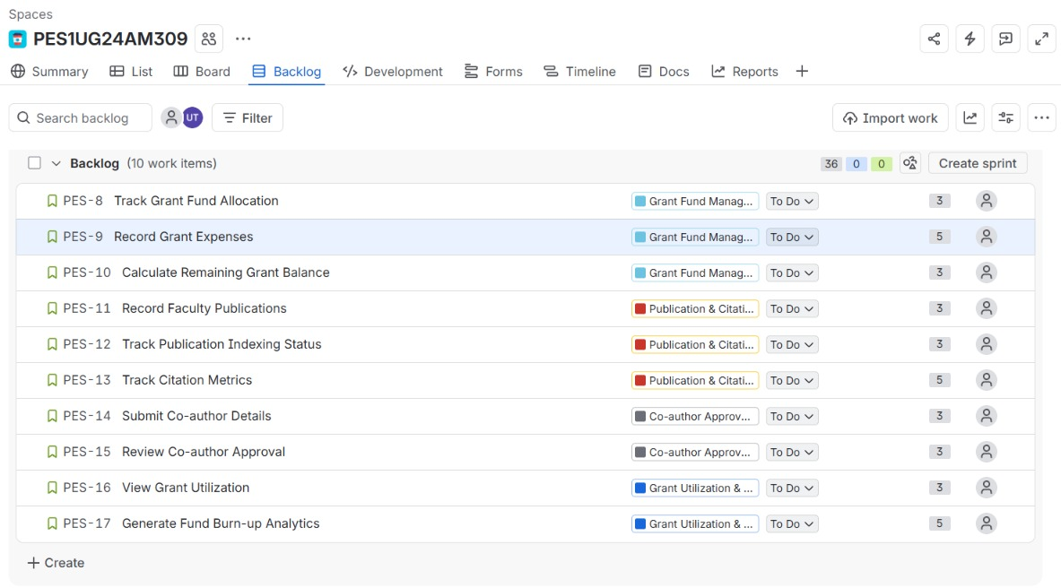
Figure 2: Initial Jira backlog with the ten User Stories.

4. Sprint Information
Sprint 1 (1 hour) — 5 stories, 17 story points
• Track Grant Fund Allocation — 3
• Record Grant Expenses — 5
• Calculate Remaining Grant Balance — 3
• Record Faculty Publications — 3
• Track Publication Indexing Status — 3

Sprint 2 (1 hour) — 5 stories, 19 story points
• Track Citation Metrics — 5
• Submit Co-author Details — 3
• Review Co-author Approval — 3
• View Grant Utilization — 3
• Generate Fund Burn-up Analytics — 5

The sprint simulation followed the Jira workflow: To Do → In Progress → In Review → Done.

5. Sprint Simulation

Sprint 1 — Board Progress
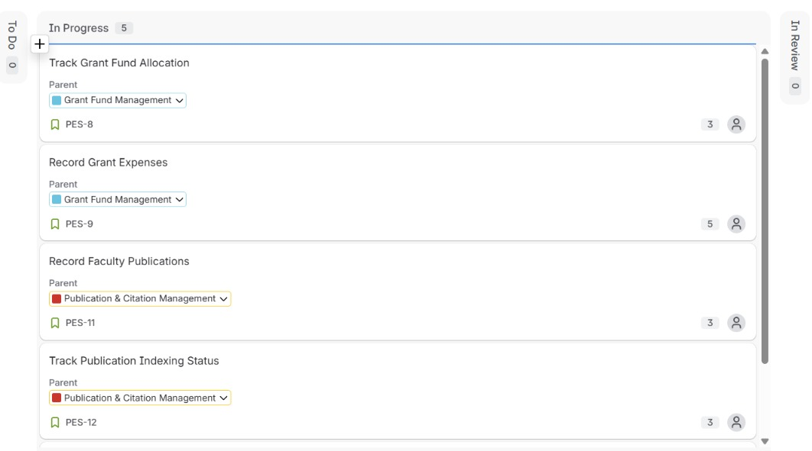
Figure 3: Sprint 1 stories moved to In Progress.
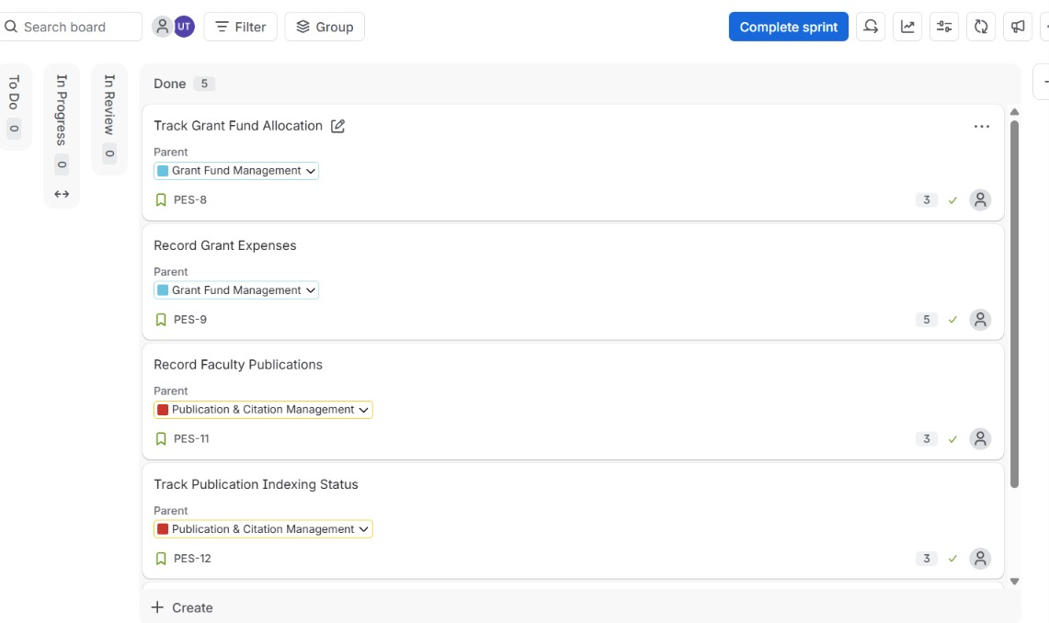
Figure 4: Sprint 1 stories shown in Done.

Sprint 2 — Board Progress
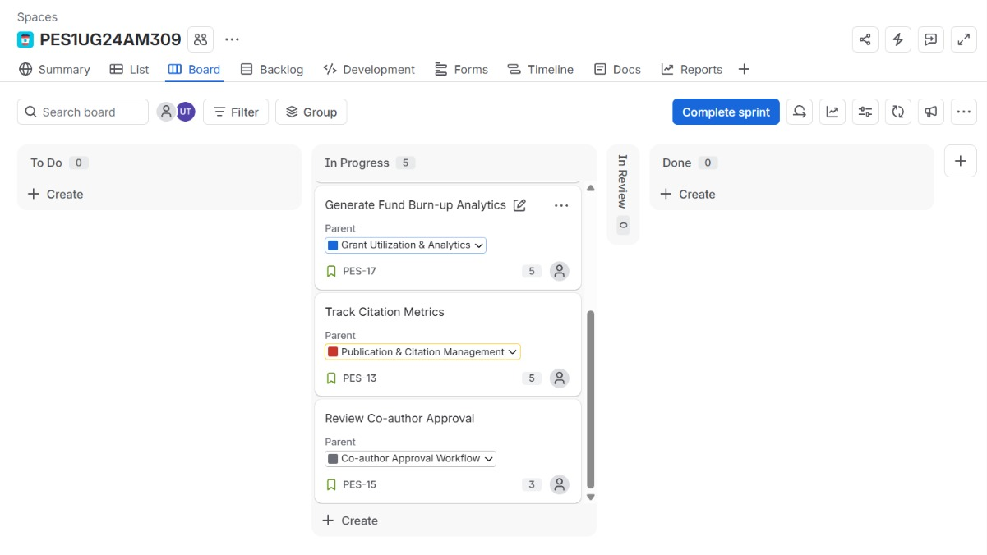
Figure 5: Sprint 2 stories moved to In Progress.
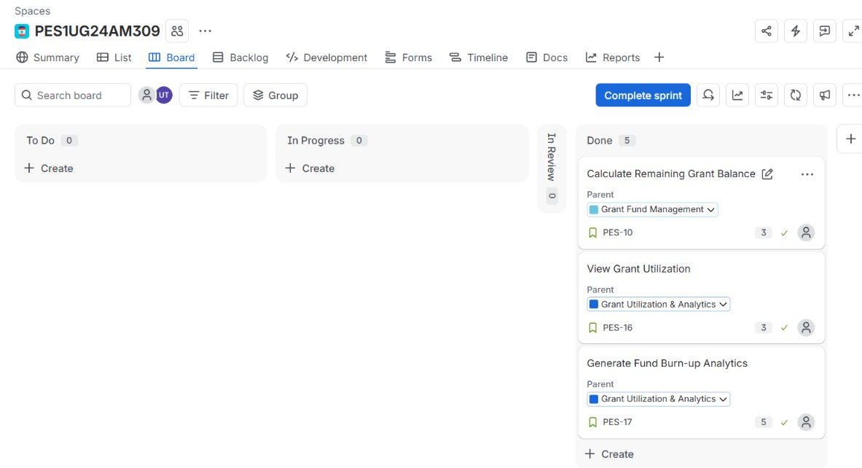
Figure 6: Sprint 2 stories shown in Done.

Final Backlog Evidence
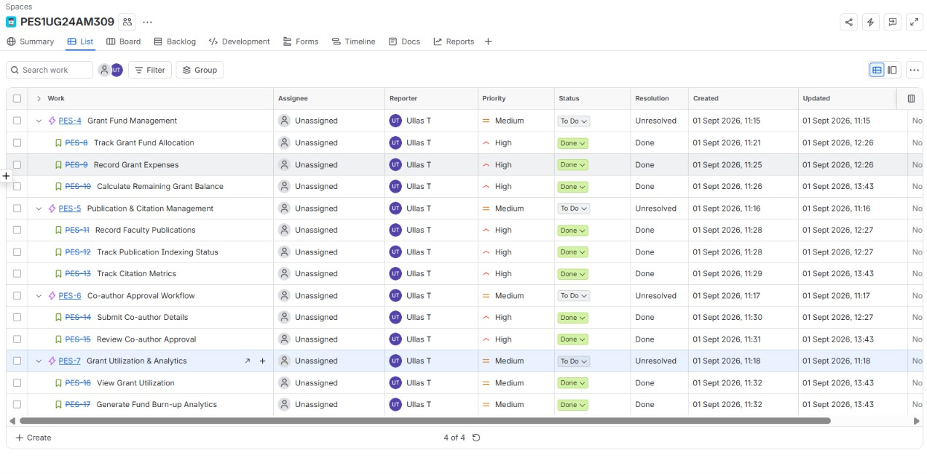
Figure 7: Final Jira list showing priorities, status, and story point estimates.
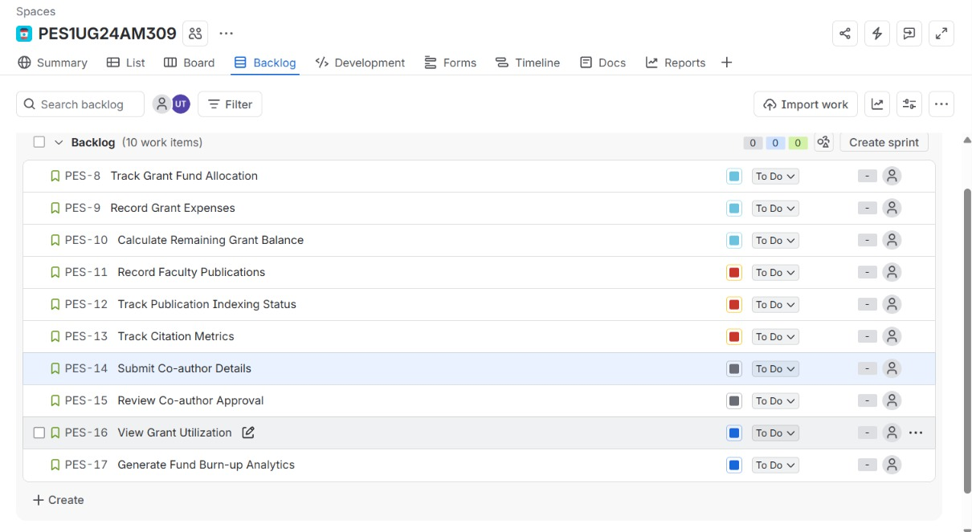
Figure 8: Jira backlog showing all ten User Stories and estimates.

6. Burndown Charts

Sprint 1 Burndown Chart
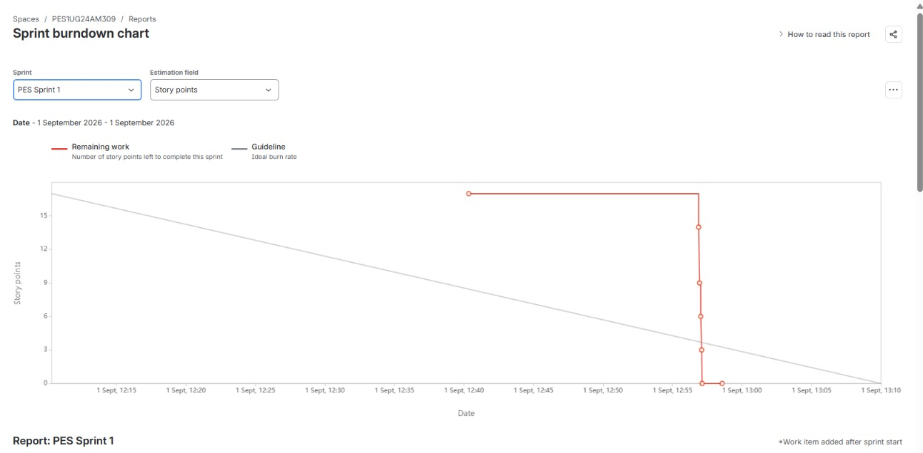
Figure 9: Sprint 1 Burndown Chart.

Sprint 2 Burndown Chart
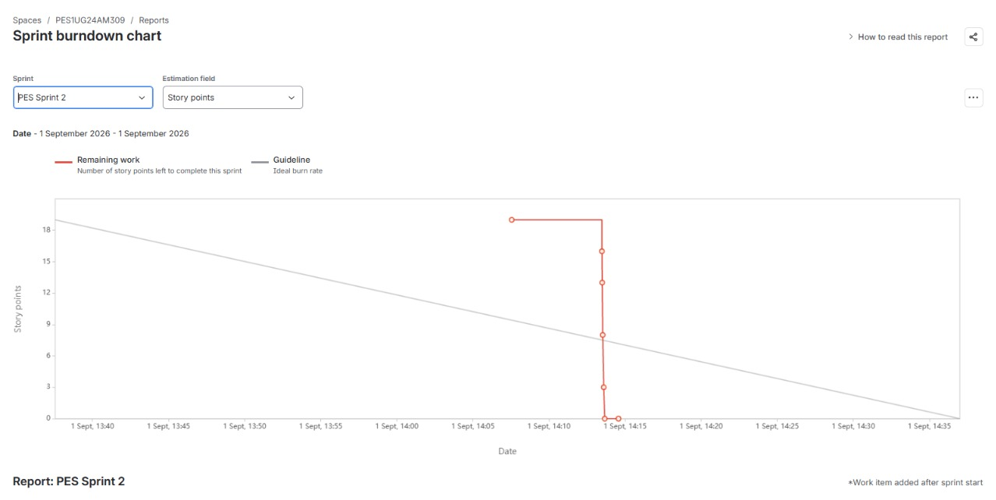
Figure 10: Sprint 2 Burndown Chart.

7. Reflection Questions
1. Did your estimations reflect the actual effort?
Yes. The story point estimates provided a reasonable relative representation of effort and complexity. Smaller activities were assigned 3 points, while comparatively more complex activities were assigned 5 points.
2. Was your backlog well-prioritized?
Yes. The backlog was prioritized according to user impact and business importance. Core grant and publication activities were given High priority, while grant utilization and analytics were assigned Medium priority.
3. How did your simulated sprint align with your plan?
The simulated sprints aligned with the plan. The ten User Stories were divided into two one-hour sprints, with 17 story points in Sprint 1 and 19 story points in Sprint 2. The stories were moved through the Jira workflow and completed.
4. What insights did the burndown chart give about your team's capacity?
The burndown charts showed the reduction in remaining story points during the simulated sprints. They provided a visual way to evaluate progress and the amount of work completed within the selected sprint duration.
Conclusion
The Jira exercise demonstrated backlog creation, prioritization, story-point estimation, sprint execution, workflow progression, and burndown-based progress analysis for the Faculty Research Grant & Publication Tracker.

