Software Engineering Lab – 1
Requirements Engineering & UML Use-Case Modelling
Problem Statement #09
Faculty Research Grant & Publication Tracker
1. Problem Context & Overview
The research deanery requires an automated portal to track sponsored research grants, faculty publication metrics (indexing, citations), co-author approval workflows, and fund burn-up analytics.
Target Stakeholders / Actors: Faculty Researcher, Research Dean
2. Complete Requirements Table
ID | Type | Description | Priority | Acceptance Criteria | Rationale
FR-001 | Functional | The system shall track grant fund allocations, allow faculty to log equipment procurement expenses, and compute the remaining budgetary balance. | High | Pass: Balance updates accurately and expenses exceeding the grant cap are blocked unless approved. Fail: Overdraft is allowed without authorization. | To ensure accurate monitoring and control of research grant funds.
FR-002 | Functional | The system shall allow faculty researchers to record publications and track their indexing status and citation metrics. | High | Pass: Publication details, indexing status, and citation count are stored and displayed correctly. Fail: Publication metrics are not correctly saved or displayed. | To provide an accurate record of faculty publication performance.
FR-003 | Functional | The system shall allow faculty researchers to submit co-author details for approval and allow the Research Dean to review and approve them. | High | Pass: A submitted co-author request can be reviewed and approved by the Research Dean. Fail: An unreviewed request is marked as approved. | To ensure proper authorization of co-author information.
FR-004 | Functional | The system shall allow faculty researchers and the Research Dean to view the status and utilization of sponsored research grants. | Medium | Pass: Current grant allocation, expenses, and utilization status are displayed accurately. Fail: Grant information is incorrect or outdated. | To help stakeholders monitor the progress and utilization of research grants.
FR-005 | Functional | The system shall generate fund burn-up analytics showing grant expenditure against the allocated budget over time. | Medium | Pass: The system generates an accurate burn-up report based on recorded grant expenses. Fail: The report does not correctly reflect recorded expenditure. | To help the Research Dean monitor spending trends and remaining grant funds.
NFR-001 | Performance & Security | The system shall maintain an immutable, tamper-evident audit ledger for all financial approvals and journal status modifications. | High | Pass: Benchmarking tests confirm target performance and security standards under simulated peak load. Fail: Audit records can be modified or deleted without authorization. | To protect the integrity and security of financial and approval records.
NFR-002 | Availability & Reliability | The system shall remain available and reliably preserve grant, publication, and approval data during normal university operations. | High | Pass: Stored records remain available and intact after normal system restarts or temporary failures. Fail: Stored records are lost or inaccessible after a system failure. | To ensure important research and financial information remains accessible and reliable.

3. UML Use-Case Diagram
Actors: Faculty Researcher and Research Dean. The diagram below models the primary use cases and includes the required «include» and «extend» relationships.
Faculty Researcher |  | Faculty Research Grant & Publication Tracker |  | Research Dean
Actor |  | Primary Use Cases |  | Actor
 | Manage Grant |  | Track Indexing & Citations
 | Record Grant Expense |  | Submit Co-author Approval
 | Manage Publications |  | Review / Approve Co-author
 | View Grant Utilization |  | Generate Burn-up Analytics
 | «include» Audit Financial/Status Changes | «extend» Track Indexing & Citations → Manage Publications | «extend» Review/Approve Co-author → Submit Co-author Approval

Relationships:
• «include»: Record Grant Expense includes Audit Financial/Status Changes.
• «include»: View Grant Utilization includes Generate Burn-up Analytics.
• «extend»: Track Indexing & Citations extends Manage Publications.
• «extend»: Review / Approve Co-author extends Submit Co-author Approval.
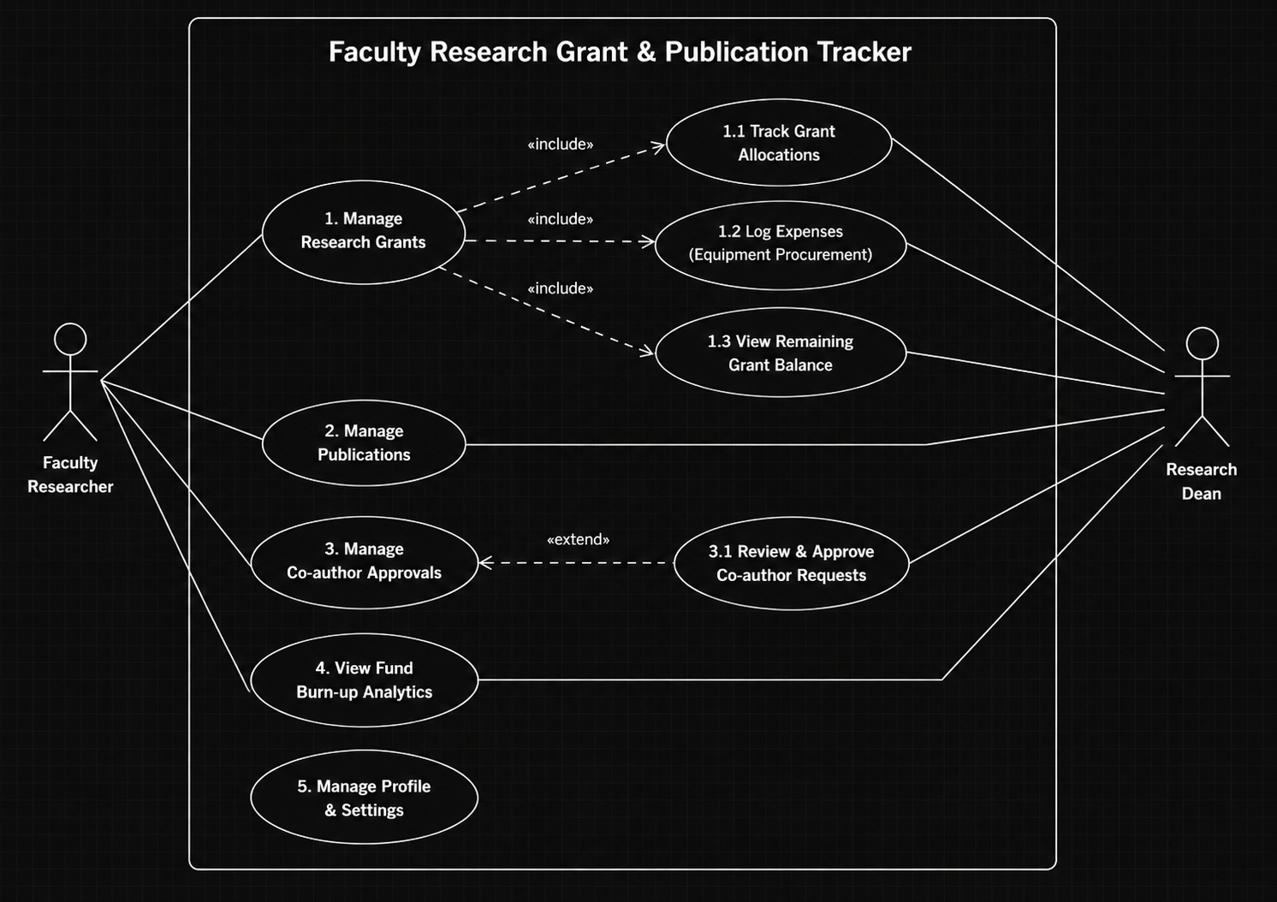
4. Use-Case Flow Specification
Use Case: Record Grant Expense
Primary Actor: Faculty Researcher
Preconditions
1. The Faculty Researcher is authenticated in the system.
2. A valid sponsored research grant exists and has an allocated budget.
3. The researcher has permission to record an expense.
Postconditions
1. The expense is stored against the selected grant.
2. The remaining grant balance is recalculated.
3. The transaction is recorded for audit purposes.
Main Success Scenario
1. Faculty Researcher selects a sponsored research grant.
2. The system displays the current allocation and remaining balance.
3. The researcher enters expense details, including amount and procurement information.
4. The system validates the expense against the available grant balance.
5. The researcher submits the expense.
6. The system records the expense and updates the remaining budgetary balance.
7. The system confirms successful submission.
Alternate Flow
4a. If the expense would exceed the remaining grant balance, the system rejects the transaction and displays an insufficient-budget message. The researcher may modify the amount or cancel the submission.
5. Submission Note
This Word document contains the requirements table, UML use-case diagram representation, and use-case flow specification in one editable document.

