Got it — I’ll update the PRD to:

1. Add **UI landing page imagery** suggestions under **UI/UX Requirements**.
2. Include an **AI-driven weather advisability feature** in the **Core Features** and **Optional AI Features** sections.

Here’s your **updated PRD**:

**Product Requirements Document (PRD)**

**App Name (Working Title)**: *SacredPath India*

**Platform**: iOS (SwiftUI)

**Version**: 1.0

**Date**: 16 August 2025

**Author**: Prajñā saḍaka

**1. Executive Summary**

SacredPath India is a mobile iOS application designed to help users **plan budget-conscious pilgrimages** to holy sites across India. Users enter their budget, preferred destinations (or let the app suggest), travel dates, and other preferences. The app then:

1. Calculates the **shortest travel route** using Google Maps API.
2. Generates a **complete itinerary** (travel, accommodation, meals) tailored to their budget.
3. Provides **cost breakdowns** and booking links.
4. Suggests **additional spiritual sites** near the route to enhance the trip.
5. **Analyzes real-time weather and travel conditions** to advise whether it’s a good time to go.

**2. Goals & Objectives**

* **Primary Goal**: Simplify pilgrimage planning in India by integrating **budget planning**, **route optimization**, and **real-time advisories**.
* **Objectives**:
  + Offer affordable travel itineraries within a specified budget.
  + Integrate with Google Maps to display shortest routes.
  + Provide dynamic recommendations for hotels, travel modes, and food options.
  + Curate a list of holy places with verified details, images, and historical/spiritual significance.
  + Warn or encourage travel plans based on **live weather and seasonal conditions**.

**3. Target Audience**

* Pilgrims of all age groups planning trips to **temples, mosques, gurudwaras, monasteries**.
* Domestic and NRI travelers looking for **affordable and optimized travel plans**.
* Tour operators and travel planners who can use it as a tool.

**4. Key Features & Requirements**

**4.1 User Inputs**

* **Budget** (total, or per day).
* **Travel start location** (GPS or manual entry).
* **Destination(s)**: user-chosen or AI-suggested.
* **Number of travelers** (adults/children).
* **Preferred travel dates**.
* **Travel mode** preference (train, bus, car, flight).
* **Accommodation type** (budget hotel, dharamshala, mid-range).

**4.2 Core Features**

**A.**

**Route Optimization**

* API: Google Maps Directions API.
* Functionality:
  + Generate the **shortest time or shortest distance route** between multiple destinations.
  + Allow user to reorder destinations and see updated route instantly.

**B.**

**Itinerary Generation**

* Break trip into **day-by-day plans**:
  + **Travel** (mode, departure/arrival times, fares).
  + **Accommodation** (name, cost, booking link).
  + **Meals** (local food spots or included options).
  + **Sightseeing & darshan timings**.
* Auto-balance budget across travel, hotel, and food.

**C.**

**Budget Breakdown**

* Pie chart of expenses: Travel / Stay / Food.
* Cost estimates in INR.
* Option to “upgrade” or “downgrade” accommodations to adjust budget.

**D.**

**AI-Driven Travel Advisability Based on Weather**

* Uses live weather data (OpenWeatherMap API or IMD API).
* AI model evaluates:
  + Monsoon flooding risks.
  + Snow/landslide warnings.
  + Heatwave advisories.
  + Festival crowd surges.
* Output:
  + “Recommended to go” (green)
  + “Proceed with caution” (yellow)
  + “Not advisable” (red)
* Suggest alternative dates or destinations in unsafe conditions.

**E.**

**Booking Integrations**

* Deep links to IRCTC (trains), RedBus, MakeMyTrip, OYO, Zomato/Swiggy.

**F.**

**Destination Profiles**

* Each holy site’s:
  + Image gallery.
  + Spiritual/historical info.
  + Best time to visit.
  + Entry fees (if any).

**G.**

**Offline Mode**

* Save itinerary and maps offline for remote areas with poor connectivity.

**4.3 Optional Features (Expanded)**

**1. AI-Powered Suggestion Engine**

* Suggest nearby lesser-known holy sites, eateries, or events.
* Recommend optimal visiting hours based on crowds, festivals, and weather.
* Uses curated pilgrimage data + Google Places reviews.

**2. Group Trip Coordination**

* Share itineraries with others, edit collaboratively.
* Assign expenses to individuals.
* Real-time sync via Firebase.

**3. Language Localization (All Indian Languages)**

* Full support for all **22 official Indian languages** under the Eighth Schedule.
* Auto-detect language from device settings.
* Spiritual glossary translations + audio guides.

**4. Expense Tracking During Trip**

* Log actual spending on travel, food, donations.
* Compare against planned budget.

**5. Push Notifications & Smart Alerts**

* Alerts for darshan timings, weather changes, or transport updates.
* Geofencing triggers for location-based alerts.

**6. Festival & Special Event Integration**

* Show upcoming spiritual events near route.
* Option to extend trip to attend.

**7. Personalized Spiritual Content**

* Daily devotional quotes.
* Legends and histories of sites before visiting.

**8. Premium Concierge Service**

* On-call help during trip.
* Human-assisted bookings.

**9. AR Pilgrimage Guides**

* ARKit-powered temple navigation.

**10. Souvenir & Donation Integration**

* Order prasad or make donations in-app.

**5. UI/UX Requirements**

**Style Guide**

* **Theme**: Minimalist + cultural heritage (warm earthy colors, saffron, deep blue).
* **Typography**: Clean sans-serif with Indic script support.
* **Iconography**: SF Symbols + custom holy site icons.
* **Illustrations**: Indian spiritual motifs.

**Core Screens**

1. **Onboarding**
   * Full-screen spiritual imagery (e.g., Golden Temple sunrise, Rameshwaram shore temple, Kedarnath in snow).
   * Tagline: “Your Sacred Journey, Perfectly Planned.”
   * Language selection screen (with flag and script preview).
2. **Home**
   * Hero banner with seasonal holy site images.
   * “Plan My Trip” primary CTA button.
3. **Trip Input Form**
   * Budget, dates, preferences.
4. **Route Map Screen**
   * Google Maps embedded view with pins.
5. **Itinerary View**
   * Card-based layout.
   * Weather advisability badge (green/yellow/red).
6. **Destination Details**
   * Image carousel.
   * Quick facts + best visiting months.
7. **Budget Adjuster**
   * Slider UI.
8. **Profile & Saved Trips**
   * User’s stored itineraries and preferences.

**6. Technical Requirements**

* **Platform**: iOS 17+, SwiftUI.
* **APIs**:
  + Google Maps Directions API.
  + Google Places API.
  + OpenWeatherMap / IMD for weather.
  + IRCTC/RedBus/MakeMyTrip APIs.
  + OYO/Booking.com APIs.
* **Database**: Firebase Firestore.
* **Offline Support**: MapKit/Google Maps offline + local storage.
* **Authentication**: Sign in with Apple / Google.
* **Push Notifications**: Firebase Cloud Messaging.
* **Localization**: Native iOS localization + translation files for 22 languages.

**7. Monetization Strategy**

* **Free Tier**: Core planning features with ads.
* **Premium Tier**: ₹199/month for ad-free, offline, AI-powered weather advisories, advanced customizations.

**8. Risks & Mitigation**

| **Risk** | **Mitigation** |
| --- | --- |
| API cost escalation | Cache routes & data locally |
| Poor data accuracy | Verify holy site info from multiple sources |
| Internet dependency | Offline mode |
| Translation issues | Professional + community translations |
| Weather misprediction | Use multiple weather APIs + trend analysis |

**9. Success Metrics**

* Avg. trips planned/user/month.
* Retention rate (30 days).
* Free-to-premium conversion.
* User satisfaction on weather advisories.

**10. Roadmap**

**Phase 1**: Core trip planner, Google Maps route, budget breakdown.

**Phase 2**: AI weather advisories, offline mode, full language support.

**Mock up image**

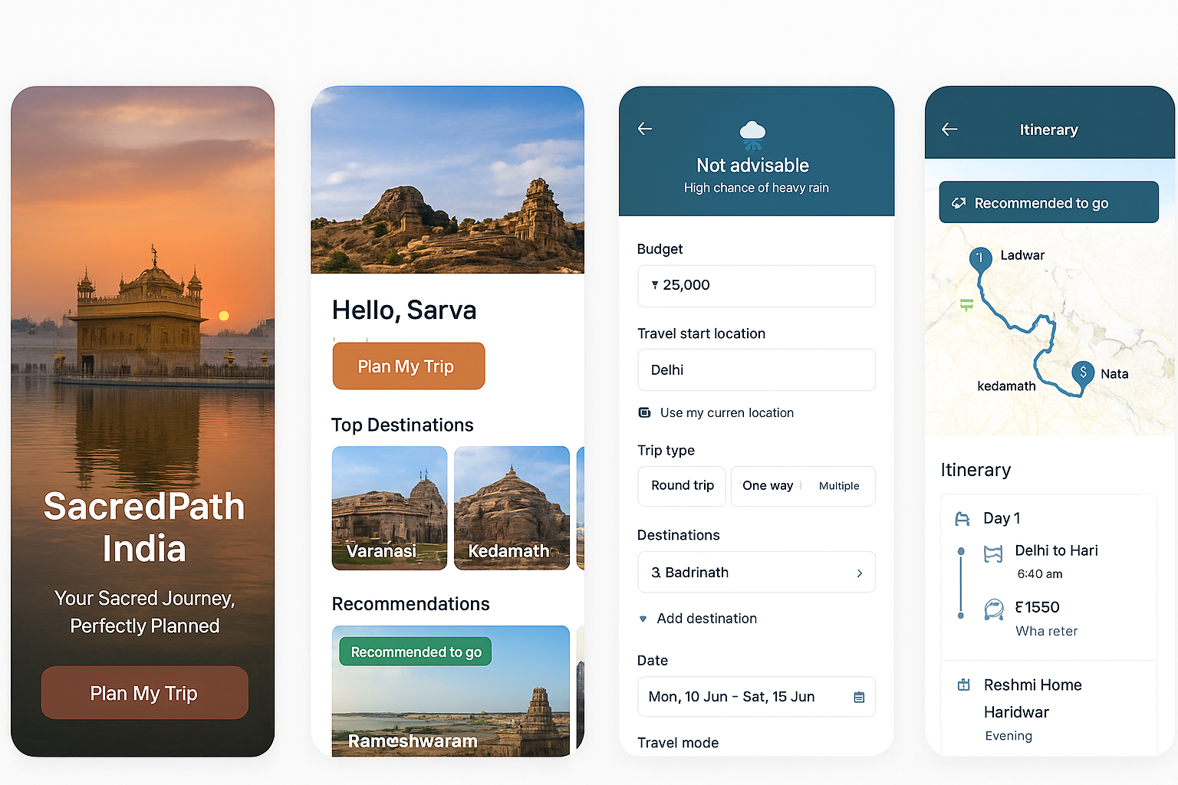

Step-step execution plan

Here’s a **90-day execution roadmap** to take your **SacredPath India** app from idea to MVP launch.

It’s structured in **4 phases** so you can track progress and ensure dependencies are handled in the right order.

**Phase 1: Foundation & Planning (Days 1–15)**

**Goal:** Get your technical, design, and content groundwork ready.

1. **Finalize PRD & UI Designs**
   * Lock in the features for MVP.
   * Confirm multilingual requirements.
   * Approve mockups for landing page, itinerary screens, and booking flows.
2. **Team Setup**
   * iOS developer (SwiftUI or UIKit).
   * Backend/API developer (Node.js, Python, or Firebase).
   * UI/UX designer.
   * Content curator for temple/festival data.
   * Project manager or yourself.
3. **Select Tech Stack**
   * Confirm frontend, backend, database, APIs.
   * Sign up for necessary developer accounts:
     + **Apple Developer Program** (₹8,000/year).
     + **Google Maps API**.
     + **OpenWeatherMap API**.
     + Travel/Hotel APIs (Booking.com, IRCTC).
4. **Content Gathering**
   * Compile top 50–100 holy sites in India.
   * Gather GPS coordinates, timings, entry fees, best visiting months.

**Phase 2: Core Development (Days 16–45)**

**Goal:** Build the main functionality of the MVP.

1. **Backend Setup**
   * Deploy backend server (AWS/GCP/Azure or Firebase).
   * Set up database schema for:
     + Users
     + Itineraries
     + Locations & routes
     + Budget preferences
2. **API Integrations**
   * Google Maps SDK & Directions API for shortest path.
   * OpenWeatherMap for live weather data.
   * Travel APIs for hotel/transport pricing.
3. **AI Modules**
   * **Budget Planner AI**: Suggests travel + stay + food within budget.
   * **Go/No-Go AI**: Weather + crowd density + event impact scoring.
4. **iOS App Core**
   * Landing page with search + budget input.
   * Map route view.
   * Itinerary detail screen.
   * Multilingual UI support.

**Phase 3: Advanced Features & Testing (Days 46–75)**

**Goal:** Add enhancements and ensure app stability.

1. **Multilingual Expansion**
   * Add Hindi, Tamil, Bengali, Gujarati, Marathi, Telugu, Kannada, Malayalam, Punjabi.
   * Use .strings localization files.
2. **Push Notifications**
   * Trip reminders.
   * Weather warnings.
   * Festival updates.
3. **Offline Mode**
   * Cache maps and itinerary for poor network zones.
4. **Testing**
   * Unit testing with XCTest.
   * UI testing for flow stability.
   * Internal QA.

**Phase 4: Launch Preparation & Marketing (Days 76–90)**

**Goal:** Get ready for public release.

1. **Beta Testing**
   * Use TestFlight for 20–50 early users.
   * Collect bug reports & usability feedback.
2. **App Store Preparation**
   * Write optimized title & description.
   * Prepare screenshots, preview video, and keywords.
   * Add privacy policy & terms of service.
3. **Marketing**
   * Social media teaser campaign.
   * Collaborate with travel vloggers & pilgrimage bloggers.
   * Partner with temple boards for promotion.
4. **Go Live**
   * Submit to App Store.
   * Monitor analytics & crash reports for first 2 weeks.
   * Plan post-launch updates.

📌 **Key Tip:**

Don’t try to perfect every feature in MVP — focus on **shortest path routing, budget planning, weather-based go/no-go advice, and clean UI**.

You can roll out group planning, AR guides, and concierge later.