Test document title (test escape characters in title: ', ", <, >, &)
Table of contents (LibreOffice)
Dedication 2
1. Links 2
2. Diagram extension 3
3. Listings 3
4. Examples 4
5. Admonitions 4
6. Test equations 5
7. Test discrete 5
8. Test footnotes 5
9. Test images 1 5
10. Vertical image test 6
Test Lists (this section heading is without a number) 9
11. A Test Section 1 (landscape) 10
11.1. A Test Section 1.1 (portrait) 11
12. Some long, very long, very very long, very very very long, very very very very long h e a d i n g of level 1 (doesn’t hang over page number) 12
12.1. Some long, very long, very very long, very very very long, very very very very long h e a d i n g of level 2 12
12.2. Some another with possible break above long, very long, very very long, very very very long, very very very very long h e a d i n g of level 2 12
12.2.1. Some long, very long, very very long, very very very long, very very very very long h e a d i n g of level 3 12
Some long, very long, very very long, very very very long, very very very very long h e a d i n g of level 4 12
Some long, very long, very very long, very very very long, very very very very long h e a d i n g of level 5 12
A. Appendix example 12
Figure index 12

Current document (“Test document title (test escape characters in title: ', ", <, >, &)”) is created with https://github.com/CourseOrchestra/asciidoctor-open-document.
Table of contents (Asciidoctor)
Dedication | 2
1. Links | 2
2. Diagram extension | 3
3. Listings | 3
4. Examples | 4
5. Admonitions | 4
6. Test equations | 5
7. Test discrete | 5
8. Test footnotes | 5
9. Test images 1 | 5
10. Vertical image test | 6
Test Lists (this section heading is without a number) | 9
11. A Test Section 1 (landscape) | 10
11.1. A Test Section 1.1 (portrait) | 11
12. Some long, very long, very very long, very very very long, very very very very long h e a d i n g of level 1 (doesn’t hang over page number) | 12
12.1. Some long, very long, very very long, very very very long, very very very very long h e a d i n g of level 2 | 12
12.2. Some another with possible break above long, very long, very very long, very very very long, very very very very long h e a d i n g of level 2 | 12
12.2.1. Some long, very long, very very long, very very very long, very very very very long h e a d i n g of level 3 | 12
Some long, very long, very very long, very very very long, very very very very long h e a d i n g of level 4 | 12
Some long, very long, very very long, very very very long, very very very very long h e a d i n g of level 5 | 12
A. Appendix example | 12

Some sort of [preamble] multiline paragraph.
Another preamble paragraph.
preamble table

Dedication
Some dedication
中文文字
Texte français
ein Löwe
Русский текст

1. Links
Asciidoctor

2. Diagram extension
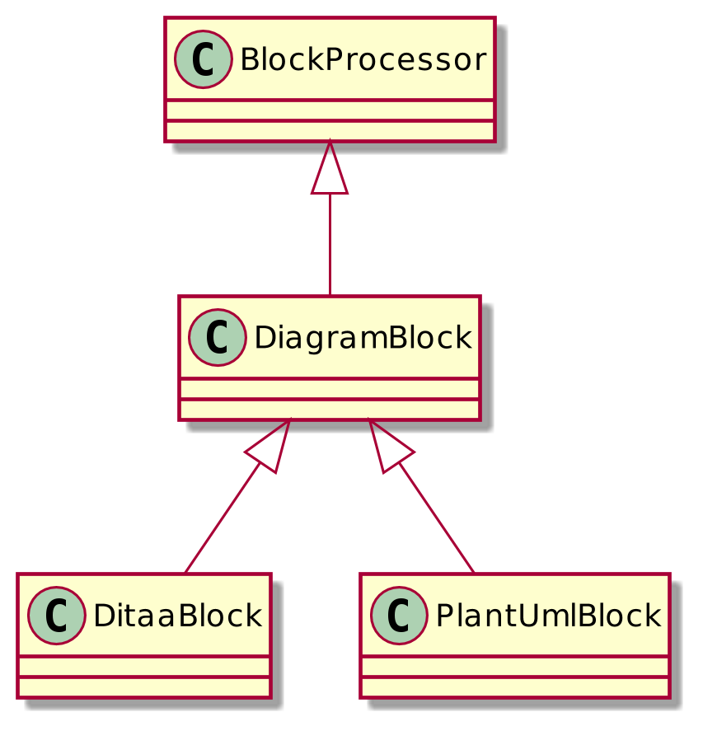
Figure 1. A diagram in adoc file

3. Listings
Asciidoc listing
Rouge doesn't support asciidoc
Some ruby listing
class BasicParagraph < BasicHelper 1 2
def h_parent_style_name 2
@sd[:parent_style_name] = $defsn_p
a = b + 3
abc[1]
end
end
1 Property setter class should inherit BasicHelper
2 Another callout and methods should start with h_
3 And something else
In lists
- List item 1
class OneMore 1
end
1 One more class
- List item 2
Table 1. In table
<a>
<b c="d"> 1
e
</b>
</a>
1 Tag with an attribute

4. Examples
Example 1. Optional title
This is an example of an example block.
The book hit the floor with a thud.
He could hear doves cooing in the pine trees’ branches.
Example 3. Example in table
Table list example
- List item 1
- List item 1
Just for the fun of it | Example 2. Some header
A deeply digged example. Interesting to see the number

5. Admonitions
Some text.
Important
Feeding the Werewolves
While werewolves are hardy community members, keep in mind the following dietary concerns:
- They are allergic to cinnamon.
- More than two glasses of orange juice in 24 hours makes them howl in harmony with alarms and sirens.
- Celery makes them sad.
Some text.
Note
Inline admonition

6. Test equations
Reference to equation (1).
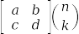 (1)
And here is an inline equation .

7. Test discrete
Discrete heading
Some text
One more discrete heading
Some more text

8. Test footnotes
The example of footnote and its reference1. Just a simple footnote.

9. Test images 1
Figure 2. Base64 image example
 Asciidoc inline icon, defined in pixels (20px), here is a long text to make this icon fall at least to the second line: . And some text after to have at least third line after this icon, just to see how does it influence line spacing.
The example of Asciidoc inline Base64 icon without width dimensions, it is 5px. Assuming 100 dpi resolution it should have smaller height than its line: . And some text after to have at least third line after this icon, just to see how does it influence line spacing.
This label height should be exactly 5mm in height: 
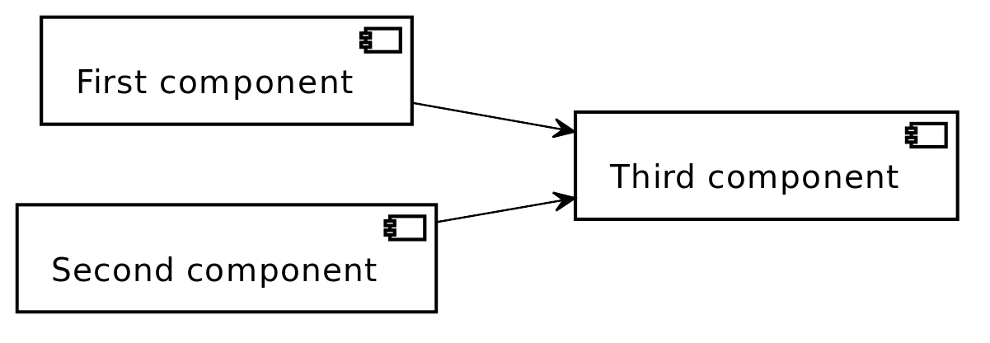
Figure 3. SVG example

Figure 4. SVG example 60x20
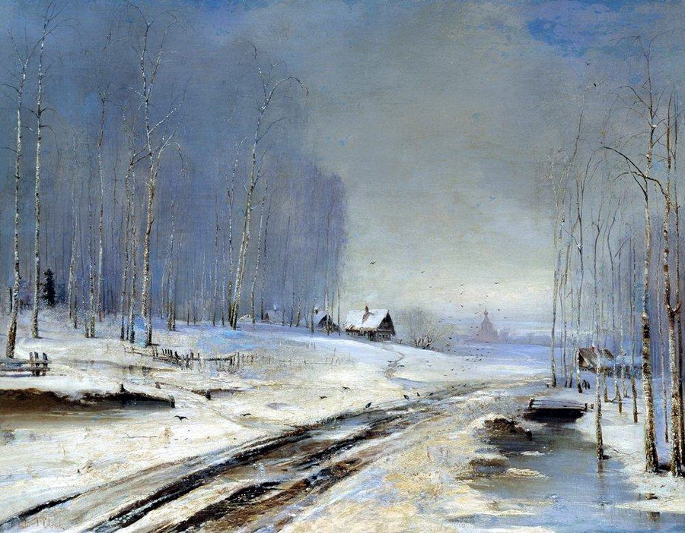
Figure 5. Spring slush

10. Vertical image test
Both images should look the same way in browser (10%), but differently in odt.

Figure 6. Ruler, made to fit page vertically (if condidered 500dpi)
Figure 7. Ruler, made to fit page vertically (if considered 100dpi)

Test Lists (this section heading is without a number)
Marked list heading
- First point (long line with fitted width)
  - Subpoint 1 (long line with fitted width)
    - And a little mix-in (short line that shouldn’t be fitted due to size)
  - Subpoint 2
- Second point with no bullet
- Third point
  - Non-bulleted subpoint 1
  - Non-bulleted subpoint 2
Numbered list heading
- First point
Warning
Admonition in list heading
Here the custom role list-level1-admonition is applied
  - Subpoint 1
    - Subsubpoint 1
    - Subsubpoint 2
  - Subpoint 2
- Second point
Second point continuation. For example some large paragraph, that describes the jist by all necessary means.
- Third point
  - Third sub point
Third point (not sub) continuation. For example some large paragraph, that describes the jist by all necessary means.
- Forth point

11. A Test Section 1 (landscape)
Example of italic, bold, subscript, superscript, simply marked, small text and monospaced.
Example of inline break
next string
Example of informal table with no vertical lines.
a1 | b1 small in table
a2 | b2
a3 | b3
a4 | b4

11.1. A Test Section 1.1 (portrait)
A Table (Table 2) Test paragraph text. A Test paragraph text. A Test paragraph text. A Test paragraph text. A Test paragraph text. A Test paragraph text. A Test paragraph text.
A Test centered paragraph text. A Test centered paragraph text. A Test centered paragraph text. A Test centered paragraph text. A Test centered paragraph text. A Test centered paragraph text. A Test centered paragraph text. A Test centered paragraph text. A Test centered paragraph text.
Table 2. Table title
a1 centered | b1 centered vertically | c1 Here a very long multiline text is situated in order to show that vertical alignment works
a2 spanned  Asciidoc contents  - a  - a1  - a2  And some text as a paragraph to check paragraph in list alignment  - b |  | c2
a3 (cell header) | b3 spanned vertically | c3 just centered
a4 | b3 spanned vertically | c5
a5 |  | b5
  sa1 | sa2
  sb1 | sb2
a6  Caution  Inline in table | b6  Tip  Table TIP caption  And some TIP in a table
a7
a8
a9
a10
A Test right-aligned paragraph text.

12. Some long, very long, very very long, very very very long, very very very very long h e a d i n g of level 1 (doesn’t hang over page number)

12.1. Some long, very long, very very long, very very very long, very very very very long h e a d i n g of level 2

12.2. Some another with possible break above long, very long, very very long, very very very long, very very very very long h e a d i n g of level 2

12.2.1. Some long, very long, very very long, very very very long, very very very very long h e a d i n g of level 3

Some long, very long, very very long, very very very long, very very very very long h e a d i n g of level 4

Some long, very long, very very long, very very very long, very very very very long h e a d i n g of level 5

A. Appendix example
An appendix

Figure index
Figure 1. A diagram in adoc file 3
Figure 2. Base64 image example 5
Figure 3. SVG example 6
Figure 4. SVG example 60x20 6
Figure 5. Spring slush 6
Figure 6. Ruler, made to fit page vertically (if condidered 500dpi) 7
Figure 7. Ruler, made to fit page vertically (if considered 100dpi) 8

A referenced footnote
Just a footnote

