1. **.Write a Java program to print "Hello, World!" to the console.**

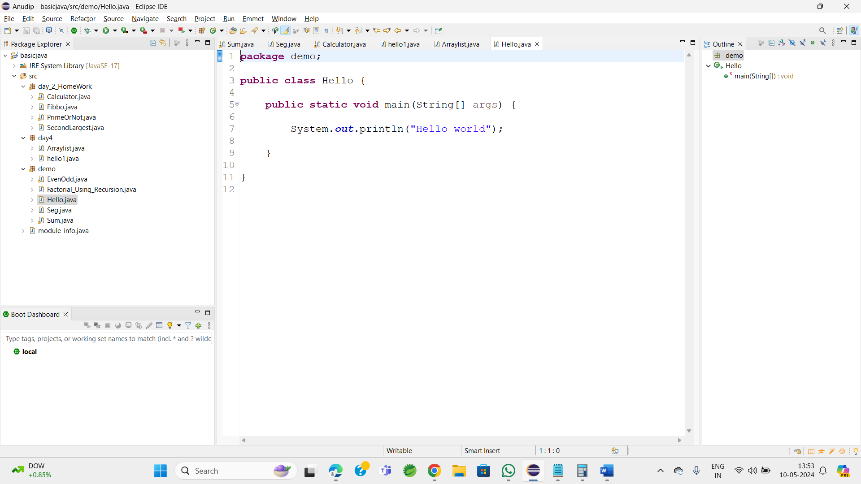

**OutPut:**

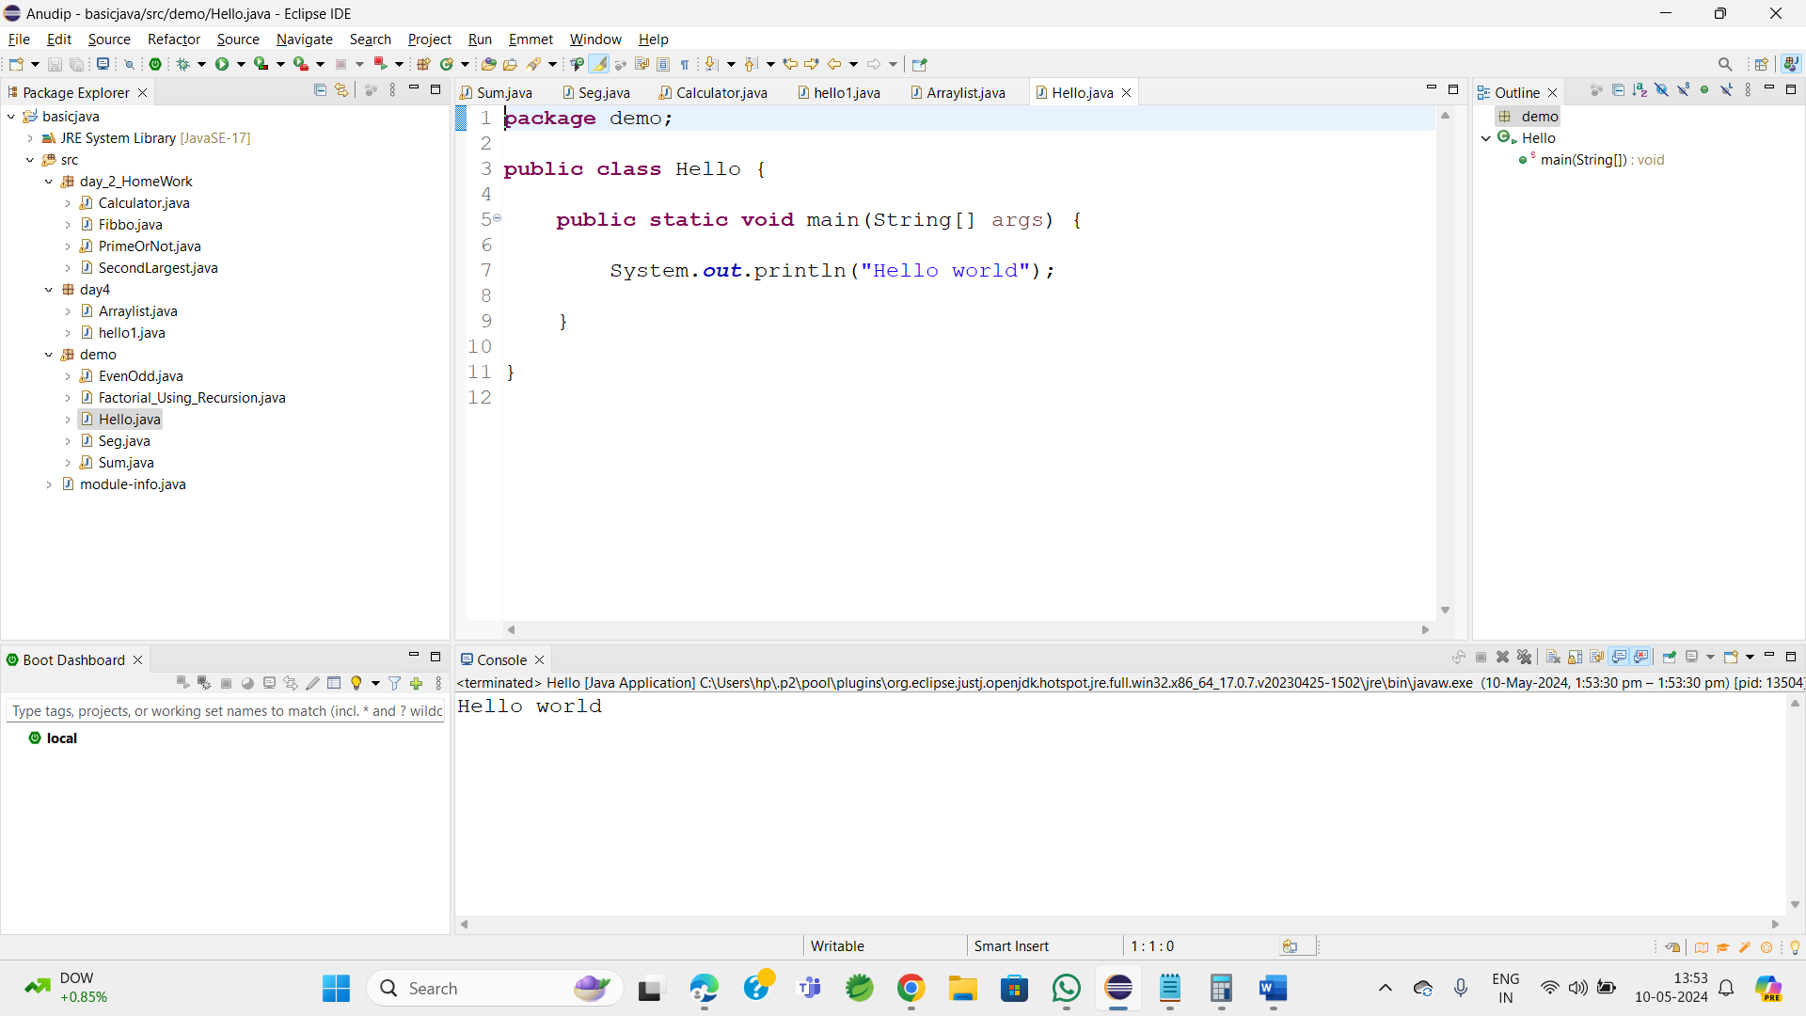

**2.Write a program to find the sum of two numbers entered by the user.**

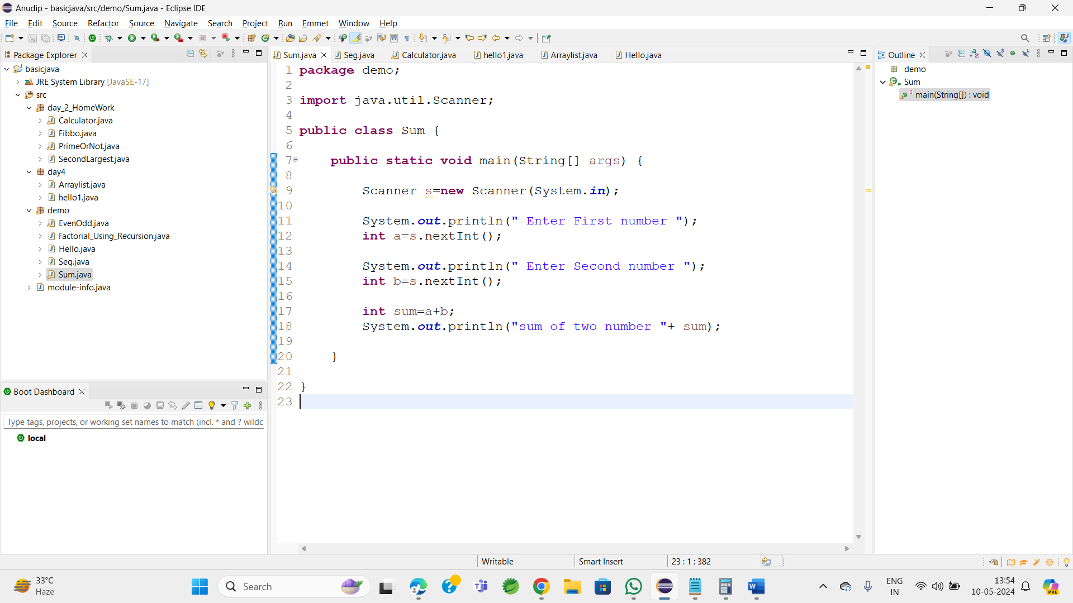

**Output:**

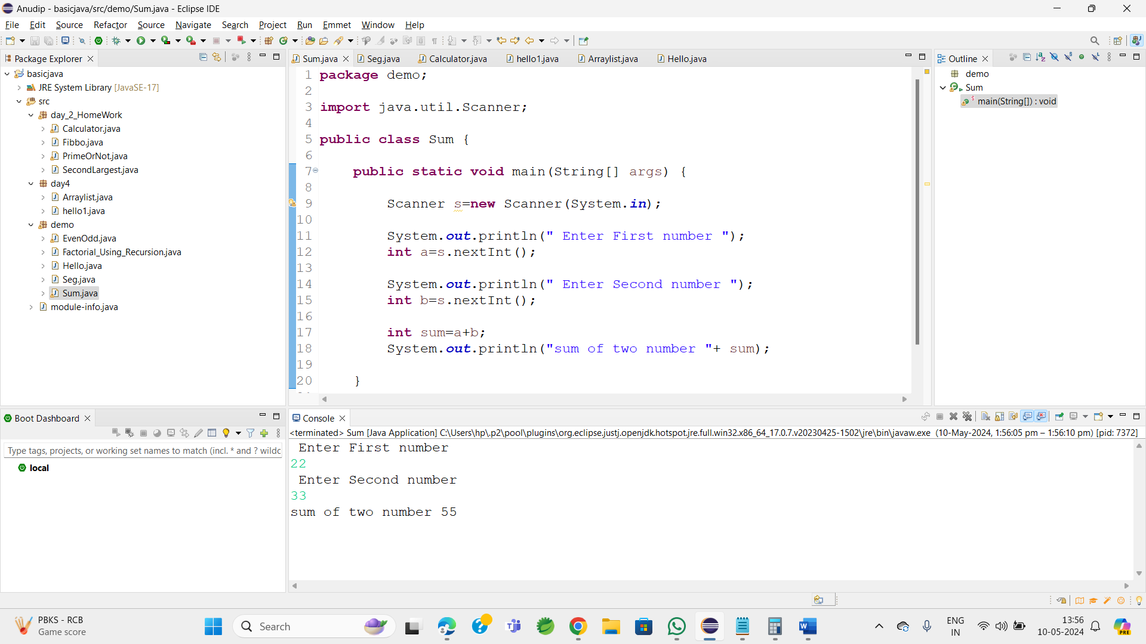

**3.Write a Java program to check whether a given number is even or odd.**

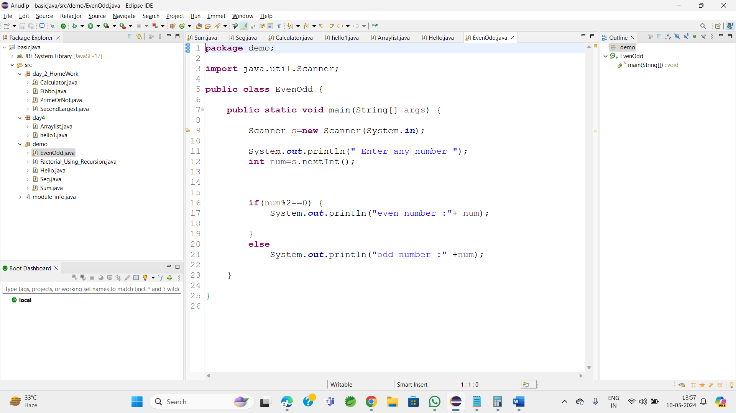

**Output:**

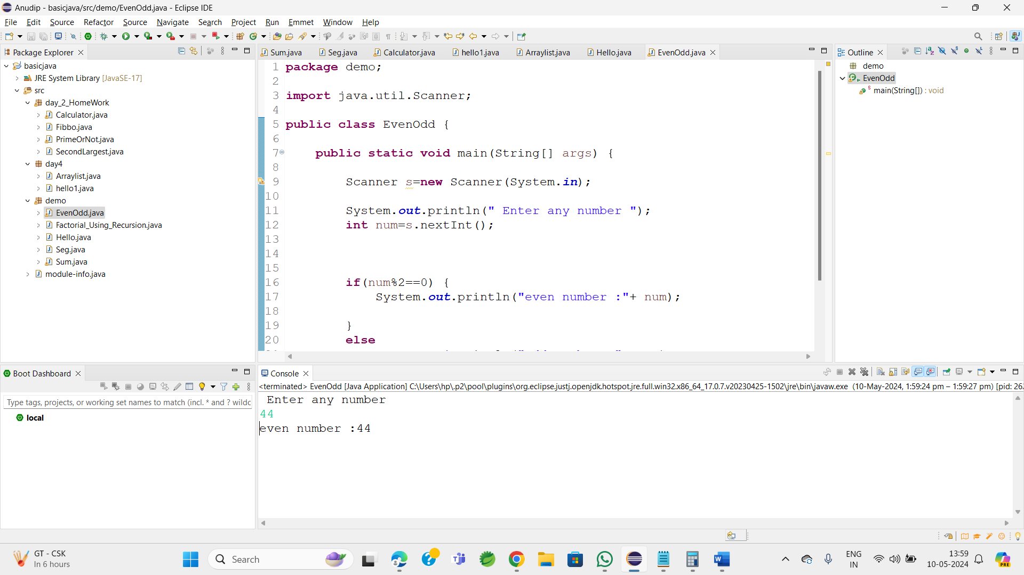

**4.Write a java program to find greatest of 2 numbers.**

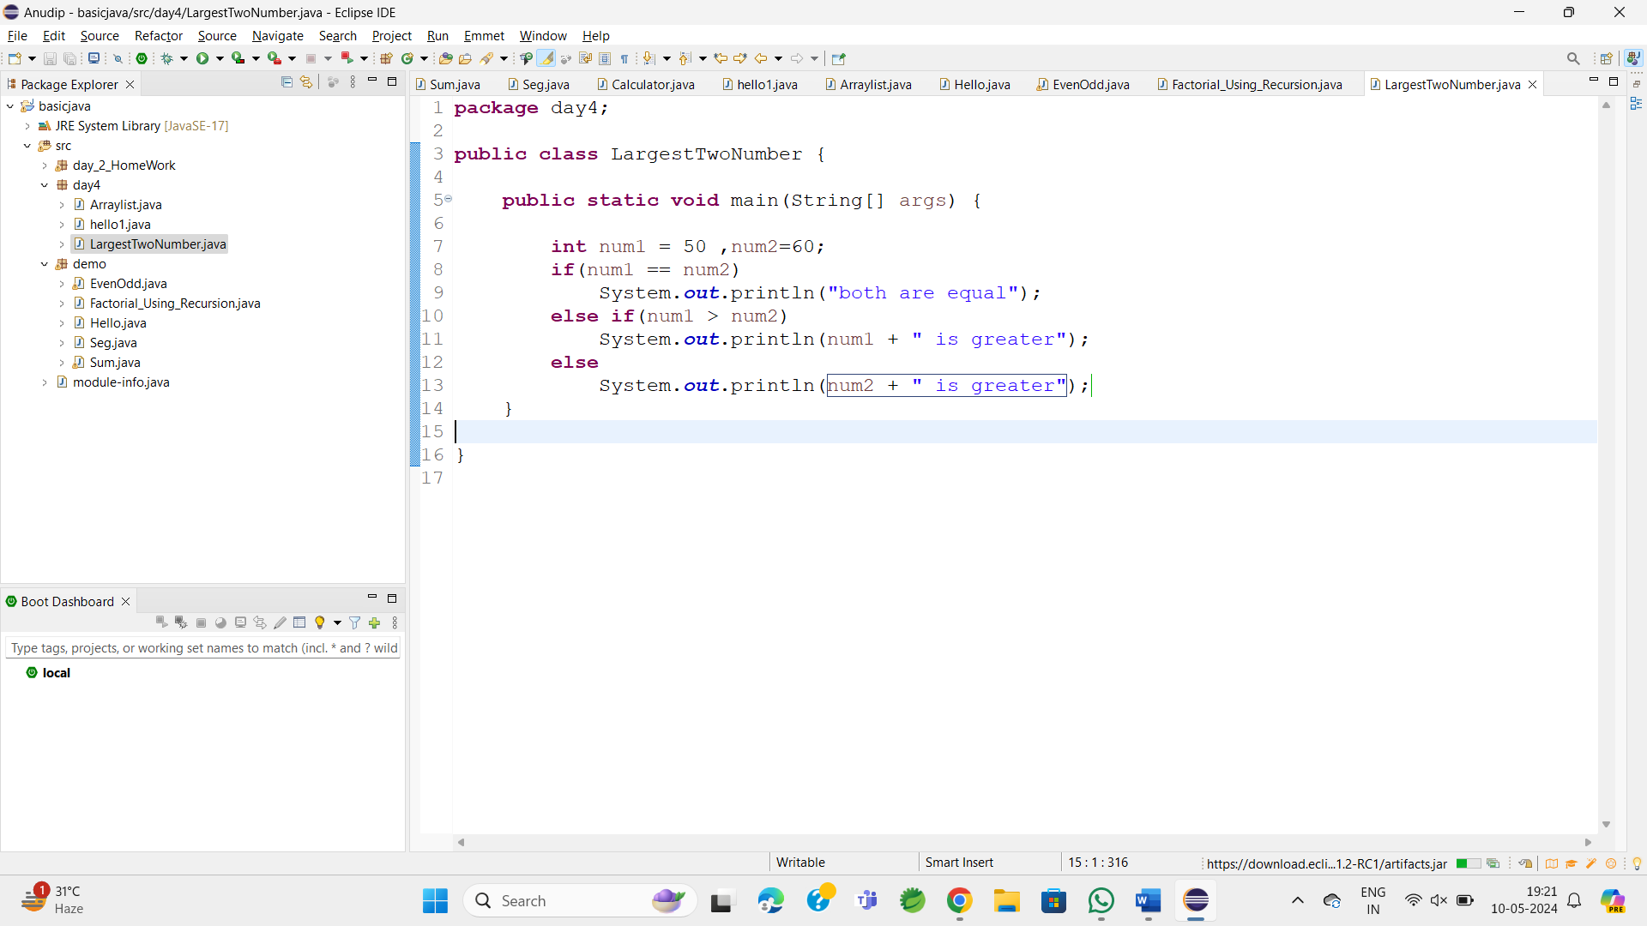

Output :

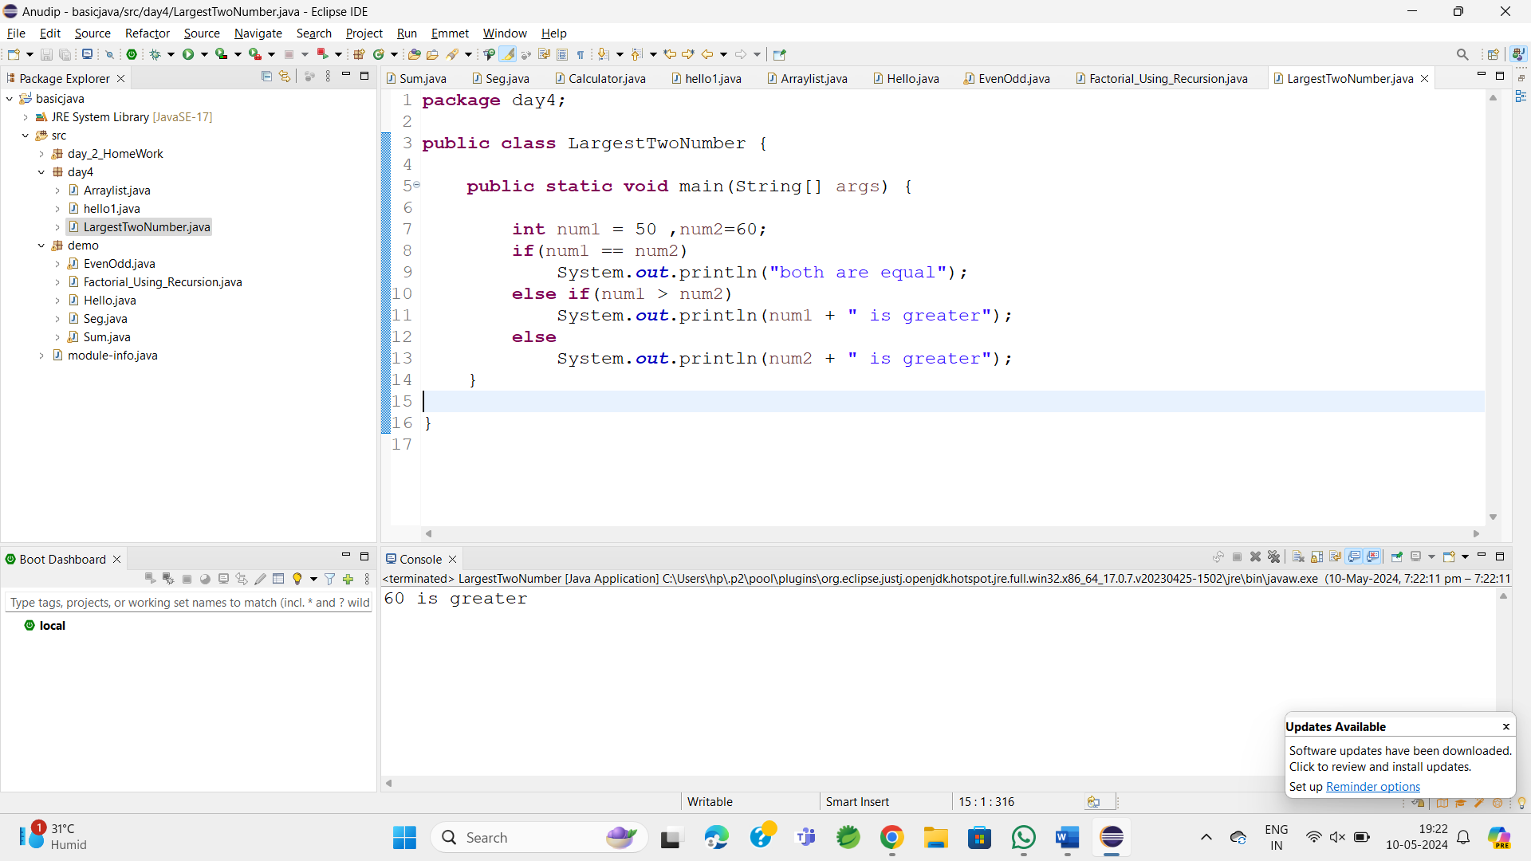

**5.Write a program to implement a basic calculator that takes input as a string expression and evaluates it.**

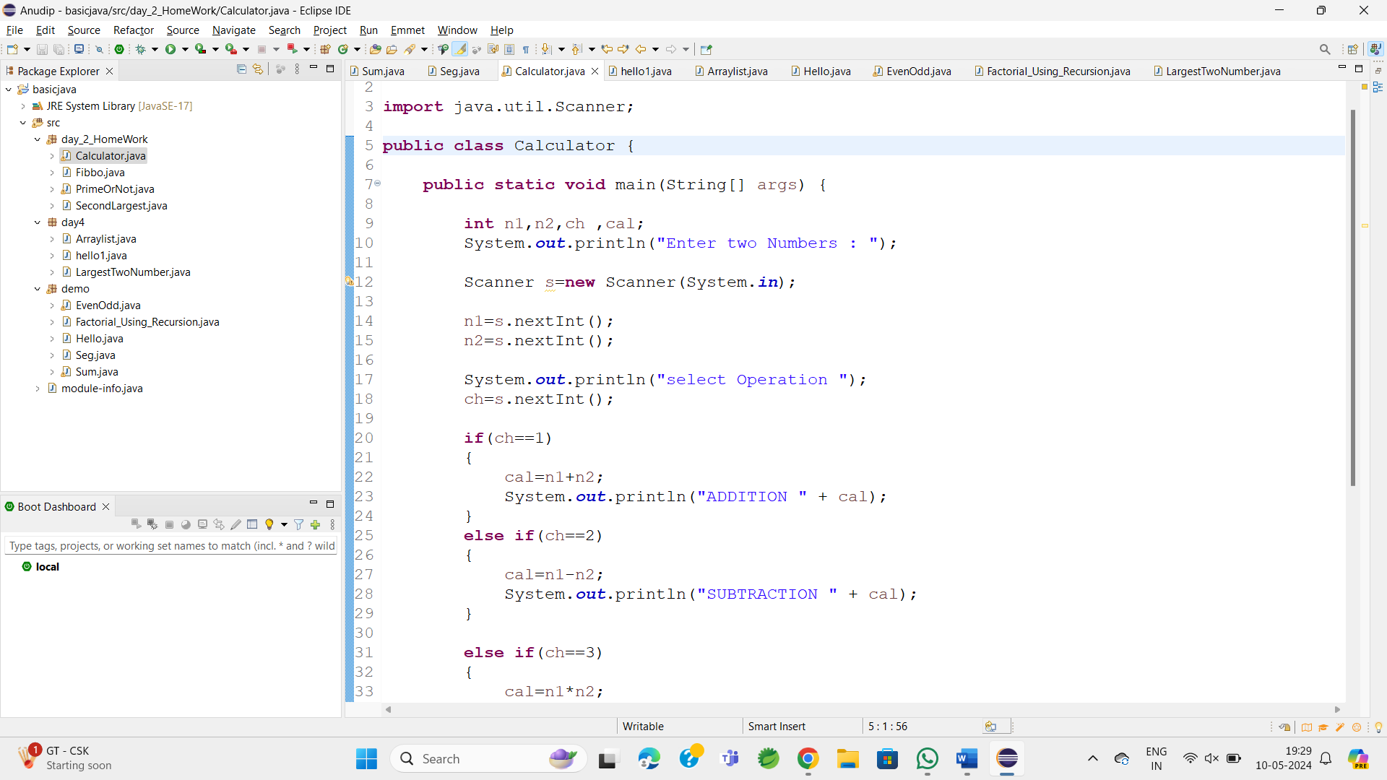

**Output:**

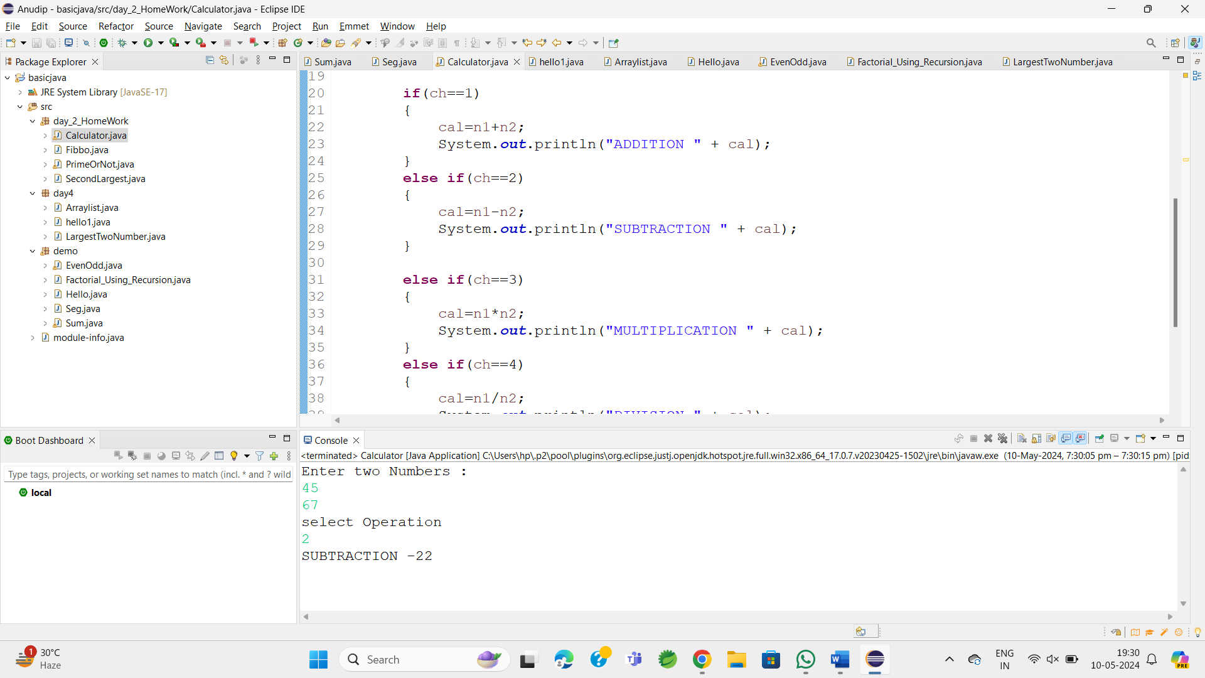

**6.Write a Java program to check if a given number is even or odd.**

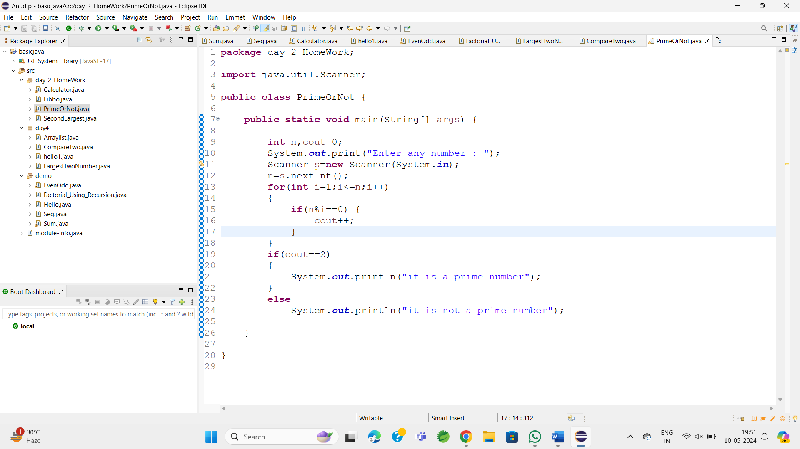

**Output:**

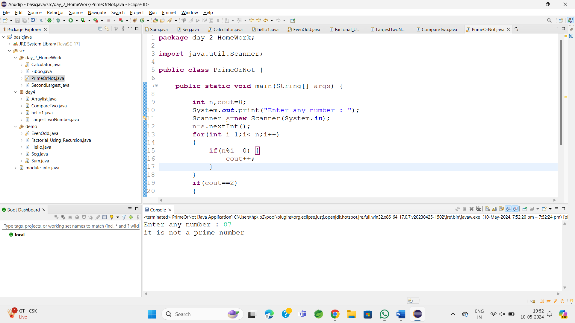

**7.Create a Java program that compares two numbers and prints the larger one.**

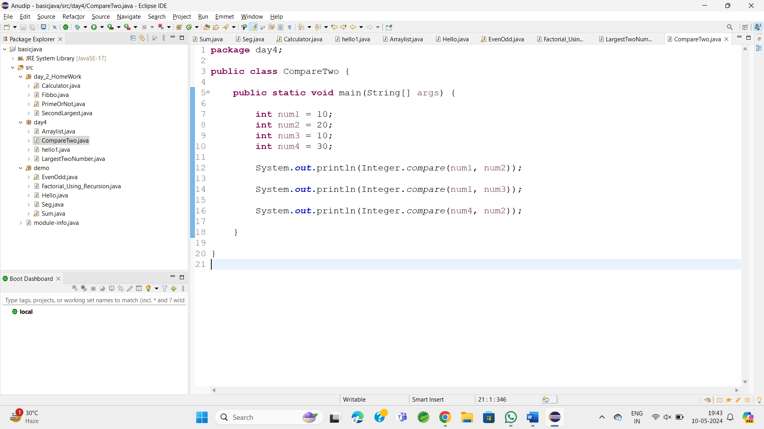

Output:

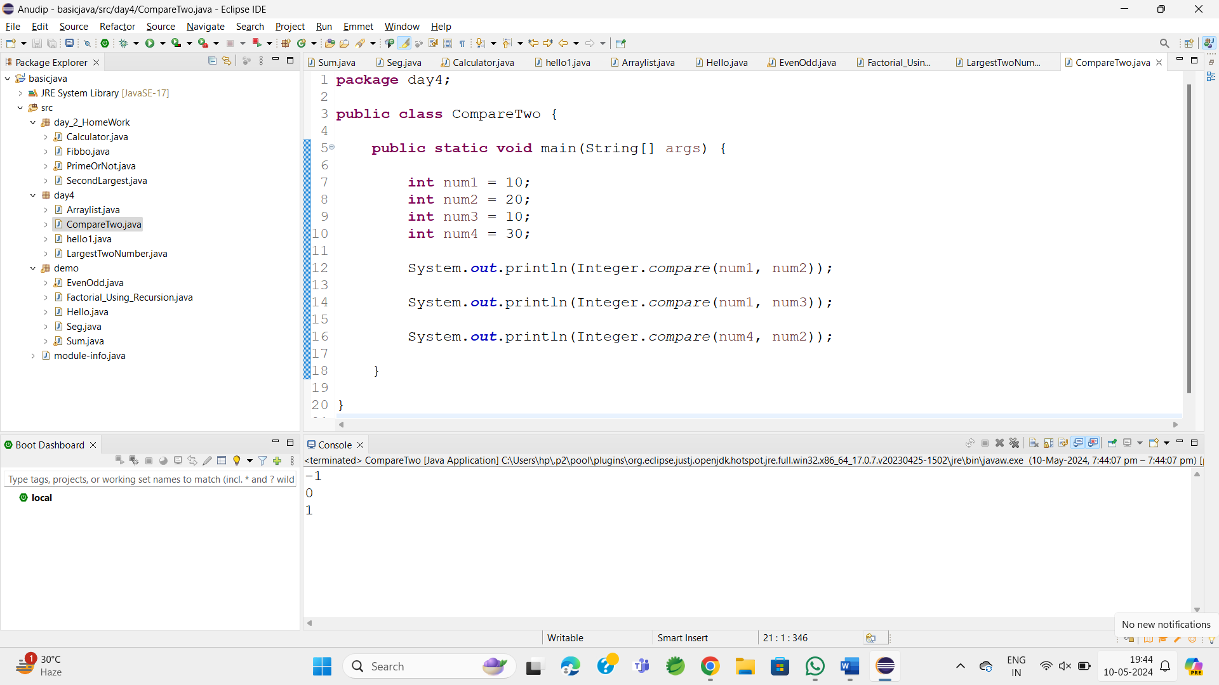

8.Write a Java program that takes an age input from the user and determines if they are eligible to vote (considering the legal voting age).

