**1.     Write a program that takes a student's score as input and outputs the corresponding grade based on the following scale:**

**A: 90-100 B: 80-89 C: 70-79 D: 60-69 F: 0-59**

**Code:**

**package** lab_2;

**import** java.util.Scanner;

**public** **class** GradeCalculator {

**public** **static** **void** main(String[] args) {

Scanner s = **new** Scanner(System.***in***);

System.***out***.println("Enter the student's score:");

**int** score = s.nextInt();

**char** grade = *calculateGrade*(score);

System.***out***.println("Grade: " + grade);

}

**public** **static** **char** calculateGrade(**int** score) {

**if** (score >= 90 && score <= 100) {

**return** 'A';

} **else** **if** (score >= 80 && score <= 89) {

**return** 'B';

} **else** **if** (score >= 70 && score <= 79) {

**return** 'C';

} **else** **if** (score >= 60 && score <= 59) {

**return** 'D';

} **else** {

**return** 'F';

}}

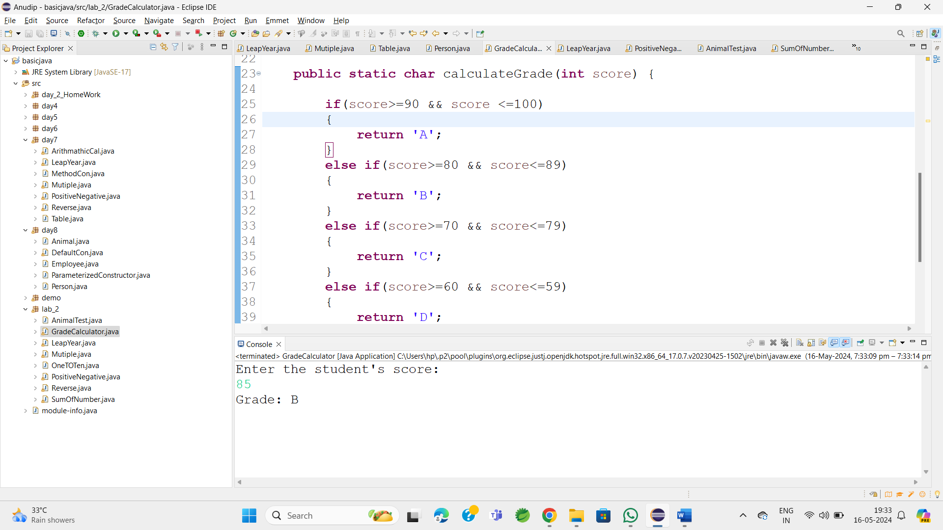

2.     Write a program to check if a given year is a leap year. (A year is a leap year if it is divisible by 4 but not by 100, or it is divisible by 400.)

**package** lab_2;

**import** java.util.Scanner;

**public** **class** LeapYear {

**public** **static** **void** main(String[] args) {

**int** year;

Scanner s = **new** Scanner(System.***in***);

System.***out***.println("Enter any year: ");

year = s.nextInt();

System.***out***.println("The entered year is : " + year);

**if** (((year % 4 == 0) && (year % 100 != 0)) || (year % 400 == 0)) {

System.***out***.println("Enter year is Leap year: " + year);

} **else**

System.***out***.println("Common year");

}

}

**OutPut:**

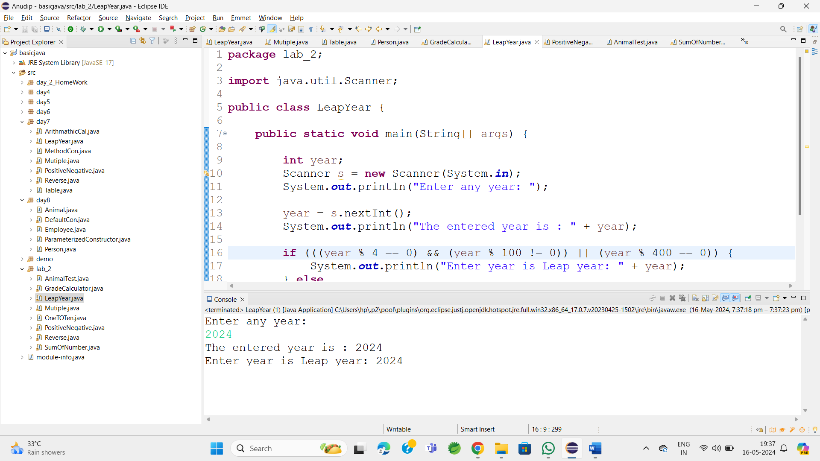

3.     Write a program that takes an integer as input and checks if it is positive, negative, or zero.

**package** lab_2;

**import** java.util.Scanner;

**public** **class** PositiveNegative {

**public** **static** **void** main(String[] args) {

Scanner s = **new** Scanner(System.***in***);

System.***out***.println("Enter any number");

**int** number = s.nextInt();

System.***out***.println("Enter any number : " + number);

**if** (number > 0) {

System.***out***.println(number + " is positive.");

} **else** **if** (number < 0) {

System.***out***.println(number + " is negative.");

} **else** {

System.***out***.println(number + " is zero.");

}

}

}

**OutPut:**

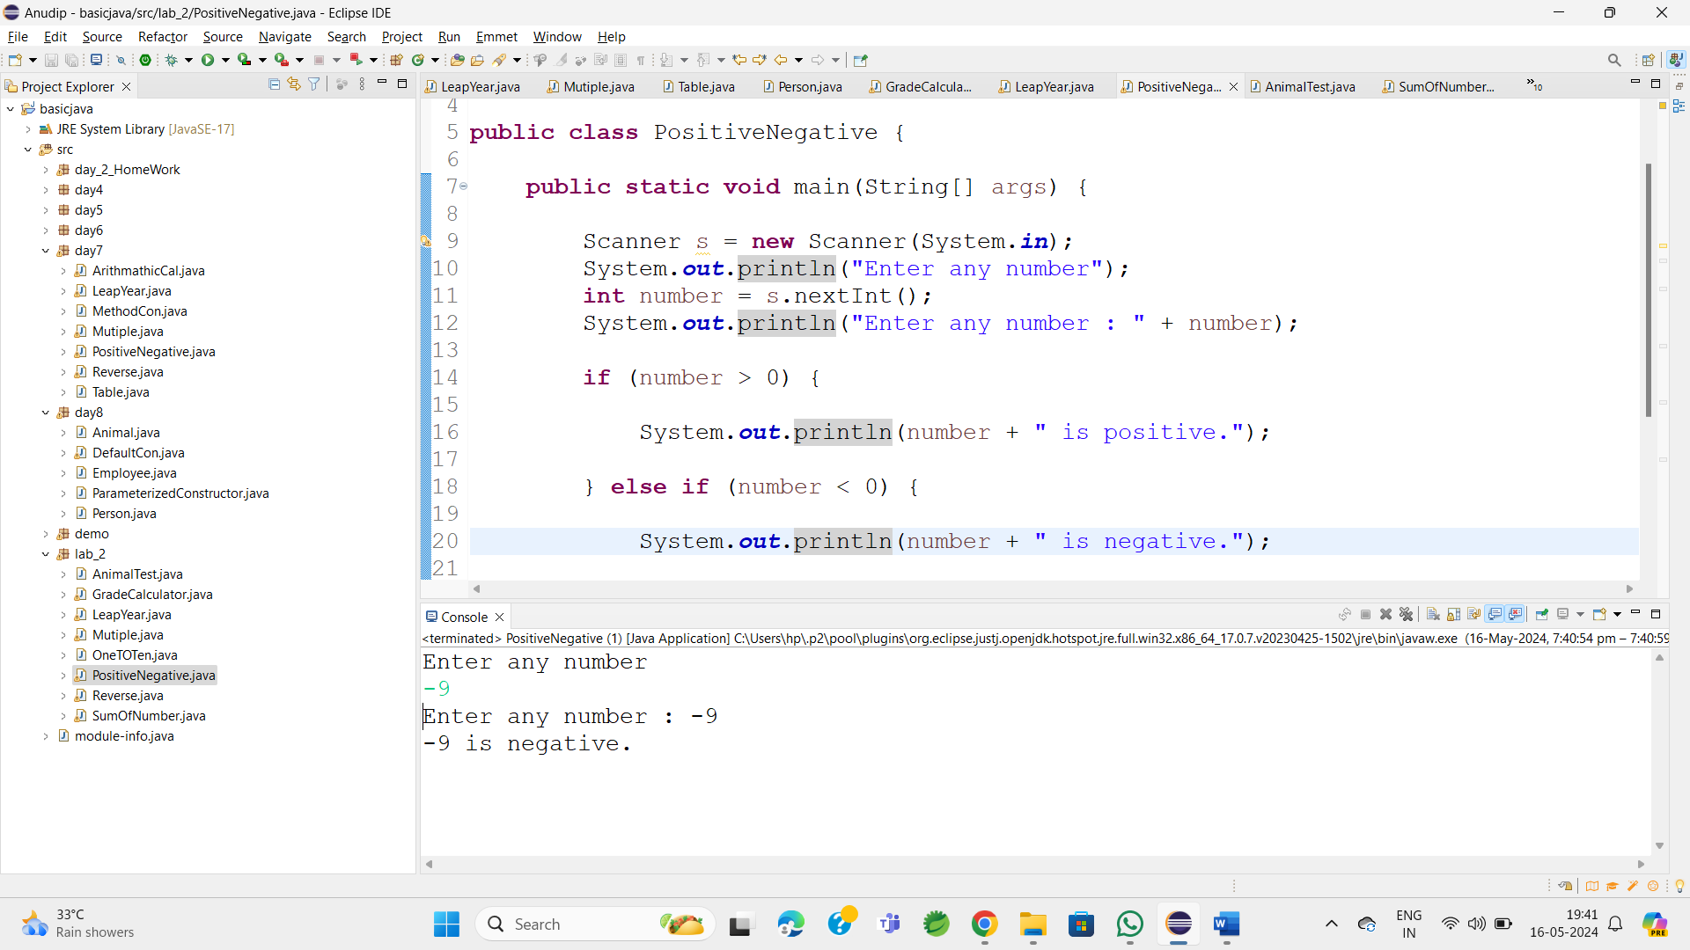

4.     Write a program that prints numbers from 1 to 10 using a loop.

**package** lab_2;

**public** **class** OneTOTen {

**public** **static** **void** main(String[] args) {

**for**(**int** i=1;i<=10;i++)

{

System.***out***.println(i);

}

}

}

OutPut:

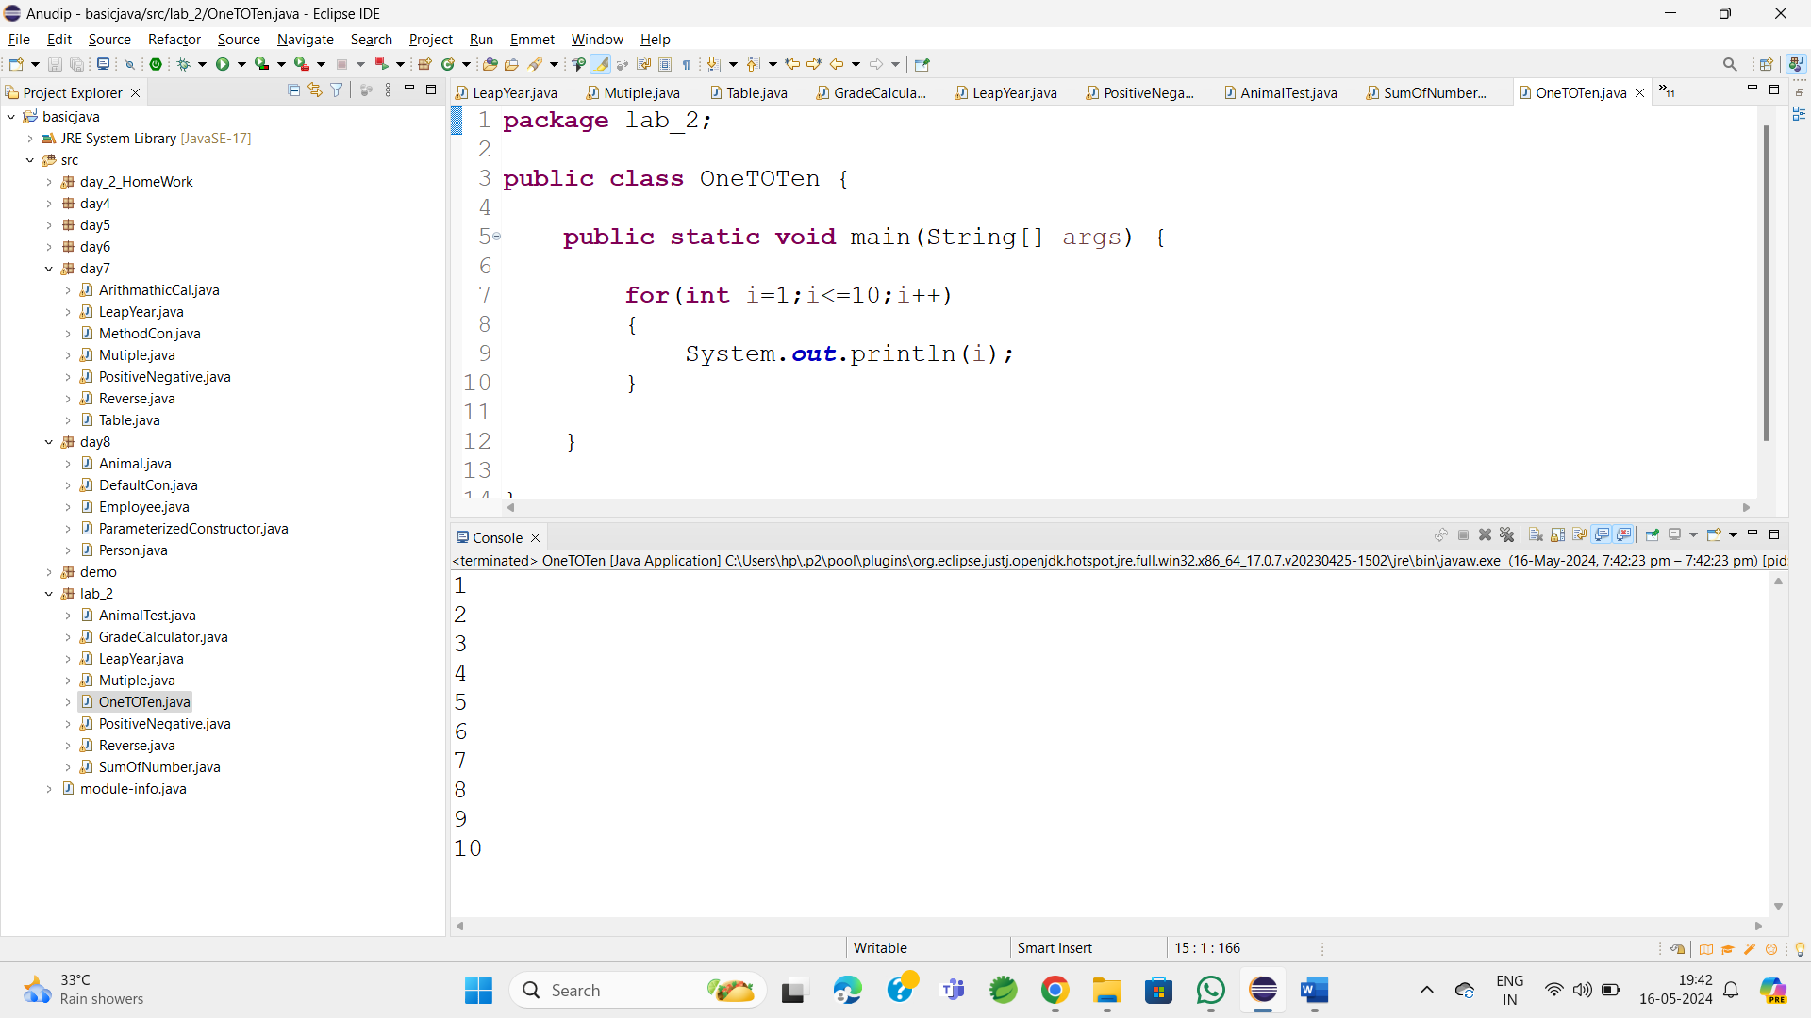

5.     Write a program that takes an integer N as input and calculates the sum of entered numbers.

**package** lab_2;

**import** java.util.Scanner;

**public** **class** SumOfNumber {

**public** **static** **void** main(String[] args) {

Scanner s=**new** Scanner(System.***in***);

System.***out***.println("Enter the number of integers to sum: ");

**int** N=s.nextInt();

**int** sum=0;

**for**(**int** i=0;i<N;i++)

{

System.***out***.println("Enter number "+ (i+1)+ ": ");

**int** num = s.nextInt();

sum+=num;

}

System.***out***.println("The sum of the entered number is: "+sum);

}}

**OutPut:**

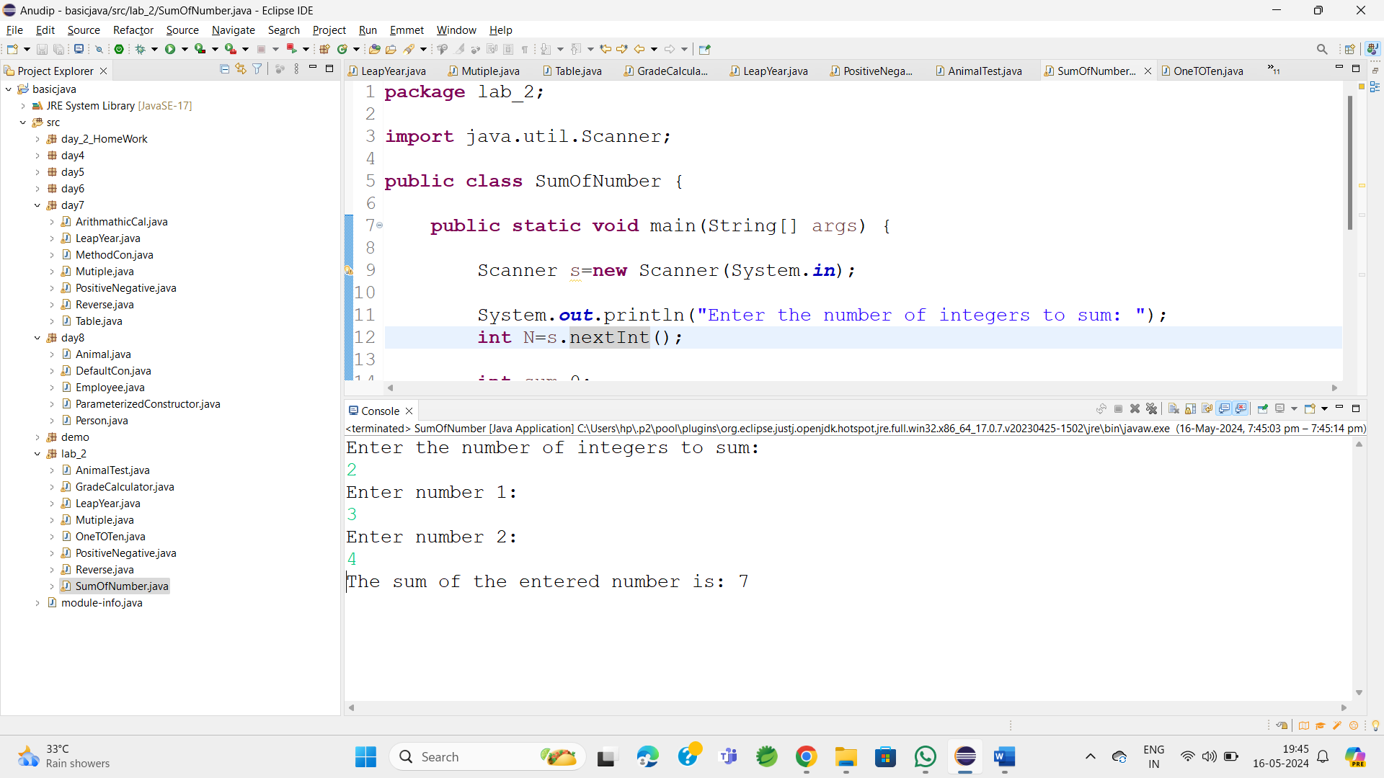

6.     Write a program that takes an integer as input and prints its multiplication table up to 10.

**package** lab_2;

**import** java.util.Scanner;

**public** **class** Mutiple {

**public** **static** **void** main(String[] args) {

Scanner s=**new** Scanner(System.***in***);

System.***out***.println("Enter number");

**int** num=s.nextInt();

**for**(**int** i=1;i<=10;i++)

{

System.***out***.println(num + " * " + i + " = " + num*i );

}

}

}

**OutPut:**

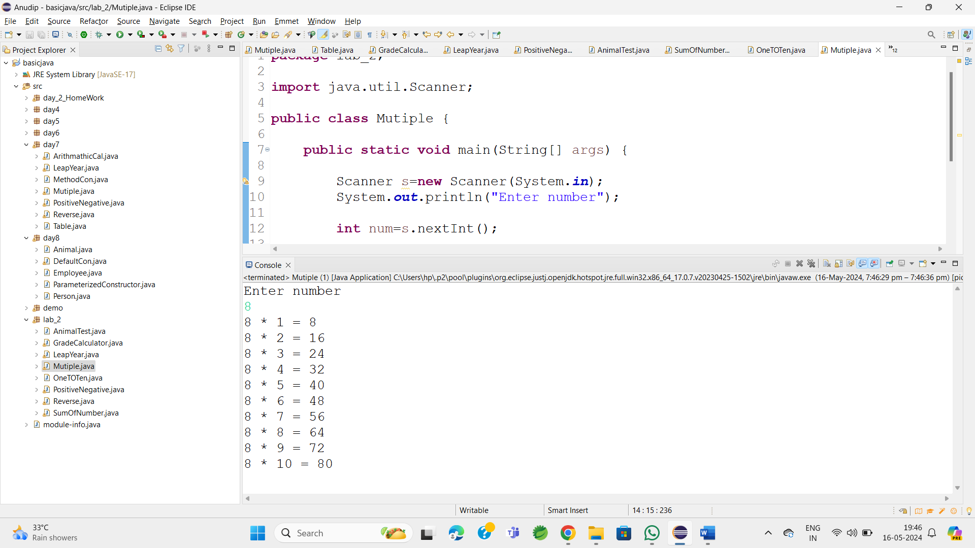

7.Write a program that takes a positive integer as input and prints its digits in reverse order.

**package** lab_2;

**import** java.util.Scanner;

**public** **class** Reverse {

**public** **static** **void** main(String[] args) {

Scanner s=**new** Scanner(System.***in***);

System.***out***.print("Enter a positive integer: ");

**int** number = s.nextInt();

**if** (number <= 0) {

System.***out***.println("Please enter a positive integer.");

**return**;

}

System.***out***.print("Reverse order of digits: ");

**while** (number > 0) {

**int** digit = number % 10;

System.***out***.print(digit);

number /= 10;

}

}

}

**Output:**

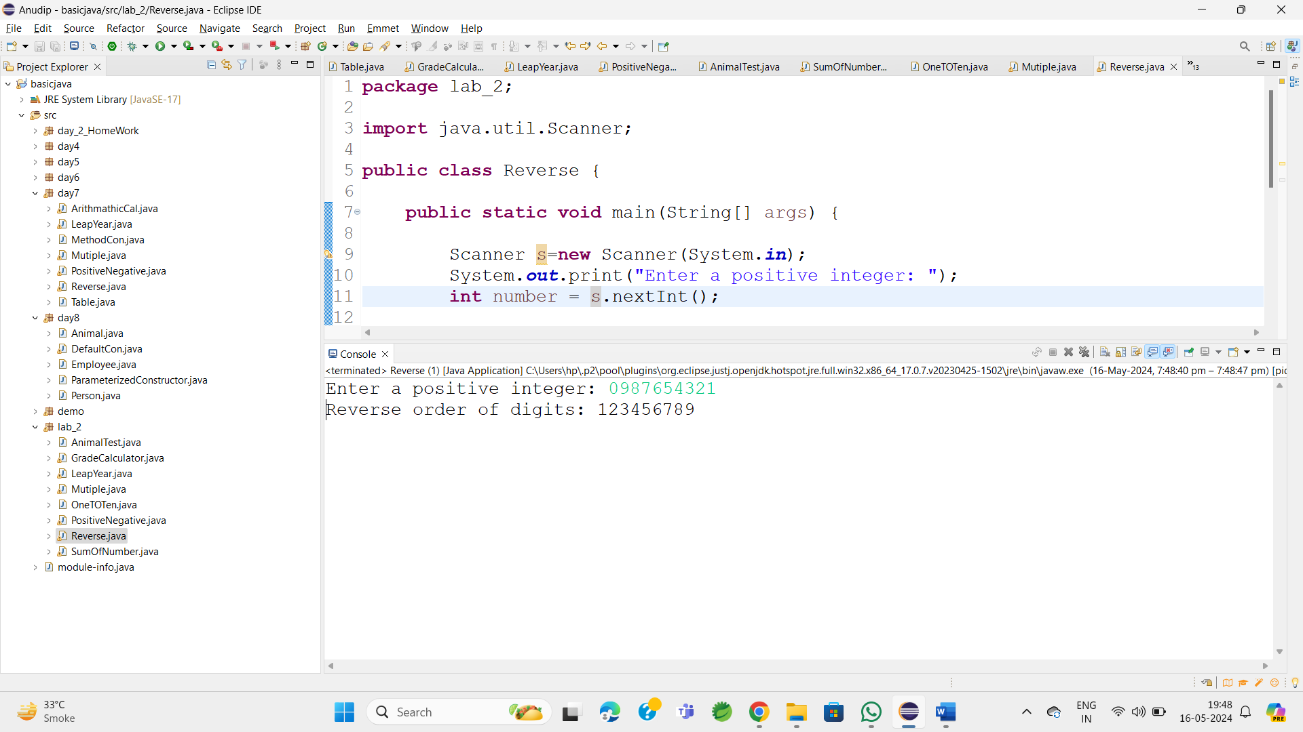

8.     Create a class Animal with a method makeSound() that prints "Some generic animal sound". Create another class Dog that extends Animal and overrides the makeSound() method to print "Bark". Write a main method to demonstrate calling the makeSound() method on an Animal reference holding a Dog object.

**package** lab_2;

**class** Animal{

**public** **void** makeSound() {

System.***out***.println("Some generic animal sound");

}

}

**class** Dog **extends** Animal{

**public** **void** makeSound() {

System.***out***.println("Bark");

}

}

**public** **class** AnimalTest {

**public** **static** **void** main(String[] args) {

Animal obj1=**new** Dog();

obj1.makeSound();

}

}

Output:

