1. **Write a program that tries to access an element outside the bounds of an array and handles the ArrayIndexOutOfBoundsException by printing a user-friendly message.**

**package** lab8;

**public** **class** ArrayOutOfBoundsDemo {

**public** **static** **void** main(String[] args) {

**int**[] array = { 1, 2, 3, 4, 5 }; // Define an array with 5 elements

**try** {

// Attempt to access an element outside the bounds of the array

**int** element = array[10];

System.***out***.println("Element at index 10: " + element);

} **catch** (ArrayIndexOutOfBoundsException e) {

// Handle the exception by printing a user-friendly message

System.***out***.println("Error: Attempted to access an index that is out of bounds.");

}

System.***out***.println("Program continues after handling the exception.");

}

}

**Output:**

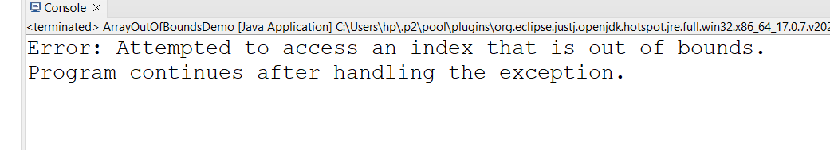

**2. Write a program that attempts to divide a number by zero and handles the ArithmeticException by printing a message that division by zero is not allowed.**

**package** lab8;

**public** **class** DivideByZeroDemo {

**public** **static** **void** main(String[] args) {

**int** num = 10;

**int** deno = 0;

**try** {

**int** result = num / deno;

System.***out***.println("Result: " + result);

} **catch** (ArithmeticException e) {

System.***out***.println("Error : Division by zero is not allowed.");

}

System.***out***.println("Porgrams continues after handling the exception.");

}

}

**OutPut:**

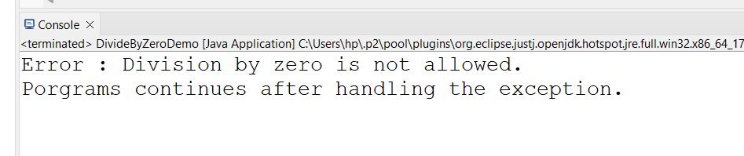

**3. Write a Java program that reads an integer input from the user and throws an IllegalArgumentException if the input is negative. Display an appropriate message when the exception is caught.**

**package** lab8;

**import** java.util.Scanner;

**public** **class** NegativeInputCheck {

**public** **static** **void** main(String[] args) {

Scanner s = **new** Scanner(System.***in***);

System.***out***.println("Please enter on integer :");

**int** userInput = s.nextInt();

**try** {

// Check if the input is negative

**if** (userInput < 0) {

**throw** **new** IllegalArgumentException("Negative input is not allowed.");

}

System.***out***.println("You entered: " + userInput);

} **catch** (IllegalArgumentException e) {

// Handle the exception by printing a user-friendly message

System.***out***.println("Error: " + e.getMessage());

}

System.***out***.println("Program continues after handling the exception.");

}

}

**OutPut:**

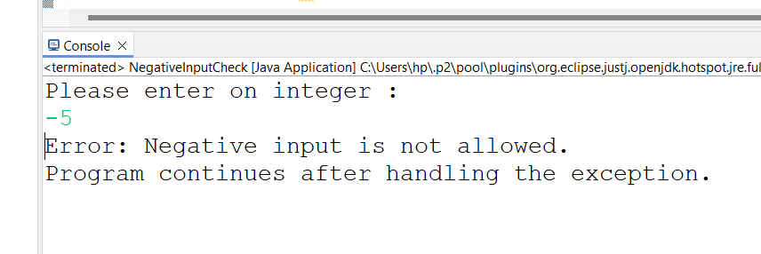

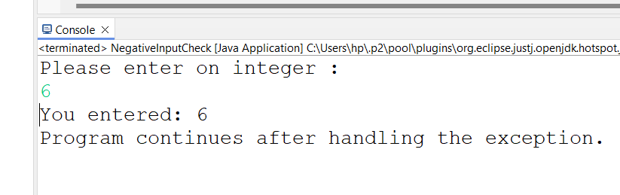

**4. Define a custom exception called InvalidAgeException. Write a Java program that throws this exception if the age provided is less than 18. Handle the exception and display an appropriate message.**

**package** lab8;

**import** java.security.InvalidAlgorithmParameterException;

**import** java.util.Scanner;

**public** **class** AgeVerification {

**public** **static** **void** main(String[] args) {

Scanner scanner = **new** Scanner(System.***in***);

System.***out***.print("Please enter your age: ");

**int** age = scanner.nextInt();

**try** {

*checkAge*(age);

System.***out***.println("Your age is valid.");

} **catch** (InvalidAlgorithmParameterException e) {

// Handle the custom exception by printing a user-friendly message

System.***out***.println("Error: " + e.getMessage());

}

// Continue with the rest of the program

System.***out***.println("Program continues after handling the exception.");

}

// Method to check the age

**public** **static** **void** checkAge(**int** age) **throws** InvalidAlgorithmParameterException {

**if** (age < 18) {

**throw** **new** InvalidAlgorithmParameterException("Age must be 18 or older.");

}

}

}

**OutPut:**

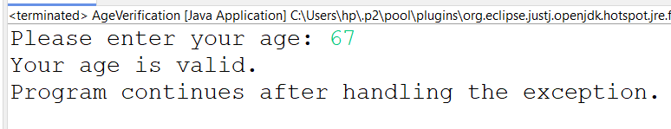

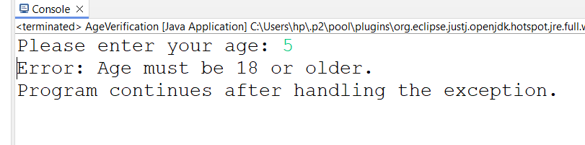

**5 Write a Java program that has a method to validate a user's email address. The method should throw a custom exception InvalidEmailException if the email does not contain @ and .. Handle the exception in the main method.**

**package** lab8;

**import** java.util.Scanner;

**public** **class** EmailValidation {

**public** **static** **void** main(String[] args) {

Scanner scanner = **new** Scanner(System.***in***);

System.***out***.print("Please enter your email address: ");

String email = scanner.nextLine();

**try** {

*validateEmail*(email);

System.***out***.println("Your email address is valid.");

} **catch** (Exception e) {

System.***out***.println("Error: " + e.getMessage());

}

System.***out***.println("Program continues after handling the exception.");

}

// Method to validate the email address

**public** **static** **void** validateEmail(String email) **throws** Exception {

**if** (!email.contains("@") || !email.contains(".")) {

**throw** **new** Exception("Email address must contain '@' and '.'");

}

}

}

OutPut:

