1. Perform the following tasks:

a. Create Student table with following attributes (STUDENT_ID , FIRST_NAME, LAST_NAME, PHONE_NUMBER, MARKS, COURSE_ID).

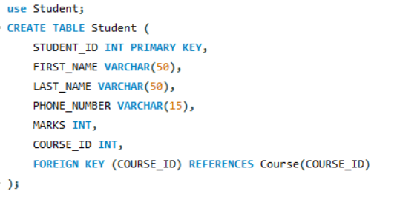

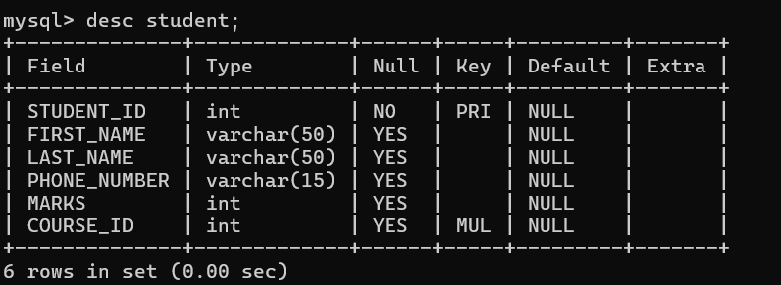

b. Create Course table with following attributes (COURSE_ID, COURSE_NAME).

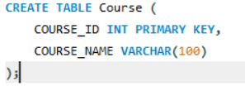

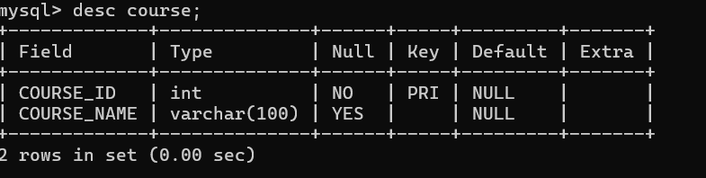

c. Write a SQL statement to insert 8 records with your own value into the tables.

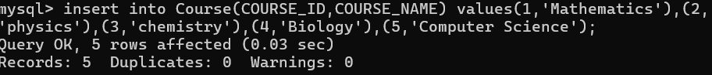

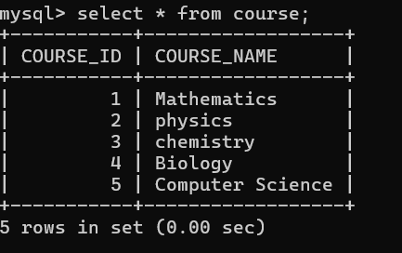

d. Write a query to get the number of students with the same course.



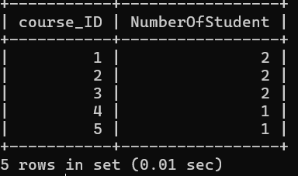

**e. Query to get the student name, course name, and marks of the students**



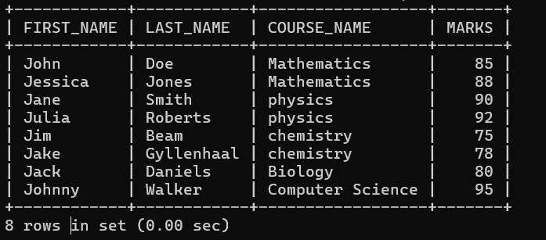

**f. Query to get the average marks of students course-wise**

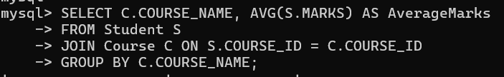

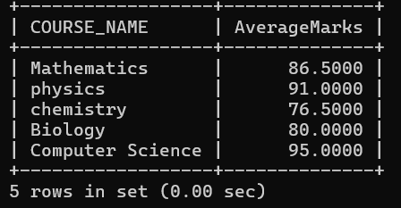

**2.  Create database for hospital management system & Perform the following tasks:**

**a. Create HEALTH CARE WORKERS table**

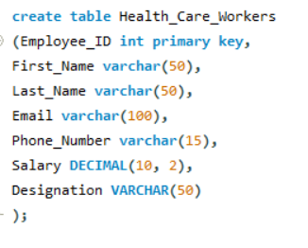

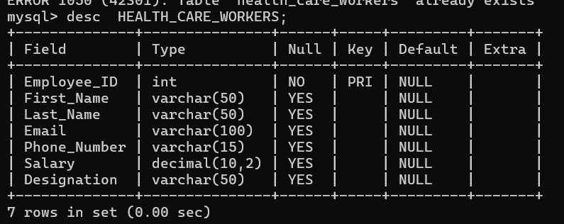

**b. Create PATIENT table**

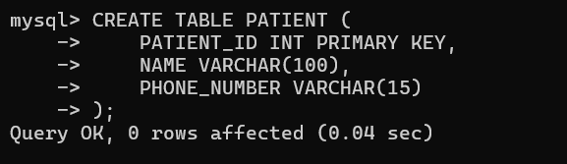

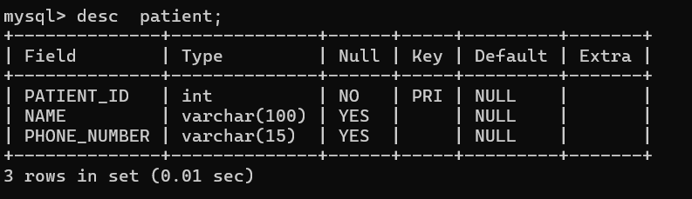

c. Insert 10 records into the tables

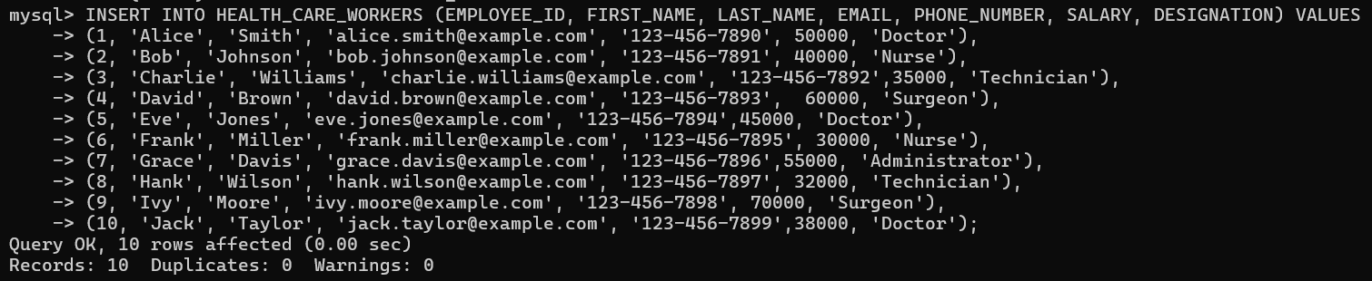

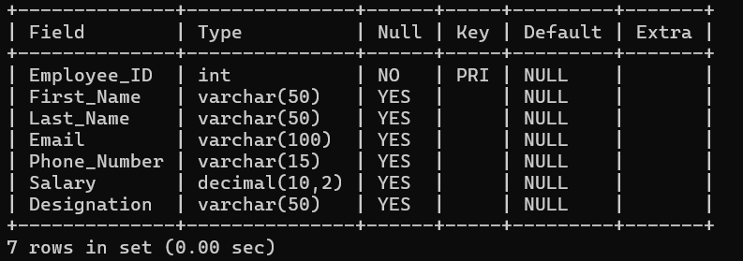

**d. Query to get the names (first_name, last_name), designation, and salary**



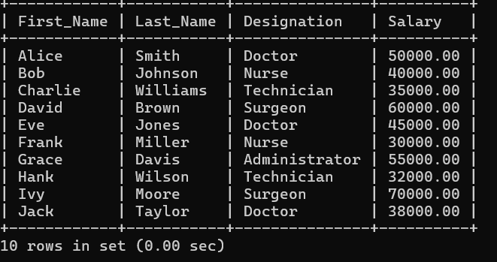

e. Write a query to get the number of employees with the same Designation

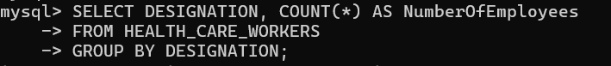

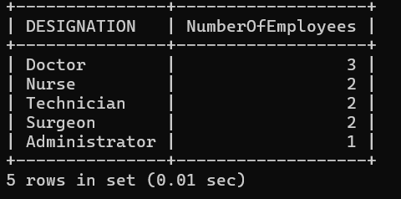

f. Write a query to get employee name who are getting salary more than 25000.

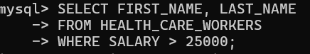

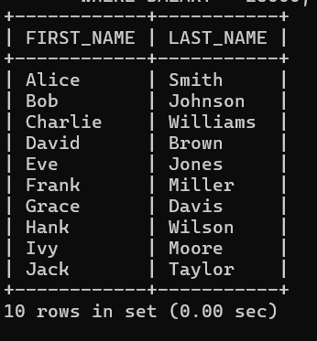

g. Fetch HEALTH CARE WORKERS name using their employee id.

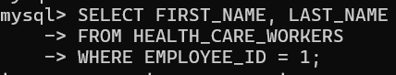

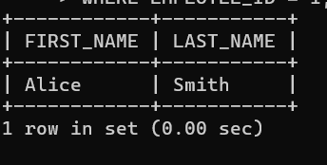

Q.**3. Retrieve the first and last names of customers along with the order date and total amount of their orders**

1. Retrieve the first and last names of customers along with the order date and total amount of their orders using an INNER JOIN:

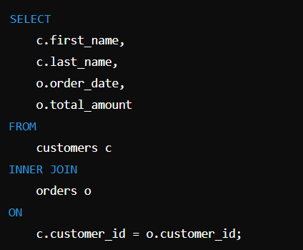

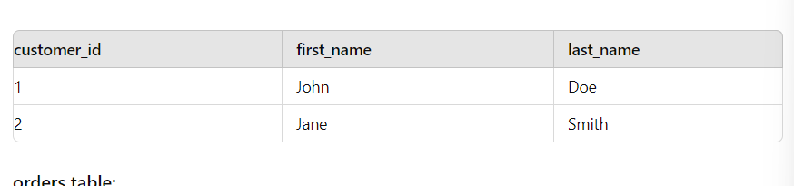

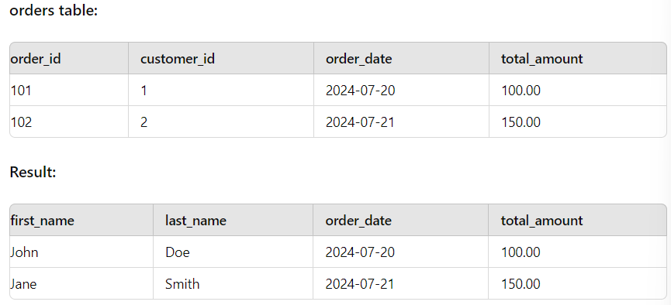

**2. Retrieve a list of all departments and the names of employees who belong to each department using a LEFT JOIN:**

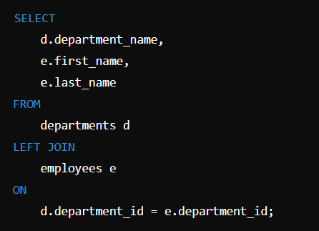

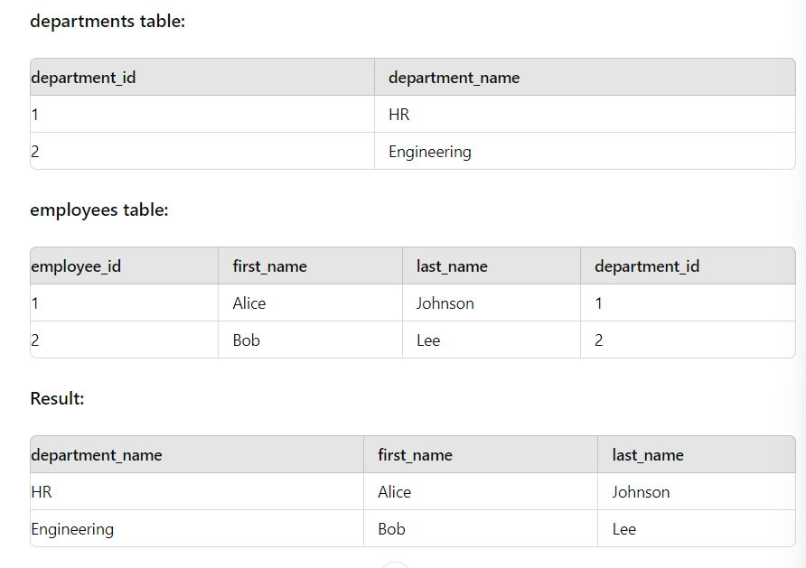

**4. Write a program to show  JDBC connection with MYSQL and perform the following operations:**

**Create table Customer with following fields:**

**Custno, Custame,Custaddress,Phoneno, City, Pincode, Country**

**Insert 5 records in Customer table.**

**a.     Insert values**

**b.    Delete values**

**c.     update city name Shimla to Shilong.**

**d.    Show table in the console**



