The Transformative Power of Artificial Intelligence

# The Transformative Power of Artificial Intelligence: Impact on Modern Society

## Introduction to Artificial Intelligence

Artificial Intelligence (AI) represents one of the most profound technological advancements of our time, rapidly reshaping the fabric of modern society. From sophisticated algorithms that power search engines to complex systems enabling self-driving cars, AI is no longer a concept confined to science fiction but a tangible reality woven into our daily lives. At its core, AI refers to the simulation of human intelligence processes by machines, especially computer systems. These processes include learning (the acquisition of information and rules for using the information), reasoning (using rules to reach approximate or definite conclusions), and self-correction. The ultimate goal of AI is to create machines that can function intelligently and independently, assisting humans in solving complex problems and enhancing overall productivity.

AI and Society

A stylized representation of AI's integration into human society.

## AI's Far-Reaching Societal Impact

The impact of artificial intelligence on modern society is pervasive, touching almost every sector and aspect of human life. In healthcare, AI is revolutionizing diagnostics, drug discovery, and personalized treatment plans, leading to more accurate and efficient medical care. For instance, AI-powered systems can analyze vast amounts of patient data to identify patterns and predict disease outbreaks, thereby improving public health outcomes. In transportation, AI is the driving force behind autonomous vehicles, aiming to enhance safety, reduce traffic congestion, and optimize logistics. Self-driving cars, powered by AI, promise a future with fewer accidents and more efficient movement of goods and people.

The finance industry has also been significantly transformed by AI, which is employed for fraud detection, algorithmic trading, and personalized financial advice. AI algorithms can detect suspicious transactions in real-time, protecting consumers and institutions from financial crime. Furthermore, AI's influence extends to education, manufacturing, customer service, and even creative industries, augmenting human capabilities and streamlining processes. Its ability to process and analyze massive datasets at speeds impossible for humans is unlocking new insights and fostering innovation across the globe, fundamentally altering how industries operate and how individuals interact with technology.

# Benefits and Applications of Artificial Intelligence

## Enhancing Efficiency and Automation

One of the most significant benefits of AI applications is their unparalleled ability to enhance efficiency and automate repetitive tasks across various industries. By leveraging AI, businesses can streamline operations, reduce manual labor, and minimize human error, leading to substantial cost savings and increased productivity. For example, in manufacturing, AI-powered robots perform complex assembly tasks with precision and speed, far surpassing human capabilities. In customer service, AI-driven chatbots and virtual assistants handle routine inquiries, freeing human agents to focus on more complex issues, thereby improving response times and overall customer satisfaction. This automation not only speeds up processes but also ensures consistency and reliability in performance.

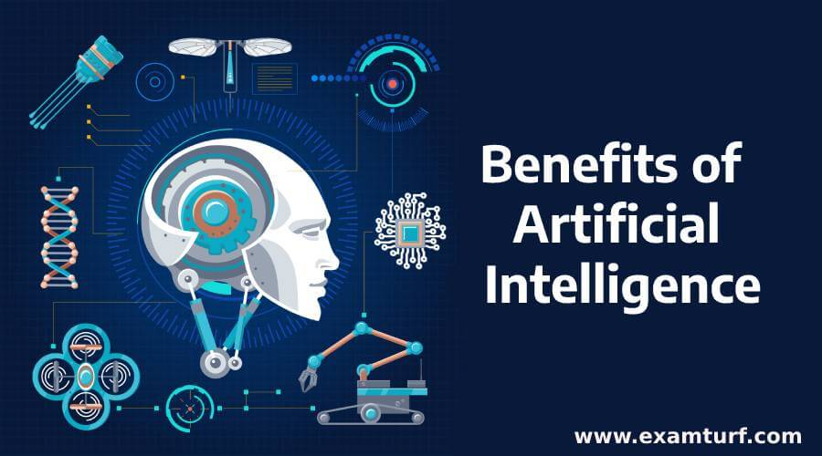

Illustration highlighting the diverse benefits of Artificial Intelligence.

## Improved Decision-Making and Diverse Applications

AI's capacity to analyze vast amounts of data at lightning speed empowers organizations with improved decision-making capabilities. Through machine learning and deep learning algorithms, AI systems can identify patterns, predict trends, and offer data-driven insights that would be impossible for humans to discern manually. In marketing, AI platforms analyze consumer behavior to optimize strategies and personalize recommendations, leading to higher conversion rates. In supply chain management, AI predicts demand and optimizes inventory levels, preventing stockouts and ensuring smooth operations.

The applications of AI are incredibly diverse and continue to expand. In agriculture, AI-powered drones monitor crop health and optimize irrigation. In cybersecurity, AI systems detect and respond to threats in real-time, safeguarding sensitive data. AI is also making strides in personalized education, developing adaptive learning platforms that cater to individual student needs. Moreover, in scientific research, AI accelerates the analysis of complex data, leading to breakthroughs in fields from genomics to climate modeling. The continuous evolution of AI promises even more innovative applications that will further redefine how we live, work, and interact with the world around us.

# Challenges, Ethical Concerns, and the Future of AI

## Addressing Ethical Concerns and Challenges

Despite its transformative potential, the rapid advancement of Artificial Intelligence also presents significant challenges and ethical concerns that demand careful consideration and responsible development. One of the foremost ethical issues is the potential for bias and discrimination embedded in AI algorithms. If training data reflects existing societal prejudices or lacks diversity, the AI system can perpetuate and even amplify these biases, leading to unfair outcomes in areas like employment, loan approvals, or even criminal justice. Another critical concern is data privacy, as AI systems often rely on extensive personal data collection and analysis, blurring the lines between security and surveillance and raising questions about individual rights and autonomy.

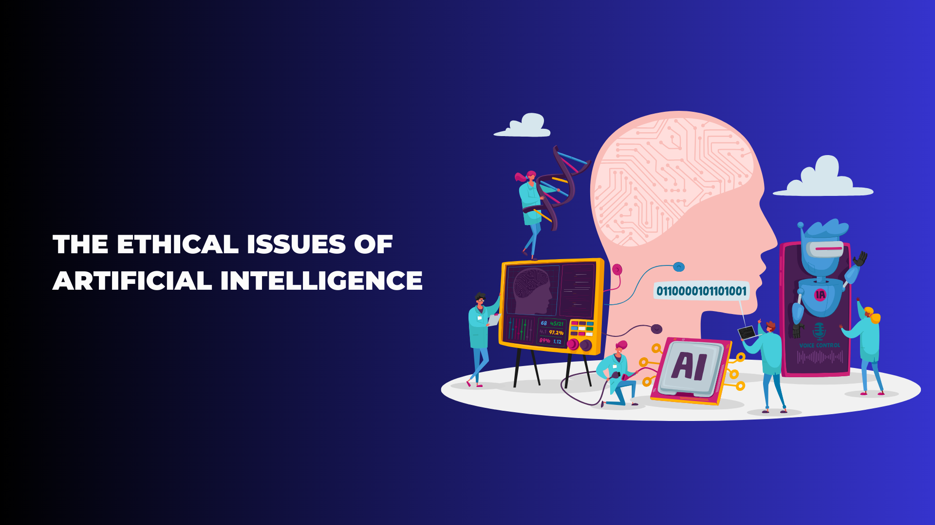

A visual representation of the ethical dilemmas surrounding AI, including data privacy and job displacement.

Accountability is another major challenge: when an autonomous AI system makes a harmful decision, determining who is responsible – the developer, the user, or the AI itself – becomes complex. The fear of widespread job displacement due to AI automation is also a pressing societal concern, necessitating proactive measures for workforce retraining and adaptation. Ensuring transparency in AI's decision-making processes, often referred to as the "black box problem," is crucial for building trust and allowing for scrutiny. Responsible AI development requires establishing robust ethical guidelines, regulatory frameworks, and fostering international collaboration to mitigate risks and ensure that AI benefits all of humanity equitably.

## Future Trends and Evolution of AI

The future of Artificial Intelligence is poised for continuous innovation, with several key trends shaping its evolution. Generative AI, exemplified by tools that can create realistic text, images, and even videos from simple prompts, is expected to become more sophisticated and integrated into various creative and professional fields. This will enable unprecedented levels of content creation and personalization. Another significant trend is the development of more advanced real-time decision-making systems, allowing AI to respond instantaneously to dynamic environments, critical for applications in autonomous systems, financial trading, and critical infrastructure management.

The push for explainable AI (XAI) will also gain momentum, focusing on making AI models more transparent and understandable, addressing the "black box" problem and fostering greater trust. Furthermore, sustainable AI practices will become increasingly important, addressing the significant energy consumption associated with training large AI models. The integration of AI into everyday tasks will deepen, with agentic AI models capable of performing complex multi-step tasks autonomously. As AI continues to advance, the focus will shift towards creating AI that is not only powerful but also ethical, human-centric, and beneficial for society as a whole, ushering in an era of augmented human intelligence and capability.