Bounded LLM Parameterization of Formal Coordination Models for a Multi-Agent Warehouse Transport System
K. V. Svyatov
Affiliation. Ulyanovsk State Technical University, Ulyanovsk, Russia
Corresponding author. K. V. Svyatov
Abstract
This paper examines how natural-language operating rules can be connected with formal coordination models in a multi-agent warehouse transport system. A local large language model is restricted to the role of a bounded strategic parameterizer: it outputs only a validated strategy vector that modifies weights, admissible robot sets, edge penalties, and dispatch limits, while task allocation and route selection remain with the Contract Net Protocol and a finite congestion game. In a standard scenario with 30 randomized seeds, retrieval-augmented parameterization reduced mean completion time from 829.9 ± 75.4 s to 645.5 ± 83.1 s, but was statistically indistinguishable from the same model without retrieval (p = 0.210). A policy-masked ablation, in which the prompt contains only operational codes whose meaning is accessible only through retrieval, changed this result: completion time fell from 1882.9 ± 254.1 s to 1315.4 ± 159.2 s (p = 1.86 × 10⁻⁹). A static domain rule encoding the bottleneck explicitly outperformed the language-model layer in both conditions. These results establish the practical scope of the approach: the language-model layer is useful when operating rules change and must be interpreted at runtime, not when a static rule already encodes the correct response.
Keywords Large language model; Multi-agent transport system; Formal coordination model; Congestion game; Contract Net Protocol; Retrieval-augmented generation; Safe artificial intelligence

1. Introduction
Warehouse robot groups require coordination at several distinct timescales. Low-level controllers track wheel velocities; path planners work with waypoints; task allocators rank assignments by priority and distance. Operational rules governing this coordination—maintenance closures, loading-zone restrictions, bypass recommendations—are typically written as natural-language statements that no formal model reads directly. Bridging this gap by manually converting each rule change into numerical parameters is error-prone; using a large language model as a direct robot controller is unsafe because it may generate physically inconsistent commands or reference non-existing objects.
The proposed approach sits between these extremes. The language model outputs a bounded strategy vector $Θ=(w_{d},w_{l},w_{c},w_{b},μ,E_{b},A^{go},A^{hold},N^{act},N^{new})$ whose fields are validated against strict type and range constraints before entering any formal procedure. Weights $w_{d},w_{l},w_{c},w_{b}∈[0.3,4.0]$ govern deadline urgency, travel length, congestion, and battery reserve; $μ∈[0.45,0.9]$ is passed to local avoidance; $E_{b}⊆E$ marks edges with a large penalty $Λ$; $A^{go},A^{hold}$ gate robot release; $N^{act},N^{new}$ bound concurrent assignments. Unknown identifiers are discarded; on timeout or parse failure the system falls back to the last valid strategy. The model never sets wheel velocities, generates paths, or modifies local robot controllers.
The paper contributes: a formal model separating task allocation, congestion-game routing, and local execution; specification of the retrieval-augmented pipeline as a bounded parameterization layer; a Webots implementation with individual robot controllers; and evaluation against eight baselines over 30 randomized seeds including a policy-masked condition.

2. Related Work
Task allocation in robot groups is studied within multi-robot task allocation, with formal taxonomies relating capabilities, task types, and optimization criteria [2]. The Contract Net Protocol models assignment as distributed bidding [1]; market-based extensions scale it to complex tasks [3]. In warehouse systems, dispatching and routing policies jointly determine throughput, waiting time, and deadlock risk [4, 5]. At the routing level, congestion games provide a mathematically clean abstraction: edges are shared resources, route cost grows with load, and best-response dynamics converge to a pure Nash equilibrium when a potential function exists [6, 7, 8]. Search-based pathfinding [9] and conflict-based multi-agent pathfinding [10] address geometric and combinatorial conflicts but do not interpret textual policies.
Retrieval-augmented generation connects language models with external documents [11], and agent frameworks enable reasoning combined with tool use [12, 13]. In robotics, language models have been used for affordance grounding [14], code generation [15], and multimodal planning [16], but surveys note that direct control remains unsafe without constrained output [17, 18]. Neuro-symbolic AI [19] and cognitive automation [20] support architectures that delegate natural-language interpretation to neural components while keeping formal execution bounded and verifiable. Guardrail methods [21] make such separation enforceable at runtime.

3. Formal Model

3.1 Warehouse, Robots, and Requests
The warehouse is a directed graph $G=(V,E)$; nodes represent intersections, pickup zones, drop-off zones, and service points; edges represent admissible passages. Robot $a=(x_{a},β_{a},σ_{a},τ_{a})$ is described by position, normalized battery level $β_{a}∈[0,1]$, status, and current assignment. Request $τ=(p_{τ},d_{τ},ρ_{τ},δ_{τ},s_{τ})$ gives pickup node, drop-off node, reward, deadline, and state. For each $τ$, the finite set $R_{τ}$ holds pre-generated route candidates.

3.2 Task Allocation
Binary variable $y_{aτ}∈\{0,1\}$ is 1 when robot $a$ is assigned to request $τ$. Single-assignment constraints are
τ∈T​yaτ≤1, a∈A​yaτ≤1. | (1)
A family mapping $ϕ:T→\{1,…,g\}$ represents shared loading zones. At most one active request per zone:
τ:ϕ(τ)=j​I(sτ∉{open,completed})≤1, j=1,…,g. | (2)
The bid that robot $a$ submits for request $τ$ at time $t$ is
$$b(a,τ,t)=ρ_{τ}+w_{d}\frac{ρ_{τ}}{\text{max}(δ_{τ}−t,ε)}−w_{l} dist(x_{a},p_{τ})−w_{b}(1−β_{a}),$$ | (3)
where $dist(x_{a},p_{τ})$ is the estimated travel distance to the pickup node and $ε>0$ prevents division by zero. Greedy dispatch sorts all $(a,τ)$ bids and selects winners subject to (1), (2), $A^{go}$, $A^{hold}$, $N^{act}$, $N^{new}$; dominant complexity is $O(mn\text{log}mn)$.

3.3 Congestion-Game Routing
Let $r=(r_{1},…,r_{q})$ be the joint route profile and $n_{e}(r)$ the load on edge $e$. The route cost for robot $i$ is
ci(ri,r−i)=wlL(ri)+wce∈ri​ne(r)+Λe∈ri​I(e∈Eb), | (4)
where $L(r_{i})$ is route length and $Λ$ is a large penalty for strategically discouraged edges. The game admits a potential function
Φ(r)=i​wlL(ri)+wce∈E​k=1ne(r)k+Λi​e∈ri​I(e∈Eb). | (5)
A unilateral route change alters $Φ$ by the same amount as the individual cost (4), making this an exact potential game [7]. Best-response dynamics on finite route sets therefore converge to a pure Nash equilibrium; the implementation uses at most 12 rounds.

3.4 Retrieval Score and Makespan
Documents in the knowledge base are ranked by the hybrid score
$$score(q,d)=0.68 \text{cos}(v_{q},v_{d})+0.32 Dice(tokens(q),tokens(d)),$$ | (6)
combining cosine similarity of PyTorch bag-of-words vectors with token overlap, the latter stabilizing retrieval for short operational codes. The primary metric is makespan
$$M=\underset{τ∈T}{\text{max}} t_{τ}^{done}−t_{0}.$$ | (7)
The fields of $Θ$ enter formal procedures as follows: $w_{d},w_{l},w_{b}$ modify bids (3); $w_{l},w_{c}$ and $E_{b}$ modify route cost (4) and potential (5); $A^{go},A^{hold},N^{act},N^{new}$ gate the allocation filter; $μ$ adjusts local avoidance clearance. No field modifies the warehouse graph or any robot controller.

4. Retrieval-Augmented Pipeline
The pipeline contains a local vector knowledge base (SQLite + PyTorch, 19 documents, 192-dimensional hashed bag-of-words), a prompt builder, the Ollama model qwen2.5:0.5b, and a guard layer. At each strategic cycle, the current warehouse state—robot and task counts, route variant, disrupted edges, active operational codes—is assembled into a textual query. Top-$k$ retrieved documents are inserted into a constrained prompt instructing the model to return a 12-field JSON object matching $Θ$. The guard layer validates every field against the bounds stated in Section 1 and replaces violations with safe defaults.
In 30 live runs, every response contained parseable JSON yet also required normalization of at least one field—most frequently congestion_weight (set too small) and traffic_rule (returned as a numeric string). This confirms that guardrails are a required structural component, not an optional safeguard.
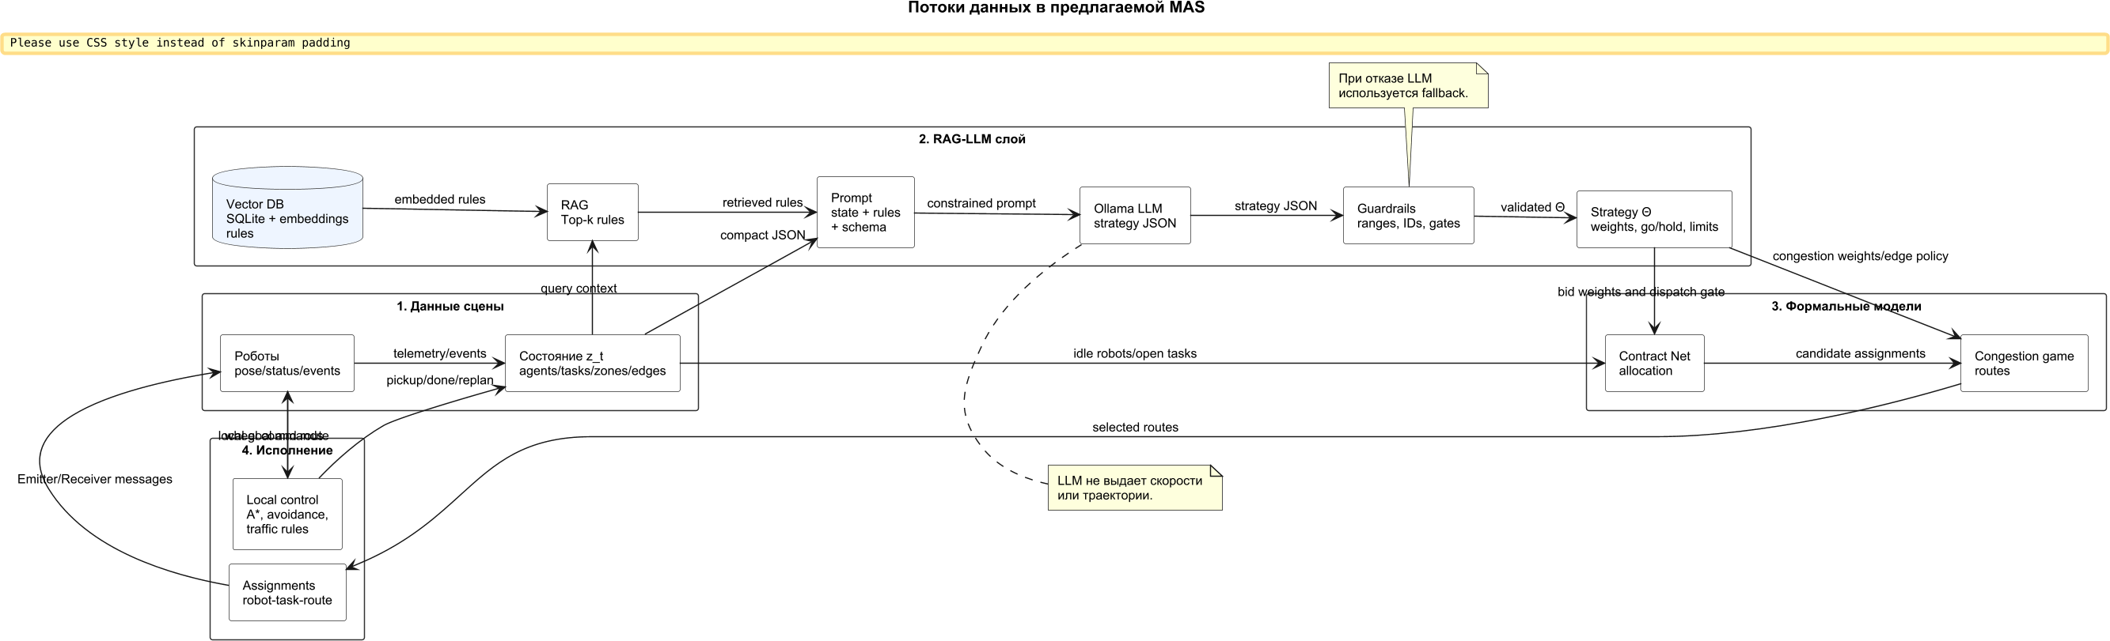
Fig. 1. Data flow: operating rules and warehouse state produce a validated strategy vector that parameterizes formal task allocation and route selection.

5. System Implementation
The system is a Webots project [22]. A supervisor manages the strategic and tactical layers: it collects robot messages, invokes the retrieval pipeline, runs Contract Net and congestion-game route selection, and dispatches assignments. Each robot runs an independent Python controller that follows waypoint routes, performs local A* replanning if needed, and reports pickup, done, and replan events. The supervisor never sets wheel velocities.
The main scenario contains eight robots and nine requests in three repeated pickup/drop-off families. All requests are visible from the start; constraint (2) and dispatch limits prevent simultaneous access to the same loading zone. The defining rule states that inspection traffic occupies the central crossing; the correct response is to raise the central corridor cost via $w_{c}$ or $E_{b}$, or to meter release via $A^{go}$/$A^{hold}$.
Figures 2–4 show the Webots scene at three representative instants.
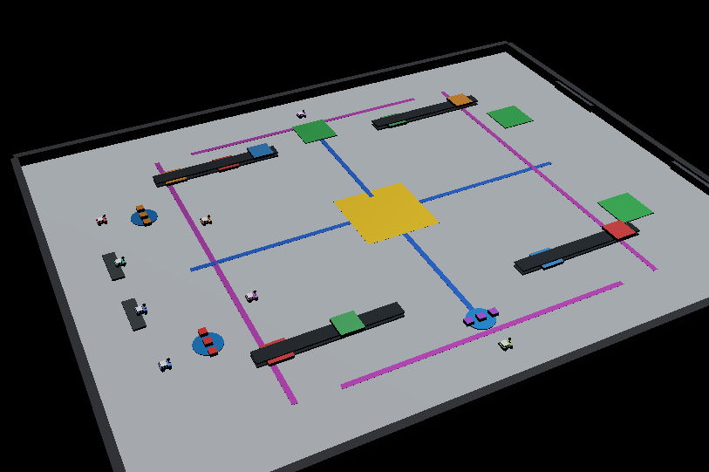
Fig. 4. t = 385: most requests fulfilled; final deliveries in progress.

6. Experimental Protocol
Statistical experiments used a headless Python simulator sharing the same Contract Net, congestion-game, route-table, retrieval, and guard modules as the Webots controllers. Webots validated scene geometry and controller communication separately.
LM-9 benchmark. 30 randomized seeds vary robot count from $\{7,8,9\}$, route variant, disrupted edges and delay, and deadline/reward jitter. Baselines: contract allocation only (no congestion penalties); fixed congestion game (constant weight); hand-tuned penalty; prioritized planning (conservative gating and edge avoidance); rule parser (keyword matching, no generative model); LLM no retrieval; RAG-LLM; static domain rule (explicit bypass of the central crossing—an oracle for this geometry). All modes use identical seeds.
Policy-masked ablation. The prompt contains only operational codes SOP-C7 and DOCK-AMBER; neither the rule text nor disrupted edge identifiers appear. Their meaning is available only through the vector knowledge base. Requests are increased to 15–18 and robots to 6–8, modeling a sustained request stream rather than a single illustrative run.
Setup: Webots R2023b; Python 3.8.15, PyTorch 2.4.1; Ollama 0.23.2, qwen2.5:0.5b; timeout 35 s; headless time step 1.0 s; dispatch period 5.0 s; macOS arm64.

7. Results

7.1 LM-9 Benchmark
Table 1 shows the main results. RAG-LLM substantially outperforms contract allocation only, fixed game routing, and rule parser (paired sign test p = 1.86 × 10⁻⁹ for all three). Against prioritized planning, mean makespan improves by 41.4 s (p = 0.0125). However, the language model without retrieval achieves 645.7 ± 83.3 s—statistically indistinguishable from RAG-LLM at 645.5 ± 83.1 s (p = 0.210). When the operational rule is present verbatim in the prompt, retrieved documents add primarily to traceability. The static domain rule obtains 559.1 ± 103.8 s (p = 5.77 × 10⁻⁸ in favor of the static rule over RAG-LLM): hard-coding the bypass outperforms all dynamic strategies.
Table 1. LM-9 benchmark, n = 30 seeds, mean ± std.
Mode | Makespan, s | CI 95% | Waiting, s | Latency, s
Contract allocation only | 829.9 ± 75.4 | 27.0 | 913.5 ± 261.9 | 0.00
Fixed congestion game | 829.9 ± 75.4 | 27.0 | 913.5 ± 261.9 | 0.00
Hand-tuned penalty | 684.8 ± 145.3 | 52.0 | 253.0 ± 214.9 | 0.00
Prioritized planning | 686.9 ± 94.4 | 33.8 | 0.0 ± 0.0 | 0.00
Rule parser | 928.7 ± 76.7 | 27.4 | 598.2 ± 189.5 | 0.01
LLM no retrieval | 645.7 ± 83.3 | 29.8 | 125.7 ± 193.4 | 7.83
RAG-LLM | 645.5 ± 83.1 | 29.7 | 124.7 ± 194.4 | 9.21
Static domain rule | 559.1 ± 103.8 | 37.1 | 123.3 ± 193.7 | 0.00
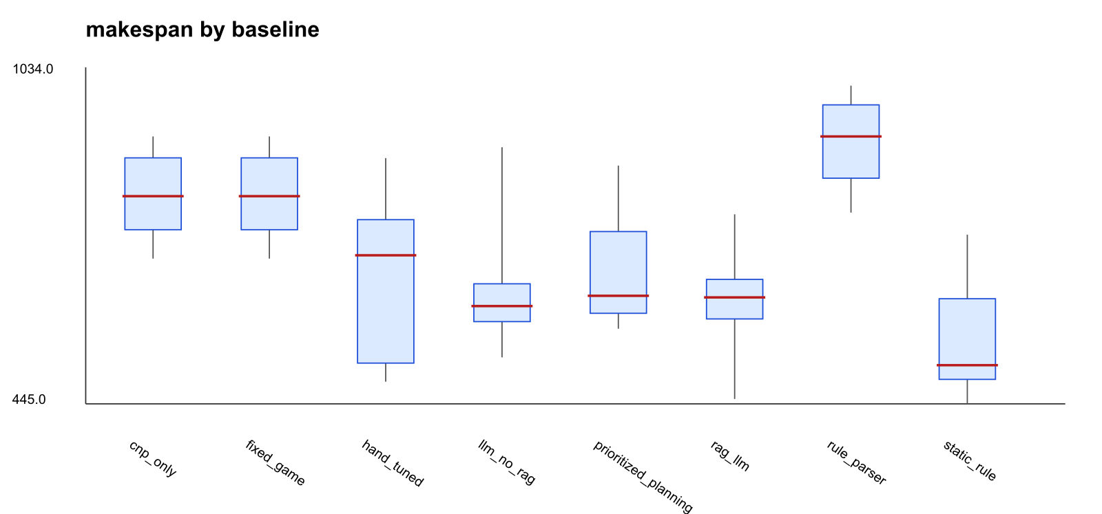
Fig. 5. Makespan distributions by mode, LM-9 benchmark (n = 30).

7.2 Policy-Masked Ablation
Table 2 shows the policy-masked results. With SOP-C7 and DOCK-AMBER as the only signal, both the keyword parser and LLM no retrieval fail to activate bypass routes (0.0 bypass per run) and produce makespans above 1880 s. The embedding-rule baseline (retrieval without generative interpretation) reduces makespan to 1517.3 ± 240.0 s and activates 11.1 bypass routes on average. RAG-LLM replay reduces it further to 1315.4 ± 159.2 s with 12.9 bypass routes and perfect success rate (p = 1.86 × 10⁻⁹ vs. LLM no retrieval). The gap between RAG-LLM and the embedding-rule baseline reflects the additional value of generative strategy synthesis over mechanical template application.
Table 2. Policy-masked SOP ablation (n = 30 replay / n = 10 live).
Mode | n | Makespan, s | Bypass | Success
Keyword parser | 30 | 1932.3 ± 237.5 | 0.0 | 0.833
LLM no retrieval, replay | 30 | 1882.9 ± 254.1 | 0.0 | 0.867
Embedding-rule baseline | 30 | 1517.3 ± 240.0 | 11.1 | 0.967
RAG-LLM replay | 30 | 1315.4 ± 159.2 | 12.9 | 1.000
Static domain rule | 30 | 1255.8 ± 160.3 | 11.1 | 1.000
LLM no retrieval, live | 10 | 1439.7 ± 398.7 | 8.4 | 0.900
RAG-LLM live | 10 | 1331.2 ± 139.8 | 10.8 | 1.000

8. Discussion
When retrieval matters. The LM-9 and policy-masked conditions produce complementary findings. When the operational rule is stated explicitly in the prompt, the language model can parameterize the strategy without retrieval; RAG and no-RAG are statistically tied. When the prompt contains only operational codes and their meaning requires lookup, retrieval reduces makespan by 30% and enables perfect task success. Retrieval is therefore not always necessary, but becomes causally essential when codes are opaque.
Limits of the language-model layer. The static domain rule outperforms RAG-LLM in both conditions because it directly encodes the correct bypass for the known central bottleneck. A language model should not be used as an expensive substitute for a stable, known deterministic rule. The architectural value lies in adapting to changing rules without manual retuning of formal parameters.
Retrieval robustness. Under 50% artificial document corruption, RAG-LLM makespan in the LM-9 scenario increased from 645.5 ± 83.1 s to 751.2 ± 177.4 s; in the policy-masked scenario from 1315.4 ± 159.2 s to 1588.0 ± 365.2 s (success rate 0.967). Guard rules and fallback strategy limit the damage, but the policy-masked degradation confirms that retrieval quality is causally relevant when codes cannot be decoded from the prompt.
Computational cost. Live language-model latency averaged 9.21 ± 2.42 s, exceeding the 5 s dispatch period. The model must be called asynchronously; at a 30 s strategic period the overhead is roughly 31%. Robots continue under the last valid strategy during inference—the correct operational mode for a component handling slow-moving policy changes.
Sensitivity and validity. A mixed sensitivity series over 40 seeds varying robot count (4–10) and request count (3–12) confirmed that performance differences shrink at low task loads and grow when bypass routes exist and rules change. Internal validity is supported by identical code across all modes (only the source of $Θ$ differs). External validity is limited: pickup and unloading are simplified, charging and robot failures are absent, and new requests do not arrive during a run. Statistical validity would benefit from at least 100 seeds and CBS/MAPF and MILP/VRP baselines.

9. Conclusion
The architecture treats a local large language model as a bounded strategic parameterizer for formal coordination models. The model suggests values in $Θ$; Contract Net, a finite congestion game, and individual robot controllers perform all physical execution.
The key finding is conditional: retrieval-augmented parameterization outperforms non-retrieval and generic strategies by a large margin when operating rules must be retrieved and interpreted at runtime (p = 1.86 × 10⁻⁹ in the policy-masked condition); it provides no statistically significant benefit when the rule is already explicit in the prompt (p = 0.210). A static rule encoding the correct bottleneck response outperforms the language-model layer in both conditions, defining the practical scope of the approach. Future work should extend the benchmark to 100+ seeds, add MAPF and optimization baselines, replace hashed bag-of-words with learned local embeddings, and transfer to a physically detailed robot model with charging, dynamic orders, and manipulation operations.

References
1. Smith RG (1980) The Contract Net Protocol. IEEE Trans Comput C-29(12):1104–1113
2. Gerkey BP, Matarić MJ (2004) Formal analysis and taxonomy of task allocation. Int J Robot Res 23(9):939–954
3. Dias MB, Zlot R, Kalra N, Stentz A (2006) Market-based multirobot coordination. Proc IEEE 94(7):1257–1270
4. Le-Anh T, De Koster MBM (2006) Design and control of AGV systems. Eur J Oper Res 171(1):1–23
5. Fragapane G, de Koster R, Sgarbossa F, Strandhagen JO (2021) Planning and control of AMRs for intralogistics. Eur J Oper Res 294(2):405–426
6. Rosenthal RW (1973) Games possessing pure-strategy Nash equilibria. Int J Game Theory 2:65–67
7. Monderer D, Shapley LS (1996) Potential games. Games Econ Behav 14(1):124–143
8. Roughgarden T, Tardos É (2002) How bad is selfish routing? J ACM 49(2):236–259
9. Hart PE, Nilsson NJ, Raphael B (1968) Heuristic determination of minimum cost paths. IEEE Trans Syst Sci Cybern 4(2):100–107
10. Sharon G, Stern R, Felner A, Sturtevant NR (2015) Conflict-based search for optimal MAPF. Artif Intell 219:40–66
11. Lewis P, Perez E, Piktus A et al (2020) Retrieval-augmented generation. NeurIPS 33:9459–9474
12. Wei J, Wang X, Schuurmans D et al (2022) Chain-of-thought prompting. NeurIPS 35:24824–24837
13. Yao S, Zhao J, Yu D et al (2023) ReAct: synergizing reasoning and acting. ICLR
14. Ahn M, Brohan A, Brown N et al (2022) Do as I can, not as I say. arXiv:2204.01691
15. Liang J, Huang W, Xia F et al (2022) Code as policies. arXiv:2209.07753
16. Driess D, Xia F, Sajjadi MSM et al (2023) PaLM-E. arXiv:2303.03378
17. Wang J, Wu Z, Li Y et al (2024) LLMs for robotics. arXiv:2401.04334
18. Li P, An Z, Abrar S, Zhou L (2025) LLMs for multi-robot systems. arXiv:2502.03814
19. Sarker MK, Zhou L, Eberhart A, Hitzler P (2021) Neuro-symbolic AI. AI Commun 34(3):197–209
20. Engel C, Elshan E, Ebel P, Leimeister JM (2024) Cognitive automation use cases. J Inf Technol 39(1):53–78
21. Dong Y, Mu R, Jin G et al (2024) Building guardrails for LLMs. ICML PMLR 235:11765–11787
22. Michel O (2004) Webots: professional mobile robot simulation. Int J Adv Robot Syst 1(1):39–42

