Citrus Payment Solutions Pvt. Ltd.

For Magento Commerce (v 1.9.1.0)

**Proprietary Notice**

*This document contains proprietary and confidential information of CITRUS PAYMENT*

*SOLUTIONS PRIVATE LIMITED and is to be used only by for the purpose of review. No part*

*of this document may be reproduced, transmitted, stored in a retrieval system, nor translated*

*into any human or computer language, in any form or by any means, electronic, mechanical,*

*optical, chemical, manual, or otherwise, without the prior written permission of the owners.*

*The respective owners own all trademarks.*

Table of Contents

Citrus Payment Solutions Pvt. Ltd. 1

Merchant Integration Kit 1

Magento Driver (v 1.0) 1

Prerequisites 5

Payment Gateway Flow 5

Installation Guide 5

Configuring Magento for CitrusPay 6

Testing Magento with CitrusPay 13

**Revision History**

|  |  |  |  |  |
| --- | --- | --- | --- | --- |
| **Version** | **Date** | **Author** | **Rationale for Change** | **Comments** |
| 1.0 | May 16, 2012 | Vaibhav Ranglani (vaibhav.ranglani@talentica.com) | Initial Draft |  |
| 2.0 | Feb 12 | Sujoy Goswami  (support@viatechs.in) | Updated | Upgraded to latest Magento |

# Prerequisites

The merchant server, where the Citrus Payment Merchant Kit will be installed, should have the following softwares already installed:-

1. Php 5.x
2. MySql Database
3. Apache 2.2.17 or higher
4. Magento Ecommerce 1.9.1.0 Platform installed.
5. Zip file of CitrusPay Magento Driver/plugin.

# Payment Gateway Flow

**Merchant Site**

**Citrus Payment Gateway Library**

**Merchant Web Server**

HTTPS & HMAC Encryption

Citrus Payment Gateway



Internet

Bank 1/2

Bank 1

Bank 2



End Users (Consumers)

# Installation Guide

**Directory Structure**

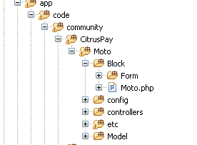

**Installation Steps (Via FTP)**

1. Extract the zip file of Magento Driver/plugin to your local disk location, let’s call it ‘SOURCE’. You will get one ‘app’ and another ‘doc’ folder where in this integration doc resides.
2. Open your FTP tool e.g. FileZilla, WSFTP, CuteFtp, etc. and in source file side point to your ‘SOURCE’ location.
3. In destination side, connect to your remote host where magento is installed and locate your magento root folder where **‘app’** folder is present**.**
4. Just upload ‘app’ folder from ‘SOURCE’ to your remote magento root.
5. Follow the configuration section to configure the module in Magento Admin panel**.**

**Installation Steps (Manual on local PC)**

1. Extract the zip file of Magento Driver/plugin.
2. In the extracted files, navigate to app/code/community. Let us call this <**Driver Path>**
3. Open a new window and navigate to the directory from where your apache server serves your magento files. Let us call this <**Magento Path>**
4. Navigate to directory app/code/community in <**Magento Path>**. The community directory can be named ***local*** on a few systems.
5. Copy the CitrusPay Directory from **Driver Path** and paste in <**Magento Path>/app/code/community/.**
6. Now again go to the folder where you extracted the Magento driver/plugin.
7. Navigate to app/etc/modules/. Let us call this <**Module Path>.**
8. Open a New window and navidate to app/etc/modules in <**Magento Path>.**
9. Copy the file CitrusPay_Moto.xml from **<Module Path>** in <**Magento Path>/app/etc/modules/.**
10. Follow the configuration section to configure the module in Magento Admin panel**.**

# Configuring Magento for CitrusPay

1. Open the admin console on Magento

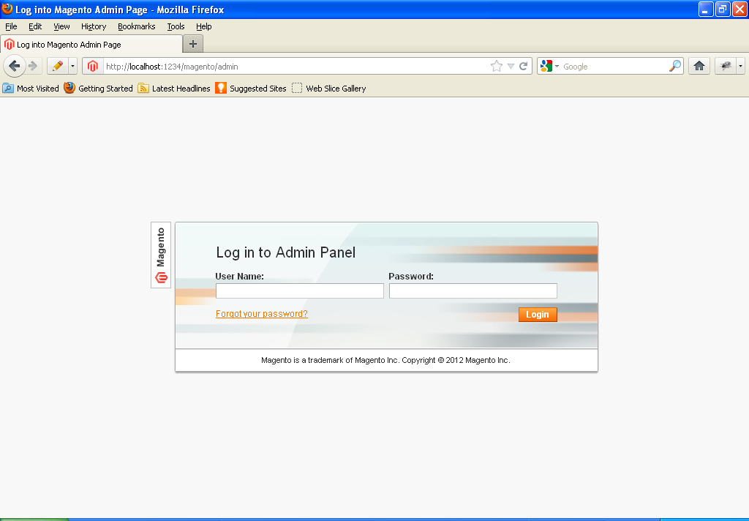

1. Login and Navigate to System->Configuration->Payment Methods

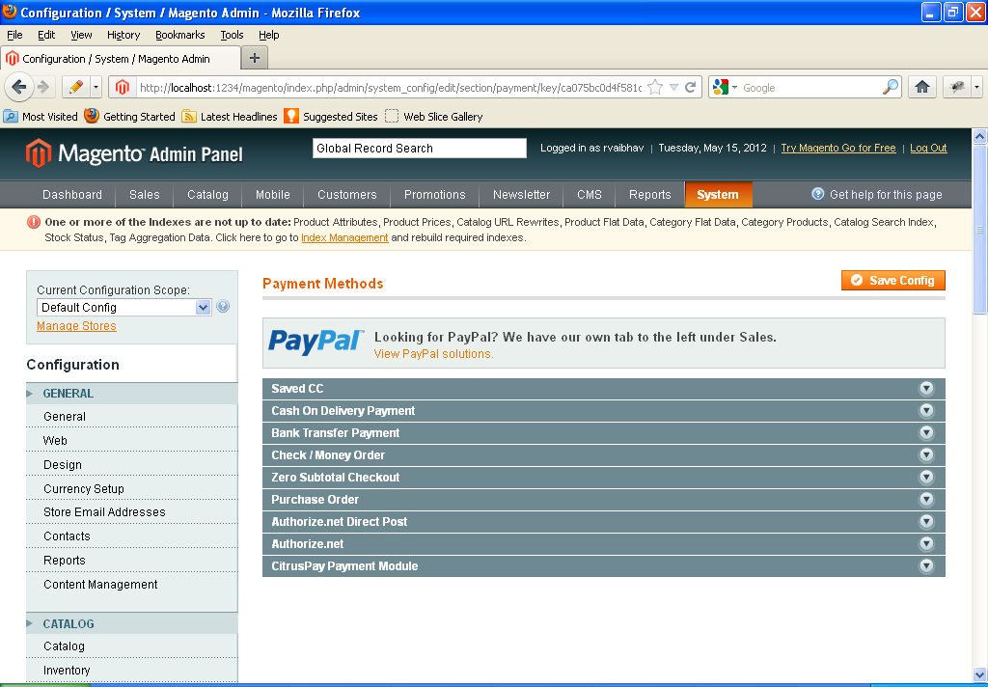

You should be able to see CitrusPay Payment Module in your Payment Methods.

If not, please go to System->Cache Management

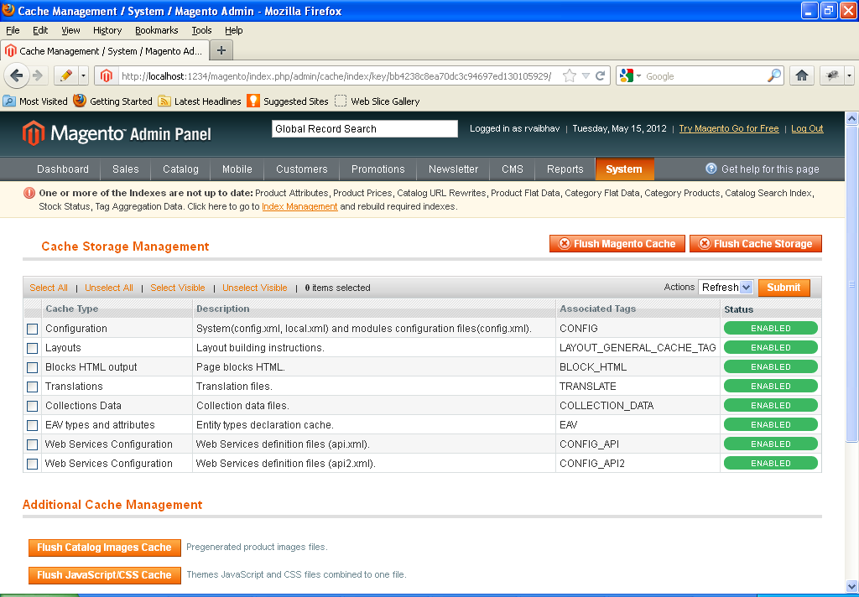

Now click on Flush Magento Cache then Flush Cache Storage.

Navigate back to System->Configuration->Payment Methods

CitrusPay Payment Module should be visible now.

1. Click on CitrusPay Payment Module and the Gateway Settings Option Opens up.

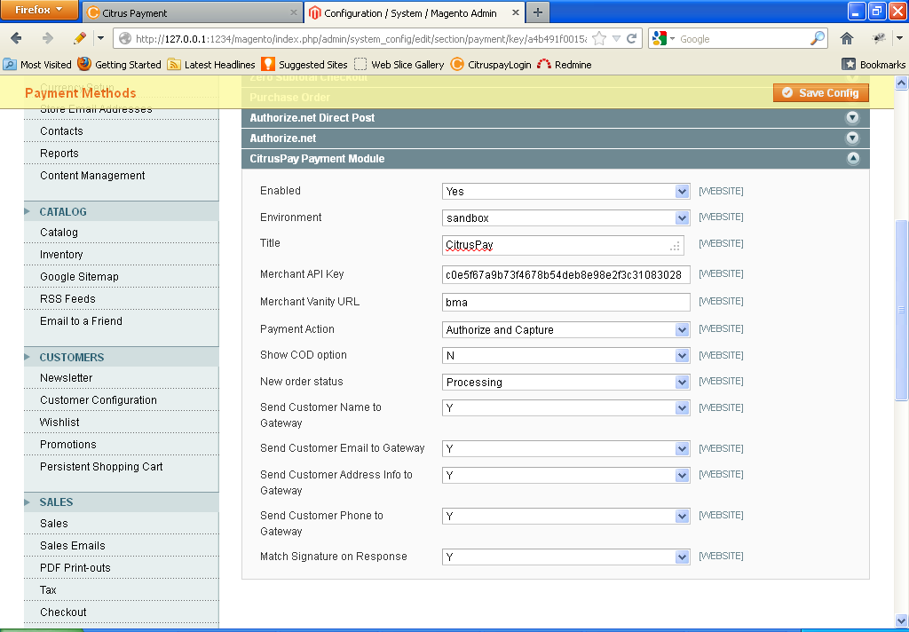

Description of the fields is as

1. **Enabled:** This field will have 2 values ‘Yes’ and ‘No’. If you select ‘yes’ the citruspay gateway will be available as a payment option to Consumer while shopping. If you select ‘No’ the module will be disabled and will not be shown while shopping.
2. **Environment:**

This field determines the gateway environment your payment will be redirected to.

This field can have three values :

1. **sandbox –** This is a test citruspay environment. Payments sent to this environment will not be processed.
2. **Staging -** This is also a test citruspay environment. Payments sent to this environment will not be processed.
3. **Production –** This is the live CitrusPay environment. Use this value only for your website in production. Payments sent to this Url will be processed.

For testing purposes we suggest only use sandbox or staging

1. **Title:** The title you want to show your consumers on Payment Options Page.
2. **Merchant API Key:** This is your unique API Key. Your Merchant Admin or Merchant Designer can retreive this from the checkout settings page on CitrusPay website. Please do not share this key with anyone. This Key uniquely identifies a Merchant. Its like your password for your email account .

Your merchant API Key

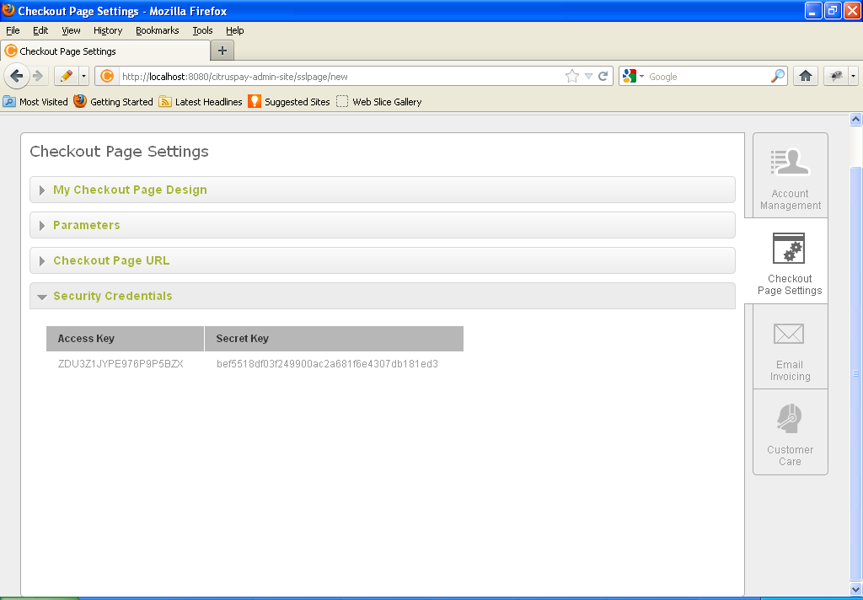

1. **Merchant Vanity Url:** Your Merchant Admin or Merchant Designer can retreive this from the checkout settings page on CitrusPay website. They need to login and navigate to Checkout settings Page as shown in screenshot below.

Your vanity url is **cleartrip** or **hihhjmoajk**

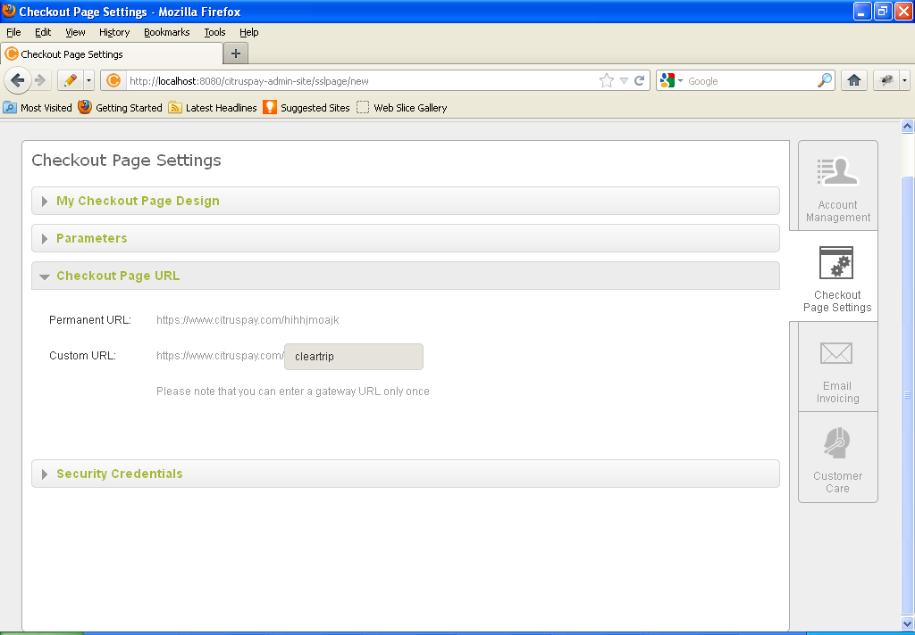

1. **Payment Action:** Select Authorize Only from Dropdown.
2. **Show COD option:** This flag says if COD option needs to be given to a user on Citruspay payment page. COD settings need to be set by the merchant by logging into citruspay website and enabling the “**check for incoming flag**”.

If the “check for incoming” checkbox is checked, and the COD flag is set to Y then the user will be shown a COD option on SSL page. This is as shown in screenshots below.

To set this flag

**Citruspay-> login->PG Management -> COD -> Edit ->** check the **“Check for incoming flag”checkbox**

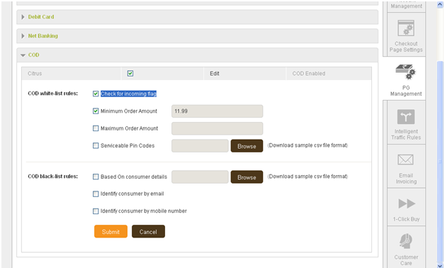

When this flag is set to “Y” and user checks out from your site and lands on CitrusPay for payment he/she is shown the COD option as shown below.

COD option will be shown like this

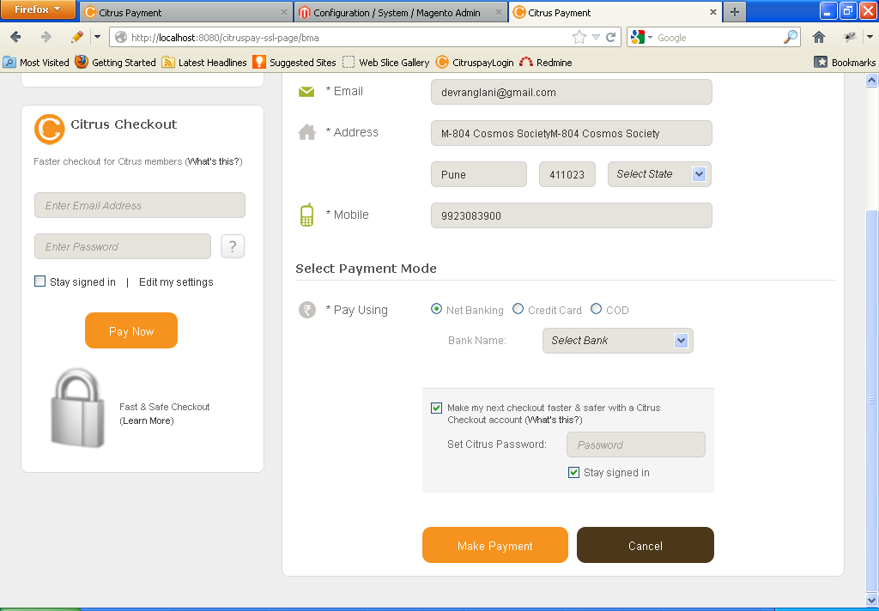

In order to add some custom business logic to show your consumers COD option, you can always write your own code in function ***isCOD()***written in Pay.php in the KIT.

1. **New Order Status:** Select Processing.
2. **Send Customer Name to Gateway:**  Select ‘Y’ if you wish to pass the Customer’s Name to the gateway else select ‘N’.
3. **Send Customer Email to Gateway:**  Select ‘Y’ if you wish to pass the Customer’s Email to the gateway else select ‘N’.
4. **Send Customer Address Info to Gateway:** Select ‘Y’ if you wish to pass the Customer’s Address Information to the gateway else select ‘N’.
5. **Send Customer Phone to Gateway:** Select ‘Y’ if you wish to pass the Customer’s Phone Number to the gateway else select ‘N’
6. **Match Signature on Response:** This option the signature coming back from Citruspay. Citruspay sends a response signature generated using the Response parameters. If this Option is set to ‘Y’ then every response that is received from Citruspay is verified for Data Integrity. A response signature is created on merchant side and both the signatures are compared. If both the signatures match, then a response message is shown based on the transaction status. If the signatures do not match then a message is shown as “Request Signature Mismatch”. For the implementation please refer IndexController.php under app/code/community/CitrusPay/Moto/controllers/IndexController.php
7. After your have setup information in step 3, click on **Save Config** and you can have your customers make payment via the CitrusPay Payment gateway.
8. While making payment CitrusPay will appear as a payment option for the Customer as shown below.

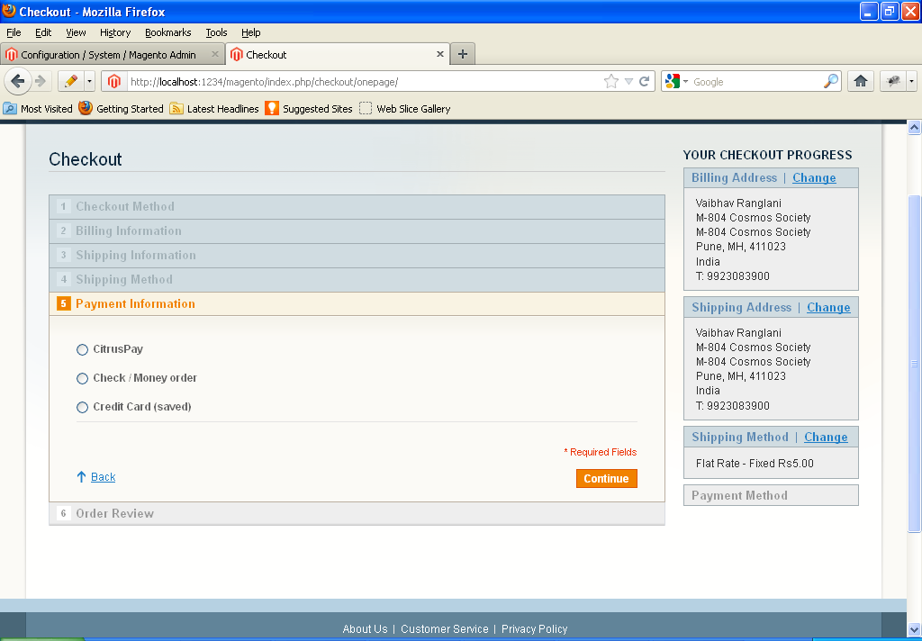

# Testing Magento with CitrusPay

1. Open your shopping portal.

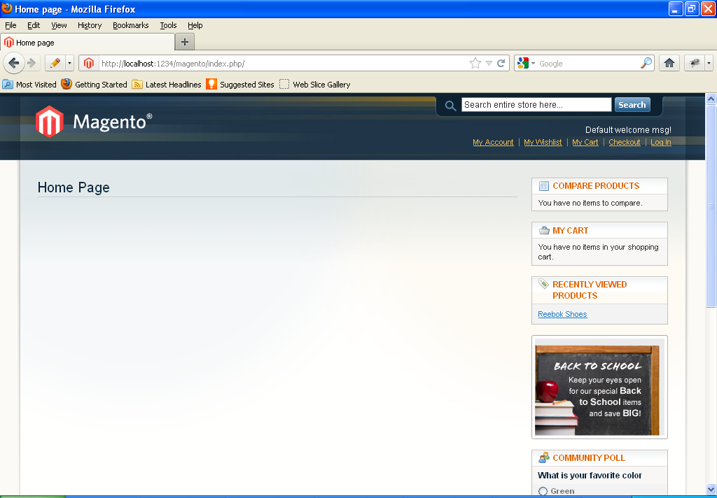

1. Choose a product.
2. Add your product to cart.

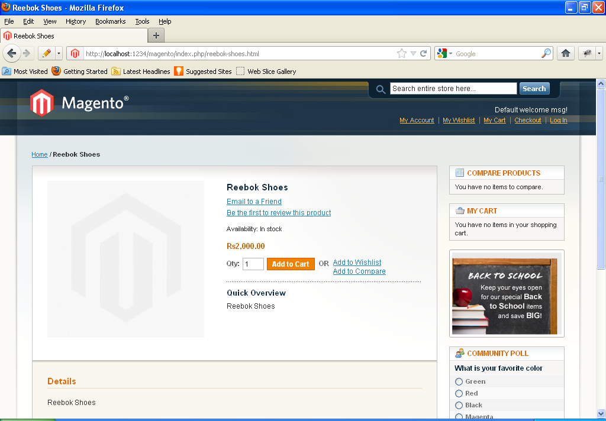

1. Click on Proceed to Checkout button

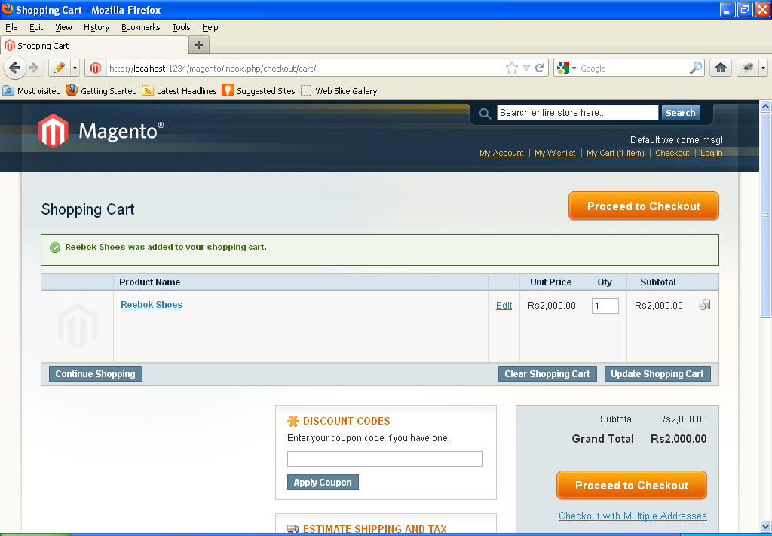

1. Fill in the required details on the checkout page.

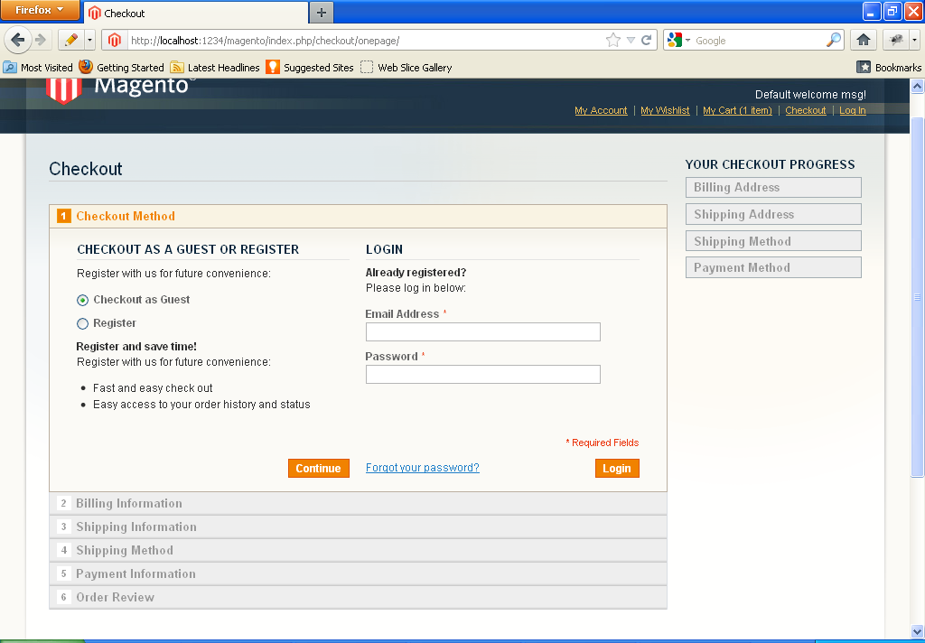

1. On Payment Options Choose “CitrusPay”.

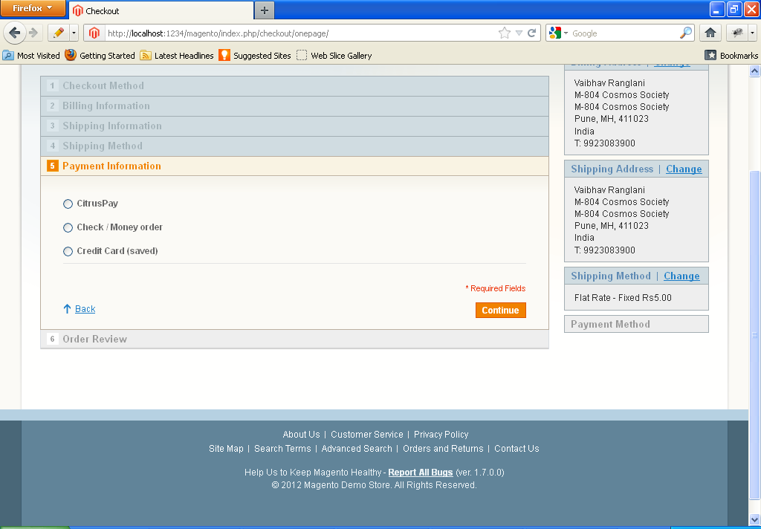

1. Finally click on Place Order.

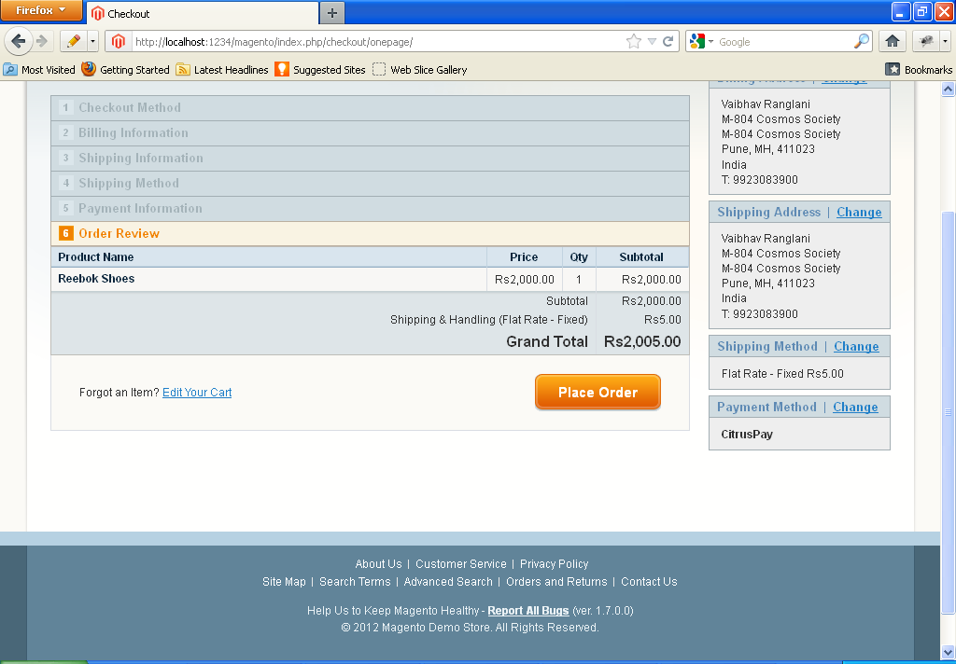

1. You will be redirected to CitrusPay Payment Gateway.

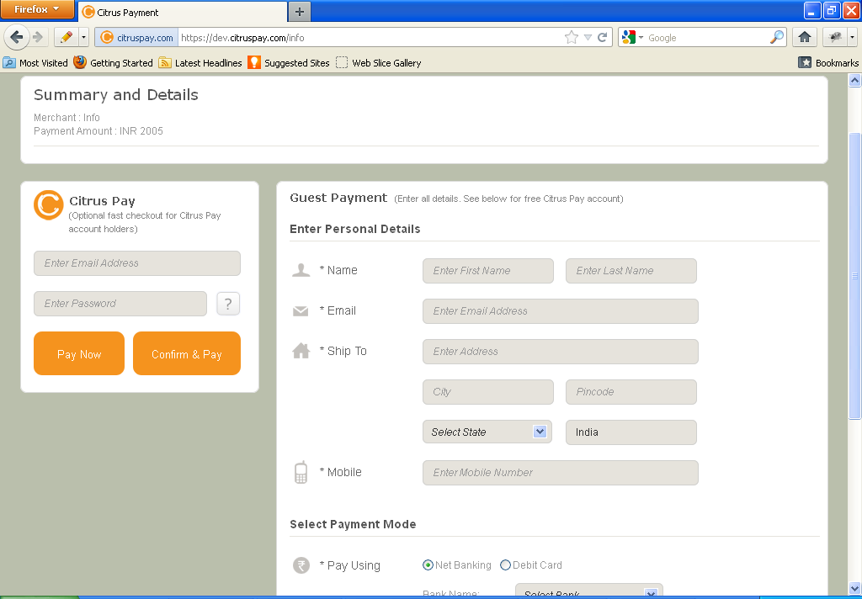

1. If payment succeeds, you will get the following screen

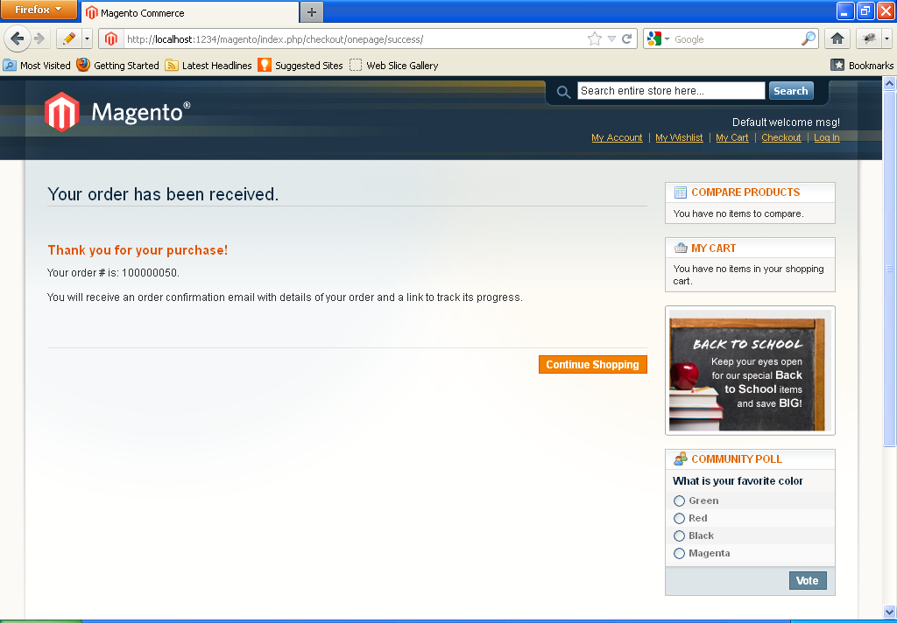

1. If payment fails, you will get the following screen

This is your Order Number.

Use this for future reference.

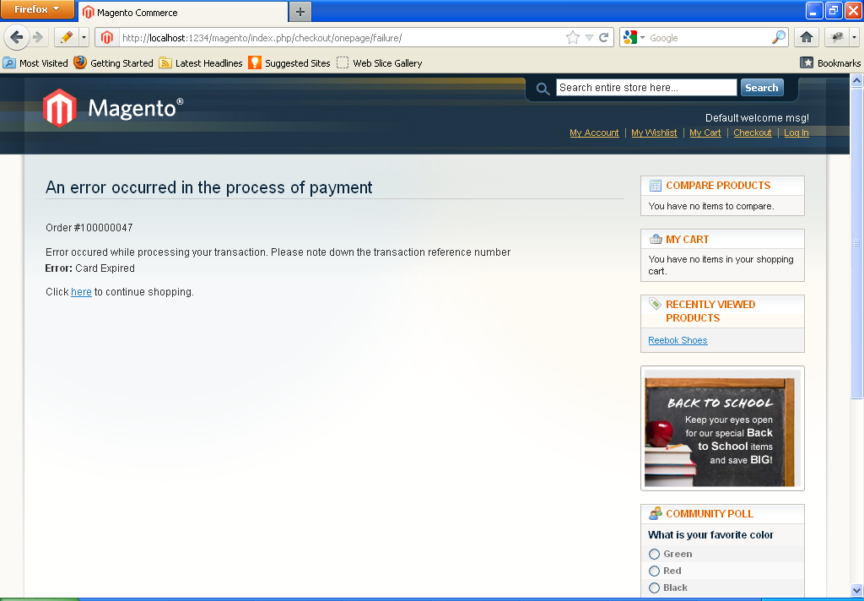

1. In steps 10 and 11, note down your order number to be used for future reference.

In case you require any assistance please contact us at

**Citrus Payment Solutions Private Limited**  
Unit no 35 & 36, Ratanjyot Industrial Estate,  
Irla Gaothan, Irla Lane,  
Vile Parle West, Mumbai 400056  
Phone: 2670 5091/6534 0917  
Email: [contact@citruspay.com](mailto:contact@citruspay.com)