# **NBI Intake – Design Document**

Source analyzed: /mnt/data/nbicode.cs (namespace KDWNMIntakeWeb; classes: Common, k2itemdata; ~11.9k LOC).

## **1) Context & Goals**

This codebase implements a New Business Intake (NBI) / matter‑opening toolkit for an ASP.NET WebForms application. It validates client & matter identifiers, persists intake data to multiple SQL Server backends, kicks off workflow in K2, and issues email notifications. There are also utilities for searching/adding parties and miscellaneous helper routines.

Primary goals:

* Capture/validate intake data (client, matter, employees, fees, compliance flags).
* Persist to operational systems (CMS, LBMS, eMatters, etc.).
* Orchestrate approvals via K2 workflow.
* Notify stakeholders via SMTP email.

## 

## 

## 

## 

## 

## 

## 

## **2) High‑Level Architecture**

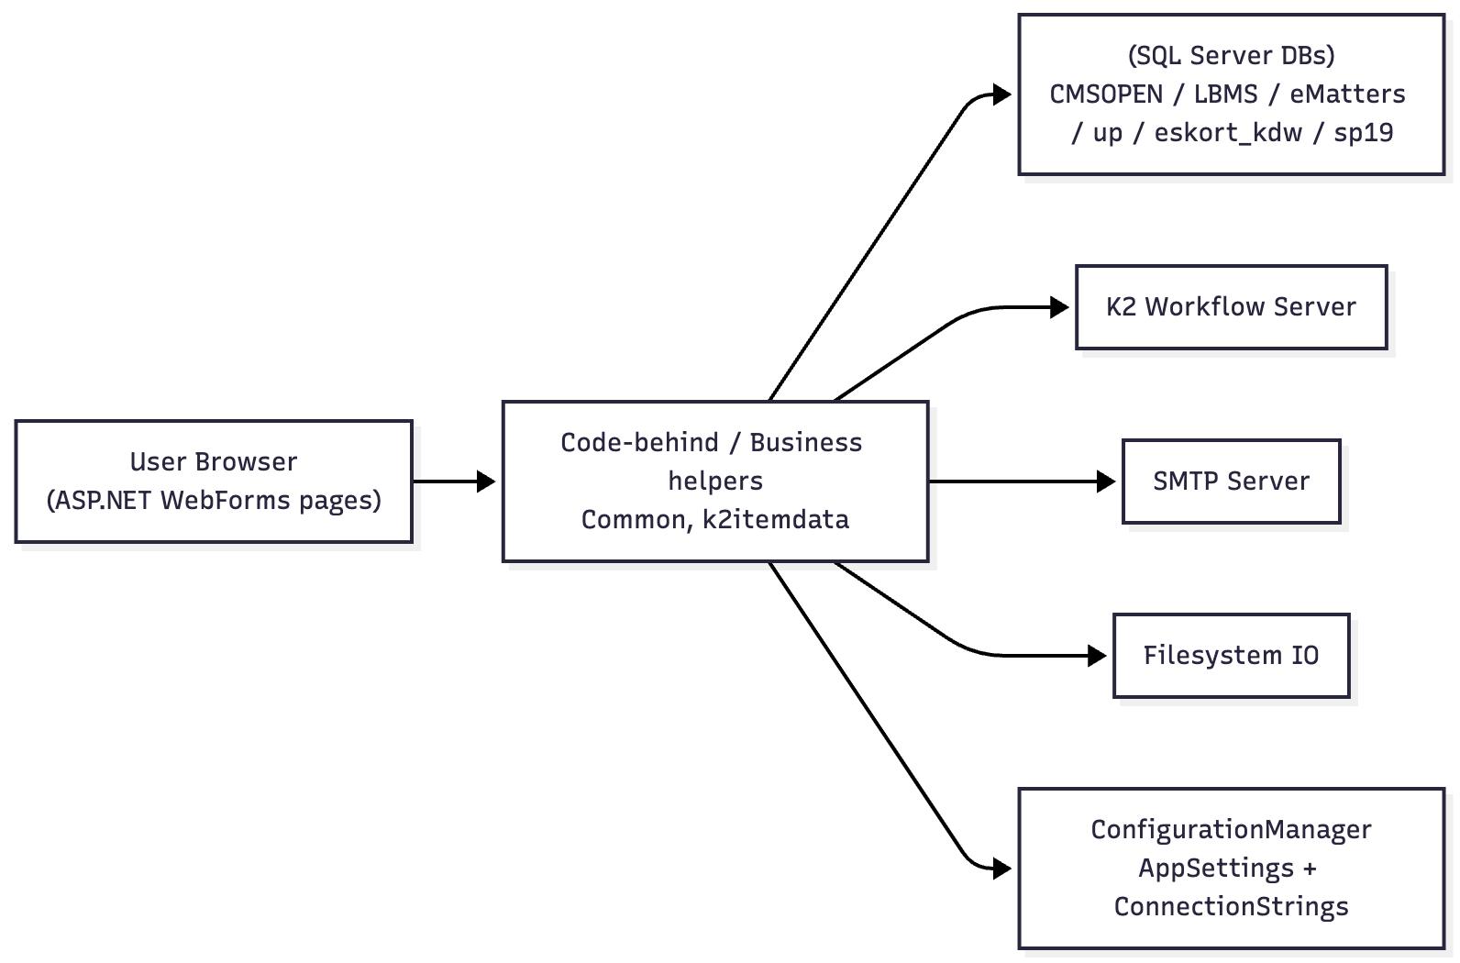

### **Key Components**

* Web UI (WebForms): Pages and controls (code-behind not included here) call helper methods in Common.
* Business Helpers (Common):* Large static utility surface: validation, CRUD using ADO.NET, search logs, party management, notification composition/sending, and K2 hand-offs.
* Workflow (k2itemdata):* Data structure(s) for K2 payloads; interaction helpers tying intake records to workflow instances.
* Data Access: Raw ADO.NET (SqlConnection, SqlCommand, SqlDataAdapter), a mixture of inline SQL and stored procedures.
* Notifications: System.Net.Mail constructs MailMessage and uses SmtpClient(smtpserver, port) to deliver.

## **3) Domain Concepts (inferred)**

* Client / Matter: IDs validated against parameter rules (e.g., HBM_PARMS for matter length/minimum). Numeric/length checks and existence checks.
* Employee / Requestor: Lookups to get employee code from login and office.
* Parties: Functions to add/update/delete parties tied to a search/intake id.
* Intake Record: Field‑heavy object persisted across databases; includes fee arrangements and billing guideline flags.

## **4) Key Workflows**

### **4.1 Intake Submission & Approval**

1. User submits intake form in WebForms page.
2. Validation in Common (isAssignedMatterValid, numeric/length checks via parameters from DB).
3. Persistence to SQL (insert/update across target DBs; sometimes stored procedure calls).
4. Workflow kick‑off: build k2itemdata, start K2 process for approvals.
5. Notifications: send confirmation and/or rejection emails to submitter/committees.
6. Auxiliary updates: party list, search logs, and reopen logic if applicable.

### **4.2 Reopen / Reject**

* Functions create a search log entry (generateSearchLog), update record state, send a templated email explaining reason.

## 

## 

## 

## 

## **5) Detailed Sequence (Happy Path: New Intake)**

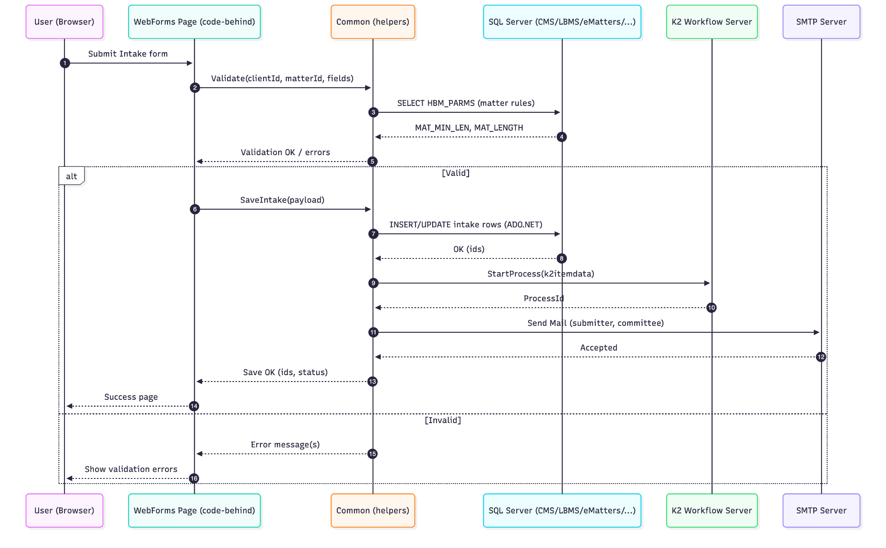

## **6) Integrations & Specifications**

This section lists the external systems the code interacts with and the expected configuration shape.

### **6.1 Databases (SQL Server via ADO.NET)**

* Providers: System.Data.SqlClient (SqlConnection, SqlCommand, SqlDataAdapter).
* ConnectionStrings (from web.config/app.config):
  + CMSOPENConnectionString
  + LBMSConnectionString
  + eMattersConnectionString
  + eskort_kdwConnectionString
  + upConnectionString
  + sp19ConnectionString (a SQL database labeled *sp19*; used for updates/selects in this codebase).
* Patterns:
  + using (SqlConnection conn = new SqlConnection(ConfigurationManager.ConnectionStrings["<name>"].ConnectionString))
  + Inline SQL for parameter rules (e.g., SELECT MAT_MIN_LEN, MAT_LENGTH FROM HBM_PARMS).
  + Occasional stored procedure calls (CommandType.StoredProcedure).
  + Parameters added via SqlCommand.Parameters.AddWithValue("@Param", value).
* Operational guidelines:
  + Ensure least‑privilege SQL logins; segregate write vs read if possible.
  + Centralize command timeouts; avoid concatenating user input (some strings appear concatenated—sanitize rigorously or use parameters).
  + Wrap multi‑table saves in transactions.

### **6.2 Workflow – K2**

* Purpose: Start/advance approval workflows for intake records.
* Config (AppSettings): k2server, k2user, k2pwd.
* Data contract: k2itemdata packs form identifiers/metadata for the process instance.
* Operational guidelines: Secure the K2 service account; use encrypted secrets.

### **6.3 Notifications – SMTP Email**

* API: System.Net.Mail (MailMessage, SmtpClient).
* Runtime: new SmtpClient(smtpserver, port); bodies are HTML (IsBodyHtml = true).
* Recipients: Dynamic (submitter, committee lists); several AppSettings hold role‑based emails (e.g., committee addresses).
* Operational guidelines:
  + Configure smtpserver & port in config; enable TLS as needed (EnableSsl, credentials) if required by your relay.
  + Centralize reusable templates; current code builds bodies inline with placeholders like [CONTENT].

### **6.4 Filesystem IO**

* API: System.IO.File.* (read/write/copy/move/delete/existence checks) in some helper paths.
* Use cases: Attachment handling and template loading.
* Guidelines: Validate paths; avoid writing into web roots; enforce quotas.

### **6.5 Configuration**

* ConfigurationManager.AppSettings[...] used extensively for flags, template paths, email lists, and feature toggles.
* Notable keys (examples): k2server, k2user, k2pwd, various committee email lists, and other functional switches.

## **7) Validation Rules (Examples)**

* Matter number:
  + Length must match rules loaded from HBM_PARMS (MAT_MIN_LEN, MAT_LENGTH).
  + Numeric check (Convert.ToInt32) with error messaging e.g., *“matter code should be a number”*.
* Assigned matter validity: isAssignedMatterValid(matterno, clientcode, out string error) consolidates checks.

## **8) Error Handling & Logging**

* Search/Action logs: generateSearchLog(...) creates tracking entries for reopen/reject and other state changes.
* Email send: try/catch blocks around SmtpClient.Send with simple failure handling (recommend retry/backoff and centralized logging).
* Gaps: No unified logging abstraction observed; consider introducing Serilog/NLog + correlation IDs.

## **9) Non‑Functional Considerations**

* Security:
  + Move secrets (SQL, K2, SMTP creds) to secret store (Azure Key Vault/AWS Secrets Manager) and out of web.config.
  + Use parameterized SQL everywhere; audit any string concatenations.
* Transactions & Consistency:
  + Multi‑DB writes should be idempotent and transactional where possible.
* Scalability:
  + Long email and K2 calls should be queued or made asynchronous.
  + Consider connection pooling settings and command timeouts.
* Maintainability:
  + Common is a large catch‑all; refactor into cohesive services (ValidationService, IntakeRepository, NotificationService, WorkflowService, PartyService).