1. Edit Property - Confirmation Message(Confirmation Message needs to be centered in middle of screen)

Are you referring to this confirm message.

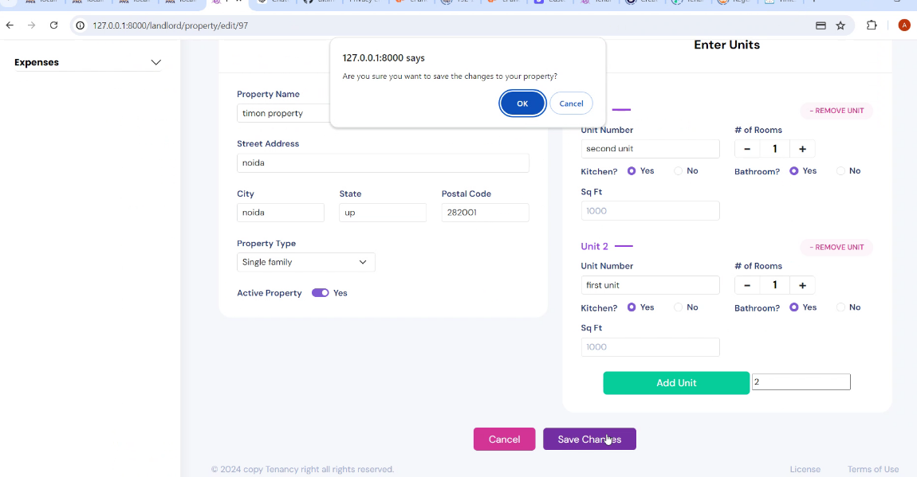

2.Edit property remove unit - On vacant unit, remove unit without save empty vacant unit.

Response: The remove button has AJAX functionality that removes data from the database. If we show the unit grayed out after pressing the remove button, it creates an issue because we've removed it from the view page, but the unit is still received from the server. As a result, when we add a unit, the indexing gets messed up. Therefore, we are removing the data, which is the standard way to manage data in this scenario.

Suggestion : We have a suggestion: when the user clicks on the remove button, an alert message will appear asking if they want to remove the unit. If the user confirms, the unit will be permanently removed. If the user clicks OK, the item will be removed; otherwise, it will not be removed.

1. Search button should display all tenants

Response: Please check

1. Tenant Information - Delete Tenant Profile

Response: Please check