

Functional Safety Concept Lane Assistance

**Document Version: 1.0**



# Document history

|  |  |  |  |
| --- | --- | --- | --- |
| Date | Version | Editor | Description |
| 11/28/18 | 1.0 | Kapy Kangombe | First draft of functional safety concept |
|  |  |  |  |
|  |  |  |  |
|  |  |  |  |
|  |  |  |  |

# Table of Contents

Document history

Table of Contents

Purpose of the Functional Safety Concept

Inputs to the Functional Safety Analysis

Safety goals from the Hazard Analysis and Risk Assessment

Preliminary Architecture

Description of architecture elements

Functional Safety Concept

Functional Safety Analysis

Functional Safety Requirements

Refinement of the System Architecture

Allocation of Functional Safety Requirements to Architecture Elements

Warning and Degradation Concept

# Purpose of the Functional Safety Concept

The purpose of the functional safety concept is to refine the safety goals established in the Hazard Analysis and Risk Assessment into functional safety requirements. These requirements define the vehicle’s functions. The functional safety concept involves allocating the safety requirements to the relevant parts of the system diagram, refining the diagram, and ultimately proving that the system actually meets the requirements.

# Inputs to the Functional Safety Concept

## Safety goals from the Hazard Analysis and Risk Assessment

|  |  |
| --- | --- |
| **ID** | **Safety Goal** |
| Safety_Goal_01 | The oscillating steering torque from the lane departure warning (LDW) function shall be limited. |
| Safety_Goal_02 | The lane keeping assistance (LKA) function shall be time limited and the additional steering torque shall end after a given time interval so that the driver cannot misuse the system for autonomous driving. |

## Preliminary Architecture

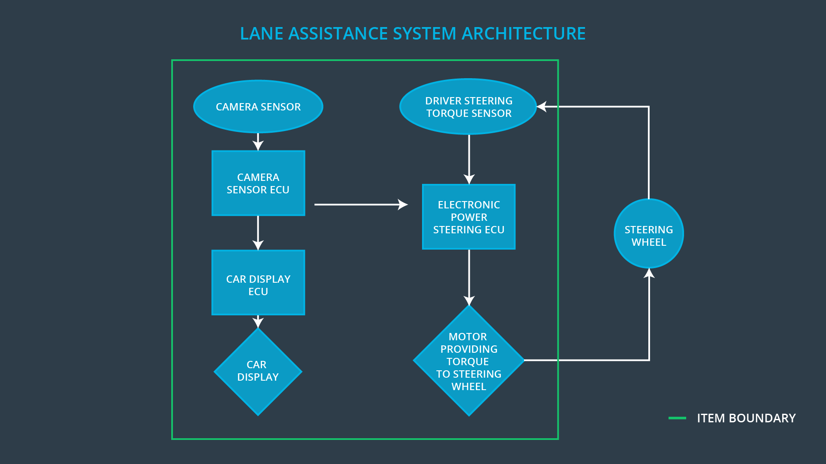

### Description of architecture elements

|  |  |
| --- | --- |
| **Element** | **Description** |
| Camera Sensor | A sensor that detects lane departures. |
| Camera Sensor ECU | A small computer that contains the hardware and software required for deep learning or for computer vision techniques like the Hough transform. |
| Car Display | A screen that displays a warning of the vehicle lane departure to the driver and also shows the status (on/off) of the the lane keeping function. |
| Car Display ECU | A small computer that contains the hardware and software to receive sensor data and display a warning of the vehicle lane departure to the driver. Also sends torque requests to the Electronic Power Steering ECU. |
| Driver Steering Torque Sensor | A sensor that detects how much the driver is turning the steering wheel. |
| Electronic Power Steering ECU | A small computer that contains the hardware and software required to receive sensor data and tell the motor how much torque to provider to the steering wheel. This is also where torque limits are applied. |
| Motor | Provides torque to the steering wheel to help the driver move the vehicle back towards the center of the lane. |

# Functional Safety Concept

The functional safety concept consists of:

* Functional safety analysis
* Functional safety requirements
* Functional safety architecture
* Warning and degradation concept

## Functional Safety Analysis

|  |  |  |  |
| --- | --- | --- | --- |
| **Malfunction ID** | **Main Function of the Item Related to Safety Goal Violations** | **Guidewords (NO, WRONG, EARLY, LATE, MORE, LESS)** | **Resulting Malfunction** |
| Malfunction_01 | Lane Departure Warning (LDW) function shall apply an oscillating steering torque to provide the driver a haptic feedback | MORE | The lane departure warning function applies an oscillating torque with very high torque amplitude (above limit) |
| Malfunction_02 | Lane Departure Warning (LDW) function shall apply an oscillating steering torque to provide the driver a haptic feedback | MORE | The lane departure warning function applies an oscillating torque with very high torque frequency (above limit) |
| Malfunction_03 | Lane Keeping Assistance (LKA) function shall apply the steering torque when active in order to stay in ego lane | NO | The lane keeping assistance function is not limited in time duration which leads to misuse as an autonomous driving function. |

## Functional Safety Requirements

Lane Departure Warning (LDW) Requirements:

|  |  |  |  |  |
| --- | --- | --- | --- | --- |
| **ID** | **Functional Safety Requirement** | **ASIL** | **Fault Tolerant Time Interval** | **Safe State** |
| Functional  Safety  Requirement  01-01 | The electronic power steering ECU shall ensure that the lane departure warning oscillating torque amplitude is below Max_Torque_Amplitude | C | 50 ms | LDW will set the oscillating torque amplitude to 0 |
| Functional  Safety  Requirement  01-02 | The electronic power steering ECU shall ensure that the lane departure warning oscillating torque frequency is below Max_Torque_Frequency | C | 50 ms | LDW will set the oscillating torque amplitude to 0 |

Lane Departure Warning (LDW) Verification and Validation Acceptance Criteria:

|  |  |  |
| --- | --- | --- |
| **ID** | **Validation Acceptance**  **Criteria and Method** | **Verification Acceptance**  **Criteria and Method** |
| Functional  Safety  Requirement  01-01 | Test to validate that Max_Torque_Amplitude is a reasonable value. Test how drivers react to different torque amplitudes to prove that we chose an appropriate Max_Torque_Amplitude value | Confirm that when the torque amplitude crosses the limit, the lane assistance output is set to zero within the 50 ms fault tolerant time interval. For this specific case, we would probably do a software test inserting a fault into the system and seeing what happens. |
| Functional  Safety  Requirement  01-02 | Test to validate that Max_Torque_Frequency is a reasonable value. Test how drivers react to different torque frequencies to prove that we chose an appropriate Max_Torque_Frequency value | Confirm that when the torque frequency crosses the limit, the lane assistance output is set to zero within the 50 ms fault tolerant time interval. For this specific case, we would probably do a software test inserting a fault into the system and seeing what happens. |

Lane Keeping Assistance (LKA) Requirements:

|  |  |  |  |  |
| --- | --- | --- | --- | --- |
| **ID** | **Functional Safety Requirement** | **ASIL** | **Fault Tolerant Time Interval** | **Safe State** |
| Functional  Safety  Requirement  02-01 | Electronic power steering ECU shall ensure that the lane keeping assistance torque is applied for only Max_Duration | B | 500 ms | LKA will set the oscillating torque amplitude to 0 |

Lane Keeping Assistance (LKA) Verification and Validation Acceptance Criteria:

|  |  |  |
| --- | --- | --- |
| **ID** | **Validation Acceptance**  **Criteria and Method** | **Verification Acceptance**  **Criteria and Method** |
| Functional  Safety  Requirement  02-01 | Test to validate that the Max_Duration chosen really did dissuade drivers from taking their hands off the wheel | Confirm that the system really does turn off if the lane keeping assistance every exceeds Max_Duration and that the safe state is reached within the 500 ms fault tolerant time interval. |

## Refinement of the System Architecture

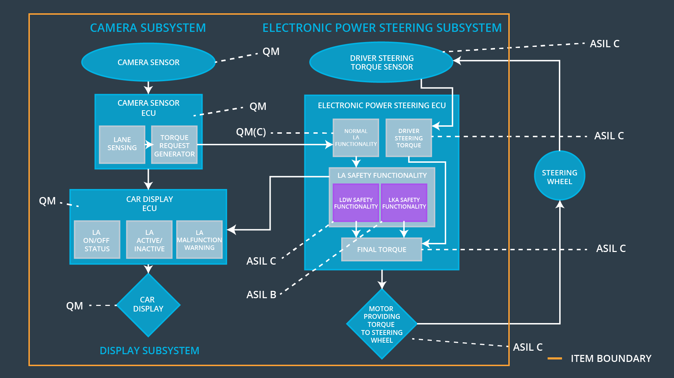

## Allocation of Functional Safety Requirements to Architecture Elements

|  |  |  |  |  |
| --- | --- | --- | --- | --- |
| **ID** | **Functional Safety Requirement** | **Electronic Power Steering ECU** | **Camera ECU** | **Car Display ECU** |
| Functional  Safety  Requirement  01-01 | The electronic power steering ECU shall ensure that the lane departure warning oscillating torque amplitude is below Max_Torque_Amplitude | **X** |  |  |
| Functional  Safety  Requirement  01-02 | The electronic power steering ECU shall ensure that the lane departure warning oscillating torque frequency is below Max_Torque_Frequency | **X** |  |  |
| Functional  Safety  Requirement  02-01 | Electronic power steering ECU shall ensure that the lane keeping assistance torque is applied for only Max_Duration | **X** |  |  |

## Warning and Degradation Concept

|  |  |  |  |  |
| --- | --- | --- | --- | --- |
| **ID** | **Degradation Mode** | **Trigger for Degradation Mode** | **Safe State invoked?** | **Driver Warning** |
| WDC-01 | Turn off LDW function | LDW malfunction | Yes | LDW malfunction warning light on dashboard |
| WDC-02 | Turn off LKA function | LKA malfuntion | Yes | LKA malfunction warning light on dashboard |