

Technical Safety Concept Lane Assistance

**Document Version: 1.0**



# Document history

|  |  |  |  |
| --- | --- | --- | --- |
| Date | Version | Editor | Description |
| 11/28/18 | 1.0 | Kapy Kangombe | First draft of technical safety concept |
|  |  |  |  |
|  |  |  |  |
|  |  |  |  |
|  |  |  |  |

# 

# Table of Contents

Document history

Table of Contents

Purpose of the Technical Safety Concept

Inputs to the Technical Safety Concept

Functional Safety Requirements

Refined System Architecture from Functional Safety Concept

Functional overview of architecture elements

Technical Safety Concept

Technical Safety Requirements

Refinement of the System Architecture

Allocation of Technical Safety Requirements to Architecture Elements

Warning and Degradation Concept

# Purpose of the Technical Safety Concept

The purpose of the technical safety concept is to:

* turn functional safety requirements into technical safety requirements, and
* allocate technical safety requirements to the system architecture

The technical safety concept refines the requirements outlined in the functional safety concept and goes into greater detail by drilling down into the relevant subsystems (i.e., focusing on component level).

However, not all technical safety requirements are derived from functional safety requirements. ISO 26262 requires five other categories of technical safety requirements:

1. Detecting faults within a system
2. Detecting faults in an external device interacting with the system
3. Reaching a safe state
4. Implementing a warning and degradation concept
5. Preventing latent faults

# Inputs to the Technical Safety Concept

## Functional Safety Requirements

|  |  |  |  |  |
| --- | --- | --- | --- | --- |
| **ID** | **Functional Safety Requirement** | **ASIL** | **Fault Tolerant Time Interval** | **Safe State** |
| Functional  Safety  Requirement  01-01 | The electronic power steering ECU shall ensure that the lane departure warning oscillating torque amplitude is below Max_Torque_Amplitude | C | 50 ms | LDW function turned off |
| Functional  Safety  Requirement  01-02 | The electronic power steering ECU shall ensure that the lane departure warning oscillating torque frequency is below Max_Torque_Frequency | C | 50 ms | LDW function turned off |
| Functional  Safety  Requirement  02-01 | Electronic power steering ECU shall ensure that the lane keeping assistance torque is applied for only Max_Duration | B | 500 ms | LKA function turned off |

## Refined System Architecture from Functional Safety Concept

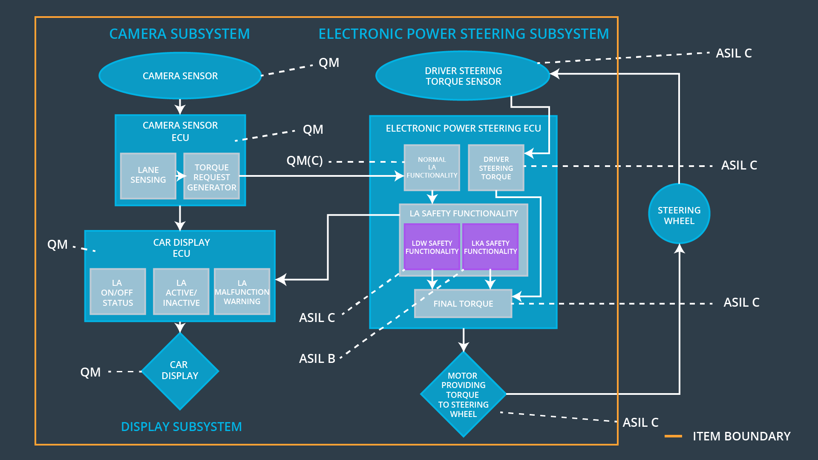

### 

### Functional overview of architecture elements

|  |  |
| --- | --- |
| **Element** | **Description** |
| Camera Sensor | A sensor that detects lane departures. |
| Camera Sensor ECU - Lane Sensing | A software block that senses where the vehicle is with respect to the lane (i.e., lane departure detection). |
| Camera Sensor ECU - Torque request generator | A software block to send a torque to the electronic power steering ECU subsystem. |
| Car Display | A screen that displays a warning of the vehicle lane departure to the driver and also shows the status (on/off) of the the lane keeping function. |
| Car Display ECU - Lane Assistance On/Off Status | A software block that controls a light that tells the driver if the lane keeping item is on or off. |
| Car Display ECU - Lane Assistant Active/Inactive | A software block that controls a light that tells the driver if the lane departure warning is activated. |
| Car Display ECU - Lane Assistance malfunction warning | A component that displays warning lights/information when there is a malfunction message sent from the electronic power steering ECU. |
| Driver Steering Torque Sensor | A component that senses how much the driver is turning the steering wheel. |
| Electronic Power Steering (EPS) ECU - Driver Steering Torque | A software block to analyze the driver steering torque from the driver steering torque sensor. |
| EPS ECU - Normal Lane Assistance Functionality | A software block that receives the vibrational torque request from the camera subsystem. It takes care of normal functional behavior. |
| EPS ECU - Lane Departure Warning Safety Functionality | A software block that takes care of LDW malfunctions and applies oscillating torque amplitude & frequency limits. |
| EPS ECU - Lane Keeping Assistant Safety Functionality | A software block that takes care of LKA malfunctions and applies the max_duration limits. |
| EPS ECU - Final Torque | The component that adds the torque request from the camera subsystem and driver steering torque. |
| Motor | Provides torque to the steering wheel to help the driver move the vehicle back towards the center of the lane. |

# Technical Safety Concept

## Technical Safety Requirements

**Lane Departure Warning (LDW) Requirements:**

Functional Safety Requirement 01-01 with its associated system elements

(derived in the functional safety concept)

|  |  |  |  |  |
| --- | --- | --- | --- | --- |
| **ID** | **Functional Safety Requirement** | **Electronic Power Steering ECU** | **Camera ECU** | **Car Display ECU** |
| Functional  Safety  Requirement  01-01 | The lane keeping item shall ensure that the lane departure oscillating torque amplitude is below Max_Torque_Amplitude | X |  |  |

Technical Safety Requirements related to Functional Safety Requirement 01-01 are:

|  |  |  |  |  |  |
| --- | --- | --- | --- | --- | --- |
| **ID** | **Technical Safety Requirement** | **ASIL** | **Fault Tolerant Time Interval** | **Architecture Allocation** | **Safe State** |
| Technical  Safety  Requirement  01 | The LDW safety component shall ensure that the amplitude of the ‘LDW_Torque_Request’ sent to the ‘Final electronic power steering Torque’ component is below ‘Max_Torque_Amplitude’. | C | 50 ms | Lane Departure Warning Safety block | Lane Departure Warning Torque Request Amplitude shall be set to zero |
| Technical  Safety  Requirement  02 | The validity and integrity of the data transmission for ‘LDW_Torque_Request’ signal shall be ensured. | C | 50 ms | Data Transmission Integrity Check | Lane Departure Warning Torque Request Amplitude shall be set to zero |
| Technical  Safety  Requirement  03 | As soon as a failure is detected by the LDW function, it shall deactivate the LDW feature and the ‘LDW_Torque_Request’ shall be set to zero. | C | 50 ms | LDW Safety block | Lane Departure Warning Torque Request Amplitude shall be set to zero |
| Technical  Safety  Requirement  04 | As soon as the LDW function deactivates the LDW feature, the ‘LDW Safety’ software block shall send a signal to the car display ECU to turn on a warning light. | C | 50 ms | LDW Safety block | Lane Departure Warning Torque Request Amplitude shall be set to zero |
| Technical  Safety  Requirement  05 | Memory test shall be conducted at start up of the EPS ECU to check for any faults in memory. | A | Ignition cycle | Safety Startup (Memory Test) | Lane Departure Warning Torque Request Amplitude shall be set to zero |

Functional Safety Requirement 01-2 with its associated system elements

(derived in the functional safety concept)

|  |  |  |  |  |
| --- | --- | --- | --- | --- |
| **ID** | **Functional Safety Requirement** | **Electronic Power Steering ECU** | **Camera ECU** | **Car Display ECU** |
| Functional  Safety  Requirement  01-02 | The lane keeping item shall ensure that the lane departure oscillating torque frequency is below Max_Torque_Frequency | X |  |  |

Technical Safety Requirements related to Functional Safety Requirement 01-02 are:

|  |  |  |  |  |  |
| --- | --- | --- | --- | --- | --- |
| **ID** | **Technical Safety Requirement** | **ASIL** | **Fault Tolerant Time Interval** | **Architecture Allocation** | **Safe State** |
| Technical  Safety  Requirement  01 | The LDW safety component shall ensure that the frequency of the ‘LDW_Torque_Request’ sent to the ‘Final electronic power steering Torque’ component is below ‘Max_Torque_Frequency’ | C | 50 ms | LDW Safety block | Lane Departure Warning Torque Request Amplitude shall be set to zero |
| Technical  Safety  Requirement  02 | The validity and integrity of the data transmission for ‘LDW_Torque_Request’ signal shall be ensured. | C | 50 ms | Data Transmission Integrity Check | Lane Departure Warning Torque Request Amplitude shall be set to zero |
| Technical  Safety  Requirement  03 | As soon as a failure is detected by the LDW function, it shall deactivate the LDW feature and the ‘LDW_Torque_Request’ shall be set to zero. | C | 50 ms | LDW Safety block | Lane Departure Warning Torque Request Amplitude shall be set to zero |
| Technical  Safety  Requirement  04 | As soon as the LDW function deactivates the LDW feature, the ‘LDW Safety’ software block shall send a signal to the car display ECU to turn on a warning light. | C | 50 ms | LDW Safety block | Lane Departure Warning Torque Request Amplitude shall be set to zero |
| Technical  Safety  Requirement  05 | Memory test shall be conducted at start up of the EPS ECU to check for any faults in memory. | A | Ignition cycle | Safety Startup (Memory Test) | Lane Departure Warning Torque Request Amplitude shall be set to zero |

**Lane Departure Warning (LDW) Verification and Validation Acceptance Criteria:**

N/A (optional)

**Lane Keeping Assistance (LKA) Requirements:**

Functional Safety Requirement 02-1 with its associated system elements

(derived in the functional safety concept)

|  |  |  |  |  |
| --- | --- | --- | --- | --- |
| **ID** | **Functional Safety Requirement** | **Electronic Power Steering ECU** | **Camera ECU** | **Car Display ECU** |
| Functional  Safety  Requirement  02-01 | The lane keeping item shall ensure that the lane keeping assistance torque is applied for only Max_Duration | X |  |  |

Technical Safety Requirements related to Functional Safety Requirement 02-01 are:

|  |  |  |  |  |  |
| --- | --- | --- | --- | --- | --- |
| **ID** | **Technical Safety Requirement** | **ASIL** | **Fault Tolerant Time Interval** | **Allocation to Architecture** | **Safe State** |
| Technical  Safety  Requirement  01 | The LKA safety component shall ensure that ‘LKA_Torque_Request’ is sent to the ‘Final electronic power steering Torque’ component for only Max_Duration. | B | 500 ms | LKA Safety block | Lane Keeping Assistance Torque Request Amplitude shall be set to zero |
| Technical  Safety  Requirement  02 | The validity and integrity of the data transmission for ‘LKA_Torque_Request’ signal shall be ensured. | B | 500 ms | Data Transmission Integrity Check | Lane Keeping Assistance Torque Request Amplitude shall be set to zero |
| Technical  Safety  Requirement  03 | As soon as a failure is detected by the LKA function, it shall deactivate the LKA feature and the ‘LKA_Torque_Request’ shall be set to zero. | B | 500 ms | LKA Safety block | Lane Keeping Assistance Torque Request Amplitude shall be set to zero |
| Technical  Safety  Requirement  04 | As soon as the LKA function deactivates the LKA feature, the ‘LKA Safety’ software block shall send a signal to the car display ECU to turn on a warning light. | B | 500 ms | LKA Safety block | Lane Keeping Assistance Torque Request Amplitude shall be set to zero |
| Technical  Safety  Requirement  05 | Memory test shall be conducted at start up of the EPS ECU to check for any faults in memory. | A | Ignition cycle | Safety Startup (Memory Test) | Lane Keeping Assistance Torque Request Amplitude shall be set to zero |

**Lane Keeping Assistance (LKA) Verification and Validation Acceptance Criteria:**

N/A (optional)

## Refinement of the System Architecture

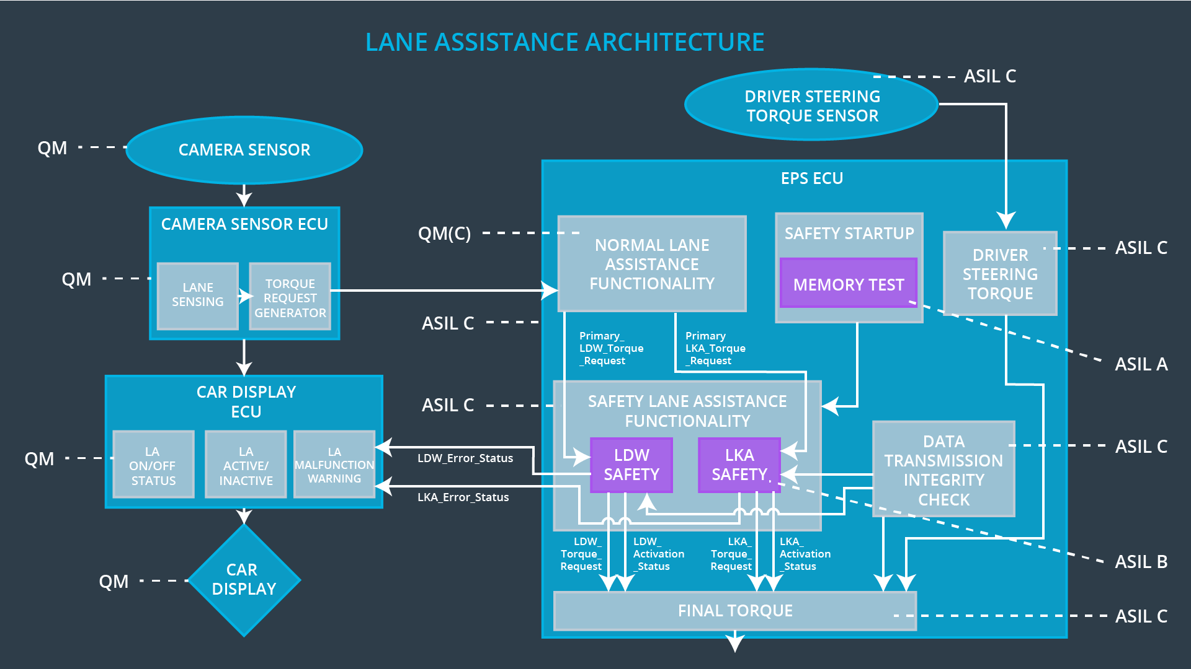

## Allocation of Technical Safety Requirements to Architecture Elements

For this particular item, all technical safety requirements are allocated to the Electronic Power Steering ECU.

## Warning and Degradation Concept

|  |  |  |  |  |
| --- | --- | --- | --- | --- |
| **ID** | **Degradation Mode** | **Trigger for Degradation Mode** | **Safe State invoked?** | **Driver Warning** |
| WDC-01 | Turn off LDW function | LDW malfunction | Yes | LDW malfunction warning light on dashboard |
| WDC-02 | Turn off LKA function | LKA malfuntion | Yes | LKA malfunction warning light on dashboard |