

Safety Plan Lane Assistance

**Document Version: 1.0**



# Document history

|  |  |  |  |
| --- | --- | --- | --- |
| Date | Version | Editor | Description |
| 11/26/18 | 1.0 | Kapy Kangombe | First draft of safety plan |
|  |  |  |  |
|  |  |  |  |
|  |  |  |  |
|  |  |  |  |

# Table of Contents

Document history

Table of Contents

Introduction

Purpose of the Safety Plan

Scope of the Project

Deliverables of the Project

Item Definition

Goals and Measures

Goals

Measures

Safety Culture

Safety Lifecycle Tailoring

Roles

Development Interface Agreement

Confirmation Measures

# Introduction

## Purpose of the Safety Plan

The purpose of the safety plan is to define the roles and outline the steps we will take to achieve functional safety of the lane assistance system. At a high level, it provides an overall framework for the functional safety of the system.

## Scope of the Project

For the lane assistance project, the following safety lifecycle phases are in scope:

Concept phase

Product Development at the System Level

Product Development at the Software Level

The following phases are out of scope:

Product Development at the Hardware Level

Production and Operation

## Deliverables of the Project

The deliverables of the project are:

Safety Plan

Hazard Analysis and Risk Assessment

Functional Safety Concept

Technical Safety Concept

Software Safety Requirements and Architecture

# Item Definition

The item in question is a lane assistance system (LAS). It automatically assists the driver in keeping the vehicle safely within the lane. The LAS has two main functions:

1. Lane departure warning
2. Lane keeping assistance

The lane departure warning function will vibrate the steering wheel whenever the vehicle accidently departs from the center of the lane. It shall apply an oscillating steering torque to provide the driver a haptic feedback.

The lane keeping assistance system will automatically assist the driver by steering the vehicle toward the center of the lane. It shall apply the steering torque when active in order to stay in ego lane.

The lane assistance system consists of two subsystems: the camera subsystem and the electronic power steering subsystem. The camera subsystem is responsible for the lane departure warning function, whereas the electronic power steering subsystem is responsible for the lane keeping assistance function. Below is a diagram showing the item boundary, the subsystems within the item and the subsystems outside the item.

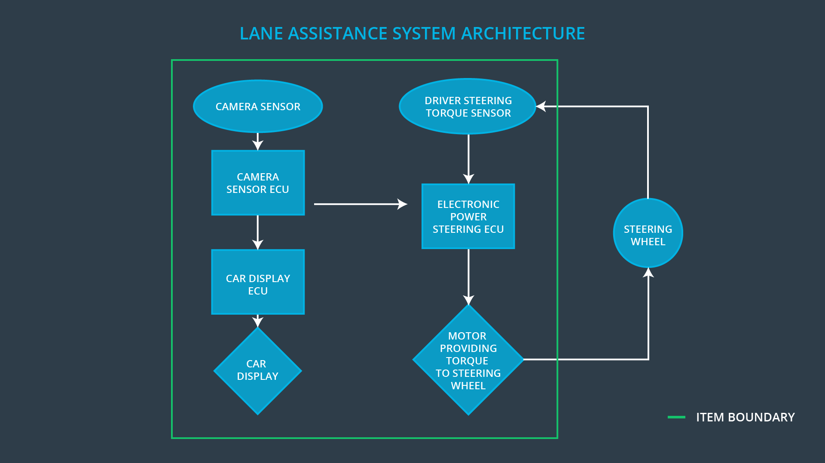

# Goals and Measures

## Goals

The goal of this project is to lower the risk of malfunction of the lane assistance system to an acceptable level according to ISO 26262. That is, to lower the risk of malfunction of the lane departure warning and lane keeping assistance systems.

## Measures

|  |  |  |
| --- | --- | --- |
| Measures and Activities | Responsibility | Timeline |
| Follow safety processes | All Team Members | Constantly |
| Create and sustain a safety culture | All Team Members | Constantly |
| Coordinate and document the planned safety activities | Safety Manager | Constantly |
| Allocate resources with adequate functional safety competency | Project Manager | Within 2 weeks of start of project |
| Tailor the safety lifecycle | Safety Manager | Within 4 weeks of start of project |
| Plan the safety activities of the safety lifecycle | Safety Manager | Within 4 weeks of start of project |
| Perform regular functional safety audits | Safety Auditor | Once every 2 months |
| Perform functional safety pre-assessment prior to audit by external functional safety assessor | Safety Manager | 3 months prior to main assessment |
| Perform functional safety assessment | Safety Accessor | Conclusion of functional safety activities |

# Safety Culture

Here are some characteristics of the company’s safety culture:

* **High priority**: safety has the highest priority among competing constraints like cost and productivity
* **Accountability**: processes ensure accountability such that design decisions are traceable back to the people and teams who made the decisions
* **Rewards**: the organization motivates and supports the achievement of functional safety
* **Penalties**: the organization penalizes shortcuts that jeopardize safety or quality
* **Independence**: teams who design and develop a product should be independent from the teams who audit the work
* **Well defined processes**: company design and management processes should be clearly defined
* **Resources**: projects have necessary resources including people with appropriate skills
* **Diversity**: intellectual diversity is sought after, valued and integrated into processes
* **Communication**: communication channels encourage disclosure of problems
* **Quality Management**: comply with the quality management system outlined in IATF 16949

# Safety Lifecycle Tailoring

The following safety lifecycle phases are in scope:

Concept phase

Product Development at the System Level

Product Development at the Software Level

The following phases are out of scope:

Product Development at the Hardware Level

Production and Operation

# Roles

|  |  |
| --- | --- |
| Role | Org |
| Functional Safety Manager- Item Level | OEM |
| Functional Safety Engineer- Item Level | OEM |
| Project Manager - Item Level | OEM |
| Functional Safety Manager- Component Level | Tier-1 |
| Functional Safety Engineer- Component Level | Tier-1 |
| Functional Safety Auditor | OEM or external |
| Functional Safety Assessor | OEM or external |

# Development Interface Agreement

The purpose of a development interface agreement (DIA) is to:

* Clarify the responsibilities of the different parties involved in a functional safety project
* Describe the work products that each company will provide
* Help avoid disputes between companies
* Clarify who will be responsible for any safety issues in post-production

As we will be taking on the role of both functional safety manager and functional safety engineer, our company will have the following responsibilties at the subsystem/component level only:

* Planning, coordinating and documenting of the development phase of the safety lifecycle
* Tailoring the safety lifecycle
* Maintaining the safety plan
* Monitoring progress against the safety plan
* Performing pre-audits before the safety auditor
* Product development of subsystems
* Integration of subsystems
* Testing all the hardware and software at the subsystem level

The first five responsibilities will be as safety manager and the last three as safety engineer.

# Confirmation Measures

Confirmation measures serve two purposes:

* that a functional safety project conforms to ISO 26262, and
* that the project really does make the vehicle safer.

The people who carry out confirmation measures need to be independent from the people who actually developed the project.

Confirmation review ensures that the project complies with ISO 26262. As the product is designed and developed, an independent person would review the work to make sure ISO 26262 is being followed.

A functional safety audit involves checking to make sure that the actual implementation of the project conforms to the safety plan is called a functional safety audit.

Confirming that plans, designs and developed products actually achieve functional safety is called a functional safety assessment.

A safety plan could have other sections that we are not including here. For example, a safety plan would probably contain a complete project schedule.

There might also be a "Supporting Process Management" section that would cover "Part 8: Supporting Processes" of the ISO 26262 functional safety standard. This would include descriptions of how the company handles requirements management, change management, configuration management, documentation management, and software tool usage and confidence.

Similarly, a confirmation measures section would go into more detail about how each confirmation will be carried out.