

CORDOVA PUBLIC COLLEGE
College of Computer Studies
Gabi, Cordova, Cebu, Philippines

Software Requirements Specifications

for

Herbal AI: A Digital Repository of Philippine Herbal Medicine with AI-Assisted Preparation

Presented By:
Kevin C. Mercado — Project Manager
Devon Descipulo — Backend Developer
Eumar Cabaluna — Frontend Developer
Submitted in partial fulfillment of the requirements for the
Degree of Bachelor of Science in Information Technology (BSIT)
May 23, 2026

Signature
This Software Requirements Specification document has been reviewed and is hereby approved for submission to the Capstone Evaluation Panel of the College of Computer Studies, Cordova Public College.

Project Lead | Kevin C. Mercado  Kevin C. Mercado
Backend Dev. | Devon Descipulo  Devon Descipulo
Frontend Dev. | Eumar Cabaluna  Eumar Cabaluna
Adviser | Name / Signature / Date
Panel Member | Name / Signature / Date
Panel Member | Name / Signature / Date

Change History
The following table records all revisions made to this Software Requirements Specification document.

Version | Date | Description of Changes | Author
1.0 | May 23, 2026 | Initial SRS document creation following IEEE Std 830-1998 format as prescribed by Cordova Public College CCS capstone documentation guidelines. | Kevin C. Mercado
2.0 | July 8, 2026 | Revised to reflect the current Advanced Integrated Prototype (Prototype v2.5) status. Updated scope, functional requirements, API endpoints, and verification plan to match actual implementation progress. | Kevin C. Mercado
3.0 | August 01, 2026 | Removed Appendix A (Project Goals) and Appendix C (Future Enhancements); renumbered remaining appendices and added the Capstone Documentation and Artifacts List. | Kevin C. Mercado
3.0 | 31 August 2026 | Revision 3.0 evidence update: records passing automated tests, lint/type checks, production build, and completed supporting documentation; preserves outstanding external verification items. | Herbal AI Project Group

Preface
This Software Requirements Specification (SRS) document provides a comprehensive and structured description of the functional and non-functional requirements of Herbal AI: A Digital Repository of Philippine Herbal Medicine with AI-Assisted Preparation. This document is intended to serve as a reference for the development team, academic advisors, panel evaluators, and all relevant stakeholders throughout the software development lifecycle.

The SRS follows the IEEE 830 standard format as prescribed by the Cordova Public College, College of Computer Studies capstone documentation guidelines.

Table of Contents
Contents
Signature 2
Change History 3
Preface 4
Table of Contents 5
List of Figures 7
List of Tables 8
1. Introduction 9
1.1. Purpose 9
1.2. Scope 9
1.3. Product Overview 10
1.3.1 Product Perspective 10
1.3.2 Product Functions 11
1.3.3 User Characteristics 11
1.3.4 Limitations 12
1.4. Definitions 12
2. References 14
3. Specific Requirements 15
3.1. External Interfaces 15
User Interface 15
Software Interfaces 15
API Endpoints (Primary) 15
Table 5 – API Endpoints and Implementation Status 15
Note: Endpoints under /api/forum and /api/messages are functionally implemented and integrated with the frontend, but remain pending full regression and load verification prior to final defense, consistent with the project's current Integration and Stabilization Phase status. 16
3.1.4 Use Case Diagram 16
3.2. Functional Requirements 17
3.2.1 Herb Library (Intelligent Search & Browse) 17
3.2.2 Interactive AI Assistant (Dr. Ai Module) 18
3.2.3 Herb Suggestion System 18
3.2.4 Admin Verification Dashboard 18
3.2.5 Community Forum 19
3.2.6 Private Messaging 19
3.2.7 Herb Comments / Discussion 19
3.2.8 User Authentication & Session Management 19
3.3. Usability Requirements 20
3.4. Performance Requirements 20
3.5. Logical Database Requirements 20
3.6. Design Constraints 22
3.7. Software System Attributes 23
3.8. Supporting Information 23
Statement of the Problem 23
Problem Solved / Solution 23
Herb Suggestion Workflow (Figure 2) 24
4. Verification 25
Testing Types 26
5. Appendices 27
Appendix A – Proponent Roles 27
Table 11 – Proponent Roles 27
Appendix B – Capstone Documentation and Artifacts List 27
Appendix C – UI Prototype Screenshots 28
Appendix D – Class Diagram 34

List of Figures
Figure 1 – Herbal AI System Architecture Diagram (Section 1.3.1)
Figure 2 – Herb Suggestion & Admin Review Workflow (Section 3.8)
Figure 3 – Use Case Diagram: Guest, Logged-in User, and Admin Actors

List of Tables
Table 1 – Document Change History
Table 2 – Intended Audience Roles
Table 3 – User Role Classifications and Privileges
Table 4 – System Definitions and Glossary
Table 5 – API Endpoints and Implementation Status
Table 6 – Functional Requirements Implementation Status Summary
Module | Status
User Authentication & Session Management (3.2.8) | Implemented
Herb Library / Intelligent Search & Browse (3.2.1) | Implemented
Dr. Ai Chat Assistant (3.2.2) | Implemented
Herb Suggestion System (3.2.3) | Implemented; status-change notifications pending
Admin Verification Dashboard (3.2.4) | Implemented; audit logging pending
Community Forum (3.2.5) | Implemented, pending full verification
Private Messaging (3.2.6) | Implemented, pending full verification
Herb Comments / Discussion (3.2.7) | Implemented
Table 7 – Database Schema: Users
Table 8 – Database Schema: Herbs
Table 9 – Database Schema: Suggested Herbs
Table 10 – Verification and Traceability Matrix
Table 11 – Proponent Roles
Table 12 – Capstone Documentation and Artifacts List

1. Introduction
Herbal AI is a web-based digital repository for Philippine herbal medicine designed to transform passive reading into active, safe guidance. Under the Traditional and Alternative Medicine Act of 1997 (Republic Act No. 8423), the Philippine state formally recognizes and mandates the validation of local botanical formulations. However, public dissemination is historically fragmented, highly reliant on oral tradition, and subject to unsafe administration due to botanical misidentification or inaccurate dosage calculations.

1.1. Purpose
The purpose of this Software Requirements Specification (SRS) document is to:

a) Provide a detailed and structured description of the functional and non-functional requirements for the Herbal AI: A Digital Repository of Philippine Herbal Medicine with AI-Assisted Preparation web application system.
b) Serve as a formal contractual basis between the development team and the academic panel of the Cordova Public College, College of Computer Studies.
c) Guide the design, development, testing, and maintenance of the Herbal AI platform in conformance with IEEE Std 830-1998.
d) Document the system’s current implementation status as an Advanced Integrated Prototype, distinguishing between features that are implemented, partially implemented, and pending verification.

Table 2 – Intended Audience Roles

Intended Audience | Role & Description
Capstone Defense Panelist | Verifies that system objectives align with CCS BSIT academic criteria and local health regulations.
CCS Technical Advisor | Monitors implementation, design constraints, and database schema relationships.
Development Team | Kevin C. Mercado (Project Manager), Devon Descipulo (Backend Developer), and Eumar Cabaluna (Frontend Developer) reference this as the master technical blueprint.
Verification Panel / QA | Executes system tests matching functional "shall" statements to verify system stability and completeness.

1.2. Scope
a) Product Name: Herbal AI: A Digital Repository of Philippine Herbal Medicine with AI-Assisted Preparation

b) What the software will do:
  - Act as a web-based digital repository for Philippine herbal medicine, transforming passive reading into active, safe guidance.
  - Provide User Authentication and Profile/Session Management, including sign-up, sign-in, logout, refresh-token session renewal, email verification, forgot/reset password, and Google OAuth SSO.
  - Enforce Role-Based Access Control (RBAC) distinguishing Administrator and Contributor/Community User roles.
  - Provide a Herb Library with browse, search/filter, herb detail pages, herb images, preparation steps, dosage, uses, and warnings.
  - Provide an Interactive AI Assistant ('Dr. Ai'), powered by the Google Gemini API, for chat-based guidance on preparation and dosage, including a safety disclaimer, quick prompts, and retrieval-augmented (RAG/knowledge-base) support.
  - Provide a Herb Suggestion System allowing logged-in users to submit herbs with image uploads, routed through a Pending review workflow.
  - Provide an Admin Verification Dashboard for reviewing/approving/rejecting suggestions, managing herb records, managing users, viewing system statistics, and managing the AI knowledge base.
  - Provide a Community Forum supporting thread creation, replies/comments, and likes.
  - Provide Private Messaging with user-to-user conversations, conversation history, and Socket.io-based real-time delivery.
  - Provide Herb Comments/Discussion allowing comments, replies, and likes directly on herb detail pages.

c) What the software will NOT do:
  - Serve as a replacement for professional medical advice, diagnosis, or clinical treatment.
  - Perform real-time pharmaceutical drug interaction analysis beyond pre-stored database information.

d) Application Goals and Objectives:
  - To ensure safe and accurate preparation via chat-based AI assistant.
  - To establish a secure crowdsourcing ecosystem with admin verification.
  - To transform passive traditional knowledge into active guidance.
  - To deliver an intuitive user experience for all Filipinos.

1.3. Product Overview

1.3.1 Product Perspective
Herbal AI is an independent, self-contained web application system. It is composed of two major subsystems:

1. Frontend Application – A server-rendered and client-interactive web application built with Next.js and styled with Tailwind CSS.
2. Backend API Server – A RESTful API server built with Node.js and Express.js, connected to a PostgreSQL database.

Layer | Technology | Responsibility
Frontend | Next.js (React) + Tailwind CSS | Server-rendered UI, herb library, Dr. Ai chat, suggestion forms, admin panel
Backend API | Node.js + Express.js | REST API, authentication (JWT), business logic, Gemini API routing
Database | PostgreSQL | Persistent storage for herbs, users, suggestions, comments, messages
AI Engine | Google Gemini API | Powers the Dr. Ai chat assistant with botanical safety instruction constraints

1.3.2 Product Functions
The major functional clusters that the software provides include:

- Herb Library (Verified Digital Repository & Visual Reference): Browse and search herbs by name or ailment, with images, preparation, dosage, uses, and warnings.
- Dr. Ai Chat Assistant: Chat-based AI assistant with Gemini API backend integration, safety disclaimer, quick prompts, and RAG/knowledge-base support.
- Herb Suggestion System: Logged-in users submit herbs with images for admin review through a Pending workflow.
- Admin Verification Dashboard: Review/approve/reject suggestions, manage herb records and users, view system statistics, and manage the AI knowledge base.
- Community Forum: Thread creation, replies/comments, and likes.
- User Authentication & Session Management: Secure registration, login, logout, refresh-token renewal, email verification, forgot/reset password, and Google OAuth SSO.
- Private Messaging: User-to-user messaging with conversation history and Socket.io real-time delivery.
- Herb Comments/Discussion: Comments, replies, and likes on individual herb pages.

1.3.3 User Characteristics
Table 3 – User Role Classifications and Privileges

User Role | Description | Key Privileges
Community Member | General public users who browse the herb library, use Dr. Ai, and participate in forums. | Browse herb library, view herb details, use Dr. Ai, join community forum, send private messages.
Contributor / Logged-in User | Registered users (herbalists, healers, researchers) who actively submit herb suggestions and participate in the community. | All Community Member privileges plus: submit herb suggestions with images, post in the forum, comment on herbs, and use Private Messaging.
Admin | Administrators who manage the system and review community submissions. | All Contributor privileges plus: access the Admin Verification Dashboard, approve/reject/edit suggestions, manage the herb catalog, manage users, view system statistics, and manage the AI knowledge base.

1.3.4 Limitations
a) Regulatory Policies: The system aligns with DOH Philippines guidelines and shall not make medical claims contradicting DOH advisories. All AI responses from Dr. Ai are bound by system instruction prompts restricting context to traditional plant information under Republic Act No. 8423.
b) Hardware Limitations: The system is web-based and dependent on internet connectivity. A stable internet connection is required to communicate between the Next.js client, Express.js server, PostgreSQL, and Google Gemini API endpoints.
c) AI Limitations: Dr. Ai response quality is subject to Google Gemini API availability and rate limits. The Gemini API key must be stored securely as a backend environment variable and must never be exposed to the frontend client.
d) Scope Boundary: The system does not integrate with external government herb databases in this release.
e) Verification Limitations: As of this revision, no automated test suite has yet been implemented; verification currently relies on manual functional testing. Automated testing, performance/load testing, and final deployment are pending and are targeted for completion prior to defense.

1.4. Definitions
Table 4 – System Definitions and Glossary

Term / Acronym | Definition
SRS | Software Requirements Specification — this document.
DOH | Department of Health (Philippines) — the regulatory body verifying the safety of Philippine medicinal plants.
Dr. Ai | The chat-based AI assistant module of Herbal AI, powered by the Google Gemini API with RAG/knowledge-base support, providing preparation and dosage guidance.
Next.js | The React-based frontend framework used for server-side rendering and client-interactive UI.
Express.js | A fast, minimalist Node.js web framework used to host the Herbal AI REST API server.
PostgreSQL / PostgreSQL | Cloud-hosted, open-source relational database storing all herb records, users, suggestions, and logs.
JWT | JSON Web Token — used for secure user authentication and session management.
IEEE 830 | IEEE Std 830-1998 — Recommended Practice for Software Requirements Specifications, the standard this document follows.
Tailwind CSS | A utility-first CSS framework used for styling the Next.js frontend.
Gemini API | Google's large language model API powering the Dr. Ai assistant with botanical safety instruction constraints.
RA 8423 | Republic Act No. 8423 — Traditional and Alternative Medicine Act of 1997 (Philippines).
FR | Functional Requirement — a "shall" statement describing a system behavior.
Prisma | A type-safe Node.js ORM used to manage the PostgreSQL database schema and queries.
RAG | Retrieval-Augmented Generation — a technique used by Dr. Ai to ground responses in a curated knowledge base.
Socket.io | A real-time, bidirectional communication library used to power live Private Messaging.
Admin Verification Dashboard | The administrator panel used to review, approve, reject, and manage herb suggestions, users, and the AI knowledge base.
Refresh Token | A credential used to renew an authenticated session without requiring the user to log in again.

2. References
The following documents, standards, and publications are referenced in this SRS:

1. IEEE Std 830-1998 – IEEE Recommended Practice for Software Requirements Specifications. IEEE Computer Society, Software Engineering Standards Committee.
2. DOH Administrative Order No. 2003-0171 – Philippine National Policy on Traditional and Alternative Medicine.
3. Republic Act No. 8423 – Traditional and Alternative Medicine Act of 1997. Philippine Institute of Traditional and Alternative Health Care (PITAHC), DOH, Manila.
4. DOH Clinical Guidelines on 10 Scientifically Validated Plants – Department of Health Bulletins on Lagundi, Sambong, Tsaang Gubat, Yerba Buena, Akapulko, Bawang, Bayabas, Niyog-niyogan, Ulasimang Bato, and Atsuwete.
5. Next.js Official Documentation. Vercel, Inc., 2026. https://nextjs.org/docs
6. Google Gemini API Technical Reference – System Instruction Prompt and Safety Filter Guidelines. Google DeepMind, 2026. https://ai.google.dev/
7. Express.js Official Documentation. Node.js Foundation, 2026. https://expressjs.com/
8. PostgreSQL Documentation – PostgreSQL Reference Manual. PostgreSQL Global Development Group, 2026. https://www.postgresql.org/docs/
9. Prisma ORM Official Documentation. Prisma Data, Inc., 2026. https://www.prisma.io/docs
10. Socket.io Official Documentation. 2026. https://socket.io/docs/

3. Specific Requirements

3.1. External Interfaces

User Interface
- Frontend Pages: Home, Herb Library, Herb Detail, Dr. Ai Chat, Herb Suggestion, Community Forum, Private Messaging, Admin Verification Dashboard, Sign In, Sign Up, Profile.
- The interface shall be responsive across screen widths from 320px (mobile) to 2560px (desktop), implemented using Next.js.
- All pages shall follow a consistent navigation structure with clear access controls per user role (Community Member, Contributor, Admin).

Software Interfaces
- Frontend Next.js client requests route through Express.js REST API handlers over HTTPS.
- Express.js communicates with the PostgreSQL database through the Prisma ORM.
- The Dr. Ai module connects to the Google Gemini API using the official Google AI SDK, with the API key secured as a backend environment variable, and is supplemented by a RAG/knowledge-base layer maintained through the Admin Verification Dashboard.
- Private Messaging uses Socket.io for real-time, bidirectional message delivery between authenticated clients.

API Endpoints (Primary)

Table 5 – API Endpoints and Implementation Status
Method | Endpoint | Description | Access | Status
POST | /api/auth/signup | Register a new user account | Public | Implemented
POST | /api/auth/login | Authenticate a user and issue JWT/session | Public | Implemented
POST | /api/auth/logout | Terminate the current user session | Authenticated | Implemented
POST | /api/auth/refresh-token | Issue a renewed access token from a valid refresh token | Authenticated | Implemented
POST | /api/auth/verify-email | Verify a user’s email address via emailed token/link | Public | Implemented
POST | /api/auth/forgot-password | Initiate a password-reset email flow | Public | Implemented
POST | /api/auth/reset-password | Reset a user’s password using a valid reset token | Public | Implemented
GET/POST | /api/auth/google | Google OAuth SSO sign-in/sign-up | Public | Implemented
GET | /api/auth/me | Fetch the currently authenticated user’s profile/session | Authenticated | Implemented
GET | /api/herbs | Fetch, search, and filter approved herb records | Public | Implemented
GET | /api/herbs/:id | Fetch a single herb detail record | Public | Implemented
POST | /api/suggest | Submit a new herb suggestion with optional image | Contributor | Implemented
POST | /api/chat | Send a query to Dr. Ai (Gemini API, RAG-backed) | Community Member+ | Implemented
GET/POST | /api/forum | Create and retrieve forum threads, replies, and likes | Community Member+ | Implemented, pending full verification
GET/POST | /api/messages | Send and retrieve private messages and conversation history | Contributor+ | Implemented, pending full verification
GET/PUT | /api/knowledge-base | View and manage the Dr. Ai knowledge base entries | Admin | Implemented
GET | /api/stats/dashboard | Retrieve aggregate system statistics for the admin dashboard | Admin | Implemented

Note: Endpoints under /api/forum and /api/messages are functionally implemented and integrated with the frontend, but remain pending full regression and load verification prior to final defense, consistent with the project's current Integration and Stabilization Phase status.

3.1.4 Use Case Diagram
Figure 3 below illustrates the system use cases for all three user roles — Guest, Logged-in User, and Administrator — and their interactions with the Herbal AI system.

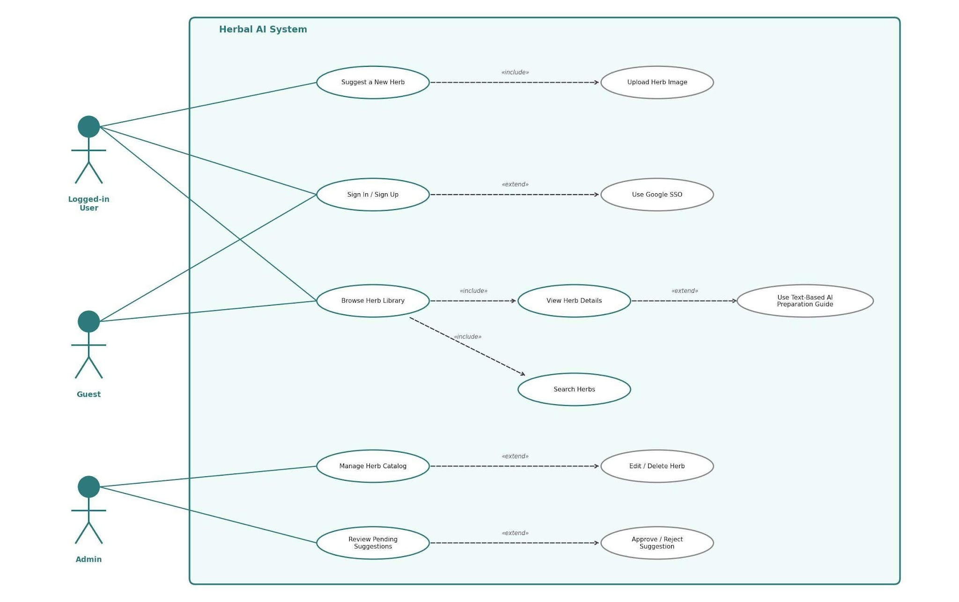
Figure 3 – Use Case Diagram: Herbal AI System (Guest, Logged-in User, Admin)

3.2. Functional Requirements
The following functional requirements are expressed as "shall" statements, organized by feature module. Each requirement is tagged with its current implementation status: Implemented, Partially Implemented, or Pending Verification.

Table 6 – Functional Requirements Implementation Status Summary

3.2.1 Herb Library (Intelligent Search & Browse)
FR-HERB-001: The system shall display a Verified Digital Repository of approved medicinal herbs. — Implemented
FR-HERB-002: The system shall allow users to search and filter herbs by name, Cebuano term, or specific ailment. — Implemented
FR-HERB-003: The Visual Reference Database shall provide high-quality, verified images alongside text-based preparation guides to prevent herb misidentification. — Implemented
FR-HERB-004: The system shall indicate DOH approval status on each herb entry to ensure data is strictly grounded in DOH safety standards. — Implemented
FR-HERB-005: The system shall display for each herb: local name, Cebuano name, scientific name, category, medicinal uses, step-by-step preparation method, dosage, warnings/contraindications, and verified images. — Implemented

3.2.2 Interactive AI Assistant (Dr. Ai Module)
FR-CHAT-001: The system shall provide 'Dr. Ai', a chat-based AI assistant powered by the Google Gemini API. — Implemented
FR-CHAT-002: Dr. Ai shall directly solve preparation and dosage risks by providing contextual, step-by-step instructions restricted to DOH-verified traditional plant information under RA 8423. — Implemented
FR-CHAT-003: The system shall display a safety disclaimer during all Dr. Ai chat sessions indicating that responses are for traditional knowledge guidance only and do not constitute medical advice. — Implemented
FR-CHAT-004: The system shall render quick-prompt symptom chips to simplify user interaction with Dr. Ai. — Implemented
FR-CHAT-005: The system shall ground Dr. Ai responses using a retrieval-augmented (RAG) knowledge-base layer maintained through the Admin Verification Dashboard. — Implemented

3.2.3 Herb Suggestion System
FR-SUG-001: The system shall allow registered logged-in users (Contributors) to submit new herb suggestions, including local name, scientific name, Cebuano name, medicinal uses, preparation method, dosage, warnings, and an optional image upload. — Implemented
FR-SUG-002: Submitted suggestions shall be set to 'Pending' status and shall not be published to the public library until approved. — Implemented
FR-SUG-003: The system shall support optional herb image uploads (JPEG/PNG, max 5MB) as part of the submission. — Implemented
The system shall notify the submitting logged-in user when their suggestion status changes (Pending → Approved or Rejected).FR-SUG-004: The system shall notify the submitting user when their suggestion status changes (Pending → Approved or Rejected). — Pending Verification (planned; not yet confirmed end-to-end)

3.2.4 Admin Verification Dashboard
FR-ADMIN-001: The system shall provide a secure Admin Verification Dashboard accessible only to Administrator-role users. — Implemented
FR-ADMIN-002: The Admin Verification Dashboard shall allow admins to approve, reject, or edit community suggestions before they are published to the public herb library. — Implemented
FR-ADMIN-003: The system shall allow Administrators to manage the herb catalog — adding, editing, or deleting herb entries. — Implemented
FR-ADMIN-004: The system shall log all admin actions (approve, reject, edit, delete) with a timestamp and admin user ID for full audit traceability. — Pending Verification (audit logging is planned but not yet fully implemented)
FR-ADMIN-005: The system shall allow Administrators to manage user accounts. — Implemented
FR-ADMIN-006: The system shall provide Administrators with a system statistics view summarizing platform activity. — Implemented
FR-ADMIN-007: The system shall allow Administrators to manage the Dr. Ai knowledge base used for RAG-grounded responses. — Implemented

3.2.5 Community Forum
FR-COMM-001: The system shall allow Contributors and Community Members to create discussion forum threads. — Implemented
FR-COMM-002: The system shall allow users to reply/comment on forum threads. — Implemented
FR-COMM-003: The system shall allow users to like forum threads and replies. — Implemented, pending full verification

3.2.6 Private Messaging
FR-MSG-001: The system shall allow registered users to send and receive private messages with other users. — Implemented
FR-MSG-002: The system shall persist and display conversation history between users. — Implemented
FR-MSG-003: The system shall deliver messages in real time using Socket.io. — Implemented, pending full verification

3.2.7 Herb Comments / Discussion
FR-COM-001: The system shall allow users to comment on individual herb detail pages. — Implemented
FR-COM-002: The system shall allow users to reply to herb comments. — Implemented
FR-COM-003: The system shall allow users to like herb comments. — Implemented

3.2.8 User Authentication & Session Management
FR-AUTH-001: The system shall allow users to register (sign up) with a unique email address and password. — Implemented
FR-AUTH-002: The system shall authenticate users on sign-in and issue a secure session token. — Implemented
FR-AUTH-003: The system shall enforce role-based access control (RBAC), distinguishing Admin and Contributor/Community User roles, restricting admin routes exclusively to Administrator-role sessions. — Implemented
FR-AUTH-004: The system shall allow users to view and edit their personal profile information. — Implemented
FR-AUTH-005: The system shall allow users to log out, invalidating the active session. — Implemented
FR-AUTH-006: The system shall support refresh-token renewal so authenticated sessions persist without requiring re-login. — Implemented
FR-AUTH-007: The system shall require email verification before granting full account privileges. — Implemented
FR-AUTH-008: The system shall provide a forgot-password flow that emails a secure password-reset link, and shall allow users to reset their password using a valid reset token. — Implemented
FR-AUTH-009: The system shall support Google OAuth SSO as an alternative sign-in/sign-up method. — Implemented

3.3. Usability Requirements
UR-001: The system shall deliver an intuitive user experience for all Filipinos, regardless of technical literacy level.
UR-002: The system shall be fully responsive across all screen sizes from 320px (mobile) to 2560px (desktop) using Tailwind CSS.
UR-003: All herb images shall include descriptive alt text for screen reader and accessibility compliance.
UR-004: The system shall provide clear, actionable error messages on all form validations.
UR-005: Navigation shall remain consistent across all pages with role-appropriate menu options visible per user role.

3.4. Performance Requirements
PR-001: The system shall load the landing page within 3 seconds under normal network conditions. — Pending Verification
PR-002: The system shall return herb search results within 2 seconds under normal load. — Pending Verification
PR-003: Dr. Ai conversational responses shall initiate rendering within 1.5 seconds of query submission. — Pending Verification
PR-004: At least 95% of standard API authentication and data transactions shall complete in under 1.0 second. — Pending Verification
PR-005: The platform architecture shall support at least 500 simultaneous user connections without performance degradation. — Pending Verification (formal load testing not yet conducted)
Formal performance and load testing has not yet been conducted as of this revision. These targets remain the acceptance thresholds for the Verification phase described in Section 4.

3.5. Logical Database Requirements
The database schema uses PostgreSQL with the following core entity tables:

Table 7 – Database Schema: users

Column | Data Type | Constraint | Description
id | varchar | PK | Unique user identifier
username | varchar | Unique | Unique display username
email | varchar | Unique | User email for authentication
password_hash | varchar | — | bcrypt-hashed password
name | varchar | — | Full name of the user
role | varchar | — | Role: 'admin', 'logged-in user', or 'member'
joined | datetime | — | Registration timestamp
emailVerified | boolean | Default: false | Whether the user has completed email verification

Table 8 – Database Schema: herbs

Column | Data Type | Constraint | Description
id | varchar | PK | Unique herb slug (e.g., 'lagundi')
localName | varchar | — | Filipino / common botanical name
cebuanoName | varchar | — | Regional Cebuano name
scientificName | varchar | — | Official scientific nomenclature
category | varchar | — | Medicinal grouping (e.g., respiratory, kidney)
medicinalUses | text | — | Documented symptoms and ailments
preparationMethod | text | — | Step-by-step preparation instructions
dosage | varchar | — | Safe quantity and frequency information
warnings | text | — | Side effects, contraindications, and toxicity boundaries
imageUrl | varchar | — | URL to verified plant photograph

Table 9 – Database Schema: suggested_herbs

Column | Data Type | Constraint | Description
id | int | PK, auto-increment | Submission identifier
submitter_id | varchar | FK → users.id | Logged-in User who submitted the proposal
localName | varchar | — | Proposed local or common plant name
scientificName | varchar | — | Proposed scientific classification
preparationMethod | text | — | Proposed preparation steps
imageUrl | varchar | — | Uploaded plant photograph URL
informationSource | varchar | — | Literature or tradition source citation
status | varchar | Default: 'Pending' | Queue state: Pending, Approved, or Rejected
submittedAt | datetime | — | Timestamp of submission

Additional entity tables implemented in the current schema include: herb_comments, threads, thread_comments, messages, and knowledge_base_entries, supporting the Community Forum, Private Messaging, Herb Comments, and Dr. Ai knowledge-base features respectively.

Figure 4 – Entity Relationship Diagram (ERD)
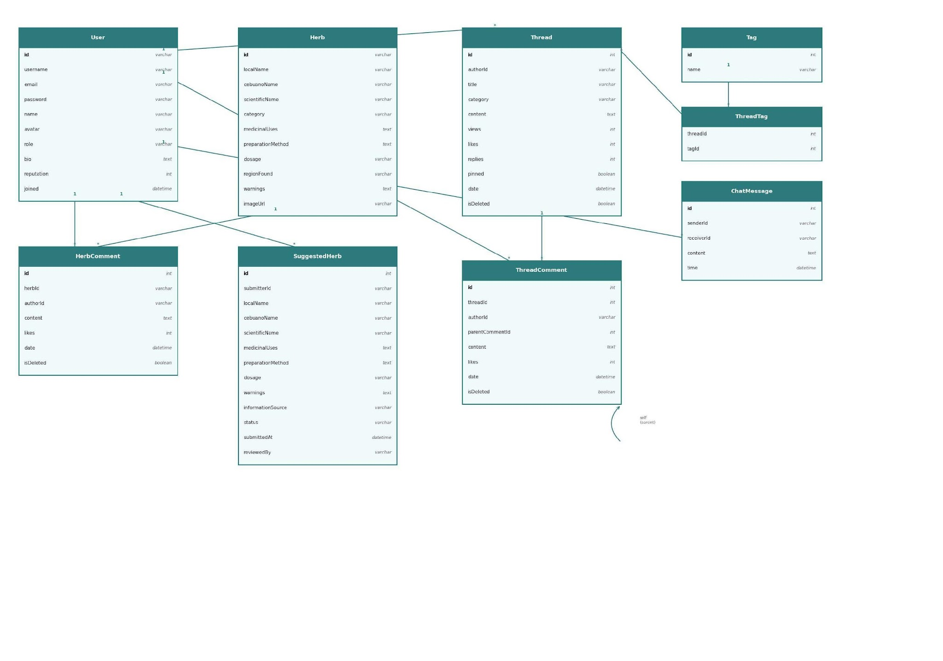
The ERD above shows all entities and their relationships in the Herbal AI PostgreSQL database, including cardinality (1-to-many, many-to-many) between User, Herb, HerbComment, SuggestedHerb, Thread, ThreadComment, Tag, ThreadTag, and ChatMessage.

3.6. Design Constraints
a) Technology Stack: The frontend uses Next.js. The backend uses Node.js and Express.js. The database is PostgreSQL, accessed through Prisma. The AI assistant uses the Google Gemini API. No substitution of these core technologies is permitted.
b) API Security: The Gemini API key is stored exclusively as a backend environment variable and is never returned in any frontend response or error message.
c) Authentication: All protected routes validate session/JWT tokens server-side, with refresh-token renewal. Admin routes verify admin-role claims before processing any request.
d) File Uploads: Herb image uploads are limited to JPEG/PNG format, maximum 5MB per file.
e) Browser Support: Chrome (latest), Firefox (latest), Safari (latest), Microsoft Edge (latest), iOS Safari, and Chrome Mobile.
f) Deployment: The system is intended to be deployable on standard cloud platforms. As of this revision, Docker packaging, CI/CD, and final hosting have not yet been fully verified and remain part of the Integration and Stabilization Phase.

3.7. Software System Attributes
a) Security: All passwords are stored using bcrypt cryptographic hashing. All API routes validate JWT authorization headers. Role-based access control restricts admin operations to verified admin-role tokens. HTTPS is enforced for all client-server communication.
b) Availability: The system targets 99.9% uptime with regular PostgreSQL backups once deployed; production availability has not yet been measured, as final hosting is pending.
c) Reliability: Standard database constraints, unique indexing on relational columns, and foreign key enforcement maintain transactional data consistency.
d) Maintainability: Clear separation of concerns — Next.js frontend, Express.js backend, PostgreSQL/Prisma database — with modular route handlers. Backend and frontend lint pass; backend and frontend TypeScript checks pass; the frontend production build passes. End-to-end and performance verification remain required.
e) Portability: The system functions correctly across all major web browsers (Chrome, Firefox, Safari, Edge, iOS Safari, and Chrome Mobile) on any screen size from 320px to 2560px.

3.8. Supporting Information

Statement of the Problem
- Information Fragmentation: Information regarding Philippine herbal medicines is scattered across unverified blogs and social media, making it difficult for users to find reliable data.
- Preparation Risks: Users lack accessible, step-by-step instructions for boiling and preparation, which frequently leads to dangerous mixtures and potential toxicity.
- Dosage Inaccuracies: There is no active system to guide users on proper consumption, resulting in ineffective treatments or accidental overdosing.
- Risk of Herb Misidentification: Users often know the name or medicinal use of a traditional plant, but lack a reliable visual reference to safely identify it in the wild or at a market.

Problem Solved / Solution
- The "Dr. Ai": A chat-based AI assistant that directly solves preparation and dosage risks through step-by-step instructions.
- Verified Digital Repository: Solves information fragmentation by ensuring all accessible data is strictly grounded in DOH safety standards.
- Visual Reference Database: Provides high-quality, verified images alongside the text-based preparation guide, allowing users to visually confirm the correct plant before using it.
- Admin Quality Control Barrier: Solves the verification gap by allowing crowdsourcing but requiring Admin approval before any new herb is published.

Herb Suggestion Workflow (Figure 2)
Step 1 | Step 2 | Step 3 | Step 4
Logged-in User Submits (Herb Suggestion Form) | Pending Admin Queue (Admin Dashboard) | Admin Reviews / Edits (Approve or Reject) | Published to Library (Public Herb Catalog)

4. Verification
The verification plan ensures each requirement specified in Section 3 is validated prior to final submission and deployment. As of Revision 3.0, an automated Vitest backend suite exists and 28 of 28 tests passed on 31 August 2026. Manual, integration, UAT, performance, and deployment verification remain required. Automated test coverage, integration testing, and performance/load testing are planned for the remainder of the Integration and Stabilization Phase.

Table 10 – Verification and Traceability Matrix

Req. ID | Requirement Target | Testing Method | Current Status | Current Status
FR-HERB | Verified Catalog & Search | System test: input search queries (e.g., "Sambong") and verify card rendering speed is under 2 seconds. | Implemented; manually verified
FR-CHAT | Dr. Ai Module & Gemini API | Integration test: send queries including potentially unsafe ones (e.g., "toxic doses"). Verify system instruction prompt restricts to safe botanical definitions with disclaimer displayed. | Implemented; manually verified
FR-SUG | Herb Suggestion Curation | End-to-end test: submit a sample herb suggestion as a logged-in user. Verify it appears in admin queue as 'Pending' and is not publicly visible. | Implemented; manually verified
FR-ADMIN | Admin Verification Dashboard | Functional test: log in as admin, approve a pending suggestion, and verify it appears live in the public herb catalog. | Implemented; manually verified
FR-AUTH | Authentication & Role Access | Unit test: attempt to access /api/admin routes with a non-admin JWT and without a JWT. Verify both are blocked with 403/401 responses. | Implemented; manually verified
UR-001 | Usability & Responsiveness | Manual test: access all pages on mobile (320px), tablet (768px), and desktop (1280px). Check layout integrity and navigation. | Implemented; manually verified
PR-001 | Performance | Load test: 500 concurrent connections. Measure page load times and API response times. | Pending — formal performance/load testing not yet conducted
FR-FORUM / FR-MSG | Community Forum & Private Messaging | Manual test of thread creation, replies, likes, and real-time message delivery. | Implemented; pending full regression verification
N/A | Automated Test Suite | Unit and integration tests covering API routes and core business logic. | Pending
N/A | Deployment & CI/CD | Verify Docker packaging, CI/CD pipeline, and production hosting. | Pending

Testing Types
- Unit Testing (Planned): API endpoint handlers and controller logic (Express.js route functions). Not yet implemented.
- Frontend-to-Backend (Next.js ↔ Express.js) and Google Gemini API integration.Integration Testing: Frontend-to-backend (Next.js ↔ Express.js) and Google Gemini API integration — currently verified manually.
- User Acceptance Testing (UAT): Manual testing of the user experience, Dr. Ai assistant responses, admin dashboard operations, and the full herb suggestion-to-publication workflow — ongoing.

5. Appendices

Appendix A – Proponent Roles

Table 11 – Proponent Roles

Name | Role | Responsibilities
Kevin C. Mercado | Project Manager | Project planning, coordination, documentation oversight, stakeholder communication, and overall system design.
Devon Descipulo | Backend Developer | Express.js REST API, PostgreSQL schema, Gemini API integration, JWT authentication, and security implementation.
Eumar Cabaluna | Frontend Developer | Next.js UI/UX, Tailwind CSS responsive design, frontend-backend integration, and accessibility compliance.

Appendix B – Capstone Documentation and Artifacts List
The following table lists the complete set of documents and artifacts required for the Herbal AI capstone project, along with their current status as of this revision.
Table 12 – Capstone Documentation and Artifacts List
# | Document / Artifact | Status
1 | Software Requirements Specification (SRS) | This document — Revision 2.0
2 | Software Project Management Plan (SPMP) | Companion document — Revision 2.0
3 | System Design Document (SDD) | In progress
4 | Entity Relationship Diagram (ERD) | Complete (Figure 4, Section 3.5)
5 | Use Case Diagram | Complete (Figure 3, Section 3.1)
6 | Class Diagram | Complete (Appendix D)
7 | UI/UX Wireframes or Prototype Screenshots | Complete (Appendix C — live prototype screenshots)
8 | Test Plan / Verification and Validation Report | In progress — manual test plan complete; automated V&V report pending
9 | User Manual | Pending
10 | Technical Manual / Installation Guide | Pending
11 | Source Code Repository | Available — active development repository
12 | Deployment Guide | Pending — deployment not yet fully verified
13 | Final Defense Presentation | Pending
14 | Final Capstone Manuscript / Project Report | Pending

Appendix C – UI Prototype Screenshots
The following screenshots show the actual prototype interface of the Herbal AI web application at 1440px width. These are taken from the working prototype developed by the team.

Figure C.1 – Home / Landing Page
The home page displays the Herbal AI landing interface featuring the Dr.Ai chat assistant preview, trending medicinal plants section, feature highlights (Preserving Heritage, AI-Assisted, Verified & Safe), and the Become a Contributor call-to-action.
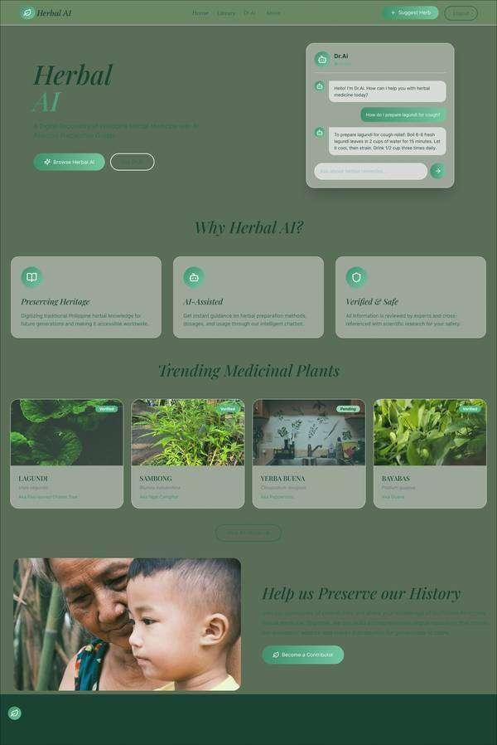
Figure C.2 – Sign In Page
User authentication page with email and password input fields, Forgot Password recovery link, Sign In button, and Google SSO option for quick authentication.
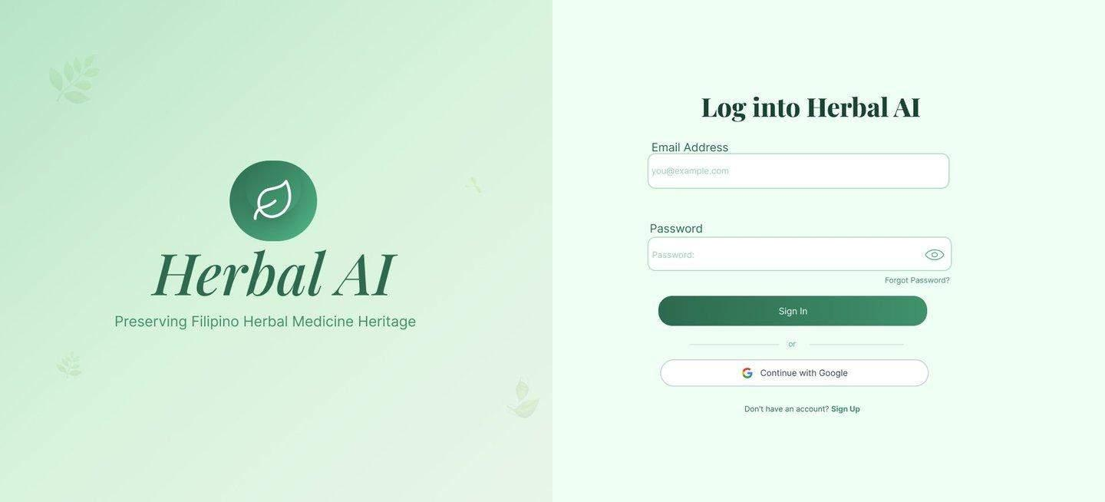
Figure C.3 – Sign Up Page
New user registration form with email, first name, last name, and password fields (minimum 8 characters), Sign Up button, Google SSO option, and link to Sign In page for existing users.
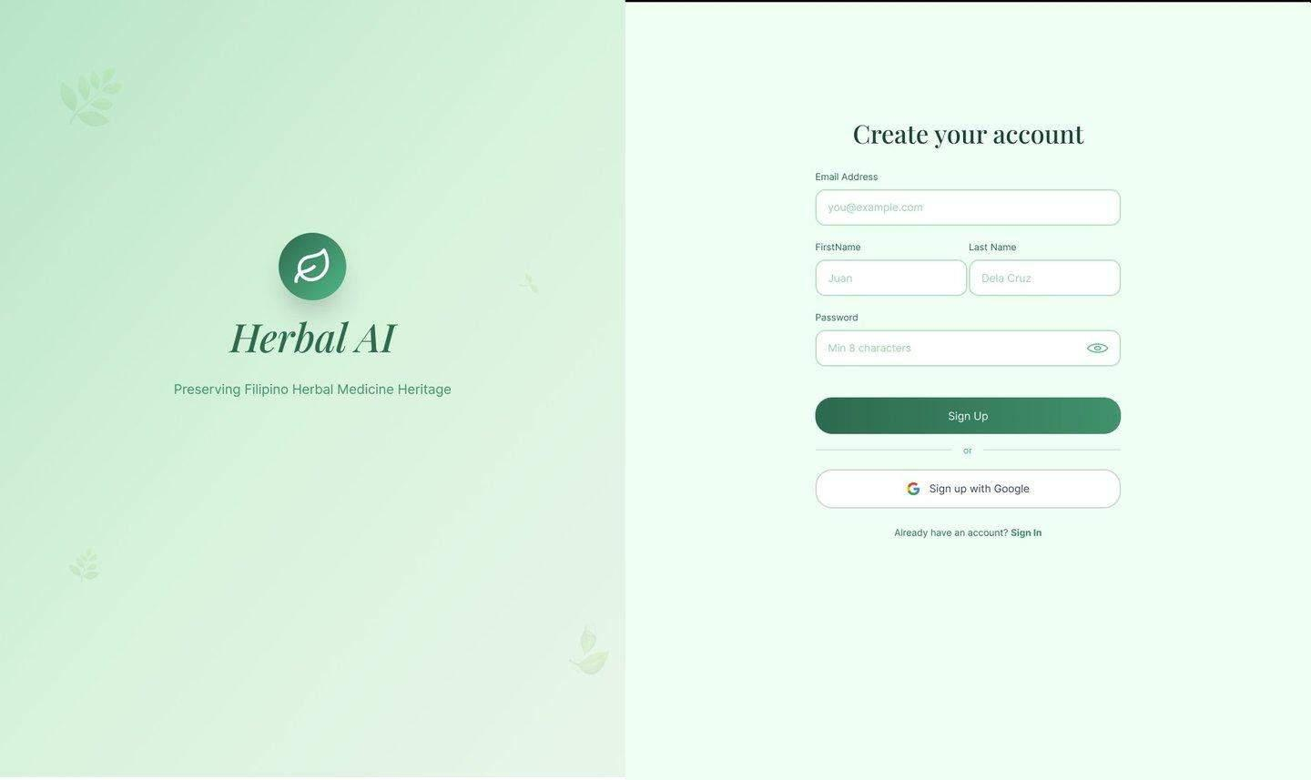
Figure C.4 – Herb Library Page
Shows the browsable herb catalog with search functionality, category filters (All, Medicinal, Aromatic, Culinary, Ornamental), and herb cards displaying verified plant images with status badges (Verified/Pending).
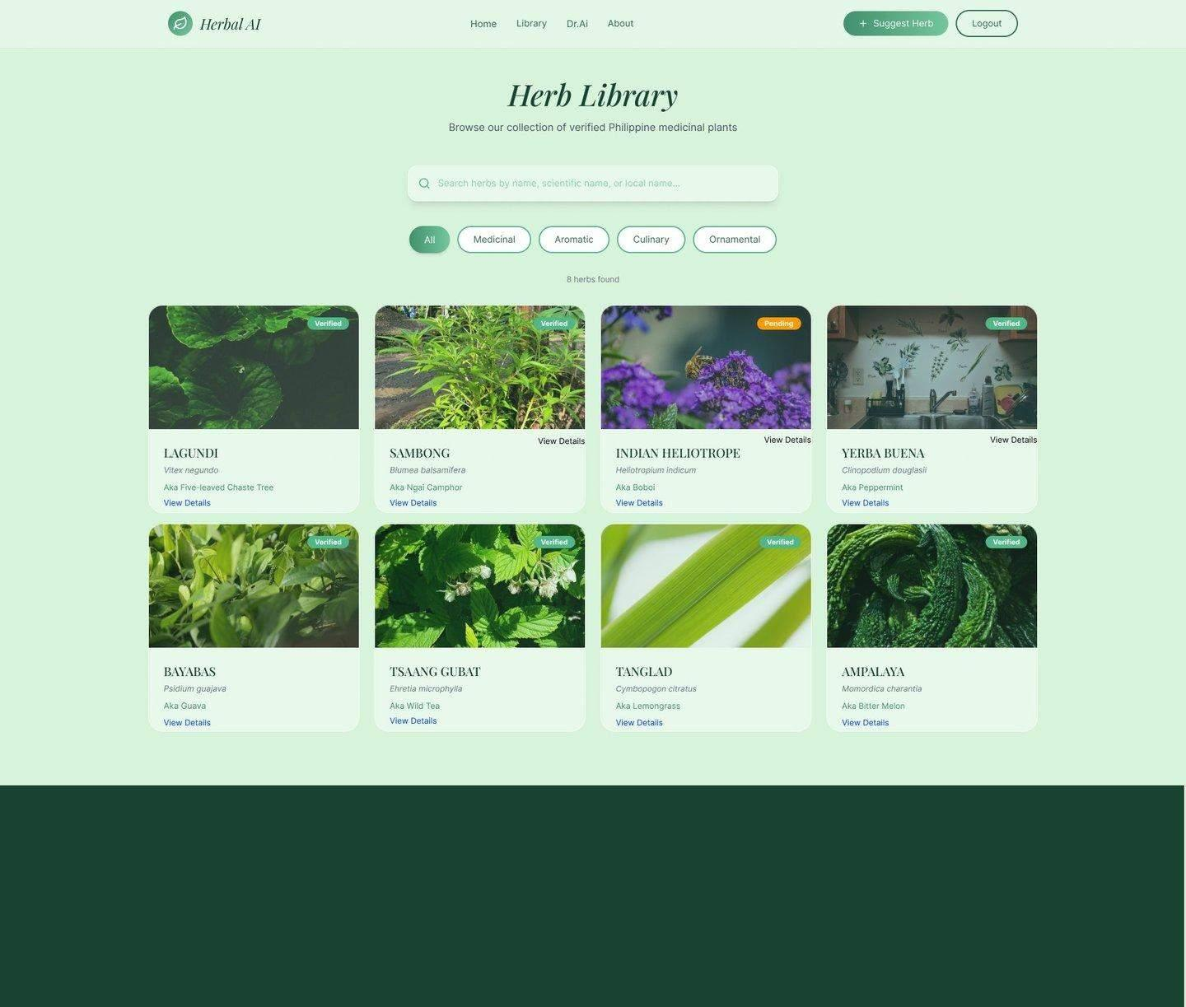
Figure C.5 – Herb Detail Page
Displays comprehensive herb information including description, preparation steps (numbered instructions), common uses, dosage information for adults and children, safety notes with warnings, and Dr.Ai integration for personalized queries.
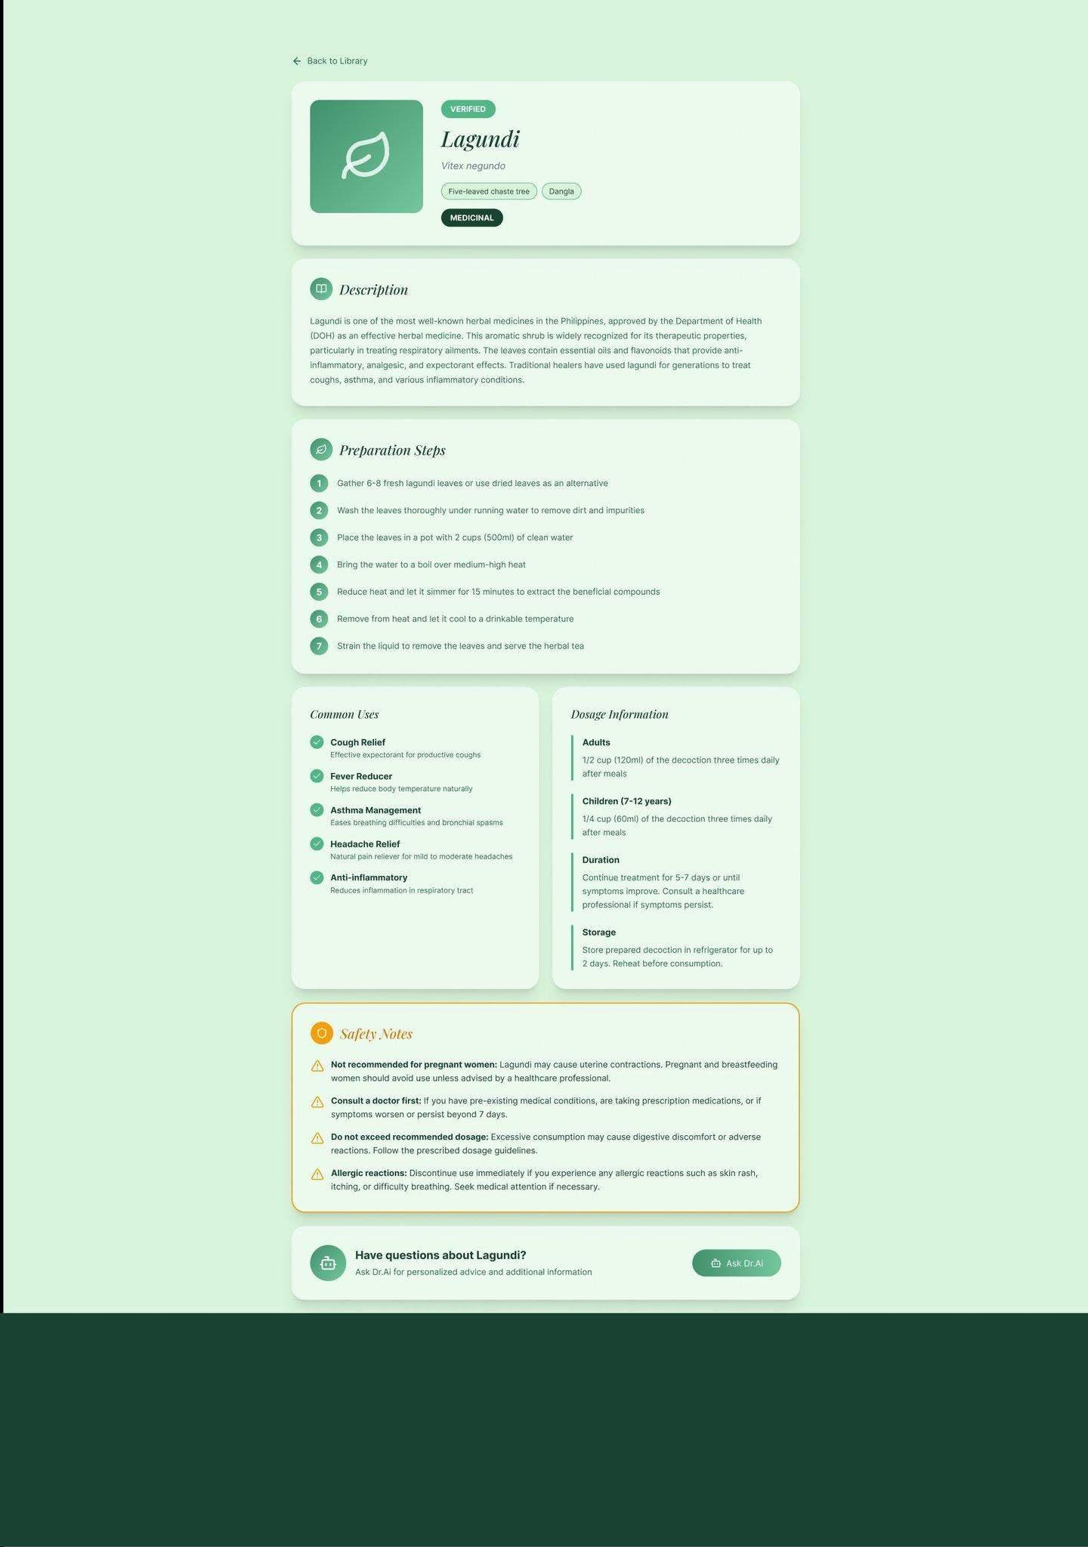
Figure C.6 – Dr.Ai Chat Assistant
Shows the interactive Dr.Ai conversational interface with quick-prompt symptom chips, AI responses with step-by-step preparation instructions, ingredients, dosage guidance, and safety warnings.
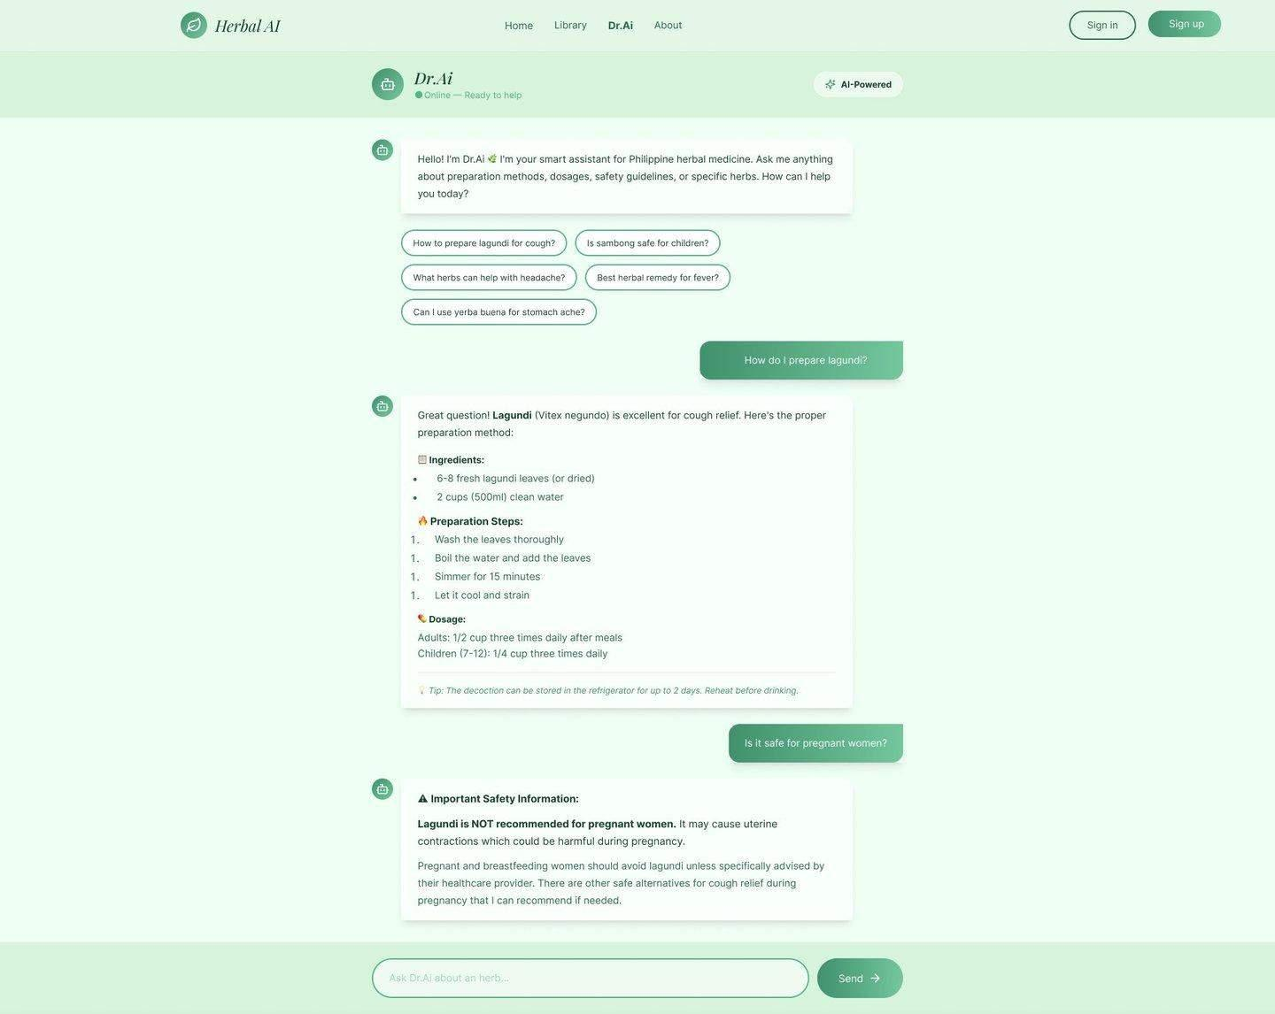
Figure C.7 – Admin Verification Dashboard (Pending Suggestions)
Admin verification panel displaying pending herb submissions with herb details, submitter information, submission date, and Approve/Reject action buttons to enforce the quality control barrier.
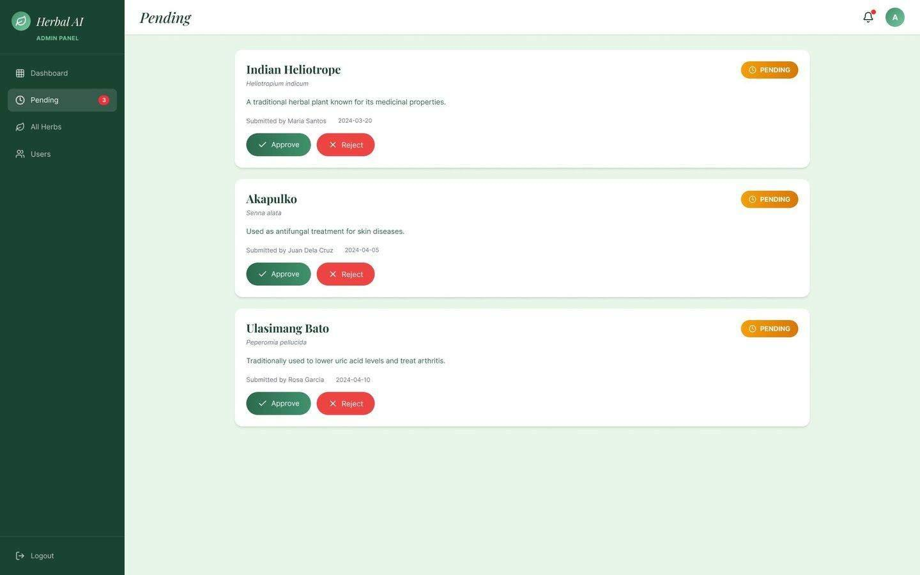

Appendix D – Class Diagram
The class diagram below illustrates the software architecture of the Herbal AI system, showing all domain entity classes, system/architectural classes (LocalDb, HerbalDb, AdminUi), their attributes, methods, and relationships.

Figure 5 – Class Diagram: Herbal AI System
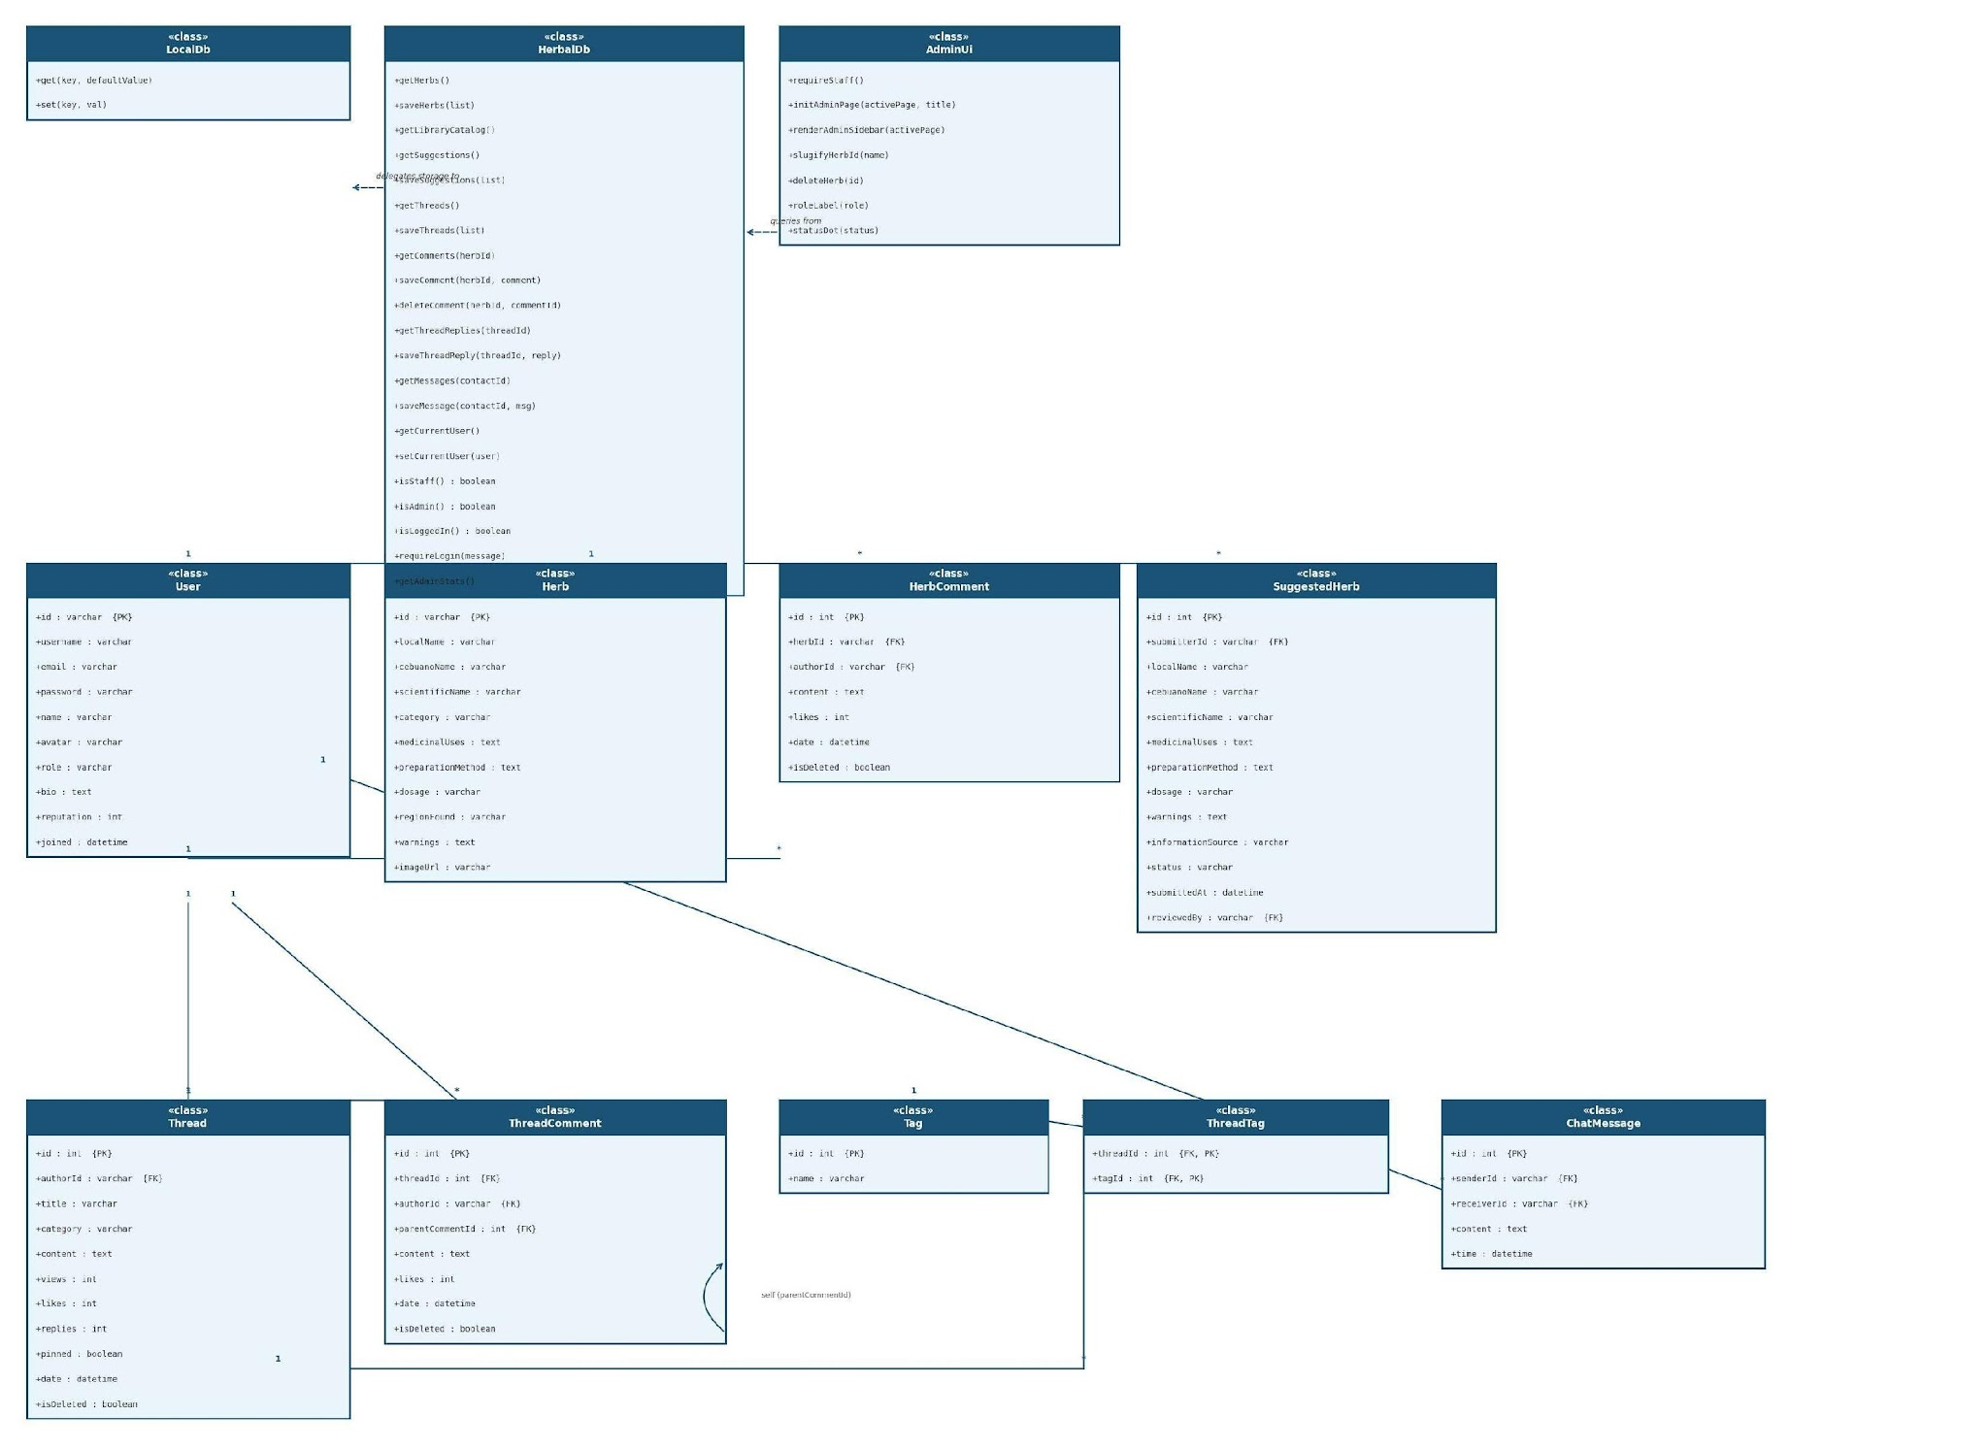

— End of Software Requirements Specification —
© 2026 Herbal AI Project Group — Cordova Public College, College of Computer Studies

Appendix E - Revision 3.0 Evidence Addendum
This addendum reconciles the SRS with repository evidence gathered on 31 August 2026.
Area | Revision 3.0 status | Evidence / remaining action
Automated verification | Verified baseline | 28/28 Vitest tests passed across 5 test files.
Code quality | Verified baseline | Backend/frontend lint and TypeScript checks passed; frontend production build passed with 18 routes.
Traceability and V&V | Documented | Requirement IDs, acceptance criteria, test execution log, UAT form, defect register, and performance plan are in Docs/.
Technical documentation | Complete | System design, privacy/backup/maintenance, deployment guide, and user manual are available in Docs/.
External evidence | Pending | UAT, performance/load testing, production deployment, backup/restore, SMTP, and OAuth verification require configured external resources.
This addendum supersedes any conflicting progress statement in earlier revisions. It does not claim completion of external deployment, UAT, email/OAuth, backup/restore, or load-test evidence that has not yet been executed.

