
CORDOVA PUBLIC COLLEGE
GABI, CORDOVA, CEBU

SOFTWARE REQUIREMENTS SPECIFICATION
CONDOMINIUM EDM PLATFORM
Presented by
BERN JUSTIN TAJANLANGIT
GERALD LITANG
MARK DONALD LAYON
HENGERT FORD KABRISTANTE
Presented to Danny Obidas
Instructor
29 October 2026

Signature
This specification defines the functional requirements, data rules, interfaces and verification criteria for the condominium EDM platform. The reviewers below may record acceptance after reviewing the document and demonstration. Blank fields do not indicate approval.
Table 1 Document review and sign off
Responsibility | Name | Signature and date
Project member | Bern Justin Tajanlangit | ________________
Project member | Gerald Litang | ________________
Project member | Mark Donald Layon | ________________
Project member | Hengert Ford Kabristante | ________________
Instructor | Danny Obidas | ________________
Evaluator | ________________ | ________________

Change History
Document version 1.0 29 October 2026
Table 2 Document change history
Version | Date | Description
1.0 | 29 October 2026 | Initial condominium EDM SRS covering the implemented four-source condominium EDM, shared Neon demonstration, account security and recorded local verification.

Preface
This Software Requirements Specification describes the condominium EDM platform for the project team, instructor and evaluators. The system integrates fictional tenancy, billing, maintenance and visitor data, checks quality during a pipeline, and restricts information according to each staff role. It demonstrates integration, data quality management and data governance in working code.
Requirement identifiers connect expected behavior to implementation and verification. The baseline includes the shared Neon demonstration and administrator-assisted account recovery as of 29 October 2026. Functional results are distinguished from unmeasured performance targets and future production controls. Account passwords, security answers and database credentials are supplied privately and are excluded from this document.

Table of Contents
Signature 2
Change History 3
Preface 4
List of Figures 7
List of Tables 8
1 Introduction 9
1.1 Purpose 9
1.2 Scope 9
1.3 Product Overview 10
1.3.1 Product Perspective 10
1.3.2 Product Functions 12
1.3.3 User Characteristics 12
1.3.4 Limitations 13
1.4 Definitions 13
2 References 14
Use of requirements language 14
3 Specific Requirements 15
3.1 External Interfaces 15
3.1.1 User Interface 15
3.1.2 Software and Communication Interfaces 15
Source data contracts 16
3.1.3 Primary API Endpoints 17
3.1.4 Use Case Diagram 19
Decision preconditions 22
3.2 Functional Requirements 22
3.2.1 Authentication and Session Management 22
3.2.2 Account Security and Assisted Recovery 23
3.2.3 Source Integration and Warehouse Loading 24
3.2.4 Data Quality Management 25
3.2.5 Governance and Classified Access 26
3.2.6 Browsing History and Audit 27
3.3 Usability Requirements 28
3.4 Performance Requirements 28
3.5 Logical Database Requirements 29
Snapshot integrity rules 31
3.5.1 Governance and Session Data 31
3.5.2 Required Persistence Behavior 32
3.5.3 Entity Relationship Diagram 33
3.6 Design Constraints 36
3.7 Software System Attributes 36
3.8 Supporting Information 37
Statement of the Problem 37
System Response 37
4 Verification 39
4.1 Acceptance Scenarios 40
4.2 Evidence and Remaining Work 41
5 Appendices 42
Appendix A Proponent Roles 42
Appendix B Documentation and Artifacts 42
Appendix C UI Prototype Screenshots 43
Appendix C Sign In 44
Appendix C Pipeline 45
Appendix C Quality and Issues 46
Appendix C Issue Queue 47
Appendix C Unified Tenant 48
Appendix C Governance 49
Appendix C Audit Detail 50
Appendix C Account Security 51
Appendix D Class and Service Diagram 52
Appendix E Implementation Evidence 53
Local demonstration sequence 53

List of Figures
Figure 1 System architecture 11
Figure 2a Property manager use cases 19
Figure 2b Data steward use cases 20
Figure 2c Finance front desk and Viewer use cases 21
Figure 3a Account and catalog relationships 33
Figure 3b Pipeline and quality relationships 34
Figure 3c Unified warehouse relationships 35
Figure 4 Pipeline quality review and correction workflow 38
Figure 5 Staff sign in 44
Figure 6 Pipeline history and source counts 45
Figure 7 Actual quality scores and rule results 46
Figure 8 Eligible quality issue review 47
Figure 9 Governed tenant detail and lineage 48
Figure 10 Field catalog and governance workspace 49
Figure 11 Readable policy audit evidence 50
Figure 12 Own security question and password controls 51
Figure 13 Service collaboration and database boundary 52

List of Tables
Table 1 Document review and sign off 2
Table 2 Document change history 3
Table 3 Intended audience 9
Table 4 Technology stack 10
Table 5 User roles and access boundaries 12
Table 6 Definitions and abbreviations 13
Table 7 Application screens 15
Table 8 Simulated source fields 16
Table 9 API endpoints and required access 17
Table 10 Functional requirement groups 22
Table 11 Usability requirements 28
Table 12 Local performance acceptance targets 29
Table 13 Source and warehouse entity dictionary 29
Table 14 Pipeline and quality entity dictionary 30
Table 15 Governance and account entity dictionary 31
Table 16 System quality attributes 36
Table 17 Requirement verification and traceability 39
Table 18 End to end acceptance scenarios 40
Table 19 Project responsibilities 42
Table 20 Project documentation and artifact inventory 42
Table 21 Release evidence and acceptance status 53

1 Introduction
Condominium staff often maintain tenant details, monthly dues, service requests and visitor entries separately. Different spellings, unit formats, missing contacts and invalid values can make combined records unreliable. The system integrates four simulated sources into a governed warehouse while retaining the original observations, quality findings and field provenance.

1.1 Purpose
This document specifies the required software behavior and observable acceptance criteria for the condominium EDM. It supports implementation review, classroom demonstration, testing and maintenance. It explains what the system integrates, how records are checked and corrected, which roles may access sensitive fields, and how actions are audited.
Table 3 Intended audience
Audience | Use of the specification
Project team | Locate requirements, source contracts, role limits, modules and acceptance criteria.
Instructor and evaluators | Assess integration, DQM, governance and the recorded classroom demonstration.
Property staff | Understand allowed work and the handling of quality issues and account recovery.
Testers and maintainers | Trace requirements to automated checks, known limitations and project artifacts.

1.2 Scope
The system shall extract from four seeded source tables, normalize and match records, evaluate database-defined quality rules, and load accepted data into a unified PostgreSQL warehouse. It shall provide pipeline history, quality results, an issue queue, tenant and unit views with lineage, a field catalog, policy and account-role controls, and an append-only audit trail.
The release includes five role accounts, fictional Filipino residents, at least 30 tenant identities and six months of dues. All roles can manage their own security question and password; a verified administrator can assist another account with a single-use recovery code. Real external integrations, SSO, file uploads, actual payments and machine learning are excluded. The shared Neon records are demonstration data, not actual condominium or financial records.

1.3 Product Overview

1.3.1 Product Perspective
The system is a browser application with separate frontend and backend workspaces. Next.js renders the interface and forwards same-origin API requests to Express. Express validates requests, verifies current permissions, runs integration and quality services, and accesses PostgreSQL through Prisma. A dedicated application schema separates project data in its configured Neon database.
Table 4 Technology stack
Layer | Technology | Responsibility
Frontend | Next.js App Router and TypeScript | Route entries, staff screens, navigation and form states.
Presentation | React, Tailwind CSS, shared controls and Lucide icons | Compact labelled forms, tables and responsive workspaces.
Backend | Node.js and Express with TypeScript | Sessions, validation, permissions, pipeline, quality and governance.
Persistence | PostgreSQL on Neon through Prisma | Source, staging, warehouse, catalog, session and audit records.
Validation and verification | Zod, Node test runner, Supertest, Playwright and Axe | Strict API contracts, local database checks and Chromium flows.
Figure 1 System architecture
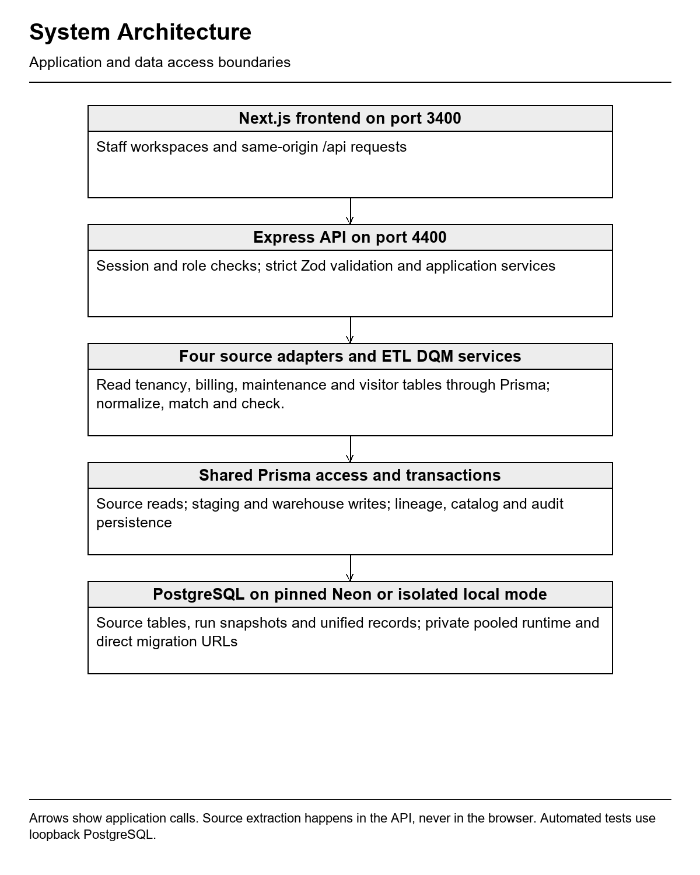

1.3.2 Product Functions
The functional groups are authentication and account security, four-source extraction, normalization and matching, warehouse loading, DQM scoring, issue decisions and corrections, role-aware browsing, catalog and policy review, account-role administration, and audit inspection. Counts and scores come from saved API/database results rather than fabricated dashboard values.

1.3.3 User Characteristics
Table 5 User roles and access boundaries
Role | Permitted work | Data or action boundary
Property manager Admin | All views; run pipeline; fix eligible issues; view amounts and visitors; edit policy prose, roles and recovery controls. | Full application data access; cannot change own role or assist own recovery through admin controls.
Data steward | Run pipeline; inspect quality and eligible issues; fix, accept or quarantine; view tenants and catalog. | No confidential dues amounts, visitor records or governance administration.
Finance | Tenant and unit browsing, quality read, financial dues and balances. | No visitors, issue mutation, pipeline triggering or governance administration.
Front desk Security | Tenant and unit browsing and restricted visitor entries. | No dues amounts, pipeline or quality administration.
Viewer | Tenant/unit browsing, quality read and catalog/policy information. | Contacts masked; no dues amounts, visitor entries or mutations.
Users need basic browser skills. A presenter may switch accounts to demonstrate different roles. The backend enforces the role boundary even if a caller bypasses the visible navigation. Private shared demo account changes affect every classmate using the same account.

1.3.4 Limitations
This synchronous classroom pipeline supports up to 500 extracted source rows per run and uses simulated sources. No live throughput, multi-user service guarantee or disaster-recovery capability is claimed. Previously accepted warehouse data is retained when a later source row is missing or rejected. A full lease transfer/termination workflow and automatic warehouse deletion are outside scope.

1.4 Definitions
Table 6 Definitions and abbreviations
Term | Meaning
EDM | Enterprise Data Management: coordinated integration, data quality and governance.
ETL | Extract, Transform, Load: read sources, standardize and reconcile records, then save accepted data.
DQM | Data Quality Management: completeness, validity, uniqueness, consistency and timeliness checks.
Staging | A run-tagged snapshot of extracted source rows and their disposition.
Warehouse | Accepted unified tenant, unit, lease, dues, maintenance and visitor records.
Lineage | The source record, source system, run and method responsible for a warehouse field.
Quarantine | A recorded rejection or explicit exclusion from future loads; not silent deletion of prior accepted data.
Data steward | A role responsible for eligible quality review and correction.
Classification | Public, internal, confidential or restricted metadata used with server permission rules.
Audit event | An append-only record of an actor, action, target, time and applicable before/after details.
Recovery code | A random, hashed-at-rest, single-use code issued after administrator verification.
MFA | Independent authentication factors; a security question is only another knowledge check and is not independent MFA.

2 References
The following references provide the course SRS structure and requirements-writing guidance. Copies are listed in the shared course Google Drive folder. Implementation evidence is listed separately in Section 4 and the appendices.
[1] IEEE, IEEE Recommended Practice for Software Requirements Specifications, IEEE Std 830-1998, 1998. Course copy: IEEE 830-1998.pdf.
[2] Cordova Public College, College of Computer Studies, Software Requirements Specifications, undated. Course template: SRS TEMPLATE.doc.
[3] D. Le Vie, Jr., Writing Software Requirements Specifications, TECHWR-L, March 7, 2007. Course copy: Guidelines.pdf.
Shared course folder: https://drive.google.com/drive/folders/1rOxZqRTiVmGWc6GVGlR8nJBUZx2ClREY

Use of requirements language
The word shall identifies required behavior in the implemented baseline. Proposed performance targets remain subject to timed measurement and are labelled accordingly. This document uses the course SRS structure without asserting formal standards certification or legal compliance.

3 Specific Requirements

3.1 External Interfaces

3.1.1 User Interface
Table 7 Application screens
Screen | Required content and actions
Sign in and recovery | Email/password login, generic error feedback, Forgot password and administrator-code recovery. No account credentials displayed.
Pipeline | Run history, trigger for authorized roles, stage/source counts, status, failures and quarantine/deduplication totals.
Tenants and units | Searchable paginated records; tenant detail, related records, permitted fields and lineage.
Data quality | Per-rule counts/scores, actual run history, prior-run comparison and rule definitions.
Issue queue | Rule/severity/status filters; protected source inspection; labelled fix fields; accept/quarantine with notes.
Governance | Catalog, policies/role permissions, account-role editor, administrator recovery and filtered audit details.
Account security | Own question enrollment/replacement, password change, confirmation and session-revocation feedback.

3.1.2 Software and Communication Interfaces
The browser shall call same-origin /api routes forwarded by Next.js to Express. The ordinary frontend binds to 127.0.0.1:3400 and the API to 127.0.0.1:4400. Loopback HTTP is for the laptop demonstration. Neon database connections require TLS, explicit endpoint pinning and matching pooled/direct database configuration. Production browser transport requires a separately configured HTTPS deployment.
The root private .env supplies the backend database settings. DATABASE_URL selects the pooled connection and DIRECT_URL selects the direct migration connection with the dedicated application schema selected. No secret is embedded in frontend source. Local mode uses the preserved ignored .local/local.env. Automated suites override database settings with their dedicated loopback database and never target Neon.
Authentication uses an opaque 12-hour HttpOnly SameSite Strict cookie. The cookie is Secure when the configured web origin uses HTTPS. Session tokens are stored as SHA-256 hashes; passwords and normalized security answers use salted scrypt. Mutations must send the exact configured Origin.

Source data contracts
Table 8 Simulated source fields
Source | Stored input fields
Tenancy | externalId, tenantId, tenantName, unitCode, email, phone, leaseStart, leaseEnd, status.
Billing | externalId, tenantId, tenantName, unitCode, period, dueDate, amountDue, amountPaid.
Maintenance | externalId, tenantId, tenantName, unitCode, description, openedAt, status.
Visitor log | externalId, tenantId, tenantName, unitCode, visitorName, enteredAt.
Each source has an internal primary key and a unique externalId. Deliberately nullable or malformed source fields let the DQM engine detect realistic defects. Billing values use PostgreSQL Decimal(12,2); source date strings are normalized before warehouse loading. The application does not upload CSV files or connect to actual condominium vendors.

3.1.3 Primary API Endpoints
Table 9 API endpoints and required access
Method and route | Purpose | Access
POST /api/auth/login | Authenticate and issue a safe profile/session cookie. | Public; eight requests per 15 minutes per IP.
GET /api/auth/me; POST /api/auth/logout | Read active profile; revoke the current session. | Signed in.
GET /api/pipeline/runs and /:id | Read paginated history and stage details. | quality:read.
POST /api/pipeline/runs | Run ETL and DQM; strict empty body. | pipeline:run; five requests per minute.
GET /api/quality/rules and /history | Read configured rules and last 12 completed quality snapshots. | quality:read.
GET /api/issues and /:id | Read eligible issues and protected source evidence. | quality:manage and classification checks.
PATCH /api/issues/:id | Fix, accept or quarantine with note and expectedUpdatedAt. | quality:manage plus required data access.
GET /api/warehouse/tenants and /units | Search/paginate permitted warehouse records. | tenants:read.
GET /api/warehouse/tenants/:id | Read related records and field provenance. | tenants:read; fields filtered by role.
GET /api/governance/catalog, /roles, /policies | Read ownership/classification metadata, roles and policies. | governance:read.
PATCH /api/governance/policies/:id | Edit prose with original text and reason. | governance:manage.
GET /api/governance/users; PATCH /users/:id/role | Read safe account list; update role with stale-change guard. | governance:manage.
GET /api/governance/audit | Filter and paginate append-only events. | audit:read.
GET /api/account/security | Read own question/configured state only. | Signed in with tenants:read.
PUT /api/account/security-question; POST /password | Set/change own question or password after fresh proof. | Signed in; ten writes per 15 minutes per IP.
POST /api/account/users/:id/recovery-code | Issue a private single-use 15-minute recovery code. | governance:manage and own password/answer.
DELETE /api/account/users/:id/security-question | Clear another account's lost question after verification. | governance:manage and own password/answer.
POST /api/auth/recovery/details and /reset | Validate email/code; verify answer if configured; reset password. | Public; shared eight requests per 15 minutes per IP.
GET /api/health | Check API process availability without querying the database. | Public.
Responses use { data: ... } or { error: { code, message } }. Zod validates bodies, queries and parameters. Statuses include 400 invalid recovery/body, 401 missing or invalid session/login, 403 denied permission/origin, 404 absent entity, 409 stale/conflicting operation, 413 oversized body, 422 invalid request values, 429 attempt/request limit and 500 sanitized unexpected failure. JSON bodies are limited to 32 KiB. Pagination uses page 1 onward and limits from 1 to 100 where supported.

3.1.4 Use Case Diagram
Figure 2a Property manager use cases
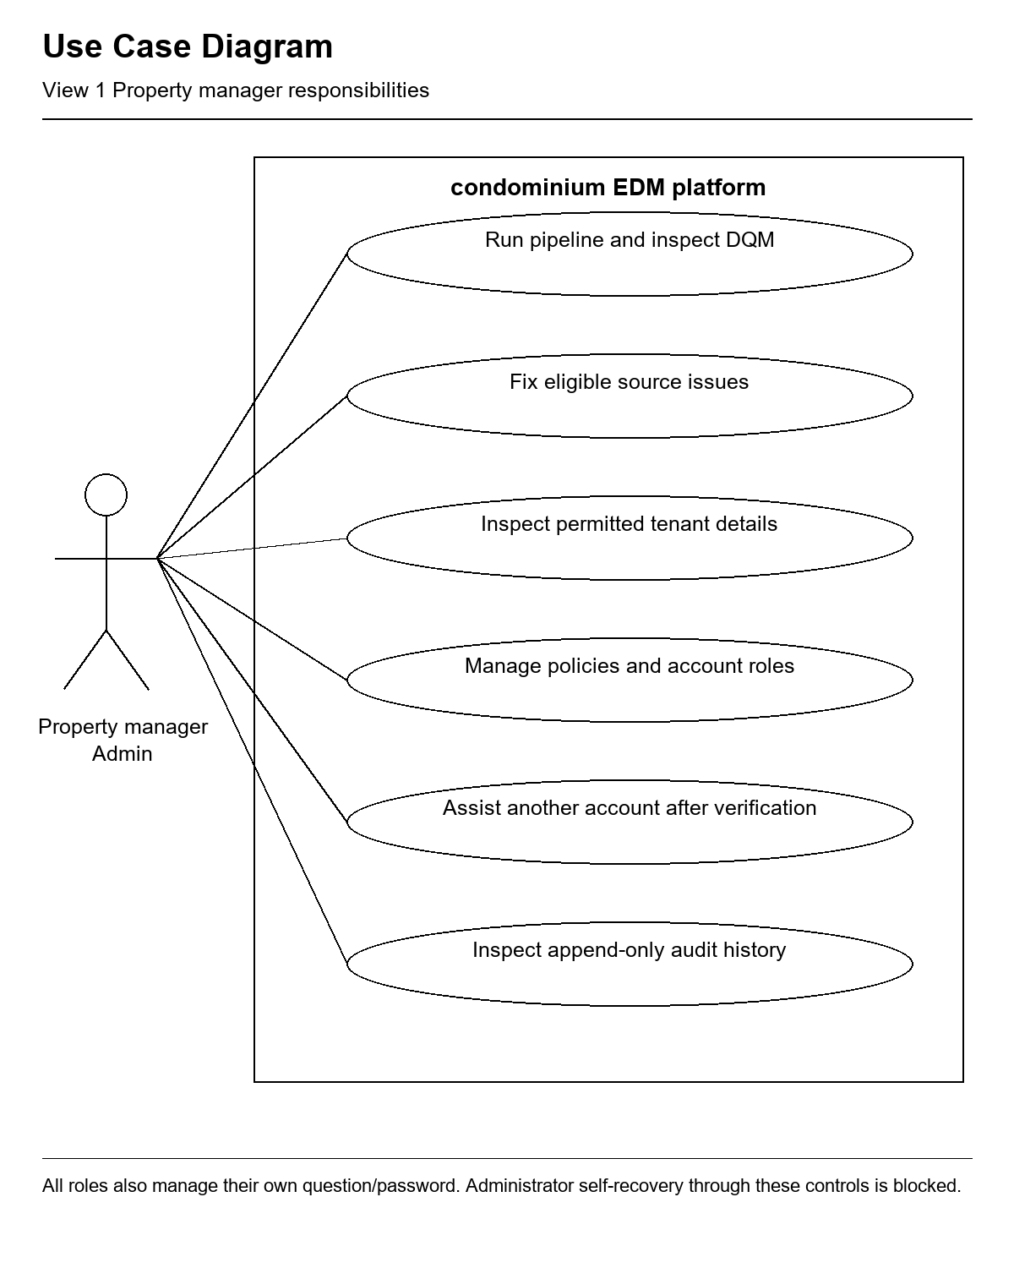
Figure 2b Data steward use cases
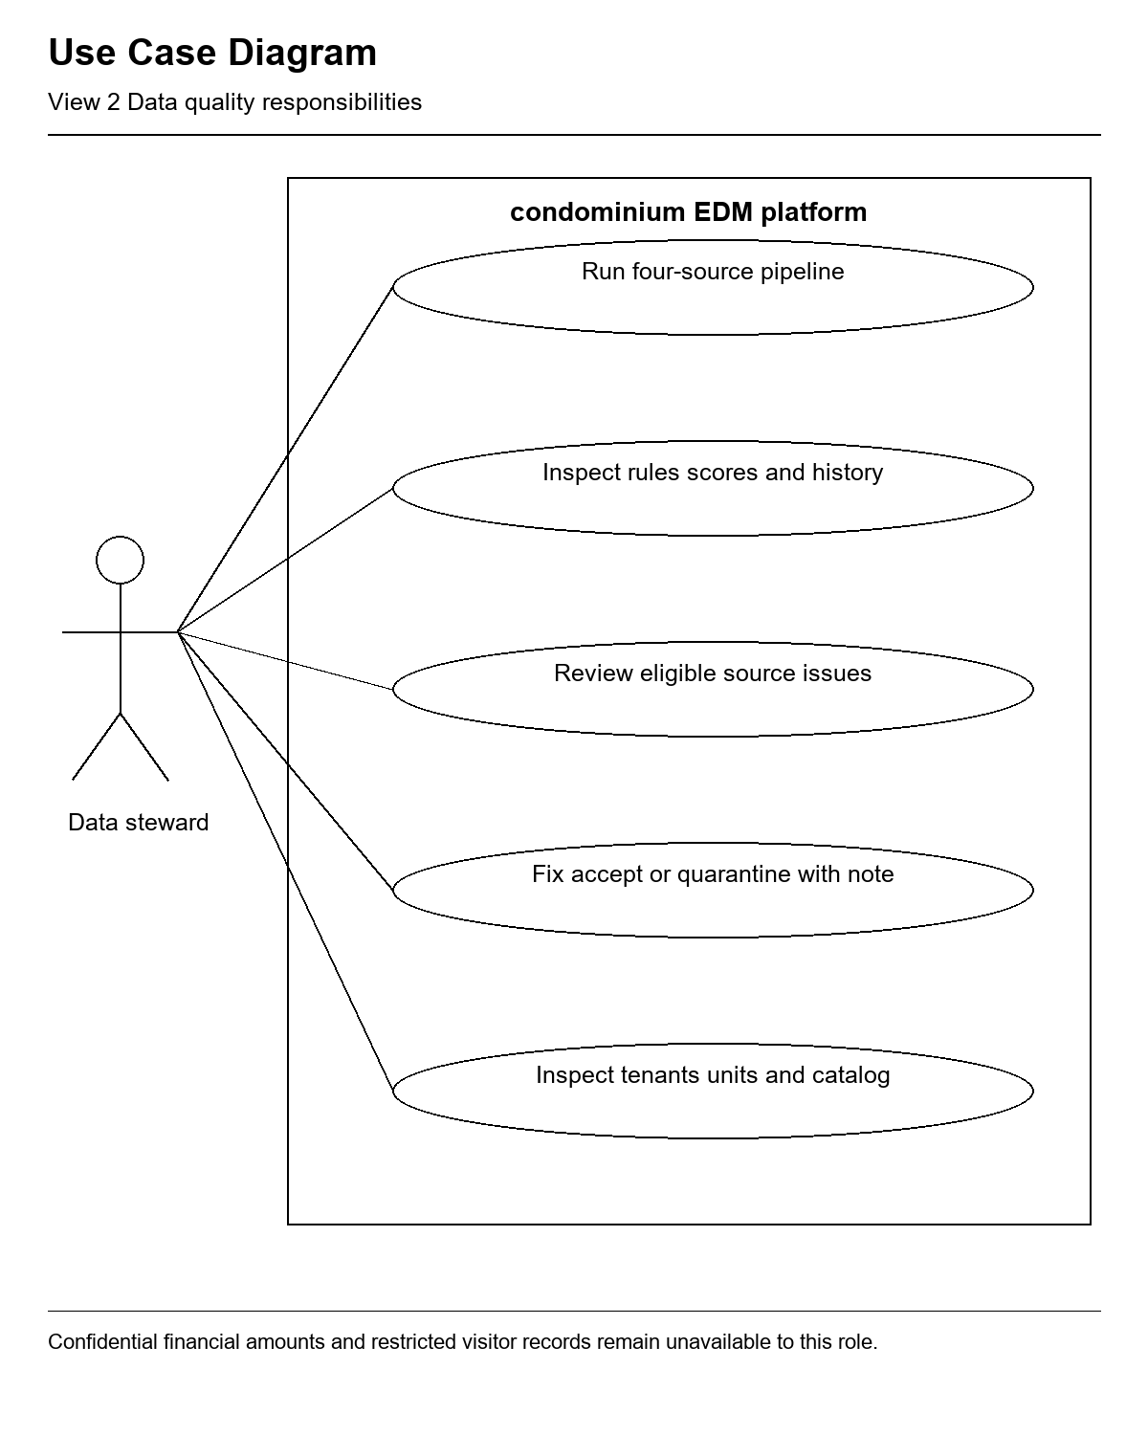
Figure 2c Finance front desk and Viewer use cases
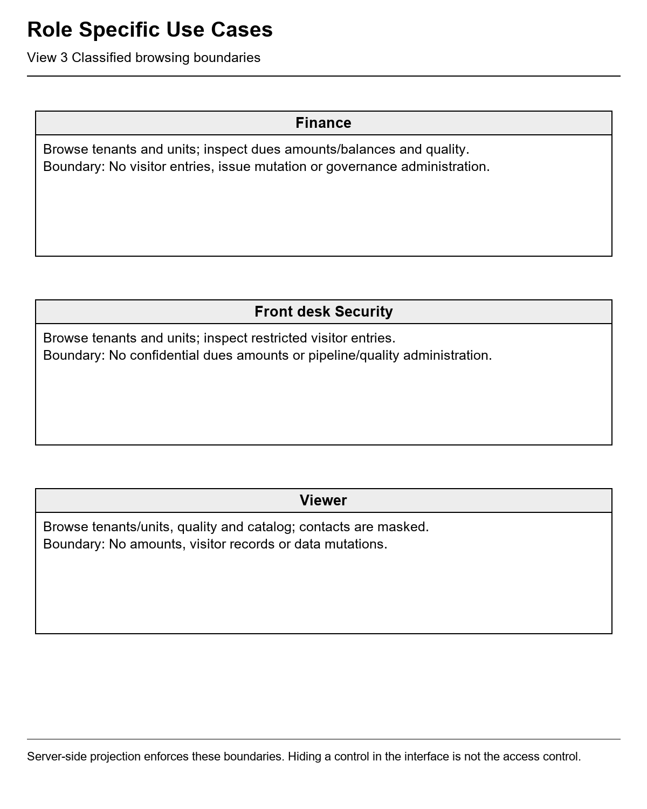

Decision preconditions
An issue decision requires the latest completed run, an unchanged source snapshot and expectedUpdatedAt. Notes must contain at least ten characters. Financial or visitor corrections require the relevant classified access. A fix must make the selected rule pass in its verification run; otherwise its transaction rolls back. Administrator recovery requires offline identity verification, a non-sensitive note, the administrator's own password and answer, and another active target account.

3.2 Functional Requirements
The following identifiers define the implemented functional baseline. Section 4 maps them to API/database checks, browser evidence and documented boundaries.
Table 10 Functional requirement groups
Group | Requirement identifiers | Purpose
AUTH | FR AUTH 01 to 06 | Authentication and Session Management
SEC | FR SEC 01 to 12 | Account Security and Assisted Recovery
INT | FR INT 01 to 10 | Source Integration and Warehouse Loading
DQM | FR DQM 01 to 09 | Data Quality Management
GOV | FR GOV 01 to 07 | Governance and Classified Access
AUD | FR AUD 01 to 05 | Browsing History and Audit

3.2.1 Authentication and Session Management
FR AUTH 01 The system shall authenticate active accounts using email and password with a generic invalid-credential message.
FR AUTH 02 The system shall store passwords as salted scrypt hashes and opaque session tokens as SHA-256 hashes without exposing them in API profiles.
FR AUTH 03 The system shall issue an opaque 12-hour HttpOnly SameSite Strict session cookie and reject expired, inactive or stale-version sessions.
FR AUTH 04 The system shall revoke the current session on logout and require authentication for protected data.
FR AUTH 05 The system shall enforce permissions in Express and reject mutations without the exact configured web Origin.
FR AUTH 06 The system shall limit login to eight requests per 15-minute IP window without automatic retry loops.

3.2.2 Account Security and Assisted Recovery
FR SEC 01 The system shall allow each role to set its own security question and normalized salted-hash answer after verifying the current password.
FR SEC 02 The system shall require the current answer as well as the current password to replace an existing question.
FR SEC 03 The system shall require a configured answer, current password and a different new password of 15 to 128 characters for password changes.
FR SEC 04 The system shall increment credential versions and revoke all account sessions and outstanding codes after password or question changes.
FR SEC 05 The system shall lock sensitive account verification for 15 minutes after five failures and persist the failure count in the database.
FR SEC 06 The system shall allow only an authorized administrator with fresh own password/answer proof and an identity-verification note to assist another active account.
FR SEC 07 The system shall issue a cryptographically random recovery code shown once, stored as a hash, email/version bound, single-use and expiring after 15 minutes.
FR SEC 08 The system shall validate the recovery code and email before showing the question, and revalidate them atomically during password reset.
FR SEC 09 The system shall require the configured answer during recovery and reject a code after five failed answer attempts, expiry, revocation or use.
FR SEC 10 The system shall allow a verified administrator to clear another user's lost question without reading or selecting a replacement answer; invalidate prior access and codes.
FR SEC 11 The system shall serialize sensitive account operations so concurrent recovery redemption succeeds at most once and old-password login cannot create surviving access after a change.
FR SEC 12 The system shall audit security changes and verification failures without recording passwords, answers or recovery codes; require sign-in after recovery.

3.2.3 Source Integration and Warehouse Loading
FR INT 01 The system shall extract from separate tenancy, billing, maintenance and visitor adapters and log source/stage row counts for every run.
FR INT 02 The system shall save each extracted row with source, source identifier, run identifier, raw payload and disposition in staging.
FR INT 03 The system shall normalize name casing/spacing, supported date formats, unit variants and status codes before matching/loading.
FR INT 04 The system shall match by tenant identifier where present and otherwise require an unambiguous compatible normalized name and unit; reject ambiguous associations.
FR INT 05 The system shall record duplicates explicitly and quarantine invalid rows with a reason rather than silently dropping them.
FR INT 06 The system shall upsert Tenant, Unit, Lease, DuesLedger, MaintenanceRequest and VisitorEntry records with stable canonical identifiers.
FR INT 07 The system shall calculate decimal balances, overdue months and request days using the run reporting time and save source-specific field lineage.
FR INT 08 The system shall reconcile extracted equals loaded plus quarantined plus deduplicated source rows and avoid duplicate canonical records on repeat input.
FR INT 09 The system shall retain previous accepted warehouse values when later source input is rejected or absent, retaining the last successful provenance.
FR INT 10 The system shall roll back failed warehouse writes, record a sanitized failed run/audit, reject concurrent pipeline/correction conflicts, and enforce the 500-source-row limit.

3.2.4 Data Quality Management
FR DQM 01 The system shall execute enabled QualityRule rows through one rule engine with recorded parameters and per-run definition snapshots.
FR DQM 02 The system shall check contact/email and lease-start completeness and validate unit formats, email, dates and nonnegative amounts.
FR DQM 03 The system shall check duplicate tenants and conflicting active leases; check unit references and normalized name consistency.
FR DQM 04 The system shall flag dues overdue by more than 90 days and open maintenance older than 30 days using configured rule thresholds.
FR DQM 05 The system shall save checked, passed and failed observations for each rule and compute per-rule and overall scores from those observations.
FR DQM 06 The system shall compare completed-run scores with the previous snapshot; show unavailable when no checks exist rather than fabricating values.
FR DQM 07 The system shall provide an eligible issue queue filtered by rule, severity and OPEN, RESOLVED, QUARANTINED or ACCEPTED status.
FR DQM 08 The system shall allow a permitted steward or administrator to correct allowed source fields, rerun validation and resolve only after the selected rule passes.
FR DQM 09 The system shall record accept/quarantine notes without rewriting older quality snapshots; quarantine shall exclude future loads while retaining prior accepted warehouse data.

3.2.5 Governance and Classified Access
FR GOV 01 The system shall maintain Admin, Data Steward, Finance, Front Desk Security and Viewer roles with server-enforced permissions.
FR GOV 02 The system shall expose confidential dues amounts/balances only to Admin and Finance and restricted visitor entries only to Admin and Front Desk Security.
FR GOV 03 The system shall mask tenant contact details for Viewer and omit prohibited related data and lineage from unauthorized responses.
FR GOV 04 The system shall provide a field catalog containing entity/field, owner, classification, source and applicable policy.
FR GOV 05 The system shall allow administrators to edit policy prose with an expected original value and reason without turning policy text into arbitrary permission grants.
FR GOV 06 The system shall allow administrators to change another account's role with a stale-role guard, preserve an active administrator, and revoke that target's sessions/codes.
FR GOV 07 The system shall retain ownership and classification metadata while stating that the policy reference to Philippine privacy law is not a compliance certification.

3.2.6 Browsing History and Audit
FR AUD 01 The system shall provide searchable paginated tenant/unit views with permitted related records and run-specific field provenance.
FR AUD 02 The system shall record pipeline start/finish, source edits, issue decisions, policy/role changes and successful confidential/restricted reads.
FR AUD 03 The system shall provide audit filters and pagination for authorized administrators and audit the inspection of audit details.
FR AUD 04 The system shall reject audit UPDATE, DELETE and TRUNCATE through database guards and expose no application audit-edit/delete endpoint.
FR AUD 05 The system shall retain run history, rule results and original snapshots so later corrections remain traceable.

3.3 Usability Requirements
Table 11 Usability requirements
ID | Requirement | Acceptance method
UR 01 | Use consistent navigation, domain labels, readable statuses and compact forms across the permitted screens. | Inspect all seven workspaces and sign-in/recovery.
UR 02 | Fit 360, 768 and 1280 pixel viewports; wide tables may scroll inside labelled focusable regions. | Browser overflow checks and visual captures.
UR 03 | Provide labelled inputs, keyboard-reachable controls, visible focus and semantic headings/tables. | Automated Axe checks plus manual inspection; full screen-reader testing remains unverified.
UR 04 | Provide loading, error with explicit Retry, empty and success states. Disable submitting forms. | Core recovery-state browser flow and form API/end-to-end checks.
UR 05 | Show correction fields and readable notes rather than requiring users to edit raw payload JSON. | Inspect issue and governance forms.
UR 06 | Do not poll, refresh on focus/reconnect or automatically retry failed requests. | Source review of explicit useResource loading and manual reload controls.

3.4 Performance Requirements
The following are proposed classroom acceptance targets, not established load-test results. Measure against a production build on the demonstration laptop and record dataset size, role, warm/cold startup and elapsed times. No production SLA or multi-user capacity is claimed.
Table 12 Local performance acceptance targets
ID | Target or implemented bound | Evidence state
PR 01 | A permitted ordinary tenant list should load within three seconds after warm startup for one operator. | Pending timed measurement.
PR 02 | A supported 237-row demonstration pipeline should complete within 30 seconds for one operator. | Pending formal timed measurement; functional runs passed.
PR 03 | Reject runs beyond 500 extracted rows; bound pagination to at most 100 rows and retain only 12 snapshots in the quality-history response. | Implemented limits; pipeline/API coverage.
PR 04 | Use a small configured runtime Neon pool and explicit user-triggered loading. | Pool pinned to two runtime connections in this setup; no remote stress test.

3.5 Logical Database Requirements
PostgreSQL is the active relational database, accessed through Prisma. All application table names use consistent project prefixes and the shared remote setup uses a dedicated application schema. Textual source values may be invalid; canonical warehouse fields use typed dates, decimal amounts and stronger constraints. The following dictionaries list principal attributes and integrity responsibilities.
Table 13 Source and warehouse entity dictionary
Entity | Principal attributes | Keys and integrity
SourceTenancy | Identifiers; name/unit; email/phone; lease dates; status. | Primary key id; unique externalId; intentionally nullable source fields.
SourceBilling | Identifiers; name/unit; period/dueDate; amountDue/amountPaid. | Unique externalId; Decimal(12,2) source values may be negative for DQM.
SourceMaintenance | Identifiers; name/unit; description; openedAt; status. | Unique externalId; source dates/status are textual.
SourceVisitorLog | Identifiers; name/unit; visitorName; enteredAt. | Unique externalId; restricted payload on application reads.
Tenant | id, externalId, name, email, phone. | Unique externalId; stable canonical identity.
Unit | id, code. | Unique normalized code with warehouse format constraint.
Lease | id, sourceKey, tenantId, unitId, startDate, endDate, status. | Unique sourceKey; Tenant/Unit foreign keys; at most one active lease per unit.
DuesLedger | id, sourceKey, unitId, period, dueDate, amounts, balance, monthsOverdue. | Unique sourceKey; Unit foreign key; decimal amounts and canonical nonnegative checks.
MaintenanceRequest | id, sourceKey, unitId, description, openedAt, status, daysOpen. | Unique sourceKey; Unit foreign key; derived days use run reporting time.
VisitorEntry | id, sourceKey, unitId, visitorName, enteredAt. | Unique sourceKey; Unit foreign key; restricted classification.
Table 14 Pipeline and quality entity dictionary
Entity | Principal attributes | Keys and integrity
PipelineRun | id, status, startedAt, finishedAt, extracted/loaded/quarantined/deduplicated counts, error. | Primary key id; persisted run lifecycle and sanitized errors.
PipelineStageLog | id, runId, source, stage, rowCount, message, createdAt. | PipelineRun foreign key.
StagingRow | id, runId, source, sourceId, payload, status, reason. | Run foreign key; row-level disposition and raw snapshot.
FieldLineage | id, entity, entityId, field, source, sourceId, runId, method. | Run foreign key; indexed entity/run/field provenance. Entity IDs are logical references.
QualityRule | id, code, title, dimension, severity, enabled, parameters. | Unique rule code; data-driven enabled definitions.
QualityResult | id, runId, ruleId, checked, passed, failed, definition. | Run/rule foreign keys; count consistency checks.
QualityIssue | id, runId, ruleId, stagingId, severity, message, status, note, timestamps. | Run/rule and optional staging foreign keys; decision history remains per run.
SourceDisposition | id, source, sourceId, note, actorId, createdAt. | Unique source/sourceId pair; explicit future-load exclusion; actor/source identifiers are logical references.

Snapshot integrity rules
Each extracted row receives a staging snapshot and one recorded disposition. Source IDs have separate system namespaces. Repeated accepted input uses stable canonical keys rather than duplicating warehouse entities. Rule results preserve the checked definition. Quality issue corrections verify the latest source snapshot before mutation. Decimal balances and age-derived values are interpreted using their successful load context.

3.5.1 Governance and Session Data
Table 15 Governance and account entity dictionary
Entity | Principal attributes | Keys and integrity
Role | id, code, name, permissions. | Unique code; User role foreign key target.
User | id, email, name, passwordHash, active, roleId, credentialVersion, question/answer hash, failures/lock. | Unique email; Role foreign key; never return password/answer hashes.
Session | id, userId, tokenHash, expiresAt, credentialVersion. | Unique tokenHash; User foreign key; cascade on user deletion; reject stale versions.
PasswordRecovery | id, userId, issuedById, tokenHash, version, expiry/use/revocation times, attempts. | User foreign key; unique tokenHash; issuer identifier is a logical reference, not a declared foreign key.
Policy | id, name, description. | Unique name; referenced by field classifications.
DataOwner | id, name. | Unique named owner; referenced by field classifications.
FieldClassification | id, entity, field, classification, source, ownerId, policyId. | Unique entity/field; DataOwner and Policy foreign keys.
AuditLog | id, optional actorId, action, entity/entityId, before/after, IP, createdAt. | Append-only database guards; actor/target IDs are logical references, not declared foreign keys.

3.5.2 Required Persistence Behavior
Source, staging, warehouse, quality, catalog, account and audit records shall persist in PostgreSQL. Schema updates use recorded migrations. Local seed reruns preserve existing account passwords and edited policies. The authorized shared Neon import is guarded against existing operational data and prior import markers; it is not a daily startup action.
A failed load shall roll back warehouse mutations and retain a sanitized failure event. Concurrent corrections shall not silently overwrite stale source changes. Database backup/restore and retention policies require a separate operational procedure; no automatic purge, archival or tested disaster-recovery plan is claimed.

3.5.3 Entity Relationship Diagram
Figure 3a Account and catalog relationships
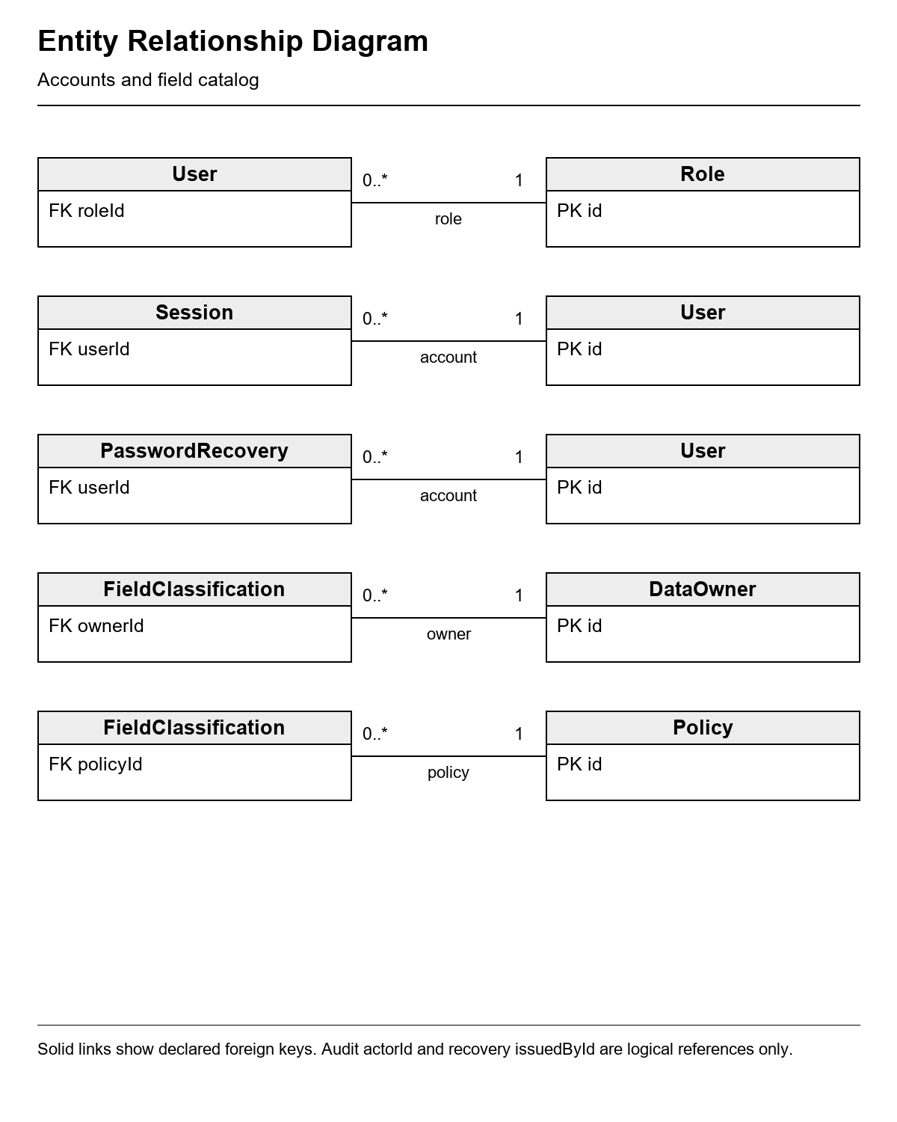
Figure 3b Pipeline and quality relationships
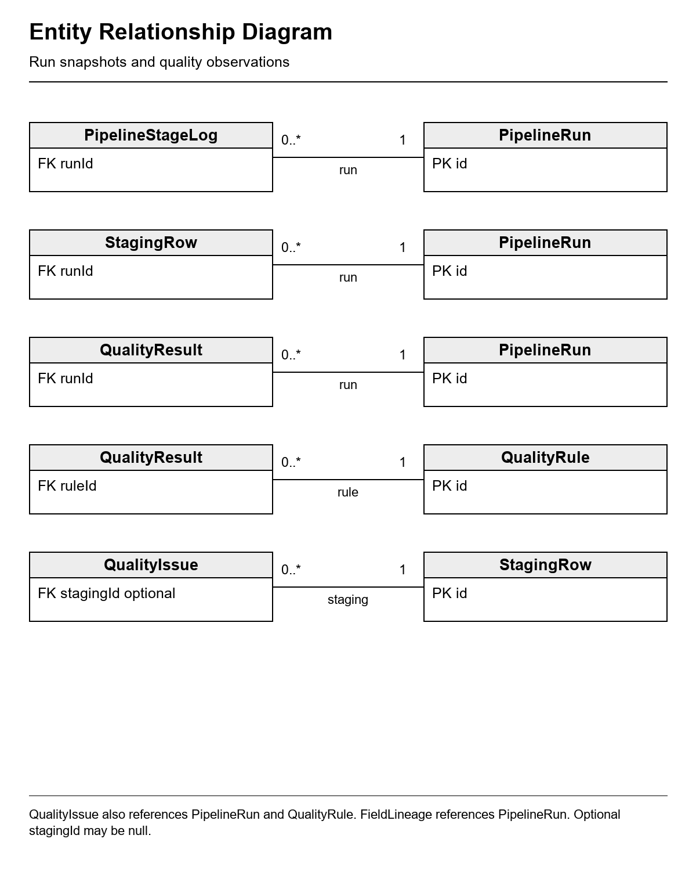
Figure 3c Unified warehouse relationships
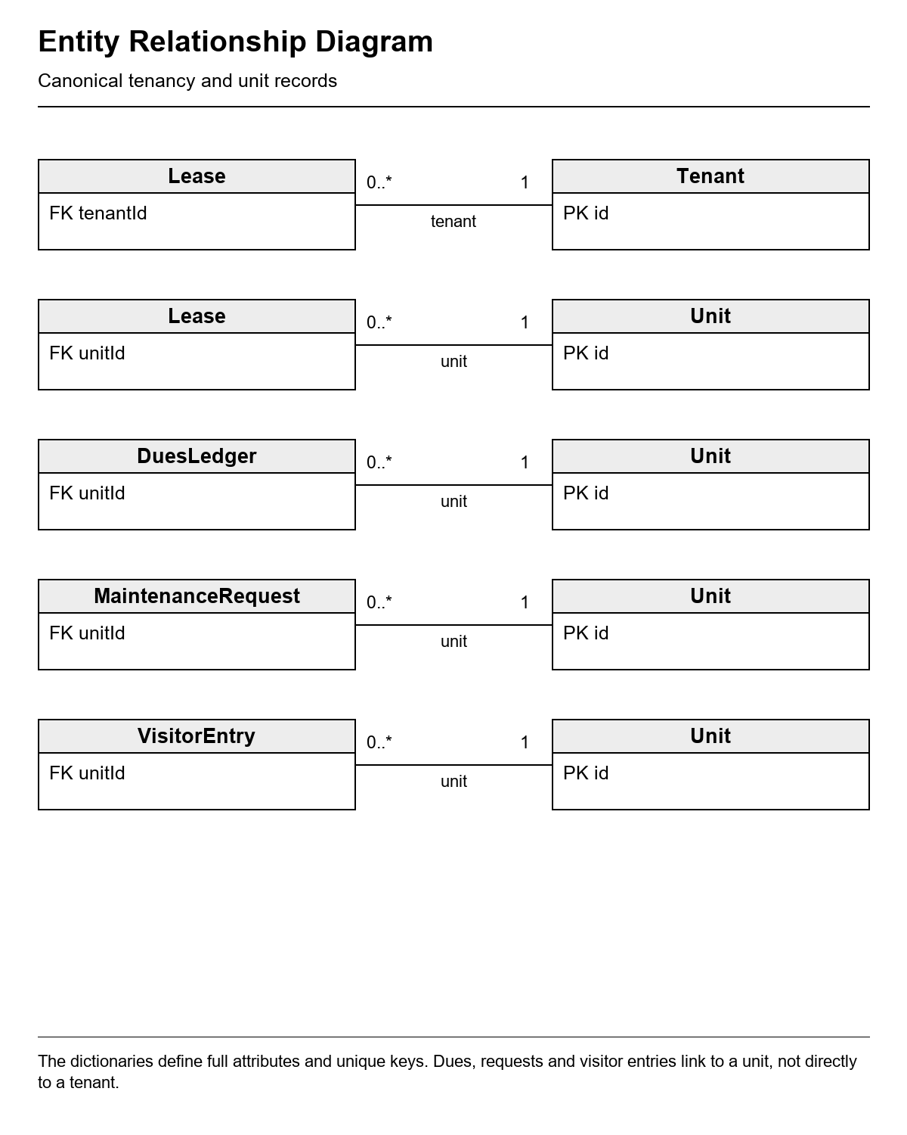
Multiplicity labels indicate one parent record and zero or many children; optional child foreign keys may be null as stated. Repeated entity boxes refer to the same table. Source payload identifiers and polymorphic lineage/audit identifiers are logical references and are not represented as enforced warehouse foreign keys.

3.6 Design Constraints
The frontend shall use Next.js App Router and TypeScript, and the backend Express and TypeScript in separate frontend and backend folders. Route entries remain in frontend/app; feature screens in frontend/src/features; backend logic in backend/src/modules. One typed browser client supplies the shared response/error contract.
Express shall own database access, transactions and classified projections. Prisma schema changes shall be stored as migrations. Pooled/direct Neon URLs and private account files shall stay ignored and out of source, screenshots and logs. No automated test shall target Neon; testing uses dedicated loopback PostgreSQL.
The interface shall retain a compact neutral palette with one accent, domain-specific labels and explicit loading. It shall not invent metrics, legal compliance, email delivery or external integrations. The application has no public sign-up, file import, payment gateway, arbitrary permission editor or classification editor.

3.7 Software System Attributes
Table 16 System quality attributes
ID and attribute | Required behavior or boundary
SA 01 Security | Fresh session/permission checks, classified projections, scrypt password/answer hashes, hashed tokens, version revocation, Origin checks and bounded attempts.
SA 02 Reliability | Transactional loads/corrections, stable keys, run locks, stale-change guards and explicit failure records.
SA 03 Maintainability | Separate route, service, repository/adapter and validation modules; documented project map and tests.
SA 04 Accountability | Named owners, field catalog/policies, source/run lineage and append-only action/read evidence.
SA 05 Portability | Document root setup and private environment placement; shared Neon runtime can be used from another laptop without local PostgreSQL.
SA 06 Availability | Persistent database storage; no measured uptime, remote throughput or multi-server rate-limit guarantee.

3.8 Supporting Information

Statement of the Problem
Separate condominium records may disagree about a tenant name or unit, contain missing contacts, refer to nonexistent units or hold overdue and invalid amounts. A simple join can spread these defects and expose financial or visitor information to the wrong role. Staff also need a record of who corrected data and why.

System Response
The system normalizes and reconciles four simulated sources, records raw run snapshots, evaluates data-defined rules, and loads accepted canonical data with lineage. Eligible staff resolve issues with notes and verification; protected API projections and audit events govern the unified store.
Figure 4 Pipeline quality review and correction workflow
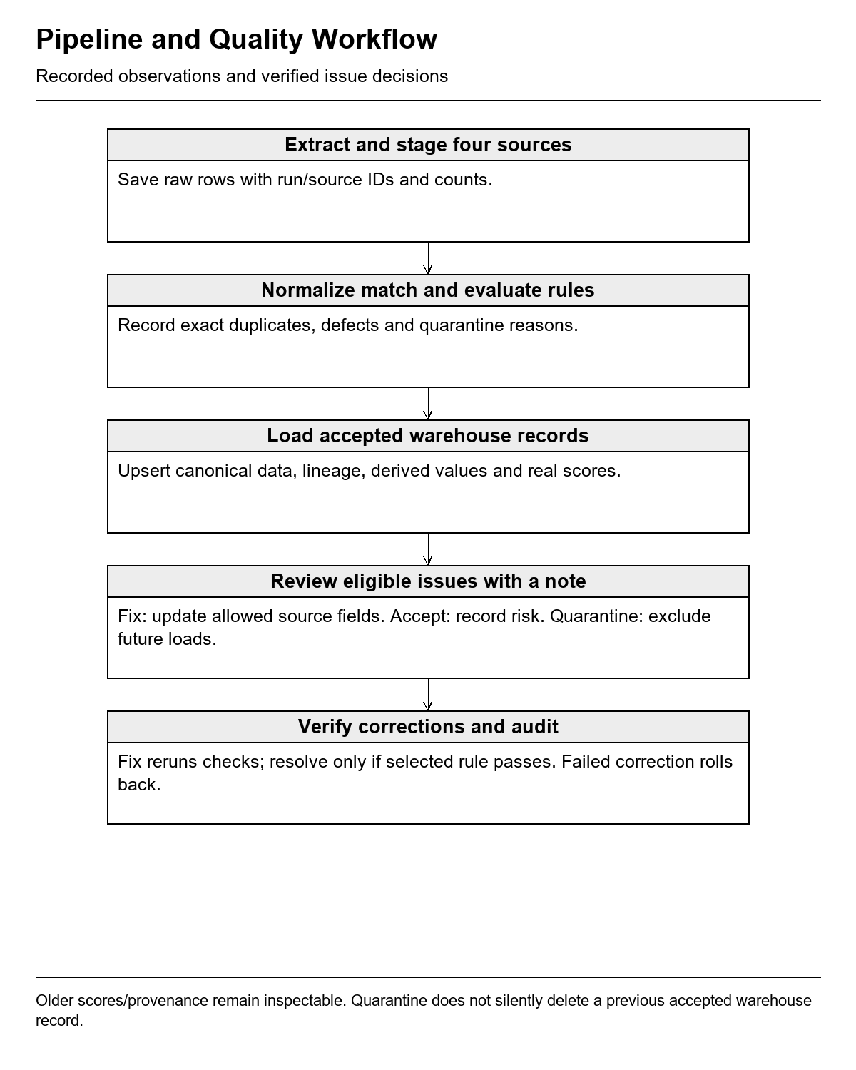

4 Verification
The implementation baseline was reviewed on 29 October 2026. Tests and browser evidence below use fictional data on isolated loopback PostgreSQL. Shared Neon provisioning, one authorized import/initialization and bounded runtime smoke checks are separate operational evidence; they do not constitute remote automated test or load-test coverage.
Table 17 Requirement verification and traceability
Requirements | Verification method | Recorded state
FR AUTH 01 to 06; FR SEC 01 to 12 | Authentication, credential-proof, session/version, permission, Origin and attempt-limit tests; full security browser flow. | Passed local API/security suites and one account-security Chromium flow.
FR INT 01 to 10 | Transform and pipeline tests; staged-row reconciliation, identity/idempotency, ambiguity, retained data, concurrency and rollback assertions. | Passed unit/integration and instructor acceptance.
FR DQM 01 to 09 | Clean/defect coverage for all 13 rules; saved counts/scores; six corrected defects and selected-rule verification. | Passed; local score improved 92.18% to 94.84%.
FR GOV 01 to 07 | Direct API permissions, classified fields, catalog/policy edits, role change/revocation and three-role tenant page. | Passed governance/acceptance and browser flows.
FR AUD 01 to 05 | Append-only guard tests, pipeline/correction/read audits, stable history and filtered audit-detail browser flow. | Passed local API/database and Chromium.
UR 01 to 06 | 360/768/1280 core layout checks; 360/1280 security/audit checks; Axe and loading/error/empty scenarios. | Passed recorded automated/visual checks; manual screen-reader and other browsers unverified.
PR 01 to 04; SA 06 | Functional bounds and configuration inspection; production build. | Limits implemented; formal latency, capacity, availability and restore measurements not established.
SA 01 to 05 | Source/configuration review, migration tests, build, docs map and secret scan. | Lint/types/build passed; 115 source/document files had no configured account/database password match before this SRS authoring.

4.1 Acceptance Scenarios
Table 18 End to end acceptance scenarios
Scenario | Expected observable result
Four-source reconciliation | One Maria Santos in unit 12-A has evidence from tenancy, billing, maintenance and visitors despite source naming/unit variants.
Row accountability | Initial 237 extracted source rows equal 206 loaded plus 30 quarantined plus one deduplicated.
Six quality corrections | Invalid email, missing contact, missing lease date, invalid date, malformed unit and negative payment can be corrected through permitted API/form actions.
Real score and history | A local correction sequence raises quality from 92.18% to 94.84%; earlier snapshots remain unchanged.
Role-specific tenant page | Admin sees financial/visitor details; Finance sees amounts without visitors; Viewer has masked contacts and no amounts/visitors.
Governed actions | Forbidden direct API calls are denied; changing a role affects the next authenticated view and revokes old access.
Audit evidence | All eight local acceptance runs have start/finish events and all six corrections/decisions have audit entries.
Password and recovery | Owner sets question/changes password; verified admin issues code; requester resets once; admin clearing a lost answer revokes old access.
Concurrent and repeat actions | Repeated pipelines preserve canonical IDs/counts; stale fixes fail; concurrent code redemption succeeds once.
Policy and audit view | Admin edits policy prose with a reason and inspects readable filtered before/after audit details.

4.2 Evidence and Remaining Work
The recorded baseline passed 32 unit tests, 41 reported normal local database/API checks, four core Chromium flows and one additional account-security browser flow. The final instructor acceptance rerun passed three access checks and ten acceptance checks including parent groups, followed by two presentation Chromium flows. Lint, both TypeScript checks and the complete Express/Next.js production build passed.
Six migrations are recorded. The sixth additive account-security migration was applied to Neon once after local verification; before/after account hashes, roles, active flags and operational counts matched. The final runtime smoke check used three HTTP requests for Viewer sign-in, account-profile read and sign-out, without changing a password or question. The shared source import and initialization were performed once.
Formal instructor sign-off is recorded only when reviewers complete the approval table. Timed performance, backup restoration, production hosting, restricted runtime database identities, distributed rate limiting and multi-user capacity need separate operational work. Non-Chromium and manual screen-reader verification remain unrecorded. These boundaries do not turn excluded live systems or payment processing into implemented features.

5 Appendices

Appendix A Proponent Roles
Table 19 Project responsibilities
Role | Name | Responsibility
Project member | Bern Justin Tajanlangit | Shared project development, testing, documentation and classroom demonstration.
Project member | Gerald Litang | Shared project development, testing, documentation and classroom demonstration.
Project member | Mark Donald Layon | Shared project development, testing, documentation and classroom demonstration.
Project member | Hengert Ford Kabristante | Shared project development, testing, documentation and classroom demonstration.
Instructor | Danny Obidas | Review project objectives, requirements and demonstration for academic evaluation.

Appendix B Documentation and Artifacts
Table 20 Project documentation and artifact inventory
Artifact | Location and status
Software Requirements Specification | This document, version 1.0, 29 October 2026.
Original task and completion map | docs/brief.md and docs/completion-checklist.md.
Code architecture | docs/project-map.md; frontend/app and frontend/src/features; backend/src/modules.
Pipeline and governed UI | docs/pipeline-quality.md and docs/governance-ui.md.
Setup and shared Neon operation | README.md; docs/neon-runtime.md; the Windows setup guide in docs.
Account security | docs/account-security.md; backend/src/modules/auth; frontend/src/features/account.
Beginner reviewer and demo | The Bisaya reviewer in docs; docs/instructor-demo.md.
Verification and evidence | docs/verification.md; ignored .local test reports/captures.
Schema and migration history | backend/prisma/schema.prisma and six migration folders.
Test implementation | backend/tests; frontend/tests; local runners in backend/scripts.
Private accounts and configuration | Ignored root .env and .local/development-access.txt; credentials excluded from this SRS.

Appendix C UI Prototype Screenshots
The following captures document the working interface with fictional local test data. They show pipeline and quality work, classified tenant views, governance, audit details and account security. Empty secret fields are used in sign-in and security captures; no password, security answer or recovery code is included.

Appendix C Sign In
Figure 5 Staff sign in
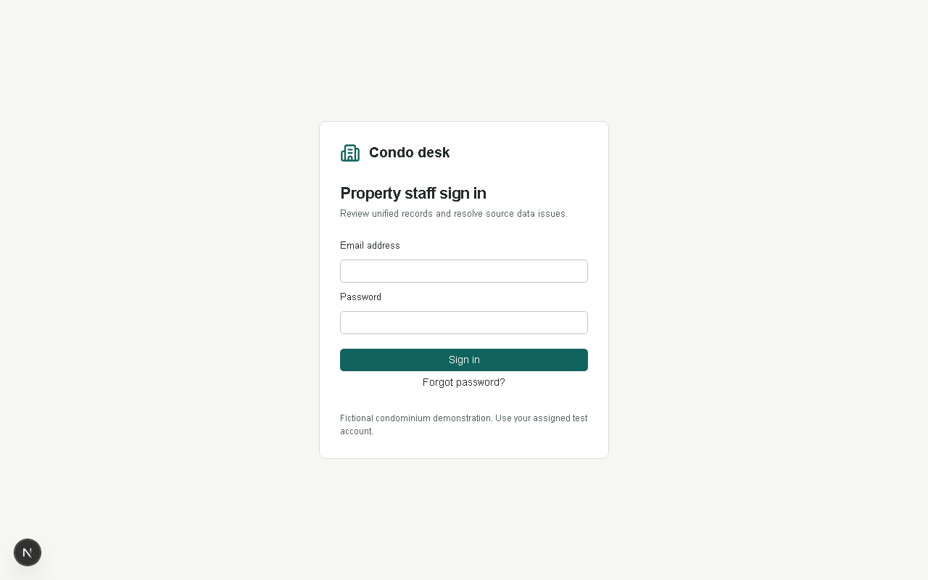
The sign-in form accepts privately assigned credentials. Forgot password opens the administrator-code recovery flow.

Appendix C Pipeline
Figure 6 Pipeline history and source counts
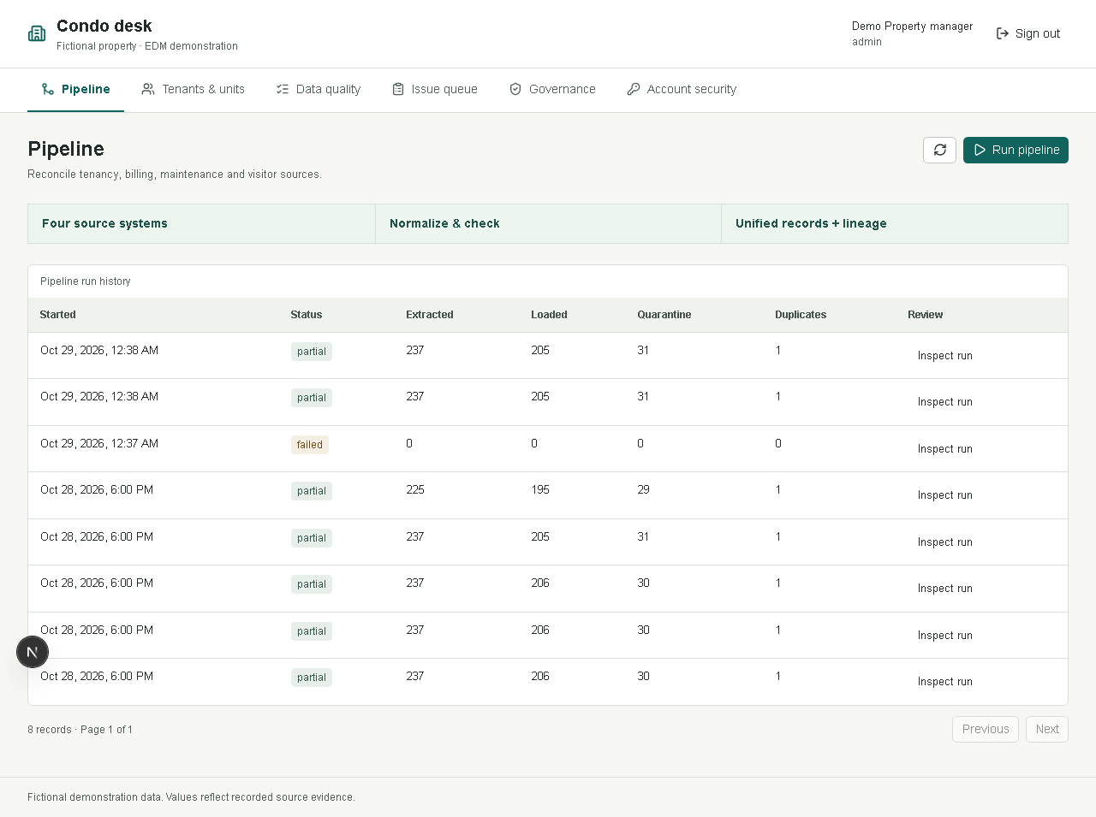
The workspace records run status, source-stage totals and quarantine/deduplication counts. Run pipeline requires the backend permission.

Appendix C Quality and Issues
Figure 7 Actual quality scores and rule results
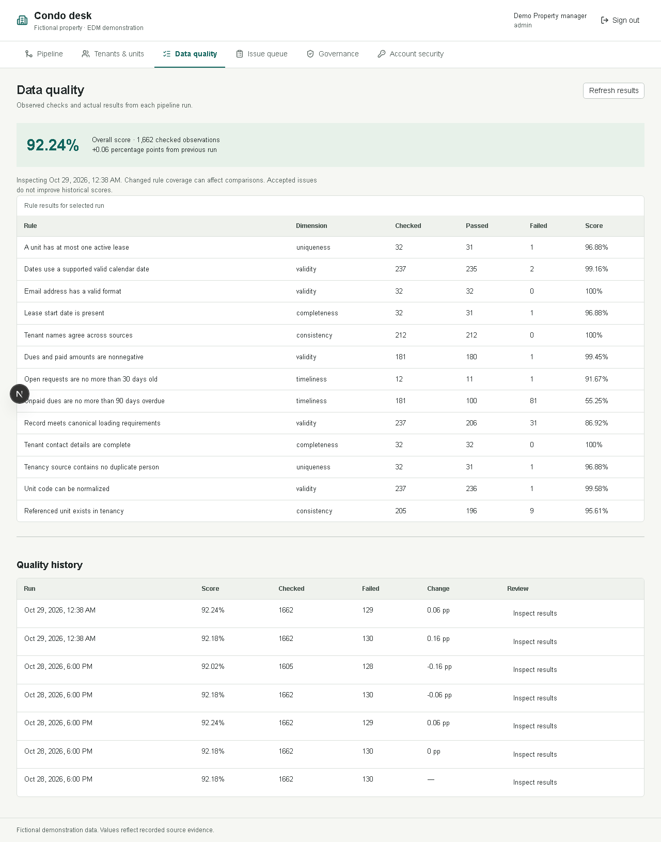
Per-rule observations and historical run scores come from saved API data; six acceptance corrections improved the local score.

Appendix C Issue Queue
Figure 8 Eligible quality issue review
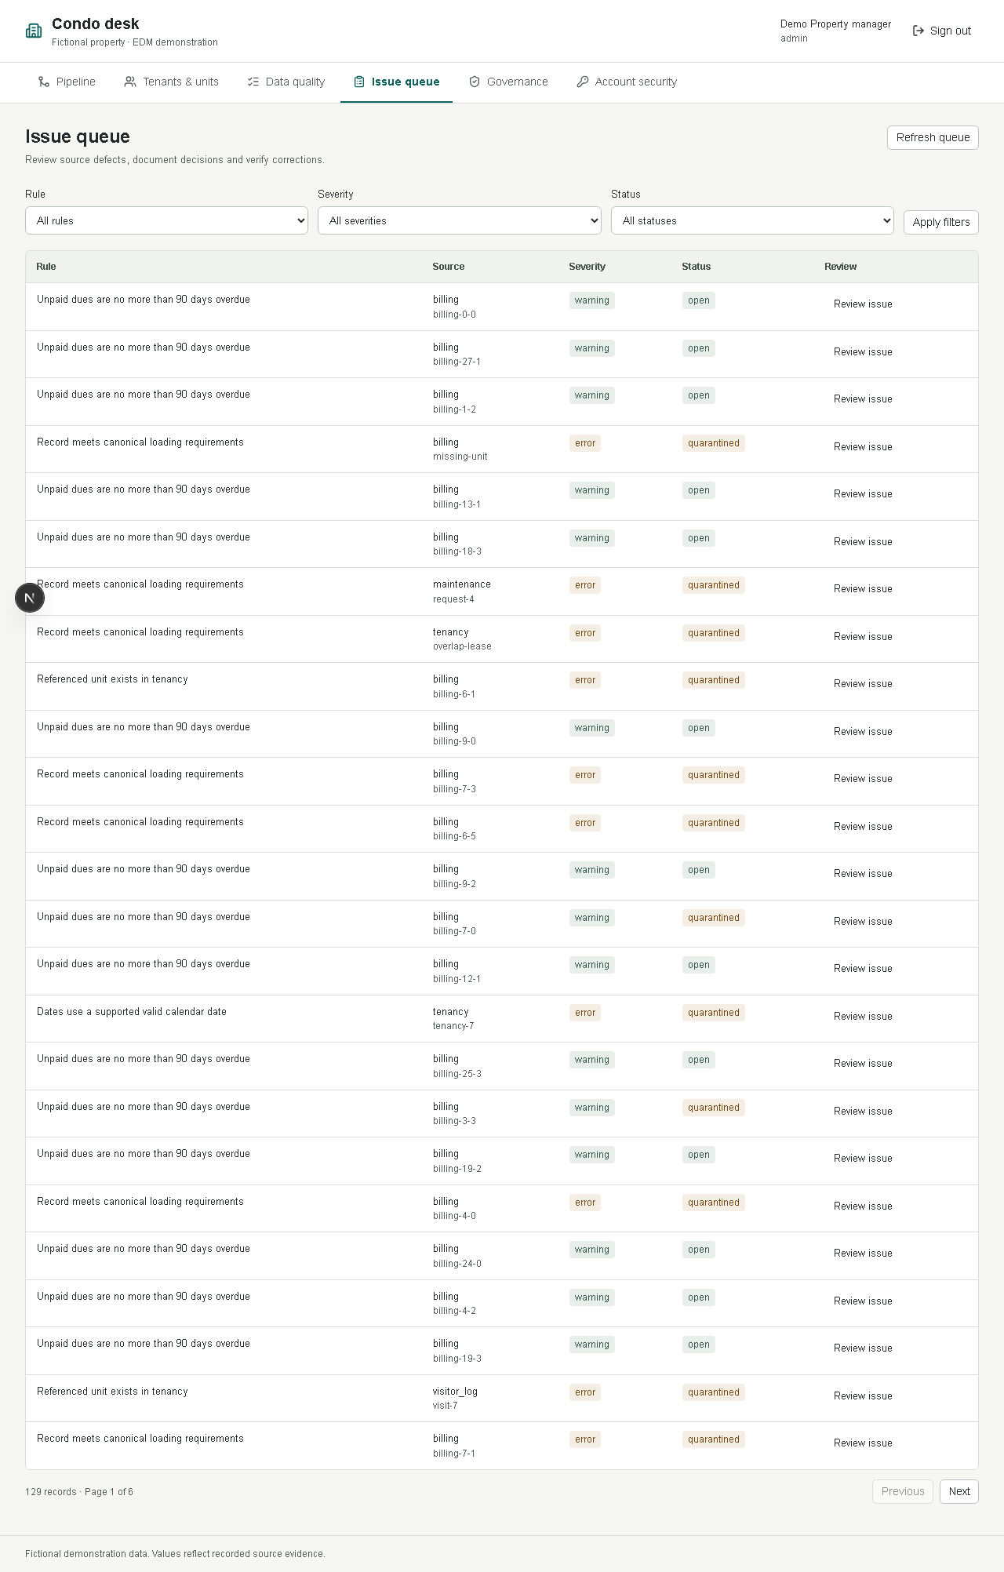
The queue filters eligible issues and exposes readable correction/decision controls for permitted roles.

Appendix C Unified Tenant
Figure 9 Governed tenant detail and lineage
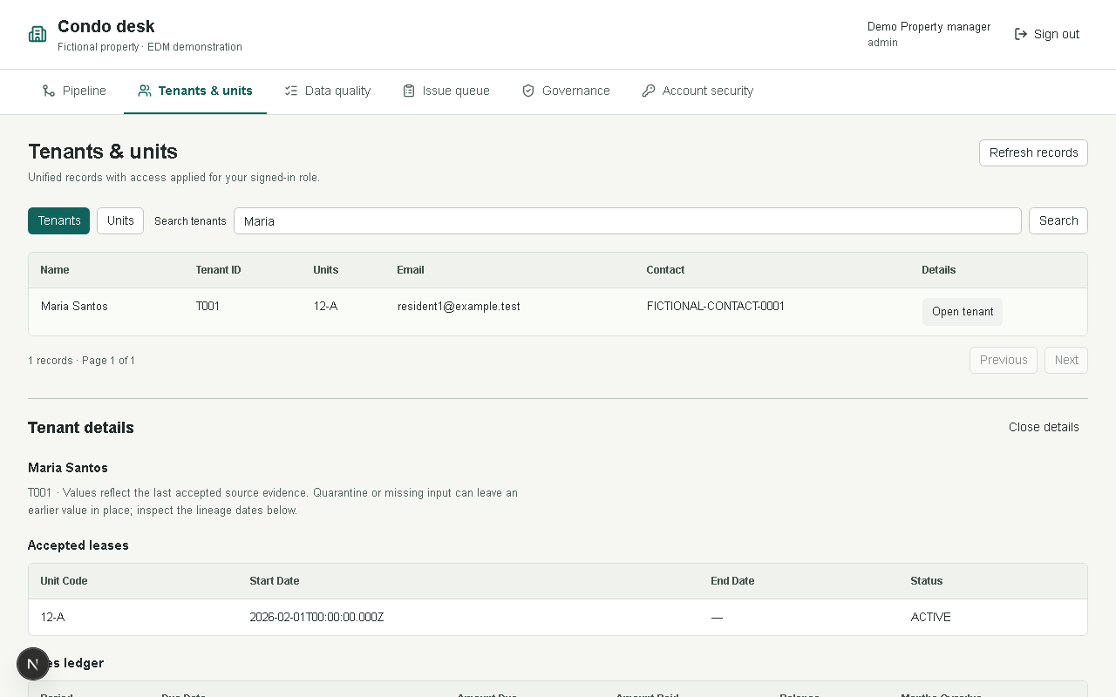
The same Maria tenant page differs for Admin, Finance and Viewer. Financial amounts and visitor entries are filtered before the API response.

Appendix C Governance
Figure 10 Field catalog and governance workspace
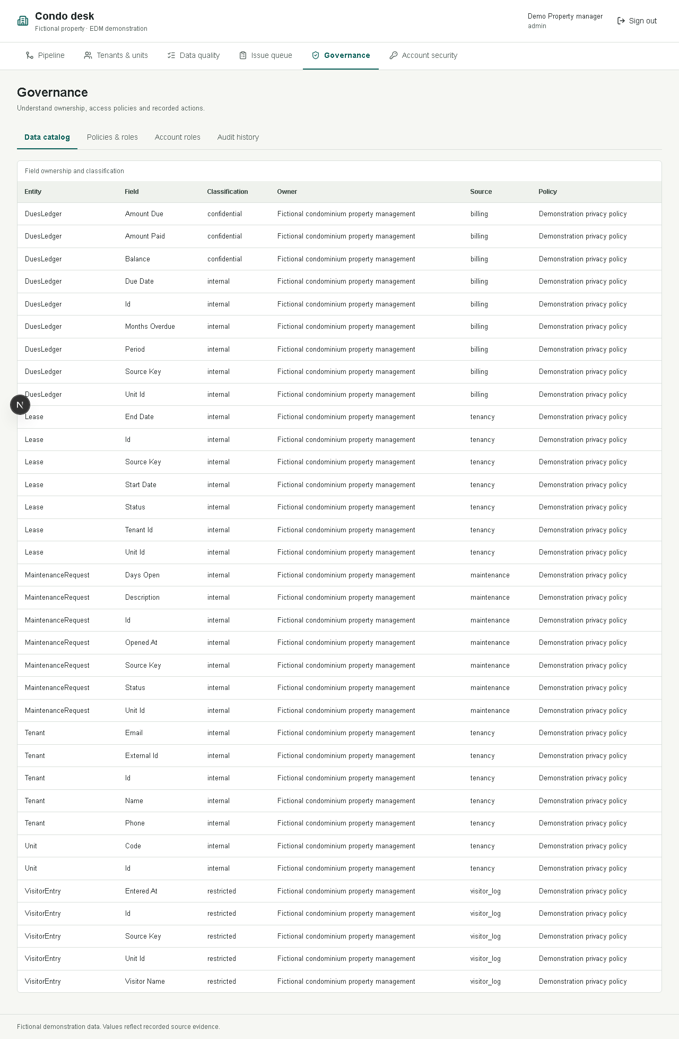
Catalog metadata connects fields to owners, classification, source and policies; administration remains role-restricted.

Appendix C Audit Detail
Figure 11 Readable policy audit evidence
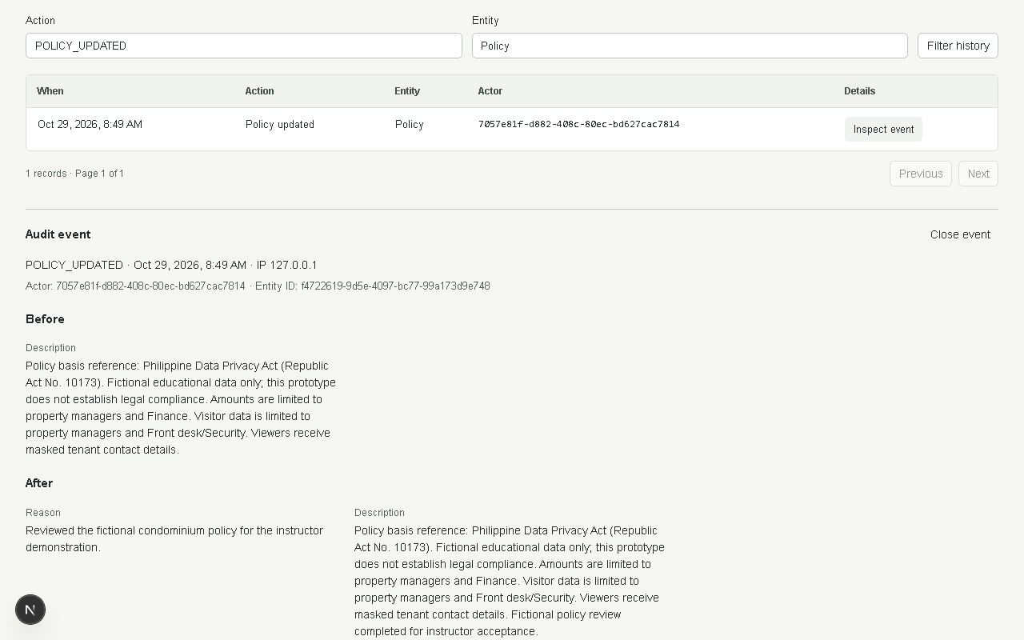
Policy audit detail exposes readable before/after text and reason. Database guards prevent ordinary audit mutations.

Appendix C Account Security
Figure 12 Own security question and password controls
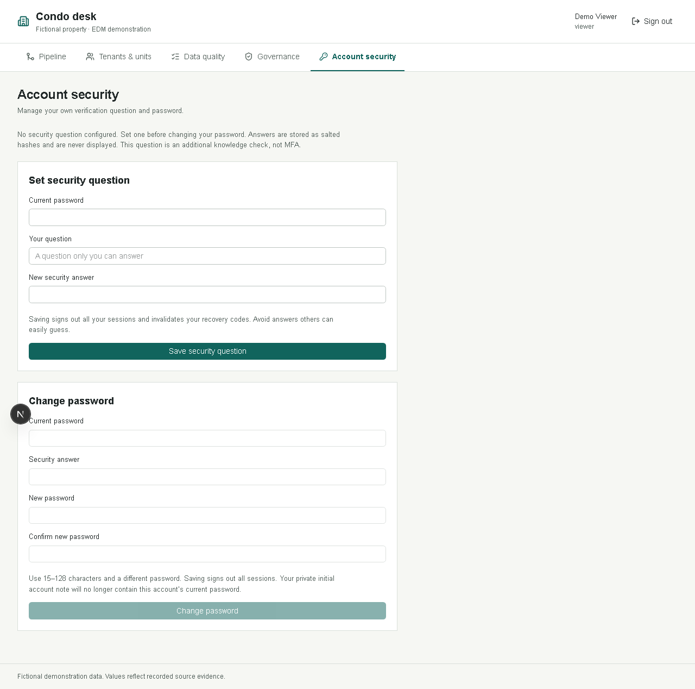
Users set their own question before changing a password. Successful credential changes revoke sessions; administrators cannot read stored answers.

Appendix D Class and Service Diagram
The following collaboration view groups the implemented TypeScript modules by responsibility. Services are functions and modules rather than an invented object hierarchy. Data entities correspond to Prisma models; routes and middleware provide the request boundary.
Figure 13 Service collaboration and database boundary
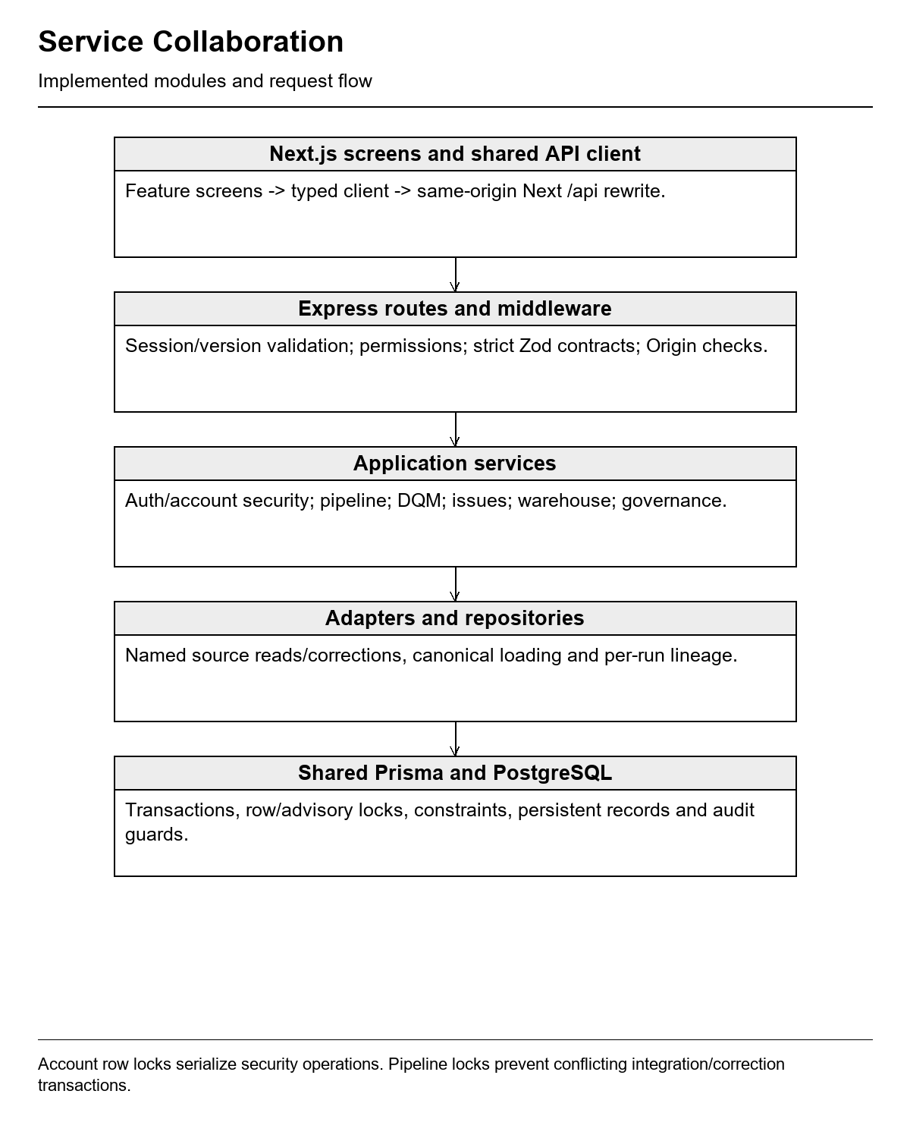

Appendix E Implementation Evidence
Table 21 Release evidence and acceptance status
Area | Baseline evidence | Remaining boundary
Database | Six local-verified migrations; dedicated Neon schema; one authorized shared fictional import; accounts preserved. | Production restricted identities and restore rehearsal require separate work.
Backend verification | 32 unit and 41 normal reported API/database checks passed; acceptance/access checks passed. | No claim to cover every possible input, vulnerability or failure mode.
Browser verification | Four core flows, one security flow and two instructor presentation flows passed in Chromium. | Manual screen-reader and other-browser validation remains unverified.
Build and source hygiene | Lint/types and full production build passed; private configuration ignored. | No Git publication, hosted deployment or production capacity certification.
Account recovery | Hashed expiring single-use code, fresh admin proof, question reset and session revocation verified locally. | Manual code delivery; no independent MFA or automatic email/SMS.
Shared runtime | Bounded sign-in/role and final account-profile smoke checks; no automated Neon suites. | Avoid repeat imports, remote test loops and unattended pipeline calls.

Local demonstration sequence
1. For the configured shared Neon classroom runtime, run npm ci and npm run db:generate after installation, keep the privately supplied .env at the project root, then run npm run dev. Open http://localhost:3400. Do not rerun remote provisioning, migration status or demo imports on every startup.
2. For isolated practice, keep npm run db:local open, then use npm run db:migrate, npm run db:seed and npm run dev:local from another project-root terminal. Use local mode for repeated corrections and password exercises so shared class accounts remain stable.
3. Demonstrate one pipeline, Maria's four-source lineage, six issue corrections, the resulting quality improvement, the Admin/Finance/Viewer difference, and the related audit events. Use the separate private account note; do not project secrets.
4. Account security is available at /account. Configure an own question first. An administrator assists a different account under Governance, Account roles, Manage recovery after identity verification. Share codes privately and do not place secrets in verification notes.
5. Reproduce checks with npm test, npm run lint, npm run typecheck, npm run test:integration, npm run test:browser, npm run test:security and npm run test:acceptance. Run database/browser suites sequentially. npm run build followed by npm start runs the production builds. All automated database suites use loopback PostgreSQL only.
End of Software Requirements Specification

