STUDY 3 – DRIVING-DYNAMICS ANALYSES
Markovići – Lastva Grbaljska (primjer) – design speed V_{r} = 100 km/h
Resulting projected-speed profile, consistency of alignment elements, travel time and fuel consumption
Contents

1 Uvod
As part of the Main Design – Markovići – Lastva Grbaljska (primjer) – driving-dynamics analyses were carried out for the adopted alignment in accordance with the Project Brief (Study 3). The aim of the analysis is to define the relevant parameters for dimensioning the structural elements of the plan and profile, to determine the operating effects (speeds, travel time, fuel consumption) and to check the consistency and homogeneity of the applied geometric design elements.
The analysed range of the alignment is ch. 0.000 – 7973.924 m. The alignment consists of of the following sections:
- segment 1: ch. 0.000 – 6640.000 m – two separate carriageways, each with its own axis – the right carriageway (driving in the direction of increasing chainage) and the left carriageway (driving against the direction of chainage) (left axis (L1); right axis (D1));
- segment 2: ch. 6640.000 – 7973.924 m – a central axis with one common geometry printout; the calculation was made for both directions of travel (in the direction of chainage and against it) (central axis (segment 2)); speed limit (scenario): 80 km/h at ch. 7624.326 – 7973.924.
With the design speed V_{r} = 100 km/h the analysis comprises:
- the resulting profile of the projected speed V_{p} (V85) for the passenger car and heavy vehicles (tractor-trailer (rulebook), tractor-trailer (modern), car transporter, passenger car) under free-flow traffic conditions, for all directions of travel over the entire alignment;
- harmonisation of the alignment elements and statistical indicators of dynamic homogeneity: the mean projected speed, the standard deviation and the coefficient of dynamic homogeneity;
- speed profile, travel time and fuel consumption of heavy vehicles;
- checking of the carriageway cross-slopes on circular curves for the obtained projected speeds; scenarij sa ograničenjem brzine na dijelu trase (poglavlje 6).
The required sight distance and optical analyses (Study 4) are not the subject of this study. The resulting projected-speed profiles from chapter 4 are the input for those analyses (P_{zp} = f(V_{p})).
The numerical calculation is given in tabular form in this study (appendices A) and in the accompanying workbook (Excel), in which all steps are done with formulas, and all diagrams in this study are made as Excel charts that recalculate automatically when new printouts are put into the Ulaz_n sheets (input data are marked in blue).

Notation and symbols
The numbers in square brackets [n] in the text refer to the list of references at the end of the study. Indices of cases (directions of travel): D1 – Right carriageway, direction of chainage, ch. 0 – 6640; L1 – Left carriageway, against the direction of chainage, ch. 0 – 6640; F2 – Central axis, direction of chainage, ch. 6640 – 7974; B2 – Central axis, against the direction of chainage, ch. 6640 – 7974.
Table O1 – Meaning of symbols
Symbol | Meaning | Unit | Source of value | Where it is used
V_{r} | Design speed | km/h | Specified by the Project Brief | 2.2, all calculations
V_{ri} | Design speed calculated from the radius (table R_{min}(V_{r})) | km/h | Rulebook, Annex 2 | 2.2
max V_{r} | Maximum projected speed = V_{r} + 20 | km/h | Rulebook, Annex 2 | 2.2
V_{p} | Projected speed = V85, obtained as a consequence of geometry | km/h | Calculation result | 4, 5
V_{p,R} | Speed from the V_{p}–R relationship (depends on the radius of the circular curve) | km/h | Table R_{min}(V_{r}), element | 2.2.1, Excel Ulaz_n
V_{p}(i_{N}) | Speed from the V_{p}–i_{N} relationship (depends on the longitudinal grade) | km/h | Tablica V_{p}(i_{N}) | 2.2.2
T (target speed) | min(V_{p,R} ; V_{p}(i_{N}) ; limit) before applying acceleration/deceleration | km/h | Calculation | Excel Profil_, kolona I
V_{p,sr} | Mean projected speed (length-weighted) | km/h | Calculation | 4.2
σ | Root-mean-square deviation of speed from V_{p,avg} | km/h | Calculation | 4.2
D_{h} | Coefficient of dynamic homogeneity = σ / V_{p,avg} · 100 | % | Calculation | 4.2
ΔV | Difference of projected speeds of adjacent elements (ΔV_{target} – difference of target speeds T, used for rating; ΔV_{res} – difference of resulting speeds) | km/h | Calculation | 4.1
V_{min}, V_{max} | Lowest and highest speed on the segment | km/h | Calculation | 4.2, 5.2
a, d | Acceleration and deceleration in the driving model | m/s² | Manual (driving model) | 2.2.3
Δs | Calculation step | m | Calculation assumption | all calculations
L, s | Segment length / chainage | m | Ulazni podaci | all calculations
T (vrijeme) | Vrijeme putovanja = Σ Δs / v | s, min | Calculation | 4.2, 5.2
R | Radius of the circular curve | m | horizontal axis printout | 3.1, 4.3
R_{min}(V_{r}) | Smallest radius for V_{r} | m | Rulebook, Annex 2 | 2.2.1, 4.3
A | Parametar klotoide, A² = R·L | m | horizontal axis printout | 3.1
L (element) | Length of the alignment element | m | horizontal axis printout | 3.1
i, i_{N} | Longitudinal grade of the grade line (+ uphill in the direction of increasing chainage) | % | longitudinal profile printout | 3.2, Appendix A
i_{ul}, i_{izl} | Grade before / after the break point of the grade line | % | longitudinal profile printout | 3.2
Δi | Algebraic difference of grades at the break point | % | Calculation | 3.2
R_{v}, L_{vk}, T, e | Radius, length, tangent and external ordinate of the vertical curve | m | longitudinal profile printout / calculation | 3.2
z | Kota nivelete | m n.m. | Calculation from break points | 3.2, Appendix A
i_{p} | Cross-slope of the carriageway on the curve (applied) | % | cross-slope printout | 4.3
i_{pk}(V_{r}) | Required cross-slope on the curve for V_{r}: 7·(R_{min}/R)^0.74 | % | Rulebook, Annex 2 | 4.3
i_{p,potr} | Required cross-slope for speed V_{p} | % | Calculation | 4.3
f_{R}, f_{T} | Permissible lateral / longitudinal friction coefficient | – | Rulebook, Annex 2 | 2.2.1, 4.3
f_{pot} | Utilised lateral friction coefficient = V²/(127R) − i_{p}/100 | – | Calculation | 4.3
m, P, C_{d}A, η, γ_{m}, μ | Mass, engine power, aerodynamic factor, efficiency, rotating-mass factor, adhesion coefficient | kg, kW, m², –, –, – | Assumptions for heavy vehicles | 5.1
v_{lim} | Speed limit of the heavy vehicle | km/h | Pretpostavka | 5.1
f_{rl}, R_{r}, R_{a}, R_{g}, F_{r} | Rolling-resistance coefficient; rolling, air and grade resistances; total resistance | –, N | Wong, Cvetanović | 5.1
F_{t}, F_{u} | Available traction force; force used for consumption | N | Calculation | 5.1
b | Specific fuel consumption | l/kWh | Pretpostavka | 5.1
ΔB | Fuel consumption per step | l | Calculation | 5.1, 5.2
Table O2 – Explanation of the columns in the tables
Table | Meaning of columns
Table 1 | V_{r} – design speed; R_{min} – smallest radius; f_{T}, f_{R} – permissible longitudinal and lateral friction coefficients.
Table 2 | i_{N} – longitudinal grade; V_{p}(i_{N}) – maximum speed for the given grade.
Tables 3–5 | No. – serial number of the element in the printout; Element – tangent / circular curve / transition curve; Direction – direction of the curve; ch. of start and end; L – length; R – radius (for a transition curve: from → to, ∞ = tangent); A – clothoid parameter.
Tables 6–8 | PT – break point of the grade line; Ch., Elev. – position of the PT; i_{in}, i_{out} – grade before and after; Δi – change of grade; R_{v}, L_{vk}, T, e – elements of the vertical curve; Type – sag (Δi > 0) or crest (Δi < 0).
Tables 9–12 | No., Element – curve (arc with transition curves) or tangent; Ch. from / to; L; R; Direction; V_{p,i} target – target speed of the element T (curve: lowest, tangent: highest); ΔV_{target} – difference relative to the next element and Rating by the 10 / 20 km/h criterion; V_{p,i} res. and ΔV_{res} – the same for the resulting profile after acceleration/deceleration.
Table 13 | Section / direction; V_{p,avg}, σ, D_{h} – statistics by length; V_{min}, V_{max}; T – travel time; the rows “entire alignment” include all sections in the same direction of travel (chained).
Tables 14–17 | Curve no. – number of the element; R; Direction; V_{p} – lowest speed on the curve (in the part inside the section); i_{pk}(V_{r}) – required slope for V_{r}; i_{p} appl. – applied slope; i_{p} ≥ i_{pk} – condition (compared to 0.1 %); f_{R}(V_{p}); i_{p,req} – required slope for V_{p}; f_{req} – utilised friction; f_{req} ≤ f_{R} – condition; R ≥ R_{min} – whether the radius is greater than the minimum for V_{r}.
Table 18 | v – speed; F_{t} – traction force derived from the equilibrium points of the diagram (Figure 3-10).
Table 19 | The speed at which the traction force equals all resistances; “Rulebook” – values from Figure 3-10.
Table 20 | V_{avg}, σ, D_{h}, V_{min} – statistics of the speed of the heavy vehicle; T – time; Fuel – total [l], per km and per 100 km; the rows “entire alignment” are the sum of the sections in the direction of travel.
Table 21 | Speed statistics of the passenger car for the geometry and the scenario with a speed limit (columns as in the homogeneity table).
Table 22 | Columns as in the consistency tables (chapter 4.1), for the scenario.
Table 23 | Columns as in the cross-slope tables, with V = resulting speed of the scenario on the curve; R_{min} for the curve speed is obtained by interpolation from Table 1.
Prilozi A | s – chainage; z – elevation; i – grade; El. – P tangent, K circular curve, Pr transition curve; R; V_{p} – passenger car; V₁, V₂ … – speeds of heavy vehicles; t – cumulative time [s]; B – cumulative consumption [l], counted from the entrance to the section.

2 Input data and methodology

2.1 Input data
The designer’s printouts were used, three files for each axis (horizontal axis, longitudinal profile, cross-slopes):
Axis | Horizontal | Longitudinal profile | Cross-slopes | No. of elem. | Length [m] | Ch. range [m] | Closure [mm] | K calculation / printout [gon/km] | Grade line [mm]
right axis (D1) | DESNA.TXT | DESNAUZDUZNI.TXT | DESNAPOPRECNINAGIBI.TXT | 27 | 8769.455 | -1280.5 – 7489.0 | 3 | 31.489 / 31.489 | 2
left axis (L1) | LIJEVA.TXT | LIJEVAUZDUZNI.TXT | POPRECNI.TXT | 28 | 8766.383 | -1271.2 – 7495.1 | 10 | 30.631 / 30.631 | 7
central axis (segment 2) | CENTRALNA.TXT | CENTRALNAUZDUZNI.TXT | CENTRALNAPOPNAGIBI.TXT | 7 | 1723.700 | 6468.3 – 8192.0 | 3 | 55.510 / 55.510 | 4
As a check of the correctness of the data import, the axes were reconstructed by numerical integration of the elements (the deviation of the end point from the printout is given in the table), and the curvature characteristic from the printout is compared with the calculated one. The longitudinal profiles were reconstructed from the tables of break points (chainage, elevation, vertical curve radius, grade after the break point, start and end of the curve); the reconstructed elevations are compared with the axis elevations in the cross-section printout (column “Grade line”).
The carriageway cross-slope for checks on curves is read from the outer lane of the left side of the carriageway; convention: a positive slope rises from the axis outwards, and the slope of the right side in the printouts equals the negative slope of the left side (maximum difference |L + R| in the printouts: right axis (D1) 0.000 %, left axis (L1) 0.000 %, central axis (segment 2) 0.000 %). The cross-slope is used only in checks on circular curves (chapter 4.3) and does not enter the speed profile, travel time and fuel consumption.
The calculation was made on a grid Δs = 5 m (in the last step of a segment the step may be shorter).

2.2 Method of determining the projected speed V_{p} (V85) – Serbian guidelines
To determine the V85 speed, the method from the Rulebook on the conditions that public roads outside settlements must meet from the aspect of traffic safety (Official Gazette of RS 50/2011), Annex 2 [1] was applied, together with the Manual for the design of roads in the Republic of Serbia (Putevi Srbije), part 4.0 [2] (driving model). According to these documents the projected speed V_{p} is not given in advance but is obtained as a consequence of the adopted geometry elements, in the range
$$V_{ri}≤V_{p}≤maxV_{r}, maxV_{r}=V_{r}+20=120 \text{km/h}$$
The maximum speed on a tangent is max V_{r}, i.e. V_{ri} + 20 km/h, and this value is compared with max V_{r} from Table 3-04 of Annex 2 and must not exceed it.
The resulting profile V_{p} is constructed along the chainage as follows:
- for each circular curve the speed that the driver achieves in the curve is determined from the V_{p} – R relationship; on tangents the target speed is max V_{r};
- from the V_{p} – i_{N} relationship (influence of the longitudinal grade) the target speed is determined as a function of the grade of the grade line in the direction of travel;
- the governing target speed is the smaller of these two (and of a possible speed limit in the scenario);
- the target speed is “smoothed” by a driving model with acceleration a = 0.77 m/s² and deceleration d = 0.77 m/s² (nominally a = d = 0.8 m/s², with the distance of speed change determined by the formula from Figure 3-09: L = 0.1·V_{avg}·ΔV, which corresponds to a = d = 0.77 m/s²);
- on the profile obtained in this way the statistical indicators (V_{p,avg}, σ, D_{h}) and the consistency of adjacent elements ΔV_{p} are determined.
The profile is constructed separately for each direction of travel: in the direction of increasing chainage and in the direction of decreasing chainage (the longitudinal grade i_{N} is taken with its sign in the direction of travel, + uphill). Cases (sections) in the same direction of travel are chained at segment boundaries: the speed at the end of one section is the entry speed of the next (both acceleration and deceleration are satisfied across the boundary). At the entrance to the alignment free driving at 120 km/h is assumed.
Note on the relationships. The V_{p} – R and V_{p} – i_{N} relationships are given graphically in Annex 2 of the Rulebook [1] (Figures 3-07 and 3-08): (a) for V_{p} – R, linear interpolation of the table of minimum radii R_{min}(V_{ri}) was applied, calculated by the formula from Figure 3-07, R_{min} = V_{ri}² / (127·(f_{R}(V) + i_{pk,max})), with i_{pk,max} = 7 % and f_{R} from Table 3-05, limited to max V_{r}; (b) for V_{p} – i_{N} the table was read from the diagram in Figure 3-08 (reading accuracy about ±5 km/h) [4]. Both relationships are input data in the workbook (sheet Parametri) and can be replaced by more precisely read values without changing the other formulas. The results of chapter 4 depend on these tables, so checking the read values against the original diagrams is recommended.

2.2.1 Zakonitost V_{p} – R
Table 1 contains data from Annex 2 of the Rulebook: minimum radii of horizontal curves and friction coefficients for the design speeds V_{r}.
Table 1 – Minimum radii (formula from Figure 3-07, i_{pk,max} = 7 %) and friction coefficients (Table 3-05, Annex 2 of the Rulebook [1])
V_{r} [km/h] | 40 | 50 | 60 | 70 | 80 | 90 | 100 | 110 | 120 | 130
R_{min} [m] | 43.4 | 75.7 | 118.1 | 175.4 | 252.0 | 335.7 | 437.4 | 560.5 | 667.0 | 782.8
f_{T} (longitudinal) | 0.44 | 0.41 | 0.38 | 0.36 | 0.34 | 0.32 | 0.30 | 0.29 | 0.28 | 0.27
f_{R} (lateral) | 0.22 | 0.19 | 0.17 | 0.15 | 0.13 | 0.12 | 0.11 | 0.10 | 0.10 | 0.10
The speed for an arbitrary radius R between the tabulated values R_{j} and R_{j+1} is obtained by linear interpolation:
$$V_{p}\left(R\right)=V_{j}+\frac{R−R_{j}}{R_{j+1}−R_{j}} \left(V_{j+1}−V_{j}\right)≤maxV_{r}$$
Example – circular curve no. 5 (central axis (segment 2), R = 400.0 m, ch. 7624.3 – 7848.9): R lies between R_{j} = 336 m (V = 90 km/h) and R_{j+1} = 437 m (V = 100 km/h):
$$V_{p}\left(400.0\right)=90+\frac{400.0−336}{437−336} \left(100−90\right)=90+0.6323⋅10=96.32 \text{km/h}$$
Curves where the V_{p} – R relationship limits the speed: right axis (D1), curve no. 9 (R = 588.30 m, ch. 115.4 – 445.8) – V_{p,R} = 112.6 km/h; left axis (L1), curve no. 9 (R = 600.00 m, ch. 113.9 – 454.9) – V_{p,R} = 113.7 km/h; central axis (segment 2), curve no. 5 (R = 400.00 m, ch. 7624.3 – 7848.9) – V_{p,R} = 96.3 km/h. All other circular curves have V_{p,R} = 120 km/h (limit max V_{r}).

2.2.2 Zakonitost V_{p} – i_{N}
Table 2 – Maximum speed as a function of the longitudinal grade (table compiled from the diagram in Annex 2 of the Rulebook, Figure 3-08 [4])
i_{N} [%] | -10.0 | -8.0 | -7.0 | -5.0 | 4.0 | 4.1 | 6.0 | 8.0 | 10.0
V_{p}(i_{N}) [km/h] | 70 | 90 | 100 | 130 | 130 | 120 | 100 | 75 | 50
Largest longitudinal grades of the grade line: D1 (Right carriageway, direction of chainage, ch. 0 – 6640) 3.662 %; L1 (Left carriageway, against the direction of chainage, ch. 0 – 6640) 3.693 %; F2 (Central axis, direction of chainage, ch. 6640 – 7974) 5.643 %; B2 (Central axis, against the direction of chainage, ch. 6640 – 7974) 5.643 %.
The V_{p} – i_{N} relationship limits the speed in the cases: B2; most unfavourable in case B2 (Central axis, against the direction of chainage, ch. 6640 – 7974), where the grade in the direction of travel reaches 5.643 %:
$$V_{p}\left(i_{N}\right)=120+\frac{5.643−4.1}{6.0−4.1} \left(100−120\right)=103.76 \text{km/h}$$
Therefore confirming the source of the table V_{p}(i_{N}) is particularly important for these sections.

2.2.3 Driving model
The transition from one target speed V₁ to another takes place with constant acceleration a or deceleration d. The speed after the distance s is determined from
$$v_{2}=\sqrt{v_{1}^{2}±2 a s}$$
and the distance needed to change the speed from V₁ to V₂ is
$$s=\frac{v_{1}^{2}−v_{2}^{2}}{2 d}$$
The Rulebook (Figure 3-09) gives the distance of acceleration and deceleration at a = d = 0.8 m/s² by the formula L_{a,d} = 0.1·(V_{avg}·ΔV), where V_{avg} = (V₁ + V₂)/2 and ΔV = |V₁ − V₂| (speeds in km/h, distance in m). This formula is equivalent to the above equations with acceleration and deceleration a = d = 1/(0.1·3.6²) = 0.7716 m/s², so these values are used in the calculation (e.g. 100 → 80 km/h: L = 0.1·90·20 = 180 m).
Example – entry into circular curve no. 5 (central axis (segment 2), reduction 120 → 96.3 km/h):
$$s=\frac{{\left(120/3.6\right)}^{2}−{\left(96.3/3.6\right)}^{2}}{2⋅0.77}=\frac{1111.11−715.90}{1.543}=256.1 \text{m}$$
The start of the curve is at ch. 7624.326 m, so (in the direction of travel towards the curve) deceleration begins about 256.1 m before the start of the curve, and after leaving the curve the speed returns to 120 km/h over the same distance.

2.3 Statistical indicators of dynamic homogeneity
On the basis of the resulting profile V_{p}(s) on a section of length L, the following are determined (weighted by length, integrated by the trapezoidal rule on the grid Δs):
$$V_{p,sr}=\frac{1}{L}\int_{0}^{L}{V_{p}}\left(s\right) ds≈\frac{1}{L}\sum_{i=1}^{n−1}{\frac{V_{i}+V_{i+1}}{2}} Δs_{i}$$
$$σ=\sqrt{\frac{1}{L}\int_{0}^{L}{{\left(V_{p}\left(s\right)−V_{p,sr}\right)}^{2}}ds}$$
$$D_{h}=\frac{σ}{V_{p,sr}}⋅100 \left[\%\right]$$
The dynamic consistency of adjacent alignment elements (tangent – curve – tangent) is expressed by the difference of projected speeds
$$ΔV_{i,i+1}=\left|V_{p,i}−V_{p,i+1}\right|$$
Rating criterion (Lamm et al. [5]): ΔV ≤ 10 km/h – good; 10 < ΔV ≤ 20 km/h – fair; ΔV > 20 km/h – poor. The projected speed of an element is taken as: on a circular curve (with transition curves) the lowest speed, on a tangent the highest speed in the element. The rating is given according to the difference of the target speeds of the elements (V_{p,R} or V_{p}(i_{N}), before smoothing by acceleration/deceleration), because the resulting profile by definition softens the jumps; the difference of the resulting speeds is given next to it for comparison.
Travel time is determined from
$$T=\int_{0}^{L}{\frac{ds}{v\left(s\right)}}≈\sum_{i=1}^{n−1}{\frac{Δs_{i}}{2}}\left(\frac{1}{v_{i}}+\frac{1}{v_{i+1}}\right)$$

3 Alignment geometry

3.1 Horizontal elements
Table 3 – Elements of the horizontal axis: right axis (D1), ch. 0 – 6640. (DESNA.TXT)
No. | Element | Direction | Start ch. [m] | End ch. [m] | L [m] | R [m] | A [m]
8 | transition curve | right | -127.982 | 115.398 | 243.380 | ∞ → 588.30 | 378.392
9 | circular curve | right | 115.398 | 445.842 | 330.444 | 588.30 | –
10 | transition curve | right | 445.842 | 664.118 | 218.276 | 588.30 → ∞ | 358.346
11 | circular curve | right | 664.118 | 862.339 | 198.221 | 3000.00 | –
12 | transition curve | left | 862.339 | 1009.403 | 147.064 | ∞ → 1300.00 | 437.244
13 | circular curve | left | 1009.403 | 1565.329 | 555.926 | 1300.00 | –
14 | transition curve | left | 1565.329 | 1765.329 | 200.000 | 1300.00 → ∞ | 509.902
15 | tangent |  | 1765.329 | 2825.454 | 1060.125 | ∞ | –
16 | transition curve | right | 2825.454 | 3075.454 | 250.000 | ∞ → 1500.00 | 612.372
17 | circular curve | right | 3075.454 | 3619.874 | 544.420 | 1500.00 | –
18 | transition curve | right | 3619.874 | 3869.874 | 250.000 | 1500.00 → ∞ | 612.372
19 | tangent |  | 3869.874 | 4183.040 | 313.166 | ∞ | –
20 | circular curve | left | 4183.040 | 4494.030 | 310.990 | 4025.00 | –
21 | tangent |  | 4494.030 | 5967.265 | 1473.235 | ∞ | –
22 | transition curve | right | 5967.265 | 6117.265 | 150.000 | ∞ → 1300.00 | 441.588
23 | circular curve | right | 6117.265 | 6309.905 | 192.640 | 1300.00 | –
24 | transition curve | right | 6309.905 | 6455.843 | 145.938 | 1300.00 → ∞ | 435.568
25 | transition curve | left | 6455.843 | 6610.179 | 154.336 | ∞ → 1285.35 | 445.394
26 | circular curve | left | 6610.179 | 7190.034 | 579.855 | 1285.35 | –
Table 4 – Elements of the horizontal axis: left axis (L1), ch. 0 – 6640. (LIJEVA.TXT)
No. | Element | Direction | Start ch. [m] | End ch. [m] | L [m] | R [m] | A [m]
8 | transition curve | right | -128.610 | 113.916 | 242.526 | ∞ → 600.00 | 381.465
9 | circular curve | right | 113.916 | 454.903 | 340.986 | 600.00 | –
10 | transition curve | right | 454.903 | 674.903 | 220.000 | 600.00 → ∞ | 363.318
11 | tangent |  | 674.903 | 923.200 | 248.297 | ∞ | –
12 | transition curve | left | 923.200 | 1123.200 | 200.000 | ∞ → 1300.00 | 509.902
13 | circular curve | left | 1123.200 | 1565.102 | 441.902 | 1300.00 | –
14 | transition curve | left | 1565.102 | 1765.102 | 200.000 | 1300.00 → ∞ | 509.902
15 | tangent |  | 1765.102 | 2822.327 | 1057.225 | ∞ | –
16 | transition curve | right | 2822.327 | 3072.327 | 250.000 | ∞ → 1525.00 | 617.454
17 | circular curve | right | 3072.327 | 3628.510 | 556.183 | 1525.00 | –
18 | transition curve | right | 3628.510 | 3878.510 | 250.000 | 1525.00 → ∞ | 617.454
19 | tangent |  | 3878.510 | 4177.408 | 298.898 | ∞ | –
20 | circular curve | left | 4177.408 | 4516.488 | 339.080 | 4000.00 | –
21 | tangent |  | 4516.488 | 5767.032 | 1250.543 | ∞ | –
22 | transition curve | right | 5767.032 | 5997.032 | 230.000 | ∞ → 1750.00 | 634.429
23 | circular curve | right | 5997.032 | 6238.615 | 241.583 | 1750.00 | –
24 | transition curve | right | 6238.615 | 6468.742 | 230.127 | 1750.00 → ∞ | 634.604
25 | transition curve | left | 6468.742 | 6623.011 | 154.269 | ∞ → 1274.65 | 443.440
26 | circular curve | left | 6623.011 | 7196.166 | 573.155 | 1274.65 | –
Table 5 – Elements of the horizontal axis: central axis (segment 2), ch. 6640 – 7973.924 (CENTRALNA.TXT)
No. | Element | Direction | Start ch. [m] | End ch. [m] | L [m] | R [m] | A [m]
2 | circular curve | left | 6622.649 | 7199.152 | 576.502 | 1280.00 | –
3 | transition curve | left | 7199.152 | 7498.097 | 298.945 | 1280.00 → ∞ | 618.587
4 | transition curve | right | 7498.097 | 7624.326 | 126.229 | ∞ → 400.00 | 224.703
5 | circular curve | right | 7624.326 | 7848.924 | 224.598 | 400.00 | –
6 | transition curve | right | 7848.924 | 7973.924 | 125.000 | 400.00 → ∞ | 223.607
Check of transition curves: for a clothoid A² = R·L holds. E.g. right axis (D1), element 8 (R = 588.30 m, L = 243.380 m): A = √(588.30 · 243.380) = 378.392 m, which corresponds to the printout (378.392 m).
Elements crossing section boundaries are assessed only in the part inside the section: right axis (D1), element 8 (ch. -128.0 – 115.4) in the section ch. 0 – 6640; right axis (D1), element 26 (ch. 6610.2 – 7190.0) in the section ch. 0 – 6640; left axis (L1), element 8 (ch. -128.6 – 113.9) in the section ch. 0 – 6640; left axis (L1), element 26 (ch. 6623.0 – 7196.2) in the section ch. 0 – 6640; central axis (segment 2), element 2 (ch. 6622.6 – 7199.2) in the section ch. 6640 – 7974. The speed profile calculation was made over the whole section (including the full entry into the curve), and the results are shown for the segment boundaries.
Curves with a radius smaller than the minimum for V_{r} (R_{min}(V_{r}) = 437 m): central axis (segment 2), curve no. 5 (R = 400.00 m, V_{p,R} = 96.3 km/h). The dynamic check of the cross-slope is given in chapter 4.3.

3.2 Longitudinal profile
Table 6 – Break points of the grade line: right axis (D1), ch. 0 – 6640. (DESNAUZDUZNI.TXT)
PT | Stac. [m] | Elevation [m] | i_{ul} [%] | i_{izl} [%] | Δi [%] | R_{v} [m] | L_{vk} [m] | T [m] | e [m] | Type
1 | 681.747 | 247.927 | -2.342 | 0.903 | 3.245 | 15400 | 499.8 | 249.9 | 2.03 | sag
2 | 1467.719 | 255.028 | 0.903 | -3.000 | 3.903 | 20000 | 780.7 | 390.3 | 3.81 | crest
3 | 3380.136 | 197.655 | -3.000 | -2.600 | 0.400 | 150000 | 600.0 | 300.0 | 0.30 | sag
4 | 6505.093 | 116.407 | -2.600 | -3.662 | 1.062 | 20000 | 212.4 | 106.2 | 0.28 | crest
Table 7 – Break points of the grade line: left axis (L1), ch. 0 – 6640. (LIJEVAUZDUZNI.TXT)
PT | Stac. [m] | Elevation [m] | i_{ul} [%] | i_{izl} [%] | Δi [%] | R_{v} [m] | L_{vk} [m] | T [m] | e [m] | Type
1 | 731.118 | 247.563 | -2.283 | 1.265 | 3.548 | 15000 | 532.2 | 266.1 | 2.36 | sag
2 | 1425.845 | 256.350 | 1.265 | -3.000 | 4.265 | 20000 | 853.0 | 426.5 | 4.55 | crest
3 | 3277.141 | 200.809 | -3.000 | -2.595 | 0.405 | 150000 | 607.3 | 303.7 | 0.31 | sag
4 | 6468.743 | 117.979 | -2.595 | -3.693 | 1.098 | 25000 | 274.4 | 137.2 | 0.38 | crest
Table 8 – Break points of the grade line: central axis (segment 2), ch. 6640 – 7973.924 (CENTRALNAUZDUZNI.TXT)
PT | Stac. [m] | Elevation [m] | i_{ul} [%] | i_{izl} [%] | Δi [%] | R_{v} [m] | L_{vk} [m] | T [m] | e [m] | Type
1 | 7735.695 | 71.490 | -3.677 | -5.643 | 1.966 | 17000 | 334.2 | 167.1 | 0.82 | crest
Elements of the vertical curve (parabola): Δi = i_{out} − i_{in}; L_{vk} = R_{v}·|Δi|/100; T = L_{vk}/2; e = T²/(2R_{v}). Example for PT 1 of axis right axis (D1) (ch. 681.747 m): Δi = 0.903 − (-2.342) = 3.245 %, L_{vk} = 15400 · 3.245/100 = 499.7 m (from the printout: 931.630 − 431.863 = 499.8 m), T = 249.9 m, e = 2.03 m.
Grade-line elevation within the curve: z(s) = z_{PT} + i_{in}/100 · (s − s_{PT}) + Δi/(200·L_{vk}) · (s − s_{TZ})². The grade-line slope changes linearly within the vertical curve: i(s) = i_{in} + Δi·(s − s_{TZ})/L_{vk}. Check: the grade-line elevation at the apex PT is z_{PT} + e = 247.927 + 2.03 = 249.954 m.
Largest longitudinal grade of the grade line (absolute) by segment: D1: 3.662 %; L1: 3.693 %; F2: 5.643 %; B2: 5.643 %.
As the reference limit for V_{r} = 100 km/h, 5.0 % is adopted (the limit should be confirmed in the rulebook and the Project Brief); this limit is exceeded at: F2 (oko 185 m); B2 (oko 185 m).
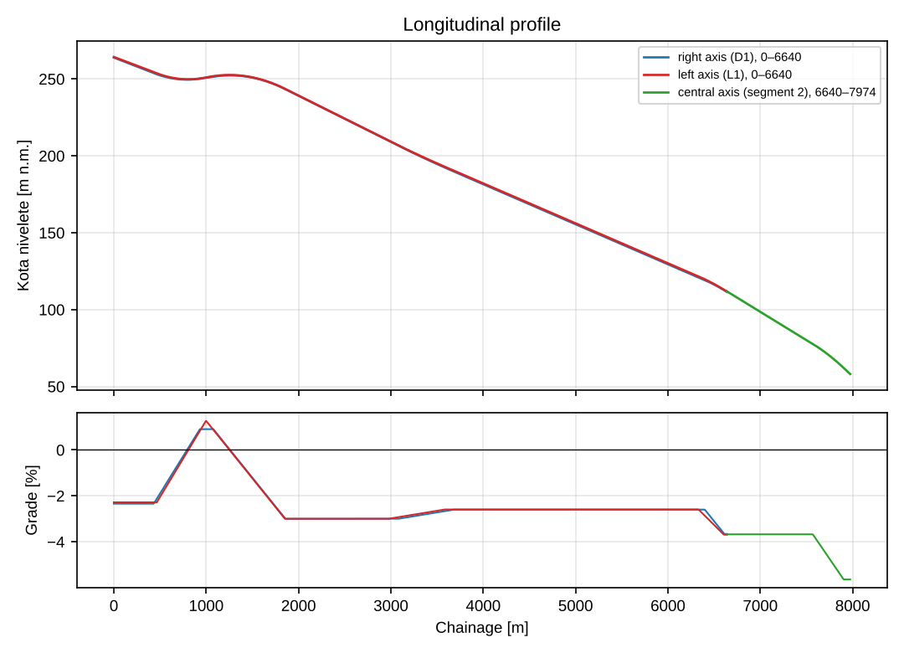
Figure 1 – Longitudinal profile of the grade line and longitudinal grade
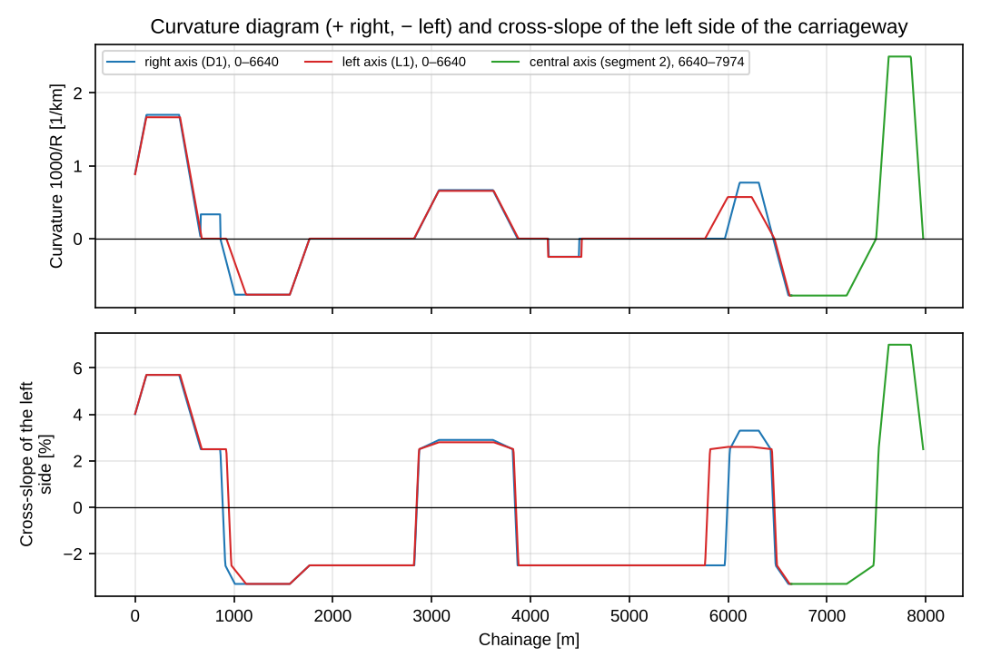
Figure 2 – Curvature diagram (1000/R) and cross-slope of the left side
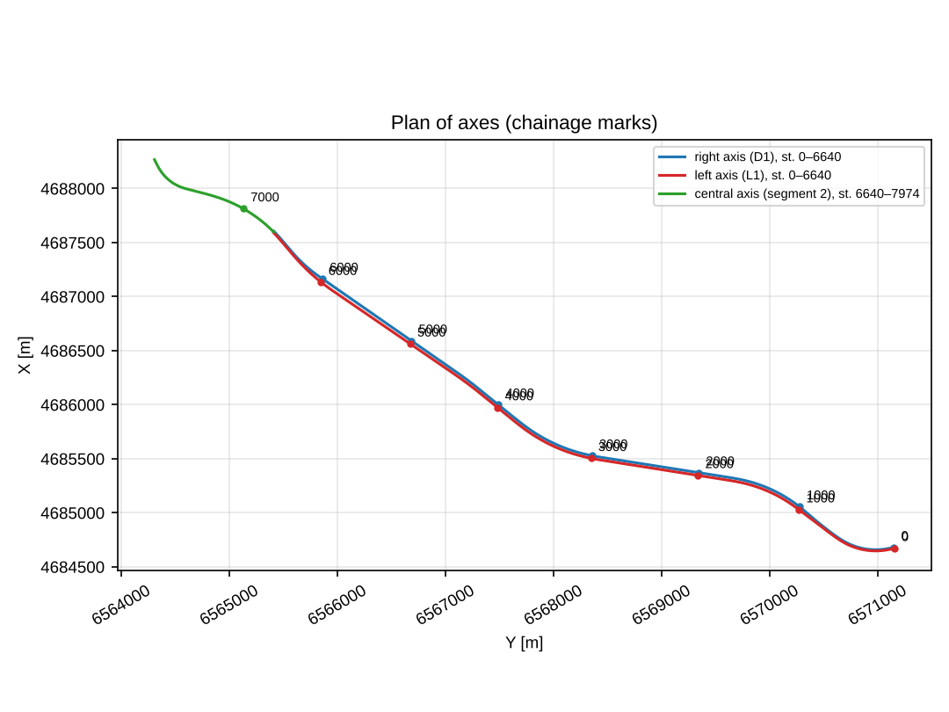
Figure 3 – Plan of axes with chainages

4 Resulting projected-speed profile – passenger car

4.1 Speeds on elements and harmonisation
By applying the method from chapter 2, the resulting V_{p} profiles in Figure 4 were obtained. Speed limitations below max V_{r} = 120 km/h occur on the curves: F2, curve no. 5 (R = 400.0 m, ch. 7624.3 – 7848.9) – V_{p} = 96.3 km/h; B2, curve no. 5 (R = 400.0 m, ch. 7624.3 – 7848.9) – V_{p} = 96.3 km/h; D1, curve no. 9 (R = 588.3 m, ch. 115.4 – 445.8) – V_{p} = 112.6 km/h; L1, curve no. 9 (R = 600.0 m, ch. 113.9 – 454.9) – V_{p} = 113.7 km/h.
Check of the condition V_{ri} ≤ V_{p}. According to item 3.3.3 of Annex 2 of the Rulebook, V_{ri} ≤ V_{p} ≤ max V_{r} must hold. The design speed is V_{r} = 100 km/h, and the resulting V_{p} is lower than it on curves F2, curve no. 5 (R = 400.0 m, V_{p} = 96.3 km/h); B2, curve no. 5 (R = 400.0 m, V_{p} = 96.3 km/h) i on segments with a large longitudinal grade: F2 (lowest V_{p} = 96.3 km/h at ch. 7625 m); B2 (lowest V_{p} = 96.3 km/h at ch. 7625 m). These elements do not satisfy the design speed and should be corrected or justified; the speed in the profile is not raised to V_{r} because that would hide the real limitation.
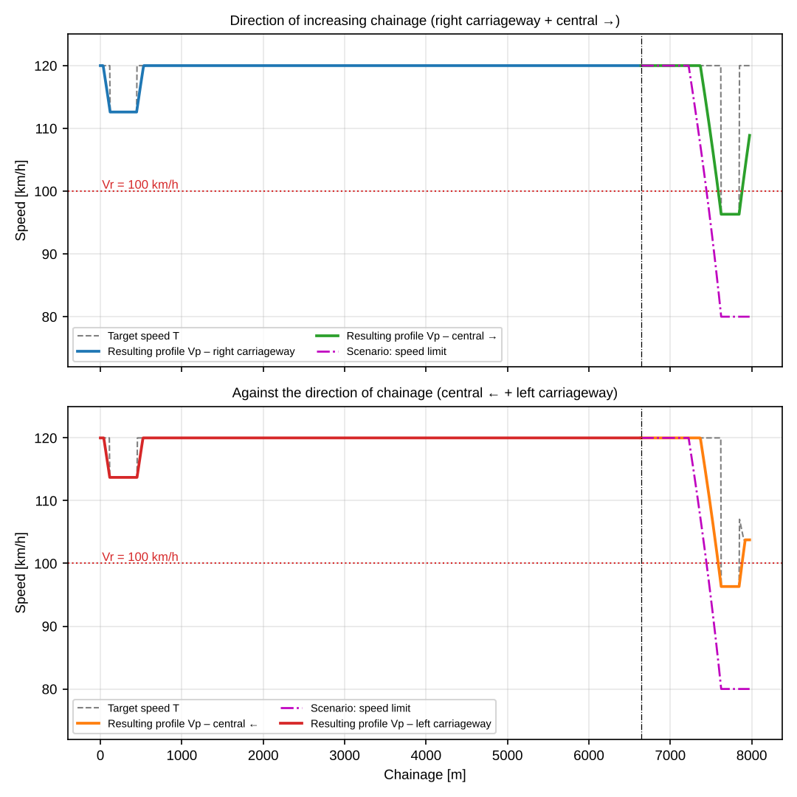
Figure 4 – Resulting projected-speed profiles – passenger car; dashed purple line – scenario with a speed limit
Table 9 – Consistency of adjacent elements, D1: Right carriageway, direction of chainage, ch. 0 – 6640 (passenger car)
No. | Element | Ch. from [m] | Ch. to [m] | L [m] | R [m] | Direction | V_{p,i} cilj [km/h] | ΔV_{cilj} [km/h] | Rating | V_{p,i} rez. [km/h] | ΔV_{rez} [km/h]
1 | curvature | 0.0 | 664.1 | 664.1 | 588.30 | right | 112.6 | 7.4 | good | 112.6 | 7.4
2 | curvature | 664.1 | 862.3 | 198.2 | 3000.00 | right | 120.0 | 0.0 | good | 120.0 | 0.0
3 | curvature | 862.3 | 1765.3 | 903.0 | 1300.00 | left | 120.0 | 0.0 | good | 120.0 | 0.0
4 | tangent | 1765.3 | 2825.5 | 1060.1 | – | – | 120.0 | 0.0 | good | 120.0 | 0.0
5 | curvature | 2825.5 | 3869.9 | 1044.4 | 1500.00 | right | 120.0 | 0.0 | good | 120.0 | 0.0
6 | tangent | 3869.9 | 4183.0 | 313.2 | – | – | 120.0 | 0.0 | good | 120.0 | 0.0
7 | curvature | 4183.0 | 4494.0 | 311.0 | 4025.00 | left | 120.0 | 0.0 | good | 120.0 | 0.0
8 | tangent | 4494.0 | 5967.3 | 1473.2 | – | – | 120.0 | 0.0 | good | 120.0 | 0.0
9 | curvature | 5967.3 | 6455.8 | 488.6 | 1300.00 | right | 120.0 | 0.0 | good | 120.0 | 0.0
10 | curvature | 6455.8 | 6640.0 | 184.2 | 1285.35 | left | 120.0 | – |  | 120.0 | –
Table 10 – Consistency of adjacent elements, L1: Left carriageway, against the direction of chainage, ch. 0 – 6640 (passenger car)
No. | Element | Ch. from [m] | Ch. to [m] | L [m] | R [m] | Direction | V_{p,i} cilj [km/h] | ΔV_{cilj} [km/h] | Rating | V_{p,i} rez. [km/h] | ΔV_{rez} [km/h]
1 | curvature | 0.0 | 674.9 | 674.9 | 600.00 | right | 113.7 | 6.3 | good | 113.7 | 6.3
2 | tangent | 674.9 | 923.2 | 248.3 | – | – | 120.0 | 0.0 | good | 120.0 | 0.0
3 | curvature | 923.2 | 1765.1 | 841.9 | 1300.00 | left | 120.0 | 0.0 | good | 120.0 | 0.0
4 | tangent | 1765.1 | 2822.3 | 1057.2 | – | – | 120.0 | 0.0 | good | 120.0 | 0.0
5 | curvature | 2822.3 | 3878.5 | 1056.2 | 1525.00 | right | 120.0 | 0.0 | good | 120.0 | 0.0
6 | tangent | 3878.5 | 4177.4 | 298.9 | – | – | 120.0 | 0.0 | good | 120.0 | 0.0
7 | curvature | 4177.4 | 4516.5 | 339.1 | 4000.00 | left | 120.0 | 0.0 | good | 120.0 | 0.0
8 | tangent | 4516.5 | 5767.0 | 1250.5 | – | – | 120.0 | 0.0 | good | 120.0 | 0.0
9 | curvature | 5767.0 | 6468.7 | 701.7 | 1750.00 | right | 120.0 | 0.0 | good | 120.0 | 0.0
10 | curvature | 6468.7 | 6640.0 | 171.3 | 1274.65 | left | 120.0 | – |  | 120.0 | –
Table 11 – Consistency of adjacent elements, F2: Central axis, direction of chainage, ch. 6640 – 7974 (passenger car)
No. | Element | Ch. from [m] | Ch. to [m] | L [m] | R [m] | Direction | V_{p,i} cilj [km/h] | ΔV_{cilj} [km/h] | Rating | V_{p,i} rez. [km/h] | ΔV_{rez} [km/h]
1 | curvature | 6640.0 | 7498.1 | 858.1 | 1280.00 | left | 120.0 | 23.7 | poor | 109.0 | 12.7
2 | curvature | 7498.1 | 7973.9 | 475.8 | 400.00 | right | 96.3 | – |  | 96.3 | –
Table 12 – Consistency of adjacent elements, B2: Central axis, against the direction of chainage, ch. 6640 – 7974 (passenger car)
No. | Element | Ch. from [m] | Ch. to [m] | L [m] | R [m] | Direction | V_{p,i} cilj [km/h] | ΔV_{cilj} [km/h] | Rating | V_{p,i} rez. [km/h] | ΔV_{rez} [km/h]
1 | curvature | 6640.0 | 7498.1 | 858.1 | 1280.00 | left | 120.0 | 23.7 | poor | 109.0 | 12.7
2 | curvature | 7498.1 | 7973.9 | 475.8 | 400.00 | right | 96.3 | – |  | 96.3 | –
Differences of target speeds of adjacent elements greater than 10 km/h: F2, transition from element 1 to element 2 (ch. 7498.1): ΔV_{target} = 23.7 km/h (poor), ΔV_{res} = 12.7 km/h; B2, transition from element 1 to element 2 (ch. 7498.1): ΔV_{target} = 23.7 km/h (poor), ΔV_{res} = 12.7 km/h. The difference of the resulting speeds is smaller because deceleration takes place on the transition curve and preceding elements; the other differences are ≤ 10 km/h (“good”).

4.2 Statistics of the resulting profile
Example of the statistics calculation for the case D1 (Right carriageway, direction of chainage, ch. 0 – 6640), length L = 6640. m, 1329 points:
$$V_{p,sr}=\frac{1}{6640.}∑\frac{V_{i}+V_{i+1}}{2} Δs_{i}=119.544 \text{km/h}$$
$$σ=\sqrt{\frac{1}{6640.}∑\frac{{\left(V_{i}−119.544\right)}^{2}+{\left(V_{i+1}−119.544\right)}^{2}}{2} Δs_{i}}=1.711 \text{km/h}$$
$$D_{h}=\frac{σ}{V_{p,sr}}⋅100=\frac{1.711}{119.544}⋅100=1.43 \%$$
$$T=∑\frac{Δs_{i}}{2}\left(\frac{1}{v_{i}}+\frac{1}{v_{i+1}}\right)=200.0 \text{s}=3.33 \text{min}$$
Table 13 – Indicators of dynamic homogeneity, passenger car
Section (direction of travel) | V_{p,sr} [km/h] | σ [km/h] | D_{h} [%] | V_{min} [km/h] | V_{max} [km/h] | T [s] | T [min]
D1: right carriageway (0–6640) | 119.54 | 1.711 | 1.43 | 112.6 | 120.0 | 200.0 | 3.33
L1: left carriageway (0–6640) | 119.61 | 1.462 | 1.22 | 113.7 | 120.0 | 199.9 | 3.33
F2: central → (6640–7974) | 112.24 | 9.808 | 8.74 | 96.3 | 120.0 | 43.1 | 0.72
B2: central ← (6640–7974) | 112.13 | 9.880 | 8.81 | 96.3 | 120.0 | 43.2 | 0.72
Entire alignment – direction of increasing chainage (D1+F2) | 118.32 | 5.096 | 4.31 | 96.3 | 120.0 | 243.1 | 4.05
Entire alignment – against the direction of chainage (B2+L1) | 118.36 | 5.090 | 4.30 | 96.3 | 120.0 | 243.1 | 4.05
Coefficient of dynamic homogeneity D_{h} by section: D1 1.43 %; L1 1.22 %; F2 8.74 %; B2 8.81 %. The D_{h} values are a direct consequence of the assumed V_{p}–R and V_{p}–i_{N} relationships (chapter 2.2): if lower speeds in curves are read from the original graphs, the profile will be lower and more varied (higher D_{h}).

4.3 Check of cross-slopes on circular curves
The required cross-slope in a curve for the design speed is determined from Annex 2 [1]:
$$i_{pk}\left(V_{r}\right)=7⋅{\left(\frac{R_{min}\left(V_{r}\right)}{R}\right)}^{0.74}, 2.5 \%≤i_{pk}≤7 \%$$
and the dynamic check for the resulting speed V (lateral friction condition):
$$f_{req}=\frac{V^{2}}{127 R}−\frac{i_{p}}{100}≤f_{R}\left(V\right), i_{p,req}=\left(\frac{V^{2}}{127 R}−f_{R}\left(V\right)\right)⋅100$$
Example – the most unfavourable arc: D1, curve no. 9 (R = 588.30 m, V = 112.6 km/h, R_{min}(100) = 437 m, applied slope 5.7 %):
$$i_{pk}\left(100\right)=7⋅{\left(\frac{437}{588.30}\right)}^{0.74}=7⋅0.803=5.621 \%⇒ 5.7 \% \left(\text{primijenjeno}\right)$$
$$f_{req}=\frac{{112.6}^{2}}{127⋅588.30}−0.057=0.1697−0.057=0.113>f_{R}\left(112.6\right)=0.100$$
$$i_{p,req}=\left(0.1697−0.100\right)⋅100=6.97 \%$$
Table 14 – Cross-slopes on circular curves, D1: Right carriageway, direction of chainage, ch. 0 – 6640
Curve no. | R [m] | Direction | V_{p} [km/h] | i_{pk}(V_{r}) [%] | i_{p} prim. [%] | i_{p} ≥ i_{pk} | f_{R}(V_{p}) | i_{p,potr} [%] | f_{pot} | f_{pot} ≤ f_{R} | R ≥ R_{min}
9 | 588.30 | right | 112.6 | 5.62 | 5.7 | da | 0.100 | 6.97 | 0.113 | NO | da
11 | 3000.00 | right | 120.0 | 2.50 | 2.5 | da | 0.100 | 2.50 | 0.013 | da | da
13 | 1300.00 | left | 120.0 | 3.13 | 3.3 | da | 0.100 | 2.50 | 0.054 | da | da
17 | 1500.00 | right | 120.0 | 2.81 | 2.9 | da | 0.100 | 2.50 | 0.047 | da | da
20 | 4025.00 | left | 120.0 | 2.50 | 2.5 | da | 0.100 | 2.50 | 0.003 | da | da
23 | 1300.00 | right | 120.0 | 3.13 | 3.3 | da | 0.100 | 2.50 | 0.054 | da | da
26 | 1285.35 | left | 120.0 | 3.15 | 3.3 | da | 0.100 | 2.50 | 0.055 | da | da
Table 15 – Cross-slopes on circular curves, L1: Left carriageway, against the direction of chainage, ch. 0 – 6640
Curve no. | R [m] | Direction | V_{p} [km/h] | i_{pk}(V_{r}) [%] | i_{p} prim. [%] | i_{p} ≥ i_{pk} | f_{R}(V_{p}) | i_{p,potr} [%] | f_{pot} | f_{pot} ≤ f_{R} | R ≥ R_{min}
9 | 600.00 | right | 113.7 | 5.54 | 5.7 | da | 0.100 | 6.97 | 0.113 | NO | da
13 | 1300.00 | left | 120.0 | 3.13 | 3.3 | da | 0.100 | 2.50 | 0.054 | da | da
17 | 1525.00 | right | 120.0 | 2.78 | 2.8 | da | 0.100 | 2.50 | 0.046 | da | da
20 | 4000.00 | left | 120.0 | 2.50 | 2.5 | da | 0.100 | 2.50 | 0.003 | da | da
23 | 1750.00 | right | 120.0 | 2.51 | 2.6 | da | 0.100 | 2.50 | 0.039 | da | da
26 | 1274.65 | left | 120.0 | 3.17 | 3.3 | da | 0.100 | 2.50 | 0.056 | da | da
Table 16 – Cross-slopes on circular curves, F2: Central axis, direction of chainage, ch. 6640 – 7974
Curve no. | R [m] | Direction | V_{p} [km/h] | i_{pk}(V_{r}) [%] | i_{p} prim. [%] | i_{p} ≥ i_{pk} | f_{R}(V_{p}) | i_{p,potr} [%] | f_{pot} | f_{pot} ≤ f_{R} | R ≥ R_{min}
2 | 1280.00 | left | 120.0 | 3.16 | 3.3 | da | 0.100 | 2.50 | 0.056 | da | da
5 | 400.00 | right | 96.3 | 7.00 | 7.0 | da | 0.114 | 6.90 | 0.113 | da | NO
Table 17 – Cross-slopes on circular curves, B2: Central axis, against the direction of chainage, ch. 6640 – 7974
Curve no. | R [m] | Direction | V_{p} [km/h] | i_{pk}(V_{r}) [%] | i_{p} prim. [%] | i_{p} ≥ i_{pk} | f_{R}(V_{p}) | i_{p,potr} [%] | f_{pot} | f_{pot} ≤ f_{R} | R ≥ R_{min}
2 | 1280.00 | left | 120.0 | 3.16 | 3.3 | da | 0.100 | 2.50 | 0.056 | da | da
5 | 400.00 | right | 96.3 | 7.00 | 7.0 | da | 0.114 | 6.90 | 0.113 | da | NO
Conclusion of the check: the criterion i_{p} ≥ i_{pk}(V_{r}) is satisfied on all curves. The dynamic check for the resulting speed V_{p} shows that the slope is insufficient at: D1, curve no. 9 (R = 588.30 m, V = 112.6 km/h, applied 5.7 %, required 6.97 %); L1, curve no. 9 (R = 600.00 m, V = 113.7 km/h, applied 5.7 %, required 6.97 %). Recommendation: increase the slope on the curve (up to 7.0 %), or accept a lower speed on the curve, or increase the radius. The condition R ≥ R_{min}(V_{r}) = 437 m is not satisfied at: F2, curve no. 5 (R = 400.00 m); B2, curve no. 5 (R = 400.00 m). The designer should confirm that a deviation is permitted for these curves or increase the radius.

5 Vehicle dynamics model – speeds, travel time and fuel consumption

5.1 Motion and consumption model
Parameters for the passenger car and heavy vehicles are not given in the Project Brief, so typical ones were adopted (they must be confirmed): reference heavy goods vehicle per the Rulebook (Figure 3-10, Annex 2): m = 40.00 t, P = 306 kW, C_{d}A = 5.20 m², v_{lim} = 80 km/h, η = 0.90, γ_{m} = 1.06, μ = 0.50, b = 0.24 l/kWh, prazan hod 2.0 l/h; heavy goods vehicle – tractor with semi-trailer (modern vehicle): m = 40.00 t, P = 350 kW, C_{d}A = 5.20 m², v_{lim} = 80 km/h, η = 0.90, γ_{m} = 1.06, μ = 0.50, b = 0.24 l/kWh, prazan hod 2.0 l/h; car transporter (towing vehicle with trailer): m = 36.00 t, P = 320 kW, C_{d}A = 7.00 m², v_{lim} = 80 km/h, η = 0.90, γ_{m} = 1.06, μ = 0.50, b = 0.24 l/kWh, prazan hod 2.0 l/h; passenger car (medium class): m = 1.50 t, P = 90 kW, C_{d}A = 0.66 m², v_{lim} = 120 km/h, η = 0.90, γ_{m} = 1.10, μ = 0.60, b = 0.28 l/kWh, prazan hod 0.8 l/h; air density ρ = 1.225 kg/m³. The speed profile of the passenger car from chapter 4 (V_{p}) is the result of the V_{p} – R and V_{p} – i_{N} relationships with acceleration and deceleration limits, while in this chapter the same vehicle is analysed with a dynamic model (resistance and traction forces), giving the speed from the traction force, the travel time and the fuel consumption. At the entrance to the alignment the vehicle has v_{lim}, and at segment boundaries the speed is carried over from the previous section in the direction of travel.
For each step Δs, according to [8] and [9] (v in m/s, G = longitudinal grade as a fraction, + uphill in the direction of travel):
$$R_{r}=f_{rl} m g, f_{rl}=0.01\left(1+\frac{v}{44.73}\right)$$
$$R_{a}=1/2 ρ C_{d}A v^{2}, R_{g}=m g G, F_{r}=R_{r}+R_{a}+R_{g}$$
$$F_{t}=min\left(\frac{η P}{v}, μ m g\right), a=\frac{F_{t}−F_{r}}{γ_{m} m}, v_{i+1}=\sqrt{v_{i}^{2}+2 a Δs}≤v_{lim}$$
Fuel consumption per step: for F_{r} ≤ 0 (engine braking, no injection) idle consumption is used; otherwise
$$ΔB=b⋅\frac{F_{u} v_{sr}}{η⋅1000}⋅\frac{Δs}{v_{sr}}⋅\frac{1}{3600} \left[\text{l}\right]$$
where F_{u} = F_{r} when the vehicle maintains v_{lim}, and F_{u} = F_{t} when the vehicle uses full power (climbing with falling speed, or accelerating).
Vehicle according to the Rulebook. For the reference heavy goods vehicle the Rulebook (Annex 2, Figure 3-10) gives a V-L diagram of speed on gradients, from which the equilibrium speeds of 68, 55, 43, 33, 24 and 15 km/h on gradients of 2 % to 7 % result. For the vehicle “Tractor-trailer (Rulebook)” the traction force is not given as a constant power but as a curve F_{t}(v), obtained from these equilibrium points (at equilibrium F_{t} = F_{r}) for a mass m = 40.0 t and C_{d}A = 5.2 m². Below the lowest speed the curve keeps the last value, and above the highest constant power applies. In this way the speeds of that vehicle on gradients coincide with the diagram from the Rulebook. The other vehicles (“Tractor-trailer (modern), Car transporter, Passenger car”) are calculated with constant power (modern vehicles), so their speeds on gradients are higher; their parameters are assumptions.
Table 18 – Traction-force curve of the vehicle according to the Rulebook
v [km/h] | 15 | 24 | 33 | 43 | 55 | 68
F_{t} [N] | 31813 | 28194 | 24616 | 21122 | 17780 | 14565
Table 19 – Equilibrium speeds of the vehicle on a gradient (model) and the diagram from the Rulebook
Grade [%] | 2 | 3 | 4 | 5 | 6 | 7
Rulebook, Figure 3-10 [km/h] | 68 | 55 | 43 | 33 | 24 | 15
Tractor-trailer (Rulebook) [km/h] | 68 | 55 | 43 | 33 | 24 | 15
Tractor-trailer (modern) [km/h] | 76 | 62 | 53 | 45 | 39 | 35
Car transporter [km/h] | 74 | 62 | 53 | 45 | 40 | 35
Passenger car [km/h] | 162 | 162 | 162 | 160 | 153 | 147
Example 1 – tractor-trailer (rulebook), L1 (left carriageway, lowest speed) ch. 6560 m: speed v = 49.0 km/h = 13.601 m/s, grade in the direction of travel G = 3.499 %, step Δs = 5 m.
$$f_{rl}=0.01\left(1+\frac{13.601}{44.73}\right)=0.01304, R_{r}=0.01304⋅40000⋅9.81=5117 \text{N}$$
$$R_{a}=0.5⋅1.225⋅5.2⋅{13.601}^{2}=589 \text{N}, R_{g}=40000⋅9.81⋅0.03499=13731 \text{N}$$
$$F_{r}=5117+589+\left(13731\right)=19437 \text{N}$$
$$F_{t}=min\left(\frac{0.90⋅306000}{13.601}, 0.50⋅40000⋅9.81\right)=min\left(20249; 196200\right)=19461 \text{N}$$
$$a=\frac{19461−\left(19437\right)}{1.06⋅40000}=0.0006 {\text{m/s}}^{2}, v_{i+1}=\sqrt{{13.601}^{2}+2⋅\left(0.0006\right)⋅5}=13.601 \text{m/s}$$
$$ΔB=0.24⋅\frac{19461⋅13.601}{0.90⋅1000}⋅\frac{0.368}{3600}=0.00721 \text{l}$$
Primjer 2 – tractor-trailer (rulebook), D1 (nizbrdica) ch. 0 m: speed v = 80.0 km/h = 22.222 m/s, grade in the direction of travel G = -2.342 %, step Δs = 5 m.
$$f_{rl}=0.01\left(1+\frac{22.222}{44.73}\right)=0.01497, R_{r}=0.01497⋅40000⋅9.81=5873 \text{N}$$
$$R_{a}=0.5⋅1.225⋅5.2⋅{22.222}^{2}=1573 \text{N}, R_{g}=40000⋅9.81⋅−0.02342=−9190 \text{N}$$
$$F_{r}=5873+1573+\left(−9190\right)=−1744 \text{N}$$
$$F_{t}=min\left(\frac{0.90⋅306000}{22.222}, 0.50⋅40000⋅9.81\right)=min\left(12393; 196200\right)=12380 \text{N}$$
F_{r} ≤ 0 – the vehicle does not use fuel for propulsion (engine braking), only idle is counted: ΔB = 2.0 · 0.225/3600 = 0.00013 l

5.2 Results
Lowest speeds of vehicle “Tractor-trailer (Rulebook)” by segment: D1 80.0 km/h; L1 49.0 km/h; F2 80.0 km/h; B2 49.2 km/h. On sections where the vehicle is mostly going downhill the speed is limited to v_{lim} = 80 km/h; on gradients the speed falls to the equilibrium value, which means a large difference relative to passenger cars. The need for an additional lane for slow vehicles should be assessed according to the applicable rulebook.
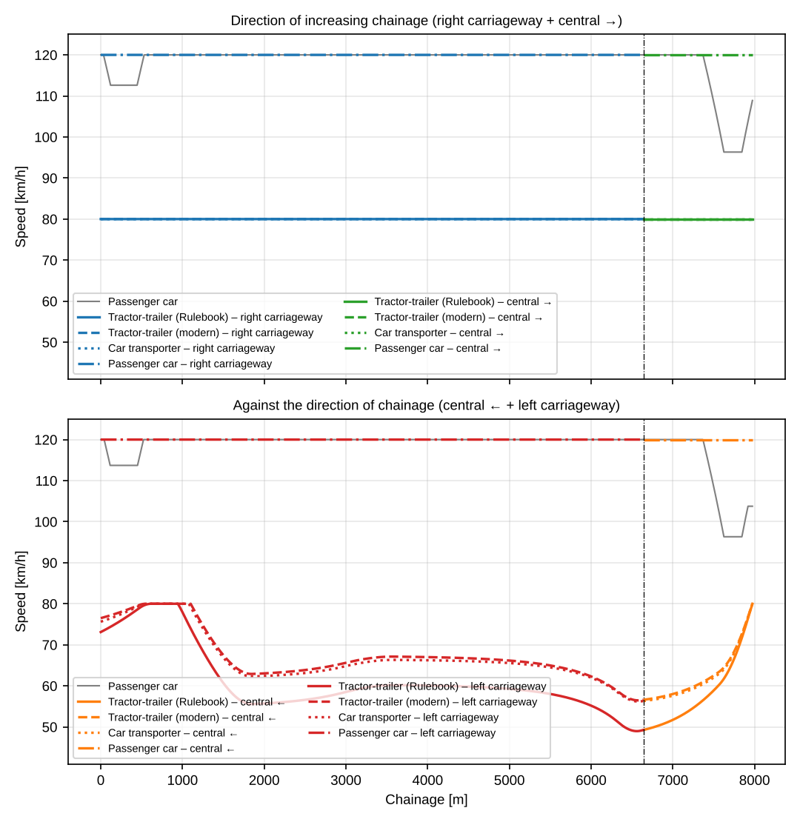
Figure 5 – Speed profile of heavy vehicles (grey line – passenger car)
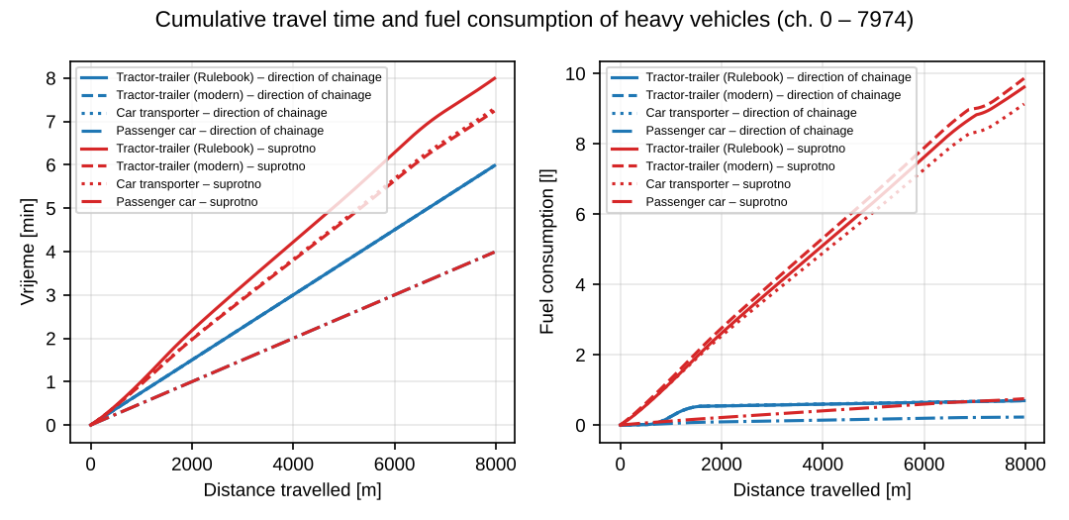
Figure 6 – Cumulative travel time and fuel consumption along the distance travelled
Table 20 – Travel time and fuel consumption of heavy vehicles
Vehicle / segment | V_{sr} [km/h] | σ [km/h] | D_{h} [%] | V_{min} [km/h] | T [s] | T [min] | Gorivo [l] | [l/km] | [l/100 km]
Tractor-trailer (Rulebook) – D1: right carriageway | 80.0 | 0.00 | 0.00 | 80.0 | 298.8 | 4.98 | 0.66 | 0.099 | 9.9
Tractor-trailer (modern) – D1: right carriageway | 80.0 | 0.00 | 0.00 | 80.0 | 298.8 | 4.98 | 0.66 | 0.099 | 9.9
Car transporter – D1: right carriageway | 80.0 | 0.00 | 0.00 | 80.0 | 298.8 | 4.98 | 0.67 | 0.100 | 10.0
Passenger car – D1: right carriageway | 120.0 | 0.00 | 0.00 | 120.0 | 199.2 | 3.32 | 0.21 | 0.032 | 3.2
Tractor-trailer (Rulebook) – L1: left carriageway | 61.4 | 8.11 | 13.21 | 49.0 | 395.2 | 6.59 | 7.92 | 1.193 | 119.3
Tractor-trailer (modern) – L1: left carriageway | 67.5 | 6.12 | 9.07 | 56.5 | 356.8 | 5.95 | 8.05 | 1.212 | 121.2
Car transporter – L1: left carriageway | 67.0 | 6.19 | 9.25 | 56.2 | 359.9 | 6.00 | 7.47 | 1.124 | 112.4
Passenger car – L1: left carriageway | 120.0 | 0.00 | 0.00 | 120.0 | 199.2 | 3.32 | 0.60 | 0.090 | 9.0
Tractor-trailer (Rulebook) – F2: central → | 80.0 | 0.00 | 0.00 | 80.0 | 60.0 | 1.00 | 0.03 | 0.025 | 2.5
Tractor-trailer (modern) – F2: central → | 80.0 | 0.00 | 0.00 | 80.0 | 60.0 | 1.00 | 0.03 | 0.025 | 2.5
Car transporter – F2: central → | 80.0 | 0.00 | 0.00 | 80.0 | 60.0 | 1.00 | 0.03 | 0.025 | 2.5
Passenger car – F2: central → | 120.0 | 0.00 | 0.00 | 120.0 | 40.0 | 0.67 | 0.02 | 0.012 | 1.2
Tractor-trailer (Rulebook) – B2: central ← | 58.0 | 8.08 | 13.93 | 49.2 | 84.2 | 1.40 | 1.69 | 1.268 | 126.8
Tractor-trailer (modern) – B2: central ← | 62.4 | 5.96 | 9.54 | 56.6 | 77.5 | 1.29 | 1.81 | 1.356 | 135.6
Car transporter – B2: central ← | 62.0 | 6.03 | 9.72 | 56.3 | 78.1 | 1.30 | 1.66 | 1.248 | 124.8
Passenger car – B2: central ← | 120.0 | 0.00 | 0.00 | 120.0 | 40.0 | 0.67 | 0.15 | 0.112 | 11.2
Tractor-trailer (Rulebook) – entire alignment, direction of increasing chainage | 80.0 | 0.00 | 0.00 | 80.0 | 358.8 | 5.98 | 0.69 | 0.087 | 8.7
Tractor-trailer (modern) – entire alignment, direction of increasing chainage | 80.0 | 0.00 | 0.00 | 80.0 | 358.8 | 5.98 | 0.69 | 0.087 | 8.7
Car transporter – entire alignment, direction of increasing chainage | 80.0 | 0.00 | 0.00 | 80.0 | 358.8 | 5.98 | 0.70 | 0.088 | 8.8
Passenger car – entire alignment, direction of increasing chainage | 120.0 | 0.00 | 0.00 | 120.0 | 239.2 | 3.99 | 0.23 | 0.029 | 2.9
Tractor-trailer (Rulebook) – entire alignment, against the direction of chainage | 60.9 | 8.21 | 13.49 | 49.0 | 479.5 | 7.99 | 9.61 | 1.205 | 120.5
Tractor-trailer (modern) – entire alignment, against the direction of chainage | 66.7 | 6.38 | 9.57 | 56.5 | 434.3 | 7.24 | 9.86 | 1.236 | 123.6
Car transporter – entire alignment, against the direction of chainage | 66.1 | 6.43 | 9.73 | 56.2 | 437.9 | 7.30 | 9.13 | 1.145 | 114.5
Passenger car – entire alignment, against the direction of chainage | 120.0 | 0.00 | 0.00 | 120.0 | 239.2 | 3.99 | 0.75 | 0.094 | 9.4
Total for traversing the whole alignment (all analysed directions): tractor-trailer (rulebook) 13.97 min i 10.31 l; tractor-trailer (modern) 13.22 min i 10.55 l; car transporter 13.28 min i 9.83 l; passenger car 7.97 min i 0.98 l. Consumption in the downhill direction is low because the vehicle moves with engine braking, while consumption in the uphill direction is determined by the engine working at full power. The absolute values depend on the adopted vehicle parameters (chapter 5.1) and serve for comparing variants, not as guaranteed consumption.

6 Scenario with a speed limit

6.1 Starting point
In addition to the basic calculation (chapters 2 – 5), in which the V85 speed results from geometry only, a scenario with an additional speed limit was made: 80 km/h at ch. 7624.326 – 7973.924. The limit acts as an additional target speed T = min(V_{p,R}; V_{p}(i_{N}); v_{lim}), and before it the vehicle decelerates at d = 0.8 m/s², and after it accelerates at a = 0.8 m/s². The speed limit lowers the actual V85 speed only if drivers comply with the limit; therefore this scenario is valid with appropriate signage and, if needed, physical speed-reducing measures, and for sight distance (Study 4) the result from geometry should also be checked.
Distance needed to decelerate from 120 to 80 km/h:
$$s=\frac{{\left(120/3.6\right)}^{2}−{\left(80/3.6\right)}^{2}}{2⋅0.77}=\frac{1111.11−493.83}{1.543}=400.0 \text{m}$$
Therefore, for a zone beginning at ch. 7624.326 m, deceleration (in the direction of travel towards the zone) begins at the latest about 400.0 m before the start of the zone, so the limit and its advance warning should be placed at that location at the latest.

6.2 Results
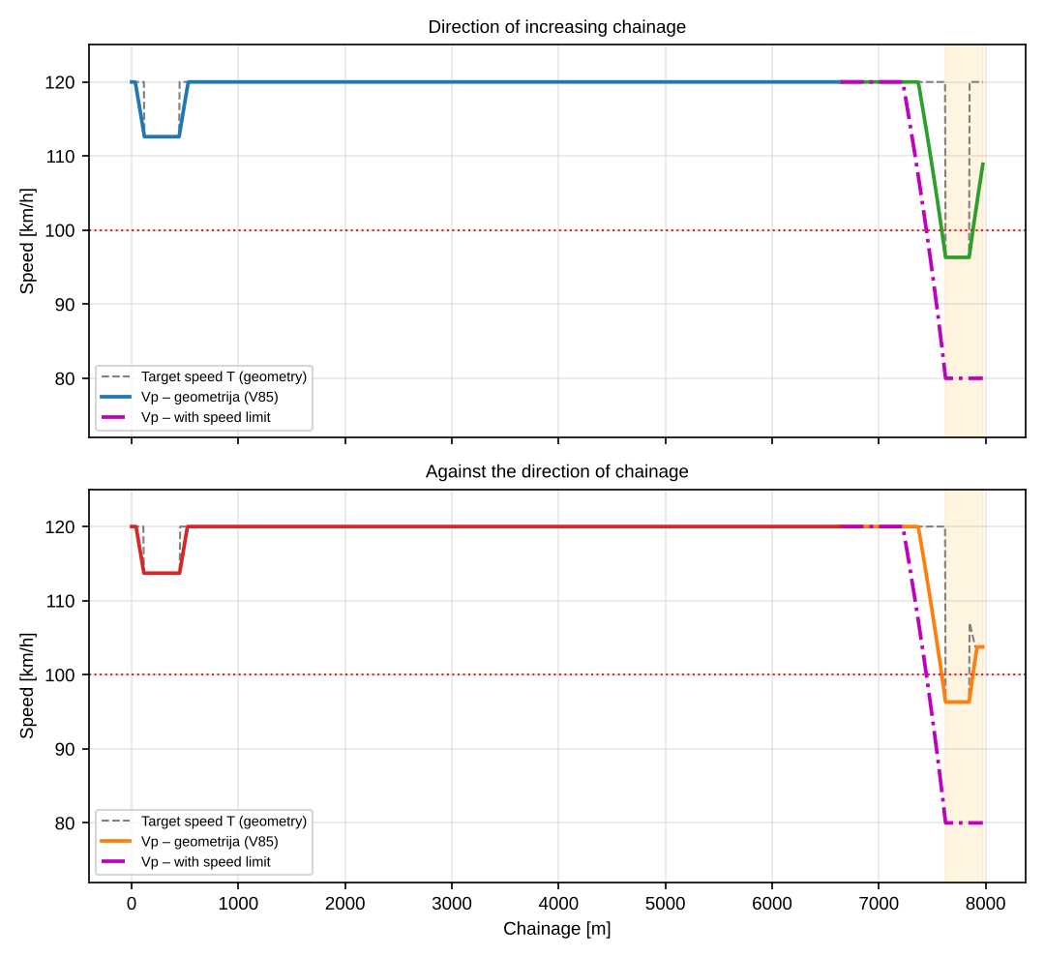
Figure 7 – Passenger car: geometry (V85) and the scenario with a speed limit
Table 21 – Comparison of scenarios, passenger car
Segment / scenario | V_{p,sr} [km/h] | σ [km/h] | D_{h} [%] | V_{min} [km/h] | V_{max} [km/h] | T [s]
F2: central →, geometry | 112.24 | 9.808 | 8.74 | 96.3 | 120.0 | 43.1
F2: central →, limit | 103.94 | 17.451 | 16.79 | 80.0 | 120.0 | 47.7
B2: central ←, geometry | 112.13 | 9.880 | 8.81 | 96.3 | 120.0 | 43.2
B2: central ←, limit | 103.94 | 17.451 | 16.79 | 80.0 | 120.0 | 47.7
Entire alignment, direction of increasing chainage, geometry | 118.32 | 5.096 | 4.31 | 96.3 | 120.0 | 243.1
Entire alignment, direction of increasing chainage, limit | 116.93 | 9.344 | 7.99 | 80.0 | 120.0 | 247.7
Entire alignment, against the direction of chainage, geometry | 118.36 | 5.090 | 4.30 | 96.3 | 120.0 | 243.1
Entire alignment, against the direction of chainage, limit | 116.99 | 9.324 | 7.97 | 80.0 | 120.0 | 247.5
Table 22 – Consistency of adjacent elements with the speed limit
Case | No. | Element | Ch. from [m] | Ch. to [m] | L [m] | R [m] | Direction | V_{p,i} cilj [km/h] | ΔV_{cilj} [km/h] | Rating | V_{p,i} rez. [km/h] | ΔV_{rez} [km/h]
F2 | 1 | curvature | 6640.0 | 7498.1 | 858.1 | 1280.00 | left | 120.0 | 40.0 | poor | 94.9 | 14.9
F2 | 2 | curvature | 7498.1 | 7973.9 | 475.8 | 400.00 | right | 80.0 | – |  | 80.0 | –
B2 | 1 | curvature | 6640.0 | 7498.1 | 858.1 | 1280.00 | left | 120.0 | 40.0 | poor | 94.9 | 14.9
B2 | 2 | curvature | 7498.1 | 7973.9 | 475.8 | 400.00 | right | 80.0 | – |  | 80.0 | –
Table 23 – Check of the cross-slope of curves in the limit zone for the limited speed
Case | Curve no. | R [m] | V [km/h] | i_{p} prim. [%] | f_{R}(V) | i_{p,potr} [%] | f_{pot} | f_{pot} ≤ f_{R} | R ≥ R_{min}(V)
F2 | 2 | 1280.00 | 120.0 | 3.3 | 0.100 | 2.50 | 0.056 | da | da
F2 | 5 | 400.00 | 80.0 | 7.0 | 0.130 | 2.50 | 0.056 | da | da
B2 | 2 | 1280.00 | 120.0 | 3.3 | 0.100 | 2.50 | 0.056 | da | da
B2 | 5 | 400.00 | 80.0 | 7.0 | 0.130 | 2.50 | 0.056 | da | da
Observations.
- Differences of target speeds of adjacent elements greater than 10 km/h: F2, elements 1–2: ΔV_{target} = 40.0 km/h (poor), ΔV_{res} = 14.9 km/h; B2, elements 1–2: ΔV_{target} = 40.0 km/h (poor), ΔV_{res} = 14.9 km/h. These differences cannot be mitigated by geometry without increasing the radii, so advance warning of the limit is necessary (sign, longitudinal markings, a preceding limit if needed).
- Coefficient of dynamic homogeneity and travel time over the whole alignment (geometry → limit): direction of increasing chainage: D_{h} 4.31 → 7.99 %, time 4.5 s longer; against the direction of chainage: D_{h} 4.30 → 7.97 %, time 4.5 s longer. Heavy vehicles are not affected if their speed is ≤ the limit anyway.
- Elements not part of the analysis (e.g. a toll plaza and the exit from it) have not been modelled; if a check of the stopping distance or of the conditions on the approach is required, the speed on the approach should be specified separately.
- The start and end of the limit zone can be changed in the workbook (sheet Parametri, table of limit zones; the scenario is switched on by cell B14 = 2).

7 Conclusions and recommendations
- Resulting projected speed (V85) and statistics by section: D1 (Right carriageway, direction of chainage, ch. 0 – 6640): V_{p} = 112.6 – 120.0 km/h, V_{p,sr} = 119.5 km/h, σ = 1.71 km/h, D_{h} = 1.43 %, vrijeme putovanja 3.33 min. L1 (Left carriageway, against the direction of chainage, ch. 0 – 6640): V_{p} = 113.7 – 120.0 km/h, V_{p,sr} = 119.6 km/h, σ = 1.46 km/h, D_{h} = 1.22 %, vrijeme putovanja 3.33 min. F2 (Central axis, direction of chainage, ch. 6640 – 7974): V_{p} = 96.3 – 120.0 km/h, V_{p,sr} = 112.2 km/h, σ = 9.81 km/h, D_{h} = 8.74 %, vrijeme putovanja 0.72 min. B2 (Central axis, against the direction of chainage, ch. 6640 – 7974): V_{p} = 96.3 – 120.0 km/h, V_{p,sr} = 112.1 km/h, σ = 9.88 km/h, D_{h} = 8.81 %, vrijeme putovanja 0.72 min.
- On sections with favourable elements the obtained V_{p} exceeds the design speed V_{r} = 100 km/h (up to 120 km/h). Sight distance in Study 4 should be checked for V_{p}, not only for V_{r}.
- Dynamic consistency of adjacent elements is not good at: F2 (elements 1–2, ΔV_{target} = 23.7 km/h – poor); B2 (elements 1–2, ΔV_{target} = 23.7 km/h – poor). It is recommended to harmonise the radii of adjacent elements or provide appropriate signage.
- A radius smaller than R_{min}(V_{r}) = 437 m is found at: F2, curve no. 5 (R = 400.00 m); B2, curve no. 5 (R = 400.00 m). It is recommended to increase the radius or justify the deviation (recommended speed, signage).
- The cross-slope is insufficient at: D1, curve no. 9 (applied 5.7 %, required 6.97 % for V = 112.6 km/h); L1, curve no. 9 (applied 5.7 %, required 6.97 % for V = 113.7 km/h). Recommendation: increase the slope (up to 7.0 %) or accept a lower speed on the curve.
- The longitudinal grade reaches 5.643 %, which is more than the reference limit 5.0 % for V_{r} = 100 km/h (confirm the limit in the rulebook / Project Brief).
- The V_{p} – i_{N} relationship determines the speed on part of the alignment (gradient), so the source of that relationship should be confirmed.
- Travel time and fuel consumption by direction: direction of increasing chainage: passenger car 4.05 min; tractor-trailer (rulebook) 5.98 min / 0.69 l; tractor-trailer (modern) 5.98 min / 0.69 l; car transporter 5.98 min / 0.70 l; passenger car 3.99 min / 0.23 l | against the direction of chainage: passenger car 4.05 min; tractor-trailer (rulebook) 7.99 min / 9.61 l; tractor-trailer (modern) 7.24 min / 9.86 l; car transporter 7.30 min / 9.13 l; passenger car 3.99 min / 0.75 l.
- The speeds of heavy vehicles in the uphill direction fall to 49 km/h; the difference relative to passenger cars is one of the inputs for the analysis of overtaking, additional lanes for slow vehicles and traffic equipment.
- Scenario with a speed limit: direction of increasing chainage: D_{h} 4.31 → 7.99 %, time 4.5 s longer; against the direction of chainage: D_{h} 4.30 → 7.97 %, time 4.5 s longer (poglavlje 6).

8 Contents and conditions of processing
The study was prepared in accordance with the Project Brief (Study of driving-dynamics analyses) and the processing conditions of the General Part. The numerical calculation is given in tables (appendices A) and in the workbook (Excel) with formulas, charts and all tables of this study. The graphical appendices (appendix B) show the curvature, the longitudinal profile and the speed profiles by alignment segment for all directions of travel. For graphical appendices at scale 1:1000, data from the workbook (sheets Profil_n) can be transferred directly to CAD; the appendices in this document are adapted to A4 format.
Prilozi: A1 – D1: Right carriageway, direction of chainage, ch. 0 – 6640; A2 – L1: Left carriageway, against the direction of chainage, ch. 0 – 6640; A3 – F2: Central axis, direction of chainage, ch. 6640 – 7974; A4 – B2: Central axis, against the direction of chainage, ch. 6640 – 7974; B – Graphical appendices; C – Assumptions and limitations.

Appendix A1 – Numerical calculation of speed profiles, D1: Right carriageway, direction of chainage, ch. 0 – 6640
Values at every 10th grid point (step 50 m; in the direction of increasing chainage; times and fuel counted from the entrance to the segment); the full calculation at step 5 m is in the workbook (sheets Profil_D1 and Voz1_D1 …). Notation: V_{p} – passenger car; V₁ – tractor-trailer (rulebook), V₂ – tractor-trailer (modern), V₃ – car transporter, V₄ – passenger car; t – cumulative time of the first heavy vehicle [s]; B – cumulative consumption of the first heavy vehicle [l].
s [m] | z [m] | i [%] | El. | R [m] | V_{p} | V₁ | V₂ | V₃ | V₄ | t [s] | B [l]
0 | 263.89 | -2.34 | Pr | ∞ | 120.0 | 80.0 | 80.0 | 80.0 | 120.0 | 0 | 0.00
50 | 262.72 | -2.34 | Pr | ∞ | 118.7 | 80.0 | 80.0 | 80.0 | 120.0 | 2 | 0.00
100 | 261.55 | -2.34 | Pr | ∞ | 114.4 | 80.0 | 80.0 | 80.0 | 120.0 | 4 | 0.00
150 | 260.38 | -2.34 | K | 588 | 112.6 | 80.0 | 80.0 | 80.0 | 120.0 | 7 | 0.00
200 | 259.21 | -2.34 | K | 588 | 112.6 | 80.0 | 80.0 | 80.0 | 120.0 | 9 | 0.01
250 | 258.04 | -2.34 | K | 588 | 112.6 | 80.0 | 80.0 | 80.0 | 120.0 | 11 | 0.01
300 | 256.86 | -2.34 | K | 588 | 112.6 | 80.0 | 80.0 | 80.0 | 120.0 | 13 | 0.01
350 | 255.69 | -2.34 | K | 588 | 112.6 | 80.0 | 80.0 | 80.0 | 120.0 | 16 | 0.01
400 | 254.52 | -2.34 | K | 588 | 112.6 | 80.0 | 80.0 | 80.0 | 120.0 | 18 | 0.01
450 | 253.37 | -2.22 | Pr | ∞ | 113.1 | 80.0 | 80.0 | 80.0 | 120.0 | 20 | 0.01
500 | 252.33 | -1.90 | Pr | ∞ | 117.4 | 80.0 | 80.0 | 80.0 | 120.0 | 23 | 0.01
550 | 251.47 | -1.57 | Pr | ∞ | 120.0 | 80.0 | 80.0 | 80.0 | 120.0 | 25 | 0.01
600 | 250.76 | -1.25 | Pr | ∞ | 120.0 | 80.0 | 80.0 | 80.0 | 120.0 | 27 | 0.02
650 | 250.22 | -0.93 | Pr | ∞ | 120.0 | 80.0 | 80.0 | 80.0 | 120.0 | 29 | 0.03
700 | 249.83 | -0.60 | K | 3000 | 120.0 | 80.0 | 80.0 | 80.0 | 120.0 | 32 | 0.05
750 | 249.61 | -0.28 | K | 3000 | 120.0 | 80.0 | 80.0 | 80.0 | 120.0 | 34 | 0.07
800 | 249.56 | 0.05 | K | 3000 | 120.0 | 80.0 | 80.0 | 80.0 | 120.0 | 36 | 0.10
850 | 249.66 | 0.37 | K | 3000 | 120.0 | 80.0 | 80.0 | 80.0 | 120.0 | 38 | 0.13
900 | 249.93 | 0.70 | Pr | ∞ | 120.0 | 80.0 | 80.0 | 80.0 | 120.0 | 41 | 0.16
950 | 250.35 | 0.90 | Pr | ∞ | 120.0 | 80.0 | 80.0 | 80.0 | 120.0 | 43 | 0.20
1000 | 250.80 | 0.90 | Pr | ∞ | 120.0 | 80.0 | 80.0 | 80.0 | 120.0 | 45 | 0.24
1050 | 251.25 | 0.90 | K | 1300 | 120.0 | 80.0 | 80.0 | 80.0 | 120.0 | 47 | 0.28
1100 | 251.69 | 0.79 | K | 1300 | 120.0 | 80.0 | 80.0 | 80.0 | 120.0 | 50 | 0.32
1150 | 252.03 | 0.54 | K | 1300 | 120.0 | 80.0 | 80.0 | 80.0 | 120.0 | 52 | 0.36
1200 | 252.23 | 0.29 | K | 1300 | 120.0 | 80.0 | 80.0 | 80.0 | 120.0 | 54 | 0.40
1250 | 252.32 | 0.04 | K | 1300 | 120.0 | 80.0 | 80.0 | 80.0 | 120.0 | 56 | 0.43
1300 | 252.27 | -0.21 | K | 1300 | 120.0 | 80.0 | 80.0 | 80.0 | 120.0 | 59 | 0.45
1350 | 252.11 | -0.46 | K | 1300 | 120.0 | 80.0 | 80.0 | 80.0 | 120.0 | 61 | 0.47
1400 | 251.81 | -0.71 | K | 1300 | 120.0 | 80.0 | 80.0 | 80.0 | 120.0 | 63 | 0.49
1450 | 251.40 | -0.96 | K | 1300 | 120.0 | 80.0 | 80.0 | 80.0 | 120.0 | 65 | 0.51
1500 | 250.85 | -1.21 | K | 1300 | 120.0 | 80.0 | 80.0 | 80.0 | 120.0 | 68 | 0.52
1550 | 250.19 | -1.46 | K | 1300 | 120.0 | 80.0 | 80.0 | 80.0 | 120.0 | 70 | 0.53
1600 | 249.39 | -1.71 | Pr | ∞ | 120.0 | 80.0 | 80.0 | 80.0 | 120.0 | 72 | 0.53
1650 | 248.48 | -1.96 | Pr | ∞ | 120.0 | 80.0 | 80.0 | 80.0 | 120.0 | 74 | 0.53
1700 | 247.44 | -2.21 | Pr | ∞ | 120.0 | 80.0 | 80.0 | 80.0 | 120.0 | 76 | 0.54
1750 | 246.27 | -2.46 | Pr | ∞ | 120.0 | 80.0 | 80.0 | 80.0 | 120.0 | 79 | 0.54
1800 | 244.98 | -2.71 | P | ∞ | 120.0 | 80.0 | 80.0 | 80.0 | 120.0 | 81 | 0.54
1850 | 243.56 | -2.96 | P | ∞ | 120.0 | 80.0 | 80.0 | 80.0 | 120.0 | 83 | 0.54
1900 | 242.06 | -3.00 | P | ∞ | 120.0 | 80.0 | 80.0 | 80.0 | 120.0 | 85 | 0.54
1950 | 240.56 | -3.00 | P | ∞ | 120.0 | 80.0 | 80.0 | 80.0 | 120.0 | 88 | 0.54
2000 | 239.06 | -3.00 | P | ∞ | 120.0 | 80.0 | 80.0 | 80.0 | 120.0 | 90 | 0.54
2050 | 237.56 | -3.00 | P | ∞ | 120.0 | 80.0 | 80.0 | 80.0 | 120.0 | 92 | 0.54
2100 | 236.06 | -3.00 | P | ∞ | 120.0 | 80.0 | 80.0 | 80.0 | 120.0 | 94 | 0.55
2150 | 234.56 | -3.00 | P | ∞ | 120.0 | 80.0 | 80.0 | 80.0 | 120.0 | 97 | 0.55
2200 | 233.06 | -3.00 | P | ∞ | 120.0 | 80.0 | 80.0 | 80.0 | 120.0 | 99 | 0.55
2250 | 231.56 | -3.00 | P | ∞ | 120.0 | 80.0 | 80.0 | 80.0 | 120.0 | 101 | 0.55
2300 | 230.06 | -3.00 | P | ∞ | 120.0 | 80.0 | 80.0 | 80.0 | 120.0 | 103 | 0.55
2350 | 228.56 | -3.00 | P | ∞ | 120.0 | 80.0 | 80.0 | 80.0 | 120.0 | 106 | 0.55
2400 | 227.06 | -3.00 | P | ∞ | 120.0 | 80.0 | 80.0 | 80.0 | 120.0 | 108 | 0.55
2450 | 225.56 | -3.00 | P | ∞ | 120.0 | 80.0 | 80.0 | 80.0 | 120.0 | 110 | 0.55
2500 | 224.06 | -3.00 | P | ∞ | 120.0 | 80.0 | 80.0 | 80.0 | 120.0 | 112 | 0.56
2550 | 222.56 | -3.00 | P | ∞ | 120.0 | 80.0 | 80.0 | 80.0 | 120.0 | 115 | 0.56
2600 | 221.06 | -3.00 | P | ∞ | 120.0 | 80.0 | 80.0 | 80.0 | 120.0 | 117 | 0.56
2650 | 219.56 | -3.00 | P | ∞ | 120.0 | 80.0 | 80.0 | 80.0 | 120.0 | 119 | 0.56
2700 | 218.06 | -3.00 | P | ∞ | 120.0 | 80.0 | 80.0 | 80.0 | 120.0 | 121 | 0.56
2750 | 216.56 | -3.00 | P | ∞ | 120.0 | 80.0 | 80.0 | 80.0 | 120.0 | 124 | 0.56
2800 | 215.06 | -3.00 | P | ∞ | 120.0 | 80.0 | 80.0 | 80.0 | 120.0 | 126 | 0.56
2850 | 213.56 | -3.00 | Pr | ∞ | 120.0 | 80.0 | 80.0 | 80.0 | 120.0 | 128 | 0.56
2900 | 212.06 | -3.00 | Pr | ∞ | 120.0 | 80.0 | 80.0 | 80.0 | 120.0 | 130 | 0.57
2950 | 210.56 | -3.00 | Pr | ∞ | 120.0 | 80.0 | 80.0 | 80.0 | 120.0 | 133 | 0.57
3000 | 209.06 | -3.00 | Pr | ∞ | 120.0 | 80.0 | 80.0 | 80.0 | 120.0 | 135 | 0.57
3050 | 207.56 | -3.00 | Pr | ∞ | 120.0 | 80.0 | 80.0 | 80.0 | 120.0 | 137 | 0.57
3100 | 206.06 | -2.99 | K | 1500 | 120.0 | 80.0 | 80.0 | 80.0 | 120.0 | 139 | 0.57
3150 | 204.58 | -2.95 | K | 1500 | 120.0 | 80.0 | 80.0 | 80.0 | 120.0 | 142 | 0.57
3200 | 203.11 | -2.92 | K | 1500 | 120.0 | 80.0 | 80.0 | 80.0 | 120.0 | 144 | 0.57
3250 | 201.66 | -2.89 | K | 1500 | 120.0 | 80.0 | 80.0 | 80.0 | 120.0 | 146 | 0.57
3300 | 200.22 | -2.85 | K | 1500 | 120.0 | 80.0 | 80.0 | 80.0 | 120.0 | 148 | 0.58
3350 | 198.80 | -2.82 | K | 1500 | 120.0 | 80.0 | 80.0 | 80.0 | 120.0 | 151 | 0.58
3400 | 197.40 | -2.79 | K | 1500 | 120.0 | 80.0 | 80.0 | 80.0 | 120.0 | 153 | 0.58
3450 | 196.02 | -2.75 | K | 1500 | 120.0 | 80.0 | 80.0 | 80.0 | 120.0 | 155 | 0.58
3500 | 194.65 | -2.72 | K | 1500 | 120.0 | 80.0 | 80.0 | 80.0 | 120.0 | 157 | 0.58
3550 | 193.29 | -2.69 | K | 1500 | 120.0 | 80.0 | 80.0 | 80.0 | 120.0 | 160 | 0.58
3600 | 191.96 | -2.65 | K | 1500 | 120.0 | 80.0 | 80.0 | 80.0 | 120.0 | 162 | 0.58
3650 | 190.64 | -2.62 | Pr | ∞ | 120.0 | 80.0 | 80.0 | 80.0 | 120.0 | 164 | 0.58
3700 | 189.34 | -2.60 | Pr | ∞ | 120.0 | 80.0 | 80.0 | 80.0 | 120.0 | 166 | 0.59
3750 | 188.04 | -2.60 | Pr | ∞ | 120.0 | 80.0 | 80.0 | 80.0 | 120.0 | 169 | 0.59
3800 | 186.74 | -2.60 | Pr | ∞ | 120.0 | 80.0 | 80.0 | 80.0 | 120.0 | 171 | 0.59
3850 | 185.44 | -2.60 | Pr | ∞ | 120.0 | 80.0 | 80.0 | 80.0 | 120.0 | 173 | 0.59
3900 | 184.14 | -2.60 | P | ∞ | 120.0 | 80.0 | 80.0 | 80.0 | 120.0 | 175 | 0.59
3950 | 182.84 | -2.60 | P | ∞ | 120.0 | 80.0 | 80.0 | 80.0 | 120.0 | 178 | 0.59
4000 | 181.54 | -2.60 | P | ∞ | 120.0 | 80.0 | 80.0 | 80.0 | 120.0 | 180 | 0.59
4050 | 180.24 | -2.60 | P | ∞ | 120.0 | 80.0 | 80.0 | 80.0 | 120.0 | 182 | 0.59
4100 | 178.94 | -2.60 | P | ∞ | 120.0 | 80.0 | 80.0 | 80.0 | 120.0 | 184 | 0.60
4150 | 177.64 | -2.60 | P | ∞ | 120.0 | 80.0 | 80.0 | 80.0 | 120.0 | 187 | 0.60
4200 | 176.34 | -2.60 | K | 4025 | 120.0 | 80.0 | 80.0 | 80.0 | 120.0 | 189 | 0.60
4250 | 175.04 | -2.60 | K | 4025 | 120.0 | 80.0 | 80.0 | 80.0 | 120.0 | 191 | 0.60
4300 | 173.74 | -2.60 | K | 4025 | 120.0 | 80.0 | 80.0 | 80.0 | 120.0 | 193 | 0.60
4350 | 172.44 | -2.60 | K | 4025 | 120.0 | 80.0 | 80.0 | 80.0 | 120.0 | 196 | 0.60
4400 | 171.14 | -2.60 | K | 4025 | 120.0 | 80.0 | 80.0 | 80.0 | 120.0 | 198 | 0.60
4450 | 169.84 | -2.60 | K | 4025 | 120.0 | 80.0 | 80.0 | 80.0 | 120.0 | 200 | 0.60
4500 | 168.54 | -2.60 | P | ∞ | 120.0 | 80.0 | 80.0 | 80.0 | 120.0 | 202 | 0.61
4550 | 167.24 | -2.60 | P | ∞ | 120.0 | 80.0 | 80.0 | 80.0 | 120.0 | 205 | 0.61
4600 | 165.94 | -2.60 | P | ∞ | 120.0 | 80.0 | 80.0 | 80.0 | 120.0 | 207 | 0.61
4650 | 164.64 | -2.60 | P | ∞ | 120.0 | 80.0 | 80.0 | 80.0 | 120.0 | 209 | 0.61
4700 | 163.34 | -2.60 | P | ∞ | 120.0 | 80.0 | 80.0 | 80.0 | 120.0 | 211 | 0.61
4750 | 162.04 | -2.60 | P | ∞ | 120.0 | 80.0 | 80.0 | 80.0 | 120.0 | 214 | 0.61
4800 | 160.74 | -2.60 | P | ∞ | 120.0 | 80.0 | 80.0 | 80.0 | 120.0 | 216 | 0.61
4850 | 159.44 | -2.60 | P | ∞ | 120.0 | 80.0 | 80.0 | 80.0 | 120.0 | 218 | 0.61
4900 | 158.14 | -2.60 | P | ∞ | 120.0 | 80.0 | 80.0 | 80.0 | 120.0 | 220 | 0.62
4950 | 156.84 | -2.60 | P | ∞ | 120.0 | 80.0 | 80.0 | 80.0 | 120.0 | 223 | 0.62
5000 | 155.54 | -2.60 | P | ∞ | 120.0 | 80.0 | 80.0 | 80.0 | 120.0 | 225 | 0.62
5050 | 154.24 | -2.60 | P | ∞ | 120.0 | 80.0 | 80.0 | 80.0 | 120.0 | 227 | 0.62
5100 | 152.94 | -2.60 | P | ∞ | 120.0 | 80.0 | 80.0 | 80.0 | 120.0 | 229 | 0.62
5150 | 151.64 | -2.60 | P | ∞ | 120.0 | 80.0 | 80.0 | 80.0 | 120.0 | 232 | 0.62
5200 | 150.34 | -2.60 | P | ∞ | 120.0 | 80.0 | 80.0 | 80.0 | 120.0 | 234 | 0.62
5250 | 149.04 | -2.60 | P | ∞ | 120.0 | 80.0 | 80.0 | 80.0 | 120.0 | 236 | 0.62
5300 | 147.74 | -2.60 | P | ∞ | 120.0 | 80.0 | 80.0 | 80.0 | 120.0 | 238 | 0.63
5350 | 146.44 | -2.60 | P | ∞ | 120.0 | 80.0 | 80.0 | 80.0 | 120.0 | 241 | 0.63
5400 | 145.14 | -2.60 | P | ∞ | 120.0 | 80.0 | 80.0 | 80.0 | 120.0 | 243 | 0.63
5450 | 143.84 | -2.60 | P | ∞ | 120.0 | 80.0 | 80.0 | 80.0 | 120.0 | 245 | 0.63
5500 | 142.54 | -2.60 | P | ∞ | 120.0 | 80.0 | 80.0 | 80.0 | 120.0 | 247 | 0.63
5550 | 141.24 | -2.60 | P | ∞ | 120.0 | 80.0 | 80.0 | 80.0 | 120.0 | 250 | 0.63
5600 | 139.94 | -2.60 | P | ∞ | 120.0 | 80.0 | 80.0 | 80.0 | 120.0 | 252 | 0.63
5650 | 138.64 | -2.60 | P | ∞ | 120.0 | 80.0 | 80.0 | 80.0 | 120.0 | 254 | 0.63
5700 | 137.34 | -2.60 | P | ∞ | 120.0 | 80.0 | 80.0 | 80.0 | 120.0 | 256 | 0.64
5750 | 136.04 | -2.60 | P | ∞ | 120.0 | 80.0 | 80.0 | 80.0 | 120.0 | 259 | 0.64
5800 | 134.74 | -2.60 | P | ∞ | 120.0 | 80.0 | 80.0 | 80.0 | 120.0 | 261 | 0.64
5850 | 133.44 | -2.60 | P | ∞ | 120.0 | 80.0 | 80.0 | 80.0 | 120.0 | 263 | 0.64
5900 | 132.14 | -2.60 | P | ∞ | 120.0 | 80.0 | 80.0 | 80.0 | 120.0 | 265 | 0.64
5950 | 130.84 | -2.60 | P | ∞ | 120.0 | 80.0 | 80.0 | 80.0 | 120.0 | 268 | 0.64
6000 | 129.54 | -2.60 | Pr | ∞ | 120.0 | 80.0 | 80.0 | 80.0 | 120.0 | 270 | 0.64
6050 | 128.24 | -2.60 | Pr | ∞ | 120.0 | 80.0 | 80.0 | 80.0 | 120.0 | 272 | 0.64
6100 | 126.94 | -2.60 | Pr | ∞ | 120.0 | 80.0 | 80.0 | 80.0 | 120.0 | 274 | 0.65
6150 | 125.64 | -2.60 | K | 1300 | 120.0 | 80.0 | 80.0 | 80.0 | 120.0 | 277 | 0.65
6200 | 124.34 | -2.60 | K | 1300 | 120.0 | 80.0 | 80.0 | 80.0 | 120.0 | 279 | 0.65
6250 | 123.04 | -2.60 | K | 1300 | 120.0 | 80.0 | 80.0 | 80.0 | 120.0 | 281 | 0.65
6300 | 121.74 | -2.60 | K | 1300 | 120.0 | 80.0 | 80.0 | 80.0 | 120.0 | 283 | 0.65
6350 | 120.44 | -2.60 | Pr | ∞ | 120.0 | 80.0 | 80.0 | 80.0 | 120.0 | 286 | 0.65
6400 | 119.14 | -2.61 | Pr | ∞ | 120.0 | 80.0 | 80.0 | 80.0 | 120.0 | 288 | 0.65
6450 | 117.77 | -2.86 | Pr | ∞ | 120.0 | 80.0 | 80.0 | 80.0 | 120.0 | 290 | 0.65
6500 | 116.28 | -3.11 | Pr | ∞ | 120.0 | 80.0 | 80.0 | 80.0 | 120.0 | 292 | 0.66
6550 | 114.67 | -3.36 | Pr | ∞ | 120.0 | 80.0 | 80.0 | 80.0 | 120.0 | 295 | 0.66
6600 | 112.93 | -3.61 | Pr | ∞ | 120.0 | 80.0 | 80.0 | 80.0 | 120.0 | 297 | 0.66
6640 | 111.47 | -3.66 | K | 1285 | 120.0 | 80.0 | 80.0 | 80.0 | 120.0 | 299 | 0.66

Appendix A2 – Numerical calculation of speed profiles, L1: Left carriageway, against the direction of chainage, ch. 0 – 6640
Values at every 10th grid point (step 50 m; against the direction of increasing chainage; times and fuel counted from the entrance to the segment); the full calculation at step 5 m is in the workbook (sheets Profil_L1 and Voz1_L1 …). Notation: V_{p} – passenger car; V₁ – tractor-trailer (rulebook), V₂ – tractor-trailer (modern), V₃ – car transporter, V₄ – passenger car; t – cumulative time of the first heavy vehicle [s]; B – cumulative consumption of the first heavy vehicle [l].
s [m] | z [m] | i [%] | El. | R [m] | V_{p} | V₁ | V₂ | V₃ | V₄ | t [s] | B [l]
0 | 264.25 | -2.28 | Pr | ∞ | 120.0 | 73.1 | 76.5 | 75.6 | 120.0 | 395 | 7.92
50 | 263.11 | -2.28 | Pr | ∞ | 119.3 | 73.6 | 76.8 | 76.0 | 120.0 | 393 | 7.87
100 | 261.97 | -2.28 | Pr | ∞ | 115.0 | 74.2 | 77.1 | 76.3 | 120.0 | 390 | 7.82
150 | 260.83 | -2.28 | K | 600 | 113.7 | 74.7 | 77.4 | 76.7 | 120.0 | 388 | 7.77
200 | 259.69 | -2.28 | K | 600 | 113.7 | 75.3 | 77.7 | 77.1 | 120.0 | 386 | 7.72
250 | 258.55 | -2.28 | K | 600 | 113.7 | 75.9 | 78.0 | 77.5 | 120.0 | 383 | 7.67
300 | 257.40 | -2.28 | K | 600 | 113.7 | 76.6 | 78.4 | 77.9 | 120.0 | 381 | 7.63
350 | 256.26 | -2.28 | K | 600 | 113.7 | 77.2 | 78.7 | 78.3 | 120.0 | 378 | 7.58
400 | 255.12 | -2.28 | K | 600 | 113.7 | 77.9 | 79.1 | 78.8 | 120.0 | 376 | 7.53
450 | 253.98 | -2.28 | K | 600 | 113.7 | 78.6 | 79.5 | 79.3 | 120.0 | 374 | 7.48
500 | 252.88 | -2.05 | Pr | ∞ | 118.0 | 79.3 | 79.9 | 79.7 | 120.0 | 372 | 7.44
550 | 251.94 | -1.72 | Pr | ∞ | 120.0 | 79.8 | 80.0 | 80.0 | 120.0 | 369 | 7.39
600 | 251.16 | -1.38 | Pr | ∞ | 120.0 | 80.0 | 80.0 | 80.0 | 120.0 | 367 | 7.35
650 | 250.56 | -1.05 | Pr | ∞ | 120.0 | 80.0 | 80.0 | 80.0 | 120.0 | 365 | 7.30
700 | 250.11 | -0.72 | P | ∞ | 120.0 | 80.0 | 80.0 | 80.0 | 120.0 | 363 | 7.26
750 | 249.84 | -0.38 | P | ∞ | 120.0 | 80.0 | 80.0 | 80.0 | 120.0 | 360 | 7.23
800 | 249.73 | -0.05 | P | ∞ | 120.0 | 80.0 | 80.0 | 80.0 | 120.0 | 358 | 7.19
850 | 249.79 | 0.28 | P | ∞ | 120.0 | 80.0 | 80.0 | 80.0 | 120.0 | 356 | 7.17
900 | 250.01 | 0.62 | P | ∞ | 120.0 | 80.0 | 80.0 | 80.0 | 120.0 | 354 | 7.15
950 | 250.41 | 0.95 | Pr | ∞ | 120.0 | 79.8 | 80.0 | 80.0 | 120.0 | 351 | 7.13
1000 | 250.96 | 1.26 | Pr | ∞ | 120.0 | 77.9 | 80.0 | 80.0 | 120.0 | 349 | 7.08
1050 | 251.53 | 1.01 | Pr | ∞ | 120.0 | 75.9 | 80.0 | 80.0 | 120.0 | 347 | 7.03
1100 | 251.97 | 0.76 | Pr | ∞ | 120.0 | 74.0 | 80.0 | 79.2 | 120.0 | 344 | 6.98
1150 | 252.29 | 0.51 | K | 1300 | 120.0 | 72.1 | 78.2 | 77.4 | 120.0 | 342 | 6.93
1200 | 252.49 | 0.26 | K | 1300 | 120.0 | 70.2 | 76.4 | 75.7 | 120.0 | 339 | 6.88
1250 | 252.55 | 0.01 | K | 1300 | 120.0 | 68.5 | 74.7 | 74.0 | 120.0 | 337 | 6.83
1300 | 252.50 | -0.24 | K | 1300 | 120.0 | 66.7 | 73.1 | 72.4 | 120.0 | 334 | 6.77
1350 | 252.32 | -0.49 | K | 1300 | 120.0 | 65.1 | 71.5 | 70.9 | 120.0 | 331 | 6.72
1400 | 252.01 | -0.74 | K | 1300 | 120.0 | 63.5 | 70.1 | 69.5 | 120.0 | 328 | 6.66
1450 | 251.58 | -0.99 | K | 1300 | 120.0 | 62.1 | 68.7 | 68.1 | 120.0 | 326 | 6.60
1500 | 251.02 | -1.24 | K | 1300 | 120.0 | 60.7 | 67.5 | 66.9 | 120.0 | 323 | 6.54
1550 | 250.34 | -1.49 | K | 1300 | 120.0 | 59.4 | 66.3 | 65.8 | 120.0 | 320 | 6.48
1600 | 249.53 | -1.74 | Pr | ∞ | 120.0 | 58.3 | 65.3 | 64.8 | 120.0 | 317 | 6.42
1650 | 248.60 | -1.99 | Pr | ∞ | 120.0 | 57.4 | 64.5 | 63.9 | 120.0 | 314 | 6.35
1700 | 247.55 | -2.24 | Pr | ∞ | 120.0 | 56.6 | 63.8 | 63.2 | 120.0 | 310 | 6.29
1750 | 246.36 | -2.49 | Pr | ∞ | 120.0 | 56.0 | 63.3 | 62.7 | 120.0 | 307 | 6.22
1800 | 245.06 | -2.74 | P | ∞ | 120.0 | 55.6 | 63.0 | 62.4 | 120.0 | 304 | 6.16
1850 | 243.63 | -2.99 | P | ∞ | 120.0 | 55.5 | 62.9 | 62.3 | 120.0 | 301 | 6.09
1900 | 242.13 | -3.00 | P | ∞ | 120.0 | 55.6 | 62.9 | 62.3 | 120.0 | 297 | 6.03
1950 | 240.63 | -3.00 | P | ∞ | 120.0 | 55.6 | 63.0 | 62.4 | 120.0 | 294 | 5.96
2000 | 239.13 | -3.00 | P | ∞ | 120.0 | 55.7 | 63.0 | 62.4 | 120.0 | 291 | 5.90
2050 | 237.63 | -3.00 | P | ∞ | 120.0 | 55.8 | 63.1 | 62.4 | 120.0 | 288 | 5.83
2100 | 236.13 | -3.00 | P | ∞ | 120.0 | 55.8 | 63.1 | 62.5 | 120.0 | 285 | 5.77
2150 | 234.63 | -3.00 | P | ∞ | 120.0 | 55.9 | 63.2 | 62.5 | 120.0 | 281 | 5.70
2200 | 233.13 | -3.00 | P | ∞ | 120.0 | 56.0 | 63.3 | 62.6 | 120.0 | 278 | 5.64
2250 | 231.63 | -3.00 | P | ∞ | 120.0 | 56.1 | 63.4 | 62.7 | 120.0 | 275 | 5.57
2300 | 230.13 | -3.00 | P | ∞ | 120.0 | 56.1 | 63.4 | 62.8 | 120.0 | 272 | 5.51
2350 | 228.63 | -3.00 | P | ∞ | 120.0 | 56.2 | 63.5 | 62.8 | 120.0 | 268 | 5.44
2400 | 227.13 | -3.00 | P | ∞ | 120.0 | 56.3 | 63.6 | 62.9 | 120.0 | 265 | 5.38
2450 | 225.63 | -3.00 | P | ∞ | 120.0 | 56.5 | 63.7 | 63.0 | 120.0 | 262 | 5.31
2500 | 224.13 | -3.00 | P | ∞ | 120.0 | 56.6 | 63.9 | 63.1 | 120.0 | 259 | 5.25
2550 | 222.63 | -3.00 | P | ∞ | 120.0 | 56.7 | 64.0 | 63.2 | 120.0 | 256 | 5.19
2600 | 221.13 | -3.00 | P | ∞ | 120.0 | 56.9 | 64.1 | 63.4 | 120.0 | 253 | 5.12
2650 | 219.63 | -3.00 | P | ∞ | 120.0 | 57.0 | 64.3 | 63.5 | 120.0 | 249 | 5.06
2700 | 218.13 | -3.00 | P | ∞ | 120.0 | 57.2 | 64.4 | 63.6 | 120.0 | 246 | 4.99
2750 | 216.63 | -3.00 | P | ∞ | 120.0 | 57.4 | 64.6 | 63.8 | 120.0 | 243 | 4.93
2800 | 215.13 | -3.00 | P | ∞ | 120.0 | 57.6 | 64.8 | 64.0 | 120.0 | 240 | 4.87
2850 | 213.63 | -3.00 | Pr | ∞ | 120.0 | 57.8 | 65.0 | 64.2 | 120.0 | 237 | 4.80
2900 | 212.13 | -3.00 | Pr | ∞ | 120.0 | 58.0 | 65.2 | 64.4 | 120.0 | 234 | 4.74
2950 | 210.63 | -3.00 | Pr | ∞ | 120.0 | 58.3 | 65.4 | 64.6 | 120.0 | 231 | 4.68
3000 | 209.13 | -2.98 | Pr | ∞ | 120.0 | 58.5 | 65.6 | 64.8 | 120.0 | 228 | 4.61
3050 | 207.64 | -2.95 | Pr | ∞ | 120.0 | 58.8 | 65.9 | 65.0 | 120.0 | 224 | 4.55
3100 | 206.18 | -2.92 | K | 1525 | 120.0 | 59.0 | 66.1 | 65.3 | 120.0 | 221 | 4.49
3150 | 204.73 | -2.88 | K | 1525 | 120.0 | 59.2 | 66.3 | 65.4 | 120.0 | 218 | 4.43
3200 | 203.29 | -2.85 | K | 1525 | 120.0 | 59.4 | 66.4 | 65.6 | 120.0 | 215 | 4.36
3250 | 201.88 | -2.82 | K | 1525 | 120.0 | 59.6 | 66.6 | 65.8 | 120.0 | 212 | 4.30
3300 | 200.48 | -2.78 | K | 1525 | 120.0 | 59.8 | 66.8 | 65.9 | 120.0 | 209 | 4.24
3350 | 199.10 | -2.75 | K | 1525 | 120.0 | 59.9 | 66.9 | 66.1 | 120.0 | 206 | 4.18
3400 | 197.73 | -2.72 | K | 1525 | 120.0 | 60.0 | 67.0 | 66.2 | 120.0 | 203 | 4.12
3450 | 196.38 | -2.68 | K | 1525 | 120.0 | 60.1 | 67.0 | 66.2 | 120.0 | 200 | 4.06
3500 | 195.05 | -2.65 | K | 1525 | 120.0 | 60.2 | 67.1 | 66.3 | 120.0 | 197 | 4.00
3550 | 193.73 | -2.62 | K | 1525 | 120.0 | 60.2 | 67.1 | 66.3 | 120.0 | 194 | 3.94
3600 | 192.43 | -2.60 | K | 1525 | 120.0 | 60.2 | 67.1 | 66.3 | 120.0 | 191 | 3.87
3650 | 191.13 | -2.60 | Pr | ∞ | 120.0 | 60.2 | 67.1 | 66.3 | 120.0 | 188 | 3.81
3700 | 189.84 | -2.60 | Pr | ∞ | 120.0 | 60.2 | 67.1 | 66.3 | 120.0 | 185 | 3.75
3750 | 188.54 | -2.60 | Pr | ∞ | 120.0 | 60.1 | 67.1 | 66.3 | 120.0 | 182 | 3.69
3800 | 187.24 | -2.60 | Pr | ∞ | 120.0 | 60.1 | 67.1 | 66.3 | 120.0 | 179 | 3.63
3850 | 185.94 | -2.60 | Pr | ∞ | 120.0 | 60.1 | 67.1 | 66.3 | 120.0 | 176 | 3.57
3900 | 184.65 | -2.60 | P | ∞ | 120.0 | 60.1 | 67.0 | 66.3 | 120.0 | 173 | 3.51
3950 | 183.35 | -2.60 | P | ∞ | 120.0 | 60.1 | 67.0 | 66.2 | 120.0 | 170 | 3.45
4000 | 182.05 | -2.60 | P | ∞ | 120.0 | 60.1 | 67.0 | 66.2 | 120.0 | 167 | 3.39
4050 | 180.75 | -2.60 | P | ∞ | 120.0 | 60.1 | 67.0 | 66.2 | 120.0 | 164 | 3.32
4100 | 179.46 | -2.60 | P | ∞ | 120.0 | 60.0 | 67.0 | 66.2 | 120.0 | 161 | 3.26
4150 | 178.16 | -2.60 | P | ∞ | 120.0 | 60.0 | 66.9 | 66.2 | 120.0 | 158 | 3.20
4200 | 176.86 | -2.60 | K | 4000 | 120.0 | 60.0 | 66.9 | 66.2 | 120.0 | 155 | 3.14
4250 | 175.56 | -2.60 | K | 4000 | 120.0 | 60.0 | 66.9 | 66.1 | 120.0 | 152 | 3.08
4300 | 174.27 | -2.60 | K | 4000 | 120.0 | 59.9 | 66.9 | 66.1 | 120.0 | 149 | 3.02
4350 | 172.97 | -2.60 | K | 4000 | 120.0 | 59.9 | 66.8 | 66.1 | 120.0 | 146 | 2.96
4400 | 171.67 | -2.60 | K | 4000 | 120.0 | 59.9 | 66.8 | 66.1 | 120.0 | 143 | 2.89
4450 | 170.37 | -2.60 | K | 4000 | 120.0 | 59.9 | 66.8 | 66.0 | 120.0 | 140 | 2.83
4500 | 169.08 | -2.60 | K | 4000 | 120.0 | 59.8 | 66.7 | 66.0 | 120.0 | 137 | 2.77
4550 | 167.78 | -2.60 | P | ∞ | 120.0 | 59.8 | 66.7 | 66.0 | 120.0 | 134 | 2.71
4600 | 166.48 | -2.60 | P | ∞ | 120.0 | 59.7 | 66.6 | 66.0 | 120.0 | 131 | 2.65
4650 | 165.18 | -2.60 | P | ∞ | 120.0 | 59.7 | 66.6 | 65.9 | 120.0 | 128 | 2.59
4700 | 163.89 | -2.60 | P | ∞ | 120.0 | 59.6 | 66.6 | 65.9 | 120.0 | 125 | 2.53
4750 | 162.59 | -2.60 | P | ∞ | 120.0 | 59.6 | 66.5 | 65.8 | 120.0 | 122 | 2.46
4800 | 161.29 | -2.60 | P | ∞ | 120.0 | 59.5 | 66.4 | 65.8 | 120.0 | 119 | 2.40
4850 | 159.99 | -2.60 | P | ∞ | 120.0 | 59.5 | 66.4 | 65.7 | 120.0 | 116 | 2.34
4900 | 158.70 | -2.60 | P | ∞ | 120.0 | 59.4 | 66.3 | 65.7 | 120.0 | 113 | 2.28
4950 | 157.40 | -2.60 | P | ∞ | 120.0 | 59.3 | 66.2 | 65.6 | 120.0 | 110 | 2.22
5000 | 156.10 | -2.60 | P | ∞ | 120.0 | 59.3 | 66.2 | 65.6 | 120.0 | 107 | 2.16
5050 | 154.80 | -2.60 | P | ∞ | 120.0 | 59.2 | 66.1 | 65.5 | 120.0 | 104 | 2.09
5100 | 153.51 | -2.60 | P | ∞ | 120.0 | 59.1 | 66.0 | 65.4 | 120.0 | 101 | 2.03
5150 | 152.21 | -2.60 | P | ∞ | 120.0 | 59.0 | 65.9 | 65.3 | 120.0 | 98 | 1.97
5200 | 150.91 | -2.60 | P | ∞ | 120.0 | 58.9 | 65.8 | 65.2 | 120.0 | 95 | 1.91
5250 | 149.61 | -2.60 | P | ∞ | 120.0 | 58.8 | 65.7 | 65.1 | 120.0 | 92 | 1.84
5300 | 148.32 | -2.60 | P | ∞ | 120.0 | 58.6 | 65.6 | 65.0 | 120.0 | 89 | 1.78
5350 | 147.02 | -2.60 | P | ∞ | 120.0 | 58.5 | 65.4 | 64.9 | 120.0 | 86 | 1.72
5400 | 145.72 | -2.60 | P | ∞ | 120.0 | 58.4 | 65.3 | 64.8 | 120.0 | 83 | 1.66
5450 | 144.42 | -2.60 | P | ∞ | 120.0 | 58.2 | 65.1 | 64.6 | 120.0 | 80 | 1.59
5500 | 143.13 | -2.60 | P | ∞ | 120.0 | 58.0 | 65.0 | 64.5 | 120.0 | 76 | 1.53
5550 | 141.83 | -2.60 | P | ∞ | 120.0 | 57.8 | 64.8 | 64.3 | 120.0 | 73 | 1.47
5600 | 140.53 | -2.60 | P | ∞ | 120.0 | 57.6 | 64.6 | 64.2 | 120.0 | 70 | 1.40
5650 | 139.23 | -2.60 | P | ∞ | 120.0 | 57.4 | 64.4 | 64.0 | 120.0 | 67 | 1.34
5700 | 137.94 | -2.60 | P | ∞ | 120.0 | 57.2 | 64.2 | 63.8 | 120.0 | 64 | 1.28
5750 | 136.64 | -2.60 | P | ∞ | 120.0 | 56.9 | 63.9 | 63.5 | 120.0 | 61 | 1.21
5800 | 135.34 | -2.60 | Pr | ∞ | 120.0 | 56.6 | 63.6 | 63.3 | 120.0 | 58 | 1.15
5850 | 134.04 | -2.60 | Pr | ∞ | 120.0 | 56.3 | 63.3 | 63.0 | 120.0 | 54 | 1.08
5900 | 132.75 | -2.60 | Pr | ∞ | 120.0 | 56.0 | 63.0 | 62.7 | 120.0 | 51 | 1.02
5950 | 131.45 | -2.60 | Pr | ∞ | 120.0 | 55.6 | 62.7 | 62.4 | 120.0 | 48 | 0.95
6000 | 130.15 | -2.60 | K | 1750 | 120.0 | 55.2 | 62.3 | 62.0 | 120.0 | 45 | 0.89
6050 | 128.85 | -2.60 | K | 1750 | 120.0 | 54.7 | 61.9 | 61.6 | 120.0 | 42 | 0.82
6100 | 127.56 | -2.60 | K | 1750 | 120.0 | 54.2 | 61.4 | 61.1 | 120.0 | 38 | 0.76
6150 | 126.26 | -2.60 | K | 1750 | 120.0 | 53.7 | 60.9 | 60.6 | 120.0 | 35 | 0.69
6200 | 124.96 | -2.60 | K | 1750 | 120.0 | 53.1 | 60.3 | 60.1 | 120.0 | 32 | 0.62
6250 | 123.66 | -2.60 | Pr | ∞ | 120.0 | 52.4 | 59.7 | 59.5 | 120.0 | 28 | 0.55
6300 | 122.37 | -2.60 | Pr | ∞ | 120.0 | 51.6 | 59.0 | 58.8 | 120.0 | 25 | 0.48
6350 | 121.05 | -2.67 | Pr | ∞ | 120.0 | 50.8 | 58.3 | 58.0 | 120.0 | 21 | 0.42
6400 | 119.67 | -2.87 | Pr | ∞ | 120.0 | 50.1 | 57.6 | 57.4 | 120.0 | 18 | 0.34
6450 | 118.18 | -3.07 | Pr | ∞ | 120.0 | 49.5 | 57.1 | 56.8 | 120.0 | 14 | 0.27
6500 | 116.60 | -3.27 | Pr | ∞ | 120.0 | 49.1 | 56.7 | 56.4 | 120.0 | 10 | 0.20
6550 | 114.92 | -3.47 | Pr | ∞ | 120.0 | 49.0 | 56.5 | 56.2 | 120.0 | 7 | 0.13
6600 | 113.13 | -3.67 | Pr | ∞ | 120.0 | 49.0 | 56.5 | 56.2 | 120.0 | 3 | 0.06
6640 | 111.65 | -3.69 | K | 1275 | 120.0 | 49.2 | 56.6 | 56.3 | 120.0 | 0 | 0.00

Appendix A3 – Numerical calculation of speed profiles, F2: Central axis, direction of chainage, ch. 6640 – 7974
Values at every 10th grid point (step 50 m; in the direction of increasing chainage; times and fuel counted from the entrance to the segment); the full calculation at step 5 m is in the workbook (sheets Profil_F2 and Voz1_F2 …). Notation: V_{p} – passenger car; V₁ – tractor-trailer (rulebook), V₂ – tractor-trailer (modern), V₃ – car transporter, V₄ – passenger car; t – cumulative time of the first heavy vehicle [s]; B – cumulative consumption of the first heavy vehicle [l].
s [m] | z [m] | i [%] | El. | R [m] | V_{p} | V₁ | V₂ | V₃ | V₄ | t [s] | B [l]
6640 | 111.78 | -3.68 | K | 1280 | 120.0 | 80.0 | 80.0 | 80.0 | 120.0 | 0 | 0.00
6690 | 109.94 | -3.68 | K | 1280 | 120.0 | 80.0 | 80.0 | 80.0 | 120.0 | 2 | 0.00
6740 | 108.11 | -3.68 | K | 1280 | 120.0 | 80.0 | 80.0 | 80.0 | 120.0 | 4 | 0.00
6790 | 106.27 | -3.68 | K | 1280 | 120.0 | 80.0 | 80.0 | 80.0 | 120.0 | 7 | 0.00
6840 | 104.43 | -3.68 | K | 1280 | 120.0 | 80.0 | 80.0 | 80.0 | 120.0 | 9 | 0.01
6890 | 102.59 | -3.68 | K | 1280 | 120.0 | 80.0 | 80.0 | 80.0 | 120.0 | 11 | 0.01
6940 | 100.75 | -3.68 | K | 1280 | 120.0 | 80.0 | 80.0 | 80.0 | 120.0 | 13 | 0.01
6990 | 98.91 | -3.68 | K | 1280 | 120.0 | 80.0 | 80.0 | 80.0 | 120.0 | 16 | 0.01
7040 | 97.07 | -3.68 | K | 1280 | 120.0 | 80.0 | 80.0 | 80.0 | 120.0 | 18 | 0.01
7090 | 95.24 | -3.68 | K | 1280 | 120.0 | 80.0 | 80.0 | 80.0 | 120.0 | 20 | 0.01
7140 | 93.40 | -3.68 | K | 1280 | 120.0 | 80.0 | 80.0 | 80.0 | 120.0 | 23 | 0.01
7190 | 91.56 | -3.68 | K | 1280 | 120.0 | 80.0 | 80.0 | 80.0 | 120.0 | 25 | 0.01
7240 | 89.72 | -3.68 | Pr | ∞ | 120.0 | 80.0 | 80.0 | 80.0 | 120.0 | 27 | 0.02
7290 | 87.88 | -3.68 | Pr | ∞ | 120.0 | 80.0 | 80.0 | 80.0 | 120.0 | 29 | 0.02
7340 | 86.04 | -3.68 | Pr | ∞ | 120.0 | 80.0 | 80.0 | 80.0 | 120.0 | 32 | 0.02
7390 | 84.21 | -3.68 | Pr | ∞ | 118.2 | 80.0 | 80.0 | 80.0 | 120.0 | 34 | 0.02
7440 | 82.37 | -3.68 | Pr | ∞ | 113.9 | 80.0 | 80.0 | 80.0 | 120.0 | 36 | 0.02
7490 | 80.53 | -3.68 | Pr | ∞ | 109.4 | 80.0 | 80.0 | 80.0 | 120.0 | 38 | 0.02
7540 | 78.69 | -3.68 | Pr | ∞ | 104.8 | 80.0 | 80.0 | 80.0 | 120.0 | 41 | 0.02
7590 | 76.83 | -3.80 | Pr | ∞ | 99.9 | 80.0 | 80.0 | 80.0 | 120.0 | 43 | 0.02
7640 | 74.86 | -4.10 | K | 400 | 96.3 | 80.0 | 80.0 | 80.0 | 120.0 | 45 | 0.03
7690 | 72.74 | -4.39 | K | 400 | 96.3 | 80.0 | 80.0 | 80.0 | 120.0 | 47 | 0.03
7740 | 70.47 | -4.69 | K | 400 | 96.3 | 80.0 | 80.0 | 80.0 | 120.0 | 50 | 0.03
7790 | 68.05 | -4.98 | K | 400 | 96.3 | 80.0 | 80.0 | 80.0 | 120.0 | 52 | 0.03
7840 | 65.49 | -5.27 | K | 400 | 96.3 | 80.0 | 80.0 | 80.0 | 120.0 | 54 | 0.03
7890 | 62.78 | -5.57 | Pr | ∞ | 100.9 | 80.0 | 80.0 | 80.0 | 120.0 | 56 | 0.03
7940 | 59.96 | -5.64 | Pr | ∞ | 105.7 | 80.0 | 80.0 | 80.0 | 120.0 | 59 | 0.03
7974 | 58.05 | -5.64 | P | ∞ | 108.9 | 80.0 | 80.0 | 80.0 | 120.0 | 60 | 0.03

Appendix A4 – Numerical calculation of speed profiles, B2: Central axis, against the direction of chainage, ch. 6640 – 7974
Values at every 10th grid point (step 50 m; against the direction of increasing chainage; times and fuel counted from the entrance to the segment); the full calculation at step 5 m is in the workbook (sheets Profil_B2 and Voz1_B2 …). Notation: V_{p} – passenger car; V₁ – tractor-trailer (rulebook), V₂ – tractor-trailer (modern), V₃ – car transporter, V₄ – passenger car; t – cumulative time of the first heavy vehicle [s]; B – cumulative consumption of the first heavy vehicle [l].
s [m] | z [m] | i [%] | El. | R [m] | V_{p} | V₁ | V₂ | V₃ | V₄ | t [s] | B [l]
6640 | 111.78 | -3.68 | K | 1280 | 120.0 | 49.2 | 56.6 | 56.3 | 120.0 | 84 | 1.69
6690 | 109.94 | -3.68 | K | 1280 | 120.0 | 49.5 | 56.7 | 56.4 | 120.0 | 81 | 1.62
6740 | 108.11 | -3.68 | K | 1280 | 120.0 | 49.8 | 56.9 | 56.6 | 120.0 | 77 | 1.55
6790 | 106.27 | -3.68 | K | 1280 | 120.0 | 50.1 | 57.1 | 56.7 | 120.0 | 73 | 1.48
6840 | 104.43 | -3.68 | K | 1280 | 120.0 | 50.4 | 57.2 | 56.9 | 120.0 | 70 | 1.41
6890 | 102.59 | -3.68 | K | 1280 | 120.0 | 50.8 | 57.5 | 57.1 | 120.0 | 66 | 1.34
6940 | 100.75 | -3.68 | K | 1280 | 120.0 | 51.2 | 57.7 | 57.3 | 120.0 | 63 | 1.27
6990 | 98.91 | -3.68 | K | 1280 | 120.0 | 51.6 | 57.9 | 57.5 | 120.0 | 59 | 1.20
7040 | 97.07 | -3.68 | K | 1280 | 120.0 | 52.1 | 58.2 | 57.8 | 120.0 | 56 | 1.13
7090 | 95.24 | -3.68 | K | 1280 | 120.0 | 52.6 | 58.5 | 58.1 | 120.0 | 52 | 1.06
7140 | 93.40 | -3.68 | K | 1280 | 120.0 | 53.2 | 58.9 | 58.4 | 120.0 | 49 | 0.99
7190 | 91.56 | -3.68 | K | 1280 | 120.0 | 53.8 | 59.3 | 58.8 | 120.0 | 45 | 0.92
7240 | 89.72 | -3.68 | Pr | ∞ | 120.0 | 54.5 | 59.7 | 59.2 | 120.0 | 42 | 0.86
7290 | 87.88 | -3.68 | Pr | ∞ | 120.0 | 55.2 | 60.1 | 59.6 | 120.0 | 39 | 0.79
7340 | 86.04 | -3.68 | Pr | ∞ | 120.0 | 56.0 | 60.6 | 60.1 | 120.0 | 36 | 0.73
7390 | 84.21 | -3.68 | Pr | ∞ | 118.2 | 56.8 | 61.2 | 60.7 | 120.0 | 32 | 0.66
7440 | 82.37 | -3.68 | Pr | ∞ | 113.9 | 57.7 | 61.7 | 61.2 | 120.0 | 29 | 0.60
7490 | 80.53 | -3.68 | Pr | ∞ | 109.4 | 58.7 | 62.4 | 61.9 | 120.0 | 26 | 0.53
7540 | 78.69 | -3.68 | Pr | ∞ | 104.8 | 59.7 | 63.0 | 62.6 | 120.0 | 23 | 0.47
7590 | 76.83 | -3.80 | Pr | ∞ | 99.9 | 60.8 | 63.8 | 63.3 | 120.0 | 20 | 0.41
7640 | 74.86 | -4.10 | K | 400 | 96.3 | 62.2 | 64.8 | 64.4 | 120.0 | 17 | 0.35
7690 | 72.74 | -4.39 | K | 400 | 96.3 | 64.0 | 66.2 | 65.8 | 120.0 | 14 | 0.29
7740 | 70.47 | -4.69 | K | 400 | 96.3 | 66.1 | 68.0 | 67.6 | 120.0 | 12 | 0.24
7790 | 68.05 | -4.98 | K | 400 | 96.3 | 68.6 | 70.0 | 69.7 | 120.0 | 9 | 0.18
7840 | 65.49 | -5.27 | K | 400 | 96.3 | 71.4 | 72.4 | 72.2 | 120.0 | 6 | 0.13
7890 | 62.78 | -5.57 | Pr | ∞ | 100.9 | 74.5 | 75.1 | 74.9 | 120.0 | 4 | 0.08
7940 | 59.96 | -5.64 | Pr | ∞ | 103.8 | 77.8 | 78.0 | 77.9 | 120.0 | 2 | 0.03
7974 | 58.05 | -5.64 | P | ∞ | 103.8 | 80.0 | 80.0 | 80.0 | 120.0 | 0 | 0.00

Appendix B – Graphical appendices
Each appendix shows an alignment segment: curvature 1000/R, grade lines and speed profiles for all relevant vehicles (by direction of travel). Dashed red line – design speed V_{r} = 100 km/h.
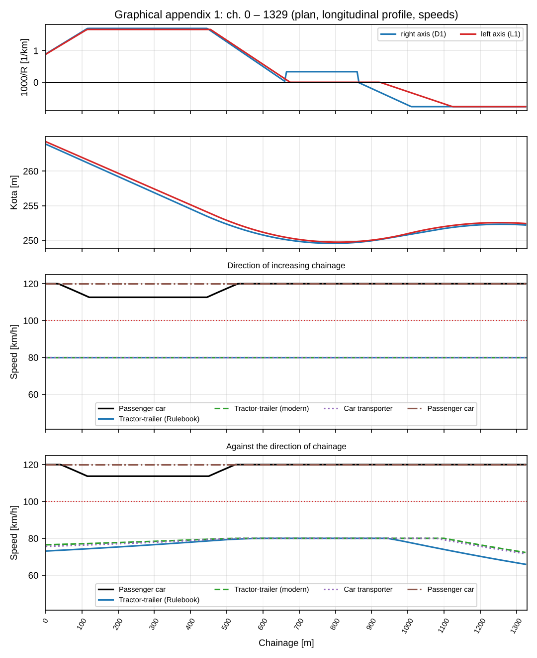
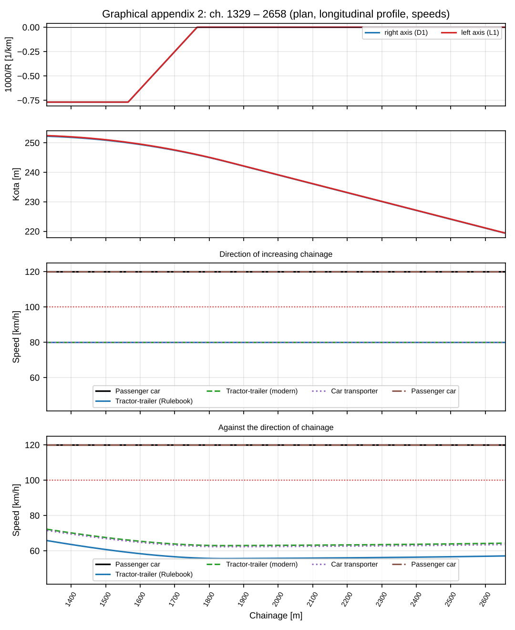
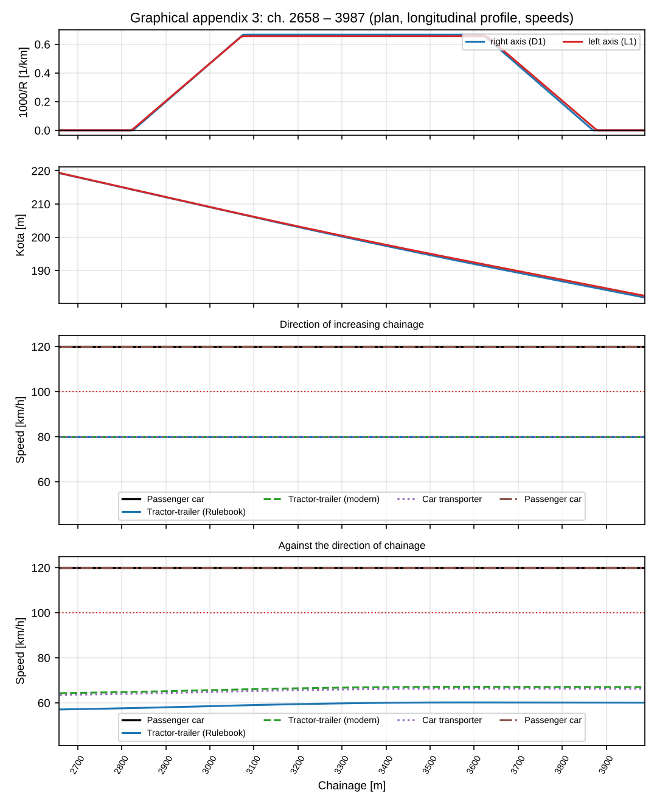
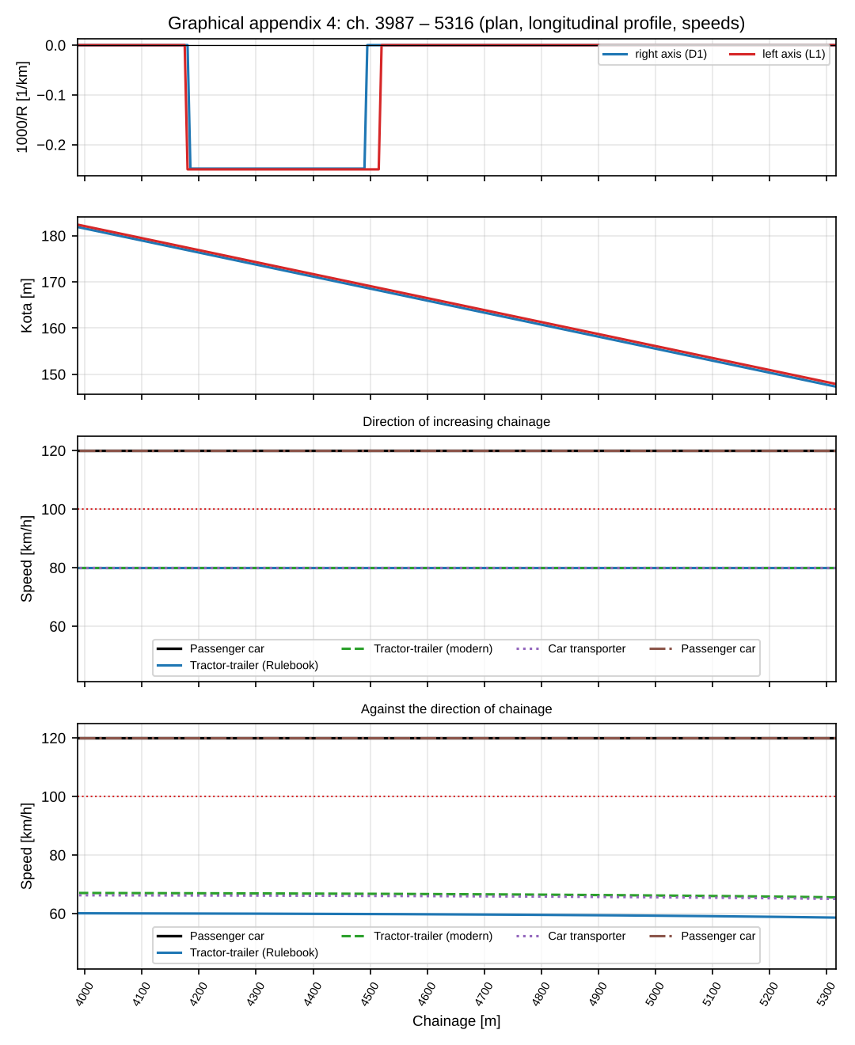
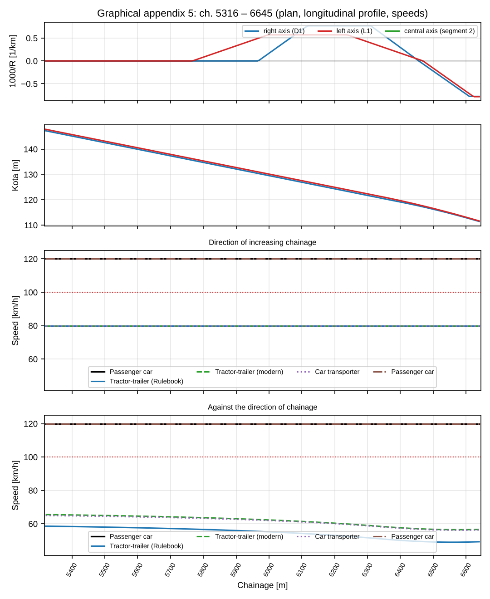
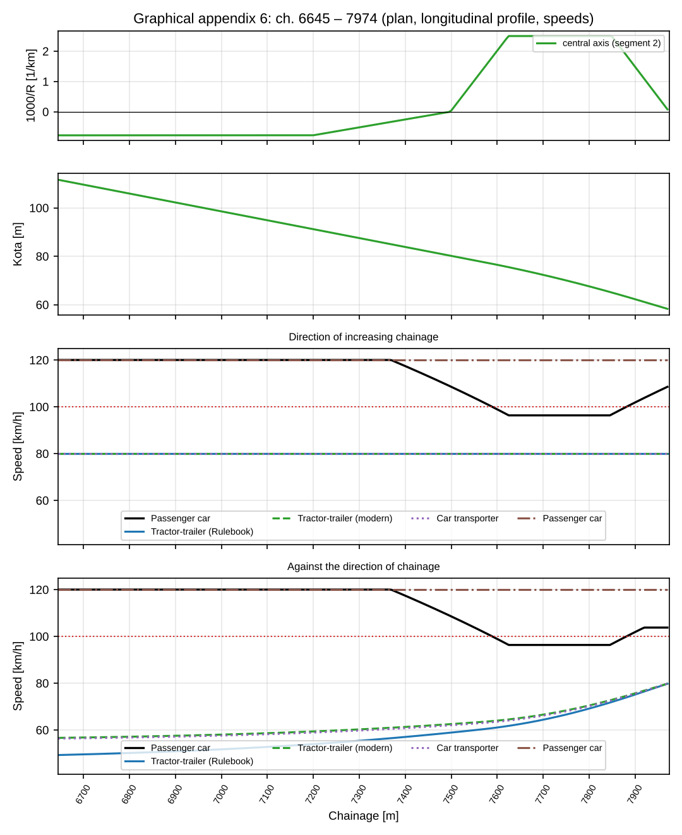

Appendix C – Assumptions and limitations
- The V_{p} – R relationship is replaced by interpolation of the table R_{min}(V_{r}) from Annex 2, limited to max V_{r} = 120 km/h (diagram: Figure 3-07 “Theoretical dependence of the projected speed on the radius of the horizontal curve”, Annex 2 of the Rulebook [1]). If lower speeds in curves are read from the original graph, the V_{p} profile will be lower and more varied (higher D_{h}).
- The V_{p} – i_{N} relationship is a table compiled from the diagram in Figure 3-08 of Annex 2 of the Rulebook [1], [4].
- Acceleration and deceleration a = d = 0.77 m/s² (equivalent to the formula L = 0.1·V_{avg}·ΔV from Figure 3-09 of Annex 2, nominally 0.8 m/s²).
- Transition curves are treated as a “tangent” for the target speed (the curve speed applies on the circular arc), which is usual when forming the V85 profile.
- Vehicle dynamics model: all vehicle parameters (passenger car and heavy; mass, power, C_{d}A, v_{lim}, η, γ_{m}, μ, specific consumption, idle) are assumed; the initial speed at the entrance to the alignment = v_{lim}. Consumption is modelled and does not replace measurements.
- Directions and chain: segments in the direction of increasing chainage are calculated in that direction, and in the opposite direction vice versa; at section boundaries the speed of the passenger car and heavy vehicles is carried over from the previous segment in the direction of travel; the entry speed of the passenger car at the start of the chain is 120 km/h. It is assumed that the vehicle moves across segment boundaries without stopping, and the chainages of the axes in adjacent segments are taken as nominally equal.
- Section boundaries: curves that cross a segment boundary are assessed only in the part inside the segment.
- The cross-slope of the applied curve = the slope of the outer lane of the left side of the carriageway (the right is equal with the opposite sign); the slope is used only in checks (tables of cross-slopes), not in the speed profile, time and fuel.
- The ΔV criterion (10 / 20 km/h) is taken from the literature (Lamm et al.) [5] and applied to the difference of the target speeds of elements; if the Manual has different limits, align them.
- Sight distance (Study 4) has not been dealt with.
- Scenario with a speed limit: the limit is applied on the specified zones (80 km/h, st. 7624.326 – 7973.924); the chainages of the start and end of the zone should be confirmed, and the document and date of the request (Investor) stated.
- The reference maximum longitudinal grade for V_{r} = 100 km/h was taken as 5.0 % (to be confirmed).
- Zadnji pravac (st. 7973,924 – 8192,048) nije u proračunu jer vozač poslije zadnje krivine usporava prema naplatnoj rampi.

Literatura
Brojevi odgovaraju oznakama [n] u tekstu.
No. | Source | What is adopted / where it is used
1 | Rulebook on the conditions that road structures and other elements of public roads must meet from the aspect of traffic safety, Official Gazette of RS no. 50/2011, Annex 2 (verify the issue number and edition of the Official Gazette). | Method of determining V_{p} (V85) and the range V_{ri} ≤ V_{p} ≤ max V_{r} (2.2); table of R_{min} and friction coefficients; i_{pk} on curves (4.3); refers to Figures 3-07 (V_{p}–R) and 3-08 (V_{p}–i_{N}).
2 | Manual for the design of roads in the Republic of Serbia, PE “Putevi Srbije”, part 4.0 “Road design elements”. | Description of the resulting speed profile, consistency and statistics (D_{h}); acceleration / deceleration (2.2.3).
3 | Project Brief for the preparation of the Main Design – General Part and Studies. | Scope and content of the study, design speed, vehicles for which the speed profile is made.
4 | Rulebook from [1], Annex 2, Figure 3-08 (dependence of speed on longitudinal grade) and Figure 3-07 “Theoretical dependence of the projected speed on the radius of the horizontal curve”. | The table V_{p}(i_{N}) and the V_{p}–R relationship were compiled from the diagrams in Annex 2 of the Rulebook.
5 | Lamm, R., Psarianos, B., Mailaender, T.: Highway Design and Traffic Safety Engineering Handbook, McGraw-Hill, 1999. | Criterion for rating consistency ΔV (≤ 10 / 10–20 / > 20 km/h).
6 | FGSV: Richtlinien für die Anlage von Landstraßen (RAS-L), 1995; Richtlinien für die Anlage von Autobahnen (RAA), 2008. | General framework for V85 and consistency of elements; numerical values were not used.
7 | Guidelines for the design, construction, maintenance and supervision of roads in Bosnia and Herzegovina, 2005. | General framework (design speeds); numerical values were not used.
8 | Wong, J. Y.: Theory of Ground Vehicles, 4. izd., Wiley, 2008. | Formulas for motion resistance and traction force (5.1).
9 | Cvetanović, B.: Theory of Motion of Motor Vehicles, Belgrade. | Driving resistances and fuel consumption (5.1).

