
FINAL PROJECT REPORT
ARTIFICIAL INTELLIGENCE AND
ADVANCED LARGE LANGUAGE MODELS
PROJECT / RESEARCH TITLE
Neural Fields for Continuous Cardiac Cine-MRI
One heartbeat stored as one continuous function f(x, y, z, t): experiments, a 4D heart model and its clinical check
GROUP PARTICIPANTS
No. | Participant Name | Student ID
1. | Nikolai Kuzmichenko | LS2657208
2. | Danil Bezborodnikov | LS2625207
3. | Yi Du | ZY2657129
4. | Qingyun Yan | ZY2657323
5. | Jianxiang Liu | ZY2657411
Course Instructor: Aqil Tariq
Submission Date: November 2, 2026
Academic Session: Fall Semester, 2026–2027 Academic Year
Hangzhou, China

Abstract
A cardiac cine-MRI scan stores one heartbeat as a grid: in our main patient 224 × 256 pixels of 1.64 mm, 10 slices 10 mm apart and 30 frames, 17.2 million values with nothing stored between slices or between frames. We represent the scan instead as one continuous function, a small sine-activated network (SIREN, 198,913 weights) that maps a position in millimetres and a moment of the heartbeat to image intensity, fitted per patient on the public ACDC dataset. Frames or slices are hidden during training and predicted; settings are chosen on separate validation frames, and the final comparison is repeated on 14 patients that were never used for any choice. SIREN beats a ReLU network of the same size on every patient (+7.4 dB on average) and a ReLU network with Fourier features by 2.3 dB. Scaling the time and slice coordinates inside the model is our own contribution and adds 6.6 dB in time. Alone, the field stays about 0.6 dB behind linear interpolation (13 of 14 patients), but a fixed 50/50 blend of field and interpolation beats interpolation on all 14 held-out patients (+0.37 dB, 95 % CI 0.26–0.48, Wilcoxon p = 0.0001). The same weights hold the heart region with 16× fewer numbers, or the whole scan with 86×. From the final field we extract a beating 3D heart; its left ventricle matches the expert outline as well as the same segmentation on the scanner data (Dice 0.87 over 14 patients) and its ejection fraction is within one point of the expert value for patient 051 (42.7 vs 43.6 %). Exploratory tests show that only motion-aware methods beat linear interpolation, which sets the direction for future work.

1. Objectives
The proposal set four objectives, all addressed in this report: (O1) a reproducible pipeline from an ACDC NIfTI scan to coordinates in physical units; (O2) a SIREN fit of a static 3D frame, tested on hidden slices against interpolation and a ReLU control; (O3) a 4D fit of the whole cycle with three time encodings, tested on hidden frames; (O4) a demonstration of the continuous cardiac cycle. During the work we added two items: a measurement of the compression–quality trade-off promised at the midterm (about 86×), and a clinical check of the 4D model through chamber volumes and ejection fraction.

2. Data
We use the ACDC dataset (MICCAI 2017) [3]: cine-MRI of 150 patients with expert labels of the right ventricle, the myocardium and the left ventricle at end-diastole (ED) and end-systole (ES). The main patient is 051 (previous myocardial infarction): 224 × 256 pixels of 1.64 × 1.64 mm, 10 short-axis slices 10 mm apart, 30 frames, ED = frame 1, ES = frame 11. Patient 015 (dilated cardiomyopathy; 256 × 216 pixels of 1.37 mm, 9 slices 10 mm apart, 21 frames) is used to repeat the hidden-slice test on a different heart. Fourteen further patients form a held-out test set that was never used to choose any setting: five with dilated cardiomyopathy (016–020), five with hypertrophic cardiomyopathy (022, 025, 030, 035, 040) and four after myocardial infarction (041, 045, 048, 050). The data are shared with the course only privately, with the citation required by the dataset.

3. Method

3.1 Representation
Every voxel becomes a sample (x, y, z, t) → I. Spatial coordinates are taken at voxel centres in millimetres, centred and divided by half of the largest physical extent, so the true 1.64 : 10 mm ratio is kept; t = 2k/(T − 1) − 1 for frame k of T; intensities are min–max scaled to [−1, 1]. The field is a SIREN [1]: four layers of 256 units computing sin(ω₀(Wx + b)) with ω₀ = 30 and the initialisation of the original paper, and a linear output. The control network has the same layer sizes with ReLU activations (also 198,913 weights).

3.2 Our contribution: scaling the coordinates inside the model
With ω₀ = 30, a small step in a coordinate already turns the first-layer sines by radians. Trained on frames (or slices) that are far apart in that coordinate, the network memorises them and oscillates in between. We therefore multiply the time coordinate by a factor s and, for the slice test, the z coordinate by a factor s_z inside the model, which slows the field down along that axis only. For time we compared raw t, scaled t and a periodic encoding (s·sin φ, s·cos φ) of the cardiac phase φ = 2πk/T, and swept s; for z we swept s_z.

3.3 Training
Mean squared error, Adam, learning rate 10⁻⁴ with cosine decay to 10⁻⁵, random batches of 16,384 points. To keep CPU training practical the field is fitted inside a square in-plane crop around the expert-labelled heart (104 × 104 pixels, 12-pixel margin); normalisation always refers to the whole volume. The 4D runs use 20,000 steps (about 25 minutes on an Intel Core Ultra 5 laptop CPU without a GPU); the final field is trained the same way on all slices and all frames.

3.4 Evaluation protocol
Only data hidden from the network is scored. Hidden slices: every second slice of the ED frame (slices 1, 3, 5, 7), so the known slices are 20 mm apart. Hidden frames: every second frame, or, in the harder setting, only every fourth frame kept (frames 0, 4, …, 28, 29; 21 hidden). Baselines: linear interpolation between the nearest known slices or frames (it uses exactly the same known data) and the ReLU control. Metrics: PSNR with a data range of 2 inside the heart (expert labels of ED and ES, dilated by 5 pixels), PSNR over the crop, and SSIM. A blend 0.5 × field + 0.5 × interpolation was also scored; its weight was fixed before testing and never tuned on hidden data.
Settings were first explored on the hidden frames of patient 051 (Table 1). To exclude that this tuned the test, the choice was repeated on separate validation frames: frames 12 and 20 were removed from the training frames and used only for selection, the test frames unchanged. A stronger baseline, a ReLU network with 64 random Fourier features [2] (its σ chosen on the same validation frames), was added, SIREN was repeated with three seeds, and every run stores an exact train PSNR over all training voxels, a temporal error (mean squared error of the frame-to-frame change inside the heart, which catches flicker) and its metadata. The intensity scaling uses the min and max of the scan; we checked that they are identical (0 and 255) when computed on the training frames only, so no test information enters through normalisation. Finally the fixed protocol was run on the 14 held-out patients, with the patient as the unit of analysis (mean, 95 % t-interval, paired Wilcoxon test).

3.5 From the field to a 3D/4D heart
The final field is queried on an isotropic grid (61 slices of 1.64 mm instead of 10 of 10 mm) at any number of time points. Blood is bright and muscle dark in cine-MRI, so the blood threshold is the midpoint of the median LV-blood and median-myocardium intensities at ED. The expert labels only select the region of each ventricle (interpolated between slices by signed distance); inside it the largest bright 3D component is the blood pool. The LV wall is the surrounding voxels in the muscle intensity band. Surfaces are extracted with marching cubes [8] and smoothed with Taubin smoothing [9]; volumes are always counted on the binary masks, never on the smoothed surfaces, and give the ejection fraction EF = (EDV − ESV)/EDV at the ED and ES frames listed with each scan. The network itself never sees labels, but this 3D step is label-assisted: the threshold, the chamber regions and the wall region come from the expert labels, which are also the reference for evaluation.

4. Implementation
The code (Python, PyTorch, NumPy, nibabel, scikit-image) is organised as a package with data loading, models, training, evaluation and visualisation modules, plus scripts: run_experiments.py (all experiments), evaluate_blend.py, render_4d.py (3D/4D heart) and pipeline.py, which runs the whole study for any patient folder or any 4D NIfTI file with one command. A setup script creates a virtual environment, installs the dependencies and runs the unit tests (models, sampling, metrics, baselines, a short training run). Each run stores its table, figures, the training curve and a JSON record of all settings and software versions. Repository: github.com/ultralightbeat/cardiac-inr.

5. Results

5.1 Time encoding and scale
Table 1. Hidden frames of patient 051, PSNR in the heart (dB) and SSIM.
Setting | Heart PSNR | Crop PSNR | SSIM
Every 2nd frame hidden · raw t | 22.74 | 23.52 | 0.543
Every 2nd frame hidden · periodic (sin, cos) × 0.25 | 28.85 | 30.61 | 0.858
Every 2nd frame hidden · scaled t × 0.25 | 29.30 | 31.74 | 0.888
Every 4th kept · t × 0.25 | 28.20 | 32.05 | 0.903
Every 4th kept · t × 0.1 | 28.87 | 32.83 | 0.920
Every 4th kept · t × 0.05 | 28.80 | 32.83 | 0.920
Every 4th kept · t × 0.25, 512 neurons (791,041 weights) | 28.92 | 32.93 | 0.919

How time enters is decisive: scaling t adds 6.6 dB over raw t, and the periodic encoding is close but slightly worse. With fewer frames the best scale is 0.1. A four times larger network reaches the same quality as the 256-unit network with the better scale, so capacity is not the limiting factor (rows 4–7 used 20,000 steps, rows 1–3 4,000). Chosen again on the separate validation frames, the scale is the same: 0.05 → 23.7 dB, 0.1 → 24.0 dB, 0.25 → 20.7 dB (validation PSNR in the heart).

5.2 SIREN against interpolation and ReLU
Table 2. Every 4th frame kept (21 hidden frames). Compression = values represented / weights.
Method | Heart PSNR | Crop PSNR | SSIM | Compression
Linear interpolation | 29.23 | 33.74 | 0.941 | none (all kept frames)
SIREN, t × 0.1 (heart crop) | 28.87 | 32.83 | 0.920 | 16× (8× in bytes)
SIREN, mean of 3 seeds (± std) | 28.91 ± 0.04 | 32.87 | 0.921 | 16×
ReLU, same size | 22.28 | 24.42 | 0.562 | 16×
ReLU + Fourier features (σ = 3, 230,657 weights) | 26.63 | 28.63 | 0.792 | 14×
Blend 0.5 SIREN + 0.5 interp. | 29.65 | 33.92 | 0.940 | none
SIREN, whole scan, no crop | 27.49 | 34.04* | 0.937 | 86× (43× in bytes)
* over the whole 224 × 256 image, where the static background inflates PSNR; compare the heart column. With every 2nd frame hidden: interpolation 33.14 dB, SIREN 31.35 dB, blend 32.92 dB.
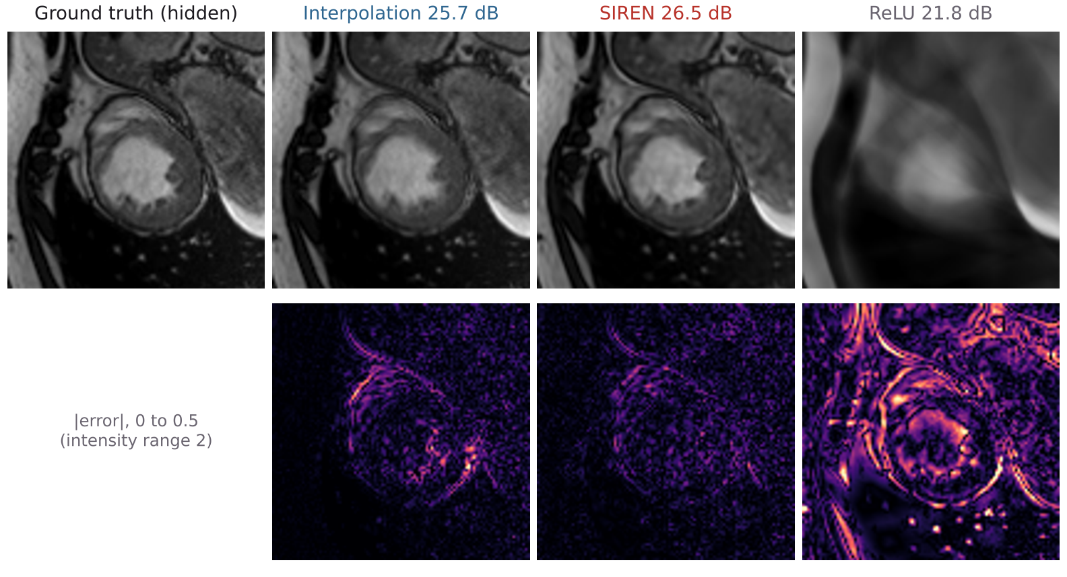
Figure 1. Hidden frame 6 (fast contraction), mid-ventricle slice, every 4th frame kept. Top: prediction and PSNR in the heart for this frame; bottom: absolute error. The ReLU network cannot represent fine detail.
SIREN beats the ReLU network by 6.6 dB on hidden frames; the ReLU network reaches only 24.5 dB even on its own training frames (SIREN 36.5 dB, both exact over all training voxels), the spectral bias described in [1, 2]. Fourier features help the ReLU network a lot (+4.4 dB) but SIREN remains 2.3 dB better with fewer weights. Three seeds differ by only 0.04 dB. The temporal error (×10⁻³) is lowest for interpolation (3.41), then SIREN (3.64), Fourier-ReLU (4.52) and ReLU (5.02). Against interpolation the field is 0.32 dB behind on average. Per frame (Figure 2) the field wins frames 5–7, the fastest part of the contraction, where a straight line between two frames misses the motion. The two methods fail in different places, and the fixed blend beats interpolation on 18 of 21 frames (+0.42 dB). With dense frames (every second hidden) there is no gain: interpolation is already near the ceiling.
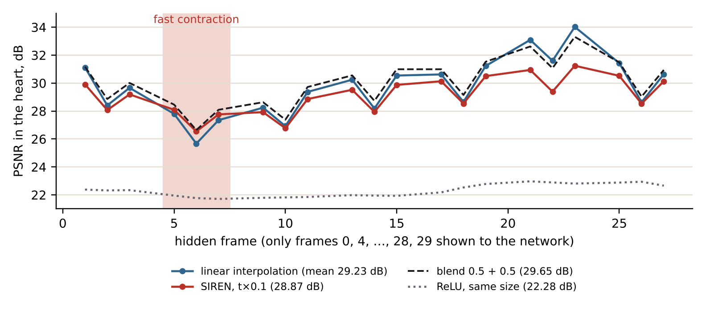
Figure 2. PSNR in the heart for each hidden frame (every 4th frame kept).

5.3 Fourteen held-out patients
Table 3. Held-out patients (n = 14), hidden frames with every 4th kept, PSNR in the heart (dB).
Quantity | Mean | 95 % CI over patients
Linear interpolation | 32.12 | 29.70 … 34.55
SIREN | 31.55 | 29.15 … 33.94
ReLU, same size | 24.12 | 22.10 … 26.14
Blend 0.5 SIREN + 0.5 interp. | 32.49 | 30.08 … 34.91
SIREN − ReLU (paired) | +7.43 | +6.28 … +8.59
SIREN − interpolation (paired) | −0.57 | −0.76 … −0.38
Blend − interpolation (paired) | +0.37 | +0.26 … +0.48

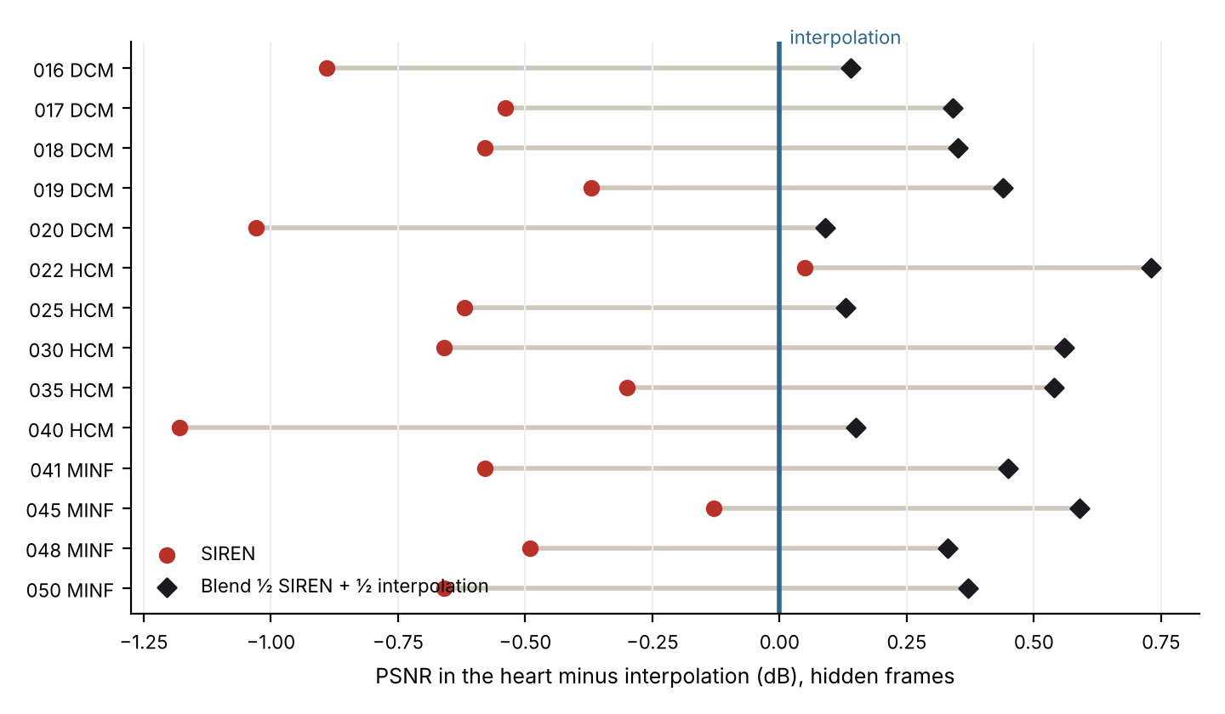
Figure 5. Each held-out patient: SIREN and the blend relative to linear interpolation.
With all settings fixed on patient 051, the picture is the same on new hearts of three disease groups. SIREN beats ReLU on 14 of 14 patients (Wilcoxon p = 0.0001); alone it is behind interpolation on 13 of 14 (median −0.58 dB); the blend is better than interpolation on all 14 (median +0.35 dB, p = 0.0001). The absolute PSNR varies between patients (26–41 dB) much more than the differences between methods, which is why paired differences are reported.

5.4 Compression
The field has 198,913 weights. The heart crop holds 104 × 104 × 10 × 30 = 3.24 million values (16× more; 8× in bytes, since voxels are 16-bit and weights 32-bit), the whole scan 17.2 million (86×; 43× in bytes). Fitting the whole scan with the same weights reaches the 86× midterm target at a cost of 1.4 dB in the heart compared with the crop (27.5 vs 28.9 dB). Interpolation is 29.2 dB but compresses nothing.

5.5 Hidden slices
Table 4. Every second slice hidden (20 mm between known slices), ED frame.
Method | Heart PSNR | Crop PSNR | SSIM
Patient 051 · linear interpolation | 20.01 | 19.55 | 0.354
Patient 051 · SIREN, raw z | 19.95 | 19.72 | 0.340
Patient 051 · SIREN, z × 0.5 | 19.87 | 19.85 | 0.378
Patient 051 · SIREN, z × 0.25 | 20.09 | 19.79 | 0.362
Patient 051 · ReLU, same size | 18.83 | 19.67 | 0.373
Patient 015 · linear interpolation | 20.68 | 20.06 | 0.403
Patient 015 · SIREN, z × 0.5 | 20.42 | 20.84 | 0.410
Patient 015 · SIREN, z × 0.25 | 20.13 | 20.45 | 0.411

No method recovers a slice 10 mm away from both neighbours (all near 20 dB): over 20 mm the heart changes shape. With raw z the field memorised the known slices (41 dB) and filled the gap with high-frequency noise (Figure 3); z × 0.25 removes the noise and makes the field level with interpolation on patient 051. On patient 015 the field is better on the crop and slightly worse in the heart.
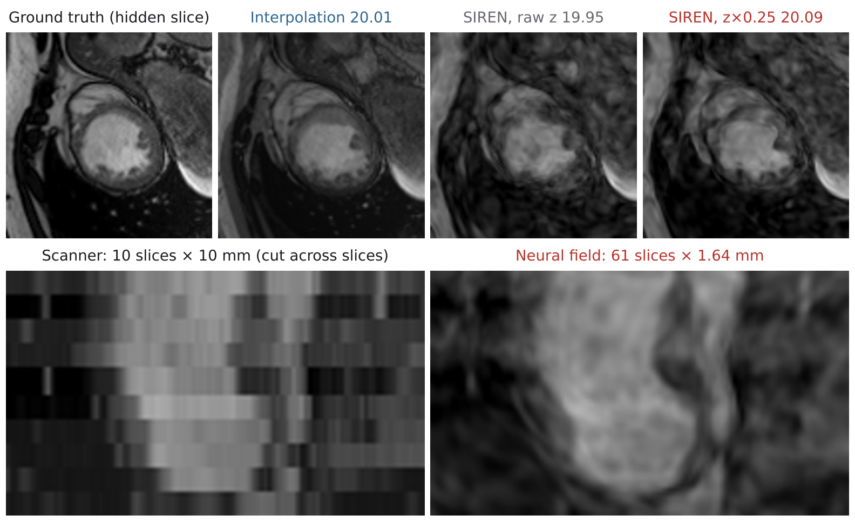
Figure 3. Top: hidden slice 5 and heart PSNR over all hidden slices. Bottom: a cut across the slices of the ED frame, scanner (10 slices) and the final field queried at 61 positions.

5.6 The 4D heart and its clinical check
Table 5. Volumes (ml) and ejection fraction at the ED and ES frames, patient 051.
Source | LV EDV | LV ESV | LV EF | RV EDV | RV ESV | RV EF
Expert labels | 212 | 120 | 43.6 % | 142 | 67 | 52.9 %
Threshold on scanner slices | 172 | 98 | 43.2 % | 113 | 70 | 37.7 %
Threshold on the neural field | 173 | 99 | 42.7 % | 112 | 72 | 35.7 %
Table 6. Agreement with the expert outlines on the scanner slices (voxel 1.64 × 1.64 × 10 mm).
Segmentation | Dice | HD95, mm | ASSD, mm | HD, mm
Patient 051 · LV, ED · threshold on scanner | 0.891 | 5.9 | 1.28 | 19.2
Patient 051 · LV, ED · threshold on field | 0.897 | 5.9 | 1.21 | 19.2
Patient 051 · LV, ES · threshold on field | 0.769 | 10.1 | 3.19 | 19.5
Patient 051 · RV, ES · threshold on field | 0.664 | 11.3 | 4.68 | 21.2
14 held-out · LV, ED · field (mean) | 0.872 | 6.9 | – | –
14 held-out · LV, ED · scanner (mean) | 0.870 | – | – | –

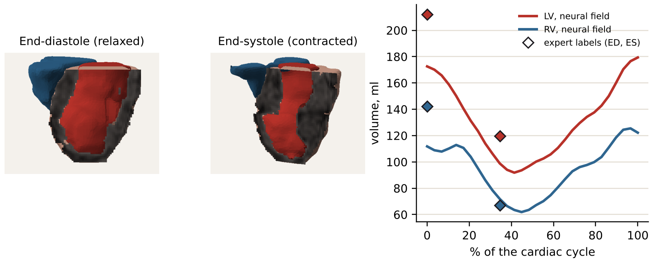
Figure 4. 3D heart from the final field (LV wall cut open: the cut face shows the field’s own intensity; red: LV blood; blue: RV blood) and chamber volumes over the heartbeat. An interactive version (heart_4d.html) is part of the submission.
For the left ventricle the field reproduces the expert ejection fraction within one point on patient 051 and within 4.6 points on average over the 14 held-out patients (mean absolute error; the threshold tends to overestimate EF). The field does not degrade the shape: its Dice equals that of the same segmentation applied to the scanner data (0.87 over 14 patients). The Hausdorff distance of about 19 mm is one slice too many or too few at the base or apex (slices are 10 mm apart); HD95 and ASSD are a few millimetres. Absolute volumes are lower because the threshold leaves the papillary muscles and trabeculae out of the blood pool, while the expert labels include them. The thin, trabeculated right ventricle at end-systole is not segmented reliably by a threshold (Dice 0.66, EF error up to tens of points): this is a limit of our segmentation, not of the field. An earlier version of this analysis took EF from the extremes of the volume curve (LV 49 %); with the ED and ES frames fixed from the scan metadata, as is standard, the agreement is better for the left ventricle and clearly worse for the right.
Sensitivity (patient 051): a different threshold rule (mean instead of median midpoint) or ±0.05 changes LV EF between 40.6 and 44.6 %; the grid density does not matter (31, 61 or 122 slices: 172 ml at ED); the region interpolation (signed distance vs union of neighbouring slices) changes nothing; the mesh smoothing used for display changes the enclosed volume by 1.2 % and moves the surface by 0.5 mm on average.

5.7 Beyond linear interpolation (exploratory)
Why does interpolation remain so strong? Its errors come from edges of the heart wall that move between frames, so the intensity of a voxel changes in jumps rather than smoothly. Consistently, higher-order interpolation in time is worse than linear on patient 051 (every 4th frame kept: cubic spline 28.54, PCHIP 29.17, Akima 29.05 vs linear 29.23 dB), while motion-compensated interpolation with TV-L1 optical flow [11] between the two neighbouring frames is better (29.49 dB; 29.78 dB blended with linear). We therefore tried a motion-based field, a SIREN template warped by a small displacement network plus a small intensity residual, with and without guidance by optical flow between the known frames. Chosen on the validation frames, it did not reach the plain SIREN (22.9 vs 24.0 dB on validation; interpolation 24.5, optical flow 24.8): one template with one in-plane warp cannot describe wall thickening, appearing papillary muscles and through-plane motion. These runs are reported for completeness and are not part of the main results.

6. Discussion and limitations
- Cine-MRI with 30 frames is close to linear between neighbouring frames, so linear interpolation is a strong baseline. The field alone is about 0.6 dB behind it, but the two err in different places and their fixed blend is better on every held-out patient.
- The field is a compact, continuous and differentiable representation: one 0.8 MB file of weights per heartbeat that can be queried anywhere. The blend gives the best reconstruction but needs the stored frames.
- Limitations: one network and one seed per held-out patient (seed spread measured only on patient 051); patients from three ACDC groups only; a 20 mm slice gap is beyond any method; the 3D step is label-assisted and a threshold, unreliable for the right ventricle; settings chosen on one development patient.
- Next steps: motion-aware fields (optical flow already beats linear interpolation; a single-template deformation was not enough), and priors learned across many patients, e.g. learned initialisations [10], which would also keep the per-patient storage small.

7. Conclusion
We built and tested a per-patient neural field of the beating heart with a protocol that separates validation from test and repeats the result on 14 unseen patients. Sine activations are essential (+7.4 dB over ReLU on every patient, +2.3 dB over ReLU with Fourier features), and so is the way the coordinates enter the network: scaling time and slice position is our own contribution and is what makes the field work between samples. Alone, the field stays slightly behind linear interpolation; combined with it, it beats interpolation on all 14 patients, while holding the heart with 16× to 86× fewer numbers. From one network we obtain a continuous 4D heart whose left ventricle agrees with the expert labels. All code, results and data instructions are in the project repository and run with one command.

References
[1] V. Sitzmann, J. N. P. Martel, A. W. Bergman, D. B. Lindell, and G. Wetzstein, “Implicit neural representations with periodic activation functions,” in Proc. NeurIPS, vol. 33, 2020. arXiv:2006.09661.
[2] M. Tancik et al., “Fourier features let networks learn high frequency functions in low dimensional domains,” in Proc. NeurIPS, vol. 33, 2020. arXiv:2006.10739.
[3] O. Bernard et al., “Deep learning techniques for automatic MRI cardiac multi-structures segmentation and diagnosis: Is the problem solved?,” IEEE Trans. Med. Imag., vol. 37, no. 11, pp. 2514–2525, 2018.
[4] J. Feng, R. Feng, Q. Wu, Z. Zhang, Y. Zhang, and H. Wei, “Spatiotemporal implicit neural representation for unsupervised dynamic MRI reconstruction,” arXiv:2301.00127, 2023.
[5] W. Huang et al., “Subspace implicit neural representations for real-time cardiac cine MR imaging,” arXiv:2412.12742, 2024.
[6] J. J. Park, P. Florence, J. Straub, R. Newcombe, and S. Lovegrove, “DeepSDF: Learning continuous signed distance functions for shape representation,” in Proc. CVPR, 2019.
[7] A. Pumarola, E. Corona, G. Pons-Moll, and F. Moreno-Noguer, “D-NeRF: Neural radiance fields for dynamic scenes,” in Proc. CVPR, 2021.
[8] W. E. Lorensen and H. E. Cline, “Marching cubes: A high resolution 3D surface construction algorithm,” Computer Graphics (SIGGRAPH), vol. 21, no. 4, pp. 163–169, 1987.
[9] G. Taubin, “A signal processing approach to fair surface design,” in Proc. SIGGRAPH, 1995, pp. 351–358.
[10] M. Tancik et al., “Learned initializations for optimizing coordinate-based neural representations,” in Proc. CVPR, 2021.
[11] C. Zach, T. Pock, and H. Bischof, “A duality based approach for realtime TV-L1 optical flow,” in Pattern Recognition (DAGM), 2007.

