Lab equipments:
DC ANALYSIS
1) Keysight E36313A triple channel programmable dc power supply
1st channel for input current (up to 10A)
2nd channel for 24 VDC voltage for nonisolated converter, 24 to 5V, for VCC of Current Sensor and Diff. OpAmp
2) Keysight 34460A 6 1/2 Digit Multimeter: To measure the Differential output voltage of OpAmp via RJ45
3) Keysight 34460A 6 1/2 Digit Multimeter: To measure Test Point voltages on the PCB by hand ( yellow points)
AC ANALYSIS
- Keysight E36313A triple channel programmable dc power supply
-> 24 VDC voltage for VIN
- Spitzenberger APS 1000 – CC mode : to amplify current in a sine wave shape with varying amplitudes and frequencies. Therefore we achieve AC ripple current with varying frequencies and amplitudes in addition to DC current.
- Micsig MOIP350P OP200-3 Optical-fiber Isolated Probe: to capture output differential signal accurately, provides isolation from high voltage transients, ground loops. Maintins signal integrity by minimizing common mode noise. Output voltage Range: ±1.25V
Since B-WIT injection transformer is known to lose gain magnitude for frequencies under 100 Hz and above 1M, as indicated in its Bode plot, its not suiable for low and ultra high frequencies. Isolated probe does not suffer from this, provides more accurate measurements across the entire frequency range.
- Micsig CP1003B Current probe: to accurately measure the current flowing, detects the input current that the Spitzenberger APS 1000 outputs and converts it into a proportional voltage signal that can be read by Bode 100.
  - 5A mode for higher sensitivity (for measuring lower currents, up to 5A), Outputs 1V for every 1A of current. (1 V/A)
- Vector Network Analyzer – Bode 100 : to measure impedance by connecting voltage probe to CH2 (with B-WIT 100) and current probe Micsig CP1003B to CH1.
Output channel to AC modulator’s input channel.
It measures Gain and transforms it directly to impedance Z using: $Z=\frac{V}{I}=\frac{V_{CH2}}{V_{CH1}}=Gain$
- Tektronix TBS 2000 Digital Oscilloscope :
-> 1st channel (yellow): differential voltage measurement of diff. OpAmp V_out (V_in of analog card) with B-WIT 100
-> 2nd channel (blue): input current measurement (current probe: Micsig CP1003B)
-> 3rd channel (red): input current measurement (current probe: Tektronix TCP0020)

Current Sensing PCB changes
- voltage rails to be -0.2V (LMM05) and +5.2V using switched regulator and a LDO
- drive common mode voltage of diff op amp to 2.5V (generated by LDO)
-
- Configure the Bode 100 to generate the desired AC signal. Connect the output channel of the Bode 100 to the input of the Spitzenberger APS 1000.
- The APS 1000 amplifies the AC signal from the Bode 100 and feeds it into the current measurement PCB.
- The PCB includes the Sensitec CAS5025SAA-LI current sensor and a differential op-amp, which outputs a differential voltage in response to the input current.
- Connect the Micsig MOIP350P OP200-3 Optical-fiber Isolated Probe to the differential output of the current measurement PCB. This probe converts the differential voltage to an optical signal, for electrical isolation.
- The optical signal is then transmitted to the Bode 100 CH1 input, where it is converted back to an electrical signal for measurement.
- Configure Bode 100 to perform a frequency sweep. Set the analyzer to measure the gain and phase response of the differential output relative to the injected signal. It measures Gain and transforms it directly to impedance Z using: $Z=\frac{V}{I}=\frac{V_{CH2}}{V_{CH1}}=Gain$
Bode 100 should interpret the voltage output from the current probe and voltage probe correctly:
- 1:1 Ratio: no scaling of input voltage
- X:1 Ratio: Bode 100 scales the input voltage by a factor of X. Use with probes that attenuate the signal by a factor of X

Conﬁguration Details:
1. Micsig CP1003B Current Probe (Set to 5A Mode): ‐ Sensitivity: 1V/A ‐ Current Measurement Range: Up to 5A ‐ outputs 1V for every 1A of current.
2. Bode 100 Current Ampliﬁer Conﬁguration: ‐ Output Setting: 5 dBm ‐ Resulting Current Output: Approximately 3A amplitude sinusoidal current with the Spitzenberger APS 1000.
3. Current Measurement PCB: ‐ Impedance: 50 milliohms (50mΩ) ‐ Output Diﬀerential Voltage: 50mV increase per 1A of input current. ‐ For a 3A current, the diﬀerential output voltage would be 3A×50mV/A= 150mV.
Choosing the Ratios for Current and Voltage Probes:
1. Current Measurement with CH1: ‐ Current Probe Mode: 5A (1V/A sensitivity) ‐ Bode 100 CH1 Probe Ratio: 1:1 ‐ Since the current probe outputs 1V for every 1A, a 1:1 ratio is appropriate. So Bode 100 correctly interprets the voltage from the current probe as the corresponding current.
2. Voltage Measurement with CH2: ‐ Voltage Measurement: ‐ The current measurement PCB outputs a diﬀerential voltage proportional to the input current. For every 1A of current, the PCB outputs 50mV (due to 50mΩ impedance). ‐ Voltage Probe Conﬁguration: ‐ If you are using standard voltage probes with a 1:1 ratio, the Bode 100 will directly read the voltage as it is. ‐ Probe Ratio for CH2: 1:1 ‐ This simpliﬁes the measurement process as the Bode 100 will directly interpret the voltage without any scaling.

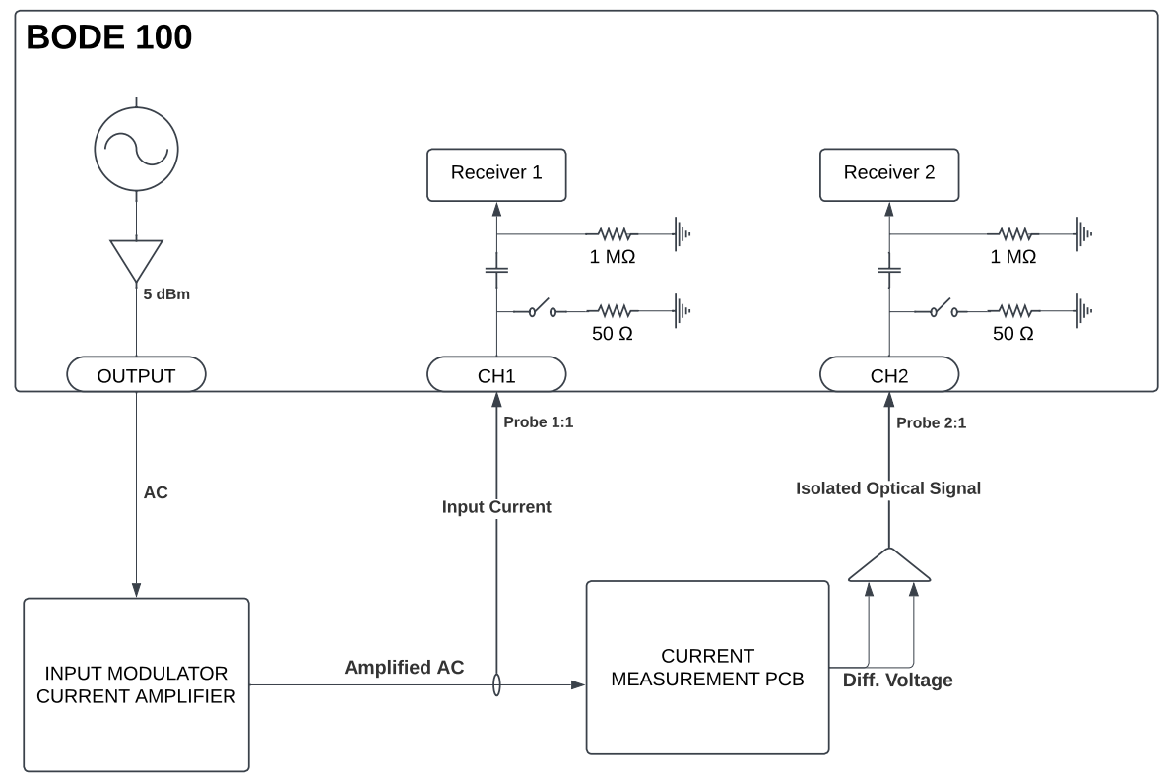
$$R_{L}$$

Manual AC measurements:
1 A_rms | 1 kHz | 50,508 mΩ | -1,384 ˚
1 A_rms | 5 kHz | 47,519 mΩ | -3,699 ˚
1 A_rms | 10 kHz | 46,167 mΩ | -2,702 ˚
1 A_rms | 25 kHz | 46,669 mΩ | -2,915 ˚
1 A_rms | 50 kHz | 51,291 mΩ | -3,134 ˚

Changes 21.01:
LDO is removed, therefore directly supplied by 5V.
Phase A: R3 and R6 unpopulated -> Current sensor is separated by OpAmp circuit
- Therefore we can obtain the impedance of the current sensor alone
Phase B: OpAmp replaced by THS4521 -> has lower BW, around 100 MHz -> no difference with gain impedance compared to other phases. Internal V_OCM was still measured to be 2.46V, not 2.5V.
Phase C: untouched

After measuring the impedance of the current sensor alone, an unexpected behavior is observed. The input current I_rms is around 7A, which is sufficient. Until 500 Hz, the impedance is quite stable around 25 mOhm, which is expected. Beyond this, the impedance drops significantly. The reason is not clear and therefore the manufacturer (Sensitec) is contacted. Since maximum of 30 Amperes is targeted, we might go with lower rated current sensor, LEM.
As a result, new pcb is designed to improve things.
- LDO 24V->5V is removed. The voltage is step down from 24V to 6.5V, then to 5.2V. As a result, VCC of 5.2V is used for current sensor and diff. OpAmp supply voltage. Reason is that we have fully rail-to-rail signal, to achieve fully the -+ 5V range at the output. Additionally, 2.5V voltage reference is implemented. Ultra high precision fixed 2.5V is used for Common mode voltage of the opamp.
- With 2 oz copper weight, minimum track width is 0.16 mm, according to JLCPCB capabilities. -> Differential route width are adjusted.
- Increased layer number to 4 layers -> more copper area for better current carrying capabillty with more cross section area, better cooling, lower thermal resistance and better thermal performance
- For input current carrying polygons between screw terminals and current transducer, the width is increased by also making the pcb wider to 11mm. Channels are spread evenly for symmetry and maximum trace width is achieved to be around 12mm for each trace here. For worst case, Input current can be up to 75A. there are 4 layers stacked on top of each other, with each copper thickness being 2, this result in a thickness of 8 oz/ft^2 for each trace. This result in an expected temperature rise of 35 °C when 75A passes through, using IPC-2221 curve fitting
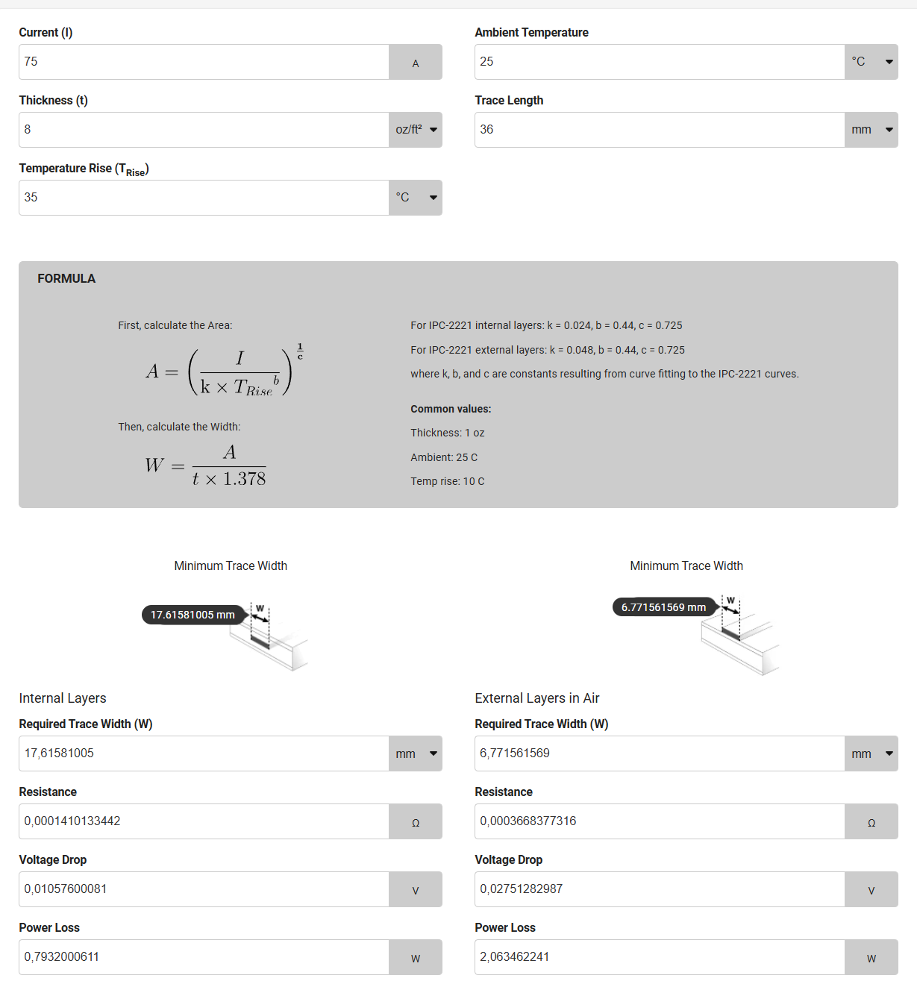

First inspections on the pcbs:
Vref -> 2.501 V
VCC+ -> 5.46 V (instead of 5.2 V)
- That’s higher according to specifications supply range of the current sensor, which is 5.25V
Reason: With VCC+ being 5.2 V and V_FB = 1.187 V according to the datasheet, 9.1.1, R21/R24 should be 3.388.

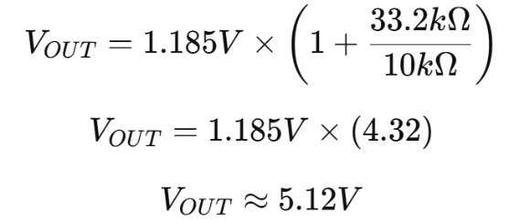
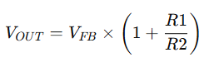
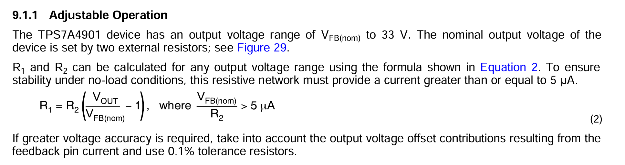
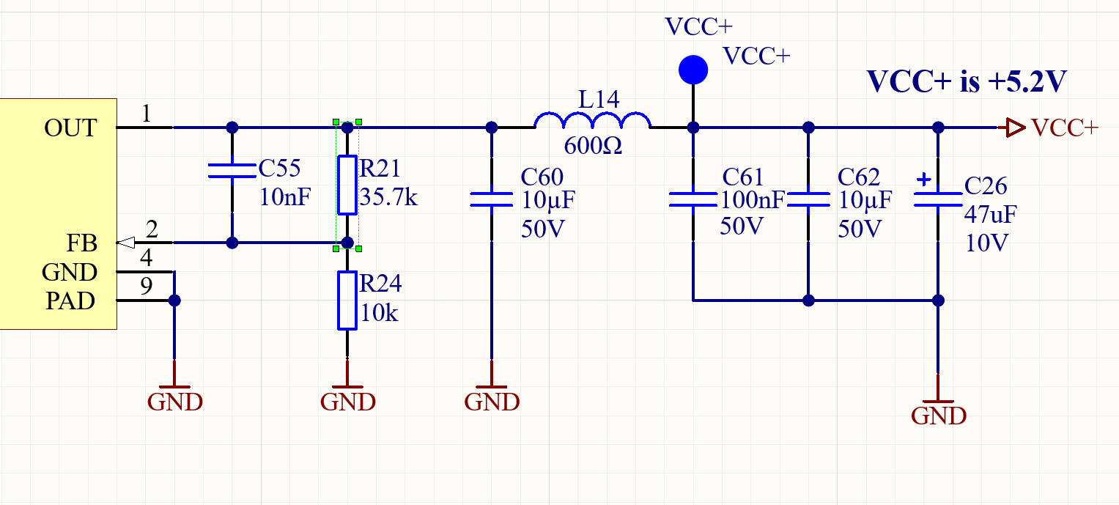

Measured VCC+ = 5.1 V

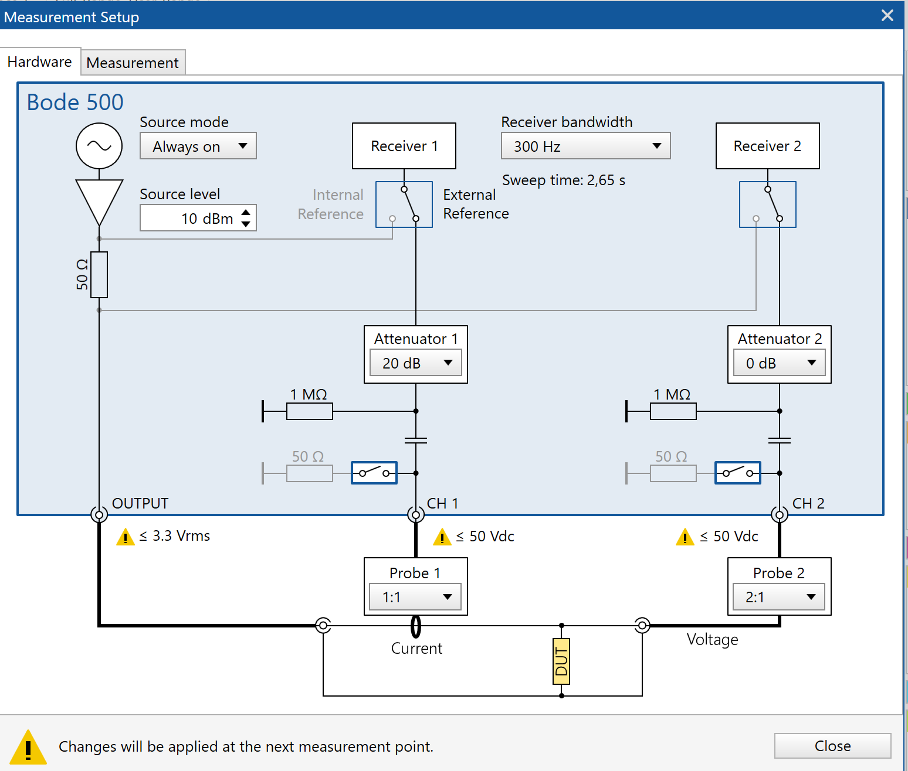

dBm (decibels relative to 1mW) is a power unit, and it can be converted to voltage using the formula:
$$V_{rms}=\sqrt{\frac{{10}^{(dBm/10)}×R}{1000}}$$Where:
- R is the load impedance, 50Ω for Bode 500
For a 50Ω impedance, $V_{rms}$is simplified to:
$$V_{rms}=0.2236* {10}^{(dBm/20)}$$
Therefore:
0 dBm = 0.2236 V
13 dBm = 1 V
15 dBm = 1.26 V
Spitzenberger APS 1000 Voltage to Current Conversion:
Observed Spitzenberger Output Current:
0 dbm -> 1.178A
13 dbm -> 5.278 A
15 dbm -> 6.65 A
$$Gain=\frac{I_{out}}{V_{in}}$$
- Spitzenberger has amplification of 5.28 A/V
$$I_{rms}=5.28*V_{rms}$$

I-limit function in the Spitzenberger APS 1000
The I-limit function in the Spitzenberger APS 1000 acts as a scaling factor that directly impacts the gain of the system by adjusting the maximum allowable output current. When set to a higher range (for example 26.4 A_peak), the amplifier provides a higher gain (~5.3 A/V), meaning a small input voltage results in a larger output current. When the I-limit is reduced (for example 3 A_peak), the system constrains the maximum current output, leading to a lower gain (~0.60 A/V). This setting leads to better resolution and linearity for low-current measurements while preventing excessive output when lower currents are required.

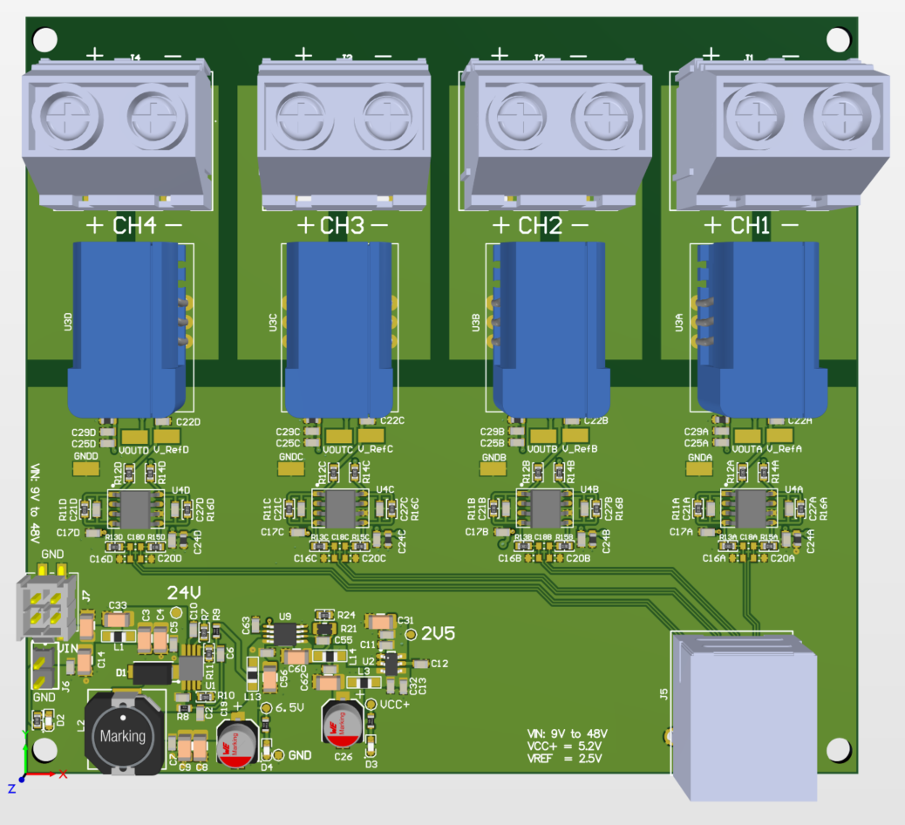

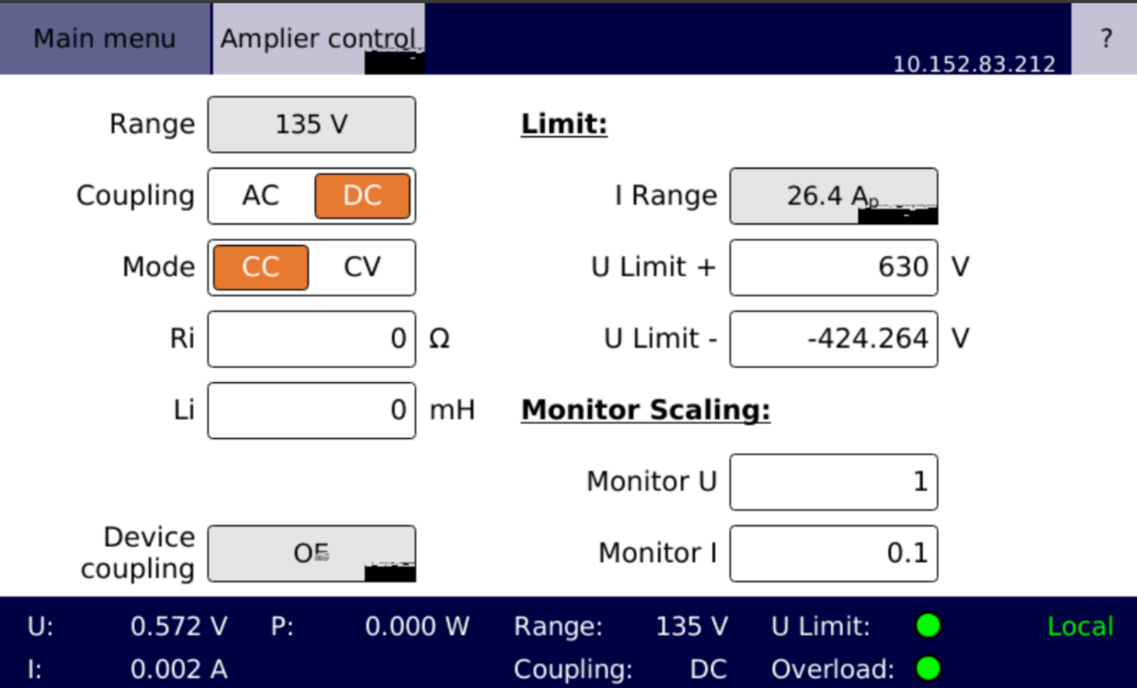

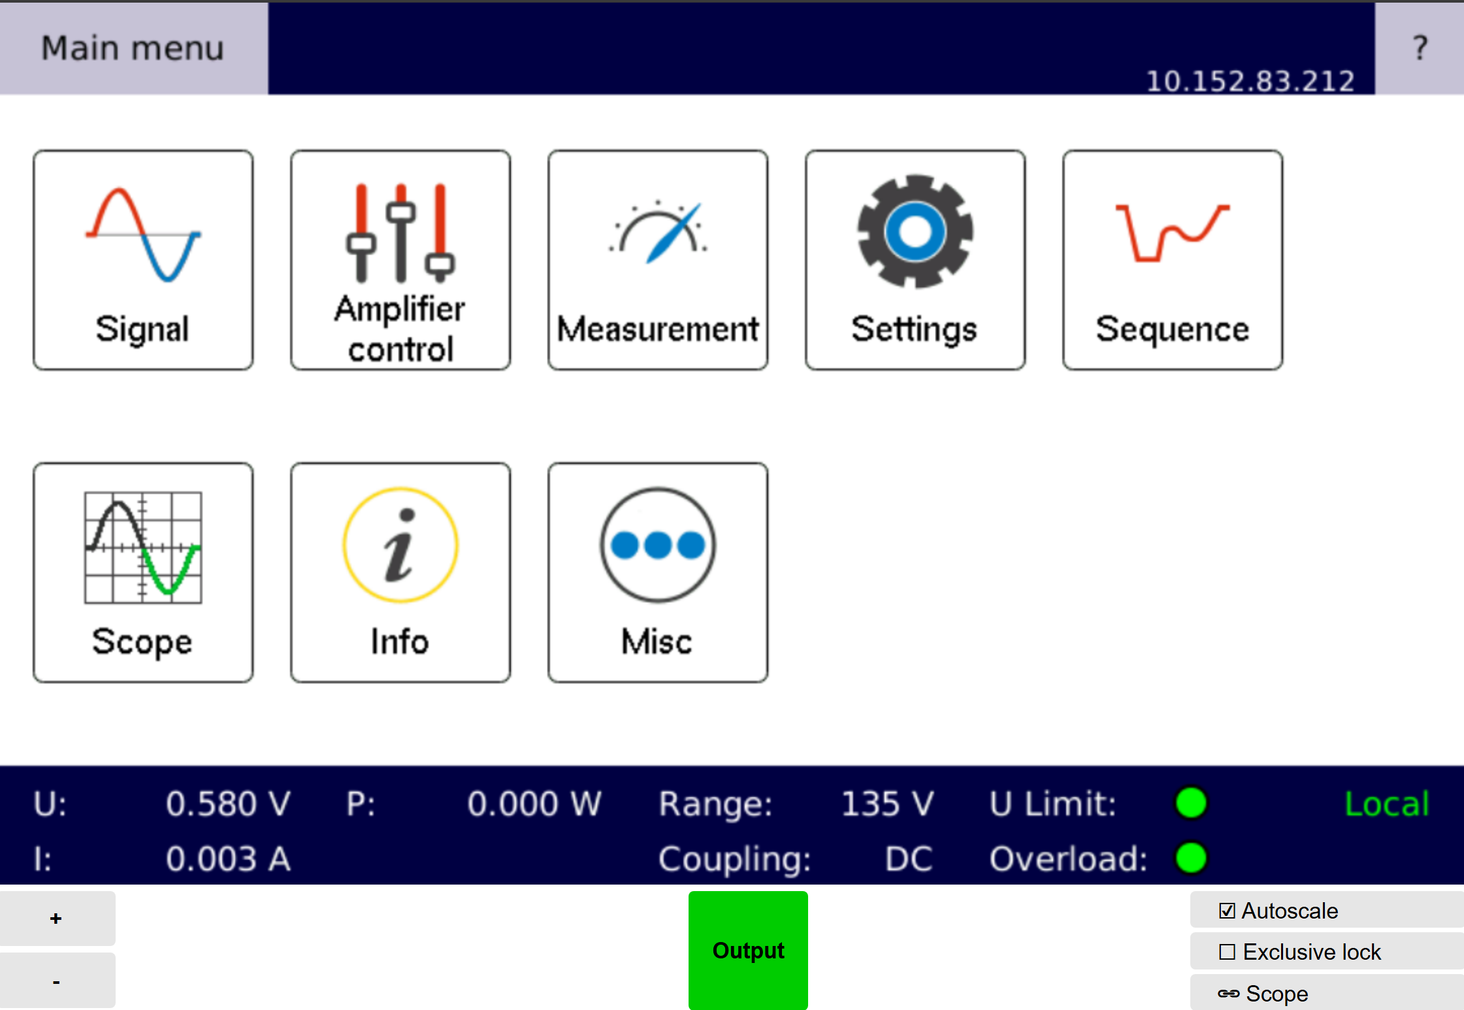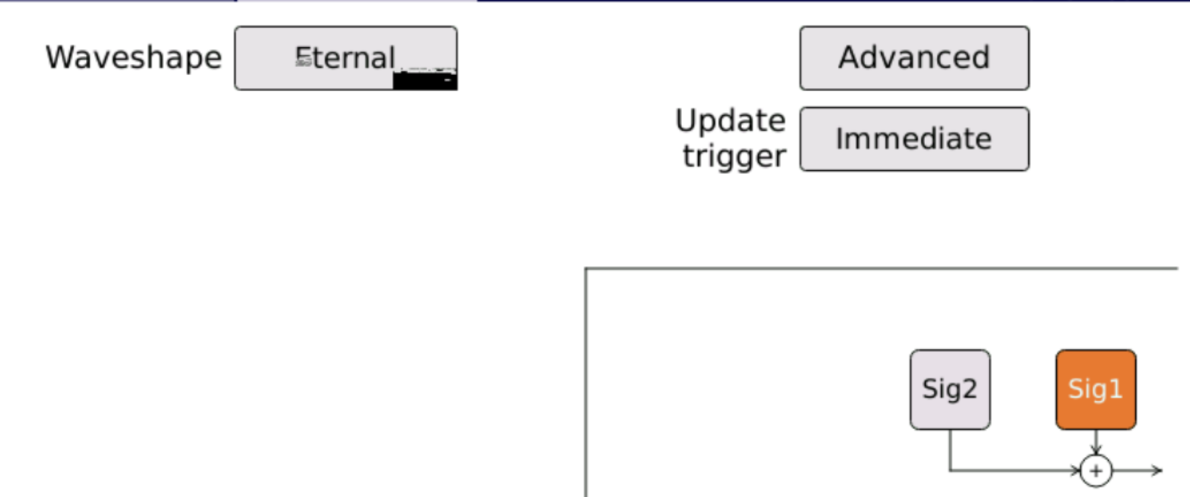
1) I Current Limit
2) CC Mode
