Test Procedure DC-Fix 24/15V

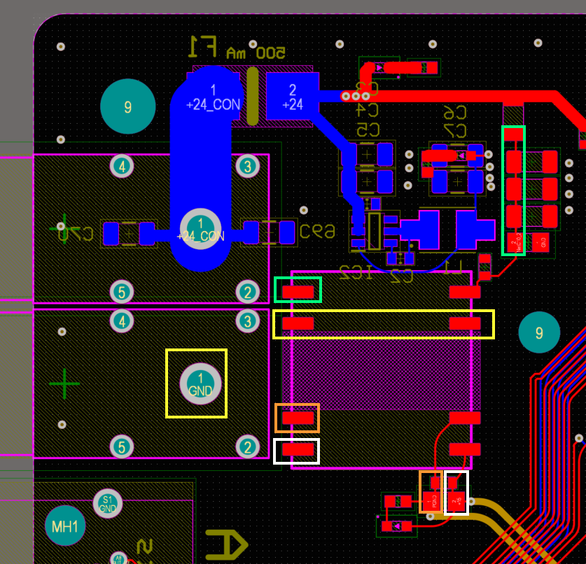

Test connection between nets of same color

Test Procedure DC-Fix 05/05 V

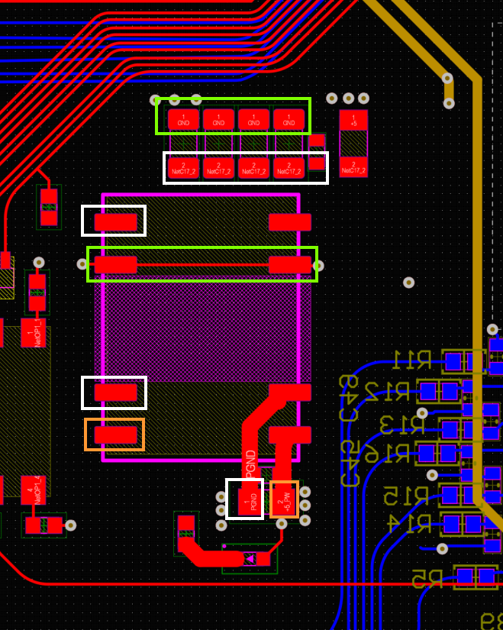
Test connection between nets of same color

