Analog Singal Test
- Soldered on: VDC voltage conditioning path with fully differential op amp
- On PCB test board: analog input signal incoming from the “inverter” coming through pin 100 (due to the Verschiebung due to differences in schematics/footprint

Things to keep in mind:
- For the fully differential op amp, make sure not to use too much solder paste as the pads are very close together
  - In the first bake we had shorted pathways

Test 1
Issue:
- No 2.5V Common Mode, Common mode displaying to be 5V - BAD
- 5/3.3 = 1.515151 Gain can be seen – GOOD!

Trouble Shooting
- Looked at the board under the microscope
  - For the OpAmp, 5V and 2.5V CM pads were connected
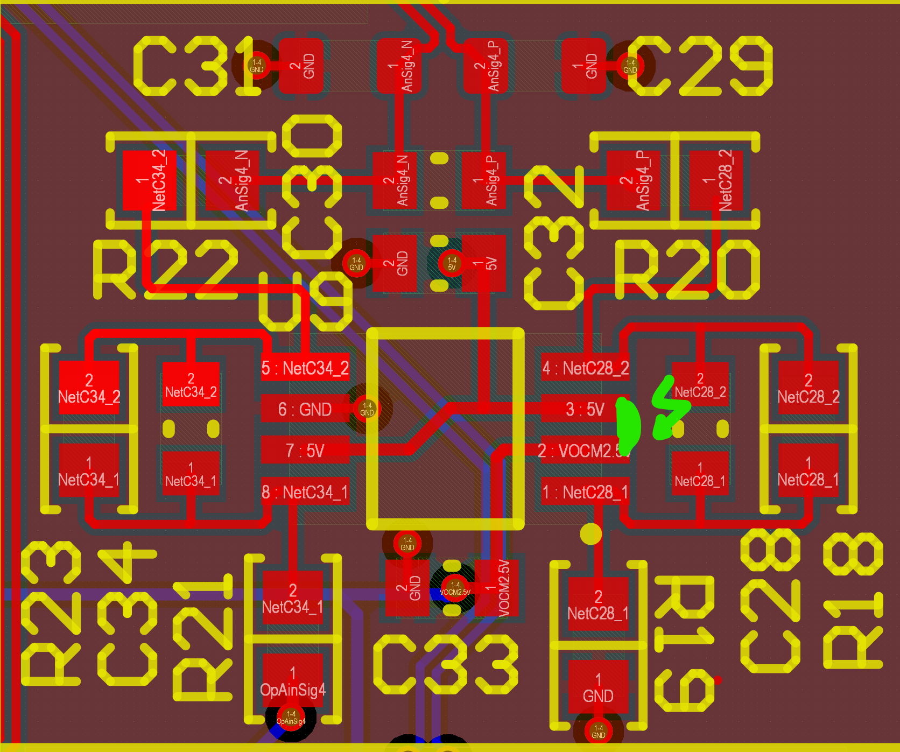
- Using heat gun, and solder wick tried to remove the excess solder
- Did not work – Accidentally burnt the op amp – one leg fell off
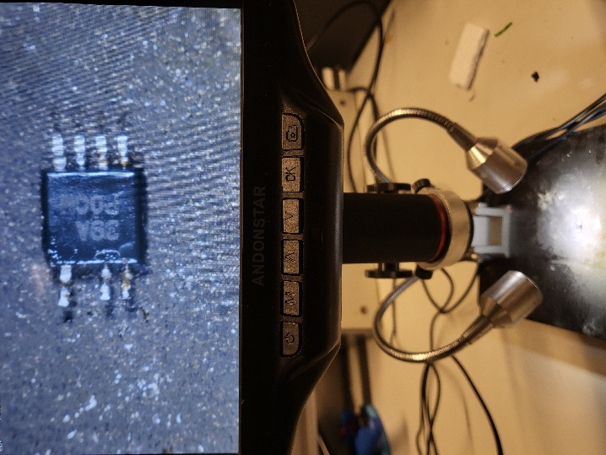
Soldered on a new Op Amp
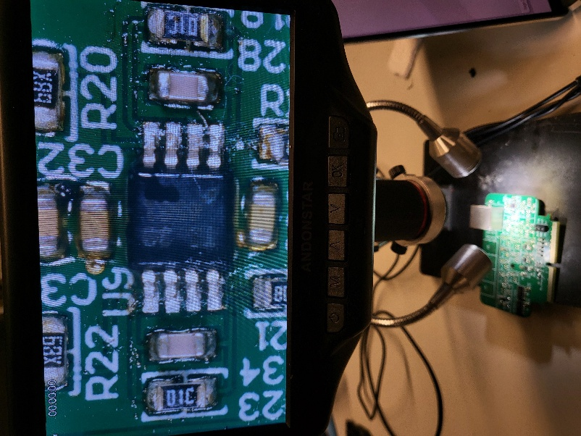
Test 2:
Setup
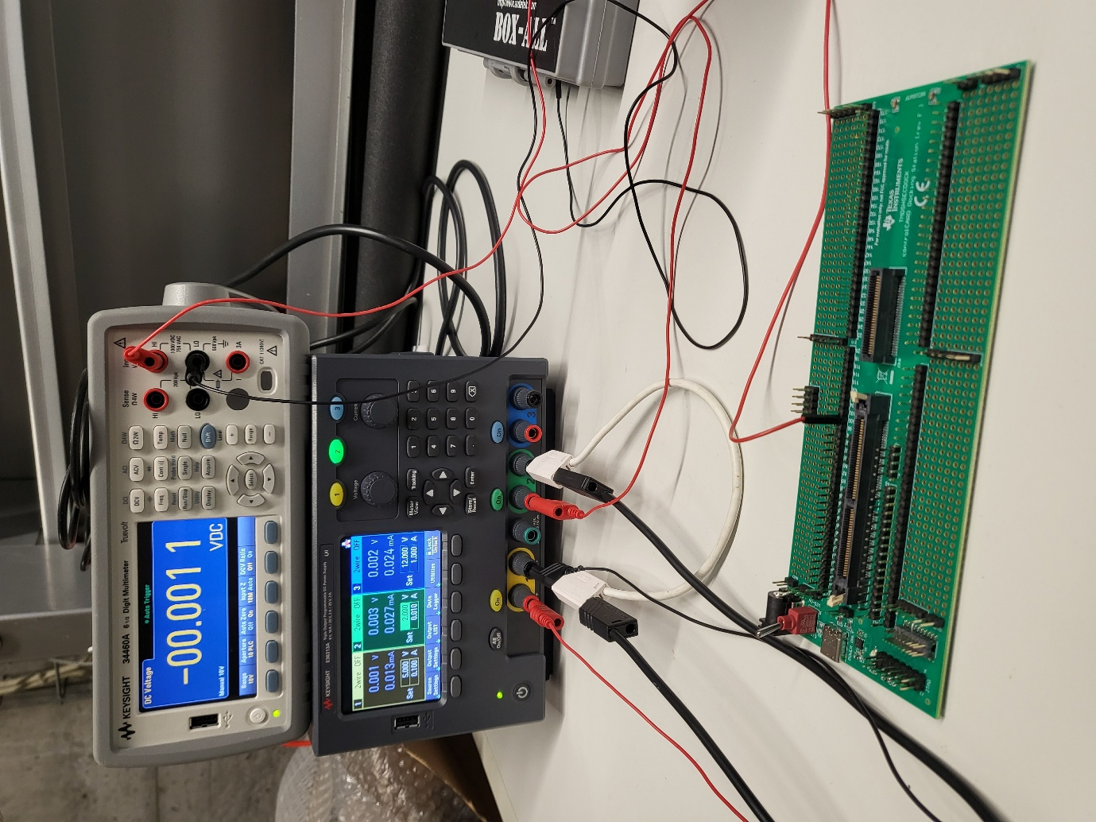
Multimeter on top
DC Power Supply on the bottom
PCB test board
We want to test the VDC Analog Signal
- Input of 2V at 0.010A at pin 100 (due to the footprint issue)
- 5V supply at 0.1A directly into the board itself
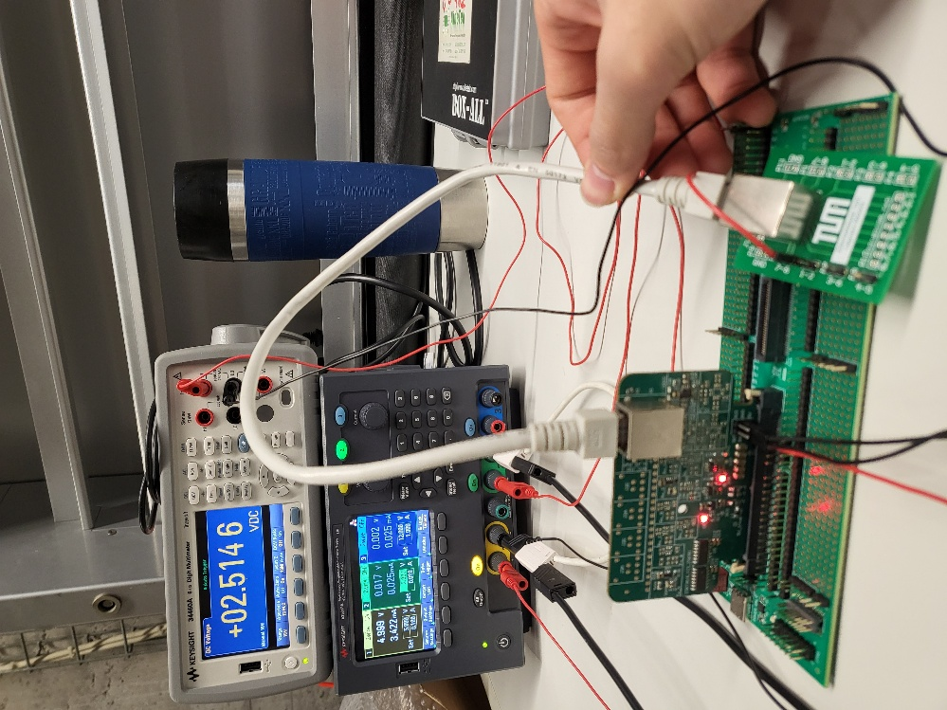
Ethernet port breakout board – pins 1 and 2 were for the VDC voltage conditioning differential signal
In picture above, measuring only with 5V supply to the board, no analog signal going though
- 2.5V is displayed for both output ethernet pins – GOOD!
- One pin set to GND, other set to breakout board
- For oth pins 2.5V when the analog signal has no current
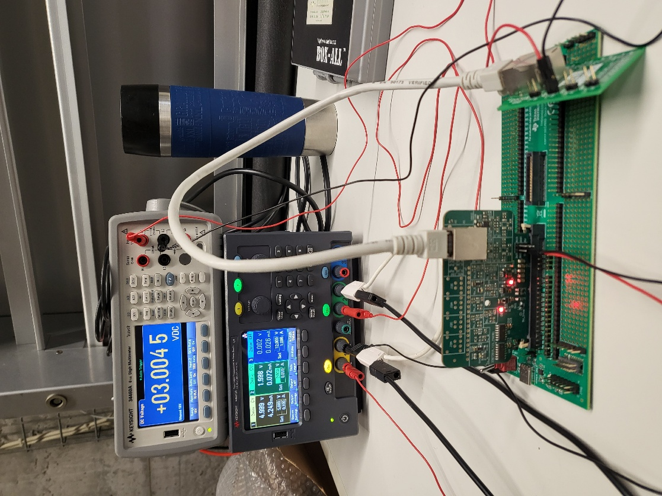
Measuring the differential signal with the analog signal on (can see on green light in the power supply
For 1.998V input, we get output of 3V
- Gain = 1.501....
- Expected gain : 5V/3.3V = 1.5151515.....

Have not tested - analog signals with bias coming in – so op amp also has 1.7V input

