SUPPLICATION, THE ESSENCE OF WORSHIP
Hands Raised to the Lord Who Says “I Am Near”
Subject: The place of supplication in servanthood, its etiquette and its meaning in everyday life | Date: Friday, 23 October 2026
Prepared by: The imam and preacher | Audience: A multi-generational community living in Europe
Main sources: The Qur’an, the hadith collections, the biography of the Prophet (sira), the Masnavi | Duration: About 40–45 minutes; adapted to the congregation

◆ Aim of the sermon and guidance
To help the congregation see supplication not merely as a remedy to turn to in times of distress, but as the essence of servanthood and an act of worship that spreads across every hour of the day; to teach the etiquette of supplication from authentic sources; and to encourage the building of homes in which families pray together. Key sentence: Supplication is the servant saying “I am in need” and the Lord answering “I am near”; the servant who supplicates is not alone, even here in Europe.
45-MINUTE SERMON TIMELINE
Stage | Page | Time | Emphasis
Opening and the bond of the heart | 2 | 4 min | The first generation’s supplication; the directness of the answer “I am near”
Supplication is the essence of worship | 3–4 | 7 min | Supplication is worship itself; we are the ones in need
At every moment, in every place | 5 | 4 min | Al ‘Imran 191; moments of greater hope for supplication
In hardship and in plenty | 6 | 5 min | He who answers the one in distress; the supplication of Yunus; knowing Him in times of plenty
Our Prophet’s day | 7 | 4 min | The supplications of a day, from waking to sleep
The etiquette of supplication | 8–9 | 8 min | Praise and blessings on the Prophet, calm, certainty, patience, lawful (halal) sustenance
Supplication never goes without a response | 10–11 | 6 min | Three responses; the Masnavi story; the most beautiful names and seeking a lawful means (tawassul)
Who is in our supplication, and the closing supplication | 12–14 | 7 min | Brothers and sisters, the first generation, our children; the seven promises; the entreaty

🎙️ NOTE FOR THE PREACHER — Guidance on using this in the pulpit
The subject of supplication touches the most sensitive place in a congregation: they have prayers they feel were not accepted, relatives they have lost, troubles that never end. Do not use judgemental language such as “If your supplication was not accepted, the fault is yours”; present the hadith on the three responses on page 10 in the language of consolation and hope. Narrations whose chain of transmission contains weakness are marked in the text; relate them by saying “it is reported”, not in the language of a firm ruling.
If time runs short, summarise the section on tawassul on page 11 by its main rule; keep pages 2, 6, 9 and 13. After the supplication for the first generation on page 12, leave a short silence so that the congregation can remember their departed elders.

SIX KEY CONCEPTS
Concept | Meaning and role in the sermon
Supplication | Turning to Allah in awareness of one’s own weakness; praising Him and asking Him for help, forgiveness and mercy.
Humbly and in secret (tadarru‘ and khufya) | Supplicating with humble pleading and in secret, with a heart free of show.
The answering of a supplication (ijaba) | Allah’s response to a supplication: granting what was asked, storing it up for the hereafter, or averting some harm.
Certainty (yaqin) | Believing from the heart that the supplication will be answered; asking without hesitation and with resolve.
Seeking a lawful means (tawassul) | Asking Allah by using as a means His names, a righteous deed done for His good pleasure, or the supplication of a righteous person who is alive.
Amin | The entreaty that seals a supplication, meaning “O Allah, accept.”

OPENING: THE LORD WHO SAYS “I AM NEAR”
🤲 SUPPLICATION — Praise, blessings on the Prophet and the opening supplication
الْحَمْدُ لِلَّهِ رَبِّ الْعَالَمِينَ، وَالصَّلَاةُ وَالسَّلَامُ عَلَى رَسُولِنَا مُحَمَّدٍ وَعَلَى آلِهِ وَصَحْبِهِ أَجْمَعِينَ
رَبَّنَا تَقَبَّلْ مِنَّا إِنَّكَ أَنتَ السَّمِيعُ الْعَلِيمُ
Praise belongs to Allah, the Lord of the worlds. May blessings and peace be upon our Prophet Muhammad, upon his family and upon all his Companions. Our Lord! Accept this from us; You are indeed the All-Hearing, the All-Knowing.
[Praise: al-Fatiha, 1:2. Blessings on the Prophet: free wording of supplication. Supplication: al-Baqara, 2:127; excerpt from the verse]

🎙️ Dear congregation! My dear brothers and sisters, you who carry the burden of life here in Europe into prostration, and your troubles and your joys alike to your Lord!
Sixty-two years ago, under the 1964 labour agreement, our first generation came to these lands with a few belongings in a suitcase, a letter from home in a pocket and a supplication on the tongue. Many of them, in a country whose language they did not know, went down into the darkness of the coal mines saying “Bismillah”; after their shift, with weary bodies, they fell on the prayer mat in a rented room and said “Ya Rabbi.” On the nights when they had no one to talk to, they talked with their Lord. If we sit in this mosque today as their children and grandchildren, the supplications they never gave up here in Europe have a share in it.
📖 QUR’ANIC VERSE — I am near
وَإِذَا سَأَلَكَ عِبَادِي عَنِّي فَإِنِّي قَرِيبٌ أُجِيبُ دَعْوَةَ الدَّاعِ إِذَا دَعَانِ فَلْيَسْتَجِيبُوا لِي وَلْيُؤْمِنُوا بِي لَعَلَّهُمْ يَرْشُدُونَ
When My servants ask you about Me, let them know that I am indeed near: when one calls upon Me, I respond to the request of the one who calls. So let them answer My invitation and believe in Me, that they may find the right path.
[al-Baqara, 2:186]

My brothers and sisters! There are many questions in the Qur’an that were put to our Prophet: about the new moons, about spending, about the sacred months, about wine and gambling, about orphans… The answers to these questions mostly begin with “Say” and are given in the words of our Prophet. In this verse, however, the word “Say” does not appear. When servants ask about their Lord, our Lord Himself gives the answer, without any intermediary: “I am near.” Supplication is an encounter in which no one stands between the servant and the Lord; there is no guard at the door, no appointment and no interpreter. In another verse our Lord tells us that He is closer to a human being than the jugular vein. (Qaf, 50:16)
Today we shall speak about supplication, that is, the essence of servanthood: the place of supplication in worship, the supplications that surrounded the day of our Prophet, the etiquette of supplication, and the seven promises that we can carry into our homes. Our key sentence is this: Supplication is the servant saying “I am in need” and the Lord answering “I am near.”

I. SUPPLICATION IS WORSHIP ITSELF
📜 HADITH — Supplication is worship itself
الدُّعَاءُ هُوَ الْعِبَادَةُ
وَقَالَ رَبُّكُمُ ادْعُونِي أَسْتَجِبْ لَكُمْ إِنَّ الَّذِينَ يَسْتَكْبِرُونَ عَنْ عِبَادَتِي سَيَدْخُلُونَ جَهَنَّمَ دَاخِرِينَ
According to the narration of al-Nu‘man ibn Bashir (may Allah be pleased with him), our Prophet said, “Supplication is worship itself,” and then recited this verse: “Your Lord has said: Call upon Me in supplication, and I will accept your supplication. Those who are too proud to worship Me will enter Hell, humiliated!”
[al-Tirmidhi, Da‘awat, 1 (3372); Abu Dawud, Witr, 23 (1479). Verse: Ghafir (al-Mu’min), 40:60]

Supplication is turning to one’s Lord in awareness of one’s own weakness: extolling Him, offering Him praise and thanks, and asking Him for help, forgiveness and mercy. Supplication is not tied to any particular ceremony, form, time or place. The ritual prayer begins with al-Fatiha, that is, with a supplication, and ends with the tashahhud, the blessings on the Prophet and the Rabbana supplications. There is supplication in the pilgrimage, in fasting, in sacrifice and in zakat as well. In one respect all acts of worship are supplication, while supplication is the essence of all acts of worship.
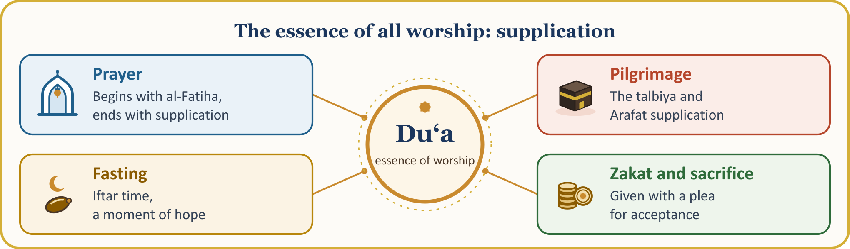
📜 HADITH — Most valuable in Allah’s sight
لَيْسَ شَيْءٌ أَكْرَمَ عَلَى اللَّهِ تَعَالَى مِنَ الدُّعَاءِ
Nothing is more valuable in Allah’s sight than supplication.
[al-Tirmidhi, Da‘awat, 1 (3370); Ibn Majah, Du‘a’, 1 (3829)]

The chain of narration of the report meaning “Supplication is the essence of worship” contains weakness; the saying that expresses the same meaning authentically is the hadith we have just read, “Supplication is worship itself.” This is why we call supplication the essence of servanthood: worship means saying “I am a servant,” and supplication says this in its simplest form: “I am in need, and You are the Self-Sufficient; I am helpless, and You are the All-Powerful; I am at fault, and You are the Ever-Forgiving.”
Let us also pay attention to the warning at the end of the verse: abandoning supplication is described as arrogance. A person who does not supplicate is saying, even if not with the tongue, “I need no one.” Those who supplicate, on the other hand, know their own limits; they regard knocking at their Lord’s door not as a humiliation but as an honour. The cry of “Ya Rabbi” is in truth a confession that the servant knows their Lord as He deserves to be known, and exalts Him.

II. WE ARE THE ONES IN NEED: SUPPLICATION REMINDS US OF OUR PURPOSE IN CREATION
📖 QUR’ANIC VERSE — Were it not for your supplication
قُلْ مَا يَعْبَأُ بِكُمْ رَبِّي لَوْلَا دُعَاؤُكُمْ
Say: “Were it not for your servanthood and your entreaty, why would Allah value you?”
[al-Furqan, 25:77; excerpt from the verse]

In this verse our Lord gives the measure of our worth: not our wealth, our rank, our passport or our diploma, but our turning to our Lord. The Qur’an tells us that He created jinn and humankind only so that they might worship Him. (al-Dhariyat, 51:56) Since the essence of servanthood is supplication, a person who supplicates has remembered the purpose of their creation and returned to their origin. Allah has no need of our supplication; it is we who are in need: “O people! It is you who are in need of Allah. Allah is the One who needs nothing, and it is He who is forever worthy of praise in His absolute perfection.” (Fatir, 35:15)
📜 HADITH — Ask Me
يَا عِبَادِي كُلُّكُمْ ضَالٌّ إِلاَّ مَنْ هَدَيْتُهُ فَاسْتَهْدُونِي أَهْدِكُمْ يَا عِبَادِي كُلُّكُمْ جَائِعٌ إِلاَّ مَنْ أَطْعَمْتُهُ فَاسْتَطْعِمُونِي أُطْعِمْكُمْ
“O My servants! All of you are astray except those whom I guide; so ask Me for guidance and I shall guide you. O My servants! All of you are hungry except those whom I feed; so ask Me for food and I shall feed you.”
[Muslim, Birr, 55 (2577); excerpt from a divine hadith (hadith qudsi)]

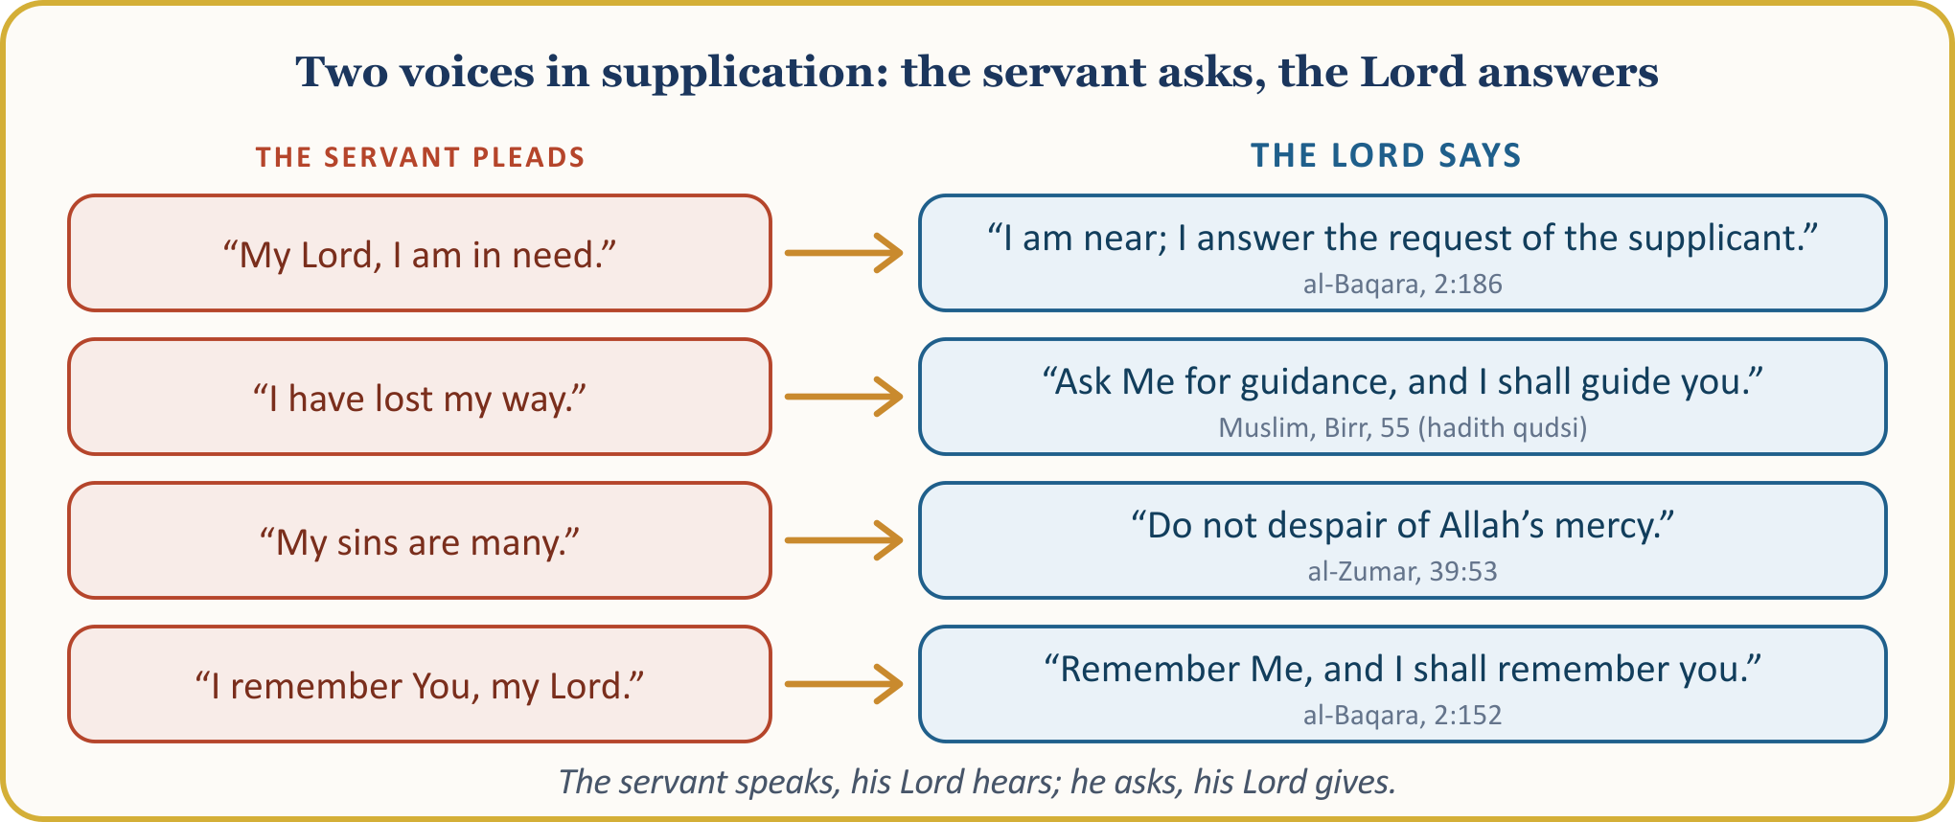
In supplication the servant lays their condition before the Lord: they speak of their weakness, loneliness, fear and joy, and in return ask for help, bounty, forgiveness, mercy and strength. In this way they show their devotion, submission and sincerity towards Him. The servant speaks, and the Lord hears; the servant asks, and the Lord gives; even if the servant forgets, the Lord does not forget them.

III. THE TIME OF SUPPLICATION IS EVERY MOMENT, ITS PLACE EVERYWHERE
📖 QUR’ANIC VERSE — Standing, sitting, lying on one’s side
الَّذِينَ يَذْكُرُونَ اللَّهَ قِيَامًا وَقُعُودًا وَعَلَىٰ جُنُوبِهِمْ وَيَتَفَكَّرُونَ فِي خَلْقِ السَّمَاوَاتِ وَالْأَرْضِ رَبَّنَا مَا خَلَقْتَ هَٰذَا بَاطِلًا سُبْحَانَكَ فَقِنَا عَذَابَ النَّارِ
Standing, sitting and lying down, they remember Allah always; they reflect on the creation of the heavens and the earth (and they say): “Our Lord! You did not create this in vain; we glorify You and declare You holy. Protect us from the punishment of the Fire!”
[Al ‘Imran, 3:191]

The verse speaks of those who remember Allah while standing, sitting and lying on their sides. These three states are all the states of a human being. So there is no need to wait for special clothing, a particular place or an hour for supplication: on the morning tram, on the factory line, on the building site, behind the steering wheel, in a hospital corridor, while dropping our child at the school gate… If our heart is turned towards our Lord, that place is a place of supplication.
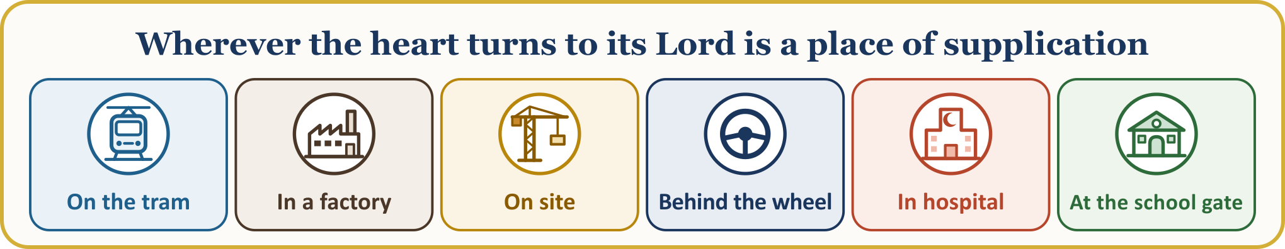
Supplication can be made in any language. The ritual prayer is performed in Arabic, but in supplication outside the prayer our Lord hears every language. Our children who think in French, Dutch or German can turn to their Lord in their own words; and it is our duty to teach them the supplications of the Qur’an and the Sunnah in such a way that they come to love them.
MOMENTS OF GREATER HOPE FOR SUPPLICATION
Time and state | The good news in the sources | Source
The last third of the night | Our Lord says, “Who supplicates to Me, that I may answer his supplication?” | al-Bukhari, Tahajjud, 14
Prostration | It is the moment when the servant is closest to his Lord; so make supplication abundantly. | Muslim, Salat, 215
Between the adhan and the iqama | A supplication made in this interval is not turned away. | Abu Dawud, Salat, 35
Friday | On Friday there is an hour in which, when a Muslim makes supplication, what they ask for is given. | al-Bukhari, Jumu‘a, 37
The fasting person at the breaking of the fast | It is reported that the supplication of one who is fasting is not turned away until they break their fast. | al-Tirmidhi, Da‘awat, 128
The wronged, the traveller and the father | There is no doubt about the acceptance of these three supplications. | al-Tirmidhi, Birr, 7

These are the times when the door is opened wider; otherwise our Lord’s door is never closed, not for a single moment. That hour is also hidden within today, that is, within Friday; after the prayer, let us set aside a few minutes for it.

IV. SUPPLICATION IN HARDSHIP AND IN PLENTY
📖 QUR’ANIC VERSE — Who answers the one in distress?
أَمَّن يُجِيبُ الْمُضْطَرَّ إِذَا دَعَاهُ وَيَكْشِفُ السُّوءَ وَيَجْعَلُكُمْ خُلَفَاءَ الْأَرْضِ أَإِلَٰهٌ مَّعَ اللَّهِ
And who is it that comes to the aid of the one in distress when they call out to Him, removes their affliction and makes you the governors of the earth? Is there a god besides Allah?
[al-Naml, 27:62; excerpt from the verse]

Throughout life a person meets burdens that they cannot carry alone: illness, debt, the loss of a job, trouble from their children, the distance from parents back home, loneliness and despair. At such moments supplication is the firmest branch a person can hold on to; the hope that it will be accepted lightens the heart and gives strength to endure and patience. The saying commonly known among people, “Supplication is the weapon of the believer,” is not established as a hadith; but its meaning lies hidden in this verse: the refuge of the one in distress is the One who hears supplication.
🤲 SUPPLICATION — The supplication in the belly of the fish
لَا إِلَٰهَ إِلَّا أَنتَ سُبْحَانَكَ إِنِّي كُنتُ مِنَ الظَّالِمِينَ
There is no god but You. I declare You exalted above all imperfection. Truly, I have done evil deeds!
[al-Anbiya’, 21:87; excerpt from the verse]

Yunus (peace be upon him) made this supplication in the layered darkness of the night, the sea and the belly of the fish; our Lord saved him and said, “And thus do We save the believers.” (al-Anbiya’, 21:88) Our Prophet also told us that a Muslim who makes supplication with these words will not be left without a response. (al-Tirmidhi, Da‘awat, 81)
Yet our Lord does not wish to be remembered only when we are in distress. The Qur’an criticises the person who turns away and withdraws on receiving a blessing, and then prays at great length when some harm befalls them. (Fussilat, 41:51; Yunus, 10:12)
📜 HADITH — Increasing supplication in times of plenty
مَنْ سَرَّهُ أَنْ يَسْتَجِيبَ اللَّهُ لَهُ عِنْدَ الشَّدَائِدِ وَالْكُرَبِ فَلْيُكْثِرِ الدُّعَاءَ فِي الرَّخَاءِ
Whoever is pleased that Allah should answer their supplication in times of distress and difficulty, let them make supplication abundantly in times of plenty and ease.
[al-Tirmidhi, Da‘awat, 9 (3382)]

Our Prophet gave the young Ibn ‘Abbas this advice: “Know Allah in times of plenty, and He will know you in times of hardship.” (Ibn Hanbal, I, 307) Do we raise our hands when our work is going well, our home is peaceful, our residence permit has come through and our child has finished school? Let us not turn supplication into an emergency button pressed only when a fire breaks out; it is a door that we keep open every day.

V. SUPPLICATION IN OUR PROPHET’S LIFE: THE SUPPLICATIONS OF A DAY
When we look at the life of the noble Messenger, we see that supplication encompassed every moment of the day. On waking, on leaving the house, on sitting down to eat, on setting out on a journey and on lying down in bed, he spoke with his Lord; he would begin his tasks with supplication and end them with praise. His Companions memorised these supplications from him and taught them to their children.
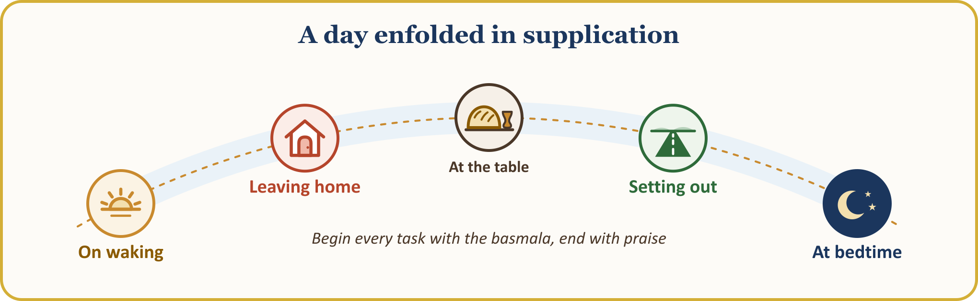
📜 HADITH — On waking
الْحَمْدُ لِلَّهِ الَّذِي أَحْيَانَا بَعْدَ مَا أَمَاتَنَا، وَإِلَيْهِ النُّشُورُ
Praise be to Allah, who gave us life after having caused us to die. To Him is the return.
[al-Bukhari, Da‘awat, 16 (6324); Muslim, Dhikr, 59 (2711)]

THE SUPPLICATIONS OF A DAY
Moment | Transliteration | Meaning | Source
Leaving home | Bismillah, tawakkaltu ‘ala-llah, la hawla wa la quwwata illa billah. | In the name of Allah; I have put my trust in Allah. There is no might and no power except with Allah’s help. | al-Tirmidhi, Da‘awat, 34
On sitting down to eat | Bismillah. | In the name of Allah. | al-Bukhari, At‘ima, 2
After the meal | Al-hamdu li-llahi lladhi at‘amani hadha wa razaqanihi min ghayri hawlin minni wa la quwwa. | Praise be to Allah, who fed me this and provided it for me as sustenance, without any strength or power on my part. | al-Tirmidhi, Da‘awat, 55
Setting out | Subhana lladhi sakhkhara lana hadha wa ma kunna lahu muqrinin. Wa inna ila rabbina la-munqalibun. | Exalted is the One who has subjected this to us; we could never have managed it ourselves! And to our Lord we shall surely return. | al-Zukhruf, 43:13–14
At bedtime | Bismika llahumma amutu wa ahya. | O Allah! In Your name I die, and in Your name I come to life. | al-Bukhari, Da‘awat, 16

When he lay down on his bed at night, he would give thanks in these words: “Praise be to Allah, who has fed us, given us drink, met our needs and given us shelter. How many there are who have no one to meet their needs or give them shelter.” (Muslim, Dhikr, 64) When he wanted to do something, he would ask Allah for what was best; he used to teach his Companions the prayer for guidance (istikhara) as he would teach them a surah of the Qur’an. (al-Bukhari, Tahajjud, 25)
When making supplication he would sometimes face the qibla (Muslim, Jihad, 58); in the supplication for rain he would raise his hands so high that the whiteness of his armpits could be seen (al-Bukhari, Istisqa’, 22); and he advised his Companions to ask Allah with the palms of their hands (Abu Dawud, Witr, 23). The servant who opens the palms of their hands is, in effect, saying, “My hands are empty; I ask only of You.”

VI. THE ETIQUETTE OF SUPPLICATION: BEGINNING WITH PRAISE, ASKING WITH PROPRIETY
📜 HADITH — First praise, then blessings on the Prophet, then supplication
عَجِلْتَ أَيُّهَا الْمُصَلِّي إِذَا صَلَّيْتَ فَقَعَدْتَ فَاحْمَدِ اللَّهَ بِمَا هُوَ أَهْلُهُ وَصَلِّ عَلَىَّ ثُمَّ ادْعُهُ
أَيُّهَا الْمُصَلِّي ادْعُ تُجَبْ
Fadala ibn ‘Ubayd (may Allah be pleased with him) relates: While our Prophet was sitting, a man came in, prayed, and said, “O Allah, forgive me and have mercy on me.” Our Prophet said, “You have been hasty, O worshipper! When you have prayed and sat down, praise Allah as is worthy of Him, invoke blessings upon me, and then call upon Him.” Then another man prayed; he praised Allah and invoked blessings upon our Prophet. Our Prophet said to him, “O worshipper, make your supplication; it will be accepted.”
[al-Tirmidhi, Da‘awat, 64 (3476–3477); Abu Dawud, Witr, 23 (1481)]

This order that our Prophet taught is the etiquette of supplication: first we praise our Lord, then we invoke blessings on the Prophet, then we present our need; and we complete the supplication with praise, blessings and “amin”.
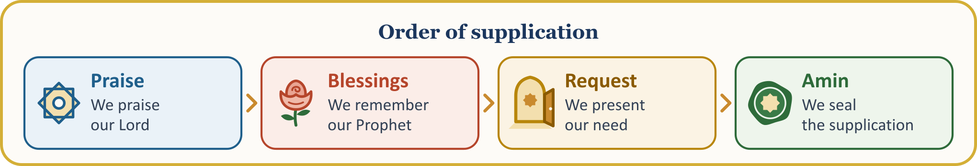
📖 QUR’ANIC VERSE — Humbly and in secret
ادْعُوا رَبَّكُمْ تَضَرُّعًا وَخُفْيَةً إِنَّهُ لَا يُحِبُّ الْمُعْتَدِينَ
وَادْعُوهُ خَوْفًا وَطَمَعًا إِنَّ رَحْمَتَ اللَّهِ قَرِيبٌ مِّنَ الْمُحْسِنِينَ
Call upon your Lord humbly and in secret. Know that He does not love those who transgress. … Call upon Allah in fear and in hope. Surely Allah’s mercy is very near to those who do good.
[al-A‘raf, 7:55–56; excerpts from the verses]

On a journey, the Companions were calling out the takbir loudly each time they climbed a hill. Our Prophet called out to them: “O people! Have pity on yourselves (lower your voices)! You are not calling on one who is deaf or far away; you are calling on the One who hears everything, sees everything and is very near to you.” (al-Bukhari, Tawhid, 9; Muslim, Dhikr, 44) This does not prevent the imam from leading the congregation in supplication aloud; the measure is not to shout, to avoid showing off, and to make supplication as a whisper of the heart.
Our Prophet loved short, comprehensive supplications rather than long and ornate sentences. When the Companion Sa‘d ibn Abi Waqqas heard his son supplicating by listing the blessings of Paradise one by one, he warned him and reminded him that our Prophet had said, “A people will come who transgress the limits in supplication.” (Abu Dawud, Witr, 23) What matters in supplication is not the ornament of words but the sincerity of the heart.
Saying “amin” at the end of a supplication is also a fine courtesy. Amin means “O Allah, accept”; it is reported that our Prophet said of a man who was praying insistently, “If he ends with amin, he has earned (Paradise).” (Abu Dawud, Salat, 167–168; its chain of narration contains weakness) Although the chains of the reports about wiping the face with the hands after supplication are weak, scholars have regarded the practice as good because the reports support one another.

VI. (CONTINUED) CERTAINTY, PATIENCE AND LAWFUL (HALAL) SUSTENANCE
📜 HADITH — Believing that it will be accepted
ادْعُوا اللَّهَ وَأَنْتُمْ مُوقِنُونَ بِالإِجَابَةِ وَاعْلَمُوا أَنَّ اللَّهَ لاَ يَسْتَجِيبُ دُعَاءً مِنْ قَلْبٍ غَافِلٍ لاَهٍ
Call upon Allah in supplication, believing wholeheartedly that it will be accepted. Know that Allah does not accept a supplication that comes from a heedless and careless heart.
[al-Tirmidhi, Da‘awat, 65 (3479); its chain of narration contains weakness]

Our Prophet also forbade saying in supplication, “O Allah, forgive me if You wish; have mercy on me if You wish,” and said, “Let one ask for one’s wish firmly and resolutely, for there is no one who can compel Allah.” (al-Bukhari, Da‘awat, 21; Muslim, Dhikr, 9) The believer asks not with hesitancy before their Lord but trusting in His generosity.
📜 HADITH — Not being hasty
لاَ يَزَالُ يُسْتَجَابُ لِلْعَبْدِ مَا لَمْ يَدْعُ بِإِثْمٍ أَوْ قَطِيعَةِ رَحِمٍ مَا لَمْ يَسْتَعْجِلْ قِيلَ يَا رَسُولَ اللَّهِ مَا الاِسْتِعْجَالُ قَالَ يَقُولُ قَدْ دَعَوْتُ وَقَدْ دَعَوْتُ فَلَمْ أَرَ يَسْتَجِيبُ لِي فَيَسْتَحْسِرُ عِنْدَ ذَلِكَ وَيَدَعُ الدُّعَاءَ
A servant’s supplication continues to be accepted as long as they do not ask for something sinful or for the severing of family ties, and do not become hasty. He was asked, “O Messenger of Allah, what is haste?” He said, “It is to say, ‘I have supplicated and supplicated, and I have not seen it accepted,’ and then to grow weary and give up supplication.”
[Muslim, Dhikr, 92 (2735); al-Bukhari, Da‘awat, 22 (6340)]

A farmer sows the seed in the soil; the next morning he does not dig the soil up to look and ask, “Why hasn’t it sprouted?” Supplication is like that: sometimes it finds its response at once, sometimes years later, and sometimes in the hereafter. The servant who supplicates keeps knocking at the door and leaves it to the Owner of the door to decide when it will open.
📜 HADITH — Lawful (halal) sustenance
ثُمَّ ذَكَرَ الرَّجُلَ يُطِيلُ السَّفَرَ أَشْعَثَ أَغْبَرَ يَمُدُّ يَدَيْهِ إِلَى السَّمَاءِ يَا رَبِّ يَا رَبِّ وَمَطْعَمُهُ حَرَامٌ وَمَشْرَبُهُ حَرَامٌ وَمَلْبَسُهُ حَرَامٌ وَغُذِيَ بِالْحَرَامِ فَأَنَّى يُسْتَجَابُ لِذَلِكَ
…Then our Prophet spoke of a man who, having travelled a long way, dishevelled and covered in dust, stretches his hands to the sky and pleads, “Ya Rabbi, ya Rabbi!” Yet what he eats is unlawful, what he drinks is unlawful, what he wears is unlawful; he has been nourished on the unlawful. “How can such a person’s supplication be accepted!” he said.
[Muslim, Zakat, 65 (1015); excerpt of the narration]

This hadith holds up a mirror to our life here in Europe: the acceptance of our supplication is closely tied to the lawfulness of the morsel that reaches the table and of the earnings that reach the pocket. Hands raised with earnings that are open to doubt — over taxes, over a worker’s due, over honest weights and measures or over a declaration for social benefits — will block their own way, however much they plead.

VII. NO SUPPLICATION GOES WITHOUT A RESPONSE
📜 HADITH — He is too modest to return empty hands
إِنَّ اللَّهَ حَيِيٌّ كَرِيمٌ يَسْتَحِي إِذَا رَفَعَ الرَّجُلُ إِلَيْهِ يَدَيْهِ أَنْ يَرُدَّهُمَا صِفْرًا خَائِبَتَيْنِ
According to the narration of Salman al-Farisi (may Allah be pleased with him), our Prophet said, “Truly Allah is Modest and Generous. When a servant raises their hands to Him, He is too modest to return them empty, with nothing in them.”
[al-Tirmidhi, Da‘awat, 104 (3556); Abu Dawud, Witr, 23 (1488)]

📜 HADITH — The three responses to supplication
مَا مِنْ مُسْلِمٍ يَدْعُو، لَيْسَ بِإِثْمٍ وَلاَ بِقَطِيعَةِ رَحِمٍ، إِلاَّ أَعْطَاهُ إِحْدَى ثَلاَثٍ: إِمَّا أَنْ يُعَجِّلَ لَهُ دَعْوَتَهُ، وَإِمَّا أَنْ يَدَّخِرَهَا لَهُ فِي الْآخِرَةِ، وَإِمَّا أَنْ يَدْفَعَ عَنْهُ مِنَ السُّوءِ مِثْلَهَا، قَالَ: إِذًا نُكْثِرُ، قَالَ: اللَّهُ أَكْثَرُ
To every Muslim who turns to Allah with a supplication that contains neither sin nor the severing of family ties, Allah gives one of three things without fail: either He accepts the supplication at once, or He stores it up for them in the hereafter, or He averts from them an evil equal to their supplication. They said, “Then we shall supplicate abundantly.” He said, “What Allah gives is greater still.”
[al-Bukhari, al-Adab al-mufrad, 710; Ibn Hanbal, III, 18]

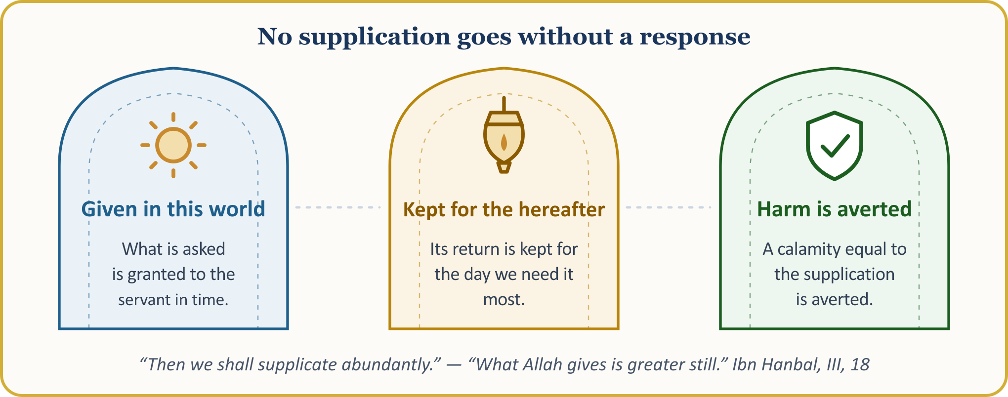
This means that no supplication goes to waste. Sometimes what we ask for is given at once; sometimes our Lord keeps it for the day when we shall need it most; and sometimes an evil that was going to befall us, without our knowing it, is averted thanks to our supplication. Our Lord says, “You may dislike something although it is good for you… Only Allah knows; you do not know.” (al-Baqara, 2:216; excerpt from the verse) Zakariyya (Zechariah; peace be upon him) also said, “My Lord! In my supplications to You I have never returned empty-handed.” (Maryam, 19:4)
💡 A LESSON FROM HISTORY — A piece of wisdom from the Masnavi: “Your saying ‘Allah’ is My saying ‘Here I am’”
Rumi (Mawlana) tells of a man who used to call out “Allah” in his supplications at night. Satan whispered to him, “You have said ‘Allah’ so many times; has even one ‘Here I am’ ever come back to you?” The man’s heart was broken; he gave up supplication and went to sleep. In his dream he saw al-Khidr (peace be upon him), who asked, “Why have you stopped remembering Allah?” The man said, “No ‘Here I am’ ever comes; I fear being driven away from the door.” Al-Khidr then conveyed to him this message from his Lord: “Your saying ‘Allah’ is My saying ‘Here I am, My servant.’ That burning longing of yours is the messenger I sent to you; beneath every ‘Ya Rabbi’ you say lie many of My answers, ‘Here I am.’” If the wish to supplicate falls into the heart, the door is open; to be enabled to supplicate is the first answer to supplication.
[Rumi (Mawlana), Masnavi, III, 189–197; a wisdom story, not a hadith]

VIII. TURNING TO ALLAH BY HIS MOST BEAUTIFUL NAMES, AND SEEKING A LAWFUL MEANS (TAWASSUL)
📖 QUR’ANIC VERSE — The most beautiful names
وَلِلَّهِ الْأَسْمَاءُ الْحُسْنَىٰ فَادْعُوهُ بِهَا
The most beautiful names belong to Allah; call upon Him by these beautiful names.
[al-A‘raf, 7:180; excerpt from the verse]

Our Lord wants us to call upon Him by His most beautiful names. The sick person calls out “Ya Shafi”, the one seeking sustenance “Ya Razzaq”, the one ashamed of their sin “Ya Ghafur, ya Tawwab”, the one who has lost their way “Ya Hadi”. Choosing the name that suits our need is a sign that we know our Lord. Anas ibn Malik (may Allah be pleased with him) relates: After the prayer a man made this supplication: “O Allah! Praise belongs to You; there is no god but You. O One of abundant grace, Originator of the heavens and the earth, O Lord of majesty and generosity, O Hayy, O Qayyum! I ask You.” Our Prophet said, “He has called upon Allah by His Greatest Name, the one by which, when He is called upon, He answers, and when He is asked, He gives.” (Abu Dawud, Witr, 23; al-Nasa’i, Sahw, 58)
Seeking a lawful means (tawassul) is resorting to a means in supplication, in order to draw closer to Allah or for the acceptance of a request. Our Lord says, “Seek a means of drawing near to Allah.” (al-Ma’ida, 5:35) There are three forms of tawassul that the scholars have unanimously regarded as lawful: making Allah’s beautiful names and exalted attributes a means; making a righteous deed that one has done for His good pleasure a means; and asking a righteous person who is alive to supplicate. In a year of drought, ‘Umar asked for rain through the supplication of al-‘Abbas, the uncle of our Prophet. (al-Bukhari, Istisqa’, 3 (1010))
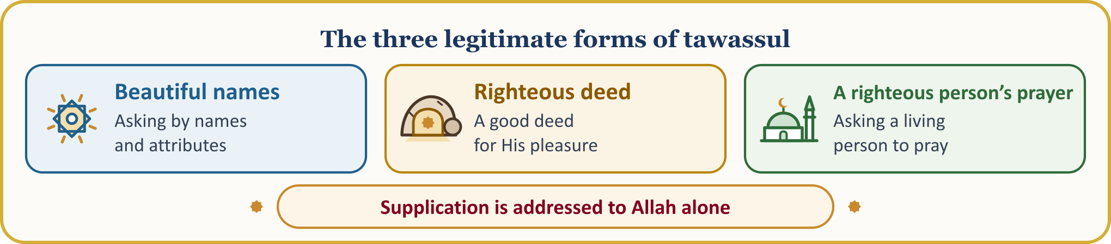
💡 A LESSON FROM HISTORY — The three men in the cave
Our Prophet relates: Three men from the communities before you were travelling when rain overtook them, and they took shelter in a cave. A great rock that broke loose from the mountain closed the mouth of the cave. They said to one another, “Remember the righteous deeds you did solely for Allah’s good pleasure, and call upon Him, making them your means.” The first told how he used to bring his elderly parents their milk, and how, when they had fallen asleep, he could not bring himself to wake them and waited by their heads until morning with the bowl in his hand. The second said that a woman, a relative of his, had fallen into difficulty and asked him for help, and that when he was about to fall into what is forbidden, he had held back at her words “Fear Allah,” and had also left her the gold he had given. The third told how he had put to work and multiplied the due of a labourer who had left without taking his wage, and how, years later, when the labourer came, he handed over to him all the property, together with its flocks. Each of them prayed, “O Allah, if I did this seeking only Your good pleasure, rescue us from the distress we are in”; with each supplication the rock opened a little more, and after the third supplication they came out of the cave. A righteous deed done for Allah’s good pleasure is a key in the servant’s hand in times of hardship.
[al-Bukhari, Ijara, 12; Adab, 5; Muslim, Dhikr, 100 (2743); summarised]

⚖️ GUIDANCE FROM FIQH — Supplication is addressed to Allah alone
“(Our Lord!) You alone we worship, and from You alone we seek help.” (al-Fatiha, 1:5) Our Prophet also said, “When you ask, ask Allah; when you seek help, seek help from Allah.” (al-Tirmidhi, Sifat al-qiyama, 59) A means is a courtesy that carries the supplication to Allah; it is not a recourse set up in Allah’s place. To look for help from a person, a grave or an object in the way one asks Allah is contrary to the spirit of supplication.

IX. WHOM SHALL WE INCLUDE IN OUR SUPPLICATION? BROTHERS AND SISTERS, THE FIRST GENERATION, OUR CHILDREN
📜 HADITH — Supplication made in the other person’s absence
دَعْوَةُ الْمَرْءِ الْمُسْلِمِ لأَخِيهِ بِظَهْرِ الْغَيْبِ مُسْتَجَابَةٌ عِنْدَ رَأْسِهِ مَلَكٌ مُوَكَّلٌ كُلَّمَا دَعَا لأَخِيهِ بِخَيْرٍ قَالَ الْمَلَكُ الْمُوَكَّلُ بِهِ آمِينَ وَلَكَ بِمِثْلٍ
A Muslim’s supplication for his brother in his absence is accepted. An angel is appointed at his head; each time he prays for good for his brother, that angel says, “Amin, and the same for you.”
[Muslim, Dhikr, 88 (2733)]

Our Lord commands our Prophet to ask forgiveness both for himself and for believing men and believing women. (Muhammad, 47:19) Let us not confine our supplication to ourselves: our brother lying in hospital, our neighbour who has lost his job, the oppressed caught in the midst of war and tyranny, our elders back in the homeland… Whoever prays for their brother earns the angel’s supplication for themselves.
📖 QUR’ANIC VERSE — Those who passed away before us in faith
رَبَّنَا اغْفِرْ لَنَا وَلِإِخْوَانِنَا الَّذِينَ سَبَقُونَا بِالْإِيمَانِ وَلَا تَجْعَلْ فِي قُلُوبِنَا غِلًّا لِّلَّذِينَ آمَنُوا رَبَّنَا إِنَّكَ رَءُوفٌ رَّحِيمٌ
Our Lord! Forgive us and our brothers who believed before us; leave no ill thought or ill feeling in our hearts towards those who believe. Our Lord! You are indeed full of compassion, most merciful.
[al-Hashr, 59:10; excerpt from the verse]

This verse reminds us of the first generation of our mosques: the elders who laid the first stone of this mosque, who set aside from their wages to pay the first rent, who taught the first lessons of the Arabic alphabet at the Qur’an course, and some of whom have today passed on to the hereafter. They prayed for us; now it is our turn.
A father’s supplication for his child is also among the supplications whose acceptance is beyond doubt. (al-Tirmidhi, Birr, 7) For this reason, as parents, let us refrain from cursing our children in moments of anger; our Prophet forbade us to curse ourselves, our children and our possessions. (Muslim, Zuhd, 74) The Qur’an teaches us to pray for our parents, “My Lord! Have mercy on them, as they raised me with tenderness when I was small” (al-Isra’, 17:24), and for our spouses and descendants, “Our Lord! Grant us spouses and children who will bring us joy, and make us leaders of those who guard against sin!” (al-Furqan, 25:74)
🧳 A SCENE FROM OUR LIFE IN EUROPE — An illustrative scene: a supplication in French
A seven-year-old girl opens her hands before going to bed and prays in French: “O Allah, protect my mum, my dad and my grandad; make my exam tomorrow easy.” Her father at first thinks to himself, “If only she knew Arabic.” Then he remembers the words of the imam of the mosque: “Our Lord hears every language. Teach her to love al-Fatiha and the Rabbana supplications; but do not silence her own words either.” From that evening on, father and daughter each make a supplication for the other every night. Supplication is first seen being lived, before it is taught.
[This is an illustrative example; it is not presented as a real event]

X. FROM THE PULPIT TO THE HEART: THE SUPPLICATIONS OF THE PROPHETS AND THE SEVEN PROMISES
🎙️ Dear congregation! The Qur’an entrusts the supplications of the prophets to us like a treasure.
SUPPLICATIONS OF THE PROPHETS
Prophet and situation | Supplication | Verse
Adam and Eve: after the mistake | Our Lord! We have wronged ourselves. If You do not forgive us and have mercy on us, we shall surely be among the losers! | al-A‘raf, 7:23
Ibrahim (Abraham): for his descendants | Our Lord! Make us among those who submit to You, and bring forth from our descendants a community that will submit to You. | al-Baqara, 2:128
Zakariyya (Zechariah): longing for a child | My Lord! Grant me, from Yourself, pure offspring! You are indeed the Hearer of supplication. | Al ‘Imran, 3:38
Musa (Moses): in a foreign land, weary and alone | My Lord! I am in need of every kind of good that You bestow on me! | al-Qasas, 28:24
Ayyub (Job): in illness | This affliction has befallen me. But You are the most merciful of the merciful. | al-Anbiya’, 21:83

Let us pay attention to the supplication of Musa (peace be upon him): he has left Egypt and reached Midian; he is weary, alone and a stranger. Withdrawing into the shade of a tree, he makes this supplication. This is the supplication of life far from home, and ours as well here in Europe: “My Lord! I am in need of every kind of good that You bestow on me!”
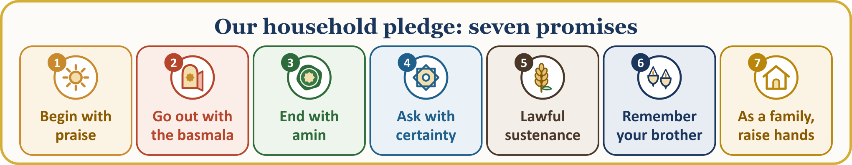
OUR HOUSEHOLD’S SUPPLICATION PLEDGE — let us put it up on our fridge door
1 | I will begin the day with praise and close the night with praise. I will recite our Prophet’s supplications on waking and on going to bed.
2 | I will begin every task with the basmala. I will mention Allah’s name when leaving the house, sitting down to eat and setting out on a journey.
3 | I will begin my supplication with praise and blessings on the Prophet and end it with amin. I will ask with short, sincere words that come from the heart, humbly and quietly.
4 | I will ask believing that it will be accepted. I will not give up, saying, “I supplicated, but it was not accepted”; I will leave the outcome to my Lord.
5 | I will support my supplication with lawful sustenance. I will keep my earnings, my table and everything that comes into my home on the side of what is lawful.
6 | I will include my brothers and sisters in my supplication. I will remember my parents, my children, the first generation, the sick and the oppressed in my supplications in their absence.
7 | One evening a week I will raise my hands together with my family. I will help my children come to love supplication in their own languages, and we will memorise the Qur’anic supplications together.

Supplication is the servant saying “I am in need” and the Lord answering “I am near.” As we leave this Friday prayer, let us ask ourselves: When did I last speak with my Lord alone? When did I last pray for a brother in his absence? Let us begin that conversation again this evening.

THE PULPIT CLOSING HERE IN EUROPE AND THE CONGREGATION’S ENTREATY
🎙️ My dear brothers and sisters! Let us open our hands and our hearts to our Lord.
🤲 SUPPLICATION — Seeking refuge, praise and blessings on the Prophet
أَعُوذُ بِاللَّهِ مِنَ الشَّيْطَانِ الرَّجِيمِ
الْحَمْدُ لِلَّهِ رَبِّ الْعَالَمِينَ، وَالصَّلَاةُ وَالسَّلَامُ عَلَى رَسُولِنَا مُحَمَّدٍ وَعَلَى آلِهِ وَصَحْبِهِ أَجْمَعِينَ
I seek refuge in Allah from the evil of the accursed Satan. Praise belongs to Allah, the Lord of the worlds. May blessings and peace be upon our Prophet Muhammad, upon his family and upon all his Companions.
[Praise: al-Fatiha, 1:2. Seeking refuge and blessings on the Prophet: free wording of supplication]

🤲 SUPPLICATION — Our Lord, accept my supplication
رَبِّ اجْعَلْنِي مُقِيمَ الصَّلَاةِ وَمِن ذُرِّيَّتِي رَبَّنَا وَتَقَبَّلْ دُعَاءِ ۝ رَبَّنَا اغْفِرْ لِي وَلِوَالِدَيَّ وَلِلْمُؤْمِنِينَ يَوْمَ يَقُومُ الْحِسَابُ
My Lord! Make me and my descendants among those who establish the prayer; our Lord, accept my supplication. Our Lord! Forgive me, my mother, my father and the believers on the day when the reckoning is set up.
[Ibrahim, 14:40–41]

O Allah! Make us among Your servants who call upon You as You deserve, who persist in their supplication and who never lose hope at Your door. Make us love supplication; fill our tongues with Your remembrance, our hearts with certainty, our tables with what is lawful, and our homes with the sound of praise and thanksgiving. Make us among Your servants who do not forget You in hardship and do not turn away from You in plenty.
O Allah! Have mercy on those of our first generation who have passed on to the hereafter, who took the first step into life here in Europe, who founded this mosque and who entrusted faith and supplication to us; grant health and peace to those who are still alive. Grant healing to our sick, relief to our debtors, companionship to those of us who are alone, and help to the oppressed. Make our children among the generations who love the prayer and supplication and who remember You in their own languages too.
O Allah! Forgive all our sins, whether committed knowingly or unknowingly, in earnest or in jest, in secret or in the open. Protect us from bad character, bad deeds and bad desires. Grant us to love You, to love those who love You, and to love the deeds that will bring us to Your love.
Rabbana atina fi’d-dunya hasanatan wa fi’l-akhirati hasanatan wa qina ‘adhaba’n-nar: “Our Lord! Give us good in this world and good in the world to come, and protect us from the punishment of the Fire!” (al-Baqara, 2:201) Amin. Wa-l-hamdu li-llahi Rabbi’l-‘alamin. Al-Fatiha.
🎙️ NOTE FOR THE PREACHER — Method of sourcing
The wording of the verses rests on the Tanzil text, and the translations of their meaning on the Kur’an Yolu translation; hadith numbers follow the common numbering; the definitions of the concepts have been compared with the TDV İslâm Ansiklopedisi.

