**REVISION HISTORY**

|  |  |  |  |
| --- | --- | --- | --- |
| **Date** | **Version** | **Description** | **Author** |
| 09/11/2016 | 0.01 | 1 Introduction, 2 Software Architecture Overview, 4 COTS Identification | Mehmet Uluç Şahin |
| 09.11.2016 | 0.02 | Software Design Description added for Model component. (3.1) | Mehmet Melih Arıcı |
| 09.11.2016 | 0.03 | Software Design Description added for View component. (3.2) | Eren Balatkan |
| 09.11.2016 | 0.04 | Software Design Description added for View component. (3.3) | Arda Mutlu Berkay Bayram |

**TABLE OF CONTENTS**

**Revision History**

**1** **Introduction**

***1.1*** ***References***

1.1.1 Project References

**2** **Software Architecture overview**

**3** **Software design description**

***3.1*** ***Component 1***

3.1.1 Component interfaces

3.1.2 Component design description

3.1.3 Workflows and algorithms

3.1.4 Software requirements mapping

***3.2*** ***Component 2***

3.2.1 Component interfaces

3.2.2 Component design description

3.2.3 Workflows and algorithms

3.2.4 Software requirements mapping

***3.3*** ***Component 3***

3.3.1 Component interfaces

3.3.2 Component design description

3.3.3 Workflows and algorithms

3.3.4 Software requirements mapping

**4** **COTS Identification**

# **Introduction**

This document describes the design of the RMS software system. This document is supposed to be a guidance to the architecture of this software project and outlines all parts of the software and how they will work.

## ***References***

### **Project References**

|  |  |  |
| --- | --- | --- |
| # | Document Identifier | Document Title |
| 1 | 002 | Software Requirements Specifications |

# **Software Architecture overview**

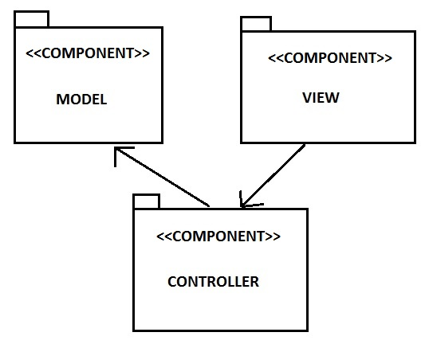

# **Software design description**

This part describes each top level component of RMS.

## ***Component 1***

Model

### **Component interfaces**

Public methods;

GetBuildingID

GetRoomID

GetUserID

GetReservationID

getCapacity

### **Component design description**

### **Workflows and algorithms**

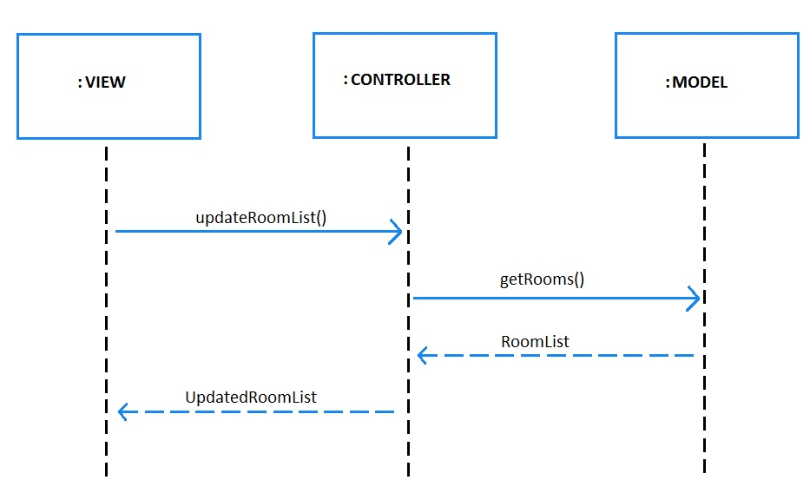

### **Software requirements mapping**

SRS-SQ-RMS-020.0 – Database connection

SRS-SQ-RMS-030.0 - Database connection

SRS-SQ-RMS-040.0 – Room Reservation

SRS-SQ-RMS-050.0 – Room Reservation Cancellation

## ***Component 2***

View

### **Component interfaces**

void updateView()

void changeView(int viewCode)

### **Component design description**

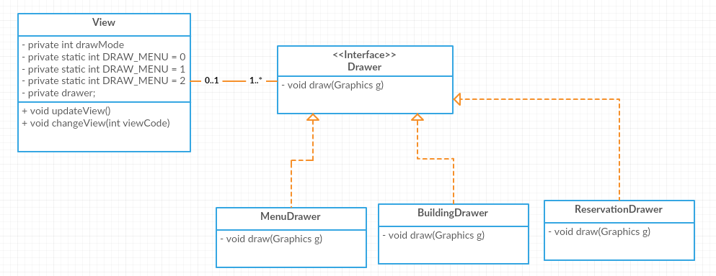

### **Workflows and algorithms**

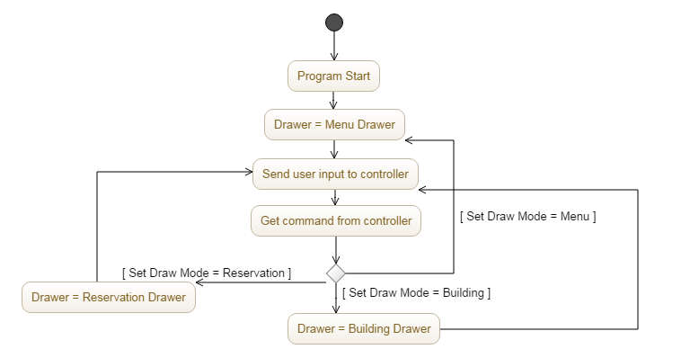

### **Software requirements mapping**

SRS-SQ-RMS-040.0 – Room Reservation

SRS-SQ-RMS-050.0 – Room Reservation Cancellation

## ***Component 3***

Controller

### **Component interfaces**

-

### **Component design description**

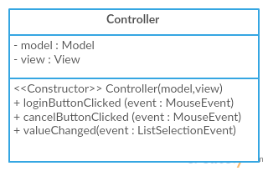

### **Workflows and algorithms**



### **Software requirements mapping**

SRS-SQ-RMS-010.0 – Login system

SRS-SQ-RMS-040.0 – Room Reservation

SRS-SQ-RMS-050.0 – Room Reservation Cancellation

# **COTS Identification**

RMS will not use any external components/libraries.