CASE STUDY · META ADS
UAC Startup Sprint
Recruiting 60+ international students from 10+ universities with $103 in Meta Ads
60+  Event participants | 10+  Universities reached | ~$1.72  Ad spend per participant | $0.12  Cost per link click
PROJECT SNAPSHOT
Client | A South Korean university
Project | UAC Startup Sprint 2026, a startup competition for international students
Industry | Higher education / student recruitment
Platforms | Meta Ads: Facebook and Instagram
Target audience | International students studying in South Korea
Campaign objective | Traffic (link clicks to the application form)
Budget | $120 total ($60 lifetime budget per campaign)
THE CHALLENGE
A South Korean university was hosting the UAC Startup Sprint, a startup competition open to international students at any university in the country. The university’s own channels mainly reached its own students, but the event needed participants from across South Korea.
The task was to reach a niche, geographically scattered audience and move them to a high-commitment action: completing an application form and taking part in the competition, on a total budget of $120.
THE APPROACH
- Channel: Meta Ads on Facebook and Instagram, where international students in Korea are active.
- Objective: Traffic, optimizing for link clicks to send as many relevant students as possible to the application form at a low cost.
- Structure: Two campaigns, each with a $60 lifetime budget, targeting international students in South Korea.
- Management: Monitored delivery and performance in Ads Manager, and delivered applicant information directly to the university.
THE RESULTS
Business outcome: 60+ international students from more than 10 universities participated in the event. All participants were recruited through the Meta Ads campaigns.
Metric | Sprint #1 | Sprint #2 | Total
Amount spent | $59.83 | $43.54 | $103.37
Impressions | 26,251 | 16,960 | 43,211
Link clicks | 496 | 367 | 863
CPM | $2.28 | $2.57 | $2.39
Link CTR | 1.89% | 2.16% | 2.00%
Cost per link click | $0.121 | $0.119 | $0.12
Landing page views* | ~429 | ~327 | ~756
*Landing page views calculated as amount spent ÷ cost per landing page view.
Outcome metric | Calculation | Result
Cost per participant | $103.37 ÷ 60 participants | ~$1.72
Click-to-participant rate | 60 participants ÷ 863 link clicks | ~7%
Because participation was 60+, the true cost per participant is slightly lower and the conversion rate slightly higher than shown.
Ads Manager campaign data
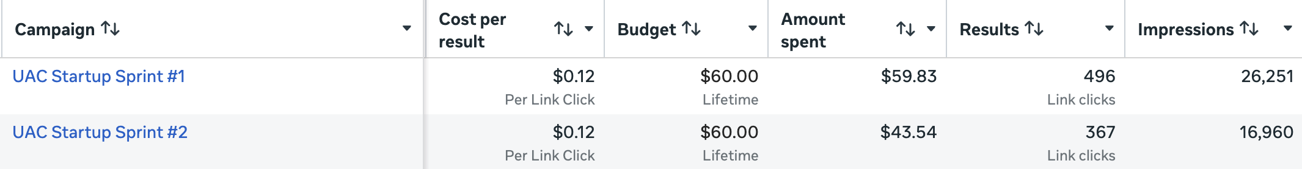
KEY INSIGHTS
- The core goal was achieved. Participants came from 10+ universities, so the campaigns reached well beyond the host campus.
- Efficient, high-quality traffic. A 2.0% link CTR, roughly double the ~1% often cited as a general Meta average, and about 88% of clicks loaded the landing page, so clicks were real visits.
- CTR alone does not define efficiency. Sprint #2 achieved a higher CTR (2.16% vs 1.89%) but also a higher CPM ($2.57 vs $2.28). Both campaigns delivered the same $0.12 cost per click.
- Clicks to participants is the key lever. About 1 in 14 people who clicked went on to participate, the stage with the most room to improve.
NEXT ITERATION: WHAT I WOULD DO NEXT
- Switch to the Leads objective (Instant Forms or a tracked application form) so Meta optimizes for applicants, not just clicks.
- Retarget landing page visitors who did not complete the application.
- Test one variable at a time (creative, copy or audience) and shift budget toward the lowest cost per application.
WHAT THIS MEANS FOR YOUR CAMPAIGNS
A small, focused Meta Ads budget can reach a niche audience and turn attention into real-world action. I measure success by what matters to your business, such as cost per participant or cost per lead, not just clicks.

