1. RRR Robot with inertia and mass:

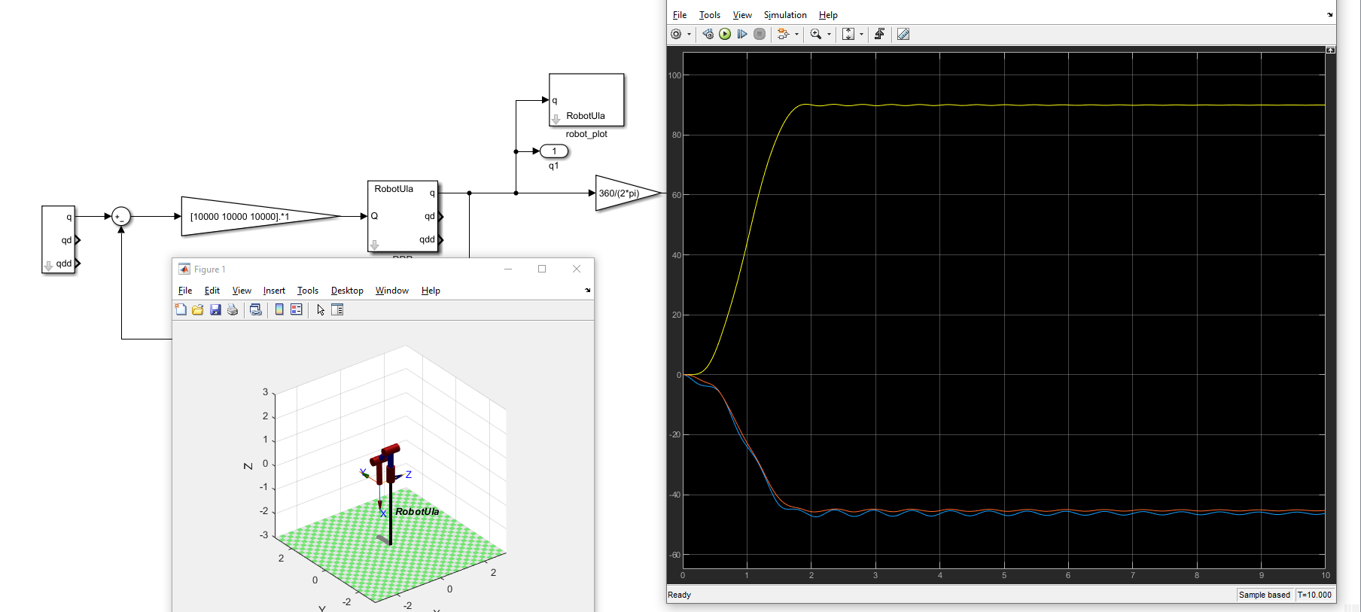

1. RRR Robot neglecting inertia and mass

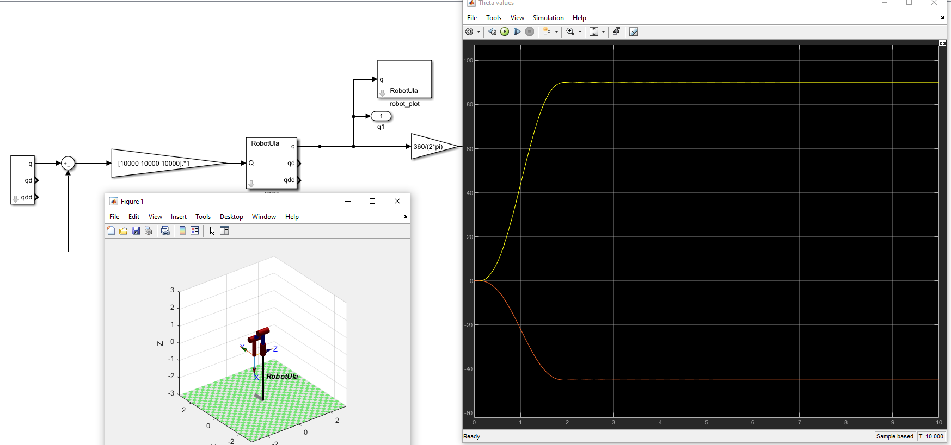

1. RRR Robot neglecting inertia, mass and using RNE

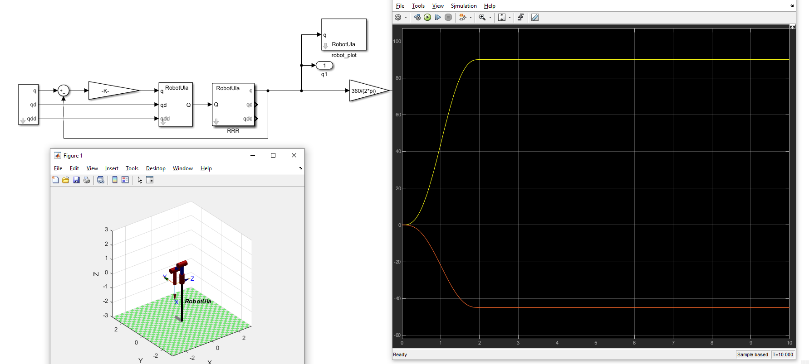

1. RRR Robot using control system

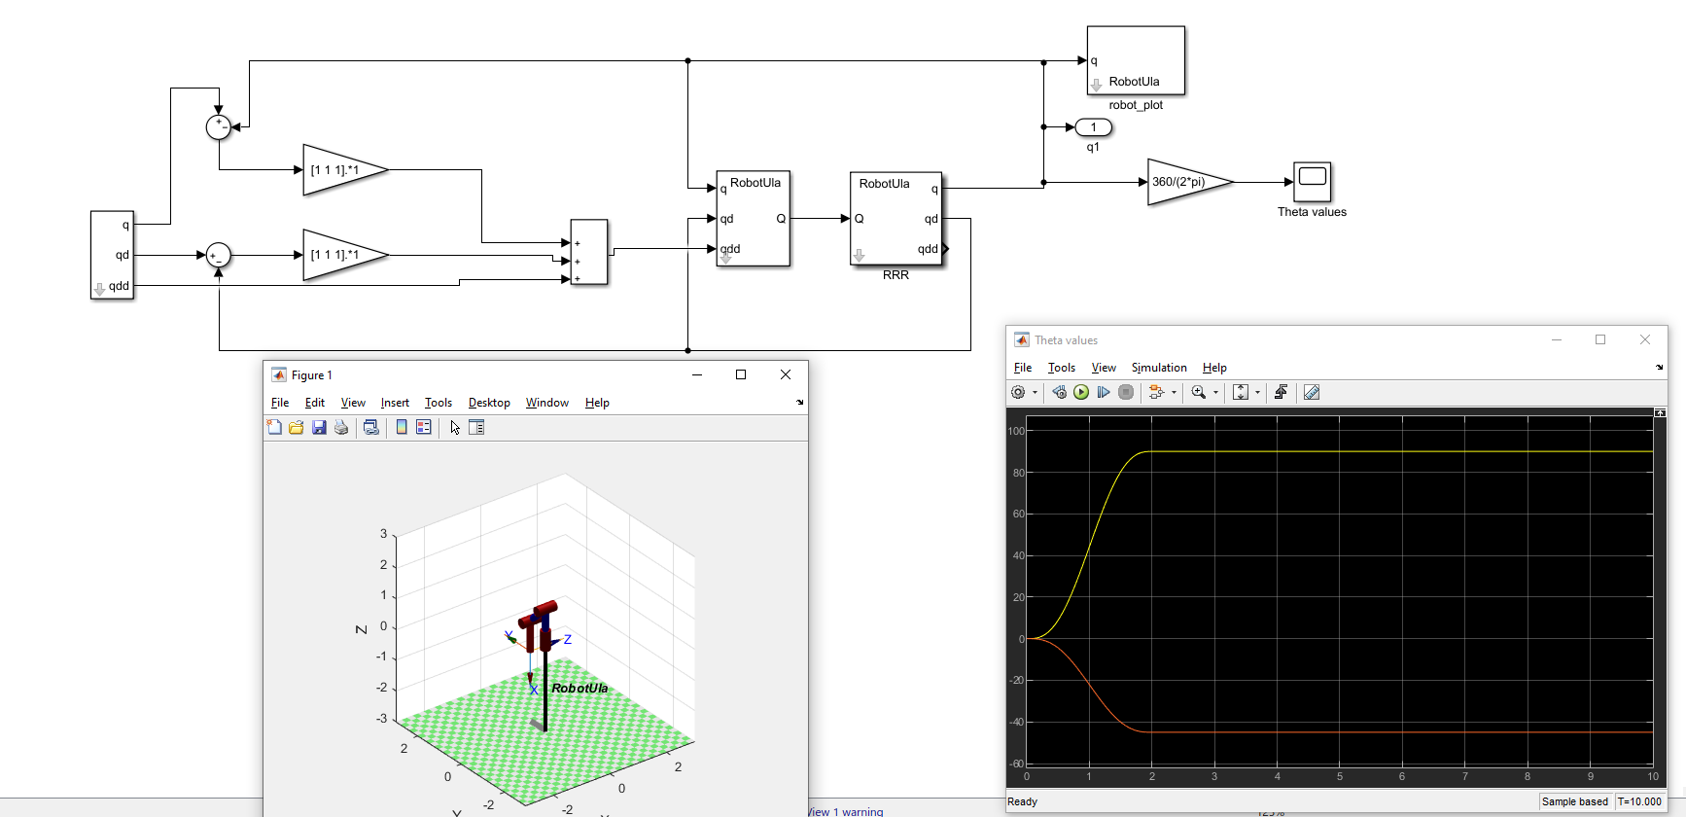

1. Planar Robot

