Mortgage Loan Pool Analysis
Ipoteka kredit hovuzi tahlili

Pool Summary
Hovuz xulosasi
Metric / Ko'rsatkich | Value / Qiymat
Total Loans / Jami kreditlar | 200
Total Principal (UZS) / Jami asosiy qarz | 87,319,473,953
Average Loan Size (UZS) / O'rtacha kredit | 436,597,370
Min Loan (UZS) / Eng kichik kredit | 63,585,139
Max Loan (UZS) / Eng katta kredit | 798,846,217
WAC (%) / O'rtacha vaznli kupon | 19.18%
WAM (months) / O'rtacha vaznli muddat | 118.5
WALTV (%) / O'rtacha vaznli LTV | 66.16%

Eligibility Criteria
Muvofiqlik mezonlari
• Maximum LTV: 80.0%
• Maximum Days Past Due: 30
Eligible: 136 / 200 loans (68.0%)

Distribution Analysis
Taqsimot tahlili

Loan Size Distribution / Kredit hajmi taqsimoti
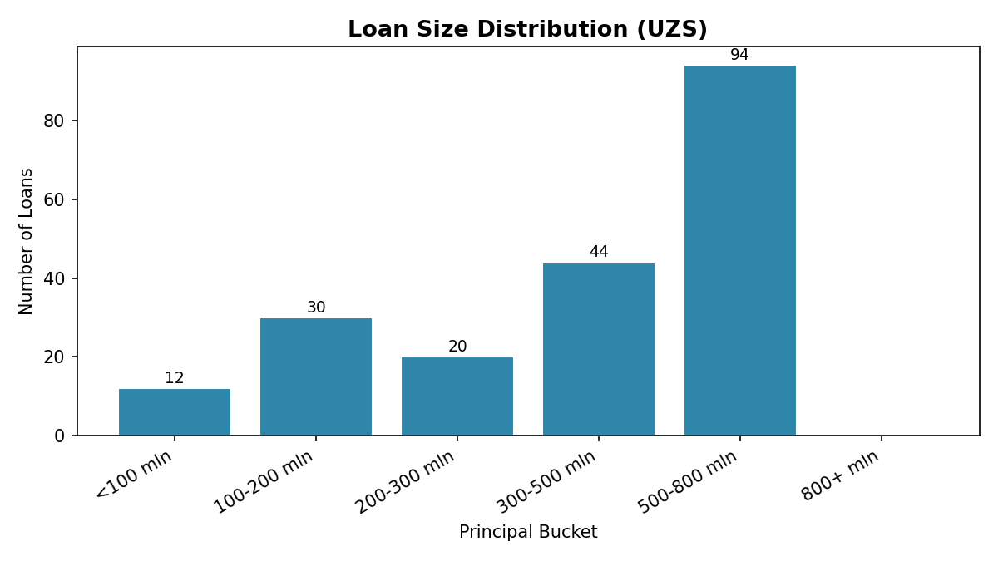

Regional Distribution / Hududiy taqsimot
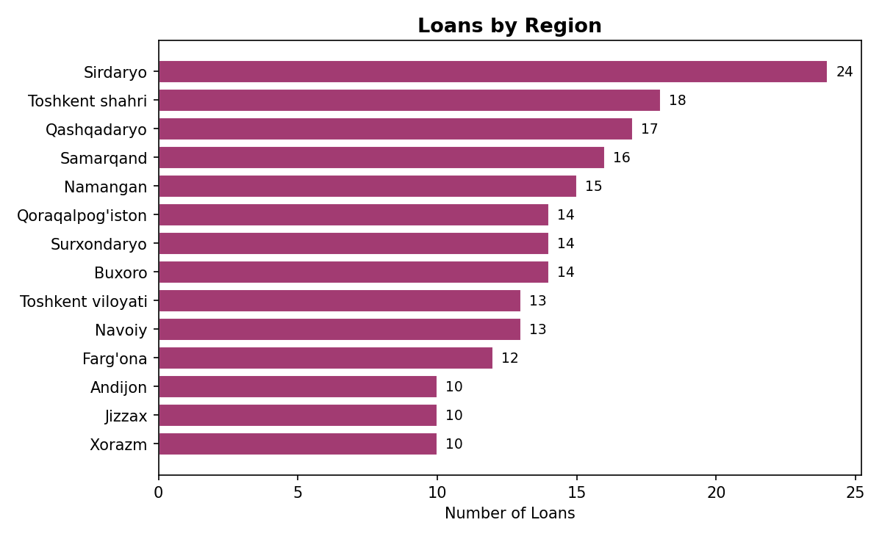

LTV Distribution / LTV taqsimoti
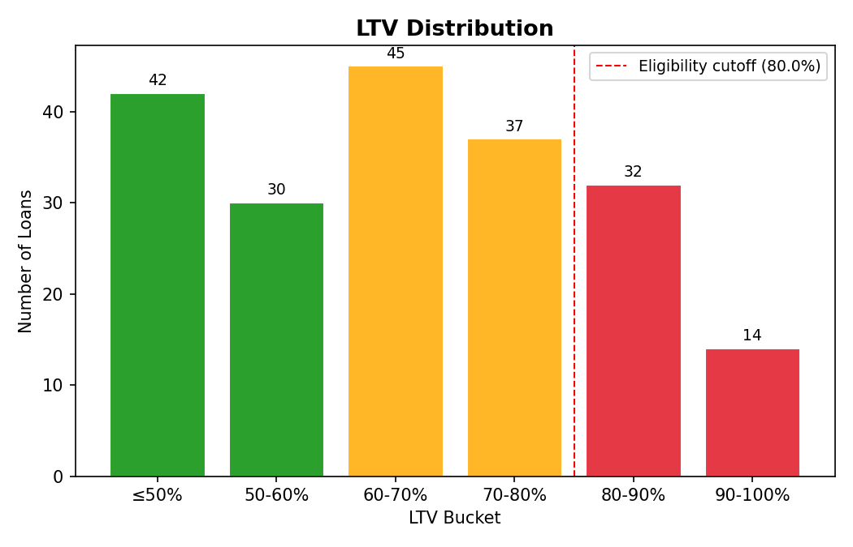

Ineligible Loans
Nomuvofiq kreditlar
64 loan(s) flagged as ineligible / 64 ta kredit mezonlarga mos emas:
Loan ID | Region | LTV % | Days Past Due | Reason / Sabab
UZ-MTG-00004 | Andijon | 78.4 | 35 | Past due 35d > 30d
UZ-MTG-00011 | Xorazm | 85.2 | 0 | LTV 85.2% > 80.0%
UZ-MTG-00013 | Samarqand | 63.6 | 90 | Past due 90d > 30d
UZ-MTG-00014 | Navoiy | 81.6 | 0 | LTV 81.6% > 80.0%
UZ-MTG-00019 | Sirdaryo | 57.8 | 60 | Past due 60d > 30d
UZ-MTG-00021 | Farg'ona | 82.1 | 0 | LTV 82.1% > 80.0%
UZ-MTG-00022 | Navoiy | 91.1 | 0 | LTV 91.1% > 80.0%
UZ-MTG-00023 | Toshkent shahri | 89.5 | 0 | LTV 89.5% > 80.0%
UZ-MTG-00026 | Namangan | 83.2 | 0 | LTV 83.2% > 80.0%
UZ-MTG-00034 | Toshkent viloyati | 42.8 | 35 | Past due 35d > 30d
UZ-MTG-00040 | Sirdaryo | 55.7 | 60 | Past due 60d > 30d
UZ-MTG-00041 | Toshkent viloyati | 84.9 | 0 | LTV 84.9% > 80.0%
UZ-MTG-00048 | Sirdaryo | 88.5 | 15 | LTV 88.5% > 80.0%
UZ-MTG-00050 | Buxoro | 84.9 | 0 | LTV 84.9% > 80.0%
UZ-MTG-00053 | Jizzax | 92.9 | 0 | LTV 92.9% > 80.0%
UZ-MTG-00071 | Namangan | 81.1 | 0 | LTV 81.1% > 80.0%
UZ-MTG-00075 | Toshkent shahri | 81.4 | 0 | LTV 81.4% > 80.0%
UZ-MTG-00078 | Farg'ona | 82.2 | 0 | LTV 82.2% > 80.0%
UZ-MTG-00079 | Buxoro | 41.4 | 35 | Past due 35d > 30d
UZ-MTG-00081 | Surxondaryo | 83.0 | 0 | LTV 83.0% > 80.0%
UZ-MTG-00082 | Navoiy | 86.7 | 35 | LTV 86.7% > 80.0%; Past due 35d > 30d
UZ-MTG-00085 | Namangan | 88.5 | 0 | LTV 88.5% > 80.0%
UZ-MTG-00087 | Buxoro | 88.4 | 0 | LTV 88.4% > 80.0%
UZ-MTG-00089 | Farg'ona | 83.6 | 0 | LTV 83.6% > 80.0%
UZ-MTG-00094 | Xorazm | 91.9 | 0 | LTV 91.9% > 80.0%
UZ-MTG-00095 | Qashqadaryo | 66.3 | 35 | Past due 35d > 30d
UZ-MTG-00097 | Xorazm | 94.7 | 0 | LTV 94.7% > 80.0%
UZ-MTG-00102 | Buxoro | 83.3 | 0 | LTV 83.3% > 80.0%
UZ-MTG-00103 | Jizzax | 85.5 | 0 | LTV 85.5% > 80.0%
UZ-MTG-00107 | Namangan | 65.9 | 90 | Past due 90d > 30d
UZ-MTG-00114 | Navoiy | 52.4 | 35 | Past due 35d > 30d
UZ-MTG-00115 | Qashqadaryo | 91.3 | 0 | LTV 91.3% > 80.0%
UZ-MTG-00117 | Qoraqalpog'iston | 91.4 | 0 | LTV 91.4% > 80.0%
UZ-MTG-00119 | Qoraqalpog'iston | 87.8 | 0 | LTV 87.8% > 80.0%
UZ-MTG-00120 | Sirdaryo | 57.5 | 60 | Past due 60d > 30d
UZ-MTG-00121 | Qoraqalpog'iston | 93.1 | 0 | LTV 93.1% > 80.0%
UZ-MTG-00123 | Andijon | 83.0 | 0 | LTV 83.0% > 80.0%
UZ-MTG-00130 | Jizzax | 64.3 | 35 | Past due 35d > 30d
UZ-MTG-00131 | Buxoro | 86.5 | 0 | LTV 86.5% > 80.0%
UZ-MTG-00132 | Navoiy | 59.7 | 60 | Past due 60d > 30d
UZ-MTG-00138 | Buxoro | 84.2 | 0 | LTV 84.2% > 80.0%
UZ-MTG-00140 | Andijon | 81.2 | 0 | LTV 81.2% > 80.0%
UZ-MTG-00142 | Samarqand | 85.3 | 0 | LTV 85.3% > 80.0%
UZ-MTG-00145 | Toshkent shahri | 45.4 | 35 | Past due 35d > 30d
UZ-MTG-00146 | Andijon | 64.4 | 60 | Past due 60d > 30d
UZ-MTG-00149 | Andijon | 85.6 | 0 | LTV 85.6% > 80.0%
UZ-MTG-00153 | Xorazm | 82.8 | 0 | LTV 82.8% > 80.0%
UZ-MTG-00154 | Qoraqalpog'iston | 68.7 | 90 | Past due 90d > 30d
UZ-MTG-00156 | Surxondaryo | 46.9 | 90 | Past due 90d > 30d
UZ-MTG-00160 | Sirdaryo | 85.7 | 0 | LTV 85.7% > 80.0%
UZ-MTG-00162 | Buxoro | 93.3 | 0 | LTV 93.3% > 80.0%
UZ-MTG-00171 | Sirdaryo | 94.1 | 35 | LTV 94.1% > 80.0%; Past due 35d > 30d
UZ-MTG-00176 | Namangan | 90.6 | 0 | LTV 90.6% > 80.0%
UZ-MTG-00177 | Toshkent viloyati | 87.9 | 0 | LTV 87.9% > 80.0%
UZ-MTG-00180 | Xorazm | 92.3 | 0 | LTV 92.3% > 80.0%
UZ-MTG-00181 | Andijon | 90.8 | 60 | LTV 90.8% > 80.0%; Past due 60d > 30d
UZ-MTG-00184 | Sirdaryo | 87.5 | 0 | LTV 87.5% > 80.0%
UZ-MTG-00185 | Surxondaryo | 90.0 | 0 | LTV 90.0% > 80.0%
UZ-MTG-00188 | Sirdaryo | 90.5 | 0 | LTV 90.5% > 80.0%
UZ-MTG-00190 | Jizzax | 44.5 | 35 | Past due 35d > 30d
UZ-MTG-00193 | Qashqadaryo | 59.9 | 35 | Past due 35d > 30d
UZ-MTG-00194 | Surxondaryo | 95.0 | 0 | LTV 95.0% > 80.0%
UZ-MTG-00196 | Namangan | 82.4 | 0 | LTV 82.4% > 80.0%
UZ-MTG-00199 | Sirdaryo | 82.3 | 0 | LTV 82.3% > 80.0%

