Assignment – 28-01-2026
Name: Syed Ahmed Hussain Ulvaan
Ht.No: 2303A51949
Batch: 07
Scenario: A startup wants a simple front-end dashboard to display static information such as welcome messages and course details. The team decides to use React for building reusable UI components.

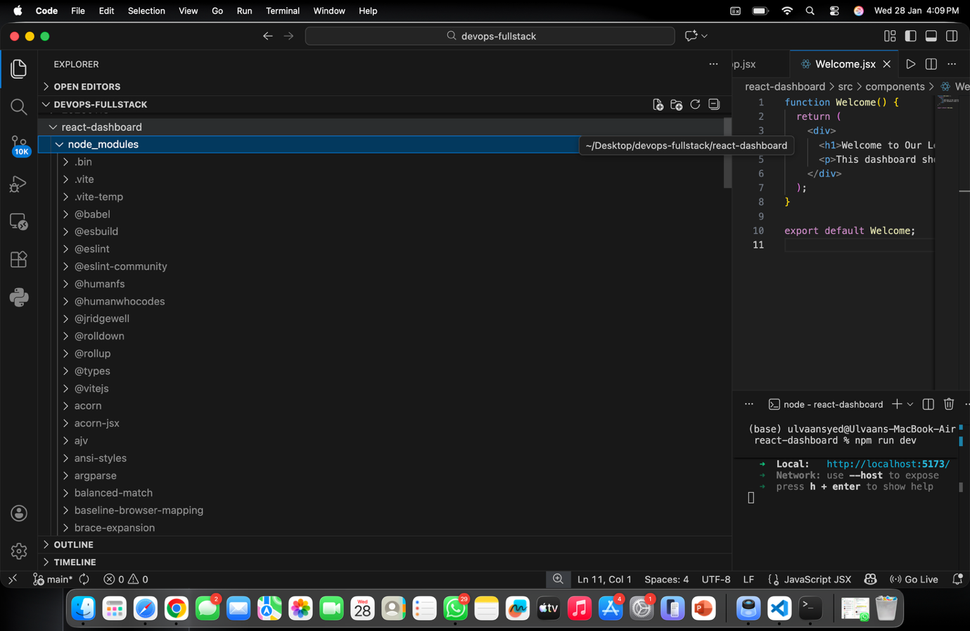
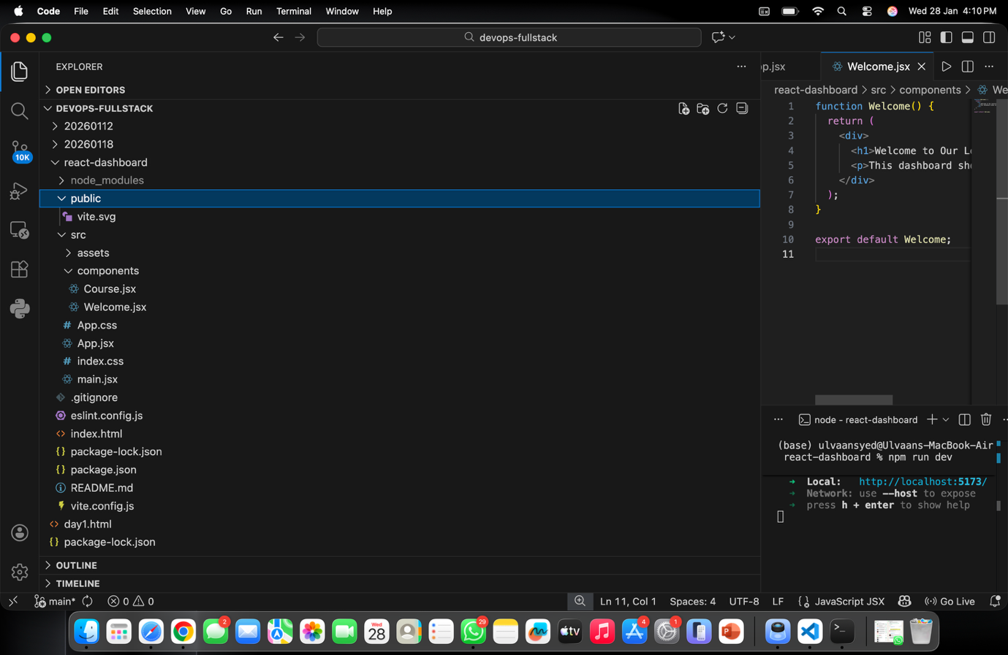
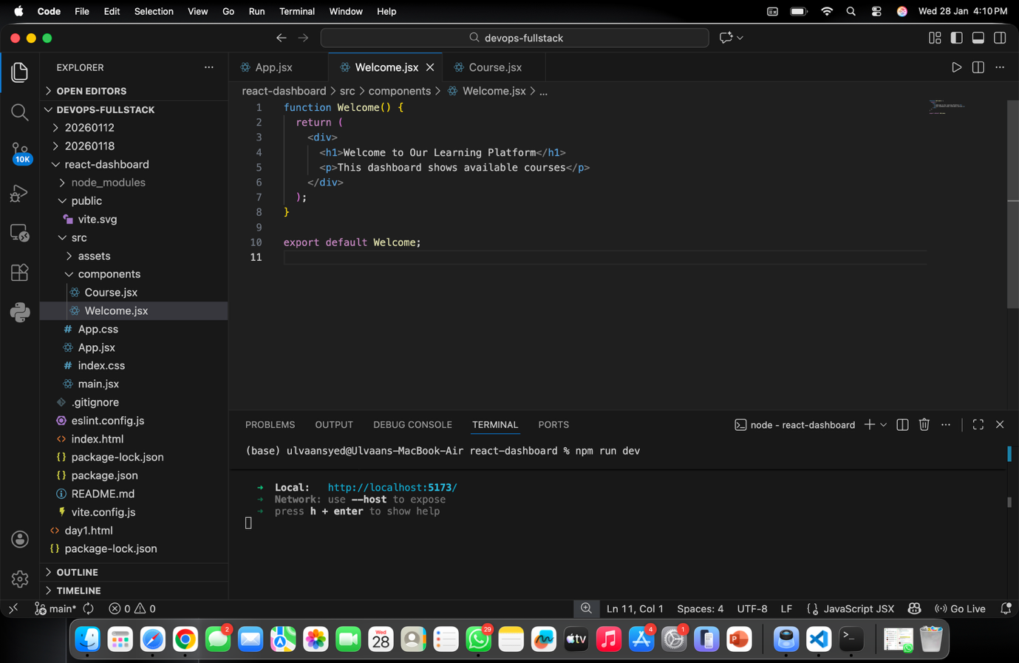
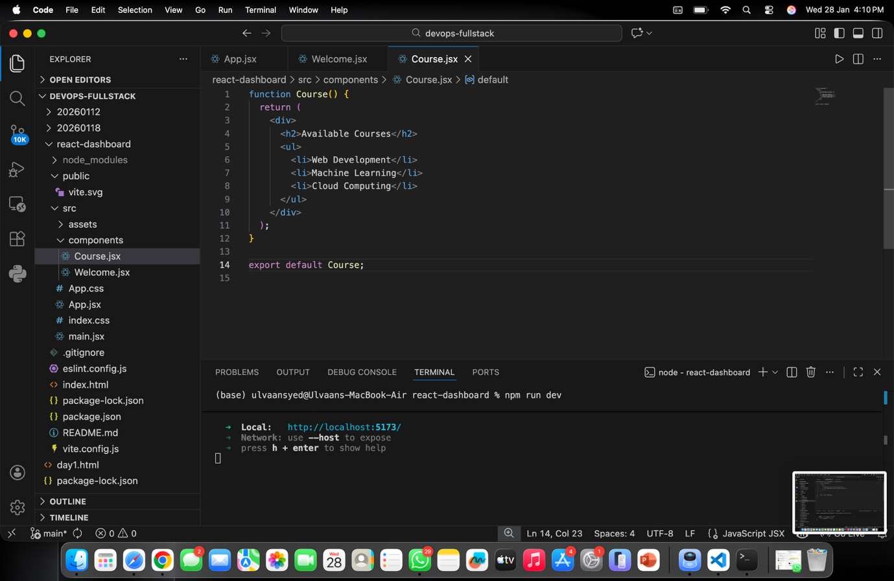
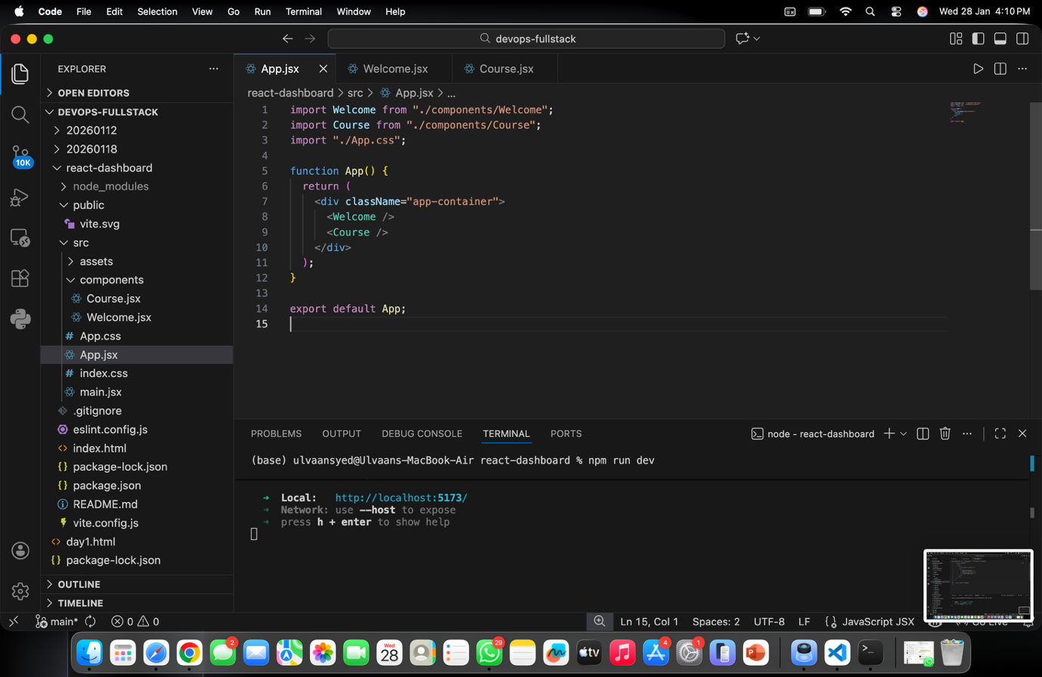
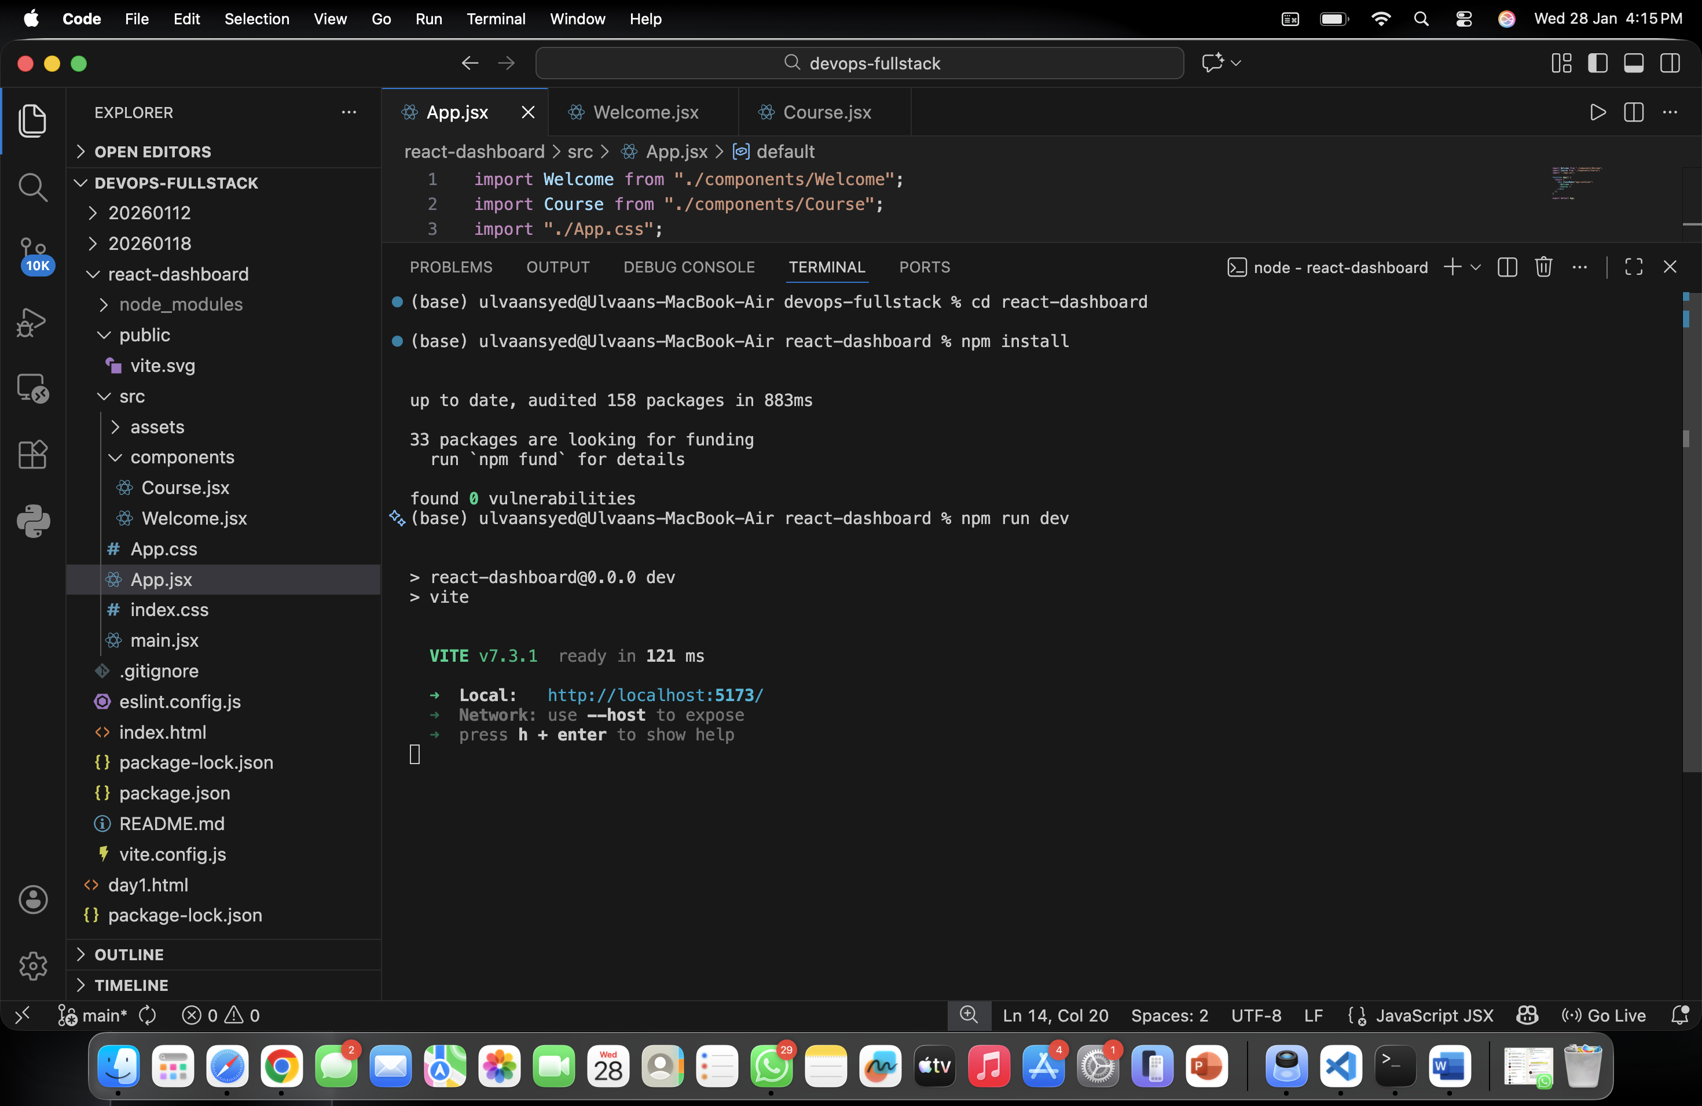


2. What is the role of package.json in a React project?
Ans: package.json is the main configuration file that manages the React project.

Functions:
- Stores project metadata (name, version)
- Lists dependencies (React, React-DOM, Vite)
- Defines scripts (start, build, dev, test)
- Controls package versions
3. How do you create a functional component in React?
Ans:
src/components/Welcome.jsx
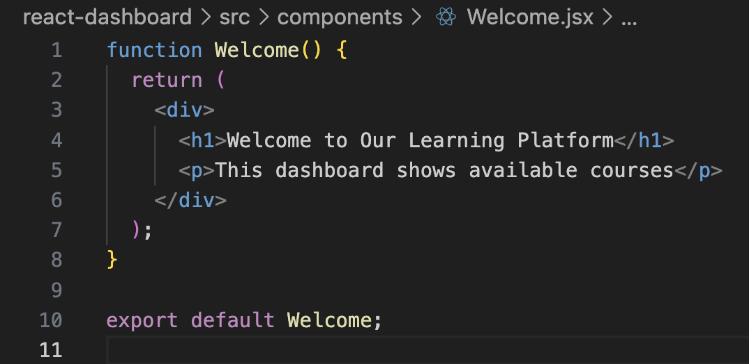
4. How are components rendered inside the main App component?
Ans:
src/App.jsx
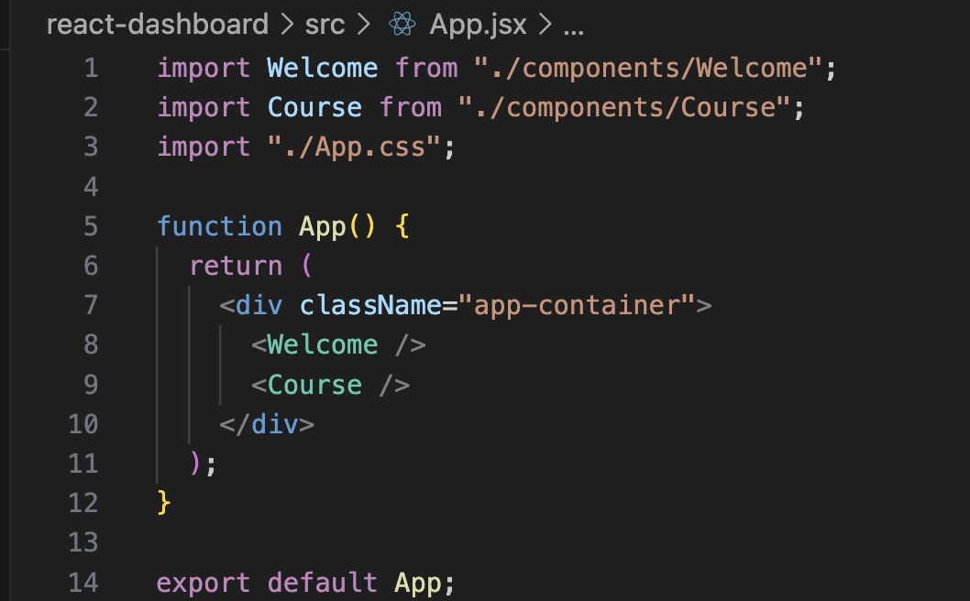

5. What are the benefits of breaking the UI into small reusable components?

Benefits of Breaking UI into Small Reusable Components

Advantages:
- Reusability
Same component can be used multiple times in different pages.
- Easy Maintenance
Errors can be fixed in one file without affecting the whole project.
- Improved Readability
Code becomes clean and well-structured.
- Faster Development
Team members can work on different components simultaneously.
- Scalability
New features can be added easily without modifying existing code.

