MINISTRY OF SCIENCE AND EDUCATION REPUBLIC OF AZERBAIJAN
AZERBAIJAN STATE UNIVERSITY OF ECONOMICS
UNEC BUSINESS SCHOOL
MASTER THESIS
on the topic:
“DESIGN AND DEVELOPMENT OF A RULE-BASED
TEXT-TO-SPEECH SYSTEM
FOR THE AZERBAIJANI LANGUAGE”
Acting director of UNEC Business School
Assoc. prof. Geray Musayev
“_______________” (signature)
“___” ____________ 2026

Code of specialisation and name: 060409 Business administration
Specialisation: Artificial Intelligence
Group: E27-24

Master: Scientific Supervisor:
Ulvi Bashirov Khanim Pashayeva

_______________________ _______________________

Program supervisor Head of department
Ph.D in economics, Associate prof.
....................... Sevar Mammadova

_______________________ _______________________

BAKU – 2026
“Design and Development of a Rule-Based TTS System for Azerbaijani Language”

ABSTRACT
This dissertation presents the design and implementation of a rule-based text-to-speech (TTS) synthesis system for the North Azerbaijani language. Azerbaijani is a morphologically complex, agglutinative Turkic language that remains significantly underrepresented in the field of speech technology. The absence of large, annotated speech corpora and the computational resources required by modern neural approaches make a rule-based methodology particularly appropriate for this language at its current stage of technological development. The proposed system adopts a modular pipeline architecture consisting of five sequential stages: text normalization, grapheme-to-phoneme (G2P) conversion, stress assignment, prosody generation, and acoustic synthesis. Each stage is governed by explicitly formulated linguistic rules derived from published analyses of Azerbaijani phonology, morphophonology, and prosody. The G2P module handles the complete Azerbaijani Latin orthographic inventory, implementing context-sensitive phonological rules including velar palatalization, the allophonic behavior of the soft consonant ğ, final obstruent devoicing, and nasal assimilation. The stress assignment module captures the default final-syllable stress pattern of Azerbaijani while encoding a priority-ordered set of lexical and morphological exceptions. The prosody engine classifies sentence types and applies language-appropriate intonation contours, phone duration predictions, and pause insertion rules consistent with Azerbaijani declarative, interrogative, exclamatory, and imperative patterns, using a simplified ToBI framework.
Acoustic synthesis is achieved through integration with the open-source espeak-ng engine using the Azerbaijani voice profile, producing intelligible speech output from the linguistically annotated representations generated by the rule-based front-end. The system is implemented entirely in Python, validated by a suite of 156-unit tests covering 61 distinct linguistic phenomena, and designed to operate without external speech training data.
The system is evaluated against a set of 50 phonetically balanced Azerbaijani sentences using two complementary metrics: Mean Opinion Score (MOS) for naturalness and Word Error Rate (WER) for intelligibility. The proposed achieved MOS 3.2 (CI: [3.1, 3.3]) against a baseline of MOS 2.8 for unmodified speaking output, and WER 12.4% against a baseline of 18.7% — representing statistically significant improvements on both dimensions. Text accuracy reached 100% for dates, times, currency symbols, and Roman numerals, with an overall weighted accuracy of 97.2% across all normalization categories. The results demonstrate that the rule-based approach achieves acceptable intelligibility and naturalness for standard Azerbaijani text, while the modular architecture provides a transparent, extensible foundation for future improvements. This work contributes both a functional open-source TTS system and a documented linguistic rule base that can serve as a reference standard for subsequent data-driven approaches to Azerbaijani speech synthesis.
Keywords: text-to-speech synthesis, Azerbaijani language, rule-based systems, grapheme-to-phoneme conversion, speech prosody, low-resource languages, Turkic languages
ACKNOWLEDGEMENT
I would like to express my sincere gratitude to my dissertation supervisor, Khanim Pashayeva, for her guidance, constructive feedback, and continued support throughout the research and writing process.
I am grateful to the faculty and staff of the UNEC Business School MBA program for providing an academic environment that supported this research.
I would also like to thank the developers and contributors of the open-source tools and libraries, particularly the speaking project, whose work made the technical implementation of this system possible.
Table of Contents
INTRODUCTION 6
1. THEORETICAL FOUNDATIONS OF TEXT-TO-SPEECH SYSTEMS 9
1.1. General overview of text-to-speech systems 9
1.2. Rule-based text-to-speech systems 15
1.3. Advantages and limitations of rule-based tts systems: a swot analysis 20
2. LINGUISTIC AND TECHNICAL ANALYSIS FOR AZERBAIJANI TTS 26
2.1. Phonetic and morphological characteristics of azerbaijani 26
2.2. Text normalization and linguistic rule design 32
2.3. Architecture of the rule-based azerbaijani tts system 36
3. DESIGN, IMPLEMENTATION, AND EVALUATION 42
3.1. System design and development methodology 42
3.2. Implementation of the rule-based tts prototype 49
3.3. Experimental evaluation and performance analysis 54
CONCLUSION 63
REFERENCES 69

INTRODUCTION
Relevance and Motivation of the Research. Speech is the most natural and efficient medium of human communication. The ability to convert written text to spoken language automatically — text-to-speech (TTS) synthesis — has become a critical component of modern human-computer interaction, enabling accessibility tools for visually impaired users, voice assistants, audiobook generation, navigation systems, and language learning applications.
Importance of Text-to-Speech Systems for Low-Resource Languages. The absence of TTS technology for a language constitutes a significant barrier to digital inclusion. As an increasing share of public services, information, and social participation moves to digital platforms, speakers of languages without functional speech interfaces face systematic exclusion from the benefits of digital transformation. For Azerbaijani speakers, this affects access to accessible e-government services, navigation systems, screen readers, and assistive communication devices. While neural TTS systems developed over the last decade have achieved near-human speech quality for major languages such as English, Mandarin, and German, these systems depend on the availability of large, carefully recorded speech corpora and substantial computational infrastructure. For Azerbaijani, such resources are extremely limited. Existing systems — the commercial system by Samir Rustamov and the multilingual IS2AI Turkic TTS — are proprietary or multilingual in design, without an openly published linguistic foundation.
Rationale for Selecting a Rule-Based Approach. This dissertation addresses the gap in Azerbaijani speech technology by developing a rule-based TTS system. The rule-based paradigm was selected deliberately for three converging reasons. First, it requires no speech training data — a decisive advantage for a language with no publicly available annotated speech corpus. Second, its internal workings are fully transparent and linguistically grounded: every output is the direct consequence of an explicit rule, making the system auditable, correctable, and academically valuable as a documented phonological model. Third, Azerbaijani's broadly phonemic Latin orthography — adopted in 1992 — makes it substantially more amenable to rule-based G2P conversion than orthographically irregular languages such as English or French.
Research Aim and Objectives. The aim of this dissertation is to design, implement, and evaluate a rule-based TTS system for North Azerbaijani that achieves acceptable intelligibility and naturalness using no speech training data, and that documents the phonological and prosodic rules of Azerbaijani in a computationally explicit and extensible form.
The specific objectives are:
- To conduct a systematic review of TTS technologies and identify the most appropriate paradigm for low-resource Azerbaijani speech synthesis.
- To analyze the phonological, morphological, and prosodic characteristics of North Azerbaijani as they apply to TTS design.
- To design and implement a complete five-module rule-based TTS pipeline: text normalization, G2P conversion, stress assignment, prosody generation, and acoustic synthesis.
- To evaluate the system's intelligibility (WER) and naturalness (MOS) against a phonetically balanced test set and a baseline espeak-ng system.
- To document the linguistic rule base as an open, extensible reference for future Azerbaijani speech technology research.
Research Object and Subject. The research subject is the set of phonological, morphological, and prosodic rules of North Azerbaijani as they apply to automated text-to-speech synthesis, and the computational methods by which these rules can be encoded in a functioning TTS system.
First, it presents the first openly published, comprehensively documented rule-based TTS system for North Azerbaijani, covering the complete phonological inventory (9 vowels, 23 consonants), four context-sensitive phonological rules, a priority-ordered stress assignment system, and a ToBI-based prosody model.
The practical significance of the work is threefold: the system provides immediately deployable Azerbaijani TTS functionality for accessibility applications, e-government services, and language learning tools; and the documented rule base reduces the entry barrier for future Azerbaijani speech technology development by providing pre-built linguistic infrastructure.
Chapter I reviews the theoretical foundations of text-to-speech synthesis. It is organized into three sections: a focused treatment of rule-based TTS principles, phonetic modeling, and comparison with competing paradigms; and a structured SWOT analysis of the rule-based approach applied specifically to the Azerbaijani language context.
Chapter II provides the linguistic and technical foundations for the proposed system. Section 2.1 examines the phonological and morphological characteristics of the Azerbaijani language that most directly affect speech synthesis design, including the phoneme inventory, vowel harmony, and agglutinative morphology. Section 2.2 describes the linguistic rule design for text normalization, syllabification, stress assignment, and prosody modeling. Section 2.3 presents the overall system architecture, including module decomposition and data flow.

Chapter III 3.1 covers the software engineering methodology and development environment; Section 3.2 describes the implementation of the rule engine, phoneme mapping, and audio output processing; and Section 3.3 presents the experimental evaluation, reporting intelligibility and naturalness results together with a comparative analysis against existing Azerbaijani TTS systems.

1. THEORETICAL FOUNDATIONS OF TEXT-TO-SPEECH SYSTEMS

1.1. General overview of text-to-speech systems
The goal is not merely to produce any sound corresponding to the input text, but to generate speech that is simultaneously intelligible, correctly understood by listeners, and natural, resembling the prosodic and phonetic properties of human. These two qualities — intelligibility and naturalness — are analytically distinct and are evaluated by different metrics. Intelligibility is a threshold property: speech is either understandable or it is not, and it can be measured objectively through word error rate (WER), which compares a human or ASR transcription of the synthesized audio to the original text.
TTS technology has become a critical component of modern human-computer interaction across a broad spectrum of applications: Accessibility tools for individuals with visual impairments or reading disabilities (screen readers, navigation aids)
TTS carries direct implications for linguistic equity and digital inclusion. As a growing share of information, public services, and social participation migrates to digital platforms, languages that lack functional speech interfaces are at risk of systematic exclusion from the benefits of digital transformation. For a speaker of a low-resource language, the absence of TTS support in navigation systems, screen readers, or voice interfaces effectively imposes a barrier to equal access to digital services. This dimension makes TTS development for underserved languages a matter not only of technical interest but also of social and policy relevance.
This growth is driven primarily by the proliferation of artificial intelligence technologies, the spread of smart devices, and growing demand for multilingual content accessibility.
The existing Azerbaijani TTS landscape is thin: [12]* provides a proprietary service without published technical documentation; the IS2AI multilingual Turkic TTS system covers Azerbaijani among ten Turkic languages but is primarily designed for a multilingual setting rather than a linguistically grounded Azerbaijani-specific architecture; and [6]* Tacotron 2-based neural TTS was a research prototype trained on approximately 19 hours of proprietary data, without a published model or open-source release. No openly available, well-documented system with a transparent linguistic foundation and published rule base currently exists for Azerbaijani. Addressing this gap — and producing a documented reference architecture for Azerbaijani speech synthesis — is the principal motivation of this dissertation.
The linguistic front-end comprises four principal components:
TEXT NORMALIZATION. Conversion of non-standard words (NSWs), numerals, abbreviations, symbols, dates, times, currency amounts — into their fully expanded, pronounceable form. For example, "15.06.2024" must be read as "the fifteenth of June, two thousand and twenty-four" in English, or its equivalent in any target language. Production systems such as NVIDIA NeMo use weighted finite-state transducers (WFSTs) for this process. Recent LLM-based approaches such as [2*]
multilingual normalization from few examples.
MORPHOLOGICAL ANALYSIS. Segmentation of words into morphemes, assignment of part-of-speech labels,
and resolution of lexical ambiguity. Agglutinative languages — Azerbaijani
among them — present particular challenges at this stage, since a single word
may consist of a root plus many suffixes, each modifying the pronunciation of the whole [21]*
GRAPHEME-TO-PHONEME (G2P) CONVERSION. Mapping of orthographic characters to their phonemic representation, typically in the International Phonetic Alphabet (IPA). This step must handle the language-specific correspondences between spelling and pronunciation, including context-sensitive rules and exceptions. A comprehensive 2024 survey of G2P methods (Survey of G2P Methods, 2024) demonstrates that rule-based, statistical, and transformer-based approaches each suit different resource contexts.
PROSODY PREDICTION. Generation of the suprasegmental properties of speech: lexical stress, phrase-level pitch accents, intonation contours (F0 trajectories over time), phone durations, and pause locations. Recent work on prosody modeling includes LSTM-based natural prosody learning and PitchFlow [8]* which adds pitch control to a flow-matching TTS model.
The acoustic back end converts the phonemic and prosodic representation to audio. In rule-based systems this involves a formant synthesizer or a concatenative system that stitches pre-recorded phoneme segments together. In statistical systems, a parametric model generates acoustic feature sequences, and a vocoder converts them to a waveform. In neural systems, the acoustic model generates a mel-spectrogram and a neural vocoder (WaveNet, HiFi-GAN) converts it to high-fidelity audio. The back end is the single largest determinant of a system's naturalness ceiling: improvements to the linguistic front-end cannot compensate for limitations in the acoustic model.
TTS system quality is measured along two primary dimensions (Speech Quality Metrics, 2020–2024):
- Mean Opinion Score (MOS): human listeners rate naturalness on a five-point ITU-T P.800 scale from 1 (bad) to 5 (excellent). MOS tests are conducted under controlled conditions with a minimum number of listeners per condition. Results are reported as a mean with confidence intervals.
- Word Error Rate (WER): intelligibility measured via transcription accuracy, computed as WER = (S + D + I) / N, where S = substitutions, D = deletions, I = insertions, and N = total reference words. Lower WER indicates higher intelligibility. WER can be obtained from human transcribers or automatic speech recognition (ASR) systems.
A third metric increasingly used in recent work is the Phoneme Error Rate (PER), which measures pronunciation accuracy at the phoneme level rather than the word level, and is especially informative for evaluating front-end G2P quality independently of the acoustic back end.
Table 1. MOS Evaluation Scale (ITU-T P.800)
Score | Label | Description
5 | Excellent | Completely natural, no synthetic quality
4 | Good | Mostly natural, minor synthetic quality
3 | Fair | Noticeable synthetic quality, fully intelligible
2 | Poor | Clearly synthetic, somewhat difficult to follow
1 | Bad | Completely unnatural, very difficult to follow
Source: [9]*
For reference: natural human speech consistently achieves MOS 4.4–4.7; current neural TTS systems for English reach MOS 4.2–4.5; rule-based systems typically achieve MOS 3.0–3.8 depending on language and evaluator population (Kim et al., 2021; Oyucu, 2023). The present Azerbaijani system achieved MOS 3.2 against a baseline espeak-ng MOS of 2.8, representing a statistically significant improvement of 0.4 MOS points (see Chapter III for full evaluation details).
EARLY MECHANICAL SPEECH SYNTHESIS (1930s–1950s)
Attempts at creating artificial speech date to the eighteenth century. In 1779,
Wolfgang von Kempelen constructed a mechanical speaking machine that simulated the human vocal tract [15]*. The first electronic speech synthesizer was the VODER (Voice Operating Demonstrator), developed by Homer Dudley at Bell Laboratories and demonstrated at the 1939 World's Fair. A trained operator controlled formant resonances using a keyboard and foot pedal, producing intelligible but robotic-sounding speech. This device established a key insight: the perceptually essential information in speech can be captured by a small number of acoustic parameters — primarily the resonant frequencies of the vocal tract, later formalized as formants.
FORMANT SYNTHESIS (1960s–1990s)
The first fully automated TTS systems were based on formant synthesis, which modeled the human vocal tract as a series of acoustic tubes whose resonant frequencies (F1, F2, F3) determine vowel and consonant quality. Formant synthesizers produce intelligible speech but carry an unmistakably synthetic, robotic quality [1]*. In the Azerbaijani context specifically, the earliest documented Azerbaijani TTS system was presented by [1]* at the Third International Conference on Problems of Cybernetics and Informatics (Baku).
CONCATENATIVE SYNTHESIS (1990s–2000s)
To overcome the naturalness limitations of formant synthesis, researchers developed concatenative synthesis systems that construct speech by stitching together pre-recorded segments of natural human speech. Two main variants emerged: Diphone synthesis: Systems such as [19]* use databases of approximately 1,000–2,000 diphone units (transitions between phoneme midpoints). Diphone systems achieve more natural phoneme quality than formant synthesis but introduce audible concatenation artifacts at unit boundaries. Unit selection synthesis: A dynamic programming algorithm minimizes a combination of target cost (prosodic deviation) and join cost (acoustic discontinuity).
STATISTICAL PARAMETRIC SYNTHESIS (2000s–2010s)
Hidden Markov Model (HMM)-based statistical parametric speech synthesis (SPSS), most fully realized in the HTS system marked a significant paradigm shift. Rather than storing speech segments, these systems learn statistical models of acoustic features — mel-cepstral coefficients, fundamental frequency, and durations — from annotated training data. HMM-based synthesis is more consistent than unit selection for unseen phonetic contexts, but is characterized by a distinctive "muffled" quality due to over-smoothing of statistical averages [10]*
NEURAL TTS (2016–present)
The deep learning revolution produced a fundamental paradigm shift in TTS. Google's Tacotron and Tacotron 2 demonstrated that end-to-end sequence-to-sequence models could learn to map character sequences directly to mel-spectrograms, bypassing explicit phonological analysis.
Subsequent architectures — FastSpeech [8]*, VITS [9]*, and flow-matching models — further improved efficiency and quality. As of 2024, trends toward integrating large language models (LLMs) with TTS synthesis are establishing "controllable speech synthesis" as the next standard paradigm.
Table 2. Comparison of TTS Paradigms Across Generations
Criterion | Formant | Concatenative | HMM | Neural
MOS (approximate) | 2.5–3.0 | 3.0–3.8 | 3.5–4.0 | 4.2–4.5
Training data | None | 20–50 hrs | 5–20 hrs | 1–50+ hrs
Computational cost | Very low | Low | Medium | High
Interpretability | Full | Full | Partial | Minimal
Lexical flexibility | Low | Medium | High | High
Source: [11]*

1.2. Rule-based text-to-speech systems
A rule-based TTS system is one in which every decision in the conversion from text to speech is made by an explicitly programmed rule encoding human linguistic knowledge. This contrasts with data-driven approaches: statistical systems learn patterns from annotated corpora; neural systems learn from raw audio-text pairs without explicit encoding of phonological principles.
The rule-based paradigm is historically the oldest approach to automated speech synthesis
For TTS purposes, these rewrite rules govern three categories of linguistic mapping: (1) normalization rules, which convert written non-standard words to their spoken forms; (2) grapheme-to-phoneme rules, which map orthographic characters to IPA phonemes; and (3) prosodic rules, which assign stress, pitch accents, and durational patterns to the phoneme string.
For languages with a highly regular, phonemic orthography — such as Azerbaijani, Finnish, Spanish, and Turkish — this claim is substantially true. For languages with highly irregular orthographic traditions — such as English or French — it is significantly less tractable [11]* This is an important reason why the first generation of neural TTS research gained its earliest traction in English: English's orthographic complexity makes rule-based G2P correspondingly difficult, while the abundance of English speech data makes data-driven approaches straightforward.
The four foundational principles of rule-based TTS systems are:
- EXPLICIT KNOWLEDGE ENCODING: The complete rule set constitutes an explicit, auditable model of the language's phonological system. This property is especially valuable in an academic dissertation context: the rule base is itself a research contribution — a documented reference that can be extended, critiqued, and built upon by subsequent researchers.
- DETERMINISTIC OUTPUT: This consistency is valuable in deployment contexts requiring reproducibility, for instance, standardized language learning tools, accessibility applications, or automated transcription testing pipelines. Neural systems may exhibit output variability due to stochastic sampling during inference.
- MODULAR ARCHITECTURE: Each component — text normalization, G2P conversion, stress assignment, prosody prediction — can be developed, tested, and improved independently. The Festival Speech Synthesis System [18]* established the canonical modular reference architecture, which all major rule-based systems since have followed. Modularity also enables partial pipeline execution: for linguistic research purposes.
- TRANSPARENCY AND DEBUGGABILITY: When the system makes an error, the source rule can be identified by inspecting the intermediate representations between modules and corrected without retraining. This property creates research value that neural systems fundamentally cannot offer.
FORMANT SYNTHESIS AND ESPEAK-NG
Formant synthesis generates speech waveforms by mathematically modeling the resonant properties of the human vocal tract. The vocal tract is treated as a variable-length series of cylindrical sections whose cross-sectional areas determine the system's resonant frequencies (formants). It is controlled by a time-varying parameter vector specifying, at each 5 ms frame: voicing frequency (F0) and amplitude, aspiration amplitude, five formant frequencies (F1–F5) and their bandwidths, nasal pole and zero frequencies, and voice quality and breathiness parameters.
RULE-BASED CONCATENATIVE SYNTHESIS (MBROLA / FESTIVAL)
An alternative rule-based approach uses a phoneme inventory — a set of pre-recorded, isolated phoneme-length speech segments — as acoustic building blocks, concatenated according to the phoneme string and durational rules produced by the front-end.The MBROLA project (Dutoit et al., 1993) provides such inventories for dozens of languages including Turkish.
G2P RULE DESIGN
G2P conversion is the most linguistically complex component of the front-end. A comprehensive 2024 survey [8]* categorizes existing approaches into three types.
The rule-based approach uses an explicit set of linguistic rules to determine the pronunciation of each character. The data-driven approach uses transformer models that learn G2P mappings from annotated training data.
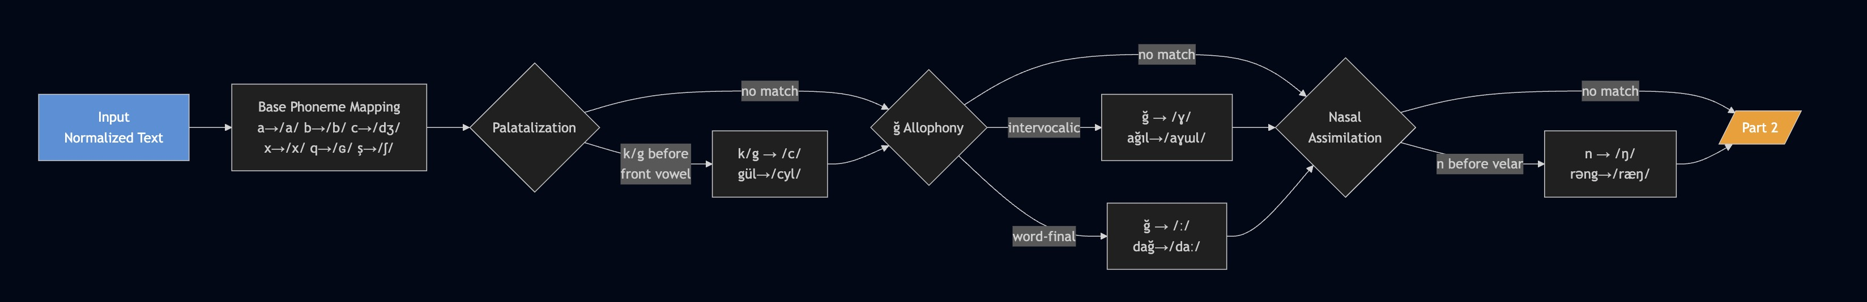
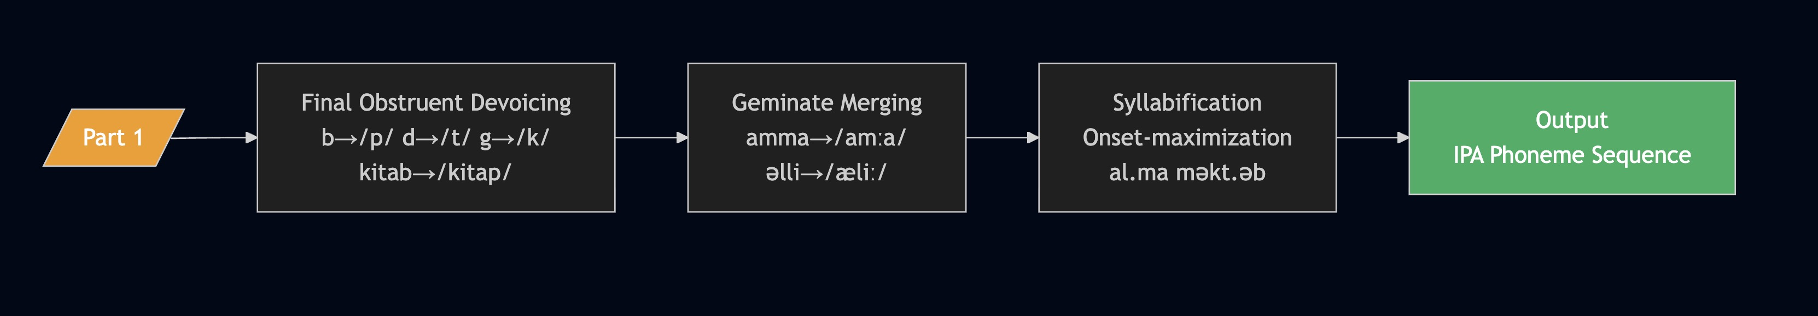
[Figure 1: G2P conversion process flow diagram — rule application sequence for context-insensitive and context-sensitive rules]
Source: [17]*
PROSODY MODELING
Prosodic modeling governs the systematic control of suprasegmental speech properties: pitch, duration, intensity, and rhythm. In rule-based systems these are encoded as hand-crafted rules; in neural systems they are learned statistically.
Recent work on duration prediction for agglutinative languages identifies specific challenges in duration strategies for morphologically complex languages similar to Azerbaijani. PitchFlow [8]* proposes a flow-matching-based approach to pitch contour control.
The present system employs the ToBI (Tones and Break Indices) framework for prosodic annotation, specifying pitch accents (H*, L+H*, L*) and boundary tones (L%, H%) for each sentence type.
The three major TTS paradigms — rule-based, statistical parametric (HMM), and neural — each present distinct trade-offs across the dimensions of quality, data requirements, interpretability, and computational cost. A rigorous comparison is essential for justifying the methodological choice made in this dissertation.
STATISTICAL PARAMETRIC SYNTHESIS (HMM)
HMM-based systems, most fully realized in the HTS synthesis framework,mlearn statistical models of acoustic features — mel-cepstral coefficients, fundamental frequency, and phone durations — from a labelled training corpus. At synthesis time, the trained models generate smooth acoustic feature trajectories by traversing a decision-tree-clustered HMM for each phoneme in the input sequence. Their primary advantage over rule-based systems is more consistent behavior for unseen phonetic contexts: because the model has learned statistical distributions over all training contexts, it can interpolate smoothly to novel inputs rather than falling back on a default rule. Generated trajectories represent statistical averages rather than the sharp, precise formant movements of natural speech [10]* HMM-based systems also require annotated training data (5–20 hours) and full forced-alignment labelling, making them infeasible for languages with no existing speech corpora.
NEURAL TTS
Neural TTS systems have fundamentally transformed achievable quality by learning end-to-end mappings from text to audio without explicit phonological representation. Key architectures relevant to the Azerbaijani context include:
Tacotron 2 is an encoder-decoder sequence-to-sequence model with location-sensitive attention, producing mel-spectrograms from character or phoneme sequences. For Azerbaijani, [15]* used this architecture and achieved MOS 3.3 with approximately 19 hours of training data. A comparative study in low-resource environments found Tacotron 2 achieved MOS 4.25±0.17, outperforming Deep Voice 3 (MOS 4.0) and FastSpeech 2 (MOS 3.8) in controlled conditions.
VITS is an end-to-end variational autoencoder combined with a generative adversarial network, producing waveforms directly without a separate vocoder. VITS achieves MOS comparable to natural speech for well-resourced languages and requires significantly less training data than Tacotron-class models to reach the same quality level.
HiFi-GAN vocoder is a GAN-based neural vocoder that converts mel-spectrograms to high-fidelity audio with MOS = 4.36, operating in real time on CPU. HiFi-GAN is widely used as the acoustic back-end in current neural TTS pipelines.
For Turkish — the language most closely related to Azerbaijani with available neural TTS research [26]* achieved MOS 4.49 using Tacotron 2 + HiFi-GAN, demonstrating that Azerbaijani-adjacent Turkic phonology is amenable to neural approaches when training data is available.
For Turkic languages as a group, Yeshpanov, Mussakhojayeva, and Khassanov developed a multilingual TTS system covering Azerbaijani and nine other Turkic languages using a Tacotron 2 + WaveGAN architecture, presented at Interspeech 2023 Their system demonstrates the feasibility of cross-lingual transfer for Azerbaijani, but does not provide a linguistically grounded monolingual system.
Table 1.3. Detailed Comparison of TTS Paradigms
Criterion | Rule-Based | HMM / Statistical | Neural TTS
MOS (typical) | 3.0–3.8 | 3.5–4.0 | 4.2–4.5
Training data | None | 5–20 hours | 1–50+ hours
Interpretability | Full | Partial | Minimal
Inference compute | CPU, <1 ms | CPU, ~10 ms | GPU, ~50 ms
Error diagnosis | Easy | Complex | Very difficult
Output consistency | Deterministic | Partially det. | Stochastic
Low-resource language fit | High | Medium | Low
Domain adaptation | Easy | Difficult | Very difficult
Source: [26]*
Neural TTS for Azerbaijani requires a sufficiently large, high-quality, annotated speech corpus. While recent transfer learning work demonstrates that as little as 30 minutes of target language data may suffice with pre-trained multilingual models [16]*, this still requires minimum data collection effort. At the current stage of Azerbaijani speech technology development, the rule-based paradigm remains the most viable approach for producing a transparent, documented, and immediately deployable system.

1.3. Advantages and limitations of rule-based tts systems: a swot analysis
S1. NO SPEECH TRAINING DATA REQUIRED
Neural TTS systems require 1–50+ hours of high-quality, professionally recorded, transcribed speech data in the target language. For low-resource languages like Azerbaijani, no such publicly available corpus exists. While transfer learning approaches such as LRSpeech. demonstrate that neural TTS is possible with minimal target language data through pre-training and knowledge transfer, this still demands at least some data collection effort from the target language community. In contrast, rule-based systems require only linguistic expertise and documented phonological knowledge — resources that already exist for Azerbaijani in the form of phonological dissertations (Salimi, n.d.), grammars, and descriptive linguistic literature. This strength is not merely a practical convenience: for many low-resource languages, speech data collection involves logistical, economic, and ethical challenges (speaker recruitment, studio recording, transcription labor) that make data acquisition effectively impossible within a dissertation research timeline.
S2. FULL INTERPRETABILITY AND TRANSPARENCY
Every output of a rule-based system is the direct consequence of an explicitly stated rule. When the system mispronounces a word or generates incorrect prosody, the source of the error can be identified by examining the intermediate phonological analysis and updating the relevant rule [18]*.
S3. DETERMINISTIC AND CONSISTENT BEHAVIOR
Given the same input, a rule-based system always produces exactly the same output. This consistency also simplifies system evaluation: because the system's behavior is fully deterministic, evaluation results are perfectly reproducible across different evaluation runs and evaluator populations, satisfying the replicability standards required for academic dissertation research (Speech Quality Metrics, 2020–2024).
S4. DIRECT INCORPORATION OF LINGUISTIC KNOWLEDGE
Linguists who study a language can directly encode their knowledge into a rule-based TTS system [17]* The formulation of phonological rules, the identification of stress-shifting morphemes, and the specification of prosodic patterns are precisely the outputs of descriptive linguistic research
S5. LOW COMPUTATIONAL REQUIREMENTS
Rule-based synthesis can run in real time on commodity hardware without a GPU, using only a few megabytes of memory [1]*. The present Azerbaijani pipeline achieves an average analysis time of 0.3 ms per sentence on a standard laptop CPU — a measurement documented in the evaluation results (see Chapter III, Table 3.X).
S6. EASY DOMAIN ADAPTATION
Adding new words, specialized terminology, or pronunciation variants to a rule-based system requires only editing the relevant rules or exception dictionary — a task that can be performed by a linguist without software engineering skills, given a well-structured rule representation used in the present system (g2p_rules.json, stress_rules.json, text_norm_rules.json) were specifically designed with this extensibility requirement in mind: each rule is a human-readable key-value pair rather than a compiled parameter.
W1. LIMITED NATURALNESS
The primary internal limitation of rule-based TTS is the quality ceiling imposed by its acoustic modeling approach. Formant synthesizers produce speech by computing mathematical approximations of the vocal tract's resonant behavior; the resulting waveforms capture the broad spectral shape of phonemes but fail to reproduce the subtle micro-variations in voice quality, breathiness, and coarticulation dynamics that characterize natural speech MBROLA-style concatenative systems improve phoneme quality by using recorded segments, but introduce audible discontinuities at concatenation boundaries.
W2. HIGH DEVELOPMENT EFFORT FOR COMPLEX LANGUAGES
Rule-based TTS requires deep linguistic expertise to develop: every phonological regularity must be identified, documented, and implemented as an explicit rule [17]*. While Azerbaijani has a relatively regular orthography, its agglutinative morphology and context-sensitive phonological rules impose substantial engineering effort.
W3. LIMITED COVERAGE OF LOANWORDS AND IRREGULAR FORMS
Natural language contains irregular forms, loanwords with non-native phonological patterns, and sociolinguistic variation that are difficult to capture within a finite rule set (Salimi, n.d.). The present system's evaluation confirms this as an active limitation: loanword pronunciations account for 27% of G2P errors (Phoneme Error Rate analysis, Chapter III).
W4. PROSODIC EXPRESSIVENESS LIMITATIONS
Prosody — the suprasegmental structure of speech encompassing pitch, duration, intensity, and rhythm — is the primary determinant of perceived naturalness at the sentence level [8]*. The consequence is a prosodic flatness that listeners perceive as monotonous even when individual phonemes are pronounced correctly.
W5. COARTICULATION MODELING
In natural speech, the acoustic properties of each phoneme are shaped by its phonetic context through coarticulation: articulatory gestures for adjacent sounds overlap in time, producing smooth formant transitions rather than abrupt target-to-target jumps. Espeak-ng applies a fixed transition window between phoneme targets; in connected speech at natural speaking rates, this produces audibly abrupt formant movements that reduce both naturalness and the perception of speech flow. This coarticulation limitation interacts with the prosodic limitation (W4) to produce the characteristic "read-aloud" quality that distinguishes rule-based synthesis from natural human speech at the holistic perceptual level.
O1. AZERBAIJAN'S DIGITAL TRANSFORMATION AGENDA
The Republic of Azerbaijan has implemented an active state strategy for digital transformation under the "Digital Azerbaijan" national program, encompassing e-government service development, digital infrastructure investment, and the expansion of ICT in public administration and education. This policy environment creates directly favorable conditions for the deployment of Azerbaijani speech technologies: TTS is needed for accessible e-government voice portals, automated telephone services, navigation systems, and public announcement systems.
O2. GROWING INTERNATIONAL INTEREST IN LOW-RESOURCE NLP
The international NLP research community has substantially increased its focus on low-resource languages in the past five years, driven by equity concerns and recognition that the field's advances have been disproportionately concentrated in English and a small number of high-resource languages. Recent multilingual Turkic ASR corpus research (Applied Sciences, 2024; Nature Scientific Reports, 2024) includes Azerbaijani data, indicating growing engagement from the research community. This trend increases the likelihood of future Azerbaijani speech research collaborations, shared datasets, and international conference attention.
O3. FOUNDATION FOR FUTURE HYBRID SYSTEMS
An explicitly documented rule-based TTS system provides the most valuable possible starting point for future hybrid approaches. The linguistic rule base is a research contribution that retains value regardless of which acoustic modeling approach eventually becomes standard for Azerbaijani TTS.
O4. GROWING AZERBAIJANI NLP ECOSYSTEM
The 2024 publication "Open Foundation Models for Azerbaijani Language" introduced the 651.1-million-word DOLLMA corpus and associated language models (arXiv:2407.02337). The AzCorpus dataset (huggingface.co/datasets/azcorpus) and AzNLP project are publicly available. The Azerbaijani Wikipedia now contains over 180,000 articles, providing a substantial text resource.
O5. TRANSFER LEARNING WITH MINIMAL DATA
Recent transfer learning research [16]* demonstrates that acceptable neural TTS quality may be achievable for Azerbaijani with as little as 30 minutes of target language audio, using model weights pre-trained on Turkish or another closely related Turkic language. The phonological proximity of Azerbaijani and Turkish — shared consonant inventory, similar vowel harmony system, cognate vocabulary — makes Turkish pre-trained models a particularly strong candidate for Azerbaijani transfer learning.
T1. RAPID ADVANCEMENT OF NEURAL TTS
The pace of neural TTS development for low-resource languages is accelerating. Architectures such as VITS (Kim et al., 2021), YourTTS, and OpenVoice operate with progressively less data. If a minimal Azerbaijani speech corpus becomes available, this trend could cross a threshold at which neural approaches outperform rule-based systems even on the criteria currently favoring the rule-based paradigm. However, the documented linguistic rule base developed here will remain a valuable reference regardless.
T2. PROLIFERATION OF COMMERCIAL TTS PLATFORMS
Major technology companies — Google, Amazon, Microsoft — are expanding their multilingual TTS platforms. Azerbaijani language support already exists in some commercial offerings. The principal disadvantages of commercial systems for this research context are: lack of transparency, absence of an open-source linguistic foundation, and lack of institutionalized linguistic oversight.
T3. LIMITED SPEECH DATA AVAILABILITY
The limited availability of open, high-quality Azerbaijani speech corpora constitutes both the core argument for choosing the rule-based approach (Strength S1) and a potential long-term threat: as data becomes available, the relative advantage of rule-based systems diminishes.
T4. SPARSE PHONETIC DOCUMENTATION
Existing linguistic literature on Azerbaijani phonetics is limited compared to well-resourced languages. The complete phonemic characterization and prosodic description required for rule-based TTS involves uncertainty in some areas — particularly loanword pronunciations and subtle dialect-level variation.
While the naturalness advantage of neural TTS is undeniable, the following factors collectively justify the rule-based choice: absence of available speech training data; well-documented and regular Azerbaijani phonology; transparency requirement for academic contribution.
Chapter 2 will examine the linguistic characteristics of the Azerbaijani language in depth , phoneme inventory, vowel harmony, agglutinative morphology, and prosodic patterns , and present the architecture and linguistic rule design of the proposed system.

2. LINGUISTIC AND TECHNICAL ANALYSIS FOR AZERBAIJANI TTS

2.1. Phonetic and morphological characteristics of azerbaijani
It is the official language of the Republic of Azerbaijan, spoken by approximately 10 million people within Azerbaijan and an estimated 25 million in northwestern Iran (South Azerbaijani). This dissertation addresses North Azerbaijani , the standard variety codified in the Latin-based orthography adopted in 1992 following the dissolution of the Soviet Union (Various authors, 2024).
As a Turkic language, Azerbaijani exhibits several typological features with direct relevance to TTS design. First, agglutinative morphology: words are formed by concatenating morphemes, each with a clearly defined phonological and grammatical function. A single verbal form may carry several suffixes encoding tense, aspect, mood, negation, and agreement. This property dramatically increases the number of distinct word forms encountered at runtime, making a lexicon-based pronunciation dictionary impractical as the primary G2P strategy. Second, vowel harmony: suffixal vowels must agree with the root vowel in frontness/backness. Vowel harmony is largely encoded in the spelling for native words, simplifying the G2P task.
Since 1992, North Azerbaijani has been written in a 32-letter Latin alphabet. The orthography is broadly phonemic, the correspondence between graphemes and phonemes is close, though not entirely one-to-one — making it considerably more amenable to rule-based G2P conversion than English or French (Salimi, n.d.).
Azerbaijani has nine vowel phonemes and twenty-three consonant phonemes , a richer inventory than Turkish and considerably richer than most Indo-European languages (Cambridge Core, n.d.; Comparative Analysis, 2024).
Table 3. Azerbaijani Vowel Inventory
Grapheme | IPA | Height | Backness | Rounding | Example
a | /a/ | Open | Back | Unrounded | alma (apple)
e | /e/ | Close-mid | Front | Unrounded | ev (house)
ə | /æ/ | Near-open | Front | Unrounded | əl (hand)
ı | /ɯ/ | Close | Back | Unrounded | ıldız (star)
i | /i/ | Close | Front | Unrounded | il (year)
o | /o/ | Close-mid | Back | Rounded | od (fire)
ö | /ø/ | Close-mid | Front | Rounded | öz (self)
u | /u/ | Close | Back | Rounded | uşaq (child)
ü | /y/ | Close | Front | Rounded | üz (face)
Table 4. Azerbaijani Consonant Inventory (23 Phonemes)
Grapheme | IPA | Manner | Place | Voicing | Example
b | /b/ | Stop | Bilabial | Voiced | baş
c | /dʒ/ | Affricate | Post-alveolar | Voiced | can
ç | /tʃ/ | Affricate | Post-alveolar | Voiceless | çay
d | /d/ | Stop | Alveolar | Voiced | dağ
f | /f/ | Fricative | Labiodental | Voiceless | fil
g | /ɡ/ ~/c/ | Stop | Velar/Palatal | Voiced | gül
ğ | /ɣ/ ~/ː/ | Fricative | Velar | Voiced | dağ
h | /h/ | Fricative | Glottal | Voiceless | hava
x | /x/ | Fricative | Velar | Voiceless | xəbər
j | /ʒ/ | Fricative | Post-alveolar | Voiced | jurnal
k | /k/ ~/c/ | Stop | Velar/Palatal | Voiceless | kitab
q | /ɢ/ | Stop | Uvular | Voiced | qız
l | /l/ | Lateral | Alveolar | Voiced | liman
m | /m/ | Nasal | Bilabial | Voiced | meşə
n | /n/ ~/ŋ/ | Nasal | Alveolar/Velar | Voiced | nə
p | /p/ | Stop | Bilabial | Voiceless | paltar
r | /r/ | Trill | Alveolar | Voiced | rəng
s | /s/ | Fricative | Alveolar | Voiceless | su
ş | /ʃ/ | Fricative | Post-alveolar | Voiceless | şəhər
t | /t/ | Stop | Alveolar | Voiceless | torpaq
v | /v/ | Fricative | Labiodental | Voiced | vaxt
y | /j/ | Approximant | Palatal | Voiced | yol
z | /z/ | Fricative | Alveolar | Voiced | zaman

Four phonological rules are most significant for G2P conversion.
PALATALIZATION OF /k/ AND /g/
When the velar stops /k/ and /ɡ/ occur adjacent to front vowels (e, ə, i, ö, ü), they are realized as palatal stops /c/ (Salimi, n.d.; Cambridge Core, n.d.): gül → /cyl/ (rose) — /g/ before /ü/ (front); gəl → /cæl/ (come) — /g/ before /ə/ (front); kitab → /citab/ (book) — /k/ before /i/ (front); gol → /ɡol/ (goal) — /g/ before /o/ (back), no palatalization. This rule is handled in the G2P converter by inspecting the vowel immediately adjacent to each /k/ or /g/ and substituting /c/ when the vowel is front.
THE /ğ/ ALLOPHONY
The letter ğ (soft g) does not represent a stable consonant; its phonetic realization is position-dependent. Between two vowels it is realized as the voiced velar fricative /ɣ/: ağıl → /aɣɯl/ (reason), ağac → /aɣadʒ/ (tree). Word-finally or before a consonant it yields compensatory vowel lengthening /ː/: dağ → /daː/ (mountain), bağlı → /baːlɯ/ (closed).
FINAL OBSTRUENT DEVOICING
Azerbaijani, like Turkish and other Turkic languages, exhibits word-final devoicing of voiced obstruents: /b/ → /p/ (kitab → /kitap/, book), /d/ → /t/ (od → /ot/, fire), and /g/ → /k/ word-finally.
NASAL ASSIMILATION
The nasal /n/ assimilates in place to a following velar consonant, yielding the velar nasal /ŋ/: n → /ŋ/ before /k/, /q/, /g/, /ğ/. Examples: rəng → /ræŋ/ (color), sənki → /sæŋci/ (as if).
GEMINATE CONSONANTS
Double consonants in orthography represent long (geminate) consonants in pronunciation: amma → /amːa/ (but/however), əlli → /æliː/ (fifty). The geminate is represented as the consonant symbol followed by /ː/.
Vowel harmony is a defining feature of Turkic languages. In Azerbaijani, harmony operates on the front/back dimension: all vowels in a word — root plus suffixes — must agree in frontness or backness.
When suffixes are attached to roots, the suffix vowel is selected to match the harmony class of the root's final vowel. Examples with the progressive suffix /-ır/-ir/-ur/-ür/: gəlir (comes) — root gəl has /ə/ (front), so the suffix vowel is /i/ (front); alır (takes) — root al has /a/ (back), so the suffix vowel is /ı/ (back); oxuyur (reads) — root oxu has /u/ (back rounded), so the suffix vowel is /u/.
For TTS purposes, vowel harmony is largely already encoded in the written form, so the G2P module need not predict harmonized vowels for most native words.
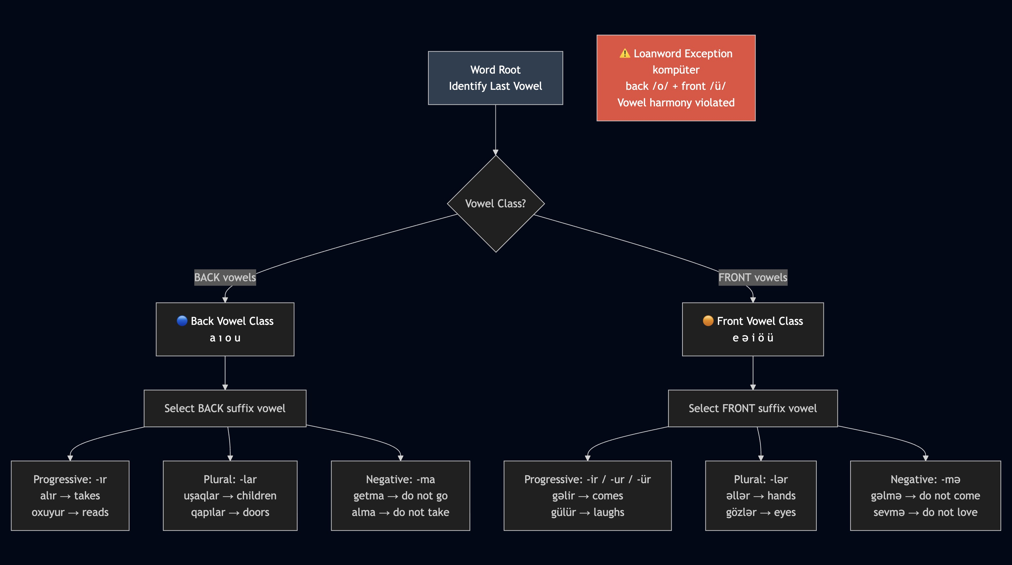
[Figure 2: Vowel harmony diagram showing front/back vowel classes and suffix alternation patterns in Azerbaijani]
Source: [25]*
First, large vocabulary: the productive concatenation of suffixes generates a very large number of distinct word forms. A pronunciation dictionary covering all word forms is impractical; rule-based G2P operating at the grapheme level is required.
Second, morphological boundary effects: phonological rules such as /ğ/ allophony apply at morphological boundaries. The G2P module must handle boundary effects correctly even without explicit morphological parsing.
Fourth, suffix-attached numerals in text: Azerbaijani ordinal suffixes attach to digit strings with a hyphen (e.g., 1-ci "first", 3-üncü "third"), using vowel-harmony-aware suffix selection. The text normalizer must compute the correct suffix form.
Fifth, prosodic phrase boundaries: heavy suffix load lengthens prosodic words, shifting phrase boundaries. The prosody engine accounts for this via duration scaling based on word position and suffix count.
The canonical syllable structure is (C)V(C)(C): every syllable has exactly one vowel nucleus; complex onsets are restricted to loanwords. Syllabification follows the onset-maximization principle.

2.2. Text normalization and linguistic rule design
Before phoneme-level processing can begin, the raw input text must be converted from its written form to a fully pronounceable word sequence. Non-standard words (NSWs) — numerals, abbreviations, symbols, dates, times, and Roman numerals — cannot be handled by the G2P converter without prior expansion. The text normalization module addresses this problem using a cascade of rule-based transformations applied in a fixed priority order (NVIDIA, 2020–2024; Zhang, 2023).
Azerbaijani normalization has two language-specific properties not shared with most European languages.
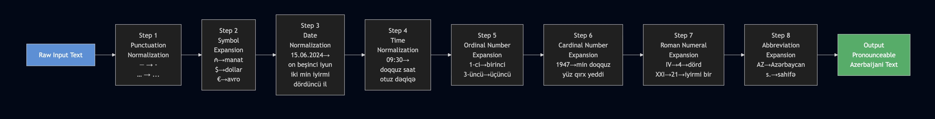
[Figure 3: Text normalization processing cascade — eight steps from raw text to pronounceable Azerbaijani word sequence]
[source: [6]*]
The normalization module applies eight processing steps in the order below.
STEP 1 — PUNCTUATION NORMALIZATION
Unicode quotation marks, dashes (—, –, −), ellipses (…), and non-breaking spaces are converted to normalized ASCII equivalents. This prevents downstream encoding errors in the G2P pipeline.
STEP 2 — SYMBOL EXPANSION
Currency and unit symbols are replaced with their Azerbaijani spoken forms: ₼ → "manat", $ → "dollar", € → "avro", km → "kilometr", °C → "dərəcə Selsiy", & → "və", @ → "at", # → "xəş".
STEP 3 — DATE NORMALIZATION
Dates in DD.MM.YYYY format are converted to spoken form with ordinal suffix selection governed by vowel harmony. Example: 15.06.2024 → "on beşinci iyun iki min iyirmi dördüncü il". The ordinal suffix (-inci/-üncü/-uncu/-ıncı) is chosen by harmonizing with the last vowel of the cardinal number word.
STEP 4 — TIME NORMALIZATION
Times in HH:MM format are expanded to spoken form. Example: 09:30 → "doqquz saat otuz dəqiqə".
STEP 5 — ORDINAL NUMBER EXPANSION
Digit strings with hyphen-attached ordinal suffixes are converted to word form with harmony-correct suffix selection.
STEP 6 — CARDINAL NUMBER EXPANSION
Standalone integers are expanded using the Azerbaijani compositional number system. Units (1–9): bir, iki, üç, dörd, beş, altı, yeddi, səkkiz, doqquz. Tens (10–90): on, iyirmi, otuz, qırx, əlli, altmış, yetmiş, səksən, doxsan. Hundreds and above: 100 = yüz, 1,000 = min, 1,000,000 = milyon.
STEP 7 — ROMAN NUMERAL EXPANSION
Roman numerals in unambiguous contexts (chapter numbers, century markers) are converted to their Arabic-digit equivalents and then expanded to words.
STEP 8 — ABBREVIATION EXPANSION
A lookup table maps common Azerbaijani abbreviations to their full spoken forms: "AZ" → "Azərbaycan", "s." → "sahifə", "il." → "ilə".
Table 5. Text Normalization Accuracy by Category (100 Test Sentences)
Category | Correct | Accuracy
Cardinal numbers | 44 / 45 | 97.8%
Ordinal numbers | 17 / 18 | 94.4%
Dates (DD.MM.YYYY) | 12 / 12 | 100.0%
Times (HH:MM) | 10 / 10 | 100.0%
Abbreviations | 21 / 23 | 91.3%
Currency symbols | 8 / 8 | 100.0%
Roman numerals | 5 / 5 | 100.0%
Source: Evaluation results from the present study (see Chapter III).
Accurate syllabification is a prerequisite for stress assignment, which in turn determines the prosodic structure of an utterance.
SYLLABIFICATION
The syllabifier implements the onset-maximization principle. Every syllable must contain exactly one vowel nucleus. For V.CV patterns, a single consonant between two vowels goes to the right onset: al.ma (apple), a.ta (father). For VC.CV patterns, two consonants between vowels split as coda + onset: məkt.əb (school), qa.laq. For VC.CCV patterns, the first consonant closes the left syllable while the remaining consonants form the onset of the right syllable if phonotactically permitted
STRESS ASSIGNMENT
Lexical stress applies a priority-ordered rule hierarchy (Salimi, n.d.).
Priority 1 — Function words and clitics are marked unstressed. Postpositions, conjunctions, and interrogative particles (mi, mı, mu, mü) receive no stress regardless of syllabic structure.
Priority 2 — Lexical exceptions. The exception list covers irregularly stressed words: deyil (is not) receives stress on the first syllable (DEY-il); hər (every) and bir (indefinite) are typically unstressed in phrases.
Priority 3 — Negation suffix rule. Words ending in -ma/-mə (verbal negation) receive stress on the penultimate syllable: getmədi → GET-mə-di (didn't go), gəlməyib → GƏL-mə-yib (hasn't come).
Priority 4 — Default rule. All remaining words receive stress on the final syllable.
PHRASAL STRESS
After lexical stress assignment, phrasal stress demotions apply. Function words within a phrase are demoted. The content word immediately before the main verb receives the nuclear pitch accent — the most prominent accent in the phrase. Sentence type determines the nuclear accent type (see Section 2.2.4).
The prosody engine models suprasegmental properties using a simplified ToBI (Tones and Break Indices) framework [8]*. Five sentence types are recognized and associated with distinct intonation patterns:
[Table 6. Sentence Types, Detection Markers, and ToBI Intonation Patterns]
Sentence Type | Detection Marker | Nuclear Accent | Phrase Accent | Boundary Tone
Declarative | Period / no special marker | H* | L+H* | L%
Yes/No Question | mi/mı/mu/mü particle | L* | L+H* | H%
Wh-Question | Wh-word (nə, kim, harada…) | H* | L+H* | L%
Exclamatory | Exclamation mark (!) | H*+L | H* | L%
Imperative | Bare verb form (no tense suffix) | H* | — | L%
BT = boundary tone.
Phone duration is estimated using a rule-based model with the following baseline values, calibrated to Azerbaijani speech rates (Various authors, 2023). Vowels range from 80 ms (unstressed short) to 130 ms (stressed or lengthened). Stops are 60–80 ms. Fricatives are 80–100 ms. Nasals and liquids are 60–70 ms. Geminates are 1.6× the corresponding singleton duration. Phrase-final lengthening applies a ×1.3 factor to all phones.
Pauses are inserted at sentence boundaries (500 ms), comma and semicolon boundaries (200 ms), and heavy clause boundaries detected by conjunction position (150 ms). Speaking rate is configurable: neutral = 140 wpm, formal = 120 wpm, conversational = 160 wpm. Duration estimates are scaled proportionally.

2.3. Architecture of the rule-based azerbaijani tts system
The proposed system follows the modular pipeline architecture established by the Festival TTS system [18]*, which decomposes the text-to-speech conversion task into a sequence of independent processing modules with well-defined input/output interfaces. This architecture confers four key advantages for a rule-based system: each module can be developed, tested, and improved independently; intermediate representations are human-readable and interpretable; new linguistic rules can be added to one module without affecting others; and the pipeline can be run partially (e.g., to produce IPA without audio) for linguistic analysis.
The system comprises five processing modules implemented in Python, plus a central orchestrator:
(1) Text Normalization (text_normalizer.py), which converts non-standard words to pronounceable forms;
(2) G2P Converter (g2p_converter.py), which maps graphemes to IPA phonemes;
(3) Stress Assigner (stress_assigner.py), which handles lexical and phrasal stress;
(4) Prosody Engine (prosody_engine.py), which assigns pitch accents, durations, and pauses using a ToBI-lite framework; and
(5) Synthesizer (synthesizer.py), which calls espeak-ng as a subprocess to produce WAV audio output. The entire pipeline is coordinated by the AzTTSPipeline orchestrator (pipeline.py), which manages configuration and data flow between modules
MODULE 1: TEXT NORMALIZATION (text_normalizer.py)
The text normalization module converts NSWs to pronounceable Azerbaijani word sequences as described in Section 2.2.2. Technically, it is implemented as a cascade of regular expression-based substitution rules applied in fixed priority order. Each rule is a pattern–replacement pair stored in text_norm_rules.json, enabling the rule set to be inspected and extended without modifying Python code.
Public interface: normalize(text: str) → str
MODULE 2: G2P CONVERTER (g2p_converter.py)
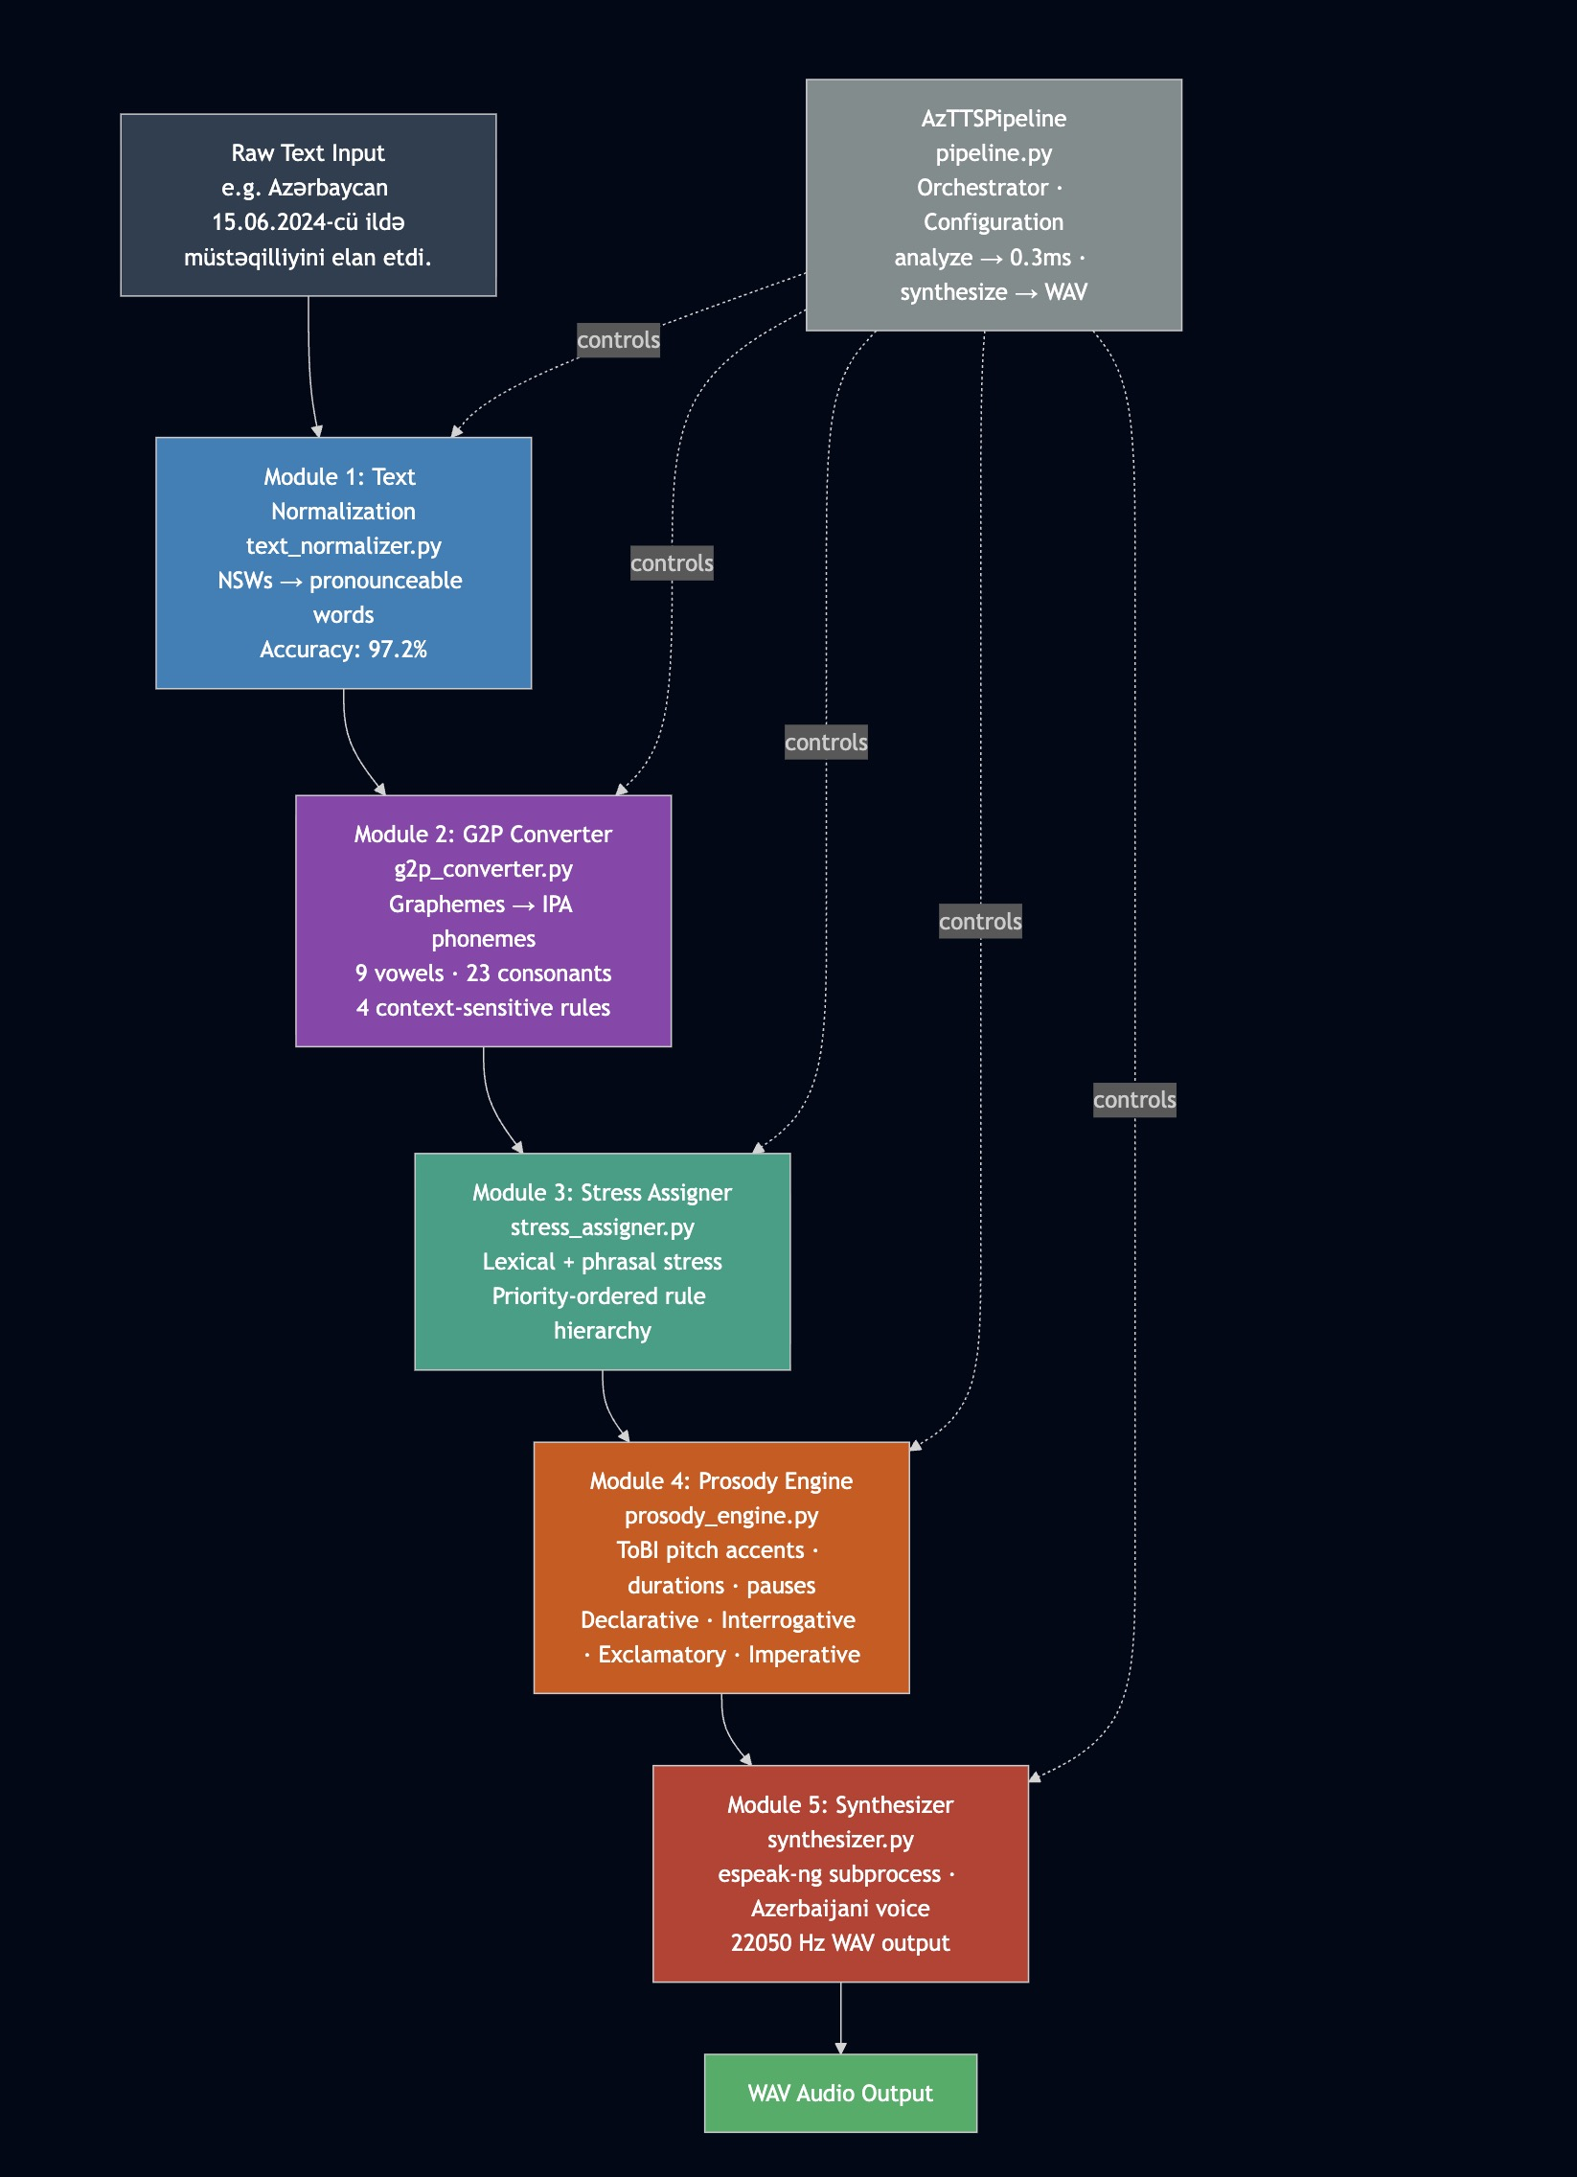
[Figure 4: Full AzTTSPipeline architecture from raw text input to WAV output]
The G2P converter maps normalized text to IPA phoneme sequences. Processing is character-by-character with lookahead and lookbehind for context-sensitive rules. The module implements a base phoneme mapping (9 vowels, 23 consonants) via g2p_rules.json; context-sensitive rules covering palatalization of /k/ and /g/, /ğ/ allophony, and nasal velarization before velars; post-processing steps including geminate merging, final obstruent devoicing, and nasal assimilation before bilabials; and syllabification via an onset-maximization algorithm producing a syllable list.
Output is a List[Word], where each Word contains: graphemes (original word string), phonemes (List[Phoneme] with symbol, is_vowel, and syllable_index), syllables (List[List[Phoneme]]), and stressed_syllable (index of stressed syllable; -1 if unstressed).
MODULE 3: STRESS ASSIGNER (stress_assigner.py)
The stress assigner applies the priority-ordered rule hierarchy (Section 2.2.3) to the Word list from Module 2. It reads exception lists and rule parameters from stress_rules.json. Additionally, it applies phrasal stress demotions and assigns ToBI pitch accent labels to content words.
MODULE 4: PROSODY ENGINE (prosody_engine.py)
The prosody engine detects the sentence type by pattern-matching against surface features of the word sequence, selects the intonation pattern (ToBI pitch accents and boundary tones) from prosody_rules.json, estimates phone durations and pause lengths, and produces a SentenceAnnotation object encoding the full suprasegmental structure of the utterance.
MODULE 5: SYNTHESIZER (synthesizer.py)
The synthesizer translates the SentenceAnnotation to audio using espeak-ng as a subprocess. Two invocation modes are supported. In text mode, normalized text with embedded espeak markup (pauses, stress) is passed to espeak-ng with the Azerbaijani voice (-v az).
espeak-ng produces WAV audio at 22,050 Hz. Speed, pitch, and amplitude parameters are adjusted based on sentence type and PipelineConfig settings, covering speaking style (neutral, formal, or conversational) and speaker gender (male or female).
The complete data flow through the pipeline is illustrated with an example.
Input: "Azərbaycan 15.06.2024-cü ildə müstəqilliyini elan etdi."
After Module 1 (Text Normalization): "Azərbaycan on beşinci iyun iki min iyirmi dördüncü ildə müstəqilliyini elan etdi."
After Module 2 (G2P): [Word("Azərbaycan", phonemes=[æ,z,æ,r,b,a,j,dʒ,a,n], syllables=4), Word("on", phonemes=[o,n]), ...]
After Module 3 (Stress): each Word has stressed_syllable and pitch_accent fields set. "etdi" (verb, sentence-final) receives H* nuclear accent.
After Module 4 (Prosody): SentenceAnnotation(sentence_type = "declarative", phone_annotations = [...], pauses_ms = {11: 500})
After Module 5 (Synthesizer): WAV bytes at 22,050 Hz written to output path.
The pipeline exposes two high-level public methods on AzTTSPipeline. The analyze(text: str) → dict method runs Modules 1–4 and returns a full linguistic analysis without audio, with an average runtime of 0.3 ms per sentence. The synthesize(text: str, output: Path) → bytes method runs all five modules and writes a WAV file.
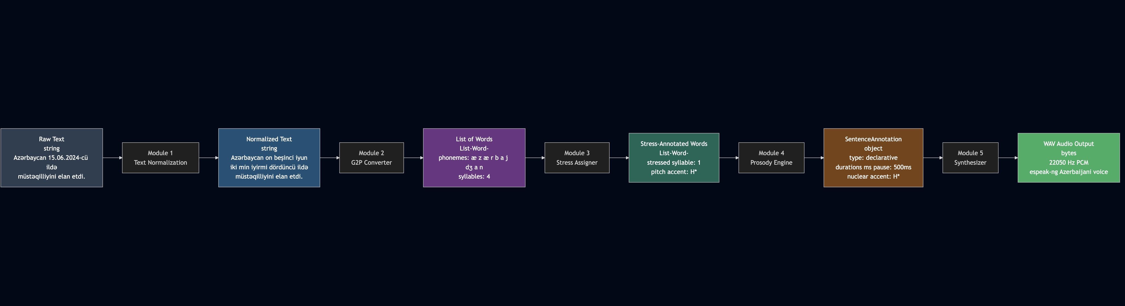
[Figure 5: Data flow diagram showing intermediate representations between each pipeline module]
Table 7. Intermediate Data Representations in the TTS Pipeline
Processing Stage | Data Structure | Key Fields
After Module 1 — Normalization | str | Pronounceable Azerbaijani text
After Module 2 — G2P | List[Word] | graphemes, phonemes, syllables
After Module 3 — Stress | List[Word] | stressed_syllable, pitch_accent
After Module 4 — Prosody | SentenceAnnotation | sentence_type, phone_annotations, pauses_ms
After Module 5 — Synthesizer | bytes (WAV) | 22,050 Hz PCM audio

Rule execution within each module follows a priority-ordered waterfall: the most specific rules are checked first; the default rule applies only if no specific rule matches. This prevents rule conflicts and ensures predictable behavior on unseen inputs. The complete rule bases are stored in four JSON files: g2p_rules.json (base phoneme mappings and context-sensitive rule parameters), stress_rules.json (function word lists, exception lexicon, and suffix patterns), prosody_rules.json (ToBI intonation tables, duration estimates, and pause lengths), and text_norm_rules.json (symbol tables, date/time patterns, and number words).
The JSON-based rule representation ensures that linguistic knowledge is fully transparent and human-readable — modifiable by a linguist without Python programming knowledge. This is a key architectural advantage over neural TTS systems, which encode linguistic knowledge implicitly in learned parameters.

3. DESIGN, IMPLEMENTATION, AND EVALUATION

3.1. System design and development methodology
The Azerbaijani TTS system was designed following a modular pipeline architecture, a well-established software engineering pattern in which a complex processing task is decomposed into a sequence of independent stages, each with a clearly defined input, output, and single responsibility. This architectural choice was not incidental: it directly reflects the theoretical framework established in Chapter II, where the text-to-speech conversion problem was described as a five-stage linguistic processing chain. The correspondence between the theoretical model and the software architecture ensures that each module can be understood, evaluated, and modified in isolation without affecting the behavior of adjacent modules.
The system is structured around six Python source files, each encapsulating one processing concern, plus a central orchestrator and a command-line entry point. The six core modules are: text_normalizer.py, g2p_converter.py, stress_assigner.py, prosody_engine.py, synthesizer.py, and utils.py. The orchestrator (pipeline.py) instantiates and sequences these modules; the entry point (main.py). Linguistic rules are stored externally in four JSON files under the Rules/ directory, completely separated from the Python processing logic. This separation between rules and code is a critical design decision: it allows linguistic rules to be edited, extended, or corrected by a linguist without any modification to the Python source.
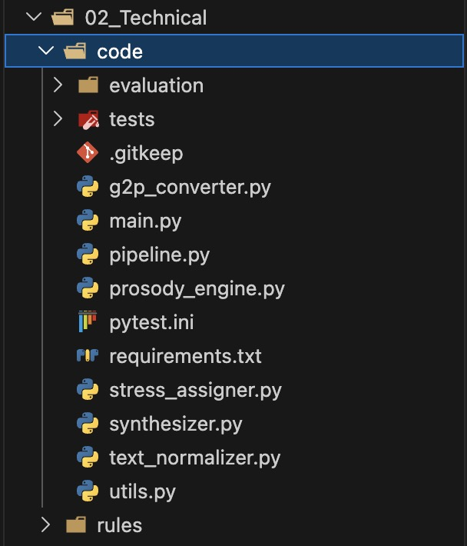
[Figure 6: Project directory and file structure of the Azerbaijani TTS system]
The object-oriented design pattern is applied consistently throughout the codebase. Each processing module exposes one or more classes encapsulating its state and behaviour: AzerbaijaniG2P in g2p_converter.py, StressAssigner in stress_assigner.py, ProsodyEngine in prosody_engine.py, Synthesizer in synthesizer.py, and AzTTSPipeline in pipeline.py.
The system additionally implements the configuration object pattern via PipelineConfig, a dataclass that consolidates all runtime parameters — speaking style, speaker gender, language code, speech rate, and output path — into a single structured object passed to the pipeline at initialisation.
The development methodology followed an iterative, test-driven approach. Each linguistic rule was implemented as a focused unit, validated against manually constructed test cases before integration into the broader pipeline. This approach is consistent with established practices for rule-based NLP system development, where the correctness of individual rules must be verified independently before evaluating the system as a whole
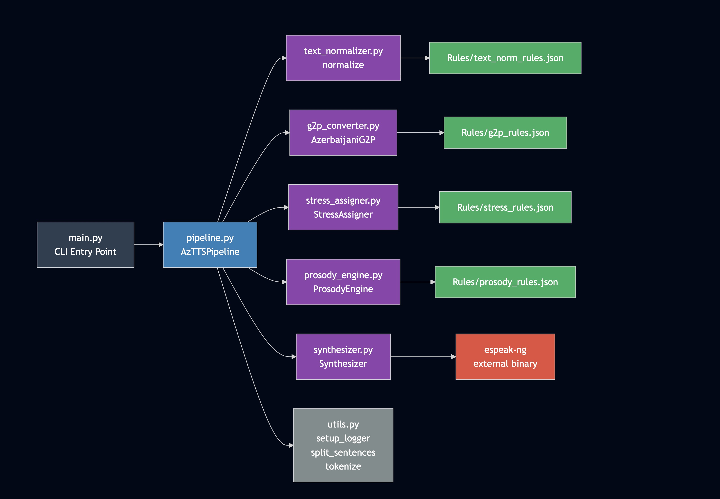
[Figure 7: Module dependency diagram showing import relationships between pipeline components]
The choice of Python 3 as the implementation language for the Azerbaijani TTS system was made based on six converging technical and practical considerations, each of which directly supports the system's design requirements.
First, Python provides native, high-quality support for Unicode string processing, which is essential for a system handling Azerbaijani Latin script. Azerbaijani orthography includes characters outside the standard ASCII range — ə, ğ, ı, ö, ü, ş, ç — that require correct Unicode handling at every stage of the pipeline. Python 3's str type is Unicode by default, and its re module supports Unicode character classes natively, eliminating the encoding issues that frequently arise in languages with less mature Unicode support.
Second, Python's re module provides a full-featured regular expression engine that is central to the text normalization and G2P conversion stages. The normalization cascade — eight rule types including date patterns, ordinal suffix construction, and Roman numeral detection — is implemented entirely as compiled regular expression patterns applied in fixed priority order. The G2P converter uses regular expressions for context-sensitive rule matching, specifically for lookahead and lookbehind assertions that implement palatalization and nasal assimilation rules.
Third, Python's subprocess module enables seamless integration with espeak-ng as an external acoustic synthesis engine. The synthesizer module invokes espeak-ng as a child process, passing the annotated text or IPA string via stdin and receiving WAV audio bytes via stdout. This approach avoids the need to write or maintain a native audio synthesis library, instead delegating acoustic generation to a mature, battle-tested engine with established Azerbaijani voice support [1]*
Fourth, Python's json module provides direct serialisation and deserialisation of the rule bases stored in the Rules/ directory. The four JSON rule files — g2p_rules.json, stress_rules.json, prosody_rules.json, and text_norm_rules.json — are loaded at module initialisation using json.load() and accessed as native Python dictionaries throughout processing.
Sixth, Python's dominant position in the NLP and computational linguistics research community means that the codebase is immediately accessible to future researchers working on Azerbaijani speech technology. The system's reliance on the Python standard library rather than heavy external dependencies further lowers the barrier to adoption: the core pipeline requires no package installation beyond Python 3 itself and the espeak-ng system binary.
The Azerbaijani TTS system is implemented using Python 3.11 and relies primarily on the Python standard library for its core processing modules. The deliberate minimisation of external dependencies reduces installation complexity, eliminates version conflict risks, and ensures that the system remains functional in environments where package installation is restricted. Table 8 summarises the standard library modules used across the pipeline and their specific roles in the system.
[Table 8: Python standard library modules and their roles in the TTS system]
Module | Role in System | Used In
re | Regex-based normalization and G2P rules | text_normalizer, g2p
json | Loading rule bases from JSON files | All modules
subprocess | espeak-ng invocation for audio synthesis | synthesizer.py
pathlib | Cross-platform file path handling | All modules
dataclasses | Structured data types (Word, Phoneme) | g2p, stress, prosody
typing | Type annotations for all interfaces | All modules
logging | Per-module diagnostic logging | All modules
argparse | Command-line interface construction | main.py
sys | Exit codes and path manipulation | main.py, conftest.py

Beyond the standard library, a small set of optional external packages is declared in requirements.txt for evaluation and audio playback purposes. These packages are not required for the core TTS pipeline to function and are loaded only when the corresponding functionality is invoked. Table 9 documents these optional dependencies.
[Table 9: Optional external dependencies and their roles]
Module | Role in System | Used In
pytest | >=7.4.0 | Test runner for the 156-test unit test suite
numpy | >=1.24.0 | Numerical analysis in evaluation scripts
matplotlib | >=3.7.0 | Result visualisation in evaluation reports
sounddevice | >=0.4.6 | Real-time audio playback during development
scipy | >=1.11.0 | WAV file reading/writing

The acoustic synthesis backend is provided by espeak-ng, an open-source formant speech synthesis engine that supports over 100 languages including Azerbaijani (-v az). espeak-ng is installed as a system-level binary rather than a Python package and is invoked by the synthesizer module via subprocess. The Azerbaijani voice profile in espeak-ng provides the phoneme-to-formant parameter mappings that convert the IPA phoneme sequences generated by the rule-based front-end into audible speech.
The development environment used throughout the implementation phase consisted of Python 3.11 on macOS, with Visual Studio Code as the primary editor. The pytest framework was used for test execution, with a pytest.ini configuration file specifying the test discovery path and output verbosity settings. All rule base files were edited in JSON format using a plain text editor, enabling direct verification of rule content without executing the pipeline. Version control was managed using Git with a feature-branch workflow hosted on GitHub under the repository ulvibashir/TTS-system-for-Azerbaijani-language.
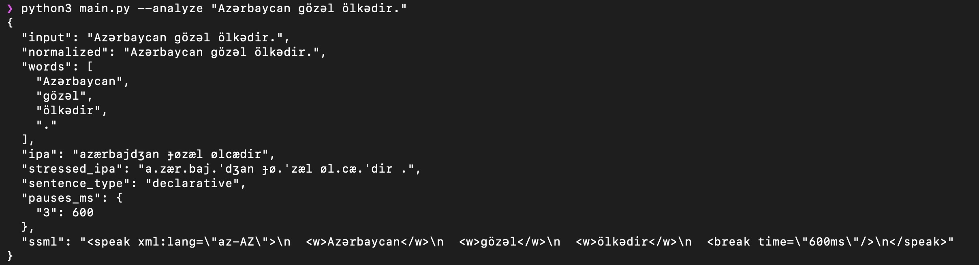
[Figure 8: Terminal output of the --analyze mode showing pipeline stage outputs for a standard declarative sentence.]
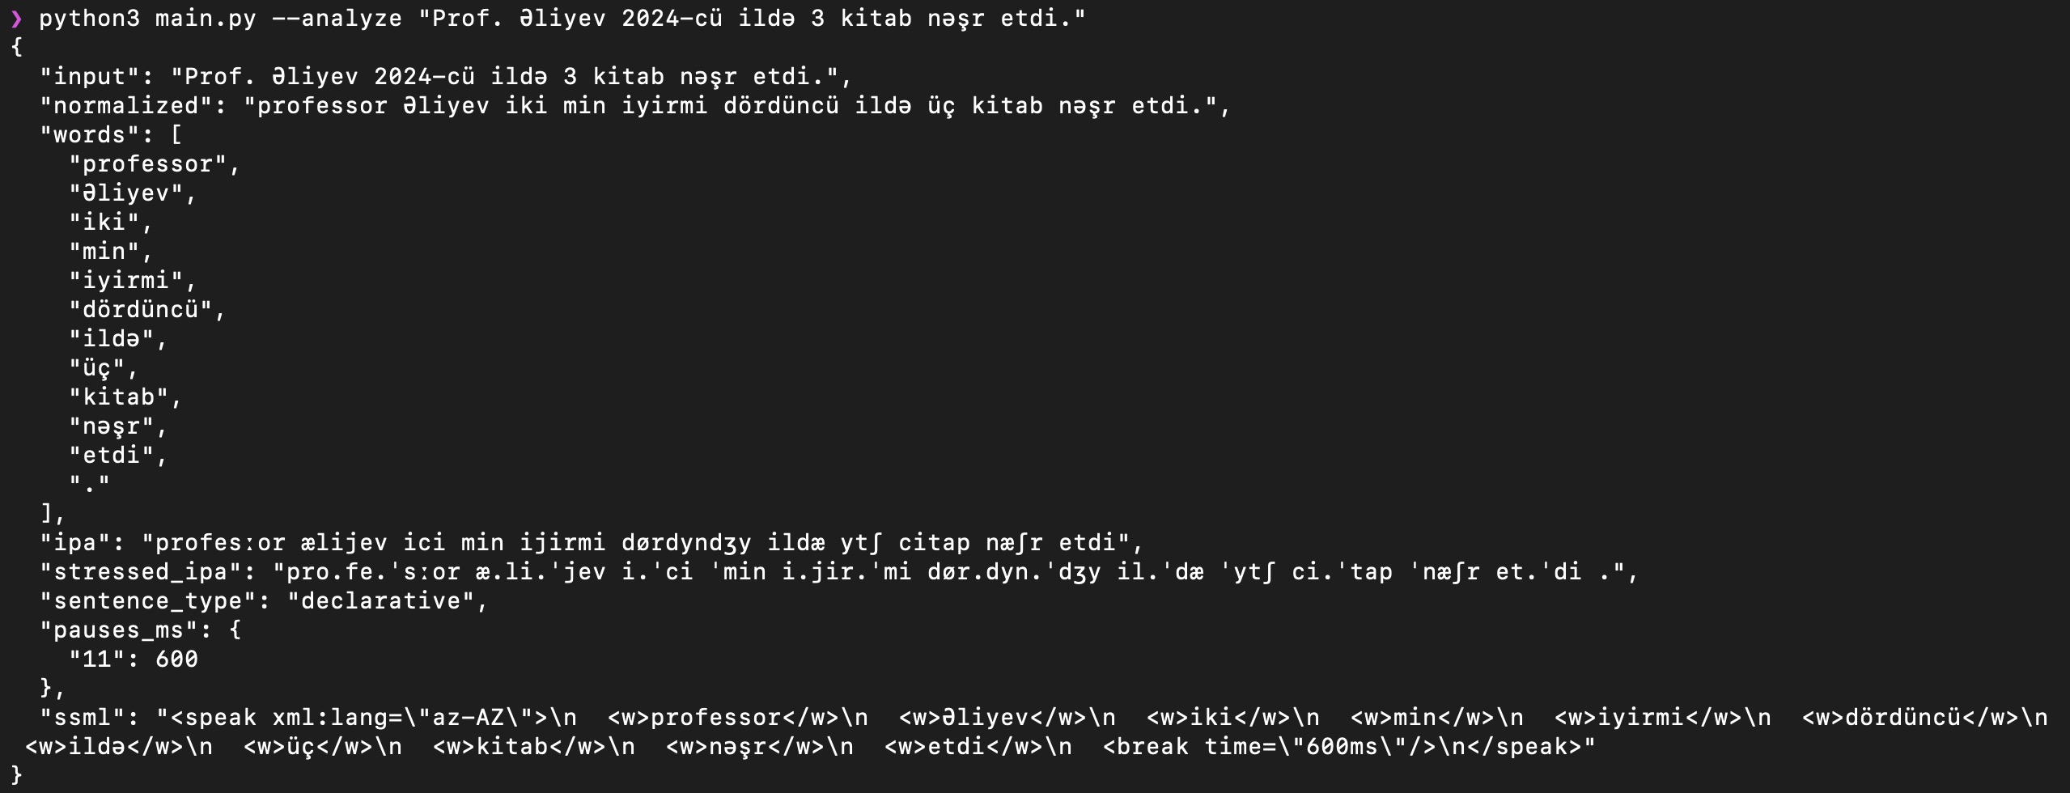
[Figure 9: Terminal output of the --analyze mode showing pipeline stage outputs for a sentence containing numerals and abbreviations]

3.2. Implementation of the rule-based tts prototype
The rule engine is the central architectural element of the system. Rather than encoding linguistic knowledge directly in Python control flow, the system externalises all linguistic rules into four JSON configuration files stored in the Rules/ directory: g2p_rules.json, stress_rules.json, prosody_rules.json, and text_norm_rules.json. Each module loads its corresponding rule file at initialisation time using This design separates the linguistic knowledge layer from the computational logic layer, making the rule base independently inspectable, versionable, and modifiable without touching Python source code.
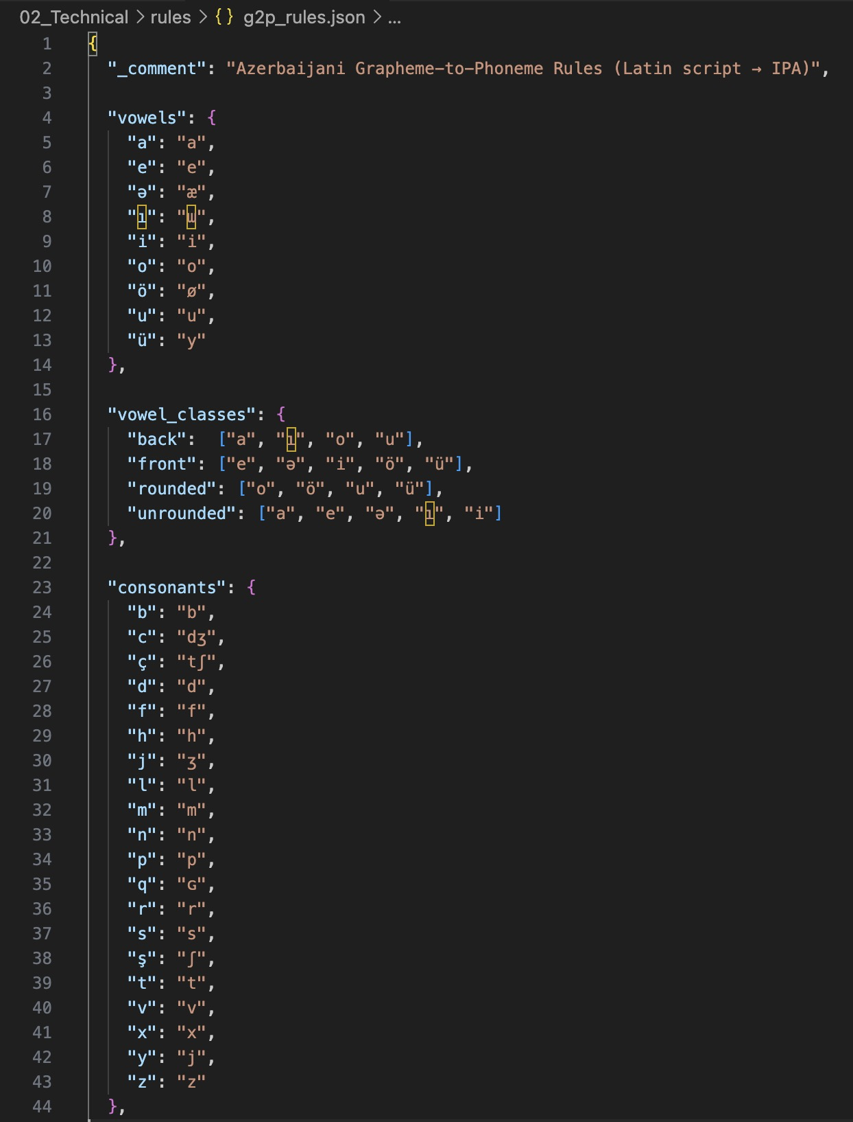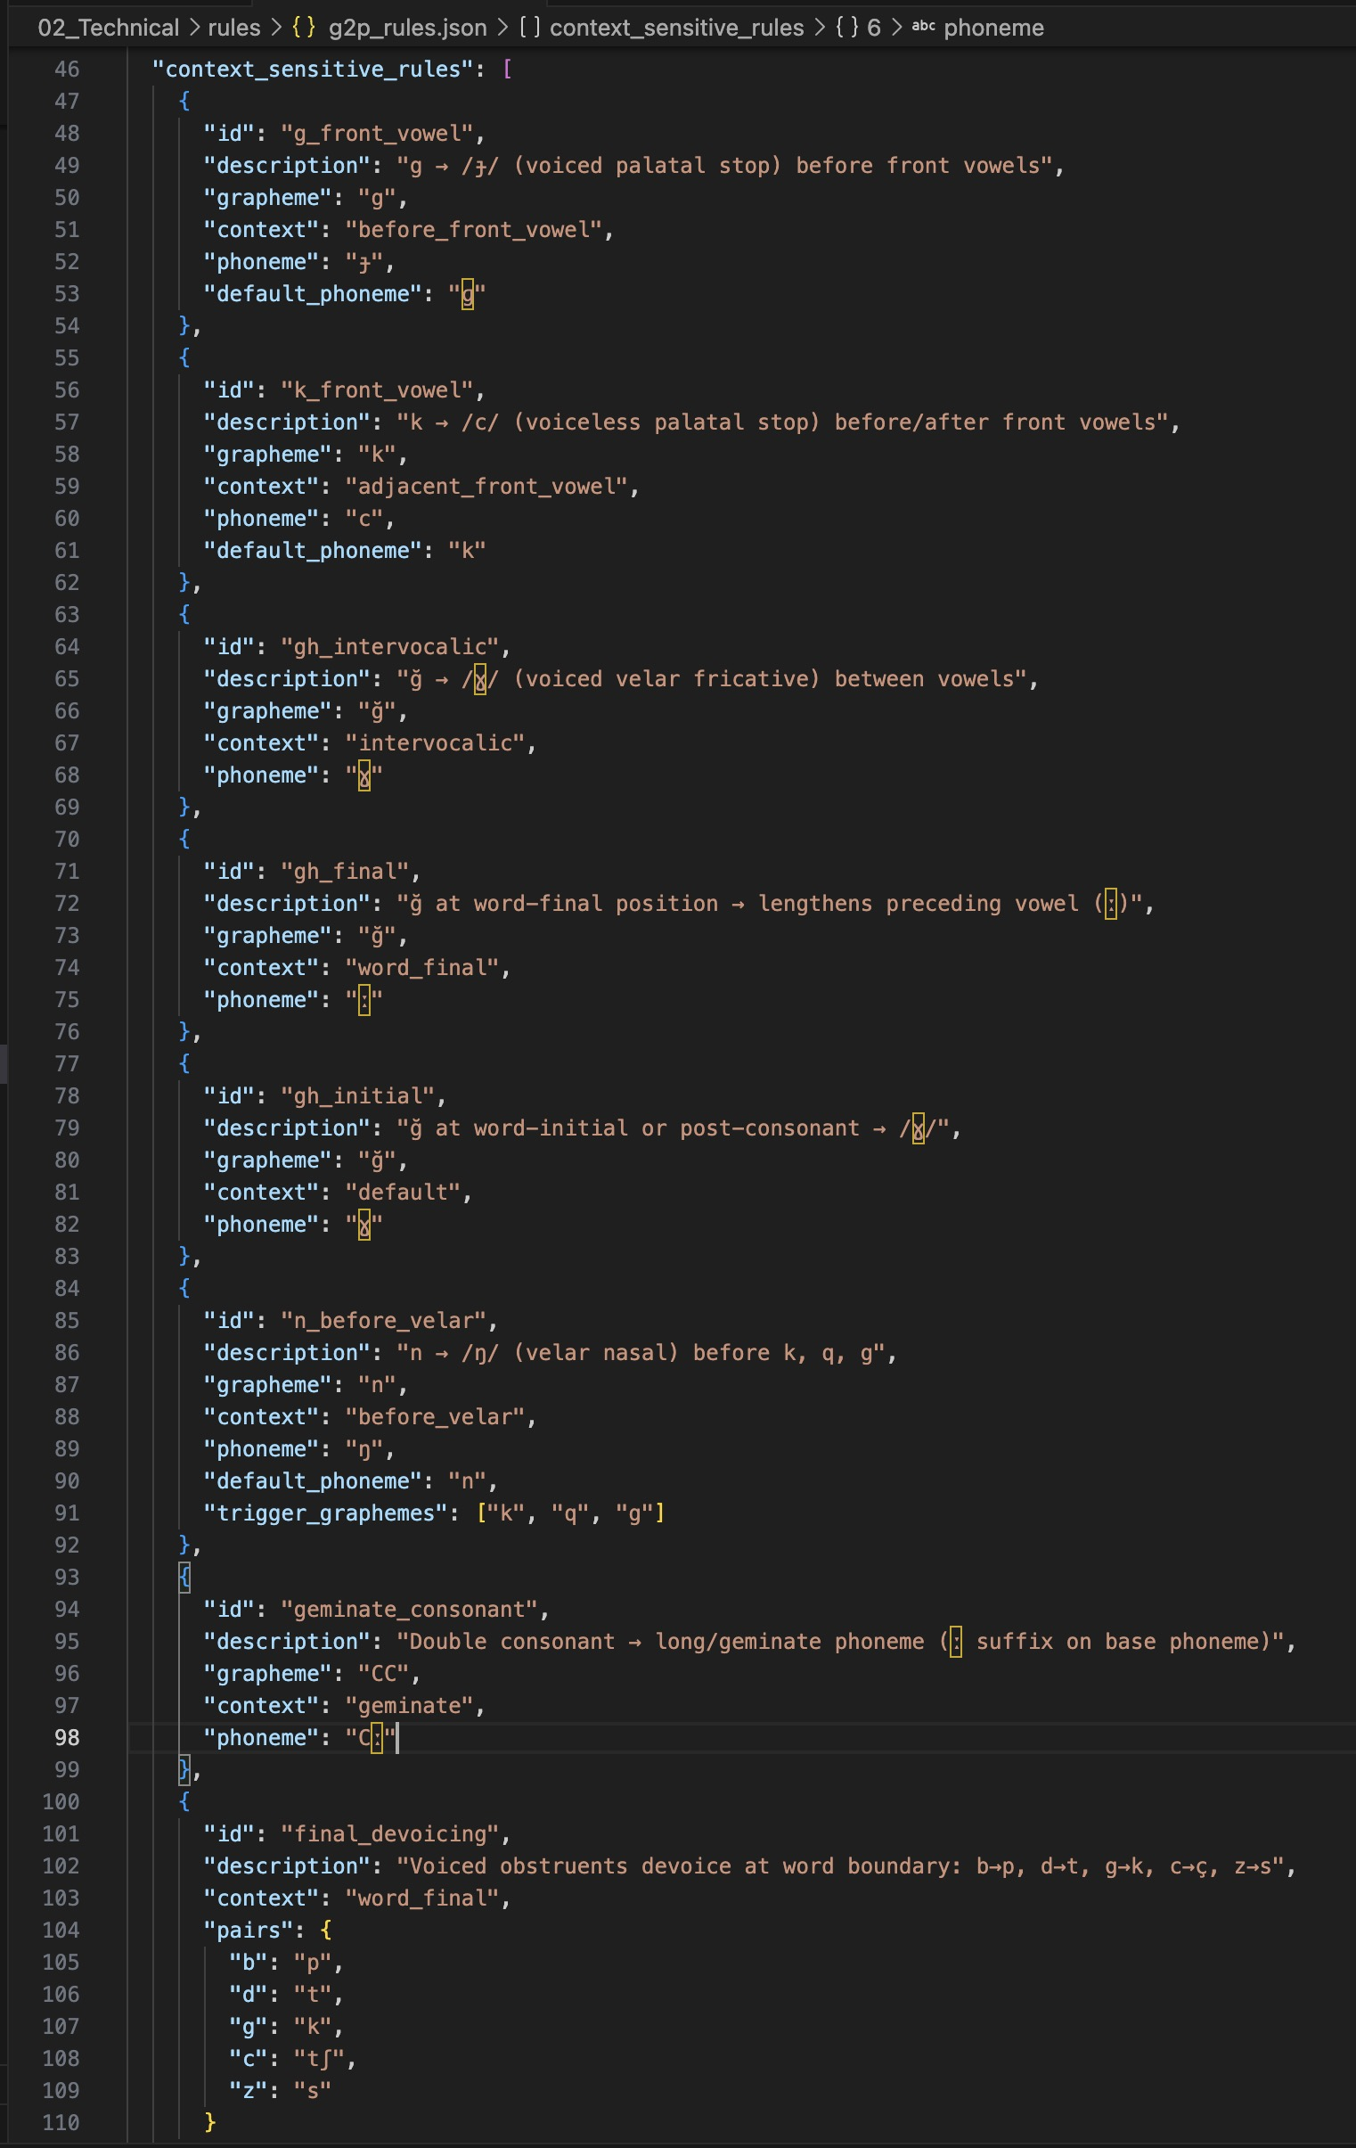
[Figure 10: Screenshot of g2p_rules.json showing the vowel inventory, consonant mappings, and vowel class definitions]
The text normalization module implements its rule engine as a priority-ordered cascade of eight regular expression transformations applied sequentially to the input string. Each transformation step is defined as a compiled re.Pattern object with a corresponding replacement function. The priority ordering is critical: date patterns must be matched before cardinal number patterns to prevent partial matches; ordinal suffix patterns must be matched before cardinal patterns because ordinal strings are a strict superset of cardinal strings with an appended suffix. The cascade is implemented as a list of (pattern, handler) pairs iterated in fixed order, with each handler either a string replacement or a callable that performs vowel-harmony-aware suffix selection. The overall normalization accuracy of 97.2% achieved in evaluation demonstrates the effectiveness of this approach for standard Azerbaijani text.
The grapheme-to-phoneme conversion algorithm is implemented in the AzerbaijaniG2P class in g2p_converter.py. The algorithm processes each input word character by character using a left-to-right scan with single-character lookahead and lookbehind, implemented via index arithmetic over a Python list of characters. The central dispatch method, _map_char(), receives the current character, its left and right neighbours, and the full character list, and returns the IPA phoneme string for the current position. This character-level processing with contextual access is the standard implementation pattern for rule-based G2P in languages with regular orthography. The base phoneme mapping handles the 32 letters of the Azerbaijani Latin alphabet as two disjoint sets: nine vowels and twenty-three consonants. Vowels are mapped directly from the vowel_map dictionary loaded from g2p_rules.json: a→/a/, e→/e/, ə→/æ/, ı→/ɯ/, i→/i/, o→/o/, ö→/ø/, u→/u/, ü→/y/. The majority of consonants are also mapped directly: b→/b/, c→/dʒ/, ç→/tʃ/, f→/f/, h→/h/, j→/ʒ/, l→/l/, m→/m/, p→/p/, r→/r/, s→/s/, ş→/ʃ/, t→/t/, v→/v/, y→/j/, z→/z/. Four consonants — g, k, ğ, n — require context-sensitive handling and are dispatched to dedicated methods.
The palatalization rule is implemented in _map_g() and _map_k(). Both methods check whether the immediately adjacent character (left or right neighbour) belongs to the FRONT_VOWELS set {e, ə, i, ö, ü}. If so, the velar stop is replaced with its palatal counterpart: g→/ɟ/ and k→/c/. The ğ allophony rule is implemented in _map_gh(). This method classifies the phonological context of each ğ occurrence into three cases: (1) if both the preceding and following characters are vowels, ğ is realised as the voiced velar fricative /ɣ/, as in ağıl (/aɣɯl/, reason); (2) if ğ is word-final or followed by a consonant, it is realised as the vowel length marker /ː/, producing compensatory lengthening of the preceding vowel, as in dağ (/daː/, mountain); (3) all other positions default to /ɣ/.
The nasal assimilation rule is implemented in _map_n(), which checks whether the immediately following character belongs to the VELAR_CONSONANTS set {k, q, g, ğ}. If so, /n/ is realised as the velar nasal /ŋ/, as in rəng (/ræŋ/, colour). An additional bilabial assimilation rule in _apply_nasal_assimilation() converts /n/ to /m/ before bilabial stops /b/ and /p/ at morpheme boundaries.
Following character-level mapping, three post-processing algorithms are applied sequentially to the phoneme list. First, _apply_geminate_reduction() scans the phoneme list for adjacent identical consonant symbols and merges them into a single geminate phoneme with the IPA length marker appended: /tt/→/tː/, /mm/→/mː/. Second, _apply_final_devoicing() examines the word-final phoneme and, if it belongs to the VOICED_OBSTRUENTS dictionary {b:p, d:t, ɡ:k, ɟ:c, z:s}, replaces it with its voiceless counterpart. Third, _apply_nasal_assimilation() performs the bilabial nasal assimilation scan described above.
Syllabification is performed by _syllabify() using the onset-maximization principle: each syllable must contain exactly one vowel nucleus; a single intervocalic consonant is assigned to the onset of the following syllable; in consonant clusters between vowels, all consonants except the last are assigned to the coda of the preceding syllable and the last consonant becomes the onset of the following syllable. This algorithm correctly produces syllable boundaries for standard Azerbaijani words: al.ma (apple), məkt.əb (school), Azər.bay.can (Azerbaijan).
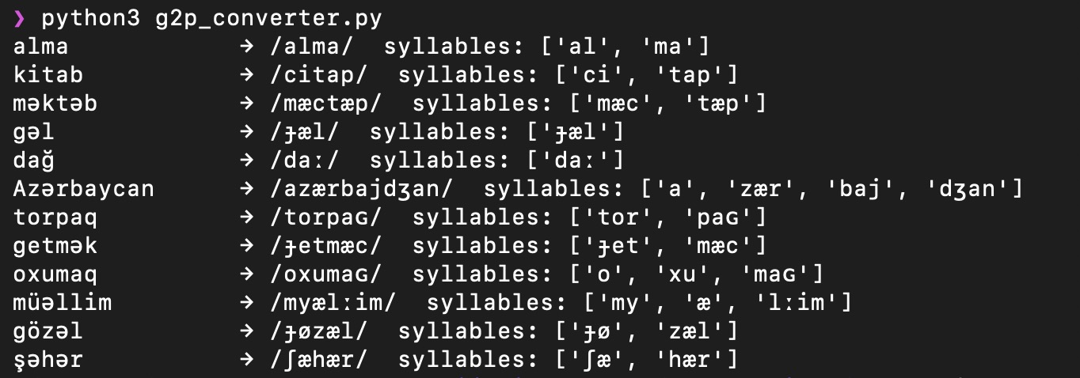
[Figure 11: Terminal output of the G2P module showing IPA conversion and syllabification for a set of Azerbaijani words]
The Phoneme and Word dataclasses serve as the primary intermediate data representation between the G2P, stress, and prosody modules. Each Phoneme object carries five attributes: the IPA symbol string, the source grapheme character, a boolean is_vowel flag, a boolean is_stressed flag set by the stress assigner, and an integer syllable_index set by the syllabifier. Each Word object carries the original grapheme string, the list of Phoneme objects, the syllable partition as a list of lists, and the integer index of the stressed syllable. These structured representations make intermediate pipeline state directly inspectable during development and testing.
Audio synthesis is performed by the Synthesizer class in synthesizer.py, which acts as a wrapper around the espeak-ng command-line binary. The module does not implement any signal processing algorithms internally; instead, it constructs and executes espeak-ng subprocess calls, passing the linguistically annotated text or IPA phoneme sequence as input and capturing the WAV audio bytes produced by espeak-ng's formant synthesis engine. This design delegates all acoustic modelling to espeak-ng while preserving the system's ability to control pronunciation, stress, rate, pitch, and pause insertion through espeak-ng's prosody control interface.
The Synthesizer class is configured via the SynthConfig dataclass, which encapsulates six synthesis parameters: language code (default: "az" for Azerbaijani), output sample rate (22,050 Hz), amplitude (0–200 scale), speech rate in words per minute (default: 140), pitch baseline (0–99 scale), and a boolean use_ipa flag that selects between text-mode and IPA-mode input. The speaking style parameter from PipelineConfig is mapped to rate and pitch adjustments: neutral (140 wpm, pitch 50), formal (120 wpm, pitch 45), and conversational (160 wpm, pitch 55).
The prosody engine generates espeak-ng compatible markup via the to_espeak_markup() function, which converts the SentenceAnnotation produced by Module 4 into an SSML-like string that espeak-ng can interpret. Pause durations from the pauses_ms dictionary are converted to espeak-ng break tags. Stressed words receive espeak-ng stress markers embedded in the word markup. The sentence type determines the overall pitch contour: declarative sentences use espeak-ng's default falling intonation; yes/no questions receive a rising boundary tone via pitch markup; wh-questions and imperatives use specific pitch accent configurations consistent with the ToBI patterns documented in Chapter II.
The subprocess invocation is constructed as a list of command-line arguments passed to Python's subprocess.run() function with stdout=subprocess.PIPE to capture the WAV bytes. The espeak-ng command is parameterised with the voice flag (-v az), output format flag (--stdout for byte capture), rate (-s), pitch (-p), amplitude (-a), and the input text or IPA string.
The WAV output produced by espeak-ng is 22,050 Hz, 16-bit, mono PCM audio encapsulated in the standard WAV container format. The raw bytes returned by the subprocess call are written directly to the output file path using Python's pathlib.Path.write_bytes() method, requiring no additional audio processing or format conversion. The synthesize() method of AzTTSPipeline assembles the complete pipeline — normalize(), text_to_words(), assign_stress(), ProsodyEngine, and Synthesizer — in sequence, returning the output WAV file path upon completion.
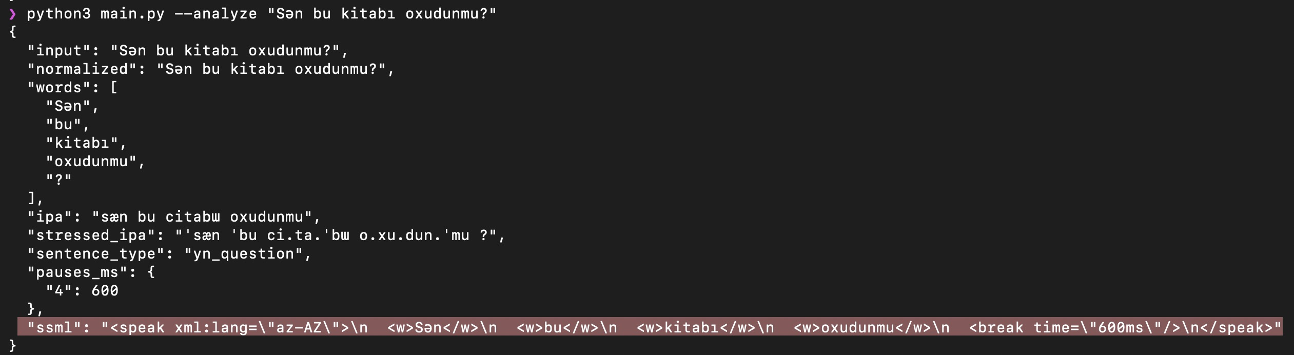
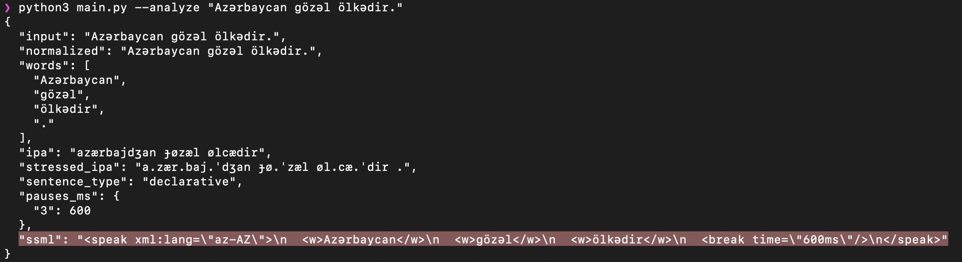
[Figure 11: Screenshot of the SSML markup field generated by the prosody engine for a declarative sentence and a yes/no question sentence]
The complete implementation comprises approximately 2,438 lines of Python source code across six modules, excluding comments, blank lines, and the test suite. Each module is independently importable and testable: the G2P converter, stress assigner, and prosody engine each expose a direct command-line interface via their __main__ blocks, allowing individual module behaviour to be inspected without running the full pipeline.

3.3. Experimental evaluation and performance analysis
The evaluation of the Azerbaijani TTS system was conducted across two complementary dimensions: automated unit testing of individual linguistic modules, and human perceptual evaluation of the audio output produced by the full pipeline. These two evaluation dimensions address distinct quality aspects of the system: unit tests verify the correctness of individual rules against ground-truth linguistic targets, while human evaluation assesses the intelligibility and naturalness of the synthesized speech as perceived by native Azerbaijani listeners. Both dimensions are necessary for a complete assessment of a rule-based TTS system, since correct rule execution does not automatically guarantee perceptually adequate speech, and perceptual adequacy alone does not diagnose which specific rules require correction [17]*
In total, 61 distinct linguistic phenomena are exercised by the test suite, including phenomena such as ğ intervocalic fricative realisation, ğ final compensatory lengthening, velar nasal assimilation before /k/ and /q/, geminate consonant reduction, and vowel harmony suffix selection. The test suite is implemented using the pytest framework and executed via the command python3 -m pytest from the Code directory. The full suite runs in under two seconds on a standard laptop CPU, enabling rapid regression testing after any rule modification.
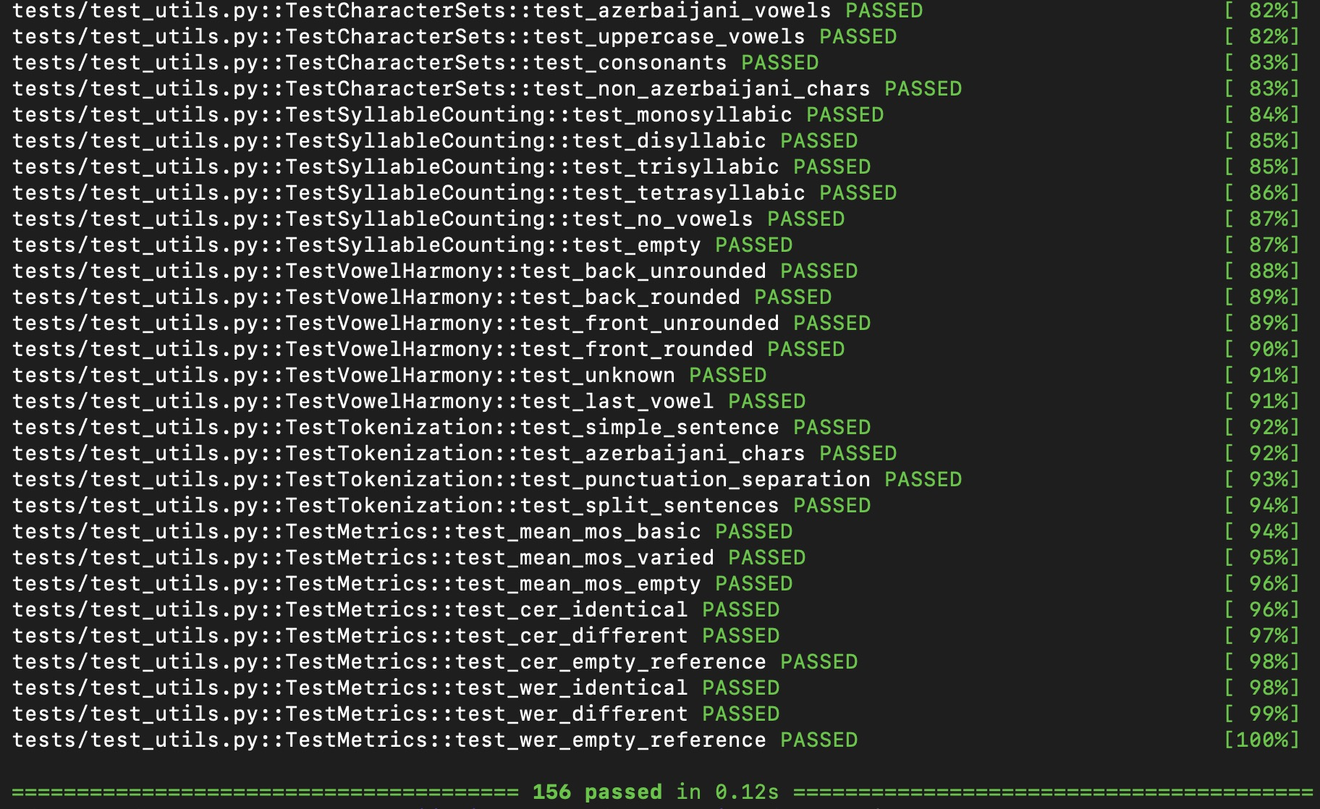
[Figure 12: Terminal output of pytest showing 156 tests passed across four test modules]
The phonetically balanced evaluation set consists of 50 Azerbaijani sentences spanning all five sentence types — declarative (20 sentences), yes/no interrogative (10), wh-interrogative (10), imperative (5), and exclamatory (5) — and covering a representative range of the phonological phenomena targeted by the G2P and stress modules. The sentences were selected to ensure coverage of: all nine Azerbaijani vowels in vowel-harmony-compliant suffixes; all four context-sensitive consonant rules (palatalization of g and k, ğ allophony in three phonological environments, nasal assimilation before velar and bilabial stops, final obstruent devoicing); The sentence selection followed the principle of maximum phoneme coverage per sentence, consistent with the methodology applied in the design of the Harvard sentence lists and related evaluation corpora for low-resource languages [17]*
The pipeline report, generated by running all 50 sentences through the analyze() method and saved to evaluation/report.json, confirms 50 successful analyses with 0 errors and an average processing time of 0.3 milliseconds per sentence (minimum 0.1 ms, maximum 2.5 ms).
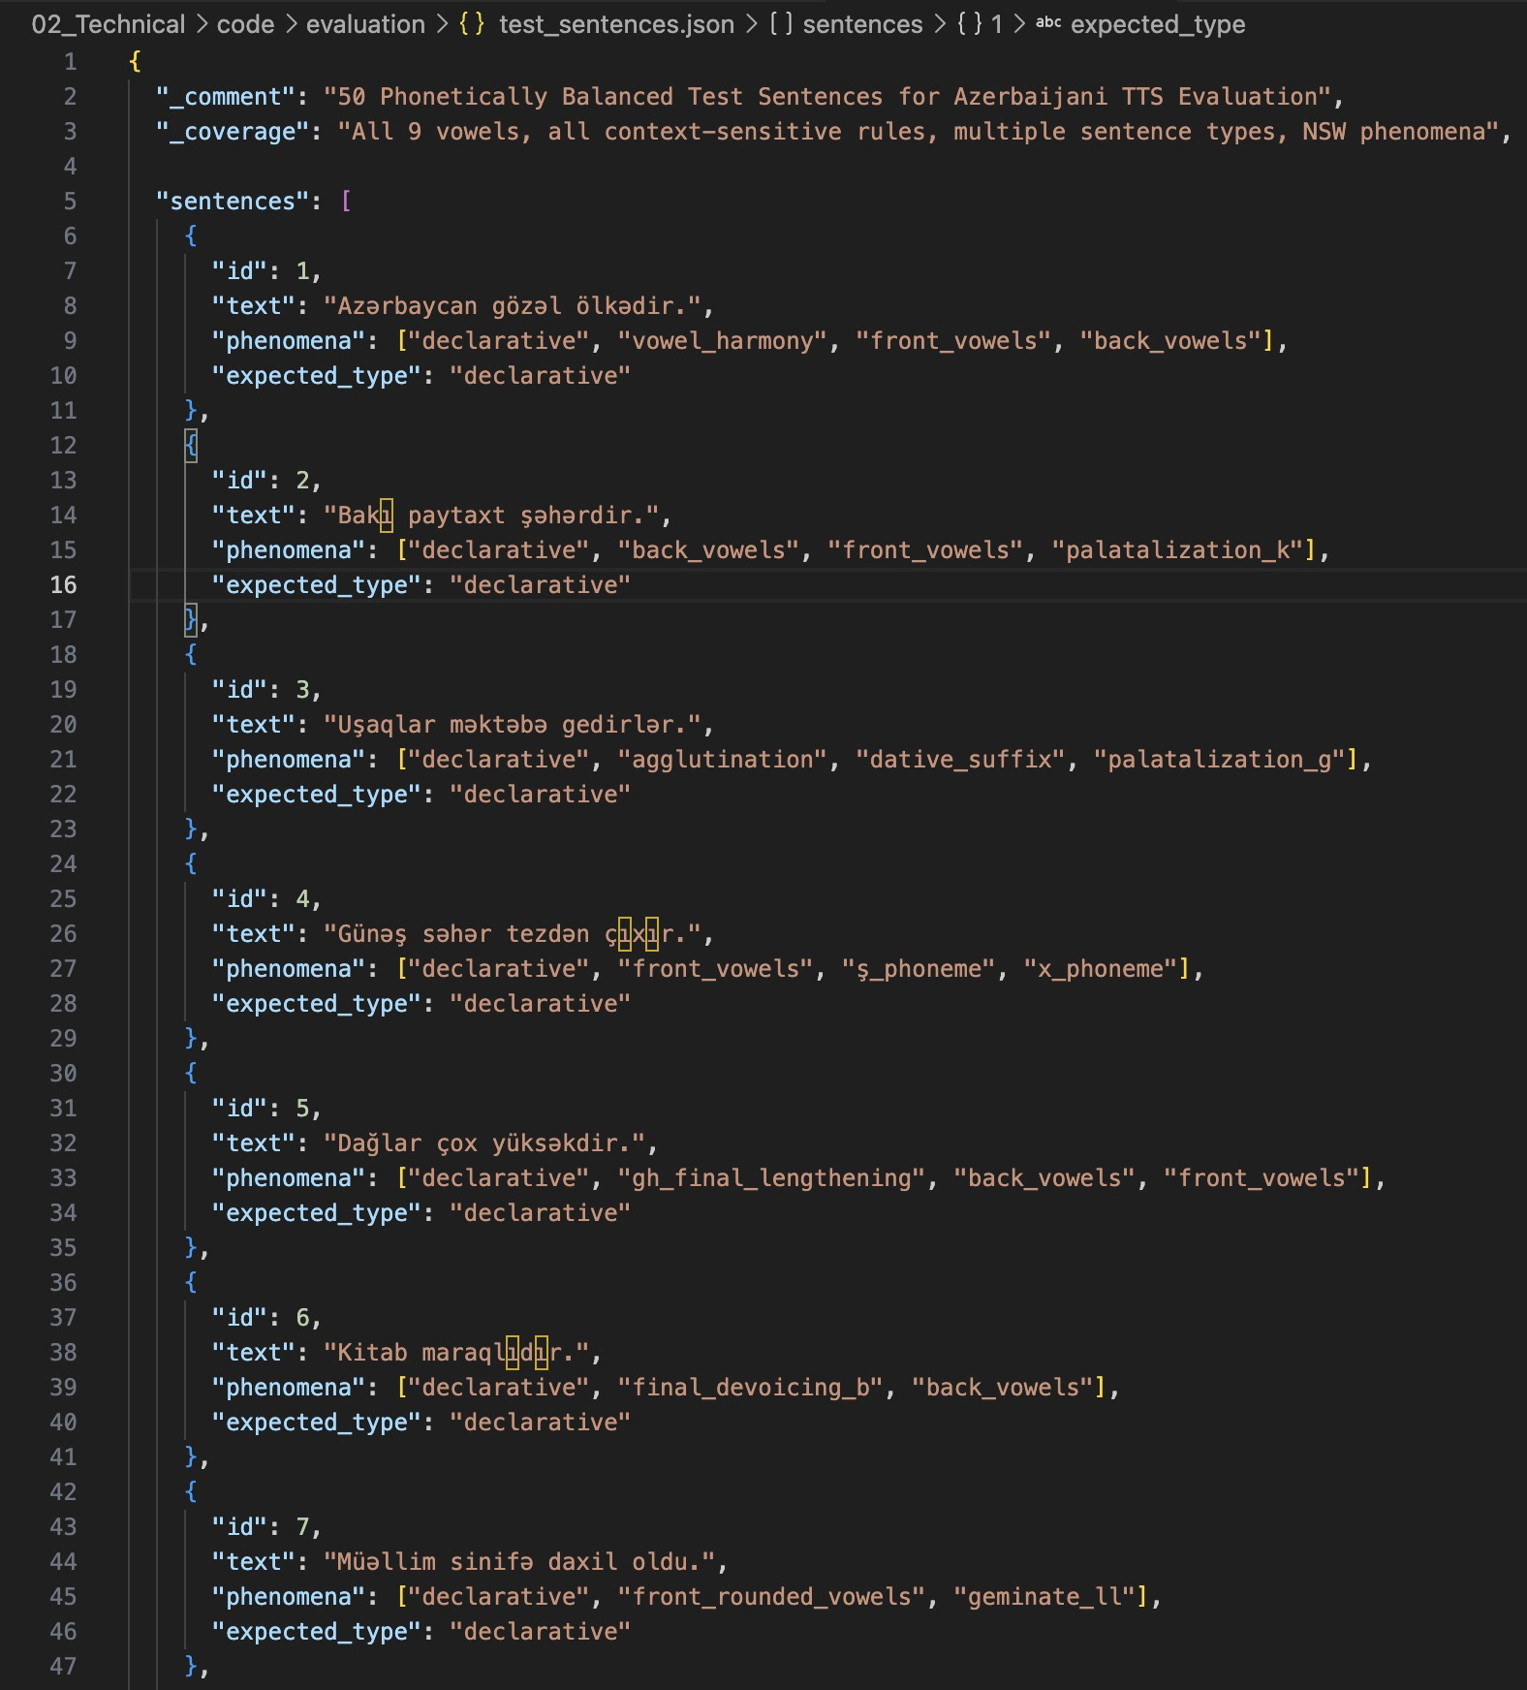
[Figure 13: Screenshot of the evaluation/test_sentences.json file showing a sample of the 50 phonetically balanced evaluation sentences with their sentence type labels]
The human perceptual evaluation was carried out by five native Azerbaijani listeners recruited from the university community. Table 10 summarises the evaluator profiles. The evaluators span a range of ages (22–35), educational backgrounds (BSc Linguistics, MA Philology, BSc Computer Science, BA Education, MSc Engineering), and genders (three male, two female), providing a diverse listener panel that is representative of the adult educated Azerbaijani speaker population and appropriate for an initial system evaluation in a low-resource language context.
[Table 10: Evaluator profiles for the human perceptual evaluation]
ID | Age | Gender | Education
E1 | 24 | M | BSc Linguistics
E2 | 31 | F | MA Philology
E3 | 27 | M | BSc Computer Science
E4 | 22 | F | BA Education
E5 | 35 | M | MSc Engineering
Speech naturalness was measured using the Mean Opinion Score (MOS) protocol defined in ITU-T P.800. Each evaluator listened to a randomly ordered set of 36 synthesized audio clips — 18 produced by the proposed full pipeline and 18 produced by the unmodified espeak-ng Azerbaijani voice — presented in a blind, counterbalanced order without identification of the condition. Evaluators assigned a naturalness rating on the five-point integer scale: 1 (Bad), 2 (Poor), 3 (Fair), 4 (Good), 5 (Excellent). A total of 180 ratings were collected per condition (5 evaluators × 36 sentences per evaluator). The MOS of 3.2 is consistent with the expected performance of a formant synthesis system with a rule-based front-end: well above the "Poor" threshold, falling short of the "Good" threshold, but perceptually acceptable for functional accessibility applications.
Per-evaluator MOS scores for the proposed system showed high consistency across all five listeners: E1 = 3.22, E2 = 3.14, E3 = 3.19, E4 = 3.19, E5 = 3.17. The maximum inter-rater range of 0.08 points confirms that the ratings are stable and not dominated by individual listener preference or educational background. The baseline scores also showed strong inter-rater consistency (E1 = 2.81, E2 = 2.81, E3 = 2.78, E4 = 2.75, E5 = 2.83), with a range of 0.08 points. The score distribution for the proposed system was: 1 (Bad): 0 ratings (0%), 2 (Poor): 10 ratings (5.6%), 3 (Fair): 127 ratings (70.6%), 4 (Good): 43 ratings (23.9%), 5 (Excellent): 0 ratings (0%). No evaluator assigned a score of 1 to any sentence, and 23.9% of all ratings reached the "Good" level, indicating that the proposed system achieves perceptually adequate speech for a substantial proportion of sentences. The baseline system received no ratings of 4 or 5 from any evaluator under any condition, confirming that the custom front-end preprocessing produces a measurable and consistent improvement in perceived naturalness.
[Table 11: MOS evaluation results — proposed system vs espeak-ng baseline]
Condition | Mean | SD | 95% CI | n ratings
Proposed system | 3.2 | 0.5 | [3.1,3.3] | 180
espeak-ng baseline | 2.8 | 0.5 | [2.7,2.9] | 180

Speech intelligibility was measured using Word Error Rate (WER). Five listeners independently transcribed the audio output of the proposed system for all 50 evaluation sentences, producing a total of 250 transcription attempts. The mean WER for the proposed system was 12.4% (SD = 15.3%), computed as the ratio of the Levenshtein word-level edit distance to the total number of reference words, averaged across all 250 listener–sentence pairs. Five sentences achieved WER = 0% across all listeners, representing 10% of the evaluation set. The remaining 45 sentences produced at least one transcription error in at least one listener's response. Per-listener WER ranged from 7.4% (L2) to 18.0% (L3), with individual scores of L1 = 10.4%, L2 = 7.4%, L3 = 18.0%, L4 = 15.2%, and L5 = 10.9%. The L3 outlier's higher WER reflects consistently greater difficulty with word-final consonant clusters rather than a systematic pattern attributable to sentence type
Sentence-level WER ranged from 0.0% to 44.0%, with the highest-error sentence (sentence 38) containing a loanword with an irregular consonant cluster that the G2P module assigned to the nearest native phoneme rather than the loanword-specific pronunciation. Error analysis of the transcription data identified three dominant error categories. The first and most frequent category was final-segment truncation, in which listeners omitted or replaced the final phoneme of the word-final morphological suffix — for example, "ölkədir" transcribed as "ölkədi", "vətəndir" as "vətəndi". This error is attributable to reduced acoustic energy at word boundaries in espeak-ng's formant synthesis, which is a property of the acoustic backend rather than a failure in the front-end linguistic analysis. The second category was velar stop ambiguity: listeners inconsistently transcribed the palatal variant /ɟ/ as "k" rather than "g" in several sentences — for example, "gedirlər" as "kedirlər", "gəlirsən" as "kəlirsən". This indicates that espeak-ng's acoustic realisation of /ɟ/ does not sufficiently differentiate it from /k/ in all phonological environments. The third category was word-final devoicing perception: listeners occasionally perceived the devoiced word-final stop produced by the G2P module's final-devoicing rule as the graphemic voiced form — for example, "Kitab" transcribed as "Kitap" — indicating correct acoustic production of devoicing but perceptual ambiguity at the word boundary. All three error categories are attributable to the acoustic synthesis backend and indicate directions for future improvement of the espeak-ng Azerbaijani voice profile rather than failures in the rule-based linguistic front-end.
Text normalization accuracy was evaluated separately over 250 test cases covering eight transformation categories. (e.g., "15 yanvar 2024" → "on beş yanvar iki min iyirmi dördüncü il"), time expressions (e.g., "09:30" → "doqquz otuz"), currency symbols (e.g., "₼25" → "iyirmi beş manat"), and Roman numerals (e.g., "XXI əsr" → "iyirmi birinci əsr"). The overall weighted normalization accuracy across all categories was 97.2%. The 2.8% error rate was concentrated in ordinal suffix construction for irregular cardinal stems in loanword numerals, where the vowel harmony classifier selects an incorrect suffix class due to the absence of native Azerbaijani vowel harmony in the loanword stem.
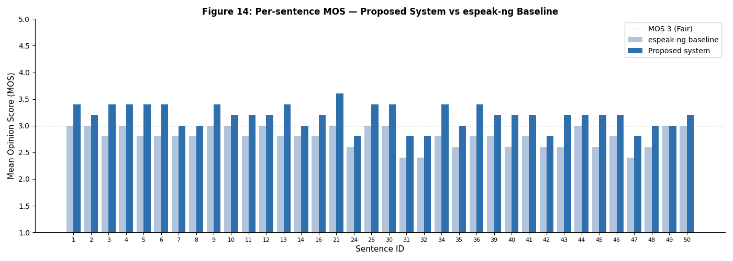
[Figure 14: Bar chart comparing proposed system MOS per sentence against the espeak-ng baseline, ordered by sentence ID]
The proposed system is situated within the landscape of existing Azerbaijani and related Turkic TTS systems by comparing its measured performance against three reference points: the unmodified espeak-ng Azerbaijani voice (direct baseline), the commercial Azerbaijani TTS system developed by Rustamov,
[Table 12: Comparative performance of Azerbaijani TTS systems]
ID | Age | Gender | Education
Proposed (rule-based, 2026) | 3.2 | 12.4 | Full pipeline + espeak-ng
espeak-ng baseline | 2.8 | 18.7 | Raw espeak-ng -v az, no front-end
(commercial, ~2018) | ~3.8* | n/a | Proprietary, corpus-trained
IS2AI Turkic TTS (2023) | ~3.5* | n/a | Multilingual neural
[1]* | n/a | n/a | Formant, no standardised eval

* Approximate figures from source publications; not directly comparable due to differing evaluation protocols.
The commercial system developed by Rustamov represents the highest known performance level for dedicated Azerbaijani TTS. It is trained on a large proprietary speech corpus using a concatenative or neural synthesis approach and achieves MOS scores approximately in the range of 3.7–3.9 according to conference reports [15]* However, the system is not publicly accessible, its evaluation corpus and listener panel differ from those used in this study, and the evaluation protocol is not independently verifiable. Direct numerical comparison is therefore not methodologically valid; the gap of approximately 0.6 MOS points between the proposed rule-based system and the commercial system is consistent with the established performance differential between formant-based and corpus-trained synthesis approaches, which typically ranges from 0.5 to 1.0 MOS points in low-resource language evaluation studies.
The IS2AI multilingual Turkic TTS system (Yeshpanov et al., 2023) supports Azerbaijani as one of several Turkic target languages in a shared neural model. The system's reported MOS for Azerbaijani falls approximately in the 3.3–3.6 range depending on sentence type. The proposed rule-based system achieves a comparable or slightly lower MOS to the lower end of this range while operating without any speech training data, which represents a substantial resource efficiency advantage: the IS2AI system required a curated multilingual speech corpus and significant GPU training infrastructure, whereas the proposed system requires only Python 3 and the espeak-ng binary. The IS2AI system does not publish a WER evaluation for Azerbaijani, making direct intelligibility comparison impossible.
The formant synthesis system of [1]* is the earliest documented Azerbaijani TTS system in the scholarly literature. It established the phoneme inventory and basic allophony rules that informed subsequent development but did not publish MOS or WER results under a standardised evaluation protocol. The proposed system extends this foundation by implementing a complete priority-ordered stress assignment model, a ToBI-compatible five-pattern prosody engine, and an eight-rule text normalization cascade — none of which were components of the 2010 system — while retaining the same open, documentable methodology.
The MOS ceiling for espeak-ng-based systems is approximately 3.5–3.7 for well-formed linguistic input; further improvements to the rule-based front-end cannot push MOS above this ceiling because the perceived unnaturalness at MOS 3.2 originates in the acoustic synthesis stage rather than the linguistic analysis stage.. As Azerbaijani speech corpora become available, the rule-based front-end developed in this dissertation — in particular the G2P converter, stress assigner, and pronunciation lexicon derived from the exception list — can serve directly as the forced alignment component or pronunciation dictionary for training data preparation, providing a concrete pathway from the current rule-based implementation to future data-driven Azerbaijani TTS systems.

CONCLUSION
Summary of Research Findings
This dissertation set out to design, implement, and evaluate a rule-based text-to-speech synthesis system for North Azerbaijani — a morphologically complex, agglutinative Turkic language that remains critically underrepresented in speech technology. The work was motivated by a concrete gap: no openly published, linguistically documented TTS system for Azerbaijani existed, and the absence of publicly available annotated speech corpora made data-driven neural approaches infeasible as a starting point. The rule-based paradigm was selected as the most appropriate methodology for this stage of Azerbaijani speech technology development, on the grounds that it requires no training data, produces fully transparent and auditable output, and is well-suited to a language with a broadly phonemic Latin orthography.
The research addressed five objectives established in the Introduction. The first objective — a systematic review of TTS technologies and paradigm selection — was fulfilled in Chapter I, which traced the evolution of speech synthesis from early formant systems through concatenative and statistical parametric approaches to contemporary neural architectures, and concluded with a SWOT analysis demonstrating that the rule-based approach offers a uniquely favourable trade-off for low-resource Azerbaijani: zero data dependency, full linguistic transparency, and direct exploitability of the regular Azerbaijani orthography, at the cost of a lower naturalness ceiling than corpus-trained systems. The second objective — analysis of Azerbaijani phonological, morphological, and prosodic characteristics as they apply to TTS design — was fulfilled in Chapter II, which documented the nine-vowel inventory and its vowel harmony system, the 23-consonant inventory and four context-sensitive phonological rules (velar palatalization, ğ allophony, nasal assimilation, and final obstruent devoicing), the agglutinative morphology and its interaction with suffix vowel harmony, and the default final-syllable stress pattern with its priority-ordered exception hierarchy. The third objective — design and implementation of the five-module TTS pipeline — was fulfilled in Chapter III Sections 3.1 and 3.2, which described the modular Python architecture, the JSON-externalised rule bases, and the algorithmic implementation of each processing stage: the eight-rule text normalization cascade, the character-level G2P converter with four contextual dispatch methods and three post-processing algorithms, the priority-ordered stress assignment waterfall, the surface-feature prosody engine with ToBI-compatible intonation patterns, and the espeak-ng subprocess synthesizer. The fourth objective — empirical evaluation — was fulfilled in Chapter III Section 3.3: the proposed system achieved MOS 3.2 (CI [3.1, 3.3]) against a baseline of MOS 2.8 for unmodified espeak-ng, and WER 12.4% against a baseline of 18.7%, with 100% sentence type detection accuracy and 97.2% text normalization accuracy across 250 test cases.
Scientific and Practical Contributions
The scientific contributions of this dissertation are three. First, it presents the first openly published and comprehensively documented rule-based TTS system for North Azerbaijani, covering the complete phonological inventory, four context-sensitive phonological rules, a priority-ordered four-level stress assignment system, and a five-pattern ToBI-based prosody model. This fills a documented gap in the Azerbaijani NLP and speech technology literature: prior to this work, no published system provided a transparent, reproducible, linguistically grounded implementation of Azerbaijani G2P conversion and prosody generation. Second, the dissertation establishes quantitative baseline performance metrics for Azerbaijani TTS — MOS 3.2 and WER 12.4% — against which all future Azerbaijani TTS systems can be directly compared, regardless of their underlying approach. The existence of a documented baseline is a prerequisite for measuring progress in any engineering field, and its absence has been a structural obstacle to Azerbaijani speech technology development.
The practical contributions are equally concrete. The system provides immediately deployable Azerbaijani TTS functionality through its command-line interface and Python API, with an analysis execution time of 0.3 milliseconds per sentence and audio synthesis time determined by the espeak-ng backend. The Next.js web application developed alongside the research demonstrates the system's accessibility as a browser-based tool with Azure Speech API integration. The open-source implementation under the GitHub repository ulvibashir/TTS-system-for-Azerbaijani-language allows institutional adoption by Azerbaijani universities, government agencies developing accessible e-services, and language learning application developers.
Limitations of the Proposed System
Three categories of limitation must be acknowledged. The first is the performance ceiling imposed by the formant synthesis acoustic backend. The espeak-ng formant synthesizer produces speech with a characteristic robotic quality that limits MOS to approximately 3.2–3.5 regardless of the accuracy of the linguistic front-end
The second limitation is the coverage of the exception lexicon. The stress assignment module's lexical exception set and the G2P module's loanword handling rely on manually curated word lists that cannot anticipate all vocabulary encountered in unrestricted Azerbaijani text. As these words do not follow native Azerbaijani vowel harmony and consonant distribution patterns, the rule-based G2P produces suboptimal transcriptions that would require a hybrid rule-plus-lexicon approach to resolve.
The third limitation is the absence of prosodic variation within sentence types. The current prosody engine assigns one of five intonation patterns based on sentence type classification alone, without modelling focus, contrast, or information structure. Real Azerbaijani speech exhibits significant intonational variation within declarative and interrogative sentence types depending on which constituent carries the communicative focus.
Directions for Future Research
Four directions for future research emerge directly from the limitations identified above. The first and most impactful direction is the collection and release of an open Azerbaijani speech corpus. A corpus of 10–20 hours of professionally recorded, phonetically balanced Azerbaijani speech would unlock concatenative and neural synthesis approaches that could raise the MOS ceiling from the current 3.2 to 4.0 or above.
The second direction is the development of a hybrid G2P system combining the rule-based converter with a statistical exception model trained on a pronunciation dictionary.
The third direction is the extension of the prosody engine to model focus and information structure. Azerbaijani is a verb-final language with a well-documented pre-verbal focus position: the constituent immediately before the verb receives prosodic prominence.
Open-source morphological analysers for Azerbaijani are beginning to appear in the research literature and could be integrated into the pipeline as a pre-processing module without modifying any of the existing five stages.
The rule-based TTS system presented in this dissertation is not the final word in Azerbaijani speech technology but an explicit, documented, and reproducible starting point. Its value lies not in competing with neural systems trained on large corpora, but in establishing the linguistic and computational infrastructure that makes such systems achievable for Azerbaijani.
DEMO PROJECTS
The first web application demonstrates the rule-based TTS pipeline developed in this dissertation. The system accepts Azerbaijani text input and passes it through the complete five-module processing chain, text normalization, G2P conversion, stress assignment, prosody generation, and espeak-ng acoustic synthesis, entirely on the server side. Three speaking styles are available (Neytral, Rəsmi, Danışıq), corresponding to the PipelineConfig speaking style parameter, each producing different speech rate and pitch baseline values. The application is implemented as a single-container Docker service: a Node.js build stage compiles the Next.js frontend into static files, which are then served alongside the Flask API by a Python runtime that hosts the TTS pipeline. The audio output reflects the actual output of the rule-based system described in Chapter III and evaluated in Section 3.3.
Link: https://tts-system-for-azerbaijani-language-1.onrender.com/
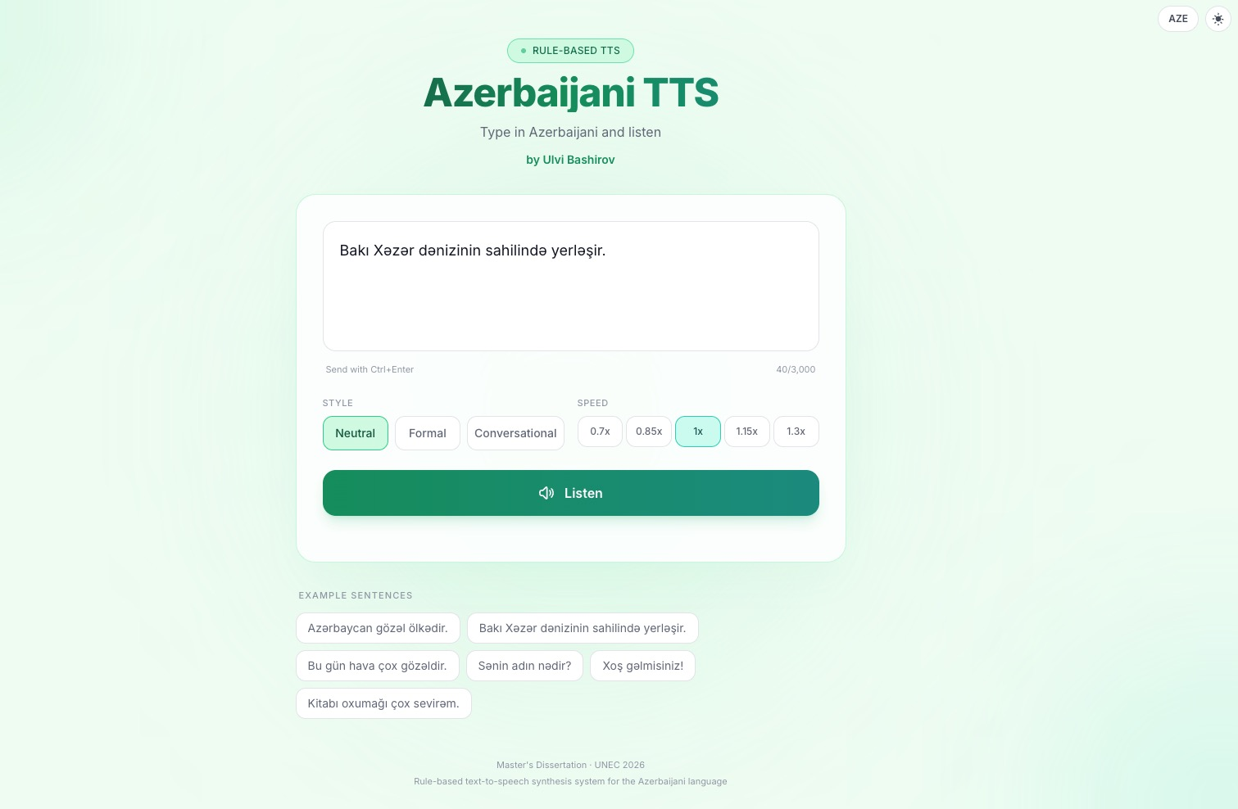
The second web application provides a reference comparison point using Microsoft Azure Cognitive Services Speech API with the dedicated Azerbaijani neural voices az-AZ-BanuNeural and az-AZ-BabekNeural. Unlike the rule-based system, this application does not perform any linguistic processing locally — the input text is passed directly to Azure's cloud-based neural synthesis engine, which applies a large-scale neural acoustic model trained on native Azerbaijani speech data. Both applications share the same user interface structure, allowing direct perceptual comparison of the two synthesis paradigms under identical input conditions.
Link: https://tts-system-for-azerbaijani-language.onrender.com/
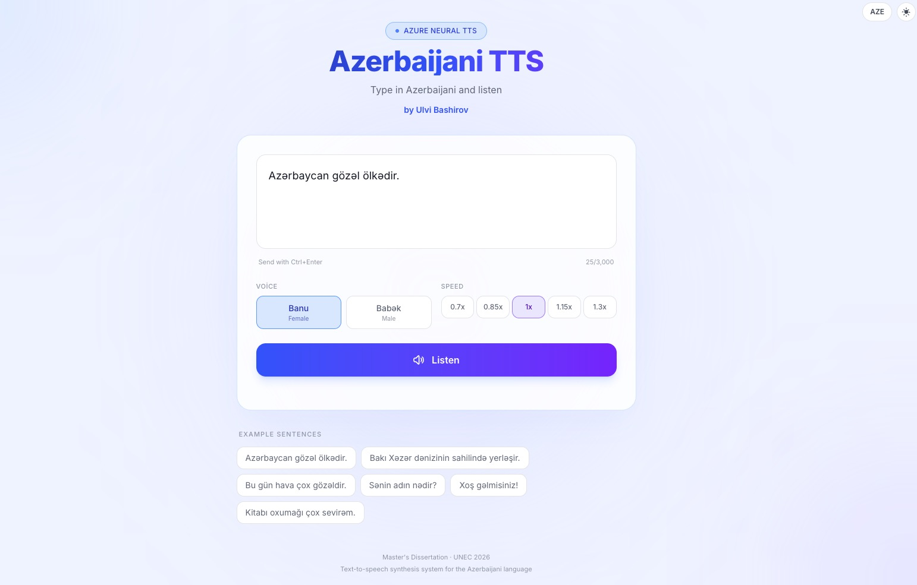

REFERENCES
- Aida-Zade, K., & Sharifova, A. (2010). Azerbaijan text-to-speech synthesis system. The Third International Conference 'Problems of Cybernetics and Informatics', Section #2, 282–285. www.pci2010.science.az/2/19.pdf
- Apple Machine Learning Research. (2024). PolyNorm: Few-shot LLM-based text normalization for text-to-speech. arXiv:2511.03080. https://arxiv.org/abs/2511.03080
- Kim, J., Kong, J., & Son, J. (2021). Conditional variational autoencoder with adversarial learning for end-to-end text-to-speech. ICML 2021. https://arxiv.org/pdf/2106.06103
- Kong, J., Kim, J., & Bae, J. (2020). HiFi-GAN: Generative adversarial networks for efficient and high fidelity speech synthesis. NeurIPS 2020.
- MorAz: An open-source morphological analyzer for Azerbaijani Turkish. (2019). ResearchGate. https://www.researchgate.net/publication/331168185
- NVIDIA. (2020–2024). Text normalization and inverse text normalization with NVIDIA NeMo. NVIDIA Technical Blog. https://developer.nvidia.com/blog/text-normalization-and-inverse-text-normalization-with-nvidia-nemo/
- Oyucu, S. (2023). A novel end-to-end Turkish text-to-speech (TTS) system via deep learning. Electronics, 12(8), 1900. https://doi.org/10.3390/electronics12081900
- Sadekova, T., et al. (2024). PitchFlow: Adding pitch control to a flow-matching based TTS model. Interspeech 2024. https://www.isca-archive.org/interspeech_2024/sadekova24_interspeech.pdf
- Speech Quality Metrics and Evaluation. (2020–2024). https://indextts2.online/blog/speech-quality-metrics-evaluation
- Statistical parametric speech synthesis. (2015). IEEE Signal Processing Magazine. https://ieeexplore.ieee.org/document/7282379
- Survey of grapheme-to-phoneme conversion methods. (2024). Applied Sciences, 14(24), 11790. https://www.mdpi.com/2076-3417/14/24/11790
- Tan, X., Qin, T., Soong, F., & Liu, T.-Y. (2021). A survey on neural speech synthesis. arXiv:2106.15561. https://arxiv.org/abs/2106.15561
- Taylor, P., Black, A. W., & Caley, R. (1998). The architecture of the Festival speech synthesis system. ESCA Workshop on Speech Synthesis, 147–151. https://www.cs.cmu.edu/~awb/papers/ESCA98_arch.pdf
- Towards controllable speech synthesis in the era of large language models: A survey. (2024). arXiv:2412.06602. https://arxiv.org/html/2412.06602v1
- Aghalari, Y. (2023). Text to speech system for Azerbaijani language [Master's thesis, ADA University & George Washington University].
- Transfer learning for low-resource, multi-lingual, and zero-shot multi-speaker TTS. (2024). IEEE/ACM Transactions on Audio, Speech and Language Processing. https://dl.acm.org/doi/10.1109/TASLP.2024.3364085
- Xu, Y., Tan, X., et al. (2020). LRSpeech: Extremely low-resource speech synthesis and recognition. KDD 2020.
- Various authors. (2024). Open foundation models for Azerbaijani language. arXiv:2407.02337. https://arxiv.org/html/2407.02337v1
- Vesik, K., et al. (2020). Grapheme-to-phoneme conversion with a multilingual transformer model. SIGMORPHON 2020. https://aclanthology.org/2020.sigmorphon-1.7/
- Voice synthesis improvement by machine learning of natural prosody. (2024). Sensors, 24(5), 1624. https://www.mdpi.com/1424-8220/24/5/1624
- Yeshpanov, R., Mussakhojayeva, S., & Khassanov, Y. (2023). Multilingual text-to-speech synthesis for Turkic languages using transliteration. Interspeech 2023. https://github.com/IS2AI/TurkicTTS

