# Overview

Thanks again for applying with us! We want to get to know you a little better and find out more about your background and experience. Please provide well-formed answers that provide real insight into your professional experience and approach to delivering working software. After we get a chance to read through your answers, we will contact you in two to three business days and set up your virtual interview with our team. Thanks again, and we’re looking forward to talking with you more soon!

# General Questions

1. What are the first things you do when reviewing someone else’s code?

The first thing I check is if the code is commented because it’s easier to look at human language describing what the code does and then it helps to understand the code itself. Then I check if the code has best practices such as modularity because that reduces the number of lines of code and it’s easier to maintain. And finally I check if it runs, to see if the code does what it is supposed to.

1. How do you determine if the code is “good” or “bad”?

If the code has best practices implemented , like SOLID, I say it’s a good code, even if it runs and it’s not structured I say it’s bad, because a code can run of many ways, a code with best practices is too much easier to read and maintain and it has more probabilities to run as well.

1. What are your guiding principles and practices for software development and team management? How did you learn them? How do you share them with your team?

My guiding principles are basically SOLID, I think SOLID got the main things to have code well structured. I learnt them when I worked with a Microsoft team and they set SOLID as a guide and when we used them the code was better done and with less code we could make a very good software. Also testing and maintaining tasks where very easy too.

We all knew how to use the SOLID principles because our leaders introduced them in a meeting and also in every “Daily Scrum” we were told to use them. So, the way I would share the SOLID principles (or any needed guide) would be through meetings just to make sure all the guides are well known by the team.

1. Tell us about a challenging bug you had to troubleshoot and resolve in a production environment. How did you find it, reproduce it, resolve it, and deploy it?

Once I was a member of very large project which included Entity Framework, and we were told to use Code First. All the tables generated by code first worked very good except for one. A friend of mine had trouble when doing any CRUD process with a single table and that was rare. So, if all the tables were created by “code first” there was a very little chance of failure (perhaps none) so probably that table was created by hand. So I compared the structure of the table in Microsoft SQL Server and the proxy class and one of the fields didn’t match with the proper parsing between a C# data type and a SQL data type, so I backed up the data of the that table, I erased it and I created the table with “migrating” commands and the problem was solved.

1. Tell us about a time you had to effectively manage your time between team member needs, your own development commitments, and client relationships.

When I worked in an Angular+Net Core project I was the Angular leader and so I was committed to do my job and also to help my team in any subject they needed. So I had to balance my time among my tasks as developer, my tasks as assistant to the team and also to deliver or give information to clients about our progress. At the beginning some of my developer’s tasks were delivered to some other partner to make sure the team reached the goals because I was 70% teaching things to my team , 20% developing and 10% talking to clients, but as time went by my team got more knowledge and so I could focus on developing and clients, hence the project ended up very well.

1. Tell us about a time you had to organize a team to meet an aggressive deadline. What steps did you take to ensure everyone could effectively meet the deadline?

I have never been in that scenario myself (to take the decisions) but I had to live it. What leaders did was to set more work hours per day and set new goals for that specific period of time with Scrum and see how we improved the speed of the project.

# Code Review

For the following questions, please review the code sample below. Imagine a developer on the team submitted this code in a pull request:

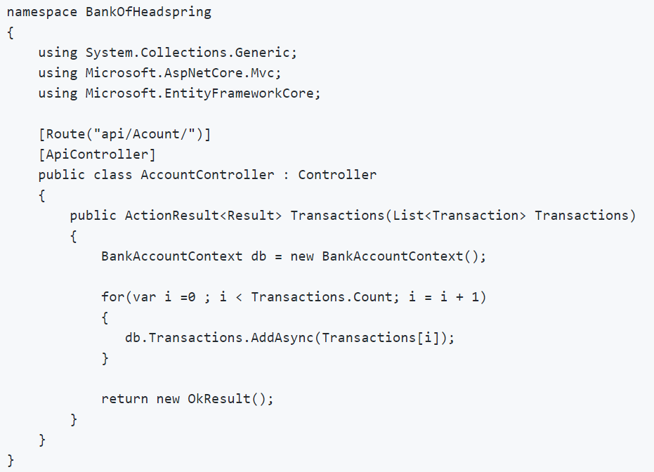

1. Please provide a comprehensive list of any issues you see with the code.

The only issue I see is the BankAccountContext, since the Controller needs this class then I would use dependency injection, any time a class depends on other it’s better to use DI, so that would be the only issue I find in the code.

1. What feedback would you give to the developer and how would you message it to them?

I would express my improvements as the following:

I think your code is good but I would recommend some fixes to improve it.

Every time a class depends on other class it’s better to used Dependency Injection, the controller needs the BanckAccountContext class so instead of calling it I would inject it. Another detail to improve would be the list of transactions’ iteration , as a list is already iterable I would use a foreach instead of a “for” loop.

# Coding Exercise

Tell us about your solution to the Coding Exercise.

1. What design tradeoffs did you make?

I figured out that the code needed to be very customizable, so I decided to create some structures so at any time you could add the token’s adaptation and the code could work for all the examples written in requirements.

1. How did you decide what testing framework to use?

I used .Net core from the beginning so I chose I Unit testing framework which matched with Net Core and C# language. For the rest of reasons I have seen most of Unit testing frameworks got same methods and concepts, so I think my election was fine.

1. What parts of the requirements were ambiguous? What assumptions did you make when the requirements were not clear?

The document said I didn’t have to use any command line arguments but then the requirements had some cases where I thought if it were necessary for the user to write some set of numbers to test so I asked if I understood well the requirements, as they said I didn’t have to use command line arguments parsed to the class so I decided to keep going.

1. What errors did you run into and how did you resolve them?

As I read the whole requirements I spent more time on trying to build a very good structure of the code so it could fit all the cases and I succeeded.

1. Is there anything you’d especially like to highlight about your solution that you felt demonstrated your design and development skills particularly well?

Yes, I planned an “all purpose” class so the user can set any number they want with any “divisor and token” parameters and the code will deliver the result.

1. What would you differently if you had to do this over again?

I would re think the possibility of using Dependency Injection for future code maintenance but my class didn’t depend on other class so the core concept wasn’t touch , hence D.I. is not needed but it would be interesting to see the results and the cost on maintenance between my current code and my do over.