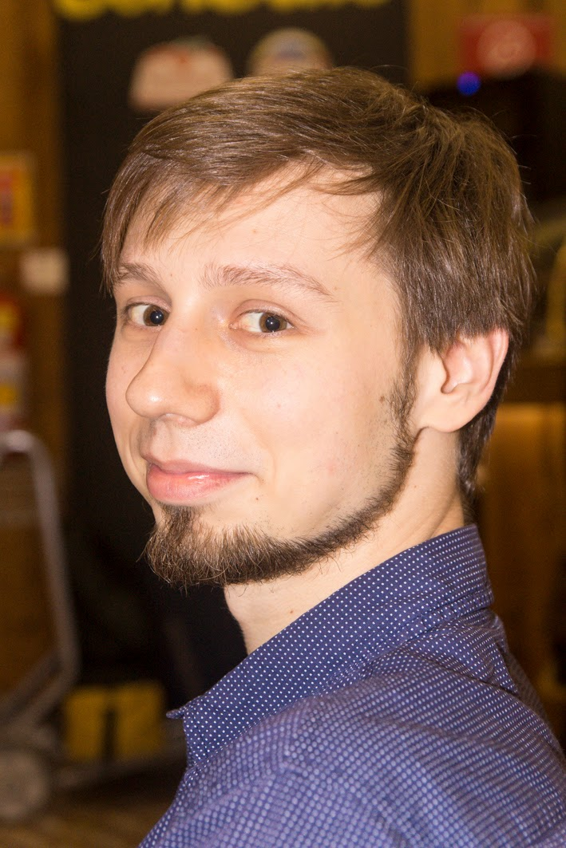
Curriculum Vitæ
Pelenitsyn Artem
Volkova st., 5/3, r.57, 344092 Rostov-na-Donu, Russia
+7 (961) 290 2878, apel@sfedu.ru, http://mmcs.sfedu.ru/~ulysses

1 Education
2003–2007 B.Sc. in Applied Mathematics and Computer Science Southern Federal University Rostov-na-Donu, Russia

2 Master thesis
BMS-algorithm and its application to decoding, supervisor: Assoc. prof. V.M. Deundyak

3 Experience

3.1 Occupation
2010–2011, 2012–present Teaching assistant, lecturer at Southern Federal University Rostov-na-Donu, Russia

3.2 Teaching (at Southern Federal University)
Computer Architecture (lectures & labs) — 2013–2015 (spring). Automata and Ciphers (lectures) — 2013–2015 (fall). Functional Programming labs — 2011 (spring). Programming Basics labs — 2008, 2010–2012, 2014. Programming Languages labs — 2008, 2010 (fall). Automata and Languages — 2010 (spring). Microprogramming/Assembler Programming labs — 2009 (fall). Geometry and Algebra — 2009 (fall).

3.3 Summer schools and other extra trainings
2011Summer School “Algebra and Geometry” Laboratory of Algebraic Geometry in the National Research University Higher School of Economics, Teachers’ Training University of Yaroslavl’Yaroslavl’, Russia http://mmcs.sfedu.ru/ ulysses/Papers/Trainings/2011-Yaroslavl.jpgLink to Certificate of Attendance (in Russian). http://bogomolov-lab.ru/SHKOLA/Link to Official Web Page (in Russian).
2010 Microsoft Algorithms and Data Structures Summer School Microsoft Research in Silicon ValeySaint-Petersburg, Russia http://mmcs.sfedu.ru/ ulysses/Papers/Trainings/2010-MIDAS-participation.jpgLink to Certificate of Attendance. http://logic.pdmi.ras.ru/midas/en/aboutLink to Official Web Page.
2010 Winter School on Applied Mathematics and Computer Science National Research University Higher School of Economics Moscow province, Russia http://mmcs.sfedu.ru/ ulysses/Papers/Trainings/2010-HSE-math-school-participation.jpgLink to Certificate of Attendance (in Russian).
2009 Marktoberdorf Summer School “Logics and Languages for Reliability and Security” Marktoberdorf, Germany http://mmcs.sfedu.ru/ ulysses/Papers/Trainings/2009-Marktoberdorf-adoption.jpgLetter of Acceptance. http://asimod.in.tum.de/2009/index.shtmlLink to Official Web Page.

3.4 Participation in MOOC
Coursera, 2013 The Hardware/Software Interface, Prof. J.D. Noe
http://mmcs.sfedu.ru/ ulysses/Edu/coursera/hwsw.pdf

Coursera, 2012 Quantum Mechanics andQuantum Computation Prof. U. Vazirani
http://mmcs.sfedu.ru/ ulysses/Edu/coursera/qmqc.pdf

Coursera, 2012 Functional Programming Principles in Scala Prof. M. Odersky
http://mmcs.sfedu.ru/ ulysses/Edu/coursera/progfun.pdf

Coursera, 2012 Introduction to Logic Assoc. Prof. M. Genesereth
http://mmcs.sfedu.ru/ ulysses/Edu/coursera/intrologic.pdf

Coursera, 2012 Compilers Prof. A. Aiken
http://mmcs.sfedu.ru/ ulysses/Edu/coursera/compilers.pdf

Coursera, 2012 Automata Prof. J. Ullman
http://mmcs.sfedu.ru/ ulysses/Edu/coursera/automata.pdf

Coursera, 2012 Cryptography I Prof. D. Boneh
http://mmcs.sfedu.ru/ ulysses/Edu/coursera/crypto-I.pdf

Coursera, 2012 Algorithms I Assoc. Prof. T. Roughgarden
http://mmcs.sfedu.ru/ ulysses/Edu/coursera/algo-I.pdf

4 Personal awards, scholarships, etc.
2012 Participation in all-russian final of international student olympiad “IT-planet” competition: “Oracle Java Olympic”
http://mmcs.sfedu.ru/ ulysses/Papers/Trainings/2012-ITPlanet-final.pdfLink to Diploma for Participation (in Russian).

2012 Diploma for taking second place in regional stage of international student olympiad “IT-planet”competition: “Oracle Java Olympic”
http://mmcs.sfedu.ru/ ulysses/Papers/Trainings/2012-ITPlanet.jpgLink to Diploma scan (in Russian)

2012 Participation in the final stage of VI Open Programming Contest of Southern Federal Universityindividual event
http://mmcs.sfedu.ru/ ulysses/Papers/Trainings/2012-TTI-olymp-participation.jpgLink to Diploma for Participation (in Russian).

2011 Scholarship from foundation "Education and Science on the South of Russia"
http://mmcs.sfedu.ru/ ulysses/Papers/Trainings/2011-CI-cert.jpgLink to the scholarship statement scan (in Russian)

2011 Rector’s commendation for participating in international accreditation of unversity teaching programmesSouthern Federal University
http://mmcs.sfedu.ru/ ulysses/Papers/Trainings/2011-rector-commendation.pdfLink to scan of the commendation text (in Russian)

2008 Diploma for the best talkstudent session during annual “Week of Science”, Southern Federal University NOT FOUND

5 Languages
Russian: Native
English: Advanced (IELTS exam band score 7.5 taken in 2012)

6 Conference Talks
2015 Scientific Conference “Modern Information Technologies in Education” talk “Storing and publication assignment infrastructure for Moodle LMS” Institute for Mathematics, Mechanics and Computer Science in honour of I. I. Vorovich, Rostov-na-Donu, Russia http://conf.sfedu.ru/inftech2010/Link to the web-site (in Russian), http://staff.mmcs.sfedu.ru/ ulysses/Papers/Talks/2015-SITO-Moodle-publication.pdflink to the slides (in Russian).
2014 Joint International Program For Scientific and Technology Cooperation talk “Computer Science Projects Developed inside (in connection with) Department of Mathematics, Mechanics and Computer Sciences / SFedU” Sao Paulo, Rio de Janeiro, Fortaleza, Brasil http://sfedu.ru/www/sfedunews.show\s\do5(f)ull?p\s\do5(n)ws\s\do5(i)d=46741Info on university web-site (in Russian), http://staff.mmcs.sfedu.ru/ ulysses/Papers/Talks/2014-BRICS-University-Forum.pdflink to the slides.
2012 Research and Pratice Conference: Free Open Source Software “FOSS Lviv 2012” talk “Software Implementation of Decoder For a Class Of Error-Correcting Codes on Algebraic Curves: Designing on a Basis of Generic Metaprogramming Templates” Ivan Franko National University of Lviv, Lviv, Ukraine http://conference.linux.lviv.ua/en/mainLink to the web-site, http://mmcs.sfedu.ru/ ulysses/Papers/Talks/2012-FOSS-Lviv.pdflink to the slides (in Russian).
2010 Scientific-Methodic Conference “Modern Information Technologies in Education” talk “Methodic Supply and IT-infrastructure for Teaching Low-Level Programming” Computing Center of Southern Federal University, Rostov-na-Donu, Russia http://conf.sfedu.ru/inftech2010/Link to the web-site (in Russian), http://mmcs.sfedu.ru/ ulysses/Papers/Talks/2010-SITO-Assembly-programming.pdflink to the slides (in Russian).
2008 Scientific-Methodic Conference “Modern Information Technologies in Education” talk “Building Web-portal for Information and Education purposes on Computing Department” Computing Center of Southern Federal University, Rostov-na-Donu, Russia http://conf.sfedu.ru/inftech2008/Link to the web-site (in Russian), http://mmcs.sfedu.ru/ ulysses/Papers/Talks/2008-SITO-IT-portal-slides.pdfLink to the slides (in Russian).
2008 International Conference on Information Security and Safety talk “Building Web-portal for Information and Education purposes on Computing Department”Taganrog, Russia http://bit.tti.sfedu.ru/?q=en/node/15Link to the web-site, or http://bit.tti.sfedu.ru/?q=ru/node/6link to the expanded version in Russian.
2008 Conference “Week of Science” in Southern Federal University talk “On Implementation of Decoder for a Class of Algebraic-Geometry Codes on Projectve Curves using Sakata algorithm” Rostov-na-Donu, Russia http://mmcs.sfedu.ru/ ulysses/Papers/Talks/2008-SFedU-SciWeek-slides.pdfLink to the slides (in Russian).

7 Seminar Talks
2011 Minicourse on Galois Theory Algebra seminar Faculty for Mathematics, Mechanics and Computer Science, Southern Federal University, Rostov-na-Donu
2011 Talks “Foundations for programming Languages”, “Automata and Formal Languages” seminar for undergraduates “Introduction to Theoretical Computer Science”Faculty for Mathematics, Mechanics and Computer Science, Southern Federal University, Rostov-na-Donu http://mmcs.sfedu.ru/ ulysses/Papers/Talks/2011-ITCS-FPL.pdfLink to the slides (in Russian)
2009 Talk “Higher-Order Computations and Model Checking” Interchair seminar on Computer Science Faculty for Mathematics, Mechanics and Computer Science, Southern Federal University, Rostov-na-Donu http://mmcs.sfedu.ru/ ulysses/Papers/Talks/2009-10-19-hoc-model-checking.pdfLink to the slides (in Russian)
2009 Talk “On multi-dimensional version of Berlekamp-Massey algorithm” Seminar on Mathematical Methods in Information Safety and Security Faculty for Mathematics, Mechanics and Computer Science, Southern Federal University, Rostov-na-Donu http://mmcs.sfedu.ru/ ulysses/Papers/Talks/2009-10-16,30-bmsa.pdfLink to the slides (in Russian)
2009 Talk “Inductive Data Types in Programming” Seminar on Category Theory Faculty for Mathematics, Mechanics and Computer Science, Southern Federal University, Rostov-na-Donu http://mmcs.sfedu.ru/ ulysses/Papers/Talks/2009-03-19-CT-inducttypes.pdfLink to the slides (in Russian)
2008 Talk “Spring Framework” Rostov Java User Group Computing Center of Southern Federal University, Rostov-na-Donu http://mmcs.sfedu.ru/ ulysses/Papers/Talks/2008-RostovJUG-SpringFramework.zipLink to the slides (xul format – to be run in Mozilla Firefox browser; in Russian)

8 Publications
Pelenitsyn A. Associated Types and Constraint Propagation for Generic Programming in Scala // “Programming and Computer Software”, 2015, No 4, pp. 224–230. DOI: 10.1134/S0361768815040064 http://mmcs.sfedu.ru/~ulysses/Papers/2015-PCS-Scala-generics.pdf
Pelenitsyn A. Generic and meta- programming approach to design of software implementation of decoder for a class of algebraic geometry codes // “Prikladnaya informatika” (Applied computer science), 2012, No 2(38), pp. 60–70. http://mmcs.sfedu.ru/ ulysses/Papers/2012-PriklInf-metaprogramming-to-decoding.pdfLink to the e-print (in Russian).
Pelenitsyn A. On exploiting one metaprogramming technique. Journal of the Ivanovo Mathematical Society, 2011, No. 1(8), pp.79–84. http://mmcs.sfedu.ru/ ulysses/Papers/2011-Ivanovo-metaprogramming.pdfLink to the preprint (in Russian).
Deundyak V., Pelenitsyn A. Operator-theoretic approach to Berlekamp–Massey Algorithm, // Izvestia vuzov (Universities’ Bulletin), Sev.-Kav. Region (Caucasus Region), Estestvennie Nauki (Sciences), 2011, No. 3. Pp. 11–13. http://mmcs.sfedu.ru/ ulysses/Papers/2011-Izv-vuzov-BMSA-through-operator-theory.pdfLink to the preprint (in Russian).
Mayevskiy A., Pelenitsyn A. Software Implementation of Algebraic-Geometry Codec using Sakata algorithm, // Izvestia Yufu (Southern Federal University Bulletin), Technology Sciences, 2008, No. 8, pp. 196–198. http://mmcs.sfedu.ru/ ulysses/Papers/2008-2-Izvestia-AGCodec-Sakata.pdfLink to the preprint (in Russian).

8.1 Papers In Conference Transactions
Pelenitsyn A. On Implementation of n-Dimensional BMS-algorithm Using Generic Programming // Transactions of Scientific School of I.B. Simonenko, 2010, pp. 197–203. http://mmcs.sfedu.ru/ ulysses/Papers/2010-2-Sbor-Simonenko-BMSA-impl.pdfLink to the preprint (in Russian).
Mayevskiy A., Pelenitsyn A. Methodic Supply and IT-infrastructure for Teaching Low-Level Programming // Transactions of Scientific-Methodic Conference “Modern Information Technologies in Education”, 2010, pp. 210–212. http://mmcs.sfedu.ru/ ulysses/Papers/2010-1-SITO-abstract-preprint.pdfLink to the preprint (in Russian).
Mayevskiy A., Pelenitsyn A. On Software Implementation of Algebraic-Geometry Codec using Sakata algorithm, // Transactions of X International Conference on Information Security and Safety, 2008, pp. 55–57.
Pelenitsyn A. On Implementation of Decoder for a Class of Algebraic-Geometry Codes on Projectve Curves using Sakata algorithm, // Transactions of the Conference "Week of Science" in Southern Federal University, 2008, vol. 1, pp. 55–57. http://mmcs.sfedu.ru/ ulysses/Papers/2008-1-SciWeek-Decoder-Sakata-preprint.pdfLink to the preprint (in Russian).
Bragilevsky V., Mihalkovich S., Pelenitsyn A. Building Web-portal for Information and Education purposes on Computing Department // Transactions of Scientific-Methodic Conference “Modern Information Technologies in Education”, 2008, pp. 48–49. http://mmcs.sfedu.ru/ ulysses/Papers/2008-3-SITO-IT-portal-preprint.pdfLink to the preprint (in Russian).

9 Book Translations
Dowek, Gilles, Levy, Jean-Jacques. Introduction to the Theory of Programming Languages. / Springer. 2011. Russian translation together with V. Bragilevskiy. Published by DMK Press in 2013 (http://www.xn–d1amf.xn–p1ai/catalog/computer/programming/978-5-94074-913-4/link to web page). http://books.google.ru/books?id=YR7RAAAAQBAJ printsec=frontcoverLink to Google.Books preview.
Bird, Richard. Pearls of Functional Algorithm Design. / Cambridge University Press. 2010. Russian translation together with V. Bragilevskiy. Published by DMK Press in 2013 (http://www.xn–d1amf.xn–p1ai/catalog/computer/programming/978-5-94074-867-0/link to web page). http://books.google.ru/books?id=JSjRAAAAQBAJ printsec=frontcoverLink to Google.Books preview.

10 Computer skills
Programming languagesC, C(14), Haskell, Java, Scala, Pascal
Markup, Scripting: LATEX, HTML, JavaScript, PHP, bash, Regular expressions
Operating systems: GNU/Linux family, Windows family

11 (Not So) Toy Programming Projects
http://code.google.com/p/cpp-mv-poly/cpp-mv-poly C-implementation of multivariate polynomials and the BMS-algrithm massively using C templates

http://code.google.com/p/mmcs-entrance-2010/mmcs-entrance-2010 Generation of entrance diagrams (in PNG) in MMCS/SFedU from oficial data (XLS) / Java

http://code.google.com/p/lj-comments-notifier/lj-comments-notifier A tool for notifying about new comments in some livejournal.com-based blog / Haskell

http://projecteuler.net/profile/ulysses4ever.pngProject Euler Link to the participant record / Haskell (mostly), C

https://github.com/ulysses4ever GitHub Profile Mostly forks of my students projects.

12 Interests
Classical literature: Homer, Goethe, Joyce, Kafka, Camus, Sartr, Brodsky
Art cinema: Bergman, Fellini, Truffaut, Tarkovsky, Wenders, Kitano, von Trier

13 Extra info
Gender: Male
Marital status: Single
Current place of living: Rostov-na-Donu, Russia
Citizenship: Russia

