Urinary phthalates and vasomotor symptoms in midlife women: The Study of Women’s Health Across the Nation (SWAN)
Short title: Phthalates and vasomotor symptoms

Rachael A. Brooks, MPH, Jiaxin Wu, MPH, Wenzhiyuan (Victoria) Zhang, MPH, Carrie A. Karvonen-Gutierrez, PhD, MPH, Bhramar Mukherjee, PhD, John F. Randolph Jr., MD, Ellen B. Gold, PhD, Siobán D. Harlow, PhD, Sung Kyun Park, ScD

Supplementary material Tables
Table S1. Hazard ratios for VMS occurrence per a doubling and tertile increase in phthalate metabolite concentrations in 1999-2000 throughout the follow-up period

Tertile HR (95% CI)
p-
Phthalate metabolite | Per doubling increase HR (95% CI) | Tertile 1 | Tertile 2 | Tertile 3 | trend
MEP (ng/mL)
 |  |  | 0.89 (0.75,
Model 1 | 1.03 (0.99, 1.07) | REF | 1.05) | 1.01 (0.85, 1.20) | 0.71
 |  |  | 0.86 (0.73,
Model 2 | 1.02 (0.99, 1.06) | REF | 1.01) | 0.98 (0.83, 1.16) | 0.96
 |  |  | 0.84 (0.71,
Model 3 | 1.03 (0.99, 1.06) | REF | 1.00) | 0.98 (0.82, 1.16) | 0.95

MnBP (ng/mL)
 |  |  | 1.12 (0.96,
Model 1 | 1.02 (0.97, 1.07) | REF | 1.31) | 1.10 (0.93, 1.30) | 0.27
 |  |  | 1.10 (0.94,
Model 2 | 1.01 (0.96, 1.06) | REF | 1.28) | 1.09 (0.92, 1.28) | 0.35
 |  |  | 1.08 (0.93,
Model 3 | 1.02 (0.97, 1.07) | REF | 1.27) | 1.09 (0.93, 1.29) | 0.30
MiBP (ng/mL)
 |  |  | 1.12 (0.97,
Model 1 | 1.06 (1.01, 1.11) | REF | 1.30) | 1.19 (1.01, 1.40) | 0.03
 |  |  | 1.10 (0.95,
Model 2 | 1.06 (1.01, 1.11) | REF | 1.27) | 1.19 (1.02, 1.40) | 0.03
 |  |  | 1.09 (0.94,
Model 3 | 1.06 (1.01, 1.11) | REF | 1.26) | 1.18 (1.00, 1.39) | 0.04
∑LMW phthalate metabolites (nmol/mL)
 |  |  | 0.94 (0.80,
Model 1 | 1.04 (1.00, 1.08) | REF | 1.11) | 1.03 (0.87, 1.22) | 0.64
 |  |  | 0.93 (0.79,
Model 2 | 1.03 (0.99, 1.07) | REF | 1.10) | 1.00 (0.85, 1.19) | 0.88
 |  |  | 0.93 (0.79,
Model 3 | 1.03 (0.99, 1.08) | REF | 1.10) | 1.00 (0.85, 1.19) | 0.88
MEHP (ng/mL)

 |  |  | 1.02 (0.88,
Model 1 | 1.06 (1.02, 1.10) | REF | 1.19) | 1.15 (0.98, 1.36) | 0.08
 |  |  | 0.99 (0.85,
Model 2 | 1.06 (1.02, 1.10) | REF | 1.15) | 1.16 (0.99, 1.37) | 0.07
 |  |  | 0.97 (0.83,
Model 3 | 1.05 (1.01, 1.09) | REF | 1.13) | 1.13 (0.96, 1.33) | 0.13
MEHHP (ng/mL)
 |  |  | 1.05 (0.91,
Model 1 | 1.05 (1.01, 1.09) | REF | 1.22) | 1.15 (0.97, 1.36) | 0.11
 |  |  | 1.06 (0.91,
Model 2 | 1.05 (1.01, 1.10) | REF | 1.23) | 1.16 (0.99, 1.38) | 0.08
 |  |  | 1.05 (0.91,
Model 3 | 1.05 (1.01, 1.09) | REF | 1.23) | 1.14 (0.96, 1.35) | 0.13
MEOHP (ng/mL)
 |  |  | 1.09 (0.93,
Model 1 | 1.05 (1.01, 1.09) | REF | 1.27) | 1.11 (0.94, 1.31) | 0.23
 |  |  | 1.08 (0.93,
Model 2 | 1.05 (1.01, 1.09) | REF | 1.26) | 1.11 (0.94, 1.31) | 0.22
 |  |  | 1.08 (0.93,
Model 3 | 1.05 (1.00, 1.09) | REF | 1.26) | 1.09 (0.92, 1.29) | 0.31
MECPP (ng/mL)
 |  |  | 1.14 (0.99,
Model 1 | 1.06 (1.01, 1.11) | REF | 1.32) | 1.28 (1.08, 1.51) | 0.00

 |  |  | 1.13 (0.98,
Model 2 | 1.06 (1.02, 1.11) | REF | 1.31) | 1.28 (1.08, 1.51) | 0.00
 |  |  | 1.15 (0.99,
Model 3 | 1.06 (1.02, 1.11) | REF | 1.33) | 1.27 (1.07, 1.50) | 0.01
∑DEHP phthalate | metabolites (nmol/mL)
 |  |  | 1.14 (0.99,
Model 1 | 1.05 (1.01, 1.10) | REF | 1.33) | 1.22 (1.03, 1.44) | 0.02
 |  |  | 1.14 (0.98,
Model 2 | 1.06 (1.01, 1.10) | REF | 1.32) | 1.22 (1.04, 1.44) | 0.02
 |  |  | 1.15 (0.99,
Model 3 | 1.05 (1.01, 1.10) | REF | 1.34) | 1.19 (1.00, 1.41) | 0.04
MBzP (ng/mL)
 |  |  | 1.11 (0.94,
Model 1 | 1.06 (1.01, 1.11) | REF | 1.31) | 1.25 (1.05, 1.48) | 0.01
 |  |  | 1.09 (0.92,
Model 2 | 1.05 (1.00, 1.10) | REF | 1.28) | 1.21 (1.02, 1.43) | 0.03
 |  |  | 1.10 (0.93,
Model 3 | 1.05 (1.00, 1.10) | REF | 1.31) | 1.21 (1.02, 1.44) | 0.02
MCOP (ng/mL)
 |  |  | 1.00 (0.85,
Model 1 | 1.01 (0.96, 1.06) | REF | 1.19) | 0.98 (0.82, 1.17) | 0.81
 |  |  | 1.00 (0.84,
Model 2 | 1.00 (0.95, 1.06) | REF | 1.18) | 0.96 (0.81, 1.15) | 0.64

 |  |  | 0.99 (0.84,
Model 3 | 1.00 (0.95, 1.05) | REF | 1.18) | 0.96 (0.80, 1.15) | 0.61
MCNP (ng/mL)
 |  |  | 0.92 (0.78,
Model 1 | 1.01 (0.96, 1.06) | REF | 1.10) | 1.10 (0.92, 1.32) | 0.15
 |  |  | 0.88 (0.74,
Model 2 | 1.00 (0.96, 1.05) | REF | 1.05) | 1.06 (0.88, 1.27) | 0.27
 |  |  | 0.85 (0.71,
Model 3 | 0.99 (0.95, 1.04) | REF | 1.01) | 1.00 (0.83, 1.20) | 0.64
MCPP (ng/mL)
 |  |  | 0.97 (0.81,
Model 1 | 1.07 (1.01, 1.13) | REF | 1.16) | 1.14 (0.95, 1.38) | 0.06
 |  |  | 0.95 (0.79,
Model 2 | 1.06 (1.00, 1.13) | REF | 1.14) | 1.13 (0.94, 1.37) | 0.06
 |  |  | 0.91 (0.76,
Model 3 | 1.06 (0.99, 1.12) | REF | 1.10) | 1.13 (0.94, 1.37) | 0.05
∑HMW phthalate metabolites (nmol/mL)
 |  |  | 1.18 (1.01,
Model 1 | 1.06 (1.01, 1.11) | REF | 1.37) | 1.19 (1.00, 1.40) | 0.05
 |  |  | 1.15 (0.98,
Model 2 | 1.06 (1.01, 1.12) | REF | 1.34) | 1.18 (1.00, 1.40) | 0.05
 |  |  | 1.15 (0.99,
Model 3 | 1.06 (1.01, 1.11) | REF | 1.35) | 1.15 (0.97, 1.37) | 0.10

Abbreviations: HR: hazard ratio; 95% CI: 95% confidence interval; LMW, low molecular weight; HMW, high molecular weight; DEHP, di(2-ethylhexyl) phthalate; MBzP, monobenzyl phthalate; MCNP, mono-carboxy-isononyl phthalate; MCPP, mono(3-carboxypropyl) phthalate; MCOP, mono-carboxyoctyl phthalate; MECPP, mono(2-ethyl-5-carboxypentyl) phthalate; MEHP, mono(2-ethylhexyl) phthalate; MEHHP, mono(2-ethyl-5-hydroxyhexyl) phthalate; MEOHP, mono(2-ethyl- 5-oxohexyl) phthalate; MEP, mono-ethyl phthalate; MiBP, mono-isobutyl phthalate; MnBP, mono-n-butyl phthalate.
Model 1: log2-transformed phthalate metabolite, and time-invariant race/ethnicity, site location, educational status, physical activity, BMI, smoking status, secondary smoke exposure. Model 2: Model 1 + menopausal status. Model 3: Model 2 + symptom sensitivity, prior anxiety, pre-menstrual symptoms.
Phthalate metabolites were adjusted for hydration using the covariate-adjusted creatinine standardization method.
∑LMW phthalate metabolites, molar sum of MEP, MnBP, and MiBP; ∑DEHP metabolites, molar sum of MEHP, MEHHP, MEOHP, and MECPP; ∑HMW phthalate metabolites, molar sum of MEHP, MEHHP, MEOHP, MECPP, MBzP, MCOP, MCNP, and MCPP.
Bold values indicate statistical significance.

Table S2. Hazard ratios for VMS occurrence per a doubling increase in phthalate metabolite concentrations in 1999-2000 throughout the follow-up period by racial/ethnic group

Phthalate metabolite | Per doubling increase HR (95% CI)
MEP (ng/mL)
White | 1.00 (0.94, 1.06)
Black | 1.12 (1.05, 1.19)
Asian | 0.98 (0.90, 1.07)
MnBP (ng/mL)
White | 0.96 (0.89, 1.03)
Black | 1.08 (0.98, 1.19)
Asian | 1.05 (0.93, 1.18)
MiBP (ng/mL)
White | 1.01 (0.94, 1.08)
Black | 1.12 (1.01, 1.24)
Asian | 1.10 (0.99, 1.22)
∑LMW phthalate metabolites (nmol/mL) White 1.00 (0.94, 1.07)
Black 1.13 (1.05, 1.21)

Asian  MEHP (ng/mL) | 0.98 (0.88, 1.09)
White | 1.07 (1.01, 1.13)
Black | 1.01 (0.94, 1.09)
Asian | 1.06 (0.97, 1.16)
MEHHP (ng/mL)
White | 1.06 (1.00, 1.13)
Black | 0.97 (0.90, 1.05)
Asian | 1.11 (1.02, 1.22)
MEOHP (ng/mL)
White | 1.07 (1.01, 1.14)
Black | 0.95 (0.87, 1.03)
Asian | 1.11 (1.01, 1.21)
MECPP (ng/mL)
White | 1.09 (1.02, 1.16)
Black | 0.98 (0.89, 1.07)
Asian | 1.11 (1.01, 1.23)
∑DEHP phthalate metabolites (nmol/mL)

White | 1.08 (1.01, 1.15)
Black | 0.97 (0.89, 1.05)
Asian | 1.11 (1.01, 1.22)
MBzP (ng/mL)
White | 1.05 (0.98, 1.12)
Black | 1.10 (0.99, 1.23)
Asian | 1.02 (0.92, 1.12)
MCOP (ng/mL)
White | 1.01 (0.94, 1.09)
Black | 1.01 (0.91, 1.11)
Asian | 0.97 (0.86, 1.08)
MCNP (ng/mL)
White | 1.02 (0.96, 1.10)
Black | 1.00 (0.91, 1.10)
Asian | 0.91 (0.81, 1.02)
MCPP (ng/mL)
White | 1.09 (1.00, 1.19)
Black | 1.03 (0.91, 1.16)

Asian 1.05 (0.92, 1.2)
∑HMW phthalate metabolites (nmol/mL)

White | 1.09 (1.01, 1.17)
Black | 0.98 (0.89, 1.09)
Asian | 1.08 (0.97, 1.21)

Abbreviations: HR: hazard ratio; 95% CI: 95% confidence interval; LMW, low molecular weight; HMW, high molecular weight; DEHP, di(2-ethylhexyl) phthalate; MBzP, monobenzyl phthalate; MCNP, mono-carboxy-isononyl phthalate; MCPP, mono(3-carboxypropyl) phthalate; MCOP, mono-carboxyoctyl phthalate; MECPP, mono(2-ethyl-5-carboxypentyl) phthalate; MEHP, mono(2-ethylhexyl) phthalate; MEHHP, mono(2-ethyl-5-hydroxyhexyl) phthalate; MEOHP, mono(2-ethyl- 5-oxohexyl) phthalate; MEP, mono-ethyl phthalate; MiBP, mono-isobutyl phthalate; MnBP, mono-n-butyl phthalate.
Hazard ratios were adjusted for time-invariant site location, educational status, physical activity, BMI, smoking status, secondary smoke exposure, menopausal status, symptom sensitivity, prior anxiety, and pre-menstrual symptoms.
Phthalate metabolites were adjusted for hydration using the covariate-adjusted creatinine standardization method.
∑LMW phthalate metabolites, molar sum of MEP, MnBP, and MiBP; ∑DEHP metabolites, molar sum of MEHP, MEHHP, MEOHP, and MECPP; ∑HMW phthalate metabolites, molar sum of MEHP, MEHHP, MEOHP, MECPP, MBzP, MCOP, MCNP, and MCPP.
Bold values indicate statistical significance.

Figures
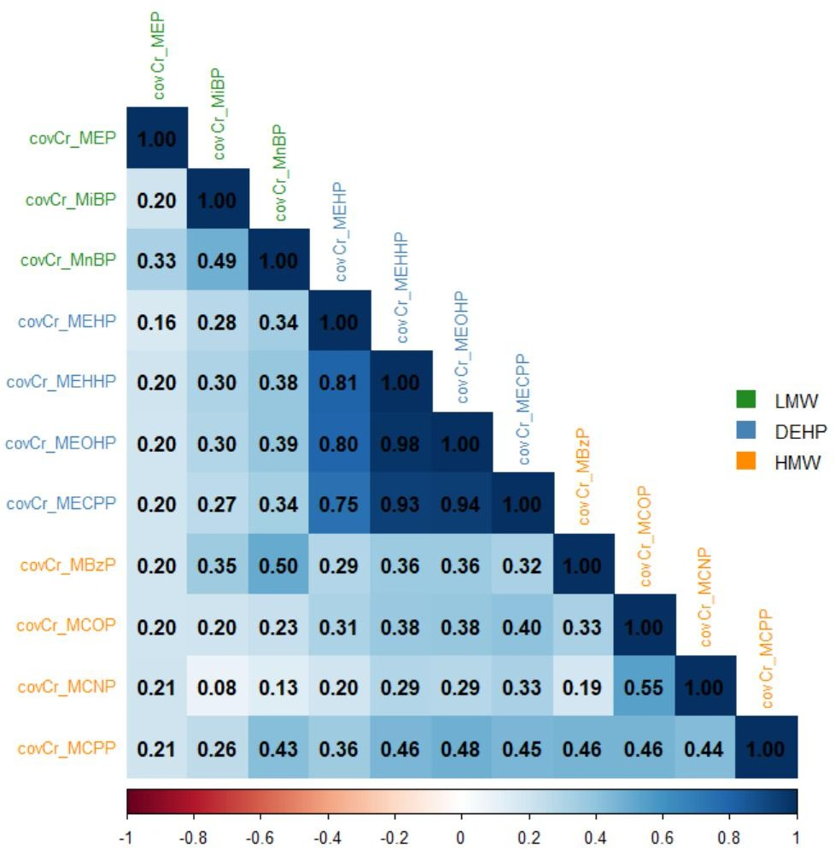
Figure S1. Spearman correlation coefficients between phthalate metabolites in 1999-2000
Phthalate metabolites were adjusted for hydration using the covariate-adjusted creatinine standardization method.
∑LMW phthalates: molar sum of MEP, MnBP, and MiBP concentrations. ∑DEHP: molar sum of MEHP, MEHHP, MEOHP, and MECPP concentrations. ∑HMW phthalates: molar sum of MEHP, MEHHP, MEOHP, MECPP, MBzP, MCOP, MCNP, and MCPP concentrations.

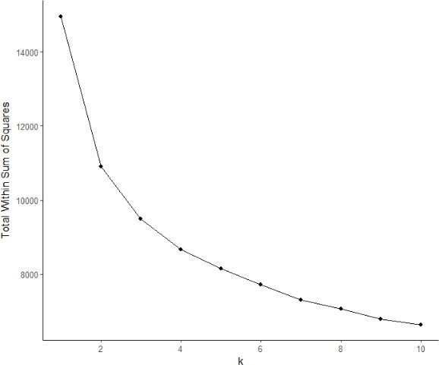

Figure S2. Elbow plot for determining the optimal number of clusters (k) in k-means clustering of phthalate metabolite concentrations. The within sum of squares was plotted against increasing values of k (1 to 10) to evaluate model fit.
Based on this plot, k = 3 was selected as the optimal number of clusters.

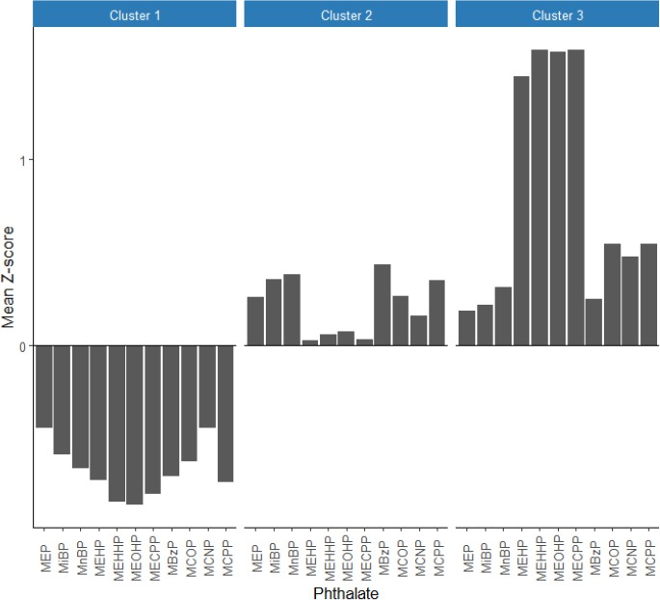

Figure S3. Cluster means of the 11 standardized log2-transformed urinary phthalate metabolites using k-means clustering method. Y-axis (cluster means) represents the mean standardized log2-transformed specific gravity adjusted phthalate concentrations. Cluster 1: low exposure pattern to phthalate mixtures; cluster 2: higher exposure to LMW phthalates and MBzP; cluster 3: higher exposure to HMW and DEHP phthalates.
Abbreviations: LMW, low molecular weight; HMW, high molecular weight; DEHP, di(2-ethylhexyl) phthalate; MBzP, monobenzyl phthalate; MCNP, mono-carboxy-isononyl phthalate; MCPP, mono(3-carboxypropyl) phthalate; MCOP, mono-

carboxyoctyl phthalate; MECPP, mono(2-ethyl-5-carboxypentyl) phthalate; MEHP, mono(2-ethylhexyl) phthalate; MEHHP, mono(2-ethyl-5-hydroxyhexyl) phthalate; MEOHP, mono(2-ethyl-5-oxohexyl) phthalate; MEP, mono-ethyl phthalate; MiBP, mono-isobutyl phthalate; MnBP, mono-n-butyl phthalate.

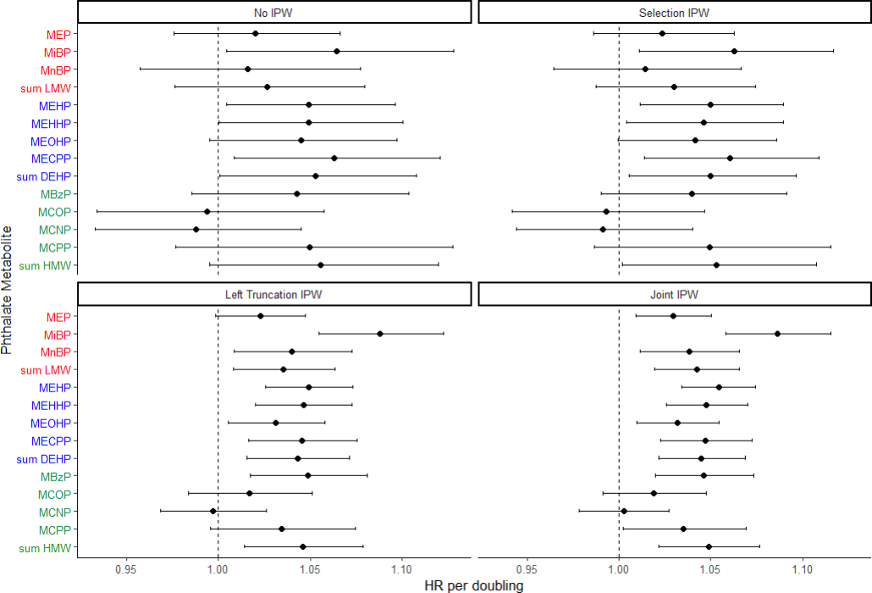
Figure S4. Hazard ratios for VMS occurrence per doubling of phthalate metabolite concentrations by different weighting strategies. The hazard ratios were adjusted for time-invariant race/ethnicity, site location, educational status, physical activity, BMI, smoking status, secondary smoke exposure, menopausal status, symptom sensitivity, prior anxiety, and pre- menstrual symptoms.
Phthalate metabolites were adjusted for hydration using the covariate-adjusted creatinine standardization method.

∑LMW phthalate metabolites, molar sum of MEP, MnBP, and MiBP; ∑DEHP metabolites, molar sum of MEHP, MEHHP, MEOHP, and MECPP; ∑HMW phthalate metabolites, molar sum of MEHP, MEHHP, MEOHP, MECPP, MBzP, MCOP, MCNP, and MCPP.
N for the unweighted model was 1,361; N for the selection IPW model was 1,361; N for the left truncation IPW model was 1,198; N for the joint IPW model was 1,198.
Abbreviations: LMW, low molecular weight; HMW, high molecular weight; DEHP, di(2-ethylhexyl) phthalate; MBzP, monobenzyl phthalate; MCNP, mono-carboxy-isononyl phthalate; MCPP, mono(3-carboxypropyl) phthalate; MCOP, mono- carboxyoctyl phthalate; MECPP, mono(2-ethyl-5-carboxypentyl) phthalate; MEHP, mono(2-ethylhexyl) phthalate; MEHHP, mono(2-ethyl-5-hydroxyhexyl) phthalate; MEOHP, mono(2-ethyl-5-oxohexyl) phthalate; MEP, mono-ethyl phthalate; MiBP, mono-isobutyl phthalate; MnBP, mono-n-butyl phthalate.

