Bitwise Computation Tutorial: Circuits and Goals
by Alden Wright and George Lesica
University of Montana Computer Science Department
Draft of March 20, 2015

Introduction
The CGP Julia package implements digital logic-gate circuit evolution in Julia using bitwise computation. This tutorial introduces the underlying concepts.

Logic Gates
Logic gates are the building blocks of logic circuits. We start with 4 basic logic gates, namely NOT, AND, OR, and XOR as shown below.
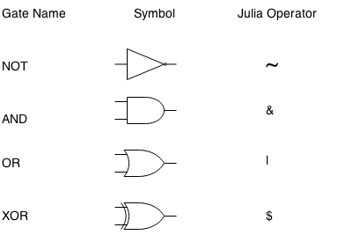
The semantics of a logic gate is described by its truth table. Here is the truth table of the NOT gate:

In other words, if the input A is T (true), then the output is F (false), and vice versa. Consistent with programming notation, we will use 1 for true and 0 for false. And I will use the Julia symbol shown above to denote the operation of the logic gate. Here is the truth table using this notation:

And here are the truth tables of all of the above gates in one table:

Next, we will transpose the table which makes columns into rows and rows into columns. Rows of the transposed truth table will correspond to what is stored in a computer word.

Circuits
Next we will look at the half-adder and full-adder circuits. These circuits are described at http://en.wikipedia.org/wiki/Adder_%28electronics%29. Here is the logic diagram of the half adder (which is copied from the wikipedia website).
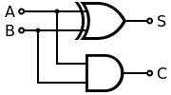

The truth table for this circuit in our transposed notation is:

Note that the C row is the same as the A & B row above since output C is just the output of an AND gate, and the S row is the same as the A | B row above since output S is just the ouput of an XOR gate.

The logic diagram for the full adder is:
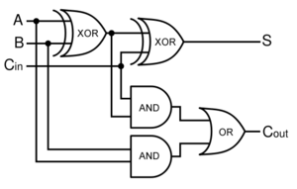

Here is the truth table with intermediate computation rows.

TO DO

Hexadecimal and Octal Notation

Goals

Chromosomes

