
Ramdeobaba University
MACHINE LEARNING PROJECT REPORT
Comparative Performance Analysis of Machine Learning Models for Breast Cancer Classification
Students | Utkarsh Mall, Faiz Sheikh, Soham Sahana
Teacher / Guide | Ayesha Khan
Course / Branch | B.Tech, Robotics and AI
Institution | Ramdeobaba University
Submission Date | 28 October 2026
Dataset: Breast Cancer Wisconsin (Diagnostic) | Task: Binary Classification

Abstract
This project develops and compares machine-learning classifiers for distinguishing benign and malignant cases in the Breast Cancer Wisconsin (Diagnostic) dataset. The workflow includes exploratory data analysis, data-quality checks, preprocessing pipelines, a stratified train/test split, five baseline algorithms, performance evaluation, GridSearchCV hyperparameter tuning, and a Streamlit interface. In the recorded run, Support Vector Machine (SVM) achieved the highest test accuracy (98.25%) and F1-score (97.62%), while the baseline Random Forest achieved the highest ROC-AUC (99.80%). The tuned Random Forest (99.67% ROC-AUC) is the model saved for the Streamlit application. This is an educational benchmark and is not a medical diagnostic tool.

1. Literature Review
The Wisconsin Diagnostic dataset was developed from digitized fine-needle aspirate images and contains numerical measurements describing cell nuclei. It is widely used as a benchmark for binary classification. Logistic Regression provides a linear probabilistic baseline; Decision Trees represent nonlinear decision rules; Random Forest combines many trees to reduce variance; Support Vector Machines seek separating margins in a feature space; and Gradient Boosting builds an additive tree ensemble. Because model rankings depend on the metric and experimental design, algorithms should be compared using a consistent split and clearly defined metrics.

2. Introduction and Problem Statement
Breast mass classification is a high-impact application area for pattern recognition. This project investigates whether numerical measurements of cell nuclei can be used by supervised machine-learning algorithms to classify records as benign or malignant. The problem is framed as binary classification. The objective is to study model performance on a public benchmark rather than to make clinical recommendations.

3. Objectives
The project objectives are to:
- Load and describe a verifiable public dataset.
- Conduct EDA and visualize distributions, class balance and correlations.
- Apply leakage-aware preprocessing.
- Train and compare at least three classifiers using a consistent evaluation procedure.
- Evaluate models using accuracy, precision, recall, F1-score and ROC-AUC.
- Tune the best baseline model using cross-validation.
- Provide a Streamlit interface and instructions for GitHub and deployment.

4. Dataset Description
Dataset: Breast Cancer Wisconsin (Diagnostic). Source: UCI Machine Learning Repository, https://archive.ics.uci.edu/dataset/17/breast+cancer+wisconsin+diagnostic. DOI: https://doi.org/10.24432/C5DW2B. The dataset has 569 records and 30 numerical predictor features, with two classes: 357 benign and 212 malignant. The 30 predictors describe ten nucleus characteristics (radius, texture, perimeter, area, smoothness, compactness, concavity, concave points, symmetry and fractal dimension) summarized as mean, standard error and worst values. The code uses the public copy distributed by scikit-learn. The target is recoded as benign = 0 and malignant = 1 so malignant is the positive class. The data check found 0 missing cells and 0 duplicate rows.

5. Exploratory Data Analysis and Visualization
The workflow examines the dataset shape, data types, descriptive statistics, missing values, duplicate records, target counts, feature distributions and correlations. The target is moderately imbalanced (357 benign versus 212 malignant), so stratified splitting is appropriate. Features such as radius, perimeter and area describe related morphology and are strongly correlated. Potential boxplot outliers are inspected rather than automatically removed, because unusual observations can contain meaningful class information.
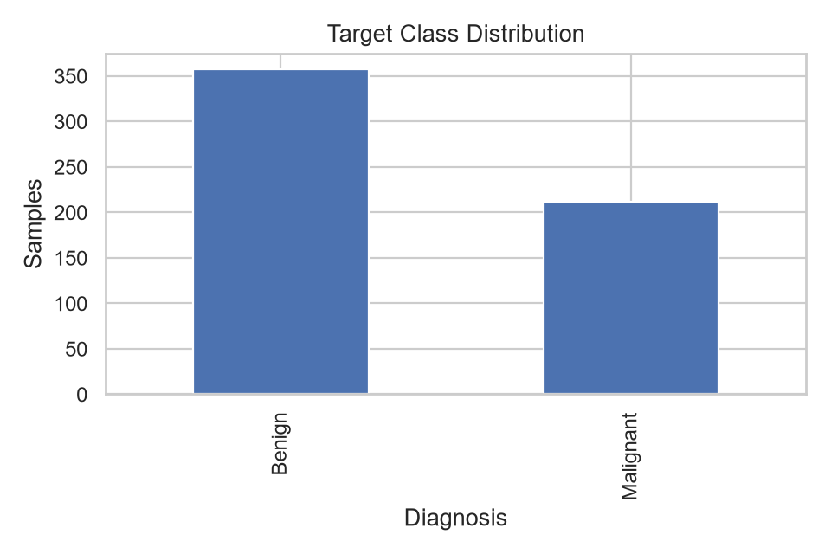
Figure 1. Class distribution (benign vs malignant).
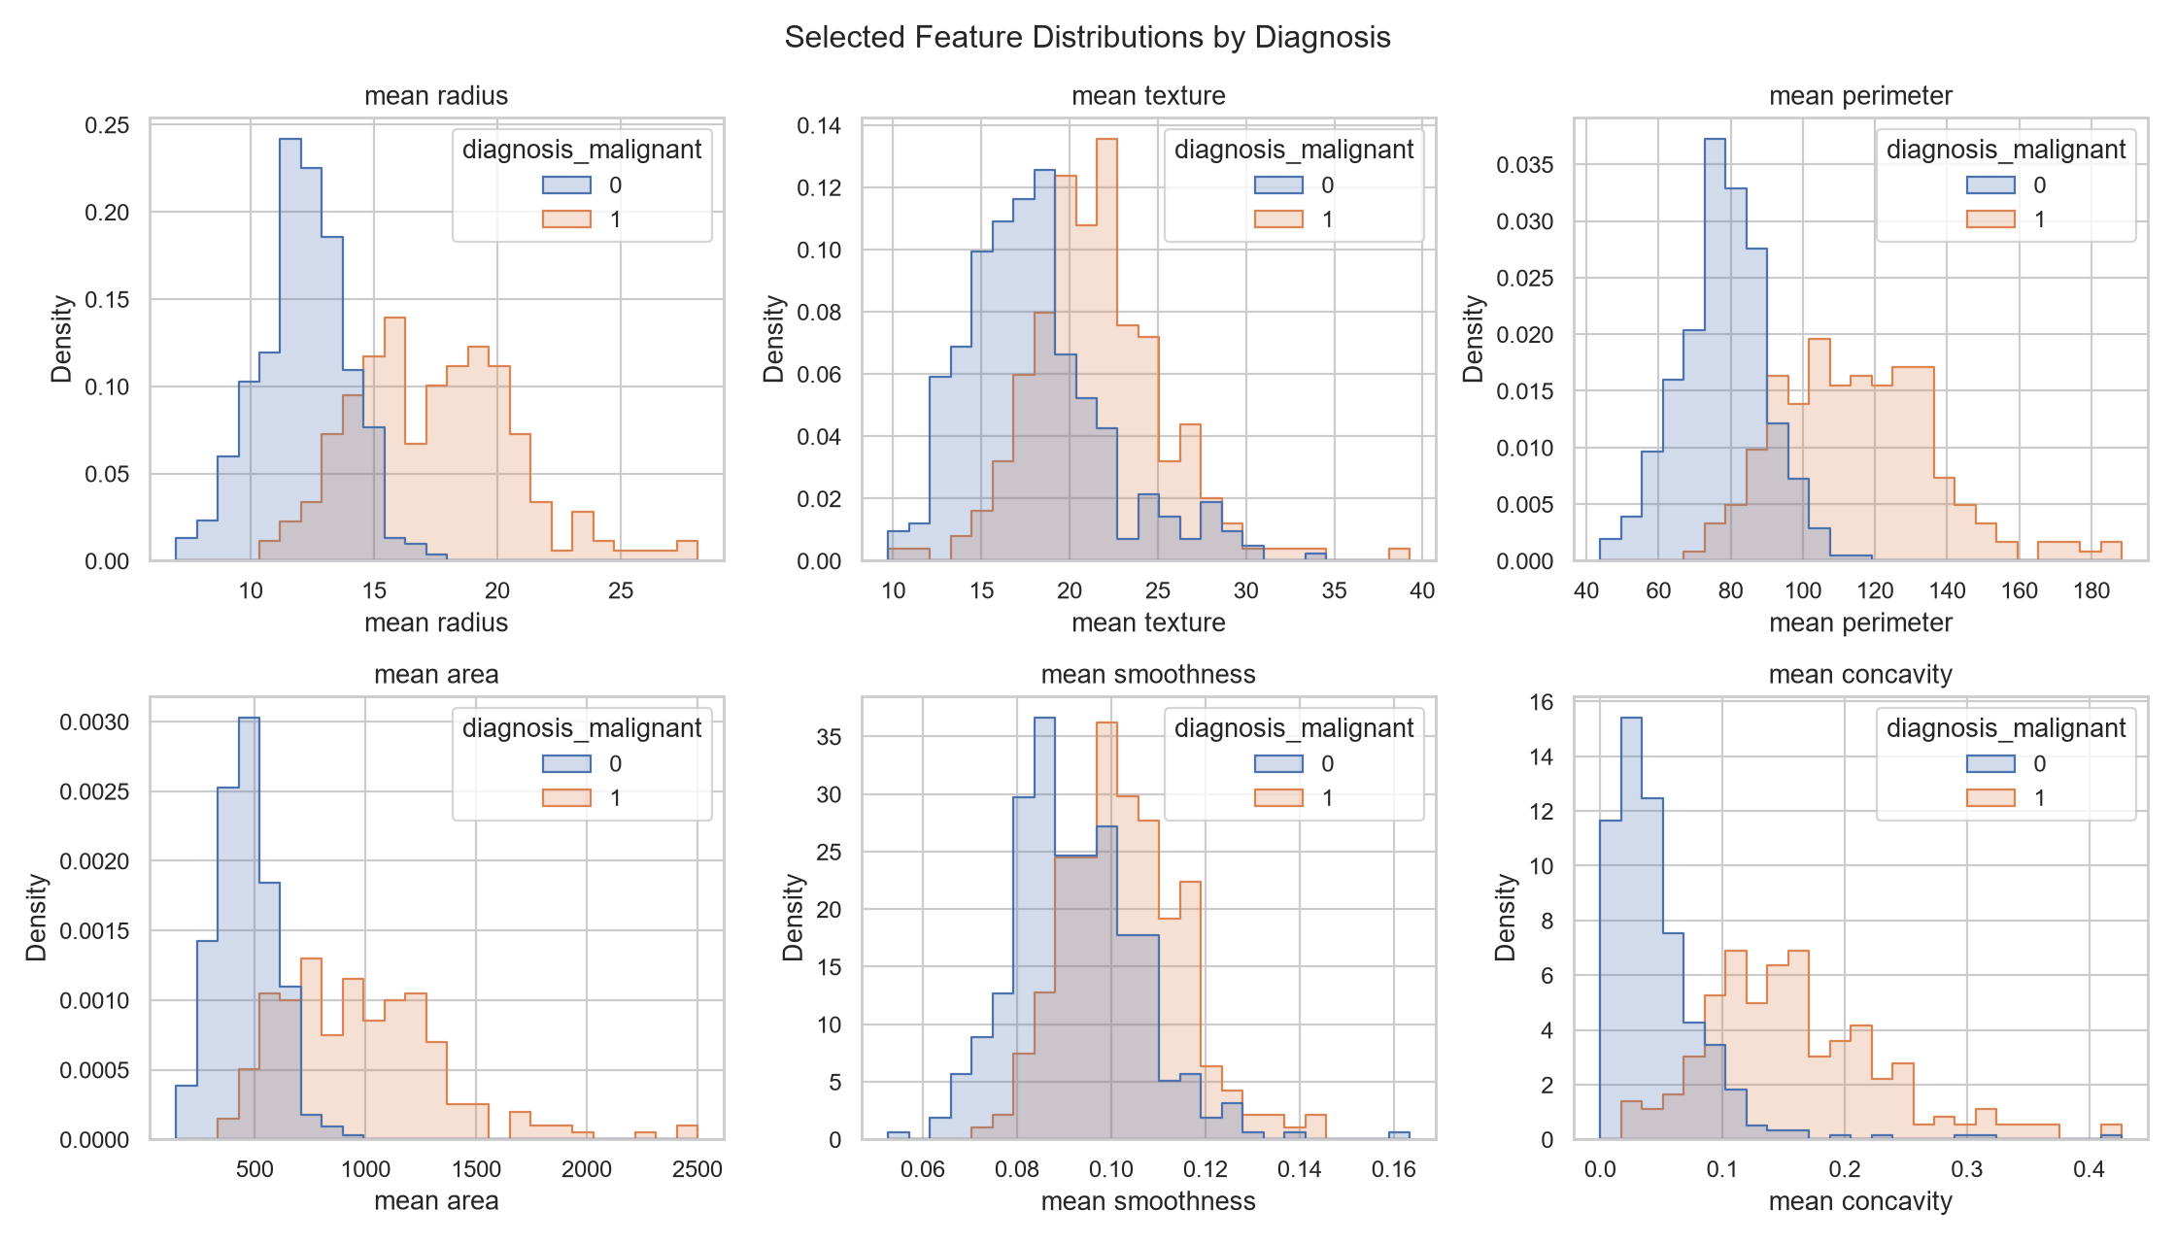
Figure 2. Distributions of selected features by diagnosis.
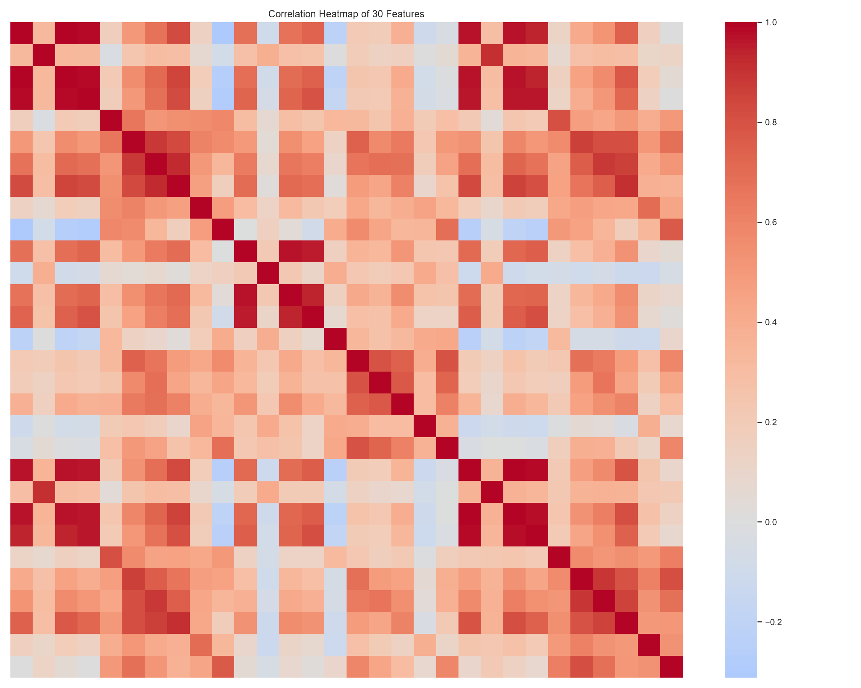
Figure 3. Feature correlation heatmap.
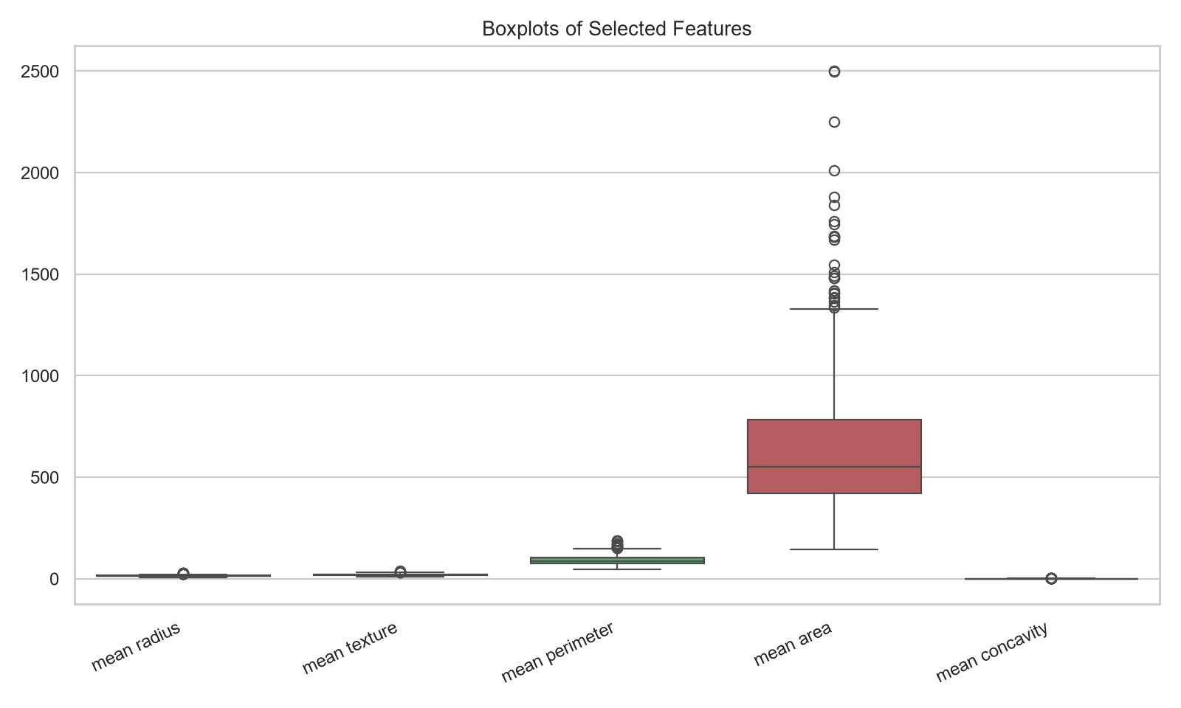
Figure 4. Boxplots of selected measurements by diagnosis.

6. Data Preprocessing
The dataset is split into 80% training (455 records) and 20% test (114 records) data using stratification and random_state=42. Median imputation is placed inside the scikit-learn pipelines so that any fitted preprocessing learns only from the relevant training fold; the dataset contains no missing predictor values. StandardScaler is applied to Logistic Regression and SVM, whose optimization is sensitive to feature scale. Tree-based models do not require scaling, so their pipelines omit it. No automatic outlier deletion is used. The test split is held out from model fitting and hyperparameter search, although the baseline-selection limitation described in Section 13 should be considered.

7. Machine Learning Algorithms Implemented
Five classifiers are trained:
- Logistic Regression with balanced class weights
- Decision Tree with balanced class weights
- Random Forest with 300 trees and balanced class weights
- Support Vector Machine with probability estimates and balanced class weights
- Gradient Boosting
Each model is evaluated on the same stratified held-out test split. Preprocessing is contained within model pipelines to reduce leakage risk.

8. Experimental Setup and Workflow
The experiment follows these steps: load the public dataset; inspect data quality and summary statistics; generate EDA figures; create a stratified 80/20 train/test split; fit all five baseline pipelines on the training data; calculate test-set metrics and confusion matrices; plot ROC curves and compare metrics; tune the selected baseline with GridSearchCV using five-fold StratifiedKFold on training data; evaluate the tuned estimator on the held-out test data; and save the model and metadata for the Streamlit app. The primary tuning score is ROC-AUC.

9. Performance Evaluation and Comparative Analysis
The table below reports the recorded run using random_state=42. Precision, recall and F1-score use malignant as the positive class. Accuracy is the fraction of correct classifications. Precision measures the proportion of predicted malignant cases that are malignant; recall measures the proportion of malignant cases detected; F1 is the harmonic mean of precision and recall. ROC-AUC measures discrimination across classification thresholds.
Model | Accuracy | Precision | Recall | F1-score | ROC-AUC
Logistic Regression | 97.37% | 97.56% | 95.24% | 96.39% | 99.54%
Decision Tree | 90.35% | 89.74% | 83.33% | 86.42% | 88.89%
Random Forest | 97.37% | 100.00% | 92.86% | 96.30% | 99.80%
Support Vector Machine | 98.25% | 97.62% | 97.62% | 97.62% | 99.54%
Gradient Boosting | 96.49% | 100.00% | 90.48% | 95.00% | 99.47%
Tuned Random Forest | 97.37% | 100.00% | 92.86% | 96.30% | 99.67%
Table 1. Test-set metrics from the completed run (random_state=42).
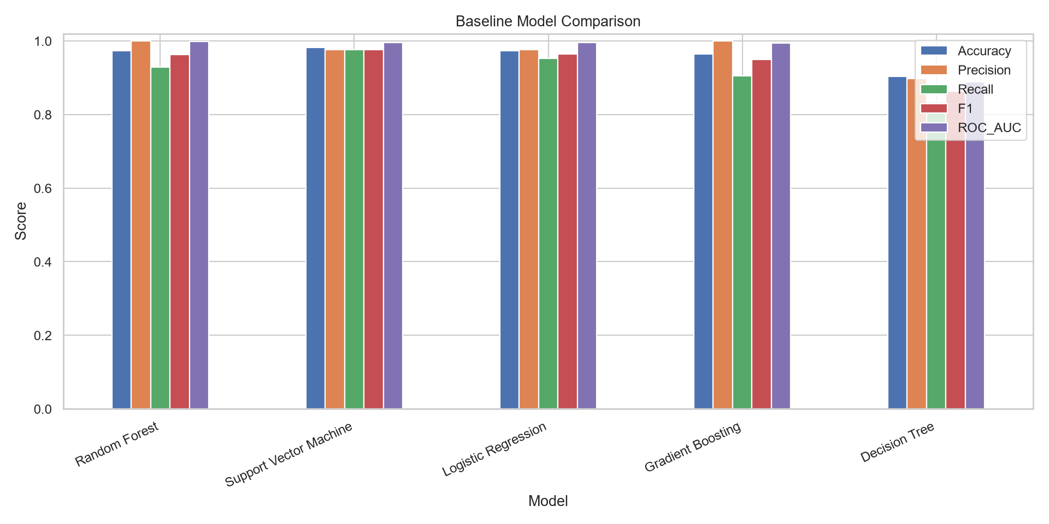
Figure 5. Comparison of model metrics on the held-out test set.
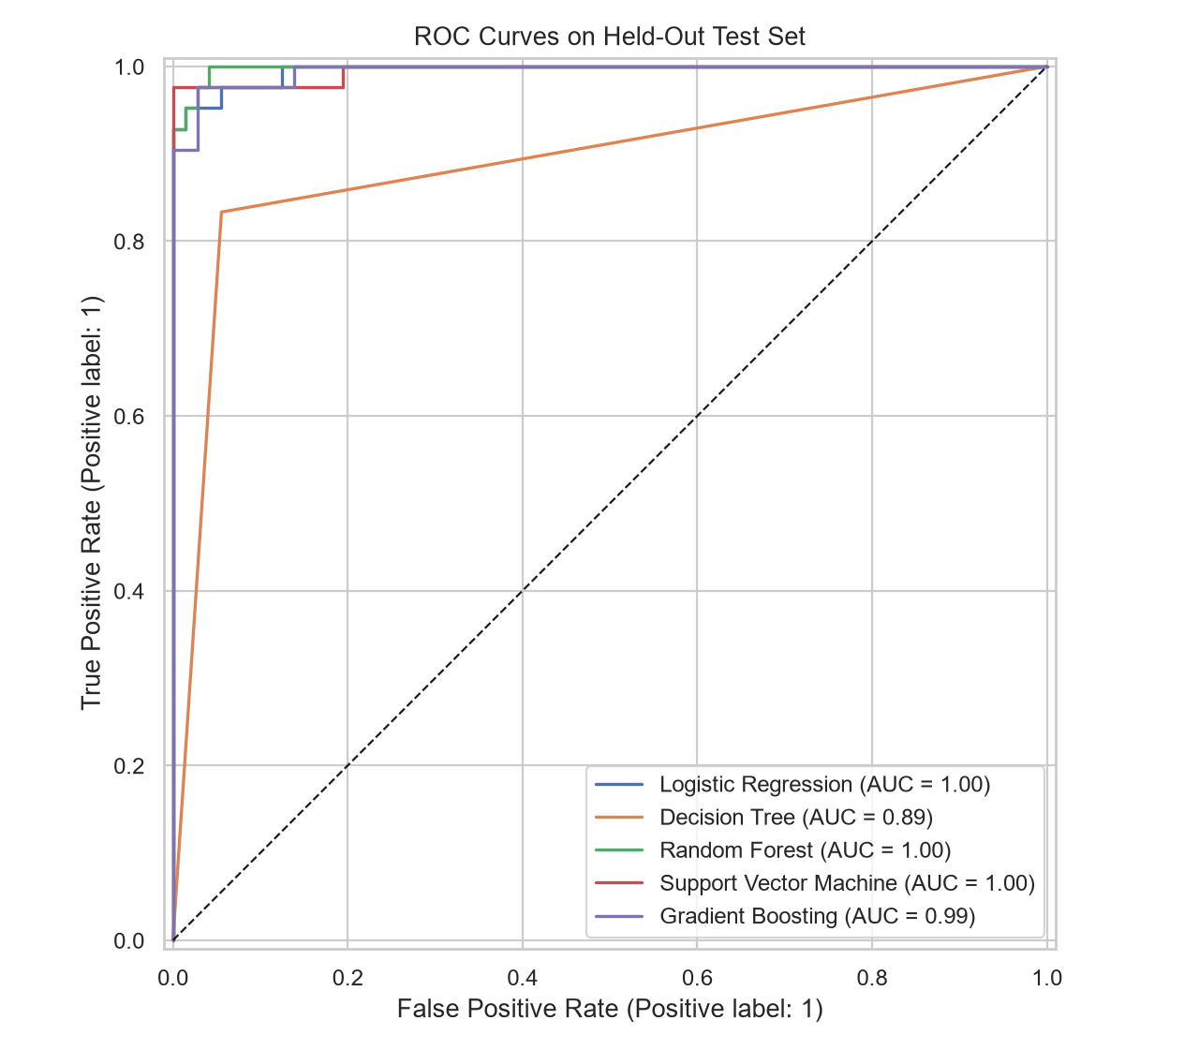
Figure 6. ROC curves of all models on the held-out test set.
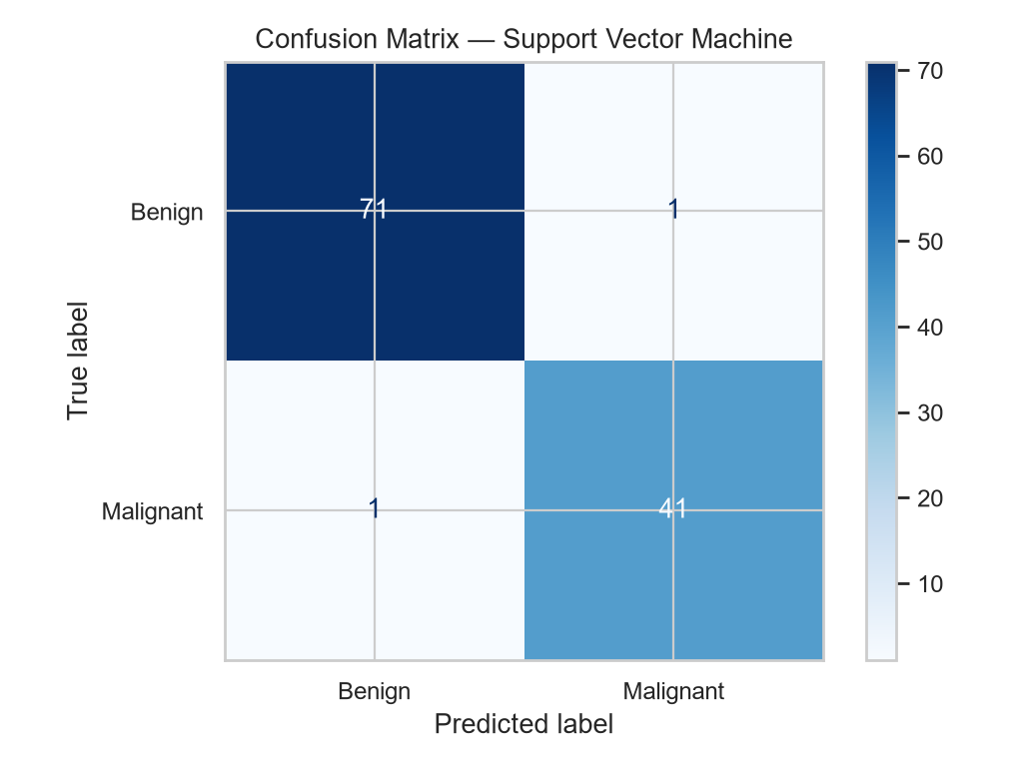
Figure 7. Confusion matrix of Support Vector Machine.
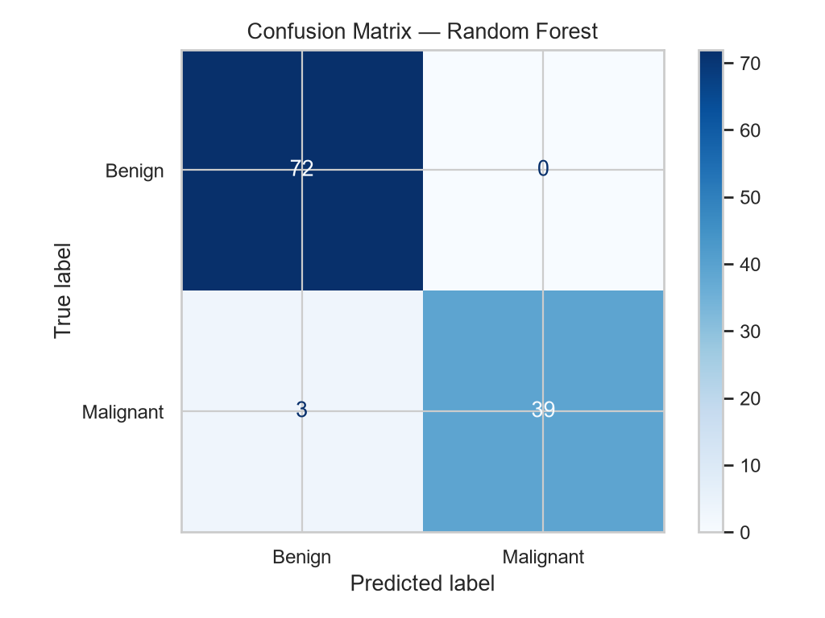
Figure 8. Confusion matrix of Random Forest (baseline).

10. Hyperparameter Tuning and Model Selection
GridSearchCV with five-fold stratified cross-validation searches a model-specific parameter grid on the training data. The baseline with the highest test ROC-AUC in this run was Random Forest, which was then tuned. The selected parameters were max_depth=10, min_samples_leaf=2 and n_estimators=200; its best cross-validation ROC-AUC was 0.9903. On the held-out test set, the tuned Random Forest reached 97.37% accuracy, 100.00% precision, 92.86% recall, 96.30% F1-score and 99.67% ROC-AUC. These values match the baseline Random Forest on accuracy, precision, recall and F1, while test ROC-AUC is marginally lower (99.67% versus 99.80%). Thus tuning did not improve the held-out test metrics in this run, and none of the Random Forest variants exceed the SVM on accuracy, recall or F1-score.
The classification report of the tuned model shows 72 benign test cases all classified correctly (recall 1.00, precision 0.96) and 42 malignant cases with precision 1.00 and recall 0.93, i.e. about 39 of 42 malignant cases detected and none of the benign cases wrongly flagged.

11. Streamlit Deployment
The project includes app.py, which loads the saved model artifact and metadata, accepts the 30 numerical feature values, and displays a predicted class and model-estimated malignant probability. Users can enter measurements manually or select an example row from the public dataset. To run locally, install dependencies, execute python train.py, then run python -m streamlit run app.py. For cloud deployment, push the project to GitHub and configure Streamlit Community Cloud to use app.py. Ensure artifacts/best_model.joblib and artifacts/model_metadata.json are included or generated during deployment.

12. Results and Discussion
SVM had the strongest test accuracy (98.25%), recall (97.62%) and F1-score (97.62%) among all models. Baseline Random Forest had the highest ROC-AUC (99.80%), and the tuned Random Forest followed at 99.67%, ahead of Logistic Regression and SVM (both 99.54%). Decision Tree had the lowest scores overall in this run. The saved and deployed model is the tuned Random Forest because the implemented pipeline tunes the best baseline by ROC-AUC and saves the tuned estimator. If accuracy or recall is the required primary metric, SVM would be selected from these results. Results come from one stratified split and should not be interpreted as evidence of clinical performance.

13. Limitations
The dataset is relatively small and represents a specific benchmark. A single train/test split can lead to variability. In the supplied script, the best baseline is selected by test-set ROC-AUC before tuning, which creates test-set selection bias because the test data influence model choice. For a stricter experiment, select the model using cross-validation on training data only, then evaluate the chosen model on the test set once. External validation, calibrated probabilities, domain expert review and clinical validation would be required before any real-world medical use.

14. Conclusion and Future Scope
This project demonstrates an end-to-end machine-learning workflow: dataset loading, EDA, leakage-aware preprocessing, baseline comparison, model evaluation, hyperparameter tuning and a Streamlit demonstration. SVM achieved the highest accuracy, recall and F1-score in the recorded run, while Random Forest achieved the highest ROC-AUC and its tuned version is the model saved for deployment. Future work includes training-only cross-validation model selection, nested cross-validation, external validation, feature-importance analysis, probability calibration, robustness testing and improved interface design. The application must remain educational and must not be used for diagnosis.

References
1. Wolberg, W., Mangasarian, O., Street, N., & Street, W. (1993). Breast Cancer Wisconsin (Diagnostic). UCI Machine Learning Repository. https://doi.org/10.24432/C5DW2B
2. UCI Machine Learning Repository. Breast Cancer Wisconsin (Diagnostic). https://archive.ics.uci.edu/dataset/17/breast+cancer+wisconsin+diagnostic
3. scikit-learn documentation. https://scikit-learn.org/stable/
4. Streamlit documentation. https://docs.streamlit.io/

Appendix A. Commands to Run the Project
python -m pip install -r requirements.txt
python train.py
python -m streamlit run app.py

