**Project description:**

Please examine the image below and use it as a guide to create your**index.html**  page, as well as **myscript.js**. All images should be stored in an **img** folder and all JavaScript files in a **js**folder.

In this Code Review, your job is to create a list of movies for a “Movie Factory” website. Information about the movies should be stored in a JSON file.

This is the proposed design - feel free to expand:

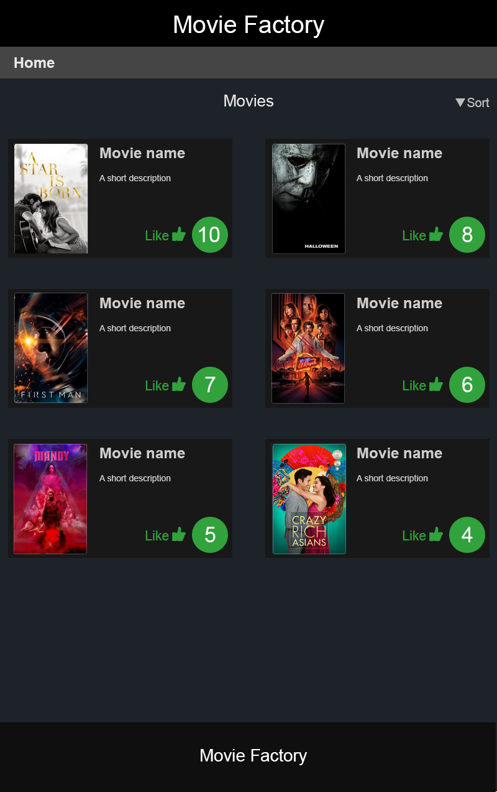

For this CodeReview, the following criteria will be graded:

* (5) Creation of a GitHub project (Repository name:**CFLMS-YourName-CodeReview-05**), successful “push” to the repository and correct information to CodeFactory through the learning management system (https://lms.codefactory.live/) with the GitHub link for the cloning procedure.
* (5) Correct HTML, CSS and JavaScript code structure (aka code indentation) that makes it easier for humans to read
* (20) Correct theme creation based on the provided design
* (10) Correct creation of a JSON file to hold the movie’s data
* (25) Correct creation of the HTML structure based on JavaScript objects: show **movie name, short description and movie poster** according to the provided design
* (10) Add a button to every movie that calls a function that increments the movie’s “likes” property on every button click.
* (25) Display movie’s “likes” property (number), that is also updated on the screen after clicking on the button “Like”

**Bonus Points:**

* (20) Add a **Sort**button that will sort the resulting list of movies according to their current likes property status (i.e. show on the top of the list the movie whose like property is currently the maximum one and so on)